Professional Career Development

Name: Fligenia Silva
Student ID: 2122643
Module code: BMSW4005
Lecturer: Rita Ukachi-Lois

Contents:
1. Introduction........................................................1
2. Gibb’s reflective cycle..................................................... 2
3. Reflection......................................... 3
4.Career development planning.....................4
5. Personal Perspective...............................5
6. Conclusion....................................................... 6

References.

1.Introduction
The Reflection is considered to be the critical and analytical thoughts that are established from the evidence of personal experiences and thoughts and often theoretical literature. Reflection is important as it helps to develop skills and review the effectiveness of past experiences (Wain, 2017). The report will cover the reflective accounts based in some of those topics. I chose the gibb’s reflective cycles model to aplay on each topics as personal perspective, and conclusion.

2.Gibbs's reflective cycle: is one of the famous and most commonly used reflective models to access own performance from past experiences. The model was propounded by Graham Gibbs in 1988 to help learners to develop knowledge from experiences (Amaechi, 2021). The reflective model comprises six stages such as description, feelings, evaluation, analysis, conclusion and action plan. Also
helping people learned from experience he people can find their best learn from their exprience.
If they dont reflect on their exprience and if they dont consiously think about how they could do better next time , they will never learn becau no way to learn without use this method.

- This is where Gibb’s Reflective Cycle is useful.
- Ex; you can use it to help your team make sense of situations at work so that they can understand what they did well and they could do it better next time.

4. Reflection

Description:
During the class, my teacher offered lectures on reflective practices and corresponding reflective models with stages. This was initially interesting as I realised that the reflection is about the experiences that I gathered in class. However, on a particular reflective account, I faced difficulty in addressing each of the stages and took help from my teacher. My teacher guided me with materials and lectures on reflective models that helped me to clarify my doubts.
Feelings:
During the class, I felt excited and intrigued by noting down my class experiences and preparing for my reflective writing. However, acting on the reflective account I faced difficulty and felt nervous. After the class, I felt relieved as I received materials and lecture notes from my teacher which helped me to gain an understanding of the application of reflective models.
Evaluation:
The good about the experience was my active listening skills which helped me to acquire knowledge and materials from my teacher that helped me in my reflective practice. The bad about the experience was my lack of analytical skills to use the best possible reflective model and apply each of the stages. I would change my perception of reflection and reflective practice by being more analytical.

Analysis:
I possess active listening skills as it helped me to acquire all possible information and focus on the details of the interaction. This is why I was able to follow my teacher’s instructions and also take note of the materials and lectures. According to (Weger Jr et all., 2014), active listening skill is significant in recognising the feelings and perspectives of others and helps to appreciate and acknowledge them. However, poor analytical skills have been demonstrated by my inability to assess the effectiveness of each of the reflective models. 5

Conclusions:
In conclusion, I learned that active listening and analytical skills are crucial for students to realise the need to listen to their teachers and peers for complete absorption of information and also to be analytical in terms of reaching solutions to problems. I would be willing to improve my analytical skills with an appropriate action plan.
Action plan:
I am going to enrol on an analytical skills development course for a period of six months. Using the course materials and guidance, I would be able to improve my knowledge about analytical skills and improve my future by using analytical reasoning to solve personal and professional problems.

4. My career developement plan
My personal career plan consists of several stages. Before I land my dream job, brand manager for a multinational global fashion company, I need to gain valuable skills and experience that will help me succeed in this job. These skills are interpersonal skills, communication skills, ability to conduct extensive complex research, creativity and others. I can acquire these skills by working in different positions that would lead me to the Executive Brand Manager position, where in each position I can master one or more of the required skills. The first is personal development. If I am not aware of myself and how my actions affect myself and others around me, I could easily come across as insensitive and not realize when I am indeed stumbling through problems trying to look smart without employing interdependence.

Discription:
As brand managers I will work to ensure that a brand remains reconiseble, up to date and exciting to costumers and plan ways to promote and change the public perception of brands, where. Organisations hire brand managers to work in house on their own brands where it is likely that they will work solely on a single brand. It is also possible for brand manager to work at a marketing agency where they my be working on a number of brands for diferent clients. brand manager are also responsable for making sure that branding is consistent across advertising and campaings.

Feeling:
After working for a company as a multilevel brand manager for about 6 months and gaining confidence and experience in communicating with customers.
I think the ossible challenges could be difficulty to getting a job due to lack of formal work experience in the field and lack of my research knowledge in management.

Evalution:
The good thing is that I was able to develop a professional relationship with a company
sharing ways and tips to further develop my existing qualities with my colleague to improve my capabilities.
The other benefits for me would be to deeply understand market segments and different management strategies of fashion world to gain more knowledge on the subject.

Analysis:
The preventive actions I plan to take are convincing potential employers that the value of my academic research can match my formal job search experience and consistently increase my knowledge of the real fashion market. and not care about showing my best work. However, if I am not careful, making it a prominent ideal will bring me to my ruin, as I am not perfect nor should I expect everything that I set my hands to be that way in my own strength.

I will land my dream job after one year of graduating from school and gaining all the knowledge I need to succeed as a brand manager to secure my dream job - one year may not seem ambitious enough, but it is a realistic estimate for implement this plan.

The possible challenge I may face as a brand manager could be the size of the business. The preventive action would be to form a good team of collaborators to face challenges.

Conclusion
I participated in the leadership development course at Fábric of Impacto in 2017.
In 2018 participated in the Kwintessential intercultural awareness course.
I Becomed a member of the fashion Market Research Society in 2019
I had made several initiatives through which I hoped to achieve certain goals both in academics and in social life. In the previous personal development plan, I had embarked more on the process that I believe would help me to think about my own learning, performance and achievements as well as to plan my personal, educational, social and career development.
In the future I will start work with publish articles on various aspects of fashion in trade magazines every month starting in 2023

Action Plan
My personal development plan aims to provide me with all the knowledge I need to proceed through all stages of my career and land my dream job. Includes the following:
Review the new issue of Rasion Week magazine every month. It will keep me updated on the latest fashion. To more inside the fashion world and be ready for competetion with the other company.

Role-play personal reflection: past week, I participated in a job interview role-play in class, which permitted me to evaluate and test my interview skills with peer I was giving my apresentation at the class. The purpose of the apresentation was role-play about job interview, the job we want to be part in the future, and talk about the the expriences we had and the skills I alredy have, and the especification in my future position in the job I applied for. Everyone knows When interviewing for a job opportunity, many individuals experience anxiety and stress during the process. From personal experience, I can admit that I do not retain the greatest interview skills - I shake uncontrollably, I demonstrate high anxiety levels, and I find it challenging to think on the spot.I been take so long at my apresentation, but I only had 10minutes for apresentation.
My lecturer asked me a question, I got frustred. She already agreed the direction of my presentation but I didn't answer my question the right way becase I started to swallow the words, and getting lost in my reasoning the words are not coming out because I was very nervous, but when my teacher calmed me down she gave me some time I calmed down and took control and started to feel more comfortable to answer the questions more calmly and with great confidence because seeing some of my colleagues calm in their presentations, I realized that it is often good to be calm and concentrated in everything you do to have a good result. But during the apresentation I wasan’t think about it I just lost where I’am I was my i froze at the time i needed the water my colleagues were encouraging me to give me the strength to keep talking but the problem was that i was not confident in my presentation because it was not happening as i wanted it to happen, the funniest thing of all this and that before I presented everything was well controlled until it was my turn everything was confused because of the anxiety I was very sad for not being able to present well as I wanted it to be. So it is some of the experience that I gained in knowing how to keep calm and relax more in any presentation. Before you begin to speak, take a few deep breaths and calm yourself. And Be pleasant and smile when you stand in front of an audience so it makes the audience feel comfortable listening to you. Speak slowly and clearly, and do not rush through sentences, as some do when they get nervous. But its okay o learn from the mixtake Irealize sometimes its happen when you are not ready for samething your emotion talk more, The good thing is that was very good expriences for me.Next time I will be more relaxed and will try to put my enxiety snd my emotion more controlled and be less spontaneous.

Recruitment and selection

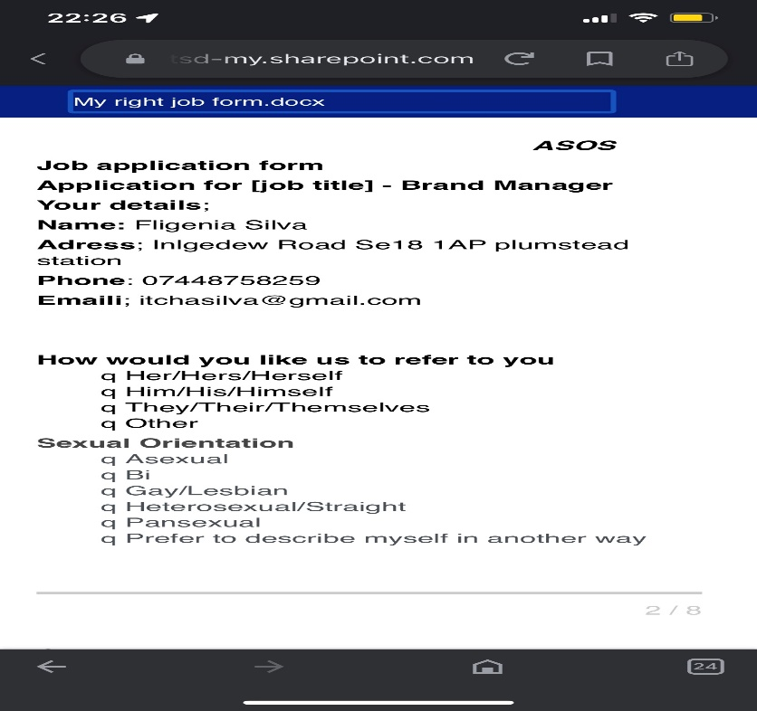

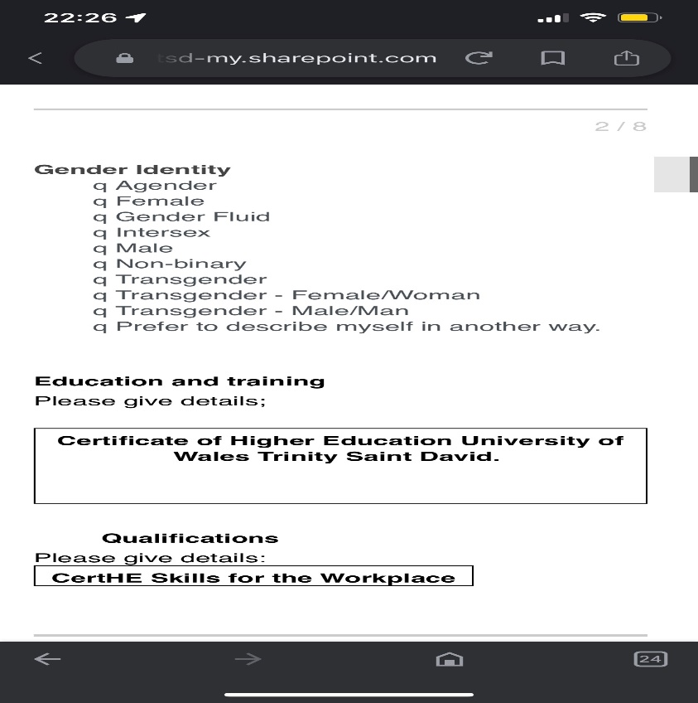

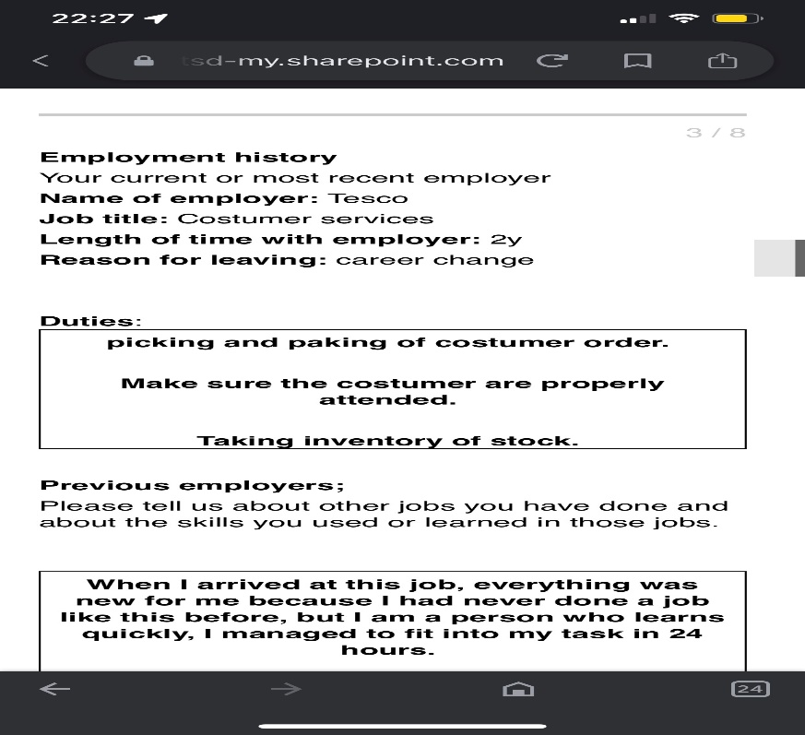

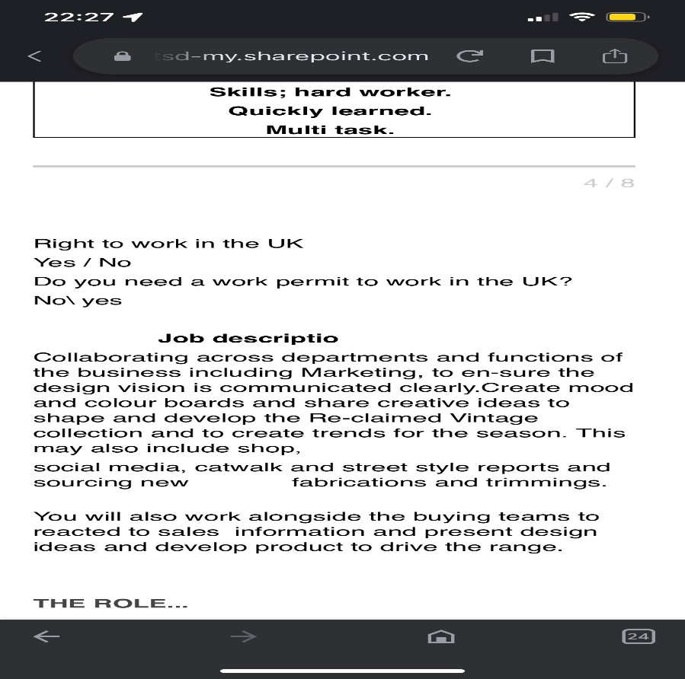

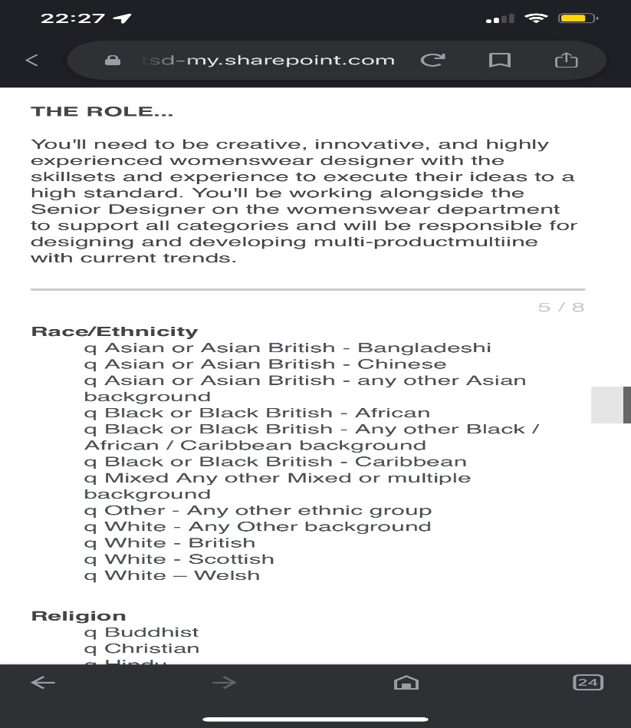

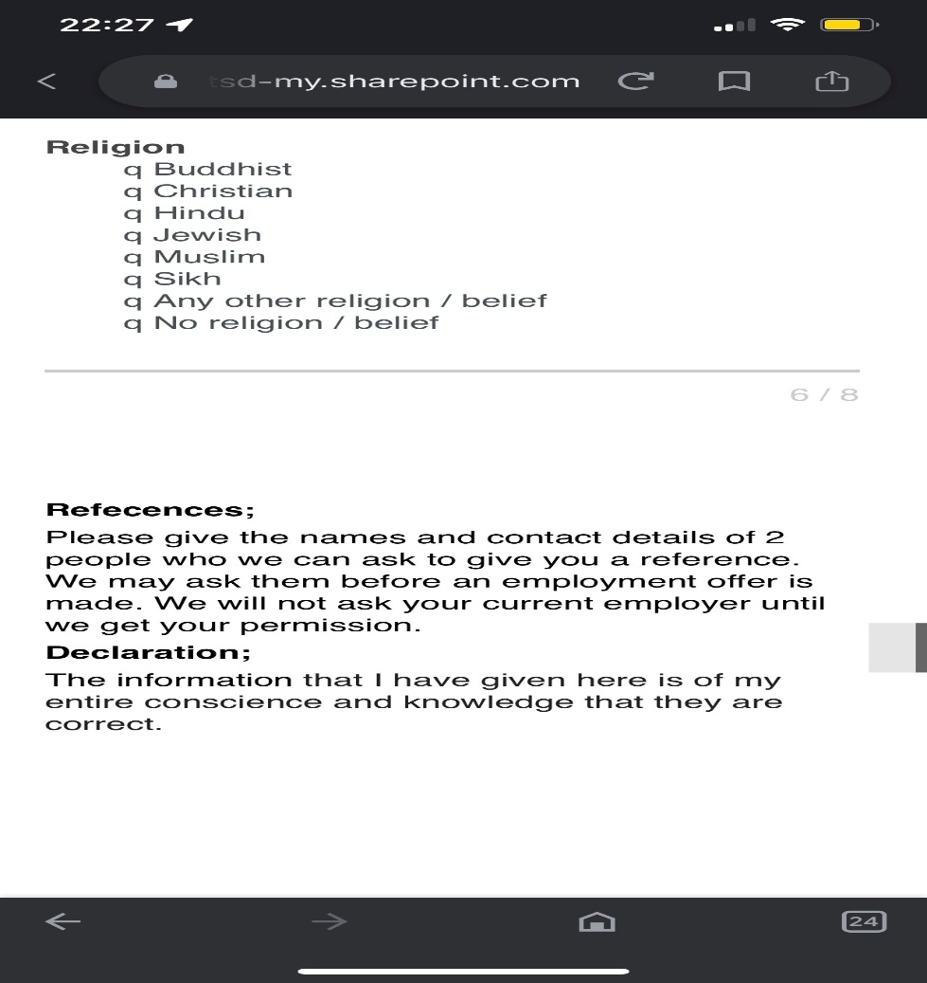
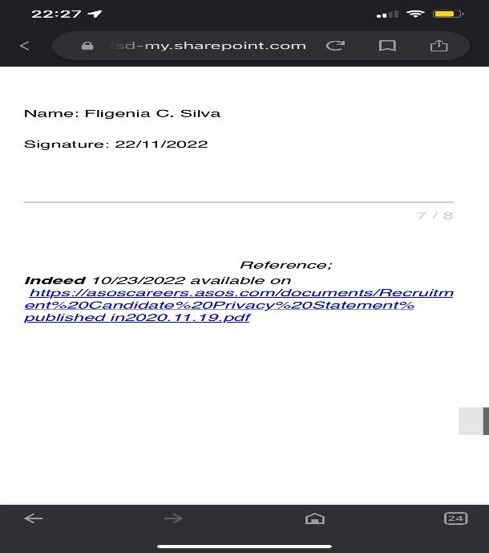

1/ tell me about your exprience
2/ wthat is your position are you applay for
3/ do you agree with your shift
4/ are you ready to start
5/ you will be able to work 5 days

References:
Cram,J 2012, available at https://www.cram.com/subjects/interview
https://moodle.uwtsd.ac.uk/course/view.php?id=6958&section=12
Jasper, M. (2013). Beginning reflective practice (2nd ed.). Cengage Learning.

