Research and case scenario
in Data Security and
Compliance
James Frew
Student University of Wales Trinity St David
Swansea, Wales
2108660@student.uwtsd.ac.uk

Abstract— This report covers the security technologies that are needed to safeguard a company’s IT system and infrastructure. This includes user access controls, content filters, firewalls, and Virtual Private Networks (VPNs). After that, it analyses the use of Intrusion Detection and Prevention Systems (IDPSs), what they are, and the different methods that are available for carrying out IDPSs.
It then goes on to give advice to an up-and-coming information security consulting agency (SwanTech) as to how they should best combat real and immediate threats from cyber-attacks. It covers security framework structures, creating security policies, and risk management techniques. It then goes on to discuss contingency planning and the different methods of protecting physical and digital company assets. Finally, it shows a draft for an information security team blueprint.
Keywords— Security Technologies, Intrusion Detection and Prevention Systems, Information Security unit

Introduction
This report will cover the aspects of security technologies – access controls, content filters, firewalls, and Virtual Private Networks (VPNs). It also looks at Intrusion Detection and Prevention Systems (IDPSs) – honeypots, and scanning and analysis tools. It then gives advice to SwanTech on successfully creating a new Information Security unit.

Reasearch in Data Security and Compliance

Security Technologies

Access Control
Access controls set the amount of control a user has over a system. Users are assigned privileges based on what applications they are expected to need. All approaches to access controls rely on identification, authentication, authorization, and accountability.
- Identification relies on users having a personalized account username.
- Authentication requires users to submit information only know to themselves – password, passphrase, etc.
- Authorization matches the user’s (or group’s) account to the level of control they have in the system.
- Accountability notes all activity taken by a user on a system so that any action – authorized or not – can be traced back to them. This ensures that if users perform illegal activities using the system, the blame can be placed on them, rather than the organization.
On top of these four main functions of access control systems, more specific controls exist:
Mandatory Access Controls (MACs) classify the data, and each user on the system, into ratings so that they can be properly assigned privileges. These are set by the system administrator.
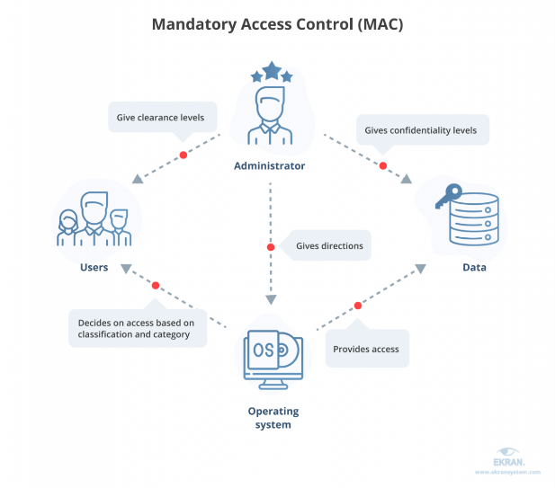

- Mandatory Access Control Diagram.
Source: Adapted from: [1]
The diagram above shows that administrators set the level of access that different users have to the operating systems. The system stores this information and locks its data behind different access levels. Administrators then give access to each user based on which access level they will need to function correctly. Users can only access data/software if they have the required access level.
Discretionary Access Controls (DACs) differ slightly in that users can request more access/higher privileges than they currently have. Users contact the system administrator and present their case for more access.
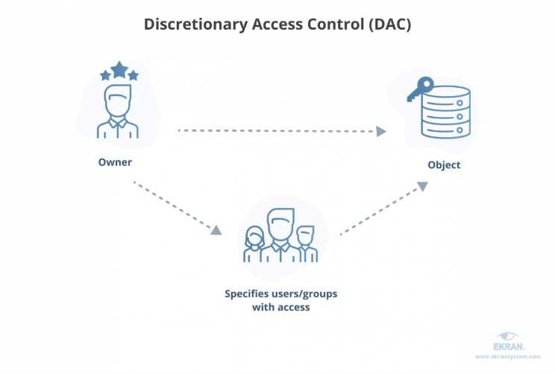
- Discretionary Access Control Diagram.
Source: Adapted from [1]
Here, an individual (the owner) has created a file (object) at their permission level. If other users/groups require access to it, they can assign those individuals/groups permissions to use the file. Users can request access to files above their access level and may grant access to their own files to those below their level. Individuals cannot assign themselves or others a higher access level than they currently have.
In contrast to DACs, Non-Discretionary Controls are a blanket set of access rights set across all subjects of a system. These settings are enforced, and they cannot be appealed as they are core principles of the system. [2]
A lack of access control policies will likely lead to a lack of direction for an organization. Furthermore, the protection that the organization’s information has will likely be inadequate and inconsistent. This could result in new threats and vulnerabilities creating a compromise of the organization’s digital assets. [3]. Additionally, employees might accidently or deliberately harm the system by having access to content they should not have access to. This can include deletion of key files, leaking organization data, etc. This aspect of an organization’s IT infrastructure is key to preventing internal damage to company applications.

Content Filters
Content filters can be a mix of software or hardware which gives administrators the power to restrict content that enters the network. [4] Scripts allow an organization to block its users from accessing sites or other online resources they deem unfit. This helps to prevent spam and viruses.

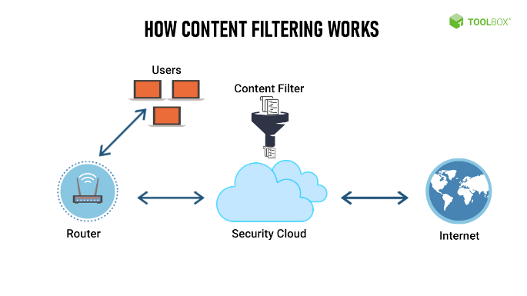
- Content Filtering Diagram.
Source: Adapted from [5]
This diagram shows users sending requests for access to internet resources to the router, which then gets transmitted to the security cloud. The content filter is applied and verifies if the requested resource is acceptable or not. If not, the user will receive a message back stating that they do not have permission to access the recourse. If they do, the content filter allows the router access to the resource.

Firewalls
Firewalls are a combination of hardware and software designed to filter communications in and out of the network. This can be performed by routers, dedicated computer systems, or specific network devices. The communications are checked against pre-defied policies set by the network administrator. [6]
Packet-filtering firewalls check packets for the header information to determine their address, source IP, protocol, etc. They can then prevent these packets from accessing their desired location if necessary. These rules come in three subsets of filtering – Static, dynamic, and stateful packet inspection (SPI).
Static filtering rules are installed directly to the firewall, whereas dynamic filtering allows the firewall to create new rules, dealing with events as they arise. SPIs use a state table to keep track of all the network connections between internal and external systems.
Application layer proxy firewalls function as both firewalls and proxy servers. Less trusted networks can expose proxy servers to higher levels of risk (due to proxy server’s often unsecure position in networks). These proxy firewalls help to defend the more vulnerable areas by allowing for additional filtering routes for data transmission.
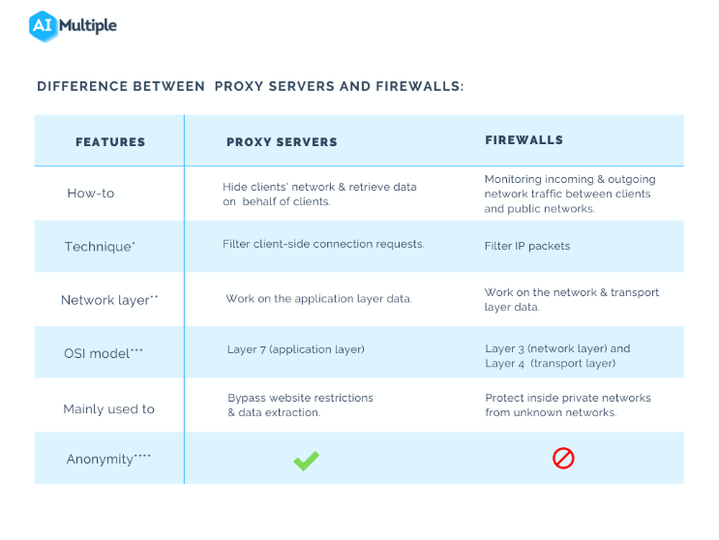
- Difference between proxy servers and firewalls.
Source: Adapted from [7]
MAC layer firewalls use the MAC address of hosts to filter the specific packets that are allowed between each address – blocking all other traffic. They operate on the media access control sublayer of the network’s data link layer. [8]
Hybrid firewalls combine elements of other firewalls, allowing for improved security without fully replacing the existing firewall system. This is useful when the organization wants to upgrade to the newest hardware or add additional elements onto their current. [9]
Firewall connection architecture varies depending on the needs of the organization’s network and is influenced by the organization’s budget and network objectives. A common architecture is the single bastion host (sacrificial host). This method relies on one firewall system connected to both the inside and outside (edge) of the network and is the singular defender there.
The screened host architecture combines an application proxy server with a packet-filtering router. This increases the protection of the network by requiring a two-part attack to successfully breach – defeating both the router and proxy server. The router pre-checks packets to increase the server’s performance.
Screened subnet architecture – the most common architecture, utilizes two or more internal routing firewalls that are stationed behind an external packet-filtering router/s with each firewall guarding a trusted network. The routers manage any connects from outside the network, with any successful connections being routed to the firewall protecting systems in the Demilitarized Zone network (DMZ).
Firewalls are an essential aspect of protecting an organization’s network and minimize the danger that external networks provide. [10] When firewalls aren’t implemented any packet is allowed to enter a network/system. These packets can easily damage an organization’s network and applications.

Virtual Private Networks
Virtual Private Networks (VPNs) are secure, private networks that connect systems together, whilst minimizing the risks to internal systems. It does this by encapsulating and encrypting traffic and authenticating the remote system.[11]
Transport mode encrypts only the data within a packet allowing a user to securely connect to a host. This allows easy end-to-end transporting of encrypted data.
Tunnel mode prevents any intercepted packets from revealing any information about their destination system. It does this by creating a connection between two tunnel servers on an unsecured network and encrypting all their traffic.
If an organization wants to connect itself to an outside source, VPNs must be used. Otherwise, all information that is transmitted between sources will be readable by attackers monitoring the connection. If sensitive information is transferred, an attacker could use this to damage an organization’s reputation by leaking it or exploit them for money through blackmail.

Intrusion Detection and prevention Systems
Intrusion Detection and Prevention Systems (IDPSs) are tools designed to detect and mitigate the breaching of a network. Software routinely scans the network for anomalies and is usually configured to automatically respond to the attack without the need of human interference. [12]
After successfully preventing the attack and the system has returned to normal function, the IDPS will seek to identify the source of the attack, and its method. IDPSs can also notify their managers in the event of a breach – most commonly through email.
A key aspect of IDPSs is data collection. This shows what damage was caused by the breach and why it was able to happen – helping not only to prevent future breaches but also works as a fear tactic to deter future attackers.

It also makes future improvements easier to implement (having already acquired data on network vulnerabilities).
Some parts of data collection in IDPSs are alarm clustering and compaction. These look for attack signatures and/or frequency of attack, which are then grouped together. Alarm filtering can access these groups to create filters for future alerts.
Variations of IDPSs:
- Host-based IDPS (HIDPS)
- Network-based IDPS (NIDPS)
Host-based IDPSs use a set host server and will only monitor activity on the system’s files. They keep a record of all main system files and monitor if intrusions create, delete, or modify any of these files or applications. HIDPSs detect only local events so can detect offences that a NIDPS might miss. Furthermore, all files on the host system have already been decrypted as they have already passed through all networking protocols (which don’t affect the HIDPS) – which speeds up processing time.
All of this creates more work for the server manager – all these settings must be configured and monitored. HIDPs’ single host nature makes them weak to direct attacks and won’t protect other non-host devices on the same network. Additionally, HIDPSs use large amounts of storage space and can carry heavy performance overheads from the host system.
Network-based IDPSs differ as they focus on attacks to a whole network – rather than a specific system’s files. They are installed in the network in a location where they can monitor incoming and outgoing traffic. They examine the network to locate patterns that might indicate an attack. These patterns are identified by comparing current network activity levels with that of previous/regular levels.
NIDPSs can be installed into networks with minimal disruptions to normal working functions, and when placed in the correct location, monitor a very wide area. Additionally, NIDPSs may not be visible for an attacker to target directly. If network traffic is too high, NIDPSs become overwhelmed and will not notice attack patterns they usually would.
NIDPSs major weakness is that they are unable to examine encrypted packets. If an attacker was able to get an encrypted packet into the network, the NIDPS would fail to detect it. They are only likely to detect an attack, not recognize if the attack was successful or not.
Wireless NIDPSs are available to monitor wireless network traffic but come with the regular issues that wireless devices have:
- Sensor range
- Sensor location and access ports
- Cost
- Physical security
When IDPSs are not present in an organization’s security system, responding to threats becomes much harder. The time it takes to detect and react to a threat would dramatically decrease which would leave the system much more vulnerable to permanent damage.

Honeypots
When it comes to combatting bots and other forms of automated attackers, honeypots (honeynets when combined) are a great way to do this. They function as a decoy target to trick bots into targeting them instead of important systems. Honeypots deliberately slow down the rate at which the bots can attack them – giving them time to collect data about the attacker and allowing an administrator long enough to document and respond to the attack. Being able to document attacks makes it easier to prevent and react to them in the future. [13]
A padded cell system is a more advanced type of honeypot which is much harder to compromise. It works in harmony with the IDPS – when an attack is detected, the padded cell system creates a simulated space to contain the attack. This simulation is secured enough to prevent the attack from doing any damage to the network.
Although honeypot-based systems are great at catching individuals snooping around the network, they do have some flaws:
- If an attack is caught and diverted into a padded cell, the attacker might decide to instead launch a more dangerous attack (out of retaliation) that the system cannot handle.
- They can be bettered by clever enough bots that can recognize the honeypot trap.
- They take quite a high level of skill to be successfully implemented
These techniques can be combined with trap-and-trace systems – a combination of either a honeypot or padded cell, with an alarm. This does, however, create potential legal issues: placing desired information with the intent of getting attention is enticement, coaxing someone into committing a crime deliberately to get them convicted is entrapment. The former is legal, whilst the latter is not – there is a fine line between the two when honeypots (etc.).
Honeypots are a simple method of stopping spam bots from easily attacking a system. Although they can be beaten when extra effort is put into developing bots, this method of defense will work to some extent to protect an organization’s network.

Scanning and Analysis Tools
Attackers need to collect information about a network before they can formulate an attack protocol and launch a successful attack against it. They do this with the use of scanning tools. Network defenders must have knowledge of these scanning tools to fight against them. [14]
There are a couple of scanning methods that can be used to gain information from a network. Footprinting is one method which involves collecting public information about the target. During this phase, fingerprinting takes place – internet addresses are collected to be used to identify more detailed network features about the host.
Multiple different aspects of the network are scanned to identify vulnerabilities. General scanners browse a network to determine where high value information might be held and create traffic to determine possible vulnerabilities. Passive scanners can find client-side weaknesses which active scanners usually miss. Passive scanners sit on the network and take note of both server and client-side software vulnerabilities.
Port scanners identify the active devices on a network using either specific scans based on protocols, resources, types of devices, etc. or just generic scans. Port scanners that are more specific will find much more useful information than scanners that only target general areas.
Alongside of port scanners are packet sniffers. They make copies of the packets that travel through ports along the network and analyze them to provide information for system, and technical issue diagnosis. When used against a network, a sniffer can sit on a network, eavesdropping on its traffic – gathering useful information to form an attack. Packet sniffers are only legally allowed to be used when the network they are deployed on is owned by the organization. The organization also must deliberately authorize their use and any users of the system must be aware that packet sniffing is taking place. There also exists packet sniffers for wireless networks.
Weak firewalls are an easy way to gain access to a network so analyzing them for weaknesses is vital. There are multiple tools that will automatically discover and analyze firewalls on a network.
Identifying the type, and version of an operating system is the best course of action for attacking a specific system in the network. If the OS is known, attacks can be tailored to target the more vulnerable aspects of that OS version.
If system administrators don’t employ the use of scanning tools to find vulnerabilities in their network, attackers will. They will use this information to formulate stronger, more direct attacks that the organization’s network is not equipped to defend against.

The Purpose of Secure Environments
It is important for modern organizations to create environments that protects their IT systems because any damage done will cause knock-on damage to the organization. The organization will lose money either due to backlash/legal repercussions from unhappy customers, or from losing sales/customers that would have used their services during system downtime.
Detecting an attack is the first step to combating it – an organization can’t protect against an attack that it doesn’t know is happening. Once an attack is detected the organization can react to it based on their security policy.
The reaction an organization takes to a threat will largely determine how well it will handle and recover from it. If there aren’t already reactionary strategies in place, the organization will not be able to employ its safeguarding/protection techniques.

SwanTech Case Scenario
Combating cyber-attacks requires setting up an information security unit. This unit will have to identify vulnerabilities, detect and (where possible) prevent attacks, and provide contingency measures to organizations who have suffered from cyber-attacks. The following is a guideline as to how SwanTech should go about setting up this information security unit.

Organisation Structure
When first starting to implement security measures, the best practice would be to use a security framework as either a rough guide or a strict set of goals the organization wants to achieve. The ISO 27000 is a commonly utilized security framework. This involves the following:
- Setting a scope and devising a general plan for how the security system will function.
- Documenting the potential risks, what effect each would have on the system, and their method of prevention.
- Implementation of the designed system to meet the scope.
- Training employees and managers to know how to operate in the system.
- Organization based review of the newly implemented security system.
- Adjustments where needed.
- Re-review the system if adjustments are made.
- Get verification by a third party.
- Repeatedly add new features and adapt based on new developments and security trends.
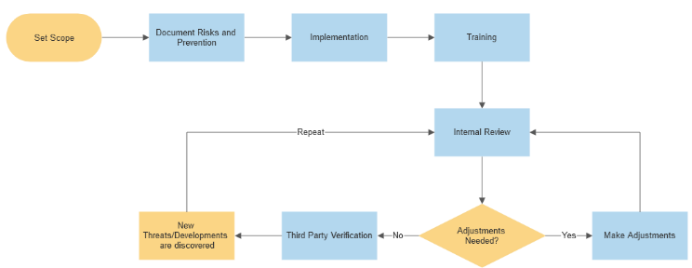

Security Policies
Regarding setting policies in place for an organization’s security, SwanTech should recommend one or more of the following plans:
- System-Specific Security Policy (SysSP)
- Enterprise Information Security Policy (EISP)
- Issue-Specific Security Policy (ISSP)
SysSPs will direct all their attention to only one specific system (or group of similar systems). This requirements for this systems policy will differentiate fully based on what the individual system is.
EISPs are written as high level documents by senior management. They cover the organization’s strategy and method of approach to all security development – essentially a large map for developing their security department and methods. SwanTech should also advise that the EISP should identify each different user’s role within the security system and what standards and guidelines they are held to. The policy must be written simply so that anyone who reads it can understand it – if it’s written in too technical a language, employees won’t be able to understand its meaning. If an employee breaks an aspect of the security policy, they can claim they didn’t realize their actions were in violation of the organization’s policy as they couldn’t understand the policy.
Each individual department within the organization is expected to create their own standards, operating procedures, and guidelines that follow the EISP policy. All without preventing their own section from functioning correctly.
If the organization decides to use an ISSP, SwanTech should advise them in adhering to the distinct security requirements that they will lay out in this policy. The ISSP will layout who has access to what types of equipment, how that equipment should be used, and what sanctions will take place in the violation of the policy. Users will have their access levels set and will be made aware of what is required of them. The management of the actual system itself is also dictated in the ISSP – storing of organization data, attack protection, physical security, etc.
Whichever policy/ies are selected, they should all make sure to not contradict the strategy laid out in the security framework. SwanTech should also advise regular, scheduled review dates to reevaluate the principles of the policy – this is due to how quickly technologies change/go out of date. Management/high level individuals who write the policy regulations should also consult with employees to understand if anything they have decided upon cannot be implemented, or if they have missed a key, routine aspect that lower-level employees deal with frequently. Often, the higher up an individual gets within an organization, the less they understand about the day-to-day running of it. Employees must be trained in accordance with the policy selected – this further emphasizes the need to create a policy that non-technical personnel can understand. SwanTech should help appoint a manger to watch over whichever security policy is put in place.

Risk Management
In the process of risk management, SwanTech should always stick to the security framework already laid out. They should begin to plan out their process of risk management by categorizing all organization assets – networks, hardware, people, data, etc. Until this has been carried out, it is not safe to start implementing any defense as any missed area can completely compromise the integrity of the security plan. People will have to be categorized manually, but tools exist that can automate hardware, etc. categorization.
After all assets have been accounted for, SwanTech should identify the potential risks to the organization’s network. This includes potential breach sites, employee-initiated vulnerabilities, etc. and will primarily be discovered using scanning and analysis tools.
Once the risk has been identified, it can then be assessed as to how damaging it would be to the network. SwanTech should base the evaluation for each risk on how fundamental the damage from that specific risk would be – one organization might be hindered much worse by a data breach than a direct attack (such as DDOS).
SwanTech’s next step of risk management would be to mitigate the risks it discovers. Fully mitigating any risk is unlikely whilst still maintaining the correct running functions of the organization. It is therefore the requirement of SwanTech to establish which risks the organization primarily wants focus on preventing/mitigating, which it is willing to accept as vulnerabilities (known as risk appetite), and the remaining risks left over after sorting these prior categories (known as residual risk). One goal of the information security department is to convert residual risks into either primary risks or appetite risks.
The balance between combating a risk and the cost it will take to do so is a difficult decision. SwanTech should advise the organization as to which they should focus on based on the risks that they are most likely to face. Another balancing act comes into place to decide on how much security is to be implemented vs how free flowing the organization wants its work rate to be – more security will mean more time working around those security measures and potentially using slower, but safer methods of working.
The organization SwanTech consults for might decide to focus all of their risk prevention on those risks that would cost them the most money or cause them to lose the most reputation (most often risks to personal user data). From a business perspective, this would make sense. From a security perspective, this is not always the best strategy – less financially devastating breaches or data loss can have massive knock-on effects to the organization that might not immediately be visible. It is often helpful to use a risk table to decide upon which risk should be targeted first:

- Risk Probability and Damage Table

Risk Probability | Damage
Frequency |  | Insignificant | Small | Notable | Major | Catastrophic
Frequency | Almost Guaranteed | Almost Guaranteed Insignificant | Almost Guaranteed Small | Almost Guaranteed Notable | Almost Guaranteed Major | Almost Guaranteed Catastrophic
Frequency | Common | Common Insignificant | Common Small | Common Notable | Common Major | Common Catastrophic
Frequency | Occasional | Occasional Insignificant | Occasional Small | Occasional Notable | Occasional Major | Occasional Catastrophic
Frequency | Unlikely | Unlikely Insignificant | Unlikely Small | Unlikely Notable | Unlikely Major | Unlikely Catastrophic
Frequency | Rare | Rare Insignificant | Rare Small | Rare Notable | Rare Major | Rare Catastrophic

Contingency Planning
There are three aspects to contingency planning that SwanTech needs to implement. The Incident Response Plan (IRP) is an immediate response to any attack on the network. The IRP uses its predefined response to allow the IR team to quickly address the incident. This team should be highly trained to recognize the signs of different attacks and how to respond to each. They are also responsible for documenting the incident, though containment is their top priority.
If the attack escalates, the Business Continuity Plan (BCP) takes over to reorganize the key functions of the business at the organization’s main site. If the main site has been compromised (most likely due to a natural disaster), the BCP will relocate primary actions to the predetermined offsite base. This requires an offsite location to store the organization’s system data and, if possible, function as a temporary main site. Techniques such as database shadowing are used to get functions running quickly.
Alongside this, the Disaster Recovery Plan (DRP) kicks in and focuses on preparing systems back on the main site for restoration after the attack has concluded.
Contingency plans should be tested to ensure that they work before a major attack has the change to take place.

Physical Protection
SwanTech should implement policies to cover the physical security of the organization’s resources. This would include who has access to rooms with system hardware – computers, servers, networking devices, etc. Rooms should be locked when not in use and any entrant should be logged as to when they entered the room (possibly using ID key cards). Rooms should also include surveillance equipment to ensure that any damage, theft, or misuse is captured, and the guilty individual can be delt with accordingly.
Physically, the organization’s network setup should employ failsafes to counteract physical hardware failure. SwanTech can achieve this by deploying redundancy and including duplicates of core systems in the network. This way, if the firewall, database, etc. system fails, there are alternatives that can manage temporarily in their place. Regular data/system backups should also take to place to prevent data loss. When taking these backups, it is essential that GDPR principles are adhered to. The data stored must be of the following:
- Lawful, fair, and transparent – information gathered must be obtained legally.
- Limited – data collected is only used for a specific purpose (which must be made clear on collection).
- Minimized – data taken is only what is really needed.
- Accurate – data must not be incorrect and any incorrect information must be amended within 30 days of request.
- Limited Storage – backups of this data can only be kept for as long as truly necessary.
- Integrous and confidential – only those who need access to the data can have access to it.
- Accountable – held accountable to GDPR standards.

Digital Protection
Digitally, SwanTech should categorize each user by what level of access control they would need to complete their work by setting Mandatory Access Controls. Files and folders should be categorized by access level to prevent the wrong staff from accessing data they shouldn’t be able to. A discretionary access control system should be implemented to allow users to request higher access levels/alternative access. Non-Discretionary Controls should be used to take special care of insuring that only administrators are able to alter workstations/installed software and other user privileges. This will all help to prevent deliberate or accidental data loss due to human error.
All online content should go through a filtering system. Any pornographic or Not Safe For Work (NSFW) content should be blocked for all users as well as any sites with potentially unsafe content that might jeopardize the safety the of network.
SwanTech should enforce the use of firewalls on the organization’s network. Depending on the size of the network, a full system might be dedicated to function as a firewall (in combination with routers and other network devices). The type of firewall (packet filtering, MAC, etc.) should be selected based on the needs of the individual organization that SwanTech is consulting for – though a hybrid system will likely be the most commonly used approach. The firewall should be filtered to block all traffic by default, then only have the necessary ports opened to allow packets through.
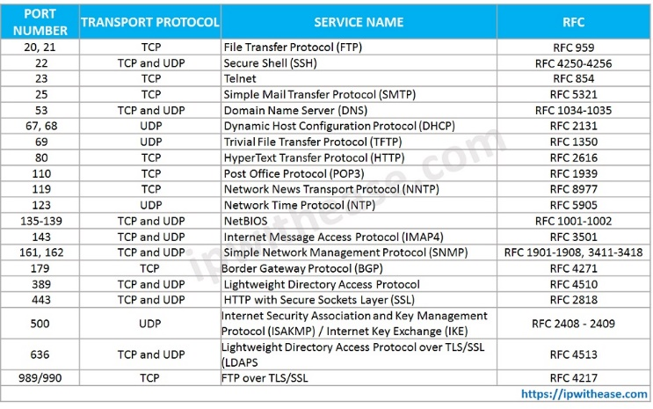
- Commonly opened/closed ports for firewalls.
Source: Adapted from [15]
If an organization needs to conduct work outside of the building which contains the main site (such as employees working from home), any connection between the main network and the external endpoint should employ the use of a Virtual Private Network (VPN). SwanTech should not allow any unencrypted data to be transmitted in and out of the network – or they risk that data being leaked.
The Intrusion Detection and Prevention System (IDPS) tool which SwanTech should advise the organization to use will depend on how their overall system functions. In general, a method of scanning the network for anomalies is a hard requirement, ideally with an automatic response to the anomaly attached. The IDPS should, on the prevention of an attack, work to identify the source of the attack and its method. This will allow SwanTech to work on defending that breaching point from future attacks. The IDPS should monitor the network’s data so that it can notify an administrator of any creation of new, removal, or edit to currently existing data.
SwanTech can either employ a host-based IDPS or network-based IDPS depending on the needs of the individual organization (and how much work they want to take on with this organization).
Honeypots may be added to the organization’s network (dependent on the type of network that the company uses). However, SwanTech must make sure as to not allow their chosen honeypot strategy to encroach on entrapment. The individual organization should also be queried to determine if they are ok with using honeypots – as they can be seen as unethical by some (primarily based on how they are deployed).
SwanTech should advise the organization to make use of scanning and analysis tools – specifically packet sniffers and firewall scanners. Both of these tools will massively help to prevent breaches and alert administrators of potential vulnerabilities that are present. The organization must ensure that they follow the legal requirements of using packet sniffers when they implement them (listed above).

Information Security Team
When implementing an information security team, SwanTech should either help the organization set up their own team or advise on outsourcing to an external company. Which option is picked will depend on how large the organization is and how much funding they have available. When creating their own IS team, the organization should look to employ a hierarchy similar to the following:

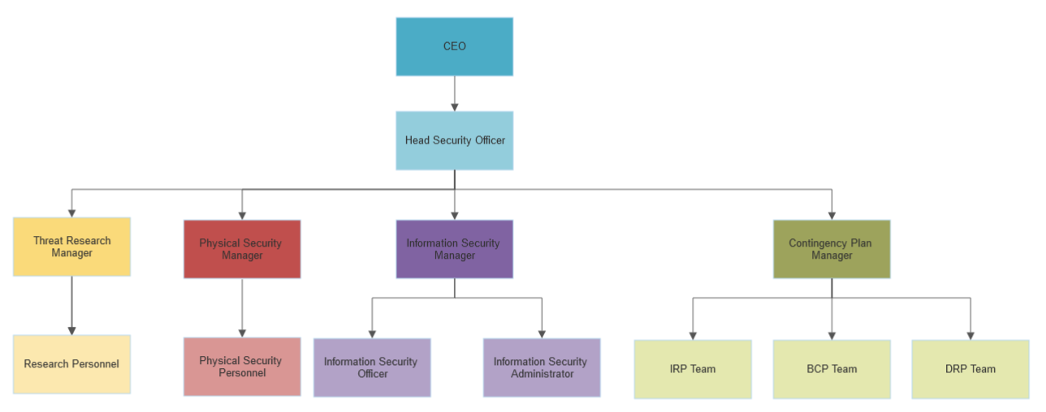

The head security office manages all aspects of the information security team. There are then four different sections below them: Threat research, physical security, information security, and contingency planning. The first three of these sections have a manager followed by personnel within that section. The fourth section (contingency planning) has a manager who oversees three separate teams: The Incidence Response Plan (IRP) team, the Business Continuity Plan (BCP) team, and the Disaster Recovery Plan (DRP) team.

Conclusion
In conclusion this report has shown the different security technologies available for use in defending a network – access controls, content filters, firewalls, and Virtual Private Networks (VPNs). It has also determined what Intrusion Detection and Prevention Systems (IDPSs) are and the specific methods they utilize – honeypots and scanning and analysis tools. The report then addresses the methodology of forming a functioning threat intelligence and consultancy company – organization structure, security policies, risk management, contingency planning, physical and digital protection, and the information security team.
Future research could more fully explore the concepts of security frameworks, or give more in-depth guidelines for a security consultancy company

References
References
[1] ("June 30, "). Mandatory vs Discretionary Access Control: MAC vs DAC Differences. Available: https://www.ekransystem.com/en/blog/mac-vs-dac [Accessed Dec 11, 2022].
[2] W. L. Ross, "Security and Privacy Controls for Information Systems and Organizations: NIST Publishes SP 800-53, Revision 5," US Official News, 2020. Available: https://doi.org/10.6028/NIST.SP.800-53r5. DOI: 10.6028/NIST.SP.800-53r5.
[3] P. Ward and C. L. Smith, "The Development of Access Control Policies for Information Technology Systems," Comput. Secur., vol. 21, (4), pp. 356-371, 2002. Available: https://www-sciencedirect-com.ezproxy.uwtsd.ac.uk/science/article/pii/S0167404802004145. DOI: 10.1016/S0167-4048(02)00414-5.
[4] V. Kaptur and O. Kniaziev, "Method of adaptive complex internet content filtering," in - 2019 International Conference on Information and Telecommunication Technologies and Radio Electronics (UkrMiCo), 2019, . DOI: 10.1109/UkrMiCo47782.2019.9165440.
[5] ("August 31, "). What Is Content Filtering? Definition, Types, and Best Practices. Available: https://www.spiceworks.com/it-security/network-security/articles/what-is-content-filtering-definition-types-and-best-practices/ [Accessed Dec 11, 2022].
[6] S. Y. P, A. Gotkhindikar and S. K. Tiwari, "Survey on CAN-bus packet filtering firewall," in - 2022 International Conference on Edge Computing and Applications (ICECAA), 2022, . DOI: 10.1109/ICECAA55415.2022.9936152.
[7] ("November 14, "). Firewalls vs Proxy Servers: Overview, Techniques and Benefits. Available: https://research.aimultiple.com/firewall-vs-proxy/ [Accessed Dec 11, 2022].
[8] (). Configuring MAC Address Filtering. Available: https://www.cisco.com/assets/sol/sb/RV180W_Emulators/RV180W_Emulator_v1.0.3.14/help/en_US/firewall11.htm [Accessed Dec 13, 2022].
[9] (). Firewalls, Packet Filtering Firewalls, Circuit Gateways, Application Firewalls (Proxies), Hybrid Firewalls. Available: https://www.omnisecu.com/security/infrastructure-and-email-security/firewalls.php [Accessed Dec 13, 2022].
[10] S. M. Bellovin and W. R. Cheswick, "Network firewalls," IEEE Communications Magazine, vol. 32, (9), pp. 50-57, 1994. . DOI: 10.1109/35.312843.
[11] M. Juma, A. A. Monem and K. Shaalan, "Hybrid End-to-End VPN Security Approach for Smart IoT Objects," Journal of Network and Computer Applications, vol. 158, pp. 102598, 2020. Available: https://www-sciencedirect-com.ezproxy.uwtsd.ac.uk/science/article/pii/S1084804520300722. DOI: 10.1016/j.jnca.2020.102598.
[12] A. Kumar et al, "Intrusion detection and prevention system for an IoT environment," Digital Communications and Networks, vol. 8, (4), pp. 540-551, 2022. Available: https://www-sciencedirect-com.ezproxy.uwtsd.ac.uk/science/article/pii/S2352864822001201. DOI: 10.1016/j.dcan.2022.05.027.
[13] A. Pashaei et al, "Early Intrusion Detection System using honeypot for industrial control networks," Results in Engineering, vol. 16, pp. 100576, 2022. Available: https://www-sciencedirect-com.ezproxy.uwtsd.ac.uk/science/article/pii/S2590123022002468. DOI: 10.1016/j.rineng.2022.100576.
[14] A. Houmz et al, "Detecting the impact of software vulnerability on attacks: A case study of network telescope scans," Journal of Network and Computer Applications, vol. 195, pp. 103230, 2021. Available: https://www-sciencedirect-com.ezproxy.uwtsd.ac.uk/science/article/pii/S1084804521002290. DOI: 10.1016/j.jnca.2021.103230.
[15] (). IP Well Known Port Numbers/ Common TCP - IP With Ease. Available: https://ipwithease.com/common-tcp-ip-well-known-port-numbers/.

