REPORT

Login

Below is the original code used for my login, it worked fine, however it was not very secure as the passwords for my user accounts that were stored in my database were not hashed and the password field was visible so it was not secure.

When doing research on hashed password logins I got the idea for my secure login from the following source- https://codeshack.io/secure-login-system-php-mysql/

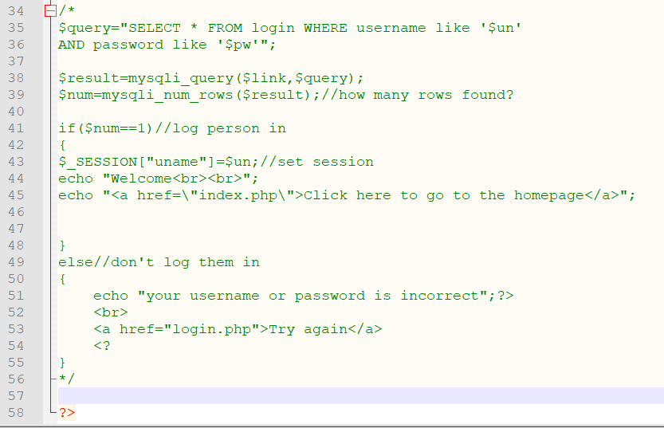
checklogin.php:

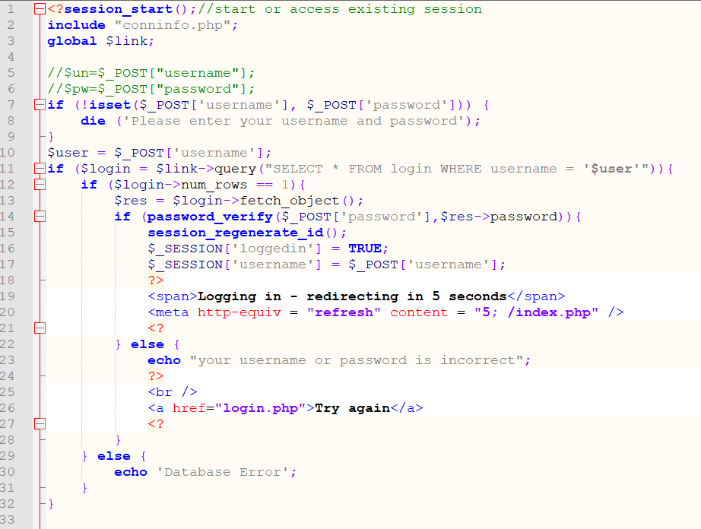
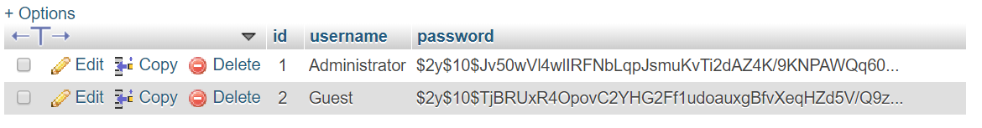
I used PASSWORD_DEFAULT to get my hashed passwords and then stored those hashed passwords in my database. I then used the password_verify function to check to see if the password that is entered matches up with the hashed password stored in my database. If the username and password matches then you will be taken to the homepage where you can have full functionality of the website. If the correct username and password are not entered then you cannot get to any of the other pages due to the ‘if (isset($_SESSION['loggedin']))’ and ‘else header('location: /login.php')’ that I put on every page.

To end the session and take the user back to logon screen I used the following code. After clicking the logout button you can’t get to any of the other pages without first signing back so that no unauthorised users can get into the system.

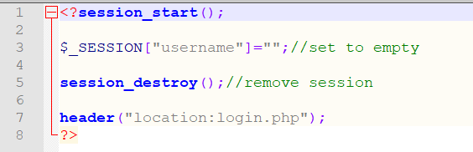

The code that is commented out is my original code that used $link=mysqli_connect. This was changed as it is Procedural Style and with this I could not get my hashed password login working. For this reason I changed it to $mysqli = new mysqli which is an Object-Orientated Programming style. After I made this change I was able to get my hashed password working.

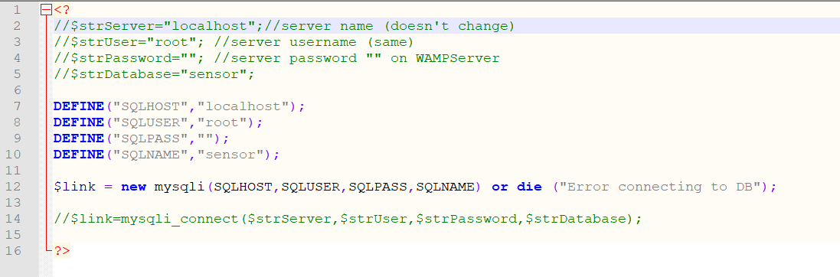
conninfo.php:

Searches/ HTML Table

Below is the code for my table, I am using bootstrap 4.4.1 to make it look more presentable. I have chosen to style my table in this way as before I styled my table all of the numbers were bunched together making it very difficult for a user to read. So by having table headings and having a border around the fields it makes it much easier to read the data.

I used W3Schools to do research on creating my tables for the webpage- https://www.w3schools.com/html/html_tables.asp

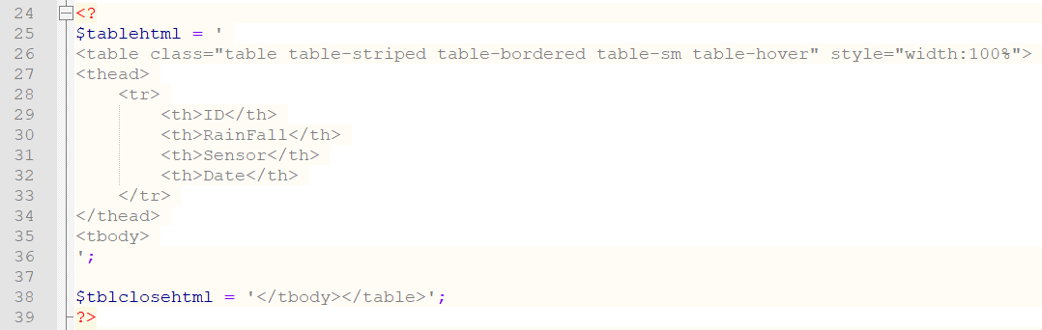
statistics.php:

There are three searches, one is to display where rainfall is more than the number entered, to find out information such as days when it rained more than 5mm of rainfall. The second is to display all data by one sensor so can do a more focused search to look at a specific sensor you want the readings from. I have also done it so you can search by the sensor and where rainfall is more than a value to narrow the findings the user is looking for even further. The last is to check between two dates so that you can find out information such as how much rainfall there was during a storm. There is also a display all button that will display all data from the sensordata field in my database.

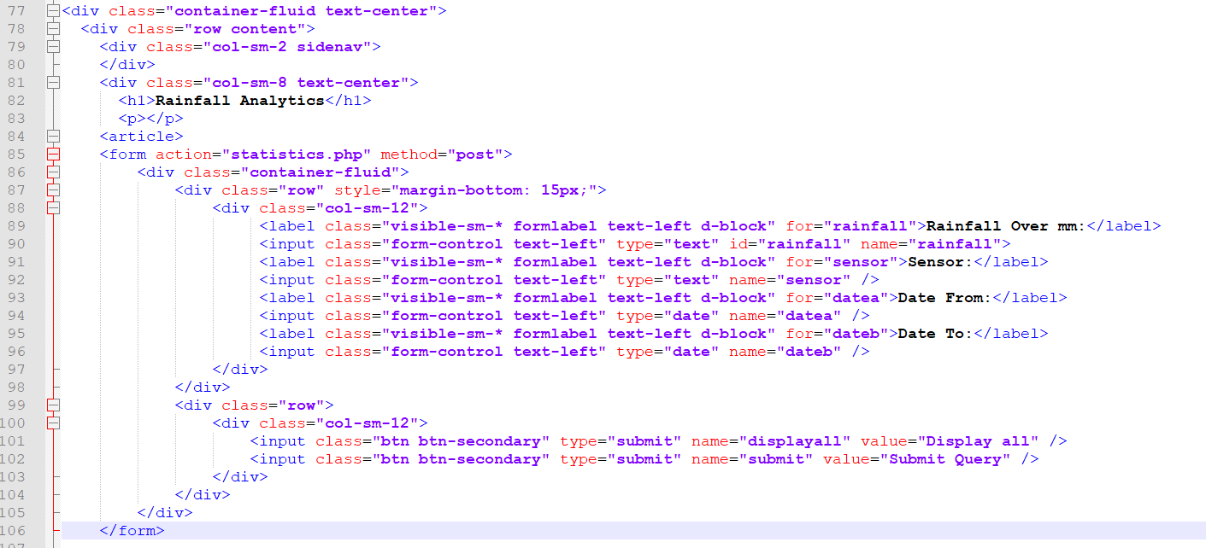
index.php:

The code shown below is for my date between search. I had to put in a wildcard at the end of 00:00:01 and 23:59:59 to get my search working due to the date/time in my database having extra numbers at the end of the time it was recorded. I formatted the date ‘d-m-Y H:i’ to display the date and time correctly in the table.
statistics.php:
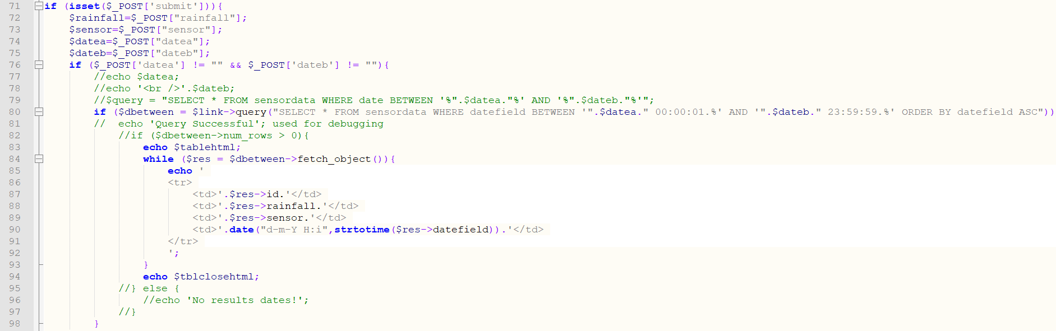

Below is the code shown for my sensor and rainfall more than search. I initially had the individual queries above the AND query in my code as I wrote them first. However, I moved this above the other two as the query would not work without being before the individual queries.
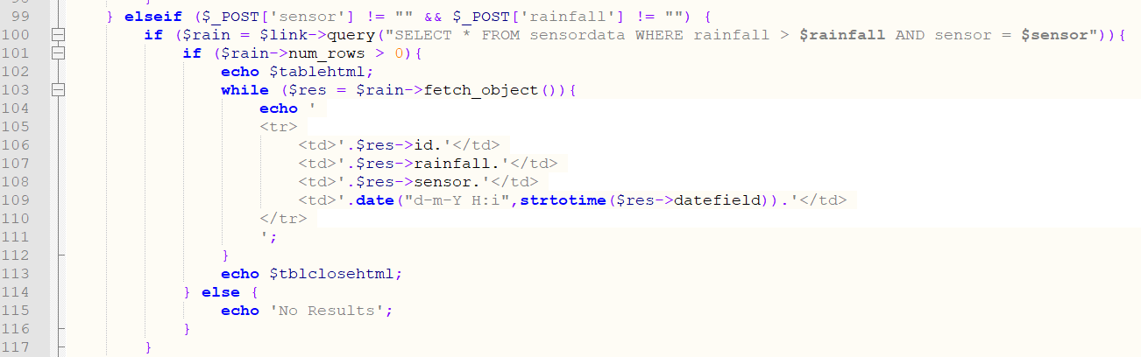

Graphs

Below is the code used to show the rainfall data graphs on one page so that the user can easily read them. I have used the phpMyGraph5.0 graph library and decided to use a Vertical Column Graph and a Vertical Line Graph. My first two graphs are to display all my rainfall data in a line and a column chart to view all the data in different graph formats. The third was a line chart displaying rainfall data from a chosen sensor as another way of viewing specific data captured by each sensor other than viewing the table. The fourth was a column graph displaying rainfall more than what was searched for to easily identify information such as the wettest days.

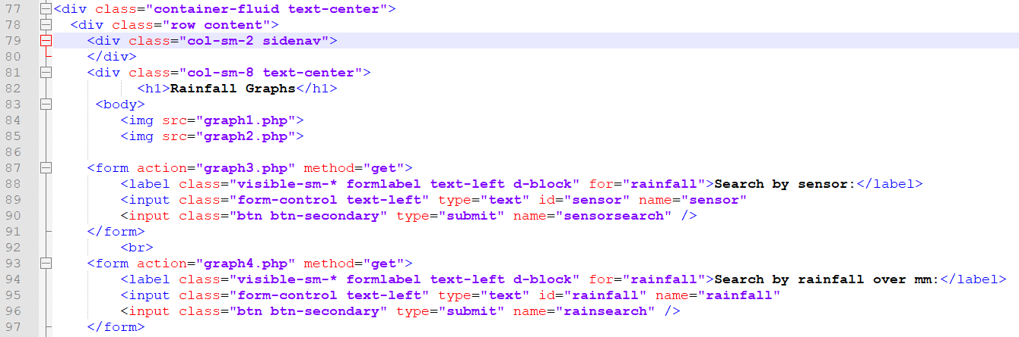
graphs.php:

graph1.php:
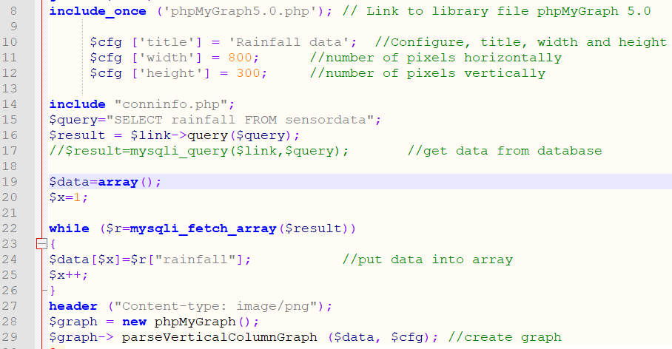
graph2.php:

I used the $_GET variable to collect the data from the form so that you can search by sensor or rainfall over and it display in a graph.

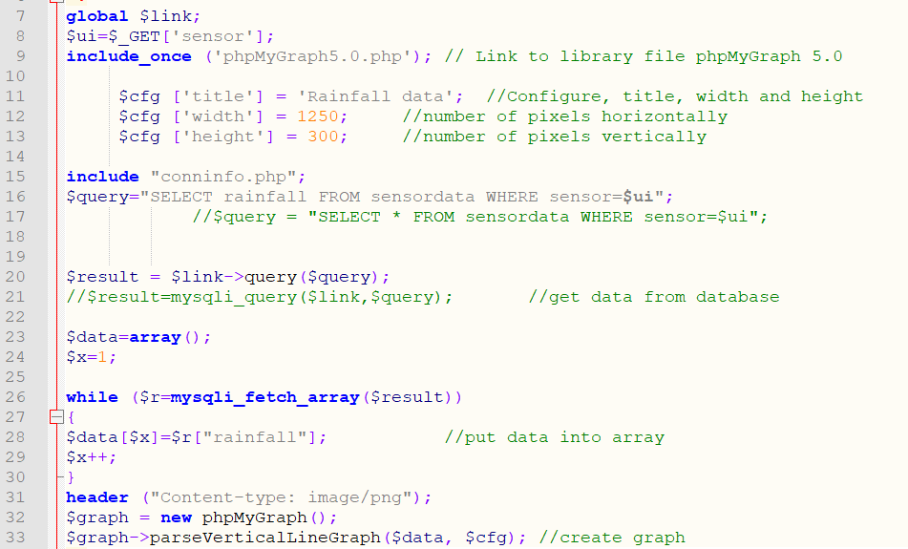
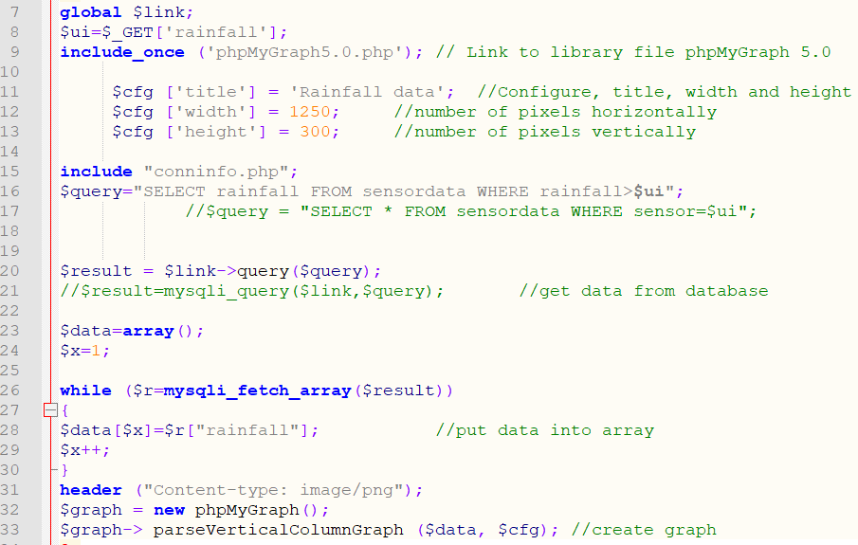
graph3.php:

graph4.php:

Import data

Below is the code used to import the data from the .txt files taken from the sensors. After the data has been imported - the txt files are emptied so that no duplicate data gets entered into the database, I have also added code that is commented out that can delete the .txt file if it needs to be. The code shown below is for the first sensor but the code was repeated for all three sensors.

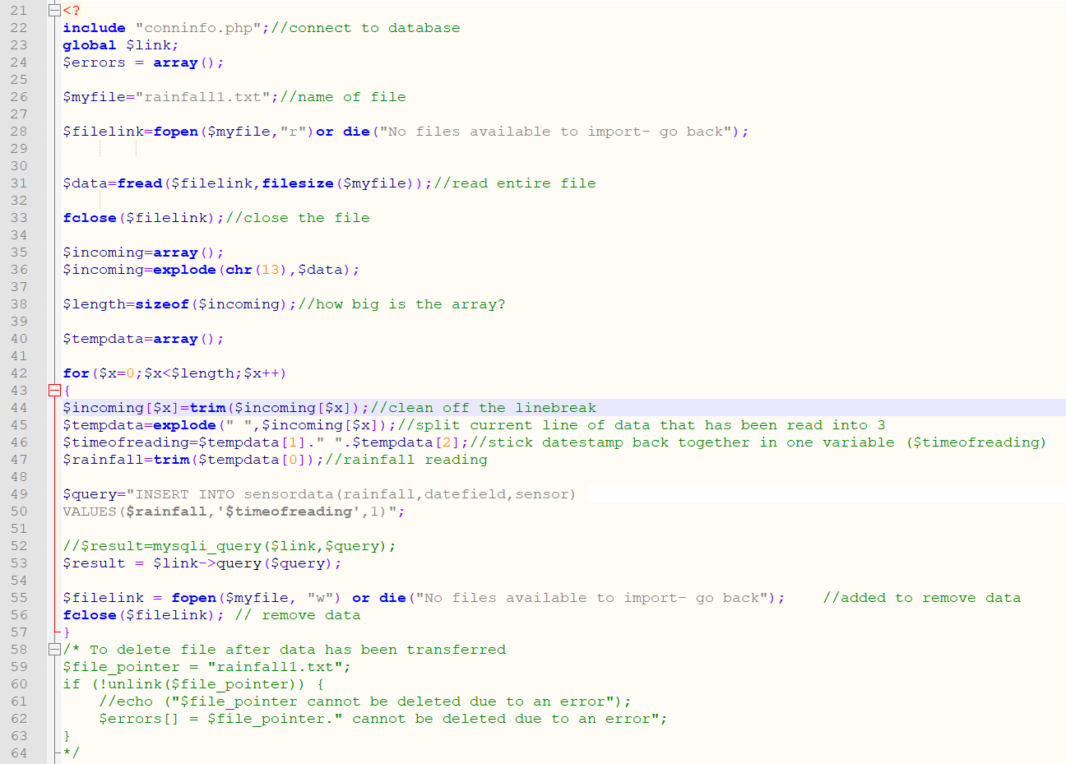
import.php:

My code initially was setup so that once the data was imported you have to click back to get to the homepage so I added the following code to make it look more professional and added the navigation bar so it is easier for the user to navigate so they can get to whatever part of the website they need to without leaving the page.

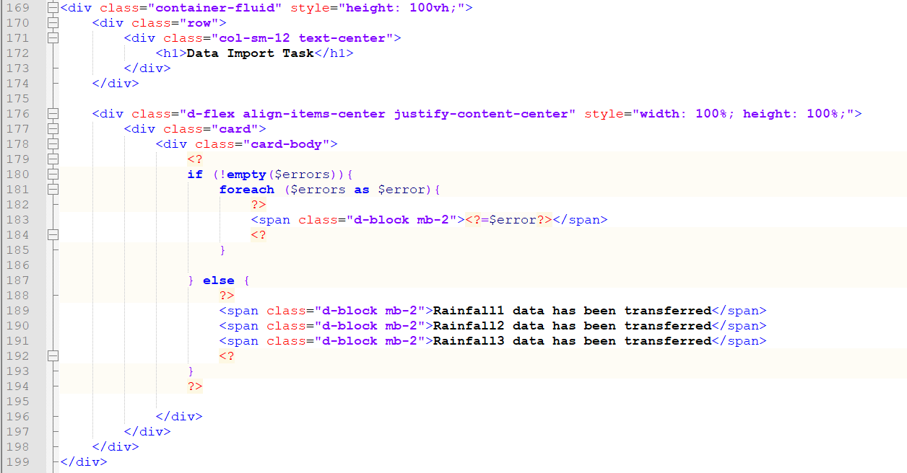
Navigation/Design

After getting the fundamentals of the website working I decided to implement bootstrap to make it look more professional. I initially was using bootstrap version 3.4.1 but changed to make my tables look better with new functionalities.

I first implemented a template from W3Schools and then changed it as I went on-
https://www.w3schools.com/bootstrap/tryit.asp?filename=trybs_temp_webpage&stacked=h

The navigation bar makes the website look more professional and makes it so you can quickly and easily navigate the website.

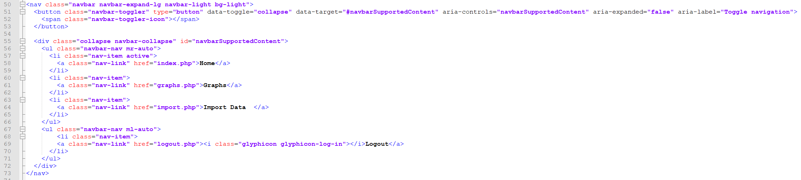
index.php:

Using bootstrap I changed how my buttons looked as I do not like the standard ‘submit’ boxes in html.

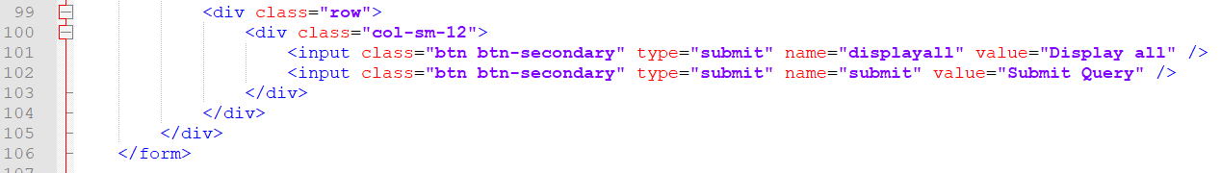

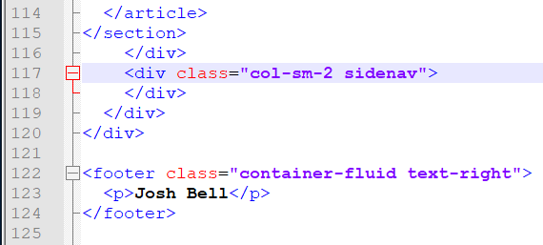
Although I did not put anything in the side columns I like the way that it looks with the colour change and it means I can add more features such as the weather forecast which will fit in well with the look of the page.

JavaScript used:

