Patient Referral
Actors/ Roles;
- GPs – Initiate Referral
- Patients - initiate referral, receive care
- Clinicians – Receive referral, Initiate referral, assess referral
- Admin staff – Manage clerical tasks I.E communication, appointment scheduling
Business Processes/capabilities

- Referral initiation
- Clinical triage
- Service matching
- Referral Acceptance / Rejection
- Appointment scheduling
- Referral tracking

Application components
- EMIS
- WCP
- WPAS
- CWS
- Email
- Paper

Application processes/services
- Referral submission
- Document transfer
- Appointment booking
- Audit functionality

Data objects
- Referral letter
- Patient demographics
- Clinical history
- Test results
- Appointment details
- Audit logs

Goals
- Timely, appropriate referral process

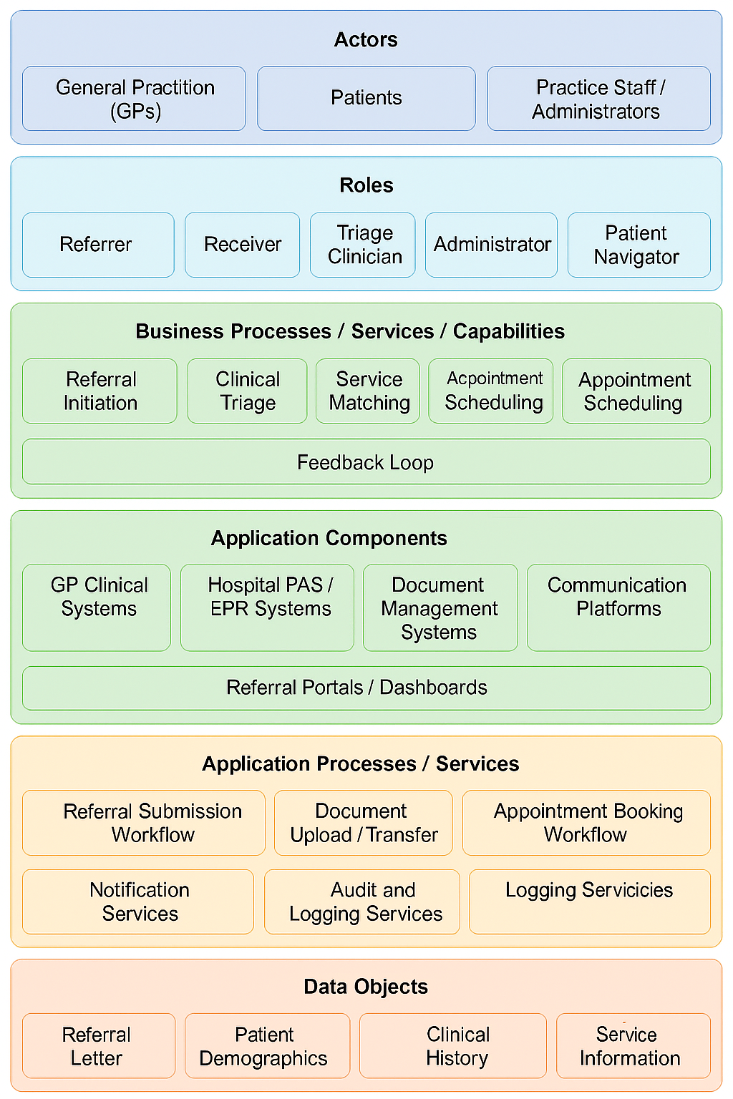
EMIS
WPAS
WCP
CWS
Referral tracking

