Carmarthen Business School
Global Business Challenges Assessment One (BMSP4001)
Lecturer: Anthony Burns
COVID-19, the short and longer lasting implications on business.
Rebecca Bartley.

COVID-19, the short and longer lasting implications on business
Covid has impacted the way business is done in a bigger way than any global event in recent history. On the whole, this article will attempt to focus on business impacts as a result of COVID-19 and the way consumer habits towards shopping have changed and continue to stick around.
In the UK on the 16TH March 2020. Matt Hancock spoke in the House of Commons stating that ‘’unnecessary social contact should be avoided’’. In addition to this, Boris Johnson during a televised statement went on to say ‘’now is the time for everyone to stop non – essential contact’’. He stated that ‘’it was advice’’. Furthermore to this Boris Johnson on the 23rd March 2020 stated that ‘’people must stay at home’’ as well as ‘’we will immediately close some businesses. (1)

Consequently, this changed shopping habits for the consumer. This being the case, The Shopper Experience Index 2022 found that people who began to shop online during the pandemic, a large quantity have continued to do so. (2)

Many small business had to diversify their businesses to stay afloat during the pandemic. In fact, on closer examination of this area it was found that some small businesses were remarkably resilient to the pandemic by innovating and changing the way they do business.
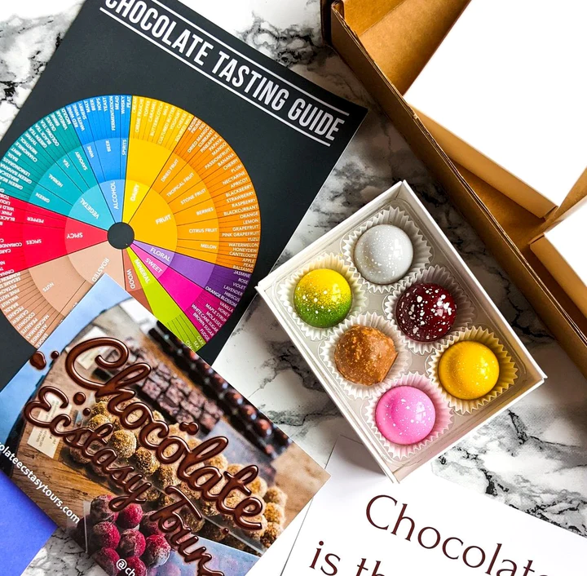
In the case of Jennifer Earle and her small business – Chocolate Ecstasy Tours. Pre pandemic the business offered walking tours of London’s chocolate boutiques, gelaterias and patisseries. After Boris Johnson’s lockdown announcement in March she had to diversify the business to keep afloat. She had to stop the walking tours and instead she started offering mystery online chocolate tastings which were sent to the consumer through the postal service. She was then selling to people who wouldn’t of made it to London for the walking tours. (3)

In 2018, before the pandemic 47% of UK shops were offering ordering for collection services also known as click and collect. It was found that between February 2020 and January 2021 online food sales through click and collect increased from 5.3% to 12.2%. (4)
Click and collect was more of a convenience service before Covid. People didn’t need to use it, they chose to as it was more convenient to them. Now its not just convenient but safer. It cuts out contact for consumers when its not needed. This helped businesses to operate through the pandemic.
A major business implication due to the pandemic is a shortage of staff in certain sectors. Hospitality staff vacancies in 2021 was at the highest level since records began. (5)
Initially most hospitality was as a result of lockdowns therefore forcing staff to find new careers. Consequently upon reopening after the lockdowns many businesses have struggled refilling these vacancies.
Consumer spending on hospitality did start rising in May 2021 but still remained at less than 70% of pre pandemic levels. (6)
Another sector hit by lack of staff is HGV drivers. This has been caused as a result of many factors due to the COVID-19 pandemic. HGV driving tests were cancelled. To try and combat this the government introduced measures to help, one of them being increased numbers of driving tests compared to pre pandemic.
Another sector which was hit hard by the pandemic was the aviation sector. Air passenger travel decline was huge and at 98% loss when the pandemic hit in April 2020. (8)
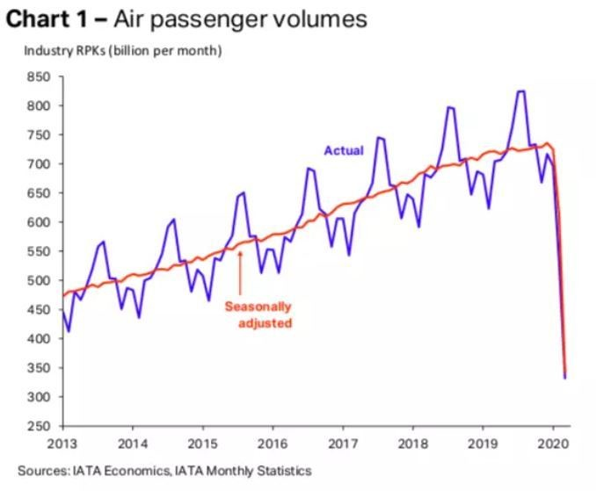

Again, some staff changed careers during the pandemic, creating many vacancies as airlines started to open back up to demand. During the pandemic airports and airlines were forced to make hundreds of redundancies. In 2021 82 travel agents and tour lines folded which was up by 68 compared to 2020. (9)
The global supply chain was massively impacted by the pandemic. Insanely, when lockdown first began a bizarre example of a huge supply chain issue was toilet roll. People started panic buying certain items, toilet roll being one of them. Stores were selling out and most sold out for some time. The panic buying even led to it being sold on the black market with people using this to their advantage and selling at much higher prices. (10)
The COVID-19 pandemic also contributed to the already affected timber shortage in the global supply chain. The pandemic began in China but very quickly hit all pats of the world. The global supply chain was tremendously hit hard as such a huge volume of products were manufactured in China. Post pandemic, companies will have to alter their business and the way they do it to not become so reliant in China being their sole supplier of goods.
Farms were impacted during the pandemic by lots of factors. Dairy farms especially struggled throughout the pandemic, they were being forced to dump their milk, sometimes thousands of litres at a time. One of the reasons for this was the demand for milk in the hospitality sector dropped by as much as 70% and even though there was a slight raise in the demand for the retail sector. There was still far too much milk being produced. Due to workplace restrictions, farms didn’t have staff to help aide the production of the milk. In addition to this, with the shortages of drivers and logistics globally, there was no way of getting such a large amount of milk out in time. (11)
Farmers were dealing with such great losses due to various factors of the pandemic, they were forced to diversify and adapt like no other way before. They had to resort to things like online cattle sales via different apps. Online auctions were being carried out via live video streaming services. They wee losing crops, this was happening because there was again a lack of staff to pick and harvest the crops. Also again, lack of drivers for the transportation of the goods. It was a realm struggle for the farmers as they had to try their upmost best to keep on going to the absolute best of their ability because if fields were not properly harvested and proper farm practices not adhered to, it would also affect future agricultural production. (12)

When thinking of the way people pay for things during and carry on doing so since the pandemic. The majority of consumers have and continue to have changed the way they pay for their goods and services. Although many businesses and services had online sales platforms and apps previous to the pandemic, so many more became available as businesses were trying to become more resilient to COVID-19. (13)
Even though card payments are still proving to be the most opted for method for paying online, paying via a digital wallet is clearly the most popular alternative. (14)
A digital wallet is an online service or an electronically enabled digital device which uses software to allow consumers or businesses to make transactions electronically. They can link debit or credit cards to the wallet and even link bank accounts. (15)
A digital wallet will typically use biometric logons with fingerprint or face identification which keeps data safe. It also reduces the need for physical contact which is why possibly more people have started using them since the pandemic.
The Apple digital wallet store more than just payment methods. Users can store tube, train and plane tickets. Boarding passes can also be stored. The possibilities seem to be endless with more and more new items being added all the times. Some vehicle manufacturers such as BMW have added keyless entry working side by side with the digital Apple wallet. (16)
Lots of different store and reward cards can also be stored and used digitally.

The pandemic has also helped many businesses to thrive. Subscription boxes which are available for a vast range of goods have proved to be very popular as consumers have sought out new ways of shopping. According to Royal Mail’s subscription box market report, consumers spent almost 1.4 billion on subscription boxes purchased in 2020. (17)
An article from The Grocer stated that meal kit subscription box service Hellofresh had started making its first profit in the UK during 2020 as sales boomed during the pandemic. (18)
As people were forced to stay at home because of lockdowns, home cooking was on the rise with people taking up cooking and baking as new found hobbies so subscription boxed that provided meal kits ands baking goods proved to be very popular.
During the pandemic, convenience and safety was very sought out by the consumer. It could sometimes be impossible to book a home delivery or click and collect slot from a supermarket as so many people were reaching out to use such services, demand was very high. Slots were booked for weeks in advance and if any extra were made available they were very quickly filled. Subscription boxes proved popular as they were sent at regular intervals to the consumers door providing supreme convenience.
Subscription boxes tend to offer a wide variety of goods which therefore means that the consumer tries out new things that they wouldn’t normally purchase. This would excite customers, wanting more boxes which seemed to be keeping them busy and entertained during lockdown.
Great flexibility is provided through subscription box services. Customers are able to spread the cost or budget in advance by paying upfront. Most subscription services have the option to pause or completely cancel their subscription at any time. This is great peace of mind for the customer if they feel they no longer enjoy the products provided or maybe they have surplus items. With such great flexibility, if a customers circumstances change, so can their subscription. (19)
Another sector which suffered great losses on a whole was gyms and leisure centres. It was found in a report by the London Medical Laboratory (LML) that at least 500 gyms and leisure centres in the UK permanently closed their doors and stopped doing business during the pandemic. It also states that the UK’s fitness industry may indefinitely suffer the consequences and may never return to normal pre covid health. (20)

In the UK, Dw Sports, a gym operator which was also a sportswear retailer collapsed into administration during 2020. The group placed the blame on the COVID-19 lockdown. (21)

On the contrary to this another gym group Planet Fitness who have 2254 gyms situated in The District of Columbia, Puerto Rico, Canada, Panama, Mexico and Australia. The CEO of Planet Fitness Chris Rondegu told Yahoo Finance Live that ‘’he was extremely happy to say that they had lost no gyms in the pandemic’’. (22)

Some gyms diversified and therefore started offering online fitness classes and also personal trainers were hosting online training sessions. Apps were created by some gyms and trainers with fitness routines added on to them to make it easy for people to stay fit during the pandemic. Evidently, things such as these have in fact helped some gyms to thrive even post pandemic as they continue to offer and run online sessions. People who wouldn’t normally feel comfortable attending a gym found themselves being happy to join up and train online at home. Some peoples busy lifestyles also wouldn’t normally allow them the time out from their schedules to visit an actual gym so an online session for 20-30 minutes suited them far more.

Some delivery companies in the United States reported that exercise and fitness gear were some of the most sold out items in 2020. This didn’t stop at home gym and training equipment but also items like bicycles and even rollerblades were proving very popular. (23)

Summer 2020 weather in the United Kingdom was very warm during the first lockdown. People didn’t just want to be confined just to the space of their own home and with the tight rules during lockdown which only allowed people to go out of their own home and garden for exercise once a day, they spent most of the waking hours in their gardens.

According to a study recently conducted by researchers from the University of Georgia it was discovered that sales for literally anything even remotely related to gardening were booming during the pandemic. (24)
Lots of people both young and old became and continue to be keen gardeners.
Seed sellers were still experiencing the same high demand for seeds in 2021 as they were during the first lockdown in 2020.
Baker Creed Seeds, a company based in Missouri had to completely close their website three times due to such high demand. (25)

Reflecting on all of the short and longer lasting implications on business due to the COVID-19 pandemic discussed in this article, it was found that there were huge impacts to more or less every single sector of business. Some positive and some negative.
Some business have sadly been forced to close while others have seen huge increases in revenue.
Businesses had to adapt and diversify the way they did business to keep going.
Staff shortages was found the be a big implication which is one of the longer lasting ones.
Although it seemed that lots of new trends emerged during the pandemic, not all of them stayed around, while some in fact flourished.
Consumer habits have changed post pandemic and many new ways to shop and pay for good seems to be the new normal.

COVID-19 implications on businesses are likely to stick around for ever in one way or another.

References
- Full Fact. (2020). When did lockdown begin in the UK. https://fullfact.org/health/coronavirus-lockdown-hancock-claim/
- Erdly,C. (2022). Shopping trends change but Pandemic behaviours are here to stay. https://forbes.com/sites/catherineerdly/2022/05/31/shopping-trends-change-but-pandemic-behaviours-are-here-to-stay/?sh=2d7533b32d58
- Ruzicka, A. (2020). Small businesses adapt and fight back. https://www.thisismoney.co.uk/money/smallbusiness/article-8947045/small-business-adapted-coronavirus-pandemic-html
- Howden, J. (2022). Is click and collect here to stay post pandemic. https://www.mobiletransaction.org/is-click-and-collect-here-to-stay/
- Race, M. (2021) is there a solution to the hospitality staff crisis? https://bbc.co.uk/news/nusiness-57817775
- Census 2021. (2021). Cornonavirus and its impact on UK hospitality: January 2020 to June 2021. https://www.ons.gov.uk/businessindustryandtrade/business/activitysizeandlocation/article/coronavirusanditsimpactonukhospitality/january2020tojune2021
- Gov.uk. UK government action to reduce the HGV driver shortage. https://www.gov.uk/government/topical-events
- Abou-Ragheb, L. (2020). How is COVID-19 changing airports? https://www.weforum.org/agenda/2020/09/how-is-covid-19-changing-our-airports
- Robson, S. (2022) Crisis-hit Manchester airport bosses took £100m of taxpayer money during pandemic while cutting staff and pay. https://inews.co.uk/news/crisis-hit-manchester-airport-100m-taxpayer-money-covid-pandemic-cutting-staff-15599562?icp=in-line_link
- James Cook University Australia. (2022). Inside the global supply chain shortage after COVID-19. https://online.jcu.edu.au/blog/global-supply-chain-shortage-covid-19
- Farming UK team. (2020). Coronavirus: farmers forced to dump thousands of litres of milk. https://www.farminguk.com/news/coronavirus-farmers-forced-to-dump-thousands-of-litres-of-milk_55377.html
- Fedunik-Hofman, L. Science.org? How does a global pandemic affect our food supply chain? https://www.science.org.au/curious/people-medicine/how-does-global-pandemic-affect-our-food-supply-chain
- Clymo, R. (2021) Pandemic has transformed consumer habits for good. https://www.techradar.com/news/pandemic-has-transformed-consumer-payment-habits-for-good
- Paysafe. (2021). How COVID-19 has permanently changed payment habits. https://www.paysafe.com/en/blog/how-covid-19-has-permanently-changed-payment-habits
- CFI Team. (2022). What is a digital wallet? https://corporatefinanceinstitute.com/resources/cryptocurrency/digital/wallet
- Apple. (2022). Wallet. https://www.apple.com/uk/wallet/
- Briggs, F. (2021). UK subscription box market to be worth 1.8bn by 2025, Royal Mail report shows. https://www.retailtimes.co.uk/uk-subscription-box-market-to-be-worth-1-8bn-by-2025-royal-mail-report-shows/
- Mattinson, A. (2021). Hellofresh makes first profit in UK amid rocketing demand. https://thegrocer.co.uk/results/hellofresh-makes-first-profit-in-uk-amid-rocketing-demand/657409.article
- Wood, R. (March, 2021). Why subscription boxes are winners in a pandemic. The Successful Founder. 22-23.
- Murden, T. (2022). A million gym users quit as sector loses £3.5bn. https://dailybuisinessgroup.co.uk/2022/03/a-million-gym-users-quit-as-sector-loses-3-5bn/amp/
- Davies, R. Sweney, M. (2020) Jobs blow as Dw Sports and Hays Travel announcements affect 2600. https://amp.theguardian.com/business/2020/aug/03/dw-sports-administration-jobs-coronavirus-lockdown
- Sozzi, B. (2022). Planet Fitness CEO flexes on 0 gym closures as pandemic battered industry. https://uk.finance.yahoo.com/news/planet-fitness-ceo-flexes-on-0-gym-closures-as-pandemic-battered-industry-171010496.html?guccounter=1
- Lill, D. (2021). 5 industries that thrived during the pandemic. https://www.talk-business.co.uk/2021/04/20/5-industries-that-thrived-during-the-pandemic/
- Dalli, K. (2022). COVID-19 pandemic sparked increase in gardening sales, study finds. https://www.consumeraffairs.com/news/covid-19-pandemic-sparked-increase-in-gardening-sales-study-finds-032222.html
- Artani, L. (2021). Gardening trend that bloomed during the pandemic and is here to stay. https://www.theguardian.com/lifeandstyle/2021/mar/31/gardening-trend-pandemic-here-to-stay

