Managing People
Module code: LCBB5004
Assessment 1
Student ID:2022780
Student name: Onisor Opris

Table of Contents
Introduction 1
A Case in favour of Flexible working concerning diversity and inclusion at work 1
An idea on flexible working 1
Role of Flexible working in promotion of diversity and inclusion at the workplace 2
Role of Human resources in promoting diversity and inclusion through flexible working 3
A Case against Flexible working concerning inequality at work 5
The downsides of flexible working 5
Role of flexible working in increasing inequality at workplace 6
Role of Human resources in addressing the concerns related to inequality due to flexible working 7
Conclusion 8
References 9

Table of Figures
Figure 1: Benefits of flexible working 2
Figure 2: H&M Employee percentage by ethnicity 3
Figure 3: Employee preference to flexible working 6

Introduction
This study will be based on the concept of flexible working in organisations and both of its positive and negative effects on that organisation. For a better idea, the organisational example of H&M, which is a multinational retailer company for apparel with over 5,000 stores in various countries worldwide (Giertz-Mårtenson, 2020). Two cases will be built, one in favour of and one against flexible working that is being implemented more and more in organisations. How the human resource functions in an organisation play a major role in addressing the concerns regarding inequality in the workplace or how it can promote diversity and inclusion better will be explained for a thorough understanding. It can be hoped that through this study a better idea can be gained regarding how a company can use human resource management to implement better values and handle challenges.

A Case in favour of Flexible working concerning diversity and inclusion at work

An idea on flexible working
Flexible working refers to the opportunity for employees to decide when or where they work to a certain extent (Joyce, 2021). There are many variations of flexible working systems and recently more and more companies are adopting this policy, H&M being one of those. The Covid-19 situation had given space to more work-from-home opportunities due to its added flexibility and increased safety (Wang, 2021). Flexible working can include the ability of an employee to change the timing of their work, which means alternating the starting and ending times and sometimes even changing the number of hours they work; this condition is called flexitime. There is also working time autonomy where the employees have greater freedom to control their work schedule and manage work quantity according to their needs. The flexible working regarding the place workers work on is referred to as a work-from-home opportunity and it is now used the most among the flexible working opportunities. It allows the employees to do their work via online devices and electronics from home without needing to be physically present at the office (Kelliher and Anderson, 2019).

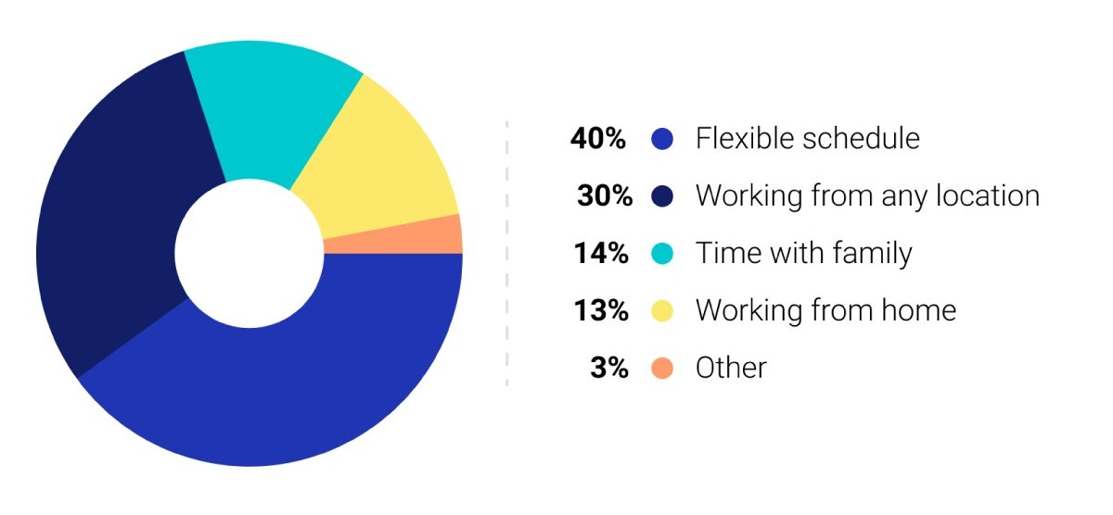
Figure 1: Benefits of flexible working
Source: (Oseland, Webber and MacDonald, 2018).
Such kind of flexible working has created more opportunities in the business world, as the reachable talent pool has expanded tremendously because companies don’t need all their employees to be physically present at work. So the global recruitment has also increased, which has given more space to choose candidates from a diverse pool of people. It has helped businesses keep afloat and even flourish during the covid-19 pandemic, and employees to be safer at their homes (Strods, Berka and Linney, 2021). People can now tend to their personal needs better because they have the option to control working hours or work quantity. So this has become a phenomenon that is causing the business world to prosper and develop better.

Role of Flexible working in promotion of diversity and inclusion at the workplace
Diversity and inclusion have become a more important aspect in organisations as there is a wide array of backgrounds where people apply to the jobs from. This diversity of backgrounds is not welcomed in every organisation, but people are now more conscious and aware of how there should be equality and justice in an organisational environment. Most of the companies are now working to promote these concepts and even making support groups and funding so that the minority groups can get equal opportunity (Roberson, 2019).

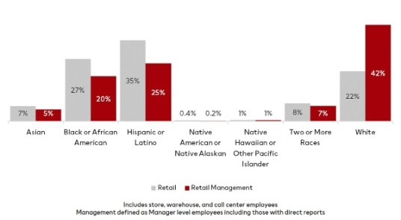
Figure 2: H&M Employee percentage by ethnicity
Source: (Ivy, 2021).
H&M is also a company that has been working hard to ensure diversity and inclusion in the workplace for decades now. There is a higher drive to bring out male-female equality among workers as well as provide opportunities to people from every racial background. The flexible working practices have made it easier to promote diversity and inclusion at workplaces.
The flexible working condition is playing a great role in providing more options for the companies to hire people from diverse backgrounds. It is because the virtual and global hiring process has made it possible to avoid cultural biases and select people based only on their talent. The employees do not need to be physically present all the time to get the work done, so the time differences among people in different countries have also become easier to handle. There is also the fact that due to flexible working, the people from different countries and cultures can be available for work based on their schedule. So flexible working is making promoting diversity and inclusion much easier in organisations.

Role of Human resources in promoting diversity and inclusion through flexible working
There are various human resource functions that an organisation maintains to make sure that they have the best employees working for themselves who are productive and efficient. A diverse pool of employees makes an organisation more successful, innovative and reachable to customers. Human resources can promote diversity and inclusion even better in a flexible working condition and it will be explained further below:

Widening the talent pool through online recruitment
The online recruitment system has paved the way for a far more diverse pool of candidates to apply for a job. This has been possible due to the flexible working system where the workers don’t have to gather together to conduct interviews or select employees. The flexibility has also allowed employees to participate in more interactive meetings via the internet, no matter their physical location which broadens their mindset regarding cultural and gender diversity. This affects the recruitment process as they can ignore their biases and stereotypes better.
Promoting diversity through mentoring
In the performance management and mentoring function of human resources, diversity and inclusion are other great aspects to assess employees. The flexible working practice allows employees to be more available to join various mandatory training without hampering their main work through online learning (Choi, 2018). These lessons are often on cultural awareness, the importance of inclusion and the management of a diverse workforce. These help the employees in understanding how they can be more inclusive and make a diverse group of people more welcomed. Including this as a metric for performance also make them more aware of their behaviour towards minority groups; which has been easier because of these flexible working policies.
The role of leadership in creating diversity
It is believed that a successful leader does not discriminate among followers and treats everyone equally regardless of their background. Such is the truth for organisations as well because the company leaders should also treat all the employees equally and fairly (Frechette, 2019). Because of the flexible working practices, the leaders might not physically be able to monitor and lead all the employees, but it has made communication much easier. The leaders are now donating to and promoting support groups for minorities in the organisation. H&M also has ethnic minority support groups where people from certain races can communicate, interact, share a close relationship and can also be guided and encouraged by the leaders and executives more easily.
So it shows how flexible working practice can be very beneficial for an organisation, ensure employee inclusion and also how human resources can have a direct influence on ensuring the successful implementation of such practices.

A Case against Flexible working concerning inequality at work

The downsides of flexible working
Even though flexible working has mostly positive sides, there are also some downsides to it that organisations and their employees face. The high level of flexibility sometimes hinders the relationship among employees because they don't maintain a fixed schedule or interact with the same group of people directly regularly. Keeping communication via the internet is easier, but less strong in terms of harmony and coronation. Another issue is that flexible working causes employees to become too detached from their workplace and become demotivated in fulfilling their duties sometimes. The employees with procrastinating tendencies suffer even more with this kind of setting. The visibility of employees for the organisation also shifts based on whether they are actually being present in the company or just working from behind the screens. The morality of employees is also getting affected because they do not have a strong bond with their employers anymore (Beňo, 2021). All of these are strong indicators of how the companies sometimes suffer because of such a setting as well, which also reflects upon employee performance and productivity. Even though due to covid-19, remote working had become essentiality which helped in keeping many businesses afloat; the permanent shift in work dynamics where many employees prefer to permanently work remotely is alarming.

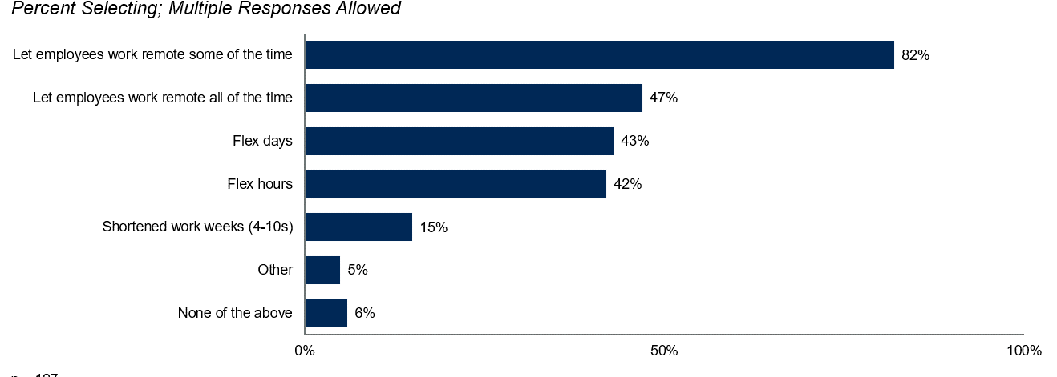
Figure 3: Employee preference to flexible working
Source: (Pierce and Newstrom, 2020).
This shift might cause an imbalance in the workplace dynamics and turn this flexibility into inconvenience. The changes in work procedures also affect employee productivity greatly and even though they might progress in the short-term, they have a higher chance of lagging in the long run. It is because the practical experience stays incomplete here due to the lack of a fixed schedule or work duties.

Role of flexible working in increasing inequality at workplace
Equality in the workplace is very important to maintain because at most companies, diversity and inclusion is considered in high regard as well as organisational justice and fairness. For a company to be equal, it needs to treat all its employees in the same way based on their talent, not their position, age, race, gender, religion or ethnicity. Flexible working has also been a popular way of operation in organisations now, but this sometimes contradicts with the equality concept of workplaces.
The flexible working practices are not available to all employees, and in some cases, it is only given to the higher-ups. The lower-paid workers are often most in need of flexible working practices due to cost-saving, and being able to spend time with their families. But most often such employees are not granted flexible working patterns and are required to physically attend offices; creating inequality (Lewis and Humbert, 2020). Also, it has been noticed that the females with spouses and children or even without ones are the ones asking for more remote or hybrid working opportunities. This is not an issue in itself, but after a time only the male workers will be visible in a workplace environment if this becomes a permanent shift, and females will be cast aside or lag in the company hierarchy due to the lack of their physical presence. There has also been inequality in the rewarding pattern based on physical presence at workplaces, whereas employee performance is what should be measured regardless of working hours.
The pay gap between the physical and remote workers are also alarming at various organisation, along with gender pay gaps and racial discrimination. This setting is providing more scope for inequality at workplaces which if not resolved, can greatly harm employee morale and productivity.

Role of Human resources in addressing the concerns related to inequality due to flexible working
Inequality Training and development opportunities
One of the greatest concerns related to flexible working is the lack of sufficient training opportunities for employees. The physical employees are offered mandatory coaching whereas many global companies including H&M offer only optional training courses for global employees or remote workers. This is because they are not sometimes able to visit or attend physically for the lessons, but it ultimately leaves a huge gap in their skill level. The online curriculums are often not as detailed, interactive or practical; instead only skim through theoretical aspects of the job. So the training and development processes should be designed in a way where a healthy balance of online and offline curriculums will be available and employees will be offered the courses based on their skill requirements, not their position. Also, there is a higher percentage of males who get offered global job opportunities because it is believed they can be more flexible in terms of the global workforce (Michailidis, Morphitou and Theophylatou, 2021). But this also causes inequality in the workplace which must be considered.
Rewards and motivation discrepancies
There is another concern regarding flexible working which causes inequality and it is related to the rewards and motivation policies in organisations, as well as the compensations. Many organisations have resorted to making their full-time employees work into a hybrid pattern now, but they have also started cutting down the remuneration and rewards because of it. Some workers perform well beyond the requirement but do not get rewarded because of their hybrid working nature, on the other hand, some workers get rewarded just for physically working in the organisation regardless of their performance. This is causing major damage to employee morale and motivation. The global employees from ethnic minorities are also suffering because of such rewards policies and also most females are also becoming victims of these (Wu, 2018). So the policies need to be reassessed for a better understanding of what should be considered while rewarding and motivating employees and ensuring equality at the workplace.
So the case against flexible working has shown what concerns are related to this practice and how human resources can play a great role in handling such issues in a workplace.

Conclusion
In conclusion, it can be said that flexibility in the organisation is a concept that has both its advantages and disadvantages, and it is up to the organisation to ensure a healthy balance of the two. While implementing flexible working patterns, the organisations need to consider how it will benefit them and highlight as well as promote those positive sides. On the other hand, the disadvantages must also be considered and the employees are needed to be handled in a way where they will not feel unfair and unjustified because of their background. So managing people can be considered a very essential activity which should be designed in a way that will closely focus on achieving objectives of the company. The human resource functions play a direct role in managing the people in an organisation and ensuring inclusion, diversity and equality in the workplace regardless of the flexible working condition, and that should be considered in every organisation very carefully.

References
Beňo, M. (2021). The advantages and disadvantages of E-working: An examination using an ALDINE analysis. Emerging Science Journal, 5, pp.11-20.
Choi, S. (2018). Flexible working as human resources strategy: Benefits to the organization and its personnel. Strategic Direction, 24(8), pp.9-11.
Frechette, J. (2019). Women, Leadership, and Equality in Academe: Moving beyond Double Binds. In Forum on public policy online (Vol. 2009, No. 2). Oxford Round Table. 406 West Florida Avenue, Urbana, IL 61801.
Giertz-Mårtenson, I. (2020). H&M–documenting the story of one of the world's largest fashion retailers. Business History, 54(1), pp.108-115.
Ivy, P.R. (2021). “An Analysis of Employees’ Performance Appraisal System: A Study on Hennes & Mauritz AB (H&M) (Doctoral dissertation, Daffodil International University).
Joyce, K., Pabayo, R., Critchley, J.A. and Bambra, C. (2021). Flexible working conditions and their effects on employee health and wellbeing. Cochrane database of systematic reviews, 31(2).
Kelliher, C. and Anderson, D. (2019). Doing more with less? Flexible working practices and the intensification of work. Human relations, 63(1),pp.83-106.
Lewis, S. and Humbert, A.L. (2020). Discourse or reality? “Work‐life balance”, flexible working policies and the gendered organization. Equality, Diversity, and Inclusion: An International Journal, 13(7), pp.195-205.
Michailidis, M.P., Morphitou, R.N. and Theophylatou, I. (2021). Women at work equality versus inequality: barriers for advancing in the workplace. The International Journal of Human Resource Management, 23(20), pp.4231-4245.
Oseland, N., Webber, C. and MacDonald, M. (2020). Flexible working benefits. Occasional Paper, 3(1), pp. 13-18.
Pierce, J.L. and Newstrom, J.W. (2020). Toward a conceptual clarification of employee responses to flexible working hours: A work adjustment approach. Journal of Management, 6(2), pp.117-134.
Roberson, Q.M. (2019). Disentangling the meanings of diversity and inclusion in organizations. Group & Organization Management, 31(2), pp.212-236.
Strods, C., Berka, A. and Linney, S. (2021). Effective global mobility and international recruitment during a pandemic. In Radical Solutions for Education in a Crisis Context (pp. 53-67). Springer, Singapore.
Wang, B., Liu, Y., Qian, J. and Parker, S.K. (2021). Achieving effective remote working during the COVID‐19 pandemic: A work design perspective. Applied psychology, 70(1), pp.16-59.
Wu, N. (2018). Flexible working: Are we ready for this? Hidden inequalities in the workplace, pp.127-154.

