
dIGITAL MARKETING
Gower Brewery Report

April 1, 2019
Jessica Rees
1703037

Contents Page

List of Figures ………………………………………………………………………Page 2
Executive Summary …………………………………………………………….Page 3
Introduction………………………………………………………………………..Page 4
Social Media Channels…………………………………………………………Page 5
Website Analysis…………………………………………………………………Page 7
Recommendations………………………………………………………………Page 9
Conclusion…………………………………………………………………………..Page 10
References…………………………………………………………………………..Page 11

List of Figures

Figure One: https://www.instagram.com/budwieserusa/ …………………………………………Page 5
Figure Two: https://www.instagram.com/budweisernigeria/ …………………………………….Page 5
Figure Three: https://www.instagram.com/budweiserindia/ ………………………………………Page 5
Figure Four :https://likealyzer.com/report/Budweiser ………………………………………………..Page 6
Figure Five: https://www.budweiser.co.uk/prohibition ................................................Page 7
Figure Six: https://www.budweiser.ca/en/ …………………………………………………………………Page 8
Figure Seven: https://budweiser.ca/en/prohibitionbrew ................................................Page 8
Figure Eight: https://budweiser.ca/en/bettertomorrow ..................................................Page 9
Figure Nine: http://www.twitonomy.com/profile.php?sn=BudweiserUK ………………………Page 9

Executive Summary

This report provides an in-depth analysis of the market leader Budweiser and how they are optimising their digital platforms but in this report we are focusing on 3 in particular: Instagram and Twitter platforms and then their website.
“Digital marketing refers to the management and execution of marketing using electronic media such as the web, email, interactive TV, IPTV and wireless media in conjunction with digital data about customer characteristics and behaviour.” (Chaffey, 2012)
To carry out the report and analysis on these specific platforms, a number of research has been conducted along with the use of some analytic tools. With this tool, it showed in detail how Budweiser uses their account and how effective this is regarding response time, retweets, likes and then company engagement with followers.
A website analysis was also carried about but within this report, Budweiser have used a clever marketing strategy and has country-orientated platforms, for example, BudweiserUK, Budweiser Canada, Budweiser India, and so forth. After analysing many of these different websites, it was clear that the company had designed pages and content in conjunction with the region it was targeting. Overall, more analysation of the page content was done and there was a positive response regarding the topics they mentioned, those being globally controversial and passionate topics such as saving the world. Budweiser has promised to become a greener company by 2025 by recycling the electricity they use to produce their beers and using their global brand to drive positive change. Another great aspect of their website was the prominent advertising of a new product that targets a different type of market: their newly created non-alcoholic beer that has the same taste as beer. The advertisement of this is great as it does reach out to a different type of market and shows a deeper care below the surface of the company.
To finalise the report, recommendations were made, although they weren’t many at all. These referred to the development of more region-specific accounts as there is room for many more and much improvement, and optimising other and perhaps newer digital platforms that they haven’t already.

Introduction

In this report, I will be analysing best digital marketing practise of market leading organisation Budweiser, on behalf of Gower Brewery; a local beer brewery within the heart of Gower. “Digital marketing refers to the management and execution of marketing using electronic media such as the web, email, interactive TV, IPTV and wireless media in conjunction with digital data about customer characteristics and behaviour.” (Chaffey, 2012)
The two main digital channels I will be observing are online advertising as Budweiser really optimises full use of their social media channels, and search engine optimisation (SEO).
Budweiser is an American produced lager produced by Anheuser-Busch; a transnational corporation, of which Budweiser is produced in various breweries across the globe. (Anheuser-Busch, 2016)

Social Media Channel

“Social media marketing refers to monitoring and facilitating customer-customer interaction and participation throughout the web to encourage positive engagement with a company and its brands. Interactions may occur on a company site, social networks and other third-party sites. This also goes hand in hand with Social media strategy which refers to the marketing communications used to achieve interaction with social network users to meet business goals. The scope of social media optimisation also includes incorporation of social media features such as status updates and sharing widgets into company websites.” (Chaffey, 2012)

Budweiser is particularly good at enhancing the opportunities their social media platforms bring, especially Instagram, as they brand their company by different regions around the world which, makes the business to consumer relationship more personal regarding language, retailers and so forth.
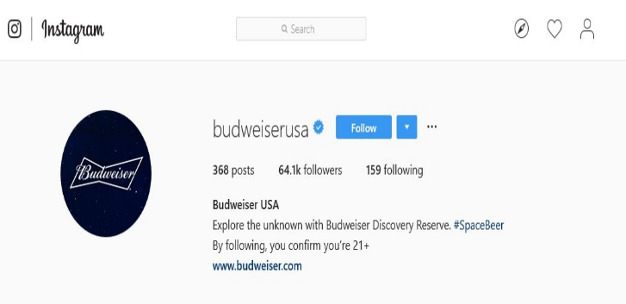
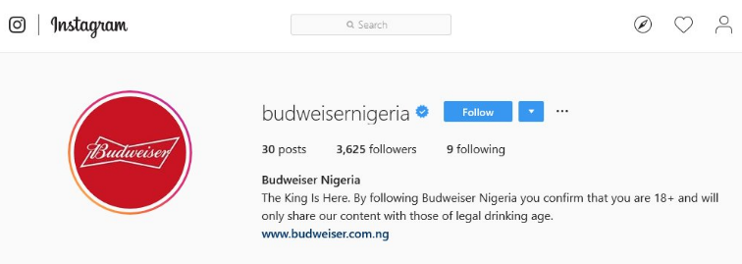

Figure Two: https://www.instagram.com/budweisernigeria/
Figure One: https://www.instagram.com/budwieserusa/
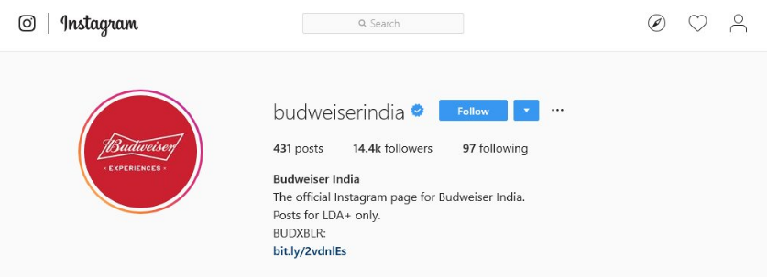

Figure Three: https://www.instagram.com/budweiserindia/

Budweiser optimises its Instagram pages very well, posting on average every 2 days with thousands of likes and comments on each post. This practise is carried out throughout all regions of their companies Instagram platforms. Their content is also unique and drags you in. They put particular emphasis on their products, creating it in a way of making you feel like you want it. They also incorporate a lot of their followers by reposting videos or photos that have a certain hashtag which is great because it makes the relationship between consumer and business more personal. Budweiser also creates great partnership with big events that are going on as for them that is more opportunities for advertisement and shows interest in these type of events.

Twitter is also another platform that Budweiser takes full advantage of. Again, the same principles apply in regards to different accounts targeting different countries, but all of which are used effectively.

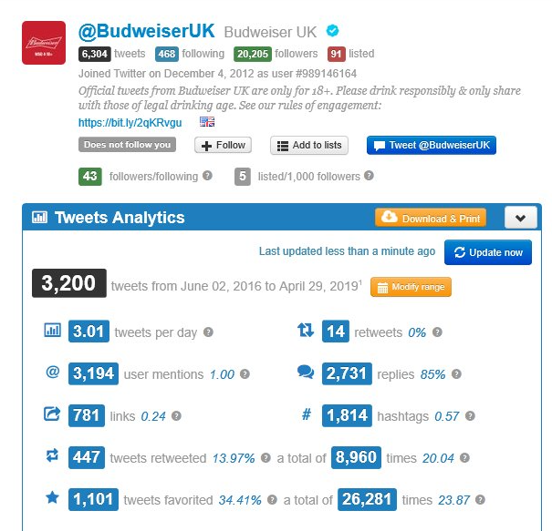

Figure Four: http://www.twitonomy.com/profile.php?sn=BudweiserUK

Using Budweiser’s UK page as an example, the analytics above show that the Twitter platform is cultivated effectively and daily with their response rate at a great average. Not only is this another platform to advertise new products, but it is also a way for the company to express their voice and opinion on the world wide movement of cutting down plastic and more recycling and recent global events such as International Women’s Day. By ameliorating these opportunities, it allows Budweiser to find ways of communicating with their consumers and followers and being passionate about topics that are controversial across the globe but then using their brand to create positive change.

Website Analysis

“A website is a collection of publicly accessible, interlinked Web pages that share a single domain name. Websites can be created and maintained by an individual, group, business or organization to serve a variety of purposes. Together, all publicly accessible websites constitute the World Wide Web.” (techopedia.com, 2019)
As mentioned in regards to their social media platforms, Budweiser also caters to the different countries of the world with their websites.
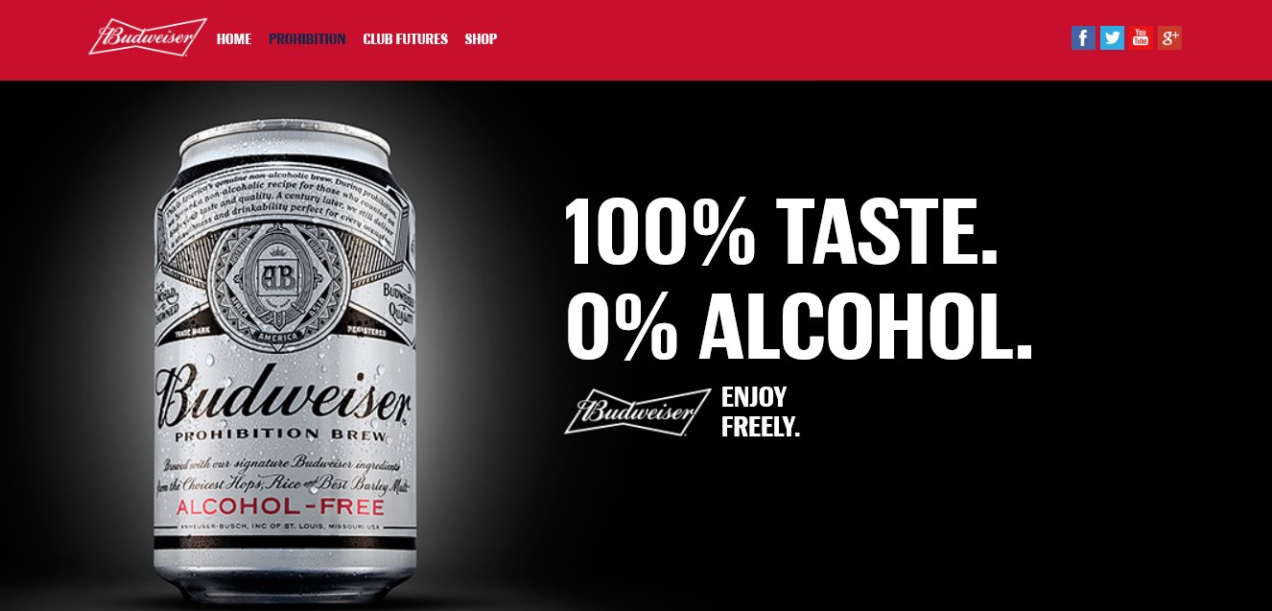

Figure Five: https://www.budweiser.co.uk/prohibition

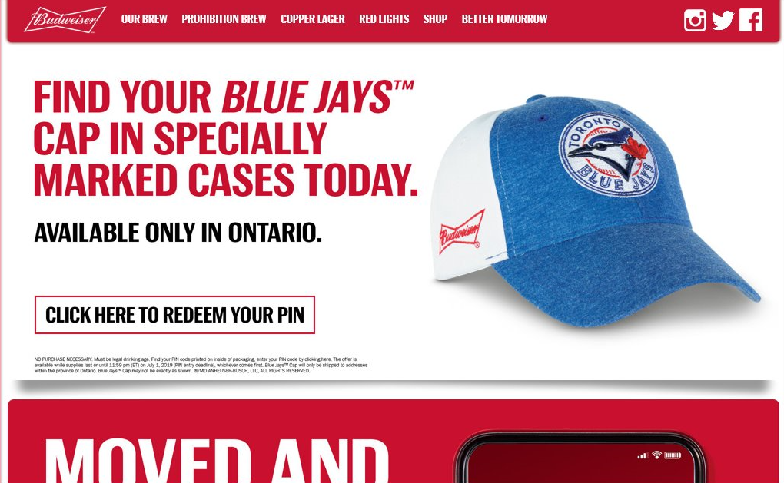

Figure Six: https://www.budweiser.ca/en/

Budweiser fully optimises their websites as they are each designed and presented in a fashion more suited to that country. For example, Budweiser’s Canadian website shows a lot of emphasis on the Blue Jays, a notorious baseball team in Canada – a highly enjoyed sport within this country. It gives a more personal touch to their visitors.
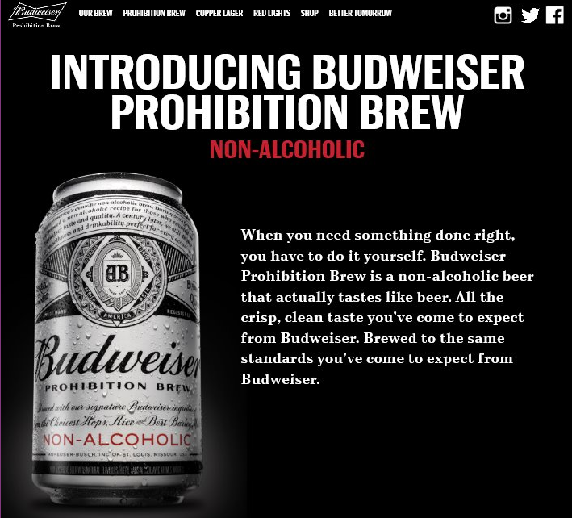
Budweiser’s websites are easy accessible and easy to use, with web pages directly at the top of the pages for effortless browsing, but these webpages are very informative.
Figure Seven: https://budweiser.ca/en/prohibitionbrew

Each Budweiser website has a page dedicated to their ‘Prohibition Brew’; a non-alcoholic beer that has the same taste. This is a great direction to bring in customers that perhaps don’t drink alcohol for many reasons but can have an alternative. With the emphasis on this new product, it shows a sense of ‘care’ for other types of customers who would prefer this type of beverage.
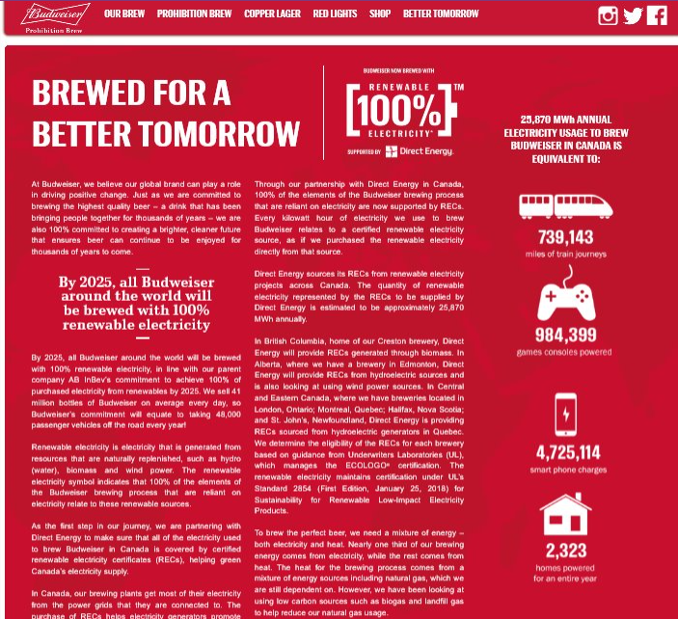
Budweiser also links to their online store, which offers many different products such as apparel, bar essentials, games, home décor and sports related items. Not only does this show the wide product portfolio they offer, but is also great to browse the different items people may not have known they offer, all categorised and described with thorough information.
Figure Eight: https://budweiser.ca/en/bettertomorrow

Lastly, one of the most imperative pages on the website is Budweiser’s promise for change – ‘using their global brand to drive positive change.’ Budweiser promises that by 2025, all the electricity used to brew their beers will be 100% renewable. In terms of marketing strategies, this is brilliant as it shows the companies interests and that they are promising to make a positive impact on the world using the large platform they have developed.

Recommendations

It is truthful that Budweiser does not have a massive room for improvement as they optimise their platforms well and to their advantage, although, they could perhaps look more into different types of platforms that they may have not thought about before such as LinkedIn. The more platforms they investigate, the more knowledge they will gain about where their digital marketing strategy is at and how strong it is and where they could also join onto. Another recommendation would be to continue building more region-specific profiles as it is clear that the response the current pages already have are excellent as this gives the customer a more personal feel towards the business rather than just a business to consumer relationship. This task could be time consuming so it would be wise to look at optimising their website or other close pages of theirs to reach out to potential customers they are missing.

Conclusion

Overall, Budweiser uses their platforms to their utmost potential. The company has a solid use of its Instagram, Facebook and Twitter accounts, with Twitter analytics showing just how much they cultivate their platform and engage with their followers and consumers. Budweiser’s website, which goes by the country you live in, also takes full advantage of their space to reach out to browsers. Through conducting research, it was clear that Budweiser designs their pages and content by the region they are specifying towards. For example, Budweiser Canada showed emphasis on the baseball team ‘Blue Jays’. The content of their websites was fulfilling and informative, touching upon real day to day controversial topics across the globe with promises of becoming a greener company by 2025 and using their global brand to drive positive change. This type of content is especially satisfying as, from a consumer point of view, it gives an insight into what the companies objectives are and they are not just driven by profit.

References
Chaffey, D. and Ellis-Chadwick, F. (2012) Digital Marketing: strategy, implementation and practice. 5th Ed., FT Prentice Hall: Harlow
Figure Eight: https://budweiser.ca/en/bettertomorrow
Figure Five: https://www.budweiser.co.uk/prohibition
Figure Four :https://likealyzer.com/report/budweiser
Figure Nine: http://www.twitonomy.com/profile.php?sn=BudweiserUK
Figure One: https://www.instagram.com/budwieserusa/
Figure Seven: https://budweiser.ca/en/prohibitionbrew
Figure Six: https://www.budweiser.ca/en/
Figure Three: https://www.instagram.com/budweiserindia/
Figure Two: https://www.instagram.com/budweisernigeria/
https://marketbusinessnews.com/financial-glossary/online-advertising-definition-meaning/
https://www.ab-inbev.com/
https://www.techopedia.com/definition/5411/website
https://www.trackalytics.com/instagram/profile/budweiser/

