Assignment title
RESEARCH AND ANALYS DATA

Name: Kazi Ahsanul Haque
Student Number: 1605418
Module Title: EMPL4012
Module Lecturer’s Name: Sheraz Alam Malik Dr

Table of Contents
1. Introduction: 3
2. Research Question: 4
3. Research Findings: 4
a. In Support of the Argument: 4
b. Against the Argument: 8
Conclusion: 11
References: 12

1. Introduction:
The online shopping is one of the common and most familiar topics in our day to day experiences. Most of our required products are purchased from the online shopping stores. The online shopping is getting more attention by the business organizations in recent years. Consequently, a debate may arise whether the business organizations prefer the online shopping strategy over the high street shopping strategy. In this report, using different secondary sources of data, some supporting arguments for the selected topic will be presented. After that, some arguments against the selected topic will be presented which will be followed by a brief conclusion.

2. Research Question:
In recent years we have seen an extensive conversion of the high street shopping into the online shopping business strategy. The rise of the internet has changed the business world drastically. Considering the rise of internet and the changing nature of the business strategy an obvious question arises that is,
“Do the business organizations prefer the online business strategy over the high street business strategy?”
There is many reasons for the business organizations to follow such strategy of online business such as increasing customers, tax advantages, getting access to the global market. However, there are some counter arguments against this business strategy such as to most of the people the online shopping isn’t much reliable (Carroll, 2017). Most of the aged people would rather stand in a line to get a product than to wait for the online shopping page to load. These issues will be addressed in the following segments of this report which will be supported by appropriate evidence and statistical analysis.

3. Research Findings:
The purpose of this research is to find an answer to the questions or issues addressed above. To serve that purpose research data has been collected from different secondary sources of data such as newspapers’ articles, internet, different published research related to these topics and so on. After collecting and analyzing the information, the following findings have been identified.

a. In Support of the Argument:
- Increasing Customers: The number of online shopping customers is increasing very rapidly. People feel more convenient to get their desire products simply by clicking twice in their mouse. Because of these increasing number of customers, the business organizations such as John Lewis is expanding the online shopping services. For example, the mentioned company has decided to establish a corner shop strategy by which the customers can easily pick or return their products which are purchased from online shopping site of the company (Carroll, 2017). The company allow its online customers to pick and return the products from 5000 independent retail stores which are very easy for the customers (Harvey, 2017). The following statistical chart is showing that the number of online customers of the Amazon is continuously increasing in rent years which is a clear indication that the number of online customers increasing worldwide. The amazon prime is one of the online shopping services of the Amazon and that is increasing with a very high growth rate.
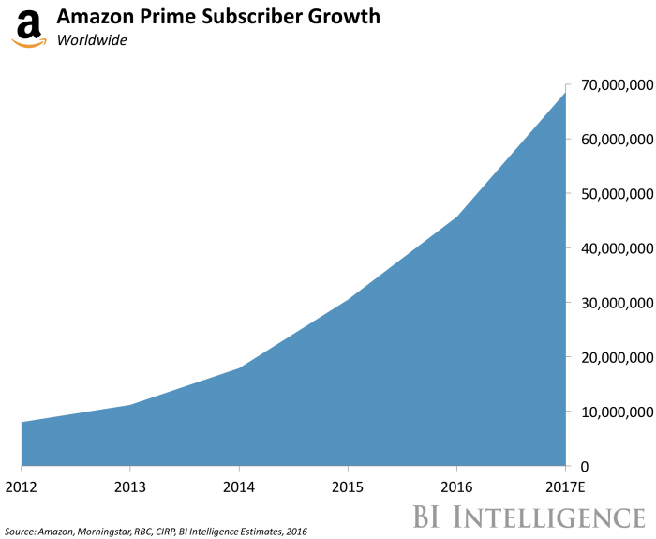
Figure 1 Increasing Number of Online Customers
Source: (Carroll, 2017)
- Increasing Online Sales: Another reason for the business organizations to prefer the idea of online shopping strategy is the increasing volume of online sales. For example, the online sales of the John Lewis have doubled in the last year and cover up the 34% of the total sales of the company which is a huge deal. Furthermore, during the Christmas season, the online shopping has increased by 44% in the last year (Butler, 2017). Considering these factors, it is obvious for the business organizations to prefer the online shopping strategy over the high street shopping. As you can see, the following table represents the growth of the online sales in different countries. The table represents that in the UK the online sales or internet sales have grown up 16.2% in 2014 to 2015 and 15.3% in 2014 to 2016. The table also represents that the highest internet sales growth during these 2013 to 2016 was in Europe that the internet sales in this area have increased from £111.23 billion to £184.44 billion. The overall sales of this area have increased by 18.4% and 18.7% in 2015 and 2016 respectively. It is also noticeable that the internet sales growth was lowest in the Canada during this year which is a growth rate of 13.2% (Bradshaw, 2017).
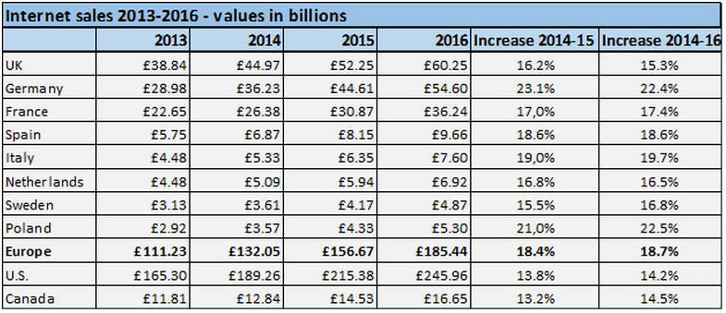
Figure 2 Increasing Sales in Online Sopping Globally
Source: (Bradshaw, 2017)
- Tax Advantages: The online shopping strategy is preferred by the business organization for another important reason also which is the tax advantage. As the article states, the government of the country is not capable of addressing the overall online sales by the business organizations. As a result, the online shopping organizations are enjoying a special tax advantage over the high street shopping organizations. Furthermore, the high street retail stores required to pay £120 million ongoing tax each year which is a huge cost for the business (Harvey, 2017). Because of this huge tax expenses, the profitability of the high street shopping organizations is lower than the online shopping business. The online shopping businesses don’t require to pay any ongoing tax like the high street retailers. As a result, the business organizations start to prefer the online shopping strategy over the high street shopping strategy.
- Low Operating Cost: Another important advantage of the online shopping strategy is the lower operating cost. In a high street shopping organization, the company require of hire the store managers, salesperson, maintenance officers and so on. And these employees require a significant amount of compensation. As a consequence, the profit margin of the company decreases. On the other hand, the online shopping store doesn’t require any such employees. It requires only a good-looking web store and an organized shopping guideline. As a result, the online shopping store can save a good amount of operating expenses. For example, the introduction of the online shopping corner in the John Lewis has helped the company to reduce its store management cost by 7% in its previous operating year (Butler, 2017).

b. Against the Argument:
- Privacy and Security: One of the main reason for the high street shopping organization to not to go for online shopping strategy is the privacy and security. In online shopping services, the buyers or customers usually make their payment online. As a result, there is a risk of security breach by the hacker group. Furthermore, the customers require providing their personal information to get registered in the online shopping sites. As a result, of these security and privacy issue, many customers simply prefer to shop from high street rather than online. In recent years, the renowned online shopping organizations have encountered different security breach from different hacker groups. It not only jeopardizes the privacy of the customers but also the goodwill of the business organizations. And the number of this incidents is increasing day by day. In 2015, 780 security breaches occurred which reveals 177,866,236 personal information of an individual (DiGiacomo, 2017). Among these numbers, 40% of the breaches were targeted towards the online shopping businesses (DiGiacomo, 2017). The following diagram represents the above information in a graphical form.
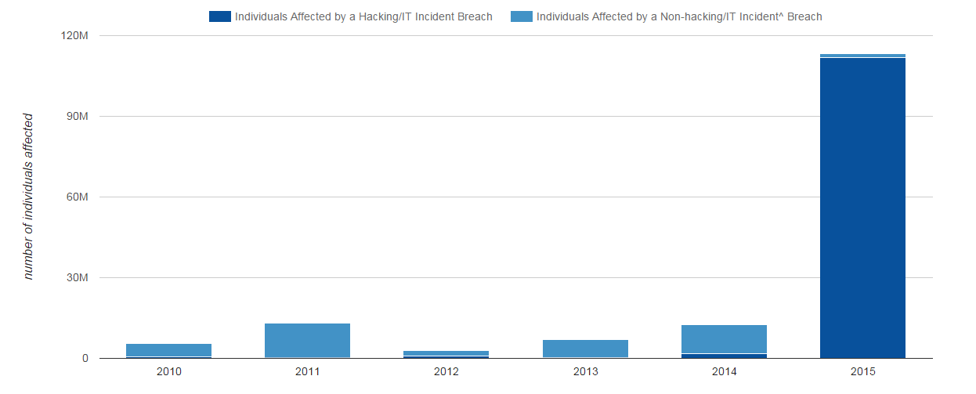
Figure 3 Security Breaches in 2015
Source: (DiGiacomo, 2017)
- Less Reliable: Apart from some renowned online business organizations, most of the online shopping service providers are failing to supply the exact products that they are displaying in the online store. In most of the cases, people get disappointed while they get their online ordered products at the time of delivery. As a result, the online shopping is becoming less reliable compared to the street shopping. In street shopping, customers can see and touch the real products. They can also choose the products by scrutinizing the products properly (Bradshaw, 2017). As a result, the customers can get their desired products with their desire quality and conditions which is not possible in an online shopping experience. Though most of the online shopping businesses have a return policy the customers simply don’t want to go through that ambiguous procedures.
- Fulfilling the Customers’ Requirement: The following diagram presents the expectation of the customers from an online shopping experience. As you can see, 70.80% of customers want to be the company trustworthy (Williams-Grut, 2017). Most of the street shopping organization simply can’t ensure this because of several reasons one of which is the lack of brand value. To build a brand value at first the company require to directly interact with the customers which are not perfectly possible in an online shopping strategy. Another important feature wanted by the customers is the clearly stated information. Most of the company don’t even understand what are the necessary information required by the customers. As a result, their online business fails to achieve their targeted benchmark. But in case of street shopping strategy, the company don’t have to worry about these staffs. All they need is a well-organized store and excellent sales person.
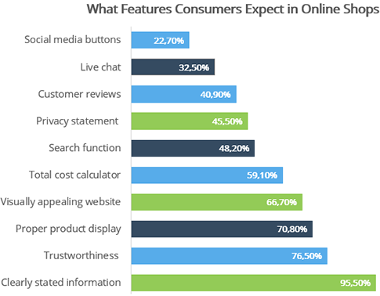
Figure 4 Expectation of Customers from Online Shopping Services
Source: (Williams-Grut, 2017)
- The requirement of High Street Stores: Even if a business organization goes for online shopping strategy, they can’t ignore the importance of high street shopping stores. The customers may require a quick home delivery or may need to quickly return the products they purchased. And to provide the customers with a very shopping experience, the online shopping strategy require the high street shopping stores also. For example, though the Kingfisher provide online shopping services, it has more than 1000 retail stores employing around 80000 employees in different places of the country (Sharma, 2017).

Conclusion:
The above analysis reveals that the online shopping is becoming more and more popular among the customers as well as the business organizations. The online shopping is preferable to the business organizations mainly because of the increasing online customers, increasing online sales, tax advantage over the high street shopping and lower operating expenses. However, the report also addressed that the high street shopping is also important and preferred by some business organizations because of the privacy and security, reliability, customers’ preference and so on.

References:
Bradshaw, J. (2017). Online retail booms as high street struggles. [online] The Telegraph. Available at: http://www.telegraph.co.uk/business/2017/01/08/online-retail-booms-high-street-struggles/ [Accessed 8 Dec. 2017].
Butler, S. (2017). John Lewis to extend online shopping empire via thousands of corner stores. [online] the Guardian. Available at: https://www.theguardian.com/business/2013/feb/21/john-lewis-online-shopping-collect?INTCMP=ILCNETTXT3487 [Accessed 8 Dec. 2017].
DiGiacomo, J. (2017). Hacking Statistics for 2015 and 2016: How Bad Will 2017 Be. [online] Revision Legal. Available at: https://revisionlegal.com/data-breach/2017-security-breaches/ [Accessed 8 Dec. 2017].
Harvey, F. (2017). Kingfisher chief warns of store closure over online firms' tax advantage. [online] the Guardian. Available at: https://www.theguardian.com/business/2013/mar/04/kingfisher-warns-of-store-closures [Accessed 8 Dec. 2017].
O&#x27;Carroll, L. (2017). City must wake up to digital growth, says tech investor. [online] the Guardian. Available at: https://www.theguardian.com/business/2013/mar/01/city-wake-up-digital-investor [Accessed 8 Dec. 2017].
Pwc. (2017). [online] Available at: https://www.pwc.co.uk/industries/retail-consumer/total-retail/uk-total-retail-survey-findings-2013-overview.html [Accessed 8 Dec. 2017].
Sharma, R. (2017). Mall or high street? Cornering the retail boom. [online] The Economic Times. Available at: https://economictimes.indiatimes.com/business/mall-or-high-street-cornering-the-retail-boom/articleshow/6494256.cms [Accessed 8 Dec. 2017].
Williams-Grut, O. (2017). 'What we're seeing is a revolution': How the internet is remaking the British High Street. [online] Business Insider. Available at: http://uk.businessinsider.com/future-british-high-street-internet-brexit-retail-2017-8 [Accessed 8 Dec. 2017].

