On the nature and direction of creative writing and its relationship with the wider humanities.

When trying to discuss the nature of creative writing as a discipline, one question must be answered before discussion can even begin: What is “Creative Writing” in the first place? At first a simple sounding question with a simple answer; as the Cambridge dictionary defines it, creative writing is ‘the activity of writing stories, poetry, etc., or the stories, poems, etc. that are written’. This definition can be found to be quite restrictive in what would then be classed as creative writing. For example some of the most famous poems such as “The Illiad” and “The Odyssey” would be discounted as they were composed orally before they were written. This definition would also claim that creative writing would not include wordless books, despite the fact that they are considered very important to the development of literature skills. Is there a line in what is considered creative writing? Even academic institutions which teach the subject would say definitions are difficult to create for a subject as amorphous as creative writing - ‘It’s challenging to settle on a concrete definition as creative writing can relate to so many different things and formats.’.

With that lack of clarity in mind, the discussion as to the nature of creative writing can be examined. The nature of “creative writing” is that it is constantly shifting, mutating, branching and expanding. It will fold in on itself and merge with other disciplines. As the subject of creative writing moves with us through time, it will grow upon itself and split into categories known as genres. These genres are themselves in constant flux:

Literary genres, like living organisms, undergo a constant process of evolution, adapting to changing cultural, societal, and artistic landscapes. Just as species diversify and develop new traits to thrive, genres too experience shifts and transformations that breathe new life into storytelling.

With the splitting of genres and the various media that creative writing can encompass it has no one specific direction that it trends toward. Now the lack of a unified direction is no doubt universal across all disciplines, humanity or not; that said however, creative writing is more like a spiderweb in its direction. That is to say it moves in every direction but some more than others. If we look at novels you can see trends in general, but then some genres will veer away from the direction others take. According to the website Goodreads, there has been a spike in the dystopian genre of flooded futures, likely as a result of climate change speculations. That is just one trend of one genre. If you look at the crime genre, books are frequently being set on trains.

Writing direction again changes with the media format; in TV shows, for example, the current trend is that the episode count is getting shorter while the episodes themselves have become longer and less fixed in runtime.
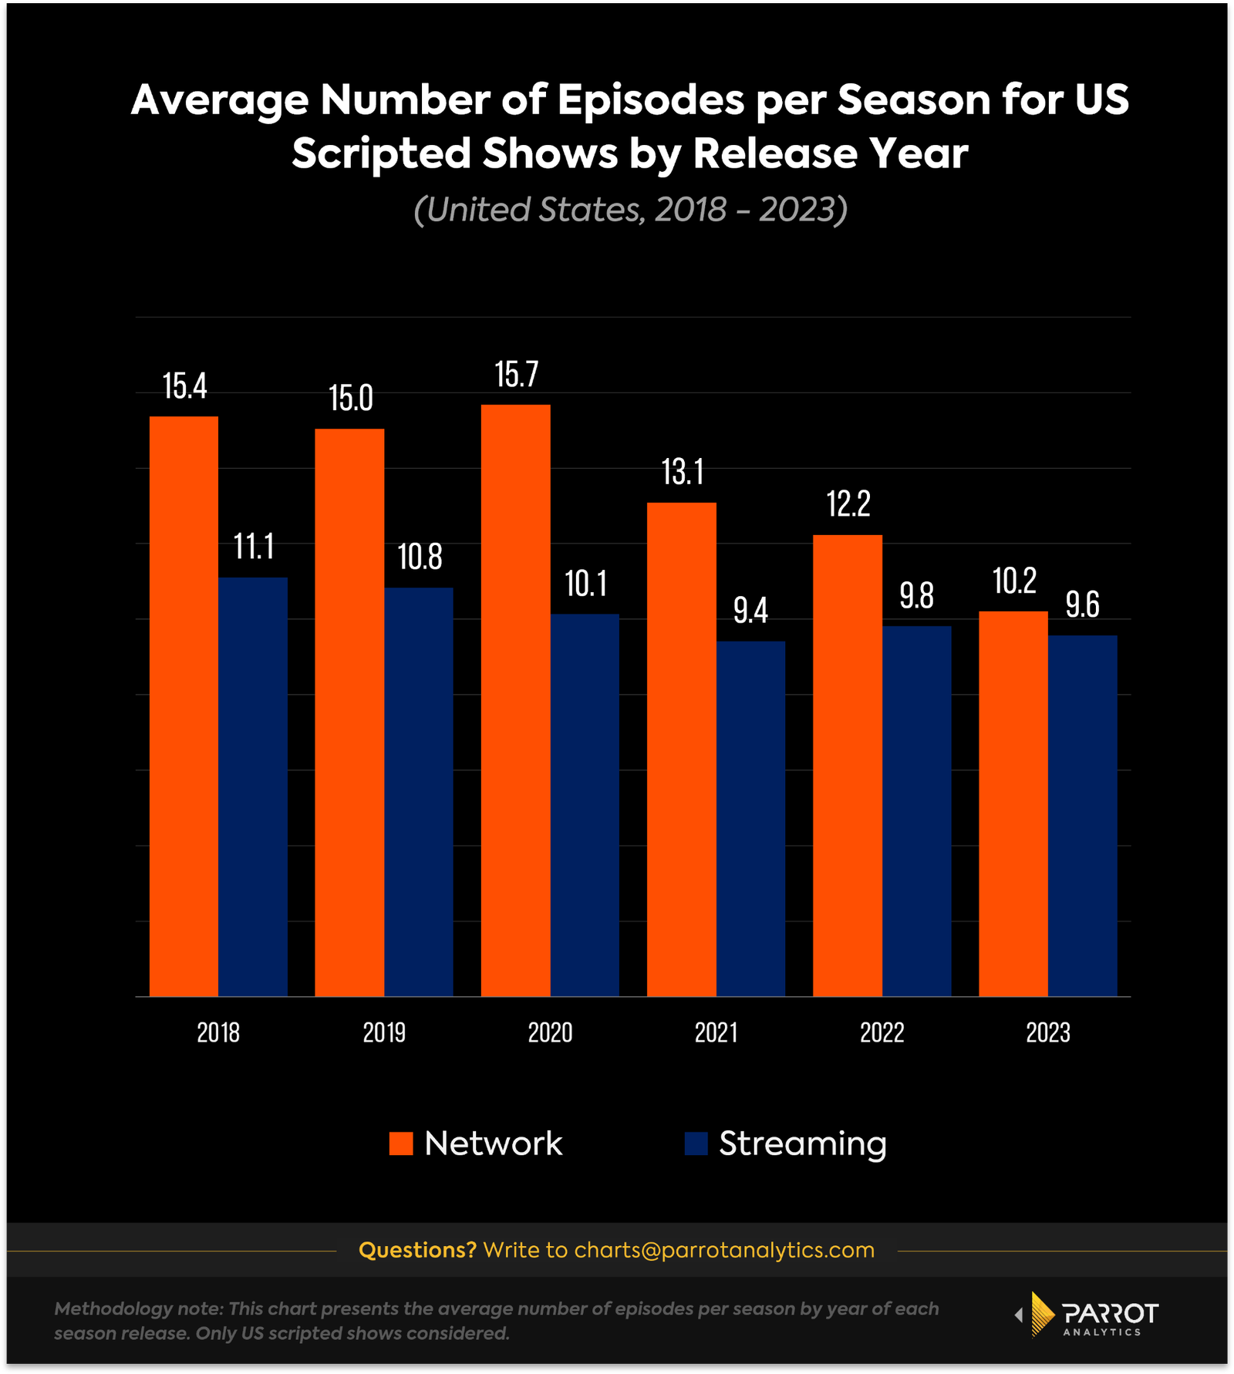
Similarly films are getting longer and have been for a long time, increasing in runtime by nearly fifty percent since the 1930s. However this trend of longer content is not true of all scripted video media. There was a rise in the very short form, online media in the form of Vine which has now continued on to TikTok and Youtube Shorts.

Given the untold breadth and depth of the scope of creative writing it is a truly impossible task to list all of the trends across all possible media. So to move on, the question should be asked, why things are shifting.

What affects the direction of creative writing and its many forms of expression? In short, technology, the shift in culture and societal norms all play their part. For example, the culture of global warming will create the inspiration for many stories in their messaging and content, even forming a genre called cli-fi as a spin on sci-fi. An example of cultural norms and mores affecting the discipline’s direction is the fluctuation in LGBT+ focused books and stories. In ancient Greece there are examples of same sex relationships between people that would have been told orally, for example the poems by Saffo; there has been the reframing of them through heteronormative lens by scholars who existed in times of enforced heteronormativity. This would have suppressed the representation of this community and with the rise in cultural acceptance, the desire for this representation became a marketable niche to be filled, leading to a ‘host of new kinds of queer fiction’.

Technology is arguably the most important factor in how the direction of creative writing changes. The earliest form of creative writing would be oral storytelling, often being postulated that it started not long after the advent of language itself, though naturally this would be impossible to prove. The next step in technology that would alter how stories were told were painting tools, which lead to cave paintings

The drawings, which date as far back as 30,000 years ago, depict animals, humans, and other objects. Some of them appear to represent visual stories. It is even possible that the scenes depicted on those cave walls were associated with some kind of oral storytelling.
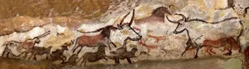

Although the exact time will be different in different parts of the world, the invention of writing would be the starting point for creative writing as we think of it now. Even though we, as a species, were able to record our stories, creative writing would long remain esoteric and niche, for literacy rates were low and access to the materials was highly expensive. Books had to be copied and bound by hand; this was an intensely laborious process and it remained so until 1450 and Gutenberg's invention of the printing press. This was not the first printing press but the most impactful as books could now be mass produced. Then along came the typewriter and anybody with one could write legibly with reasonable speed, therefore ‘the writing process became faster and more efficient’. Then radio, a new format to write for, followed by film then by film with sound then television creating further formats to work with and define.

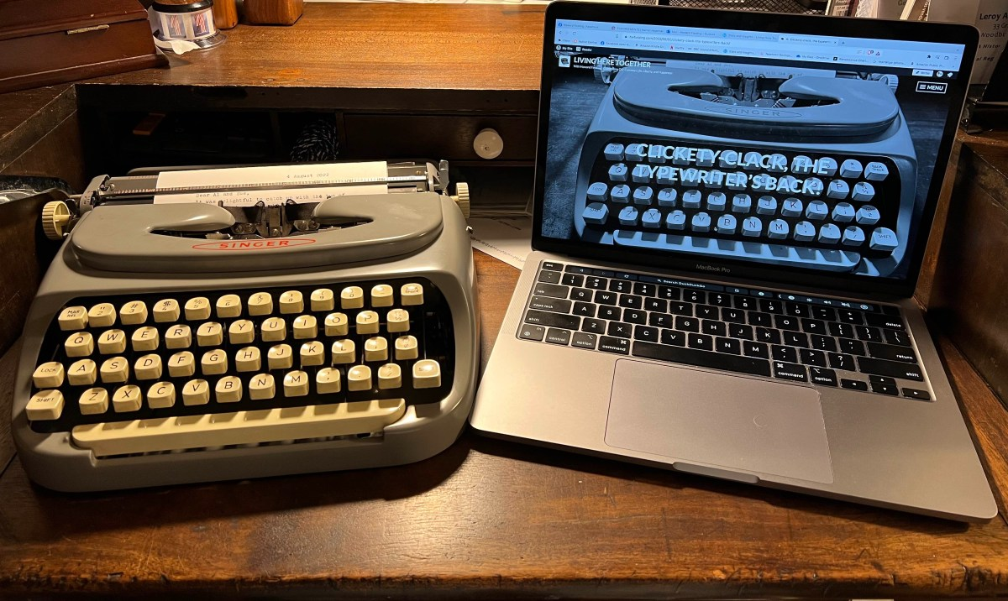
Next, computers are invented and made accessible; they affect the way the writers would write with easier writing and formatting streamlining the process. Then the internet grew and everything changed again. People's access to books changed with online shopping making purchasing easier. Then the development of the e-book reshaped the landscape once more, allowing you to carry a library of literature in your pocket with e-readers, smartphones or other devices. With the increase in access to books came an increase in access to publishing. People no longer require the help of other organisations to be published with the rise of Self-publications. The internet also causes a slew of new types of writing for people to create; every tweet, facebook status or social media post is a type of self published creative writing in a new genre developed by the medium. The way audiences consume TV changed with streaming services and the ability to binge watch an entire series in one go. The changes caused by technology are vast and always evolving. The landscape will change by the day with the advent of AI, the effects of which are only beginning to be understood. Writing is everywhere due to the internet, though, for humans, it has always been everywhere since the beginning of the species.

The act of creating stories and passing them on is pan-cultural, thus creating stories is intrinsic to the nature of humanity. It makes sense then to categorize it with the other humanities, yet next to history, archaeology, sociology etc. creative writing has a distinctly different tone. Is it truly a humanity, and if so how does it fit in with the others? According to Britannica the definition of the humanities is as follows:

…humanities, those branches of knowledge that concern themselves with human beings and their culture or with analytic and critical methods of inquiry derived from an appreciation of human values and of the unique ability of the human spirit to express itself.

Does creative writing fit this definition? Yes, for writing is one of the ways that the human spirit expresses itself. However its connection is different to how the other subjects interact with each other, with branches of linear connection. Creative writing is more like the water the other subjects are submerged in, surrounding and penetrating them.

History and creative writing are as inseparable as any of the humanities subjects can be. From the perspective of creative writing, historical research is an invaluable part of the writing process. Without an understanding of history you wouldn’t be able to write a convincing world, for any world an author will write will need a history of its own. Sam Meekings claims that the research of a writer should be modeled after the research of a historian. Worldbuilding is a vital component to that which we call a story, and research is required for worldbuilding to work.

Research forms the foundation of compelling worldbuilding, adding realism, depth, and coherence to fictional worlds. By drawing on real-world knowledge, historical examples, and cultural insights, research enriches nearly every aspect of worldbuilding.

Creative writing is also something that is vital to the subject of history. One way is that it is through the writing of times long ago that we learn of the life, ideal norms and societies of the time. For example Thomas N. Habinek looks to use Latin literature as a way to look at the politics of ancient Rome. Creative writing will also inherently interact with the disciplines of the humanities as a way to inform others of what is found and to give the subjects meaning, taking the facts and figures along with shapes of clay, stone and metal then breathing meaning into them, for it is the story behind the objects that will capture people.

This would be the same for Psychology and ethics; one of the most well known experiments and ethical questions of all time would be the Milgram experiment. The story of the experiment, that the average person could do terrible things when ordered to is something that shocked people, but told a story about society, and asked ethical questions about how we acquire knowledge. The experiment is considered flawed, yet it persists in public consciousness despite that.

I think the reason that Milgram's experiment is still so famous today is because in a way it's like a powerful parable. It's so widely known and so often quoted that it's taken on a life of its own. ... This experiment and this story about ourselves plays some role for us 50 years later.

Philosophy is intrinsic to the process of creative writing, what is fiction if not a way to express the philosophy of the writer. As such those who consume fiction are engaging with the subject of philosophy.

the general public regularly partakes in philosophical thinking. Philosophical blockbusters such as Inception make us marvel, and prompt us to think about deep questions concerning free will, skepticism, the mind, and society.

While creative writers are inherently delving into philosophy, philosophers will in turn delve into fiction. Philosophers look to fiction to ask questions about the content and what it means to write truth through an untrue story.

In conclusion, when trying to take an academic view of creative writing many roadblocks will invariably surface given that it is not an academic discipline at all, it is too vague a concept to be tied down to analysis as a whole and any attempt to do so risks accidentally shifting subject focus to English literature. Even when academic institutions attempt to define it the result is lacking even by the institution's own admission. While the subject itself is always changing in multitudes of ways and moving in multiple directions at once it also remains consistent, talking about worlds and people. Despite not being an academic subject it is linked very closely with the other academic subjects. As a humanity it explores what it is to be human and how to express that, and is a central point of study for many of the humanities. To remove creative writing from the humanities would be to cut the string of connection between every fact and figure that has been woven together in the tapestry of human understanding we have put together and to remove the humanities from creative writing would leave a bunch of words on a page devoid of connection to people and of real meaning; the two are distinct yet inseparable.

Reference list:

Aspire Publishing Hub, LLC, 'Genre Evolution: Dynamic Transformations in Literary Genres', Aspirehub.Info, <https://www.aspirehub.info/genre-evolution-dynamic-transformations-in-literary-genres/> [accessed October 28, 2025]
Cambridge Dictionary, Creative Writing, <https://dictionary.cambridge.org/dictionary/english/creative-writing> [accessed 28/10/25]
Carlick, Stephen, 'From Sappho to Stonewall, and Beyond: How Fiction Tells LGBTQ+ History', (June 01 2023) <https://www.penguin.co.uk/discover/articles/fiction-lgbtq-history-novels>
Chauhan, Nidhi and Dr Upasana Bharati, 'The Impact of Social Media Platforms on Creative Writing in English: A Critique', International Journal of Multidisciplinary Research in Arts, Science and Technology, 3 (2025), 15–23 <https://ijmrast.com/index.php/ijmrast/article/view/105>
De Cruz, Helen, 'Philosophy through Fiction', The Philosophers' Magazine Archive, (January 1 2020) <https://archive.philosophersmag.com/philosophy-through-fiction/> [accessed October 30, 2025]
Dodds, Don, 'Short-Form Video Content: Capturing Attention in the Digital Age', Forbes.Com, (March 19 2024) <https://www.forbes.com/councils/forbesagencycouncil/2024/03/19/short-form-video-content-capturing-attention-in-the-digital-age/> [accessed October 30, 2025]
Fielding, Howard, Analog and Digital, Side by Side, (hwfielding.com, 2022) <https://hwfielding.com/2022/08/22/writing-with-a-word-processor-a-review/>
Francis, Chloe, 'The Emerging Genre of Cli-Fi', Falwriting.Com, (July 15 2020) <https://falwriting.com/new-blog/the-emerging-genre-of-cli-fi-by-chloe-francis> [accessed October 30, 2025]
Habinek, Thomas N., The Politics of Latin Literature : Writing, Identity, and Empire in Ancient Rome (Princeton, N.J: Princeton University Press, 1998)
Herron, Matt, A Brief History of Creative Writing, (The Write Practice, ) <https://thewritepractice.com/history-of-writing/>
Janko, Richard, 'The Homeric Poems as Oral Dictated Texts', The Classical Quarterly, 48 (1998), 1–13, in JSTOR <http://www.jstor.org.ezproxy.uwtsd.ac.uk/stable/639747>
Kroon, Fred and Alberto Voltolini, Fiction, (Metaphysics Research Lab, Stanford University, 2019) <https://plato.stanford.edu/cgi-bin/encyclopedia/archinfo.cgi?entry=fiction>
Leanne Abel, 'Rise in Streaming Services Increases TV Episode Length', (December 2 2024) [accessed October 30, 2025]
Meekings, Sam, 'Reclaiming the Past: Exploring the Role of Primary Sources in Creative Writing Research', Writing in Practice: The Journal of Creative Writing Research, 3 (2017), in CrossRef
Mitchell, Amber, '6 Tips for World-Building in Your Fantasy', Writer's Digest, (March 24 2017) <https://www.writersdigest.com/there-are-no-rules/6-tips-world-building-fantasy> [accessed 30 October, 2025]
National Geographic Society, Storytelling, (nationalgeographic.org, 2025) <https://education.nationalgeographic.org/resource/storytelling-x/>
Ogundiran, Akin, 'Storytelling in Archaeology and the Quest for a Pedagogy of Renewal', The African Archaeological Review, 40 (2023), 447–453, in CrossRef <https://link.springer.com/article/10.1007/s10437-023-09553-6>
Oxford Royal, 'What is Creative Writing?', Oxford-Royale.Com, <https://www.oxford-royale.com/articles/what-is-creative-writing> [accessed October 28, 2025]
Parrot Analytics, 'Seasons are Getting Shorter', Parrotanalytics.Com, (15 April 2024) <https://www.parrotanalytics.com/insights/seasons-are-getting-shorter/> [accessed 28 October, 2025]
Perry, Gina, 'Taking A Closer Look at Milgram's Shocking Obedience Study', NPR, (August 28 2013) <https://www.npr.org/2013/08/28/209559002/taking-a-closer-look-at-milgrams-shocking-obedience-study> [accessed October 30, 2025]
Pryn, William, A Guide to Worldbuilding, Falmouth.Ac.Uk, (Falmouth University, 2024) <https://www.falmouth.ac.uk/news/guide-worldbuilding>
Reading Rockets, Our Favorite Wordless Picture Books, 2025 vols ([n.d.]: ) <https://www.readingrockets.org/books-and-authors/booklists/favorite-books/our-favorite-wordless-picture-books> [accessed 28 October, 2025]
Sharon, '17 New Cross-Genre Book Trends We're Spotting in 2025', Goodreads, (2025) <https://www.goodreads.com/blog/show/2889-17-new-cross-genre-book-trends-we-re-spotting-in-2025>
The Economist, 'Why Films have Become so Ridiculously Long', Economist.Com, (October 14 2023) <https://www.economist.com/culture/2023/10/14/why-films-have-become-so-ridiculously-long> [accessed October 30, 2025]
The Editors of Encyclopaedia Britannica, Rock Art, (Britannica, 2025) <https://www.britannica.com/art/rock-art>
The Editors of Encyclopedia Britannica, 'Humanities', (2025) <https://www.britannica.com/topic/humanities>
Tjaja, Faldieno, 'Binge-on-Demand: How Streaming Services Reshape our Viewing Habits and Why It’s Addictive?', Medium, (February 25 2024) <https://medium.com/cognitive-neuroeconomics/binge-on-demand-how-streaming-services-reshape-our-viewing-habits-and-why-its-addictive-7378356f8143> [accessed October 30, 2025]
Usmani, Saima, Elsadig H. F. Ali and Musadhique Kottaparamban, 'The Influence of Digital Platforms, E-Books, and Online Publishing on the Creation and Dissemination of Literature', Research Journal in Advanced Humanities, 6 (2025) <https://royalliteglobal.com/advanced-humanities/article/view/2030>

“Creative Writing,” Cambridge.org <https://dictionary.cambridge.org/dictionary/english/creative-writing> [accessed October 28, 2025].
Richard Janko, 'The Homeric Poems as Oral Dictated Texts', The Classical Quarterly, 48 (1998), 1, in JSTOR <http://www.jstor.org.ezproxy.uwtsd.ac.uk/stable/639747>
“Our Favorite Wordless Picture Books,” Reading Rockets <https://www.readingrockets.org/books-and-authors/booklists/favorite-books/our-favorite-wordless-picture-books> [accessed 28 October, 2025].
Oxford Royal, 'What is Creative Writing?', Oxford-Royale.Com, <https://www.oxford-royale.com/articles/what-is-creative-writing> [accessed October 28, 2025]
Aspire Publishing Hub, LLC, 'Genre Evolution: Dynamic Transformations in Literary Genres', Aspirehub.Info, <https://www.aspirehub.info/genre-evolution-dynamic-transformations-in-literary-genres/> [accessed October 28, 2025]
The Editors of Encyclopedia Britannica, 'Humanities', (2025) <https://www.britannica.com/topic/humanities>
The Economist, 'Why Films have Become so Ridiculously Long', Economist.Com, (October 14 2023) <https://www.economist.com/culture/2023/10/14/why-films-have-become-so-ridiculously-long> [accessed October 30, 2025]
Parrot Analytics, 'Seasons are Getting Shorter', Parrotanalytics.Com, (15 April 2024) <https://www.parrotanalytics.com/insights/seasons-are-getting-shorter/> [accessed 28 October, 2025]
Leanne Abel, 'Rise in Streaming Services Increases TV Episode Length', (December 2 2024) [accessed October 30, 2025]
Sharon, '17 New Cross-Genre Book Trends We're Spotting in 2025', Goodreads, (2025) <https://www.goodreads.com/blog/show/2889-17-new-cross-genre-book-trends-we-re-spotting-in-2025>
Ibid
Parrot Analytics ‘Seasons are Getting Shorter’
Don Dodds, 'Short-Form Video Content: Capturing Attention in the Digital Age', Forbes.Com, (March 19 2024) <https://www.forbes.com/councils/forbesagencycouncil/2024/03/19/short-form-video-content-capturing-attention-in-the-digital-age/> [accessed October 30, 2025]
Chloe Francis, 'The Emerging Genre of Cli-Fi', Falwriting.Com, (July 15 2020) <https://falwriting.com/new-blog/the-emerging-genre-of-cli-fi-by-chloe-francis> [accessed October 30, 2025]
Ibid
Stephen Carlick, 'From Sappho to Stonewall, and Beyond: How Fiction Tells LGBTQ+ History', (June 01 2023) <https://www.penguin.co.uk/discover/articles/fiction-lgbtq-history-novels>
National Geographic Society, Storytelling, (nationalgeographic.org, 2025) <https://education.nationalgeographic.org/resource/storytelling-x/>
National Geographic Society, Storytelling, (nationalgeographic.org, 2025) <https://education.nationalgeographic.org/resource/storytelling-x/>
Ibid
Matt Herron, A Brief History of Creative Writing, (The Write Practice, ) <https://thewritepractice.com/history-of-writing/>
Ibid
Matt Herron, A Brief History of Creative Writing.
Saima Usmani, Elsadig H. F. Ali and Musadhique Kottaparamban, 'The Influence of Digital Platforms, E-Books, and Online Publishing on the Creation and Dissemination of Literature', Research Journal in Advanced Humanities, 6 (2025) <https://royalliteglobal.com/advanced-humanities/article/view/2030>
Ibid
Ibid
Nidhi Chauhan and Dr Upasana Bharati, 'The Impact of Social Media Platforms on Creative Writing in English: A Critique', International Journal of Multidisciplinary Research in Arts, Science and Technology, 3 (2025), 15–23 <https://ijmrast.com/index.php/ijmrast/article/view/105>
Faldieno Tjaja, 'Binge-on-Demand: How Streaming Services Reshape our Viewing Habits and Why It’s Addictive?', Medium, (February 25 2024) <https://medium.com/cognitive-neuroeconomics/binge-on-demand-how-streaming-services-reshape-our-viewing-habits-and-why-its-addictive-7378356f8143> [accessed October 30, 2025]
Mitchell, Amber, '6 Tips for World-Building in Your Fantasy', Writer's Digest, (March 24 2017) <https://www.writersdigest.com/there-are-no-rules/6-tips-world-building-fantasy> [accessed 30 October, 2025]
Sam Meekings, 'Reclaiming the Past: Exploring the Role of Primary Sources in Creative Writing Research', Writing in Practice: The Journal of Creative Writing Research, 3 (2017), in CrossRef
Pryn, William, A Guide to Worldbuilding, Falmouth.Ac.Uk, (Falmouth University, 2024) <https://www.falmouth.ac.uk/news/guide-worldbuilding>[Accessed 30 October, 2025]
Thomas N. Habinek, The Politics of Latin Literature : Writing, Identity, and Empire in Ancient Rome (Princeton, N.J: Princeton University Press, 1998)
Ogundiran, Akin, 'Storytelling in Archaeology and the Quest for a Pedagogy of Renewal', The African Archaeological Review, 40 (2023), 447–453, in CrossRef <https://link.springer.com/article/10.1007/s10437-023-09553-6>
Gina Perry, 'Taking A Closer Look at Milgram's Shocking Obedience Study', NPR, (August 28 2013) <https://www.npr.org/2013/08/28/209559002/taking-a-closer-look-at-milgrams-shocking-obedience-study> [accessed October 30, 2025]
De Cruz, Helen, 'Philosophy through Fiction', The Philosophers' Magazine Archive, (January 1 2020) <https://archive.philosophersmag.com/philosophy-through-fiction/> [accessed October 30, 2025]
Ibid
Fred Kroon and Alberto Voltolini, Fiction, (Metaphysics Research Lab, Stanford University, 2019) <https://plato.stanford.edu/cgi-bin/encyclopedia/archinfo.cgi?entry=fiction>
The Editors of Encyclopaedia Britannica, Rock Art, (Britannica, 2025) <https://www.britannica.com/art/rock-art>
Howard Fielding, Analog and Digital, Side by Side, (hwfielding.com, 2022) <https://hwfielding.com/2022/08/22/writing-with-a-word-processor-a-review/>

