A research report on Data Centre Virtualization

  - Scenario 1 & Scenario 2

Thomas Molner
1804565
Koushik Modak

Table of Contents
1. Introduction 5
2. Virtualization 6
3. Proposed Work 6
4. Proposed Model 8
4.1 Inventory Process 9
4.1.1 Discovery 10
4.1.2 Categorize the response from the server 10
4.1.3 Categorizing the Resources of the Application 11
4.1.4 Resource Allocation 12
4.1.5 Nature & Type of Virtualization 12
4.2 Maximization of Hardware 12
4.2.1 Serer Consolidation 13
4.2.2 Migration of Virtual from Physical Live 13
4.3 Physical Infrastructure 14
4.3.1 Move to the architecture of 64-bit 14
4.3.2 Depend upon Shared Storage 14
4.4 Manage Virtualization 15
5. Benefits of Virtualization 15
6. Conclusion 16
7. Introduction 18
8. Business Scenario 18
9. Cloud Storage 19
10. Virtualized services 19
11. Current Process 19
12. Security policy - importance and influence 20
13. Data protection - SAN (Storage Area Network) 21
13.1 System Design 23
14. Conclusion 24
15. References Scenario 1 26
16. References Scenario 2 28

Scenario 1

1. Introduction
Data Centre is the main component of a huge number of services that are offered through the Internet such as e-commerce, social networking, web hosting, and various more common services like SaaS, PaaS, and cloud/grid computing. They comprise concentrated hardware to perform various functions like exchange, store, manage, and process digital information and data. For the huge organizations, they assist them with informational requirements, like partnerships and instructive establishments, and give application management or services to different kinds of information preparing, for example, intranet, internet, web hosting, information technology, and telecommunications [1]. In almost every sector, Data centers are used considering media, financial services, government institutions, high-tech, and many other economic sectors. They operate and use data centers to fix the processes of the business, communication functions, and information management. Because of the continuous growth, the continuous demand of both IT hardware and physical infrastructure, bringing about a constant expansion in energy utilization.
The IT hardware of the Data Centre has several distinct devices such as servers, storage devices, generators, cooling towers, chillers, etc. In any organization, the main source of energy consumption is the servers because are huge in number and continuously increases with the increment of the size of data centers [2]. As a result of this traditional data center implementation, consumption of energy get increases which simultaneously increases the greenhouse gas which is dangerous for the environment.
This paper recognizes a portion of the fundamental necessities to be satisfied prior to carrying out virtualization in UWTSD. It additionally portrays a total depiction of server farms and accentuates the requirement for executing virtualization innovation in a server farm and gives a five-venture model of carrying out it [3]. And surprisingly a portion of the benefits of virtualization subsequent to being carried out have been talked about.

2. Virtualization
Virtualization innovation is presently turning into a significant headway in IT particularly for business associations and has become the overall redesign of the computing business. Virtualization divides or combines the computing assets of an environment that is totally based on the server to give distinctive working conditions by utilizing various procedures and methods like equipment and programming aggregation or partitioning, complete or fractional machine time-sharing, emulation, and simulation [4]. It helps the user to more than two operating systems on the same machine. Hypervisor or VMN which stands for Virtual Machine Monitor is generally a software that gives a media in order to host several operating systems that are simultaneously sharing and running several assets between each other to gives services to the end-users based on the levels of the services that is estimated before the processes [5]. The consolidation of server and virtualization methods are considered to enhance the usage of underutilized servers in order to reduce the consumption of energy in the data center including carbon footprints.

3. Proposed Work
In this paper, the implementation model of Virtualization has been discussed which is to be followed by the UWTSD IT managers before this technology gets implemented in their data centers. This innovation has numerous overheads such as a distinct failure point, the complete expense of possession, efficiency, and energy return of investment and calculations. In this paper, I proposed a five-venture model that can be called requirements for the legitimate execution of virtualization. The proposed model means the significance of ordering the assets of the server farm into various asset pools and afterward choosing and applying the legitimate virtualization where required, to amplify the exhibition of various parts as a complete server farm.
Prior to carrying out virtualization of server in UWTSD firm, it is essential to truly design and prefer the risks related to virtualization. It is likewise significant for the server farm to check whether it has the essential foundation to deal with the expanded force and cooling densities that emerge because of the execution of virtualization. It is additionally essential to consider the distinct combined server failure since it is taking care of the responsibility of numerous applications. To appropriately carry out virtualization there is a requirement to address a portion of the inquiries such as:
What do you mean by the term Virtualization?
Why Virtualization is important?
How can it advance the business of UWTSD?
What are different types of Virtualization methods available?
What is the benefit/cost ratio of virtualization?
After the implementation what problems it will bring to UWTSD?
What structure of virtualization solution has been implemented?
Which services or applications are nest for virtualization?
Which server is best suitable to assist virtualization?

4. Proposed Model
We have come with a five-layered model which further will consist of more processes in detail. These segments give a definite fix of the state of the emerging and art problems faced by the UWTSD managers of the data centers in order to manage and implement virtualization correctly in the data center of UWTSD so that they can accomplish their expected goals. The reason for the proposed model denotes the virtualization process that should be designed and developed to meet all the essential needs of UWTSD and must be prepared within the domain of the infrastructure that is already there in the data center of UWTSD and within the timeline. It is subsequently not just stacking a virtualization innovation on various servers and changing a couple of jobs into virtual machines [6]. Or maybe it is an intricate and thorough process that should be carried out and observed appropriately. The proposed model characterizes five key advances that should be primarily followed at various stages to accomplish the productivity needed in the server farm. The segments of the proposed model are recorded underneath:
Inventory Process
Nature & Type of Virtualization
Maximization of Hardware
Architecture
Manage Virtualization
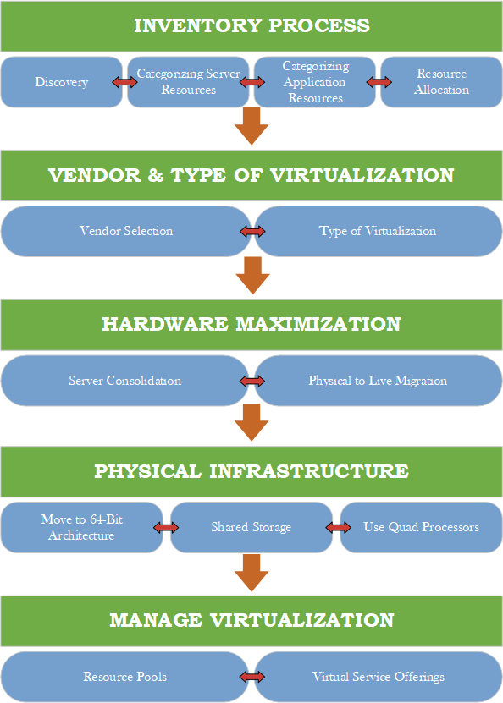
Figure 1: Proposed Virtualization Process

4.1 Inventory Process
Every virtualization process is started initially by making an inventory of all software and hardware assets incorporating the servers with their linked workloads and resources they need for storage components, networking components, processing, and many more [7]. The process of inventory incorporates the information that are based on:
Create and Processor Model
Processors types such as threads, socket, cache, core, etc.
Memory speed and size
Type of network such as speed and number of every individual port
Local storage such as RAID, capacity, disk drives
Operating System including level of their patches like the service level
Application installed
Running Services
Running Application
Device for storage
The process of inventory also identifies, discovers, and examines the network of an association before virtualization being implemented. The inventory process consists of four phases such as:

4.1.1 Discovery
It is vital for an association to know ahead of time the complete substance of its foundation prior to executing virtualization. This is the main step in the project of any virtualization implementation [8]. There are numerous instruments accessible from various sellers for performing initial investigation of an association.

4.1.2 Categorize the response from the server
Once the server of the inventory information is created, the subsequent stage is to sort the servers and their related assets and jobs into asset pools. This process is executed to evade any specialized protection, security, political, and administrative concerns between the servers, which keep them from sharing assets. Whenever examination is executed, we can arrange the service of every individual server into gatherings [9]. The services of the server are sorted into the accompanying assistance types, such as:
Network infrastructure servers
Identity Management servers
Terminal servers
File and print servers
Application servers
Dedicated web servers
Collaboration servers
Web servers
Database servers

4.1.3 Categorizing the Resources of the Application
Once the servers are categorized into various assets pools, that the assets of the application will also be categorized, such as:
Business versus in-house
Custom applications
Inheritance versus refreshed applications
Line of business applications
Crucial applications
Framework applications
Backing to business applications

4.1.4 Resource Allocation
Subsequent to making the jobs, the following interaction is to allot computing assets needed by these various jobs and afterward organizing them in a standardized structure, however for standardization, the processor usage ought to be at any rate will be half. It is vital to standardize jobs to accomplish the greatest effectiveness regarding usage, expense, and energy [10]. The method that is stated in this paper for standardization is to duplicate the use proportion of every server by absolute processor limit that is (greatest processor effectiveness * various centers * various processors).

4.1.5 Nature & Type of Virtualization
After categorizing and examining the servers and other assets, the second phase is to elaborate the types, advantages, layers, and mostly the selection and identification of vendors of virtualization in detail whose item must fulfill and suits all the requirements of the data which were collected in the first phase.

4.2 Maximization of Hardware
This is the main step of the process of virtualization. Now several virtual jobs can be run on a single server, it is essential to consider equipment problems since effectively accessible equipment isn't reasonable and sufficient for giving high accessibility of virtual responsibilities. A change is needed to put in new equipment that conveys and supports the best execution and cost [11]. By using process, it is guaranteed that the high accessibility of virtual responsibilities and furthermore gives a meaner and leaner pool of resources of assets for these virtual jobs. Equipment expansion can likewise be accomplished by buying new quad-center processors which have better equipment usage capacity alongside less utilization of energy subsequently outflows of CO2 are extraordinarily diminished.

4.2.1 Serer Consolidation
It is the kind of approach which utilizes the assets of the server efficiently in order to decrease the total number of locations of server and servers to increase the utilization of the hardware. In order to bypass the certain issues of server sprawl this technique is used and this thing is done in a scenario where various, under-used servers consume assets and take space more than expected and then they are justified by the loads of their work [12]. The combination of the process of the servers consistently starts from servers that are for the most part underused and stay inactive for long terms of time. The other most significant justification for applying the combination of servers is that these servers are in immense amounts while the accessible assets are a lot of restricted. Servers in numerous organizations use their ability typically around 15-20%, which may not be a supportable proportion in the current financial climate. Organizations are progressively going to adapt the consolidation of servers as one method for reducing superfluous expenses and augmenting profit from speculation in the server farms.

4.2.2 Migration of Virtual from Physical Live
Migration of Live from physical is the most basic, tedious, and agonizing activity when performed physically. Most server farm directors discover this cycle substantially more intricate and thorough. It incorporates cloning the current working framework and re-establishing it on an indistinguishable machine, and yet changing the entire fundamental equipment, which can prompt driver reinstallation or potentially the shocking dead blue screen [13]. To maintain a strategic distance from these ambiguities, virtualization merchants began to offer diverse physical to virtual relocation utilities. This product speeds up the development of activity and addresses fly driver contradictions, by eliminating actual equipment conditions from server working frameworks and permitting them to be moved and get fixed.

4.3 Physical Infrastructure
The physical infrastructure of a data center is the establishment whereupon telecom network and Information Technology dwells. It is the foundation of organizations, and its components give the actual lodging, force, security, fire insurance, cooling, and cablings which permit data innovation to work [14]. This actual foundation overall assists with coordinate, planning, and convey a total framework that assists with accomplishing wanted goals.

4.3.1 Move to the architecture of 64-bit
The machine architecture comprises of a bunch of various guidelines that permit reviewing or altering the state of the machine caught when executed in any or probably the special mode. To help appropriate equipment use, it is critical to refresh and update the entire server farm engineering [15]. To ensure virtual responsibilities, x-64 frameworks ought to be connected to shared capacity and organized into some type of high accessibility groups to limit the single failure point. One of the significant problems in the maximization of hardware is that for every virtual machine the accessibility and legitimate use of RAM are essential. Therefore, it is critical to think about the architecture of 64-bit, which gives more accessibility and usage of RAM for all actual and virtual frameworks.

4.3.2 Depend upon Shared Storage
It is additionally critical to consider a specific mark of failure since one server is presently running the responsibilities of different other servers. In the event that this server goes down the entire cycle of virtualization becomes fizzle. Eliminating the odds of a specific mark of failure at any stage can be accomplished by utilizing excess and bunching administrations to ensure virtual responsibilities. These administrations are generally given by Citrix and Microsoft [16]. While VMware then again utilizes a custom setup, approach known as HA or High accessibility.

4.4 Manage Virtualization
This is the main phase that includes the top administration and end-clients to settle on the choice if to carry out the virtualization. It includes numerous variables like profit, expense from arrangements of administration level, investment, and security. Virtualized server farms are overseen by isolating the functionalities of the server farm into two layers.
VSO (Virtual Service offering)
RP (Resource Pool)
It is very critical to consider the accessible assets and what different assets are needed to satisfy the necessities of appropriate execution of virtualization in the server farm [17]. It is additionally imperative to take note that change ought to consistently be favored when several servers are disconnected to ensure existing administrations and keep up assistance level arrangements with end-clients.

5. Benefits of Virtualization
Virtualization vows to profoundly change computing for the better usage of assets accessible in the server farm diminishing entire increasing agility and expenses. It decreases the operational intricacy, keeps up adaptability in choosing programming and equipment stages and item merchants [18]. It additionally expands readiness in overseeing heterogeneous virtual conditions. A portion of the advantages of virtualization are:
Application and Server Consolidation
Various environment for execution
Performance and Debugging
Sharing of Resources

6. Conclusion
This paper features the significance of virtualization innovation being carried out in server farms to save costs and amplify the productivity of various assets accessible. We proposed a five-venture model to appropriately execute virtualization in UWTSD. It begins by sorting servers and their related applications and assets into various asset pools. Considering virtualization not just as the necessities to portray the responsibilities that are intended to be virtualized yet additionally focus on the conditions into which the jobs are to be applied. It is critical to decide the sort of servers, their present status whether inactive or occupied, the amount it will cost to execute server virtualization, the kind of innovation expected to accomplish the assistance levels required, lastly meet the security/protection targets. It is likewise significant for the server farm to check whether it has the vital foundation to deal with the expanded force and cooling densities that emerge because of the execution of virtualization.

Scenario 2

7. Introduction
In present time the generation of data has risen significantly over the time in terms of velocity, variety and volume. Today the traditional data architecture does not fulfil the modern-day requirements for the enterprises. Especially in case of big data the technology needs to be evolved. Data Virtualization is a technology which has evolved to solve the enterprise problems in terms of performance, access and cost for data centres [20]. It allows diverse and massive data to be accessed by right time at right place. It can improve the organization data hardware and software performance significantly. ABC Data Ltd. is a company which has 3 physical data centres. The company also uses virtualization technology to use the 3 different data sources as single virtualized data centre. Their storage of data is secure safe and the services are provided to the customer at some charges. This report discusses about the importance of security policy of the organizations. It also discusses how SAN (Storage Area Network) can help the company to protect their using data recovery systems and data corruption.

8. Business Scenario
The main business scenario for the ABC Data Ltd is that they charge a premium price to their customers for their data services. The customers use the cloud storage and virtualized services based on monthly or yearly based fee. The data transmission is done on fibre based high bandwidth broadband connections. Mirroring technology is used between the physical data centres for resiliency [25]. The security and safe storage of the data is very important for the company. The high charges are also for the security and safety they provide; hence, it is important to have better security policy and practices.

9. Cloud Storage
In recent times, cloud storage has become an emerging solution for people’s storage problems. Cloud storage is way where the consumer can save their data securely online which can be accessed by anywhere anytime. ABC Data Ltd. also provides cloud storage services to their customers. It also offers some of the data protection and backup features for faster recovery. Along with these interesting features that cloud offers, the security of the cloud storage has become a major issue in terms of data integrity, hacking and identity theft [21]. Ultimately, the company also uses a centralised physical storage where all the data is stored. Hence it becomes very to have some security parameters for the data storage.

10. Virtualized services
Cloud storage is one of the examples of virtualized services. It simply emulates the software and hardware components to the user. For example, using APIs for location sharing, cloud servers, ERP systems [23]. The virtualized behaviours interact with the mainframe databases to get the information which is required. These services are also used in mobile devices, payment gateways, CRM systems etc. ABC Data Ltd. also provide some virtualized services to their customers in which one of the services are cloud storage.

11. Current Process
The Current process for the system is carefully designed along with the security, hardware services and storage systems. However, implementing security policies and well-designed storage are network for the company will help in disaster recover and data protection scenarios. The influence of the security policy and its importance on security measures can be discussed.

12. Security policy - importance and influence
Information is a commodity and it requires an active security policy for data centre security and strategies. A single loophole in the system can cause serious damage and havoc for the company. A data disaster can have a long-term effect on the company. In past the breaches have happened more often and it can not be defined as purely safe technology where people invest their money for different services. Security policy is very important for the data centre virtualization and it influences the design very positively closing all the loop holes in the system. The importance of the security policy can be discussed as follows:
- As per security strategy, data centre location is a very important aspect in terms of strategy. A strategically located data centre, far from urbanization is very good practice. The facility should also be risk free from the man made and natural disaster areas. High risk areas can be near buildings, bridges or airports.
- As per the policy, the system designed should follow access control management system and use biometric authentications for the premises. Based on the access control, the system can be defined as which role has how much of privileges. It is an important factor of security which can prevent the data breach from the inside of the company.
- Security surveillance is one of the great features which can be helpful for security purposes. It can be installed around the premises for 24x7 monitoring system. An integrated alarm should also be developed using motion sensors in highly protected areas.
- Following Zero trust Architecture at organizational level must be present. It treats every movement, transaction or iteration of data as suspicious activity [22]. It is commonly used intrusion detection methods for data centres.
- Security layer, system checks, and controls must be structured at the data centre which involves in management of the daily task at the physical data centre. The layers can be separated or combined as physical and digital.
- Securing all of the endpoints which can be any device connected to the data centre is importance. The customers should be able to remotely reboot their servers in case of any trouble.
- Apart from these, running regular security audits, saving entry logs, and document security procedures/protocols must be followed on a regular basis to prevent any type of data disaster.

13. Data protection - SAN (Storage Area Network)
Storage Area Network (SAN) is the most widely used storage networking architecture for the enterprises. It provides low latency, and higher throughput based on all flash storage-based data centres at low cost [19]. The entire network is block based storage which connects the servers to the logical disk unit. It is basically a pool of shared storage and range of flash storage blocks. It is mainly consisting of switches, hosts, storage devices, topologies, protocols etc. The server read the shared storage pool as logical storage. The blocks are formatted and partitioned by the servers with a file management system. There are multiple types of SAN protocols which are:
- Fibre Channel Protocol
- Fibre Channel Over Ethernet
- Non-Volatile Memory express over Fibre Channel
- Internet Small Computer System Interface
As the ABC Data Ltd system already has an infrastructure of high bandwidth fibre networks, it can implement the FC-NVMe (Non-Volatile Memory express over Fibre Channel) protocol. It is an interface protocol where the flash storage is accessed using a PCI Express bus. It supports millions of parallel and concurrent transactions. Below Image represents the system architecture design for the ABC Data Ltd. The SAN protocol is used between the servers and storage system inside the physical data centre premises [24]. The rest of the connectivity can be made remotely to the data centre server by the users of the system. This representation of a storage to a host is then accomplished with the help of virtualization.

13.1 System Design
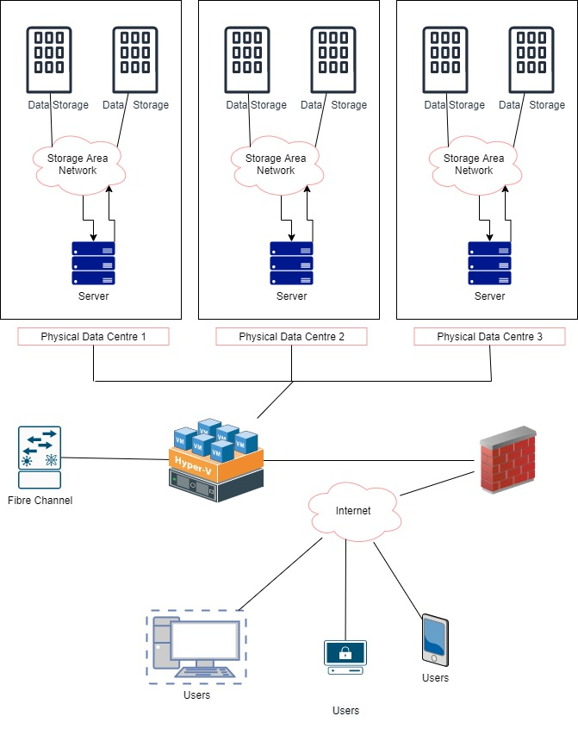
Figure 1: System Design for Data Centre virtualization with SAN
Source: Created by author
Some of the advantages of the Storage Area network for the ABC Data Ltd can be presented as below:
- It will reduce the Bandwidth issues across the network. It decreases the stress on the wired network bandwidth.
- With SAN, data protection algorithms can be implemented which also tends to stay consistent. As the data is kept on a separate network, hackers will not be able to access through customers end.
- Data backup is an important aspect of the system during each audit of the network performance. SAN allows streamlined data backup in which a single server is required to backup data from multiple locations [26]. As it is known that ABC has 3 physical data centres; hence, it will be beneficial for the company.
- SAN can help in evolving as per the business needs. Whenever the more capacity is required, storages can be added to the system directly into the SAN infrastructure. As the storages used as flash storages (NVMe), it will be easy to configure in server to see it as a single logical data source.
- SAN provides reliable disaster recovery management system; hence all hope is not based on the backup only. A data disaster always come at sudden. With proper infrastructure SAN allows the chances to reopen soon after a disaster.

14. Conclusion
By researching about SAN and virtualization for ABC Data Ltd, it can be said that systems will avail the benefits of faster backups, increased data security and improved scalability. In recent times, the SAN security is gaining attention of the enterprises for their disaster recovery and remote backup strategies. It is gradually replacing the older technologies over the time. The SAN will enhance the security features to the traditional fibre channel virtualization technology.

15. References Scenario 1
[1] Wang B. Construction Research of University Data Centre of Cloud Computing Based on Virtualization Technology. InIOP Conference Series: Materials Science and Engineering 2019 Jul 1 (Vol. 569, No. 5, p. 052022). IOP Publishing.
[2] Ananth MD, Sharma R. Cost and performance analysis of network function virtualization based cloud systems. In2017 IEEE 7th International Advance Computing Conference (IACC) 2017 Jan 5 (pp. 70-74). IEEE.
[3] Bermejo B, Juiz C, Guerrero C. Virtualization and consolidation: a systematic review of the past 10 years of research on energy and performance. The Journal of Supercomputing. 2019 Feb;75(2):808-36.
[4] Yi B, Wang X, Li K, Huang M. A comprehensive survey of network function virtualization. Computer Networks. 2018 Mar 14;133:212-62.
[5] Morabito R. Virtualization on internet of things edge devices with container technologies: a performance evaluation. IEEE Access. 2017 May 17;5:8835-50.
[6] Shuping N, Feng W. The Network Architecture Design of Distributed Dual Live Data Center. In2019 IEEE International Conference on Power, Intelligent Computing and Systems (ICPICS) 2019 Jul 12 (pp. 638-642). IEEE.
[7] Zhang W, Qi Q, Deng J. Building intelligent transportation cloud data center based on SOA. InResearch Anthology on Architectures, Frameworks, and Integration Strategies for Distributed and Cloud Computing 2021 (pp. 1084-1096). IGI Global.
[8] Jin L, Wang R, Wang X. Research on Architecture of Big Date Analysis Platform in Cloud Environment. In2020 4th International Conference on Computer Science and Artificial Intelligence 2020 Dec 11 (pp. 29-33).
[9] Comer D, Karandikar RH, Rastegarnia A. DCnet: A new data center network architecture. In2017 IEEE 7th Annual Computing and Communication Workshop and Conference (CCWC) 2017 Jan 9 (pp. 1-6). IEEE.
[10] Puthal D, Obaidat MS, Nanda P, Prasad M, Mohanty SP, Zomaya AY. Secure and sustainable load balancing of edge data centers in fog computing. IEEE Communications Magazine. 2018 May 17;56(5):60-5.
[11] Alam KM, El Saddik A. C2PS: A digital twin architecture reference model for the cloud-based cyber-physical systems. IEEE access. 2017 Jan 23;5:2050-62.
[12] Wang J, Yang Y, Wang T, Sherratt RS, Zhang J. Big data service architecture: a survey. Journal of Internet Technology. 2020 Mar 1;21(2):393-405.
[13] Wadhwa H, Aron R. Fog computing with the integration of Internet of Things: architecture, applications and future directions. In2018 IEEE Intl Conf on Parallel & Distributed Processing with Applications, Ubiquitous Computing & Communications, Big Data & Cloud Computing, Social Computing & Networking, Sustainable Computing & Communications (ISPA/IUCC/BDCloud/SocialCom/SustainCom) 2018 Dec 11 (pp. 987-994). IEEE.
[14] Kaushik S, Singh S, Pathan RK. Design of novel cloud architecture for energy aware cost computation in cloud computing environment. In2017 Innovations in Power and Advanced Computing Technologies (i-PACT) 2017 Apr 21 (pp. 1-6). IEEE.
[15] Petrenko AS, Petrenko SA, Makoveichuk KA, Chetyrbok PV. The IIoT/IoT device control model based on narrow-band IoT (NB-IoT). In2018 IEEE Conference of Russian Young Researchers in Electrical and Electronic Engineering (EIConRus) 2018 Mar (pp. 950-953). IEEE.
[16] Jing TA, Jia TA, Yutong JI, Ning ZH. Application of Cloud Edge Collaboration Architecture in Power IoT. In2020 IEEE International Conference on Information Technology, Big Data and Artificial Intelligence (ICIBA) 2020 Nov 6 (Vol. 1, pp. 18-22). IEEE.
[17] Yi S, Yuhe L, Yu W. Cloud computing architecture design of database resource pool based on cloud computing. In2018 International Conference on Information Systems and Computer Aided Education (ICISCAE) 2018 Jul 6 (pp. 180-183). IEEE.
[18] Zhao B, Hou R, Dong J, Huang M, Mckee SA, Zhang Q, Liu Y, Li Y, Zhang L, Meng D. Venice: An Effective Resource Sharing Architecture for Data Center Servers. ACM Transactions on Computer Systems (TOCS). 2019 Mar 14;36(1):1-26.

16. References Scenario 2
[19] Chen, W., Rao, J. and Zhou, X., 2017. Preemptive, low latency datacenter scheduling via lightweight virtualization. In 2017 {USENIX} Annual Technical Conference ({USENIX}{ATC} 17) (pp. 251-263).
[20] Yedder, H.B., Ding, Q., Zakia, U., Li, Z., Haeri, S. and Trajkovic, L., 2017, July. Comparison of virtualization algorithms and topologies for data center networks. In 2017 26th International Conference on Computer Communication and Networks (ICCCN) (pp. 1-6). IEEE.
[21] Atiewi, S., Abuhussein, A. and Saleh, M.A., 2018, September. Impact of Virtualization on Cloud Computing Energy Consumption: Empirical Study. In Proceedings of the 2nd International Symposium on Computer Science and Intelligent Control (pp. 1-7).
[22] Zhe, D., Qinghong, W., Naizheng, S. and Yuhan, Z., 2017, May. Study on data security policy based on cloud storage. In 2017 ieee 3rd international conference on big data security on cloud (bigdatasecurity), ieee international conference on high performance and smart computing (hpsc), and ieee international conference on intelligent data and security (ids) (pp. 145-149). IEEE.
[23] Van Rossem, S., Tavernier, W., Colle, D., Pickavet, M. and Demeester, P., 2018. Introducing development features for virtualized network services. IEEE Communications Magazine, 56(8), pp.184-192.
[24] Tate, J., Beck, P., Ibarra, H.H., Kumaravel, S. and Miklas, L., 2018. Introduction to storage area networks. IBM Redbooks.
[25] Saravanan, J., 2019. The Storage Process in Virtualization for Cloud Computing. JAC: A Journal Of Composition Theory, 12(XII).
[26] Dumka, A. ed., 2018. Innovations in Software-Defined Networking and Network Functions Virtualization. IGI Global.

