DIGITAL SURVEYING

Digital Surveying
ACBA4002

Kerri Leigh Farmer
2100037

TITLE

Digital Surveying

Index

- Introduction Pg. 4
- Classification of Surveying Pg. 4
- Classification based on Purpose of Surveying Pg. 6
- Surveying Listed Buildings & Digital Technologies Pg. 8
- Information Collection Pg. 11
- Conclusion Pg. 11
- References Pg. 12

- Introduction
“What is Digital Surveying
The technique and science of determining the terrestrial, i.e., the three-dimensional position of points and the distances and angles between them, using digital/electronic means.”
(IGI Global Dictionary, n.d)
Surveying is the measuring of altitude, angles, and heights on a large or a smaller scale this can be of buildings or land, the collection of all this data and then transferring the data and computing the data from there the data can be presented in a report, or mapped, this will create accurate measurements of the size and positions for construction or engineering purposes. The key areas for surveying 1. Research and decision making 2. Field work and data acquisition 3. Computing data processing 4. Mapping data and or presentation in a form of a drawing 5. Mapping, stake out or reporting.
The main classifications of surveying fall under to categories Plane and Geodetic surveying. Plane surveying considers the earth curvature as a flat plane, while Geodetic takes the curvature of the earth spere into consideration.
(Write, n.d)
- Classification of Surveying

Primary Classification

Geodetic Surveying
Plane Surveying

Secondary Classification

Based on Place or nature of survey
Based on Method
Based on Instruments/Equipment
Based on Purpose

The above classifications can further be divided; method of surveying into triangulation, traversing and trilateration and purpose of surveying into cadastral i.e., property lines and boundaries, city, construction, forestry, hydrographic, industrial, photogrammetric, route, and topographic are some examples of purpose of surveying.
Method Triangulation
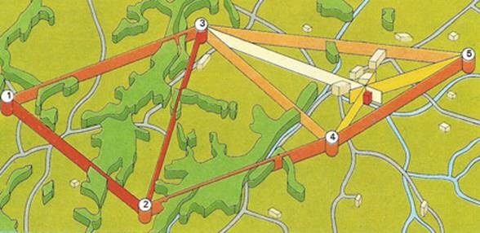
Example of triangulation surveying method
https://theconstructor.org/surveying/triangulationsurveying/11218/https://theconstructor.org/surveying/triangulation-surveying/11218/
Triangulation is the series of triangles over a specific area, triangulation is best used for areas where there are many hills. The first length of the first line of the triangle will be your baseline, the next two lines will be used as baselines for the next triangles.
(Anupoju, n.d)

Method Traversing
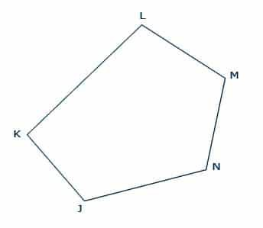
Example of
https://rkciviljungle.medium.com/traverse-surveying-definition-types-methods-checks-e4db1034d041

This is done by a number of connected lines, there are two types of traversing in surveying, closed traverse which is from a known point to a known point as a reference or a datum, then you get open traverse which is from unknown to unkown point. This is a good method for surveying large areas, for determining boundaries of forests, lakes and narrowere strips like coastlines and roads.
(Rajput, 2019)
Method Trilateration
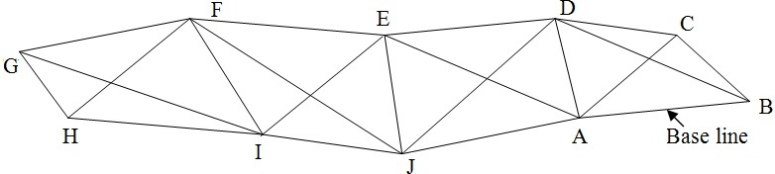
Example of trilateration surveying method
https://www.aboutcivil.org/trilateration-surveying-explained

This type of surveying is completed by measureing distances, the angles are then calculated.
(Haseeb, 2017)

- Classification based on Purpose of Surveying
The main classification of surveying based on purpose can be listed, as Cadastral, City, Construction, Forestry and Hydrographic. Due to my chosen field of study, I am going to look into construction and building survey in more detail.
  - Construction and building Surveying
Construction surveying, mainly deals with the setting out or staking out of a construction site. These types of surverys are specialist and pertain to the construction industry. This can consist of surveying for a single house, or laying out a multistory large building site, or a network of residential streets and roads.

Construction surveying plays a vital part in the construciton project whether its big or small it can influence a project deadline, budget, design, and resources. It can also be used to work out calculations based on quanitities of materials needed based on the type of survey carried out, with this you can estimate the cost of a project or certain phase of a project.

Construction surveys mark out locations and datum points for construction. Before the survey begins there is thorough research that is done prior, and a surveyor will assist throughout the construction period as required. The marking out and setting out of a site, is for the construction and engineering works. All these reference points determine where the building will go, where it will start and end, it controls the elevation, vertical and horizontal positioning.

(Anonymous, n.d)

For a construction project or proposed construction project, there will be many types of surveys that will need to be carried out. The first being the land/location and boundary surveys, this will identify where the property boundaries will end and start, the construction survey will then stake out the building boundaries and elements within the building boundaries, the construction survey will also consist of an as built survey once the construction has been completed. A construction project can also have a site planning or topographic survey to submit for planning permission. Topographic surveys are key element when adding a new building to an existing piece of land that has development on it already.

(Anonymous, Info In the Court House, n.d)

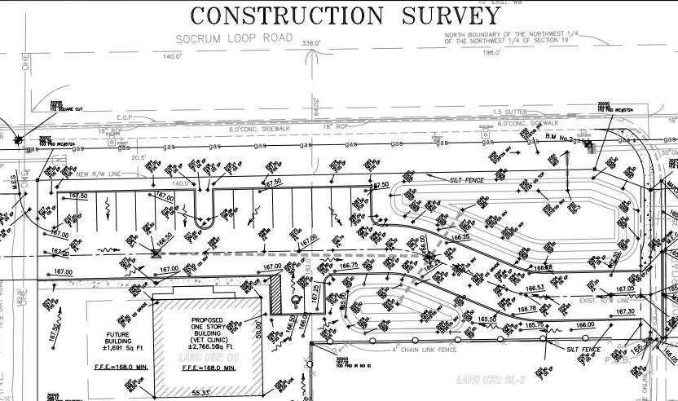
Image above is an example of a construction site survey
http://www.rapidsurveying.net/construction_survey.php

Above is an exampled of a staked out or mapped out construction survey, all the data and measurements you have collected in your survey will be mapped out accurately into a drawing, from the drawing you will need to transfer the information to the ground. This can also help the engineers and project managers determine where they may pick up any problems, by identifying problems at the staking out stage can save money, rather than picking them up at a later time in the project.

This process involves sticking stakes in the ground, at the highest accuracy as possible. The stakes will represent different elements of the site, there are two types of staking out, rough grade staking these are used for rough location and elevation of roads and building boudaries and site boundaries. The second is site layout staking, this is an accurate and comprehensive type of staking from here you can move straight onto construction work.

(Landpoint, 2016)
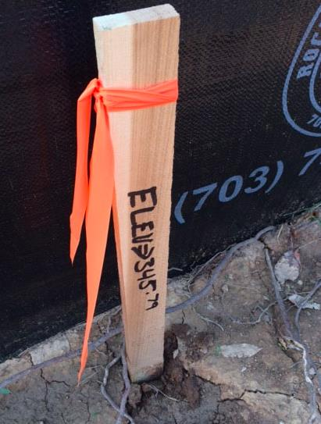
Example of an elevation stake
https://www.newdimensionsinc.com/home-building-faqs-what-is-a-stakeout-cut-sheet
The next type of construction survey is a building survey this is for existing buildings, these can be used for any renovation works, remedial works, planning purpose or for valuation purposes.

Building surveys are a in depth inspection of an existing building to produce detailed information for evalution or construction purposes.
These help property owners or developers the survey will determine the condition and risks of the building should they wish to carry out any construction or remedial works.

The main objectives of a building survey is to determine the general condition of the building, any defects, detoriation, allocated the existing services and conditions of them, as well as the structural condition of the building.
(Anonymous, Designing Buildings, 2020)

Equipment used for both construction and building surveying are namely; tapes, measuring wheel, laser measuring, thermal camera, moisture meter, digital laser levels, theodolites, and total staition.

4. Surveying Listed Buildings & Digital Technologies
The surveying of listed buildings have historical or architectural importance and need to have some level of protection of the building dependant on the grade of listing, there are many reasons to carry out a building survey on a listed building, we can produce detailed plans or elevations that may not have existed prior or not have been accurate, the data can produce ‘as is’ conditions, decisions on whether to renovate or retrofit the building or parts of the building, creating up to date records for building legislation and bringing the building up to standard with building standards and regulations. The country sides have a higher percentage of listed/graded buildings due to cities having more development.
Listed building surveying carry out the five key processes, 1. Research and decision making 2. Field work and data acquisition 3. Computing data processing 4. Mapping data and or presentation in a form of a drawing 5. Mapping, stake out or reporting.
There are many factors to take into consideration when setting out to survey a listed building, condition of the building, access is the access limited and correct use of equipment for what data you require.
Types of possible tools and equipment that can be used depending on the information required from the survey are.
Condition of the building
- Thermal cameras and moisture or protimeter these will record the insulation properties of the building, the moisture and humidity content.
Access limited
- Telescopic cameras can be used for areas hard to reach or dangerous to get too.
- Laser measurements, these can give you data for plans for drawings.
- Protimeter for dampness in walls.
- Digital cameras for images of details to be remembered and data for technical report.
All equipment needs to be used for the correct and intended purpose, taking safety of personal into consideration, capturing accurate data, ensure there is no missing data, all equipment will need to be used in a systematic way to minimise any room for error, once all this has been collected, computerised, and presented in a detailed report decisions can then be made.
Laser Scanning
With the advancement in technology 3D scanning of buildings and sites have become more popular for digital surveying technologies.
Grussenmeyer et al (2016, 306) defined laser scanning as ‘an active, fast and automatic acquisition technique using laser light for measuring, without any contact and in a dense regular pattern, 3D coordinates of points on surfaces’.
Suitable applications of 3D laser scanning include, obtaining a detailed report on a building for conservation or refurbishment prior to any work done previously, collection of significant features and details, changes in the building regarding subsidence and erosion, 3D detailed models for museums, creating a model replica.
(England, 3rd Edition January 2018)
Thermal Cameras
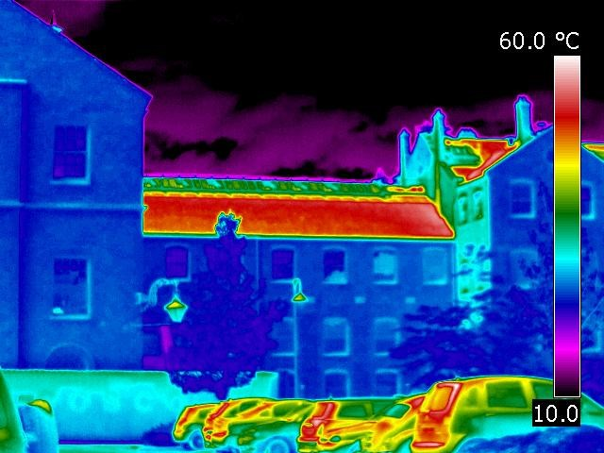
Example of thermal imaging
https://historicengland.org.uk/advice/technical-advice/building-services-engineering/maintaining-building-services/thermal-imaging/#:~:text=Infrared%20cameras%20or%20thermal%20imaging,invisible%20to%20the%20human%20eye.&text=There%20are%20multiple%20applications%20where,of%20heating%20and%20cooling%20systems
These means of surveying is non intrusive and non destructive method, it can assist in understanding and improving performance of a listed building.
- Heating and cooling loss
- Identifying all the heating and cooling systems hidden within the building
- Identify leaks and condensation points
- Deterioration and moisture content
- Defects
- Utilities faults
- Assess and reporting on thermal efficiency
- Finding hidden heating systems in listed buildings

Protimeter
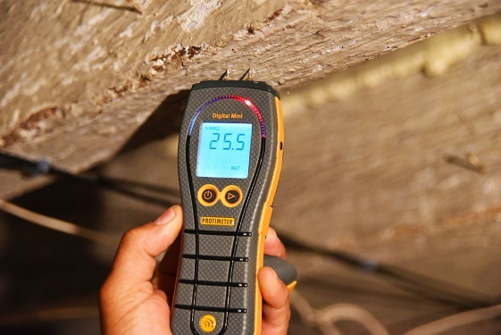
Example of a protimeter in use
https://homedefectsurveys.co.uk/
Protimeters have two prongs, that pass an electric current through them, the readings are recording in a resistance of current passed through the two prongs. Protimeters can determine the dew point tempratures as well as the humidity readings. This is known as ‘protimeter diagnostic’
(Carl, n.d)

Telescopic Cameras and Drones
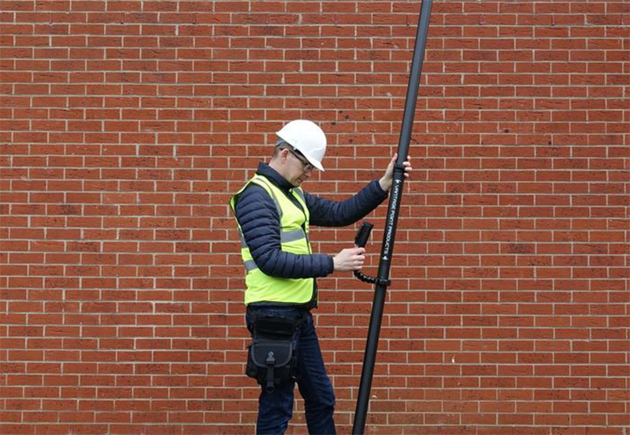
Telescopic camera for surveying
https://www.watsons-property.co.uk/valuation-survey/camera-pole-survey/
These can be used to examine hard to reach and dangerous to get to places in a listed building, for example roofs, gutters and tight spaces that are not easily accessed.
This is a pole that will hold a camera on the top of it, with a veiwing screen at the bottom of the pole. This can help reduce the unknown by giving access to examine these areas accurately with detail. Drone surverys can give you hight quality images and video of hard to access roof areas.
(Anonymous, n.d)

5. Information collection
Surveying of a listed building will need to collect a vast amount of information and date, before computorising it and creating a report and drawings of the building.
Details on the following aspects need to be collected.
Walls: material type, solid cavity insulation, painting, rendering, function and suitability
Windows & Doors: materials, rott damage, displacement, cracking distortion
Roofs: tile type, age, any signs or repairs, replacement defects. Eaves, gutters, chimneys, movement, flashings, DPC course, pointing.
Floors: material types, wood, concrete, condition and repairs, DPC, builtin floors or suspended flooring, condition and position with regard to external ground level.
Drainage: materials, man holes, direction of flow, size of drains.
Internal details information, a rough diagram needs to be drawn of a room plan, noting all shapes windows, doors and recesses. Measurements will be recorded of these details and inserted onto the rough drawing.

6. Conclusion
After the collection of all data, computing and reporting the data, a final assessment and decision can be made on the bulding. Detailed advice on the condition of the building will be available, risks both visible and hidden will be detailed, recommendations on remedies or further investigations will be establised, with the collection and reporting of this data an informed decisions for planning, purchasing, repairs, maintance can be concluded and decided. These reports can also help produce the estimated costs for repairs and maintance.

7. References
England, H., 3rd Edition January 2018. 3D Laser Scanning for Heritage, s.l.: Historic England.
Grussenmeyer, P., 2016. 3D Recording, Documentation and Management of Cultural Heritage. s.l.:s.n.
Anonymous, 2020. Designing Buildings. [Online]
Available at: https://www.designingbuildings.co.uk/w/index.php?title=Building_survey&oldid=180635
(Accessed 12 December 2021)
Anonymous, n.d. Court House Direct. [Online]
Available at: https://info.courthousedirect.com/blog/what-are-the-different-types-of-land-surveys
(Accessed 12 December 2021)
Anonymous, n.d. Oxford Land Surveying. [Online]
Available at: https://oxfordlandsurveying.com/services/construction-survey-2/
(Accessed 12 December 2021)
Anonymous, n.d. Solent Sky Services. [Online]
Available at: https://solentskyservices.co.uk/drone-roof-surveys
(Accessed 13 December 2021)
Anupoju, S., n.d. The Constructor. [Online]
Available at: https://theconstructor.org/surveying/triangulation-surveying/11218/
#9Accessed 12 December 2021)
Carl, n.d. The Damp Buster. [Online]
Available at: https://thedampbuster.com/damp-meter-readings/
(Accessed 13 December 2021)
Global, I., n.d. IGI Global Dictionary. [Online]
Available at: https://www.igi-global.com/dictionary/digital-surveying-in-cultural-heritage/56525
(Accessed 29 November 2021)
Haseeb, J., 2017. About Civil. [Online]
Available at: https://www.aboutcivil.org/trilateration-surveying-explained
(Accessed 12 December 2021)
Landpoint, 2016. Landpoint. [Online]
Available at: https://www.landpoint.net/whats-involved-with-construction-staking/
(Accessed 13 December 2021)
Rajput, K., 2019. RK Civil Jungle. [Online]
Available at: https://rkciviljungle.medium.com/traverse-surveying-definition-types-methods-checks-e4db1034d041
(Accessed 12 December 2021)
Write, J. W., n.d. Britannica. [Online]
Available at: https://www.britannica.com/technology/surveying
(Accessed 12 December 2021)

7. References
Anonymous, 2020. Designing Buildings. [Online]
Available at: https://www.designingbuildings.co.uk/w/index.php?title=Building_survey&oldid=180635
[Accessed 12 December 2021].
Anonymous, n.d. Court House Direct. [Online]
Available at: https://info.courthousedirect.com/blog/what-are-the-different-types-of-land-surveys
[Accessed 12 December 2021].
Anonymous, n.d. Oxford Land Surveying. [Online]
Available at: https://oxfordlandsurveying.com/services/construction-survey-2/
[Accessed 12 December 2021].
Anonymous, n.d. Solent Sky Services. [Online]
Available at: https://solentskyservices.co.uk/drone-roof-surveys
[Accessed 13 December 2021].
Anupoju, S., n.d. The Constructor. [Online]
Available at: https://theconstructor.org/surveying/triangulation-surveying/11218/
[Accessed 12 December 2021].
Carl, n.d. The Damp Buster. [Online]
Available at: https://thedampbuster.com/damp-meter-readings/
[Accessed 13 December 2021].
England, H., 3rd Edition January 2018. 3D Laser Scanning for Heritage, s.l.: Historic England.
Global, I., n.d. IGI Global Dictionary. [Online]
Available at: https://www.igi-global.com/dictionary/digital-surveying-in-cultural-heritage/56525
[Accessed 29 November 2021].
Grussenmeyer, P., 2016. 3D Recording, Documentation and Management of Cultural Heritage. s.l.:s.n.
Haseeb, J., 2017. About Civil. [Online]
Available at: https://www.aboutcivil.org/trilateration-surveying-explained
[Accessed 12 December 2021].
Landpoint, 2016. Landpoint. [Online]
Available at: https://www.landpoint.net/whats-involved-with-construction-staking/
[Accessed 13 December 2021].
Rajput, K., 2019. RK Civil Jungle. [Online]
Available at: https://rkciviljungle.medium.com/traverse-surveying-definition-types-methods-checks-e4db1034d041
[Accessed 12 December 2021].
Write, J. W., n.d. Britannica. [Online]
Available at: https://www.britannica.com/technology/surveying
[Accessed 12 December 2021].

