Gareth Jenkins.
Student No. 99091195.
HPAH6080. Ancient Lives in Death.

The material culture of death in Ancient Egypt: the tomb of Senneferi TT99 at Thebes.
The question of whether life endures after death has been addressed by every civilisation, both ancient and modern (Taylor 2001, p. 7). One of the characteristics which allows us to determine a society's culture is how it perceives death, and a life after death (Ikram, 2015, p. ix; Taylor, 2001, p. 7). The vast amount of funerary material that survives from the civilisation of ancient Egypt provides Egyptologists with a unique perspective on their funerary beliefs (Ikram, 2015, p. ix; Taylor, 2001, p. 7). The Egyptians had a deep-seated love of life, and believed that when they died, they would continue to live eternally in the afterlife (Ikram, 2015, p. ix; Ikram, 2023, pp. 154-155; Loynes, 2015, p.1; Taylor, 2001, pp. 10-15). This obsession with a continued existence dominated their everyday lives and they invested a significant amount of their material culture on mitigating death (Johnson, 2000, pp. 21-22; Taylor, 2010a, p.12).
The most prominent and impressive tangible artefacts that have been discovered in Egypt are tombs and their funerary assemblages (Snape, 2011, p. 4). The Egyptians placed great significance on the tomb as the place where they could live for eternity in the afterlife (Ikram, 2015, p.139; Taylor, 2010, p.113). Tombs were referred to as the ‘House for eternity’ and were therefore built of stone so that they would be everlasting (Ikram, 2015, p.139; Taylor, 2010, p. 113; Taylor, 2011, p. 22). Tombs differed in size and style depending on the owners' social standing (Taylor, 2010, p.113), and were typically divided into two sections comprised of a burial chamber below ground, where the corpse was laid to rest, and a tomb chapel above ground, where the deceased could be commemorated with offerings and prayers (Ikram, 2015, p. 139; Ikram, 2023, p.287; Taylor, 2010, pp. 113-114). The tomb was usually adorned with relief carvings and painted scenes from everyday life to enable the deceased to regenerate in an afterlife (Ikram, 2023, pp. 293-297).
This essay will examine the ancient Egyptian tomb of an 18th Dynasty high ranking official Senneferi and will discuss the material culture of the tomb and how it encapsulates Senneferi’s position in Egyptian society. (Strudwick, 2016, pp. 1-3).
Senneferi’s tomb, TT99, is located on the west bank of the modern city of Luxor in the Upper Enclosure of the Sheikh Abd el-Qurna cemetery (Strudwick, 2016, p. 1). Luxor is the modern-day city built over one of the principal cities of ancient Egypt, Thebes (Shaw & Nicholson, 2003, pp. 286-287). On the west bank are situated the mortuary temples and tombs of the Pharaohs from the Middle Kingdom to the end of the Pharaonic period (Shaw & Nicholson, 2003, p. 286). Figure 1 below is a plan of the Theban necropolis showing its close proximity to the tombs and temples of the Pharaohs, with the area at number 6 indicating the site of the Sheikh Abd el-Qurna cemetery (Shaw & Nicholson, 2003, p. 286).

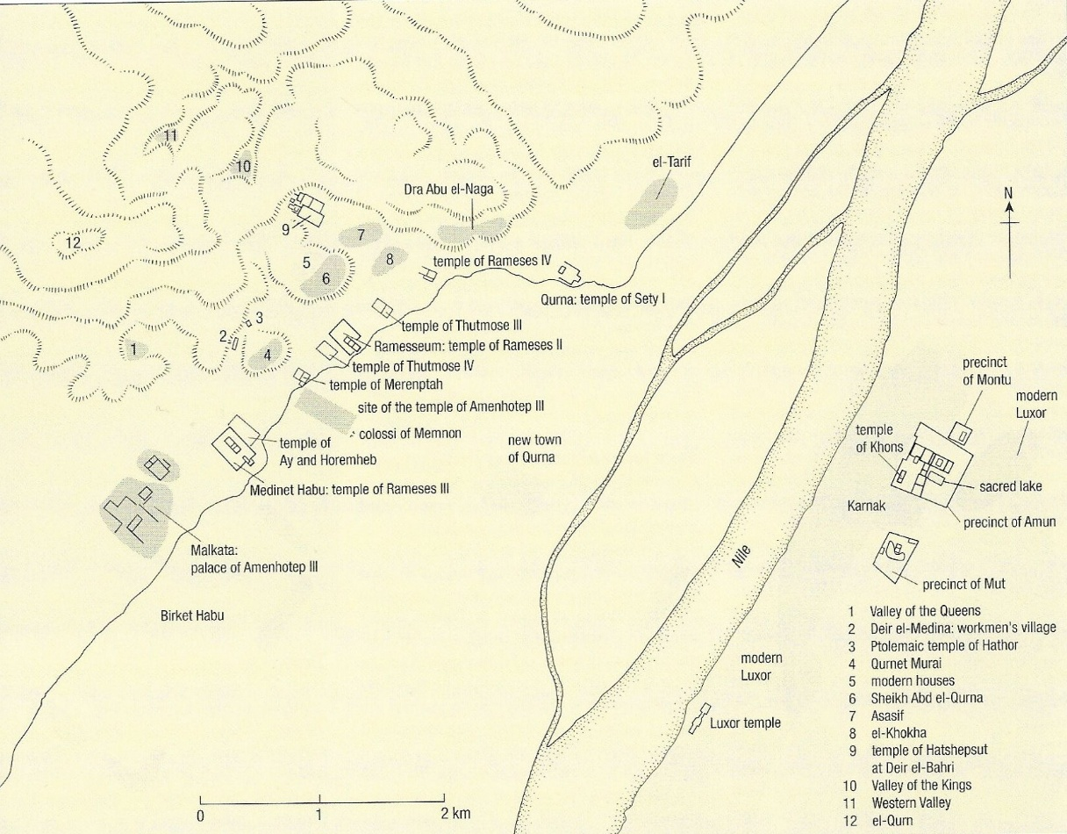
Figure 1, plan showing the location of the Theban necropolis and its close proximity to the Tombs and Temples of Pharaohs (Shaw & Nicholson, 2003, p.287).

Figure 2 is a screenshot from an on-line geographical information system for the Theban necropolis, with the red square indicating the approximate position of Figure 3 below which will show the location of TT99 within the cemetery.
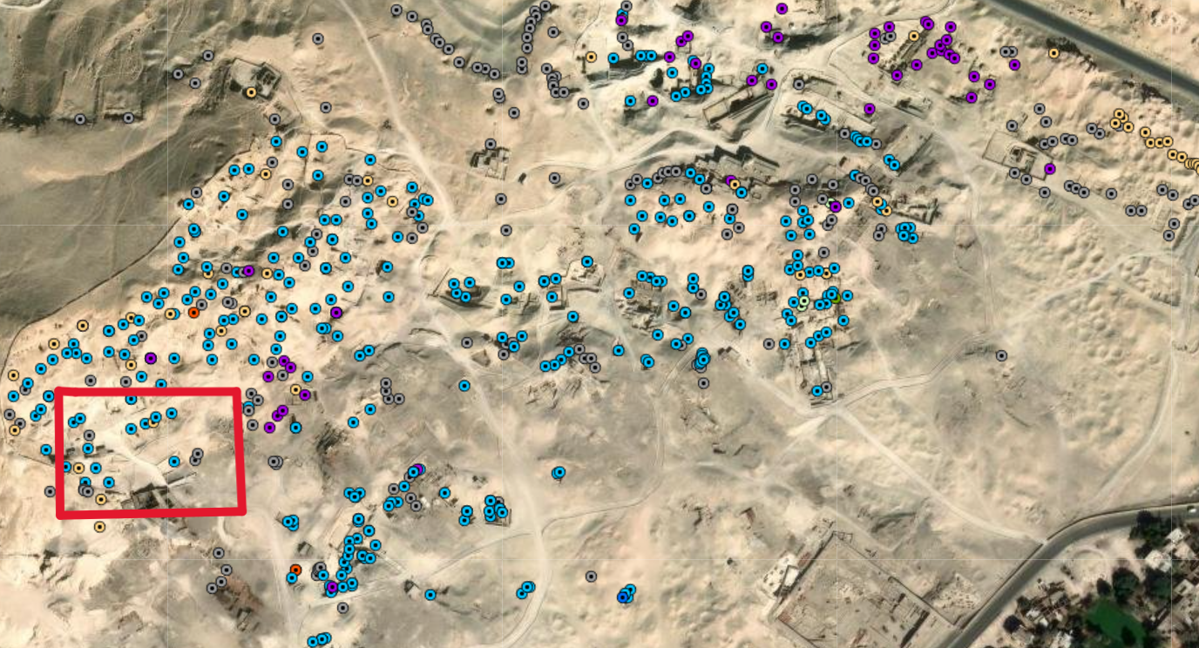
Figure 2 (Piccione & Levine, 2019).
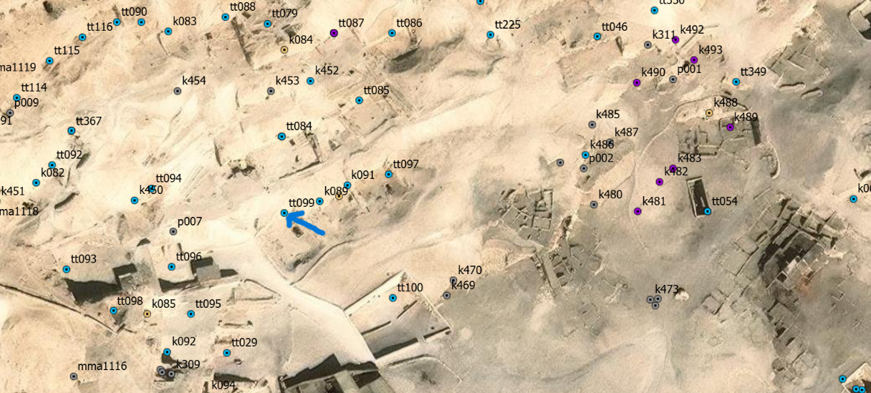
Figure 3 shows the location of TT99, highlighted with a blue arrow, within the cemetery (Piccione & Levine, 2019).
One of the most significant changes in tomb development occurred during the New Kingdom period, c. 1550-1069 BC, which saw the emergence of high-status officials who were originally from a more rural background (Shaw, 2000, p. 481; Snape, 2011, p. 180). Their newly acquired status allowed them to construct their tombs in close proximity to, and often as part of, the Royal funerary complex (Ikram, 2023, p. 166; Snape, 2011, p.180). This resulted in the west bank at Thebes having the largest concentration of high-quality tombs in ancient Egypt (Snape, 2011, p.180).
TT99 is a typical 18th Dynasty tomb and includes a T-shaped chapel with a facade, and courtyard, and with shafts sunk in both the chapel floor and the courtyard (Strudwick, 2016, p.1, and p. 45). Archaeological investigation at the tomb has identified that the front facade contains the remains of brownish plaster, a small niche above the door to the chapel and quantities of funerary cones (Strudwick, 2016, pp. 49-54). Funerary cones are flat-ended, funnel-shaped clay pieces that were typically used as ornamentation in Theban tomb walls bearing the names and titles of the tomb owners (Zenihiro, 2009, p. 10). The cones found at TT99 therefore provide good evidence of Senneferi’s status in Egyptian society with one cone in particular, DM 154 (Figure 4) bearing the following inscription, “Revered one before Osiris, hereditary noble, mayor, sealbearer of the king of Lower Egypt, sole companion, overseer of the seal, Sennefer(i) justified” (Zenihiro, 2009, p. 93). Translations of the inscription vary, with Strudwick (2016, p. 49) claiming that the translation is, “the imakhu in the sight of Osiris, the iry pat HAty-a, seal-bearer of the bity, sole companion, overseer of seal-bearers Sennefer, justified.”
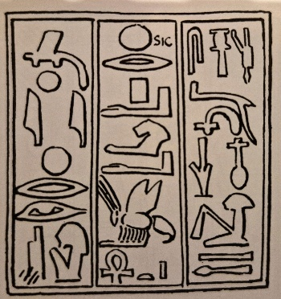
Figure 4, Cone DM 154 (Strudwick, 2016, p.49).
The front room of the chapel which has significant damage is made up of two rectangular sections with a flat ceiling, which are separated by the front door and the entrance to the passageway (Strudwick, 2016, p. 58). This room contains a false door in its southern wall, fragments of plaster from which were found on the floor of the tomb and in another nearby tomb (TT96), and in the north wall a space for a stela (Strudwick, 2016, pp. 91-106). The long passageway with a vaulted ceiling leads to the rear room or shrine, which has two central pillars which break up the room into three sections with noticeable differently styled ceilings (Strudwick, 2016, pp. 58-61). Figure 5 is a diagram of the chapel layout, providing numbered references for the walls and brief details of their decoration. In the rear wall of the shrine is a small niche which would have held offerings or may once have held a statue (Strudwick, 2016, p. 61).
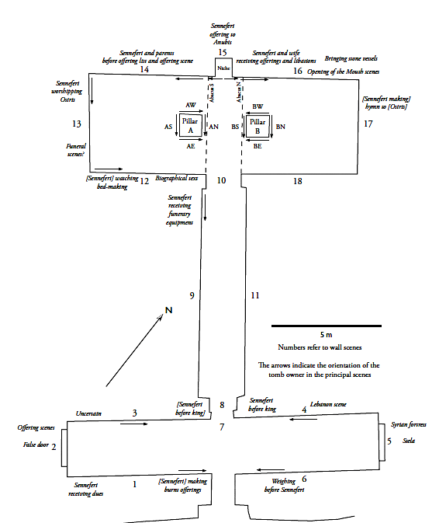

Figure 5, Diagram of TT99 showing the numbering of the walls (Strudwick, 2016, p. 85).
Most of the wall paintings in the tomb are missing, particularly on Walls 11 and 18 which are completely lacking any decoration (Strudwick, 2016, p. 62). What remains of any wall painting is limited to the top of certain walls (Strudwick, 2016, p. 161). However, these remaining pieces offer a glimpse into the life of Senneferi, beginning with the front room which shows a combination of his important accomplishments and his relationship with the king, particularly his journey to Lebanon to secure high quality wood for temple flagpoles, along with some ritual images that are a part of the "Beautiful Festival of the Valley (Strudwick, 2016, p. 162; Strudwick, 2018).
The false door and memorial stela within this room create a symbolic portal between the afterlife and the realm of the living (Shaw & Nicholson,1995, pp. 278-279; Strudwick, 2016, p. 162). Only the receipt of burial goods is presented in the poorly preserved scenes in the passage, which could be seen as a transition between the front room and the Shrine at the rear (Strudwick, 2016, p. 162).
What remains of the shrine’s decoration mainly shows the provision and upholding of the cult of the deceased on the west wall, along with scenes in which Senneferi is depicted with Osiris and Anubis, the tomb's most prominent deities, as well as a synopsis of his accomplishments in a biography on wall 12 (Figure 6), and scenes from his funeral on walls 13 - 16 (Strudwick, 2016, p. 162).
Figure 6, wall 12 Senneferi’s biographical text (Strudwick, 2016, colour plate 23a).

His biography includes the following titles, “Overseer of the priests of Horus……Royal messenger…….overseer of storehouses……overseer of seal bearers and two granaries….overseer of the priests of Sobek and Anubis…. Chief overseer of the fields of Amun” (Strudwick, 2016, p. 126).
Three burial shafts were identified in the Courtyard, all three of which had been robbed and excavated on several occasions in the past (Strudwick, 2016, pp. 65-83). Shaft I appears to have been better constructed than the other two shafts and material recovered in this shaft has identified that it led to the burial chamber of Senneferi and members of his family (Strudwick, 2016, pp. 65-83). Large quantities of ceramic sherds, including pieces of funerary cones, also wooden coffin pieces, and human remains have been recovered in these burial chambers (Strudwick, 2016, pp. 65-83). At the bottom of this shaft were recovered fragments of Senneferi’s false door as well as fragments of a stela, most probably from the front room of the tomb which is mentioned above (Strudwick, 2016, p. 76).
Analysis of the material found in burial Shaft I and its adjoining rooms, particularly coffin pieces, have identified typical Dynasty 18 style ‘black’ anthropoid coffins, including pieces of a face, inlaid eyes, wooden ears and two wooden beards to attach to a coffin (Strudwick, 2016, pp.183-185). Also discovered were wooden pieces with the remains of red and yellow plaster, and gold leaf, as well as pieces with Senneferi’s name of them (Strudwick, 2016, pp. 184-185). Additionally, wooden fragments of burial furniture were discovered, which were considered important elements in ‘elite burials’ in the 18th Dynasty (Strudwick, 2016, p. 279). These finds indicate that one of the individuals was provided with a high-status burial assemblage, which when combined with Senneferi’s association with the tomb complex, emphasises his prominent position in Egyptian society (Strudwick, 2016, p. 190).
Examination of the ceramic pieces recovered from Shaft I, which included canopic jars, large Nile silt jars, possibly to hold embalming material, clay amphorae, two of which have been stamped with a cartouche and may therefore have been royal gifts, as well as quantities of flower pots, beer jars, pilgrim jars, small dishes and flanged bowls indicate the burial of an upper-class individual and his family (Strudwick, 2016, pp. 192-193).
Fragments of jar dockets or labels found in Senneferi’s burial chamber may demonstrate the nature of offerings of food provided to a high ranking official, and four amphorae found in the burial chamber have dates on them which are linked to the reign of Thutmose III and may provide evidence of his power and wealth (Strudwick, 2016, pp. 239- 250).
Senneferi’s burial in a tomb at the Sheik Abd el-Qurna cemetery at Thebes in close proximity to the New Kingdon pharaohs indicates that he was one of the higher status individuals within Egyptian society (Shaw & Nicholson, 2003, p. 288; Snape, 2011, p.180). His tomb, a typical 18th Dynasty T-shaped tomb and funerary architecture, proclaimed his status in society and surpassed the tombs of lower status individuals (Ikram, 2023, p. 166; Strudwick. 2016, p. 1 & p. 45). Although very damaged by time, tomb robbers and modern incursions, what remains of his tomb and his funerary assemblage has provided a detailed resume of his life and accomplishments and also provided an indication of a potential close relationship with his king which would have afforded him further privileges and wealth (Strudwick, 2016 & 2018). His biography on Wall 12 of the rear room or shrine in particular outlines his deeds and attainments (Strudwick, 2016 & 2018). As an Overseer of several different agencies, he would have accumulated wealth from each position, even though he may never have done the work himself, his title granted him prominence and benefits (Ikram, 2023, p. 182).

Bibliography
Arnold, D. (2003). The Encyclopaedia of Ancient Egyptian Architecture. I.B.Tauris & Co Ltd.
Gardiner, A. H. & Weigall, A. E. P. (1913). A Topographical Catalogue of the Private Tombs of Thebes. London: Barnard Qauritch. Available at: https://archive.org/details/topographicalcat00garduoft/page/24/mode/2up (Accessed: 26 February 2026).
Grajetzki, W. (2003). Burial Customs in Ancient Egypt: Life in Death for Rich and Poor. Duckworth.
Ikram, S. & Dodson, A. (1998). The Mummy in Ancient Egypt: Equipping the Dead for Eternity. Thames & Hudson.
Ikram, S. (2015). Death and Burial in Ancient Egypt. The American University in Cairo Press.
Ikram, S. (2023). Ancient Egypt: An introduction. Cambridge University Press.
Johnson, P. (2000). The Civilization of Ancient Egypt. Weidenfeld & Nicolson.
Loynes, R. (2015). Prepared for eternity : a study of human embalming techniques in ancient Egypt using computerised tomography scans of mummies. Archaeopress.
Newberry, P.E. (1900). ‘’Extracts from my Notebooks (II), in Proceedings of The Society of Biblical Archaeology, Vol. XXII, Thirteenth Session. Available at: https://archive.org/details/ProceedingsOfTheSocietyOfBiblicalArchaeologyVol221900/page/n83/mode/2up (Accessed: 26 February 2026).
Nicholson, P. T. & Shaw, I. (Eds). (2009). Ancient Egyptian Materials and Technology. Cambridge University Press.
Piccione, P. A. & Levine, N. S. (2019). On-line Geographical Information System for the Theban Necropolis (OLGIS-TN) (version 1.0 Beta). Available at: https://scgis.maps.arcgis.com/apps/webappviewer/index.html?id=cff7333a8b61461eb9d438d91c93ff61 (Accessed: 26 February 2026).
Rice, M. (1999). Who’s Who in Ancient Egypt. Routledge.
Shaw, I. (Ed). (2000). The Oxford History of Ancient Egypt. Oxford University Press.
Shaw, I. & Nicholson, P. (2003). The Dictionary of Ancient Egypt. Harry N. Abrams.
Shaw, I. (2013). Ancient Egyptian technology and innovation : transformations in pharaonic material culture. Bloomsbury Academic.
Shirley. J. (2014). The Power of the Elite: The Officials of Hatshepsut's Regency and Coregency, in: J. Galán, B. M. Bryan, P. F. Dorman (eds.): Creativity and Innovation in the Reign of Hatshepsut, Studies in Ancient Oriental Civilization 69, Chicago.
Snape, S. (2011). Ancient Egyptian Tombs: The Culture of Life and Death. Willey Blackwell.
Snape, S. (2014). The Complete Cities of Ancient Egypt. Thames & Hudson.
Strudwick, N. 2016. The Tomb of Pharaoh’s Chancellor Senneferi at Thebes (TT99). Oxford: Oxbow.
Strudwick, N. (2018). Cambridge Theban Tombs Project: The Tomb of Senneferi, Theban Tomb 99. University of Cambridge. Available at: https://tt99.fitz.ms (Not Secure) (Accessed: 23 February 2026).
Taylor, J. H. (2001). Death and the Afterlife in Ancient Egypt. The British Museum Press.
Taylor, J. H. (2010). Egyptian Mummies. The British Museum Press.
Taylor, J. H. (Ed.) (2010a). Journey through the afterlife: Ancient Egyptian Book of the Dead. The British Museum Press.
Taylor, J. H., Virginia Museum of Fine Arts., & British Museum. (2011). Mummy secrets of the tomb (New American edition.). Virginia Museum of Fine Arts.
Wilkinson, T. (2007). Lives of the Ancient Egyptians. Thams & Hudson.
Willockx, S. (2010). Map of the Theban Necropolis. Available at: https://www.researchgate.net/publication/307547254_Map_of_the_Theban_Necropolis (Accessed: 26 February 2026).
Zenihiro, K. (2009). The Complete Funerary Cones. Maruzen Co. Ltd. Available at: https://www.academia.edu/232645/The_Complete_Funerary_Cones (Accessed: 11 March 2026).

