STUDENT ID - 2105747
SUBJECT - DISSERTATION
WORD COUNT - 20851
CHARACTER COUNT - 133452

ANALYSIS OF BRAND MANAGEMENT IN THE GLOBAL
ECONOMY

Abstract
In chapter 1, the brand management in the field of global economy has been discussed properly. Therefore, the prime reason behind the research topic, research rationale and problem statement have been identified in this chapter. Besides this, research aim, objectives and questions have been also evaluated in this chapter to give a clear view. Apart from this, the significance of the research study has been also implemented in this study.
In chapter 2, literature review has shed light on the discussion about the brand value and the brand management and the influences of the brand management on the global economy. In this chapter it has also been discussed about several strategies that have been implemented to create a value of the brand management. In this chapter the strategic implementations to improve brand management in the global economy, its negative and positive impacts on consumers and effectiveness of brand management in the global economy has been discussed with proper description. Valid arguments and points are discussed with example to support the chapter. The impact of customer loyalty has been discussed and the leadership managementhas been mentioned in this chapter.
In chapter 3, the section is mentioned with the research methodology and it conveys with the scientific and logical tools selected by the researcher. The entire study is mentioned with the qualitative research with the case study data. The chapter also focuses on the methods that heaps been applied by the researcher. In the case of Research philosophy, Interpretivism has been used. Research approach has been dealt withininductive approach that formulates more details about the study. In research design, exploratory has been usedwith the analysis of the research strategy with that of the data collection method. In this particular chapter, research methodology along with data method of collection has been performed. Secondary qualitative data has been detected along with all sorts of ethical considerations has been maintained.
In chapter 4, there has been analysis about the customer loyalty that can be impact positively on brand improving and customer loyalty can be increased by increasing goods and services. Market leaders have been effective for brand management and it has been effective for brand management in brand loyalty. Managers and employees play important role in the brand development of the organization.In this chapter we have discussed the importance of brand awareness in the growth of brand also discussed the importance of branding in the business growth and also been discussed the importance of brand value in the economic growth of the country.
In chapter 5, the factors and pathways of strategic management have been discussed in the context of business development and business promotion. The study also have analysed the factors of improvement and strategic management pathways to enhance brand image and economic state of a brand. The chapter have further discussed with brand management in the global with relevant positive and negative findings. Positive finding has discussed the positive impact of brand image in global economy.
In chapter 6, the chapter has described the conclusion of the research paper and it has discussed the brand management, productivity, and the global economy that has been influenced. It has analysed authentic data and provided effective research on brand management. The entire research has been done by a secondary data analysis method which has justified the analysis of business management and its effectiveness on the global economy.

Acknowledgement
I would like to show my deepest appreciation for the member of the research team who has continuously assisted and supported me in completing the research. Without their guidance, it would have been impossible for me to achieve this kind of results. In addition, I would like to thank my professors under whose guidance I was able to research in an adequate manner for justifying the context along with getting hold of the permissions to achieve copyright subjects. Lastly, I would also like to appreciate the efforts and support given by my peers, families and friends for the completion of this project.
Table of Contents
Chapter 1: Introduction 7
1.1 Introduction 7
1.2 Background of the study 7
1.3 Research rationale 8
1.4 Problem statement 9
1.5 Research aim and objectives 10
1.6 Research questions 11
1.7 Proposed structure of the dissertation 11
1.8 Significance of the study 12
1.9 Summary 12
Chapter 2: Literature review 13
2.1 Introduction 13
2.2 Strategic Implementations to Improve Brand Management in the Global Economy 13
2.3 Negative Impact of Branding on Consumers 14
2.4 Positive Impact of Branding on Consumers 15
2.5 Effectiveness of Brand Management in the Global Economy 16
2.6 Effectiveness of the Brand value on the global economy and its growth 17
2.7 Several marketing strategies to facilitate digitalization 17
2.8 The economic importance of brands includes several reasons 19
2. 9 Role of Brand Management in the Global Economy 20
2.10 Analysis of the effect of leadership management on the brand management 21
2.11 Analysis of the development of customer loyalty by creating competitiveness in an organisation 22
2.12 Impact of customer loyalty to explore brand management in the global market 23
2.13 Importance of brand management in the global economy 24
2.14 Impact of brand value in economics development 26
2.15 Differentiation between trade values and brand marks 27
2.16 Analysis the key values and branding ranges on economic development 27
2.17 Factors of brand management in economic development 28
2.18 Michael Spence's theory in brand management 29
2.19 Bureaucratic theory 30
2.20 Contingency management theory 31
2.21 Definition of brand management and the essential strategies of brand management 33
2.22 Scientific management theory 34
2.23 Conceptual framework 35
2.24 Literature gap 35
2.25 Summary 36
Chapter 3: Research methodology 37
3.1 Introduction 37
3.2 Research onion 37
3.3 Research philosophy 38
3.4 Research approach 40
3.5 Research design 41
3.6 Research Strategy 42
3.7 Data collection 42
3.8 Data analysis method 43
3.9 Ethical consideration 45
3.10 Summary 45
Chapter 4: Results 46
4.1 Introduction 46
4.2 Secondary data analysis 46
4.3 Summary 52
Chapter 5: Discussion 53
Chapter 6: Conclusion 59
6.1 Conclusion 59
6.2 Linking with objectives 59
6.3 Recommendation 60
6.4 Future scope 61
6.5 Research limitation 61
Reference List 62

Table of figure
Figure 1.1: Global revenue of the brand 9
Figure 1.2: Issues of the brand management 10
Figure 1.3: Challenges of brand management in the global economy 11
Figure 1.4: Proposed structure of the study 12
Figure 2.1 Conceptual Model of Future Research Direction 15
Figure 2.2: Conceptual Model of Negative Impact of Branding on Consumers 16
Figure 2.3: The cumulative body and research digital strategy 19
Figure 2.4: The research model of brand and customer loyalty 20
Figure 2.5: Role of brand management in the global economy 21
Figure 2.6: World economic transition 22
Figure 2.7: Factors in keeping customer loyalty to brands 24
Figure 2.8: Brand management 25
Figure 2.9: Impact of brand value in economics development 27
Figure 2.10: Differentiation between trade values and brand marks 28
Figure 2.11: Brand management in economic development 28
Figure 2.12: Michael Spence's theory 30
Figure 2.13: Bureaucratic theory 31
Figure 2.14: Contingency management theory 32
Figure 2.15: Brand management 33
Figure 2.16: Scientific management theory 34
Figure 2.17: Conceptual framework 35
Figure 3.1: Research onion 37
Figure 3.2: Research philosophy 39
Figure 3.3: Research approach 40
Figure 3.4: Research design 41
Figure 3.5: Data collection method 43
Figure 4.2.1: The links in the Service-profit chain 47
Figure 4.2.2: Apple and Amazon Lead in Customer Satisfaction 48
Figure 4.2.3: Coca cola brand value 50
Figure 4.2.4: The brand value of brands through branding 51

Chapter 1: Introduction

1.1 Introduction
Brand management is a significant function of the marketing process that has used techniques for increasing the value of the global economy. In this case, it has been identified that brand management has encouraged and also supported the competition based on values rather than quality, such as innovation and reputation. In this chapter, the prime reason behind the study is going to analyse to better understand brand management. Therefore, the relevant information of the study and also research rationale are going to mention in this chapter. On the other hand, the research aim, objectives as well as research questions are going to evaluate in this study to collect the proper information. In addition to this, brand management has faced various kinds of challenges and these are going to define through the problem statement. Apart from this, the main significance of the study is going to highlight in this chapter.

1.2 Background of the study
Brand management has enabled the price of the products and enhanced the perceived value of the product line. The brand value hasincreased the market operations and also analysed the demand for the services. Therefore, the name, logo and other features have distinguished the product from the competition of the consumer. In addition to this, it has encompassed within the perceptions and also associations that the consumers have included of the services and the product. As mentioned by Majerova et al. (2020), brand management has influenced the behaviour of the consumer which has developed the global economy. On the other hand, the brand value has been effective in securing the future of the company which has also developed the identification and perception of the customer based on the demand for services and also the availability of the products.
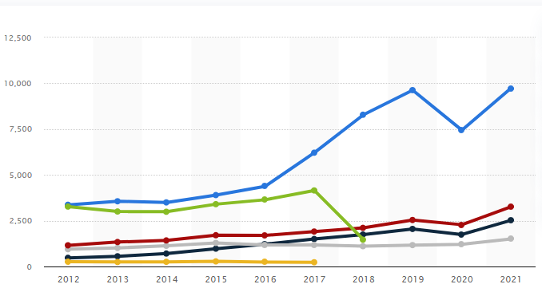

Figure 1.1: Global revenue of the brand
(Source: Statista.com, 2022)
In this case, it has been identified that the global revenue of brand management has been analysed. Therefore, Kering’s Gucci brand has generated global revenue of 9.73 billion Euros in 2021 and it has developed economic growth (Statista.com, 2022). In addition to this, brand management has provided the opportunity in the global economy to build relationships with audiences.

1.3 Research rationale
One of the main issues of brand management is the high development cost that has affected the global economy. As mentioned by Pamfilie and Croitoru(2018), branding has included huge costs as the brands have not been created overnight and also the organisation has to spend high sums in the context of advertising and also publicity. In the current scenario, it has become one of the biggest challenges as most of the brands have been creating products that have been differentiated from others.

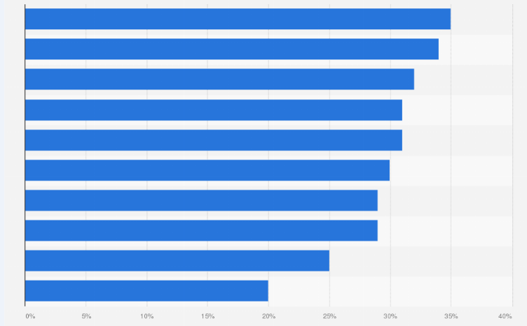

Figure 1.2: Issues of the brand management
(Source: Statista.com, 2022)
In this case, brands have also used innovative technology to create new products and this causes it has created high development costs and affected the global economy. Therefore, it has been found that 35% of respondents stated that it has created the biggest challenge for brand management and affected the global economy (Statista.com, 2022). In addition to this, through the identification of the social, ethical and business responsibilities as well as enhanced customer loyalty the issues of brand management would be mitigated.

1.4 Problem statement
Brand management has included various kinds of challenges that have affected the global economy. In this case, it has been found that digital strategy as well as maintenance of brand relevance is the major challenges of brand management. Therefore, technology adoption and cultural barriers are other challenges of brand management that have affected the global economy. As opined by Ganushchak-Efimenkoet al. (2018), another problem of brand management is creating new subcategories that have decreased the revenue of the global economy. In addition to this, integrated marketing communication has created another issue in brand management.
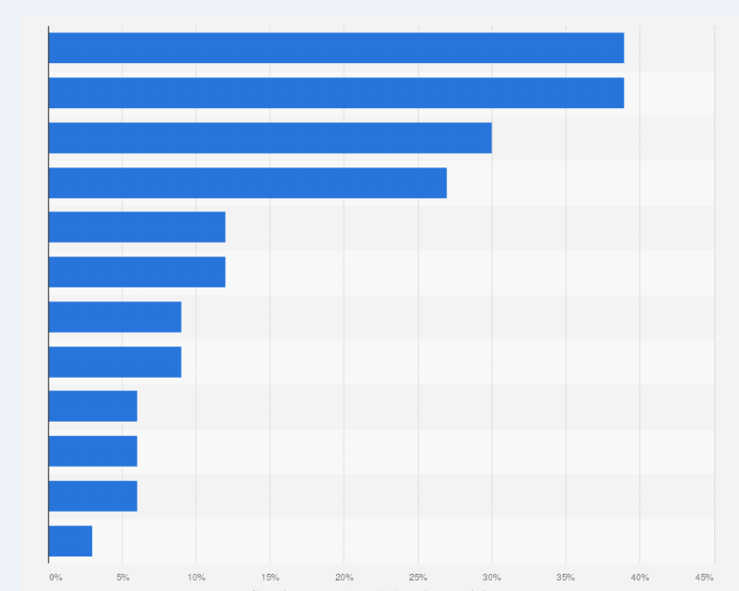

Figure 1.3: Challenges of brand management in the global economy
(Source: Statista.com, 2022)
In this case, it has been identified that brand management has included high development costs that have affected the global economy. Therefore, it has been found that ⅖th of the executives ranked position and sourcing costs are the biggest challenge for the fashion brand in 2022 (Statista.com, 2022). Apart from this, supply chain disruption and shipping delays have been recognised as challenges of brand management and affected the global economy.

1.5 Research aim and objectives
The aim of this research is to analyse the demand of brand management for addressing social, ethical, and business responsibility in the context of the global market and develop critical investigation based on multi-level and business perspectives and changed values that are constructed in business.
The objectives of the research study have been mentioned below.
- To promote, produce, and distribute effective services and goods that help to attract more consumers at both international and national levels.
- To infield the demand of business branding for supporting the sales efforts and marketing demand for developed and satisfying customers' needs.
- To assess the social, ethical, and conventional responsibilities of managers and employees to explore the brand in the global economy and market.
- To increase the customer's loyalty and business competition by differentiating the services and goods of different organizations.
- To establish the market leadership and critical literature review based on analysis of information.

1.6 Research questions
The research questions of the research are discussed below.
- What is the essential need of brand management and its objectives for exploring the services and brand values?
- What are key values and branding ranges to be explored by organizations with added economic development?
- How do managers and employees of a company evaluate the brand values and develop a good brand in a competitive economy?
- What are different brand awareness and marketing brand identities for promoting the services demanded at the right time to receive effective distribution channels in the market?
- What are effective differences between trade values and brand marks of business related to branding quizlet and marketing?

1.7 Proposed structure of the dissertation
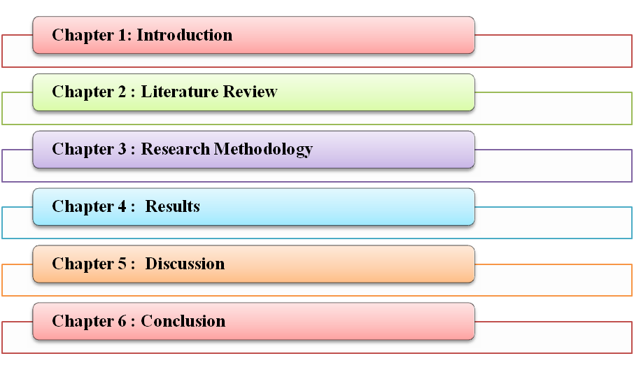

Figure 1.4: Proposed structure of the study
(Source: Created by the author)

1.8 Significance of the study
This study has been considered significant as this chapter has properly highlighted the implementing strategies in brand management in the global economy. In this case, the main significance of the study is to implement the strategies of brand management to enhance the global economy. Besides this, it has been stated that this chapter has importance in the context of mentioning the implementation of different strategies such as customer loyalty and also a business competition to introduce different products and services. In addition to this, it has helped to bring loyal customers as well as improve customer behaviour in the global economy.

1.9 Summary
From the above study, it has been summarized that brand management has helped to bring customer loyalty and the growth of the global economy. In this case, this study has properly mentioned the prime reason behind choosing the topic of the research. Therefore, the research rationale and problem statement have been discussed in this chapter. On the other hand, the aim, objectives and also questions of the research have been also discussed in this study which would be helpful to collect the relevant information regarding the topic. In addition to this, the main significance of the study has been analysed effectively to implement brand management in the global economy.

Chapter 2: Literature review

2.1 Introduction
Brand management has been considered as the programme of the strategic process of productivity that has used several techniques to develop a products and brands perceived value in the market. Proper brand management has influenced the performance of the brand and has perfectly calculated the contribution of the brand in the market. This chapter is going to talk about the several strategies that have been used in brand management and have created brand value in the market. The role, importance and effectiveness of brand management in the global economy have also been discussed in the chapter through several themes and theories.

2.2 Strategic Implementations to Improve Brand Management in the Global Economy
Branding or trademark is an essential element of modern business. It is an intangible asset of a company that becomes an identity for the customers of the company. According to Kasemsap (2018), the implementation of brand management in the global economy can begin with gathering, processing and analysing information on market situation, customer behaviour and retention, brand status and competition. Proper planning of market research, building brand development, hiring professionals and future development plans hold the second most important position in brand management. As the global market is expanding every day, branding of a company has to be done methodically and strategically. As argued by Niemelä (2019), availability of brands online has helped branding develop more than ever. Organizing by communicating amongst all the departments of the company, recruitment of proper professionals and strategic planning for future development plays an important role in strategic implementation of branding globally. Proper division of labour, encouragement amongst workers, providing of services and consulting companies to catch hold of the improvement intentions helps in brand improvement.
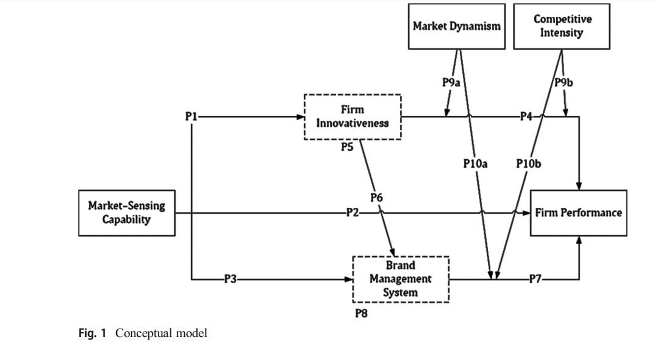

Figure 2.1 Conceptual Model of Future Research Direction
(Source: Bayighomog and Abubakar, 2020)
The brand management of companies also relies on controlling various plans and ideas. As suggested by Kasemsap (2018), the controlling of brand management depends upon strategic planning and implementation process, coordinate implementations between the company and its parties, controls costs and information. The mission of branding aims to indicate the purpose of inception of the branding, its meaning and its reasons for existence. Innovative techniques and market dynamism and competitive intensity are the key properties in improvement of brands in the global economy. As argued by Bayighomog and Abubakar (2020), economic improvement and future of brand management is dependent on knowledge management and decision-making capabilities of the management. Market sensing capabilities in future will lead to brand management and firm innovativeness of an organization, followed by the overall performance of the company. Market dynamism and competitive intensity for a firm will be dependent on the above three factors.

2.3 Negative Impact of Branding on Consumers
Branding is the most important aspect of a company, upon which the valuation of a company depends. The branding of companies and their valuation depends upon their customer and employee base, which has become volatile in today’s world. With the advent of the internet and social media, information spreads like wildfire. According to Yu and Soutar (2018), negative impacts in Brand Management are of two types; mild and high severity. In mild severity the information gathered from any media may affect the branding of a product. As argued by Paul (2019), the information that has been collected may not be authentic or verified, thus leading to a temporary tarnishing of the brand. At times with verified information, the brand may suffer temporary negativity which the company may resolve by taking various steps against it and at times re-launch the brand with brand new imaging.

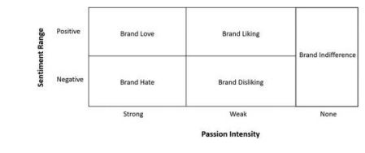

Figure 2.2: Conceptual Model of Negative Impact of Branding on Consumers
(Source: Fetscherin and Cayolla, 2019)
The severity of information may influence customers’ motivation process and may affect the brand image in the long run. As argued by Fetscherin and Cayolla (2019), negative news may impact sentiment of the customers severely.In this age of advanced social networking and media it is very easy to lose out the customer base of a company. As argued by Kasemsap (2018), it all starts with brand hate and brand disliking from a customer’s point, leading to brand indifference. Brand indifference may also arise from positive impacts as well, but indifference to a name solely depends on the negative impact made by the brand on its customers.

2.4 Positive Impact of Branding on Consumers
While ‘business branding’ may look like a trendy word, the real development of a brand relies on the development of the brand. The development of a brand and its positive impact on its business is deep rooted and meant for long term business growth. According to Paul (2019), branding management benefit is determined with the growth of the business. Over the years, the growth of the business has attracted the customers for the company and generated profits, making the brand known to its customers. It in turn cultivates customer loyalty and customer retention for the company. As argued by Cheng and Jiang (2021), customer loyalty and retention is done only after the brand develops a culture of cultivating customers, understanding their needs and meeting their grievances. Fast tracking of branding in this competitive market has to be done by the company to retain the customers for its long run success.
The loyal customer base helps a company grow in the long run and branding management has to be positively impactful on customers. According to Fetscherin and Cayolla (2019), brand love and brand liking helps a company grows. Though it may retain some indifference amongst customers, the loyal customers will not choose over the brand with something new. As argued by Cheng and Jiang (2021), even with an increase in price of the product of the company, the consumers would never go off the track as their main focus lies with the quality and value for money. Unless there is a huge difference in what was sold and what is sold to the customers, branding and its impact on consumers remain the same.

2.5 Effectiveness of Brand Management in the Global Economy
Effectiveness in branding is one of the major aspects of any viable marketing strategies. It helps in the growth of the brand, followed by the growth of its business. Effective branding leads to a long- lasting impact in the minds of the customers and it help in distinguishing the brand from others in the market. According to Kasemsap (2018), investing in building a brand pays off in the long run of any business. The major impact of effective branding starts with the emotional appeal of the brand. The consumers initially seek value for money, followed by emotional attachment towards the brand. This helps in building a loyal consumer base for the company that becomes beneficial in the long run. As argued by Fetscherin and Cayolla (2019), benefits from referrals can also be seen in case the company has managed to build a loyal consumer base. Referrals help the company grow, followed by business expansion and price regulation.
Its chance of success becomes bleak, unless a brand appeals emotionally to the mass. As opined by Bayighomog and Abubakar (2020), the companies with higher concentration of customer loyalty, grow at a faster rate compared to companies with a volatile customer base. Thus, in the age of cut-throat competition, customer retention and effective brand management is essential for a company’s growth. As argued by Yu and Soutar (2018), less risk of consumers means higher chances of customer retention, followed by higher revenue generation of a company. Profit generation of a company solely depends upon the above factors keeping brand management in hand.

2.6 Effectiveness of the Brand value on the global economy and its growth
Interest has been found in the market in the development of the value of brand management and the productivity of a particular brand. It has been opined by Paul (2019), thatbrand positioning brand equity and massive marketing have been related to the effectiveness of the brand value in the economical market. The brand value and its development and the global economy and its growth have been affected by each other's influences. Brand value has been considered an important and effective requirement for global economic growth. Moreover, several brands have supported and encouraged the competition that has been held in the market and that has been created based on brand value rather than prices. In order to increase the global economy, the brand's values have been calculated through innovation, quality and reputation. As these four elements have created a competition which has made an impact on the global economy. It has been argued by Swaminathan et al. (2020), that The Company has been recognized with a perspective view that brands have been considered as assets and analysis of several roles and functions that brands have served for companies, both financially and strategically. The moment, a co-company has been merged or bought by another owner, therefore, the new owner has wanted to use the previous images and logos for the brand identity to make a sale of products.However, the brand has an amount of value that has been forced to pay for right.

2.7 Several marketing strategies to facilitate digitalization
Several strategies have been created to make a brand value in the market and to attract customers' minds. It has been opined by Crittenden et al. (2019), that several digital marketing sites have created brand values such as content marketing, social media marketing, email marketing and voice marketing. Search engine marketing has also been considered an important digital marketing strategy that has created brand value in the market. A more direct process can effectively assess how individuals engage with brands through the advertisements that are delivered to them. It has been argued by Lee et al. (2019), that in terms of better performance of the firm, digital marketing adoption has an important role for the firm with transformational leadership. Mobile marketing and pay-per-click marketing have also been considered effective sites for digital marketing.
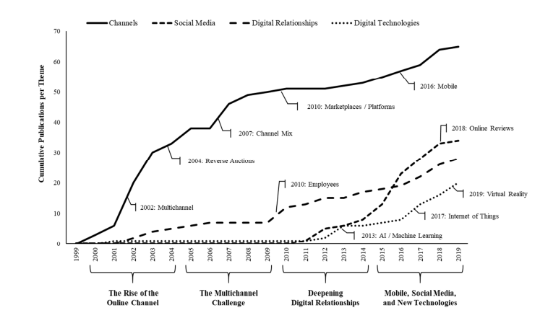

Figure 2.3: The cumulative body and research digital strategy
(Source: Herhausenet al. 2020)
Content marketing has allowed the marketing teams to make knowledge about the brand to the consumers. It has been opined by Herhausenet al. (2020), that the key focus of a digital marketing platform and its strategy is the process of digital resources.Itsinputs have created the capabilities from which competitive advantage and brand value have been derived. It has been argued that Crittendenet al. (2019)have created three stages such as the consideration stage, the awareness stage and the decision stage. Social media marketing has been considered the best marketing platform to create brand value in the market as the consumers have several social media accounts and filled several pages of brands. Email marketing has allowed brands to send attractive emails about their brand's offers with images which have helped to create brand value in the customer's mind. Mobile marketing has taken initiatives including several of the digital marketing platforms and their strategies that have been mentioned above. It typically leverages a combination of social media, text messages, pushes notifications, email, and mobile applications. Marketing automation has also been considered as the digital advertising platform that has influenced the marketing strategy and the brand value in the market.

2.8 The economic importance of brands includes several reasons
Every brand has its economic value and importance and it has included several reasons which have influenced the economic importance of a brand. It has been opined by Foroudi (2019), the process and ways through which the brand influences the consumers and its influences have grown with significance. The brand and its reputation have protected the customers of the hotel industry also by properly guiding them. It has been argued by Abdullahi (2020), that the strong brand shared a commendable performance which could have been measured by the customer. It has created economic value for the brand as a strong range of performance has influenced the economic value.

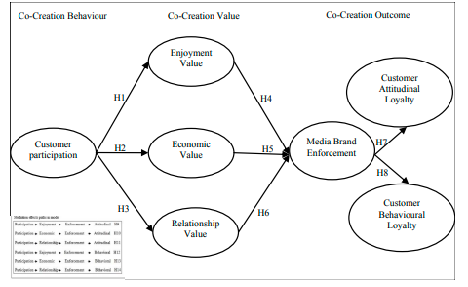

Figure 2.4: The research model of brand and customer loyalty
(Source: Khajeheian and Ebrahimi, 2021)
The above image has clarified that customer loyalty and the economic value of a brand have been influenced by each other. It has been opined by Khajeheian and Ebrahimi (2021), that customer loyalty has been considered responsible for the development of the brand's economic value. Television has that media that also manages social media accounts on Facebook, Twitter, Instagram and YouTube. It has been argued by Li et al. (2020), that brand signature has the major tool that has been created to transmit knowledge consistently and the reputation to customers. Therefore, the brand value and the brand recognition have been able to have ample space to grow.

2. 9 Role of Brand Management in the Global Economy
Brand management has generated the demand for products to enhance economic growth. In this case, it has been found that it has helped to enhance the profit margins as well as enhance the market share and core value of the organisation. Therefore, the brand's experience has captured the affective, social and also cognitive responses of the brand. As opined by Dwivedi et al.(2018), brand credibility has captured the internal subjective as well as behavioural aspects of the customers to enhance the overall performance. In addition to this, it has played a significant role to influence customers and providing the core values to the business procedures. Brand management has affected customer satisfaction as well as loyalty directly which has contributed to global economic growth. On the other hand, as argued by Tien et al. (2019), brand management has developed a good relationship with the target market that has been essential for economic growth. In addition to this, brand management has also increased the perceived value of the products and also enhances the franchise value of the brand.
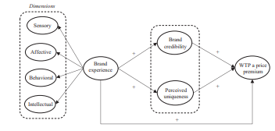

Figure 2.5: Role of brand management in the global economy
(Source: Dwivedi et al. 2018)
Brand management has changed the business process which has affected the growth as well as the adaption process in the competitive economy. As stated by M'zunguet al.(2019), brand management has helped customers to recognise the products through the brands such as exploiting brand value. Besides this, brand management has been helpful to grow the business process as well as brand awareness in the market. On the other hand, as argued by Fernandes and Moreira (2019), it has also helped businesses to inventory, calculate and also performed other records as well as allowed the business to legally protect the particular characteristics of the products. Apart from this, it has increased the price as well as the value of the products to develop economic growth.

2.10 Analysis of the effect of leadership management on the brand management
Leadership management can facile brand management to understand and influence the object of the business. Moreover, effective leadership has various functions to lead the brand management in brand management in the international business market. As opined by Purwantoetal.(2021), the leadership of the organisation indicates to development of the workforce and the production of the organisation so that the organisational are beneficiated in the global economic market. In addition to this, in the organisation, employees can be inspired by following the leader and good leadership has the potential to bring out productivity in the employees. As argued by Zhang and Ma (2021), it helps to give shape to the organisational goals in the global business market. In addition to this, the denunciative work in the organisation affects the behaviours that lead to developing the attention of the organisation. Moreover, effective leadership has the potential to creat6 a vision of the future that can ensure the employees and as well as the organisation show commitment to work in the organisation to increase the annual revenue in the global economy market.
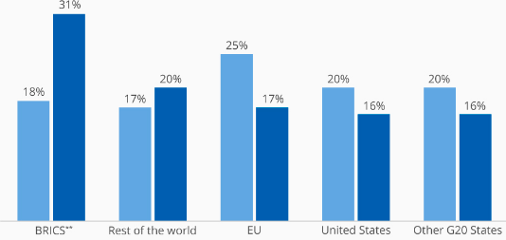

Figure 2.6: World economic transition
(Source: Statista.com, 2022)
In the above picture, it has been shown that establishing a larger group of leaders in the international business market helps to increase the world economic transaction as it has shown in the graph 25 per cent has been increased by developing leadership management in the international business market. Moreover, the past transaction was 17 per cent in the global economic market so that reason it can be stated that leadership management has helped to develop the world economy. As argued by Zeikeet al. (2019), creating, functioning and organizing leadership management to improve brand management can impact the long-term of engaging the employees. Therefore, the organisation's goal in the global economy market can be achieved effectively to focus on the objec6t of the organisation.

2.11 Analysis of the development of customer loyalty by creating competitiveness in an organisation
Customer loyalty is a constant choice of the same products from the same brand and it helps to generate the global economy in the international business market. Moreover, the loyalty of the consumer depends on the attitude of the brand in the global business market as its service and production need to improve effective to give good service. It has been observed that customer loyalty refers to becoming repeat customers based on past experiences and it also helps to increase competitiveness in the organisation. As opined by Zhang and Ma (2021), a successful business can attract customer loyalty by improving its customer relationship. Moreover, the customer relationship allows the new customer to gain at a lower cost to the company as the feedback of the organisation or the positive reputation of the organisation can help to increase the global economy of the organisation to increase customer loyalty. As argued by Al-Hawary and Al-Fassed (2022), the loyal customer can be the economic source of income for a particular organisation and it has an impact upon the people to take the incentives. Moreover, the competition in the market has increased by conducting customer loyalty programs in the organisation.
It has been observed that customer losses can be prevented and revenue streams can be secure with help of the new customer. As stated by Zeikeet al. (2019),it has been observed that customer losses can be prevented and revenue streams can be secured with help of the new customer. Moreover, it has the potential to establish great competition in the global business market and provides a competitive advantage to the particular organisation in the global economic market. As argued by Khan et al. (2022), the customer wants to trust the same organisation by sharing the value in the organization. Hence evaluation can improve the trust of the customer as they6 expect from the organisation.

2.12 Impact of customer loyalty to explore brand management in the global market
Customer loyalty has impacted various ways of brand management in the global market. As opined by Al-Hawary and Al-Fassed (2022), loyalty indicates organisational success and explores brand management effectively. In addition to this customer loyalty can explore the way to generate more revenue in the organization as it has the potential to change the buying decision of the consumer and several brands have the same product in the global market through the loyalty program of the customer can help to increase the brand value in the organisation. As argued by Ibrahim (2022), the urgent need of the customer can be to increase brand exploration in the global economic market. Moreover, the exploration of brand management is conducted by considering the various dimension of the customer in the organisation.
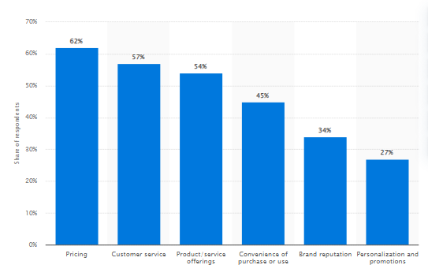

Figure 2.7: Factors in keeping customer loyalty to brands
(Source: Statista.com, 2022)
In the above graph, it has been shown that piercing is the most significant factor that impacts the customer loyalty program in the organisation as it is near 62 per cent. Moreover, the brand in the global business market has increased the low fidelity of the purchasing and its behaviours. As mentioned by Japiana and Keni (2022) the customer loyalty program led to exploring brand management as it has several dimension in the organisation to increase the annual revenue of the organisation. Moreover, the product needs to be a big admiration for exploring the brand and it has the potential to give an effort to make the customer portfolio. In addition to this, it is difficult to achieve customer loyalty at the level of absent of the particular condition. As argued by Alzoubiet al. (2022), customer loyalty can be classified as the behavioural of the consumer with positive decisions of the consumer after analysing the customer and brand relation that enables the individual to reach the other level of customer loyalty. Hence knowledge of the product and better leadership can positively impact customer loyalty for exploring brand management.

2.13 Importance of brand management in the global economy
Brand Management has provided an opportunity to ensure the intangible and visual aspects of the brand are aligned. In that case, a brand that is consistent and also puts the customer at ease and also it has played a vital role in the global market. As opined by Pamfilie and Croitoru (2018), the most important part of brand management is ongoing maintenance. In that case, it has maintained proper brand management that also involved and makes sure the promotional piece. In that case, the touch point and also every usage of the name is a message that the organization also has a proper goal by reinforcing the brand. As argued by Ozretic-Dosenet al. (2018), brand management has helped to fix the price of the object and it depends on the competitive market. Brand management is a proper board team that is used to describe a marketing strategy and also maintain that development and also brings awareness to the wider value and reputation.
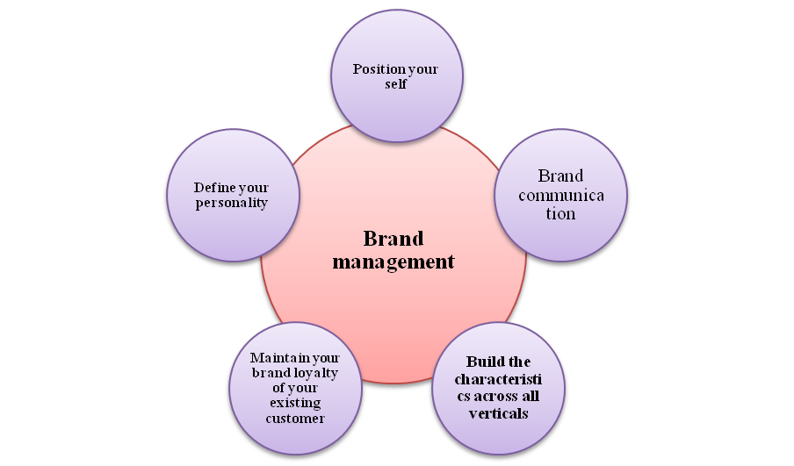

Figure 2.8: Brand management
(Source: Created by author)
There is a strong brand management strategy that has helped to build and nurture the closest relationship in audiences. As stated, that Dastgerdi and De Luca (2019), the brand management of the global economy has benefited local competitors. Global brands are stronger and also more valuable than generating greater consumer awareness. Brand management is a science that has crafted the sustaining of a brand. In that case, this means that it is identified the brand positioning and also delivers the brand value constantly. On the contrary Majerovaet al. (2020) stated that, branding has created a consumer commitment to the business and also the roust brand differences in products. This theory has played a vital role in revel the impact on brand management. There is a competitor who also gives the business and also allowing enhancing the sales and growth of the business. Brand management has handled both noticeable and also intangible emotional connections. The brand value has added to the blend of the right marketing and also creates brand loyalty. Brand management has helped the consumer to recognize the company and services through the business status. It has built the brand through the messages, images, and also sales that realizes the company's reputation. It needs to make sure that it has consistently lived up to the brand and also promise each day. Proper brand management has helped to include promotional pieces and touch on the brand name.

2.14 Impact of brand value in economics development
The brand value is an important part that has prescribed the brand which is distinct and aligns with personal values. It is really powerful that has a competitive advantage and the value refers to the worth to the consumer. As opined by Honarmandiet al. (2019), brand value has helped to increase the company's reputation in the global market and also develop the organization's revenue. In that case, the brand value has increased the foundational benefits and enhanced the company standards. As argued by Zéman and Bogdan (2019), brand value is assessing the number that has current consumers. It has also predicted the numbers of future consumers and assigned the lifetime values to each.
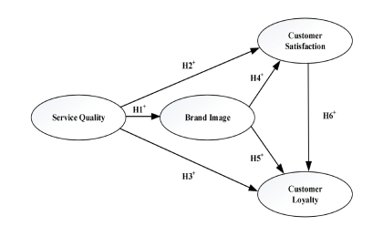

Figure 2.9: Impact of brand value in economics development
(Source: DAM and DAM, 2021)
There is a lifetime value that can be average and encompasses the typical consumer in different categories with several values. As opined by Ganushchak-Efimenkoet al. (2018), there is a brand value that has stood for a promise to a customer or market segment. The proportion is an easy reason that the consumer should buy the product and also provide services in a particular business. As argued by Maiboroda and Marchuk (2021), brand value has helped to enhance brand equality and also develop the organization's revenue. On the other hand, the brand value has developed the4 revenue scale of an organization that has helped to improve business in the global market. The brand value also attracts consumers which has increased the consumer flow and also increase the organization's revenue. In a global market, it has left an impact on the economy which is a positive symbol for business development.

2.15 Differentiation between trade values and brand marks
The brand name has a company name that ascribes an exact product or service in the global economy market. As opined by Cardosoet al. (2019), the organization has developed the brand marks as per consumers' needs. It has been used by the organization that represents its goods and also provided services and consumer refers to back. The services of the brand name have increased the value of the organization. As argued by Tienet al. (2019), a trademark is an intellectual property that is right to protect the brand in the global economy. On the other hand, the trademark is an amount of buy that has sells traders that taken at the place.
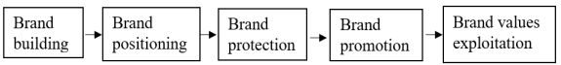

Figure 2.10: Differentiation between trade values and brand marks
(Source: Tienet al. 2019)
It has taken the account on a day to day that depends to track the overall stock. According to Handel and Schwartzstein (2018), the stock market has trended a particular stock that has included trade values. The traded may be denied that has repeated and exact sequence of exchanging of goods. On the contrary Hadadzadehet al. (2018) stated that, the market as the economy is an institution that has been created by regular trade between multiplicities of traders. The brand marks also have played a vital role to enhance the organization’s reputation.

2.16 Analysis the key values and branding ranges on economic development
Brand has included key values and ranges that have affected greatly economic development of the product. As opined by Nosratabadiet al. (2019), brand management has also encouraged the awareness of the intellectual property rights for promoting the product in the abroad. In addition to this, the effective brand management strategy has provided a major edge to enhance the competitive markets. On the other hand, as argued by Hoang Thanh et al. (2018), brand management has increased the awareness as well as encouraged the rural economy as well as protected the potential. Hence, the brand has also identified as well as differentiated the products from the other products that have been helpful for economic development.
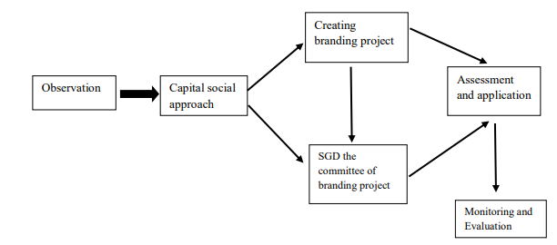

Figure 2.11: Brand management in economic development
(Source: Hoang Thanh et al. 2018)
Brand management has helped to minimise the risk of the investment as well as portfolios of the safeguarding investment. In this case, low risk has brought a great market confidence as well as enhanced support from the financial audiences that has stimulated and also encouraged for further investment. As mentioned by DAM and DAM(2021), the proper brand image has supported the clients for realizing the requirements of the brand that has led for economic development. In addition to this, brand management has cultivated the loyalty of the customers to enhance value of the product. On the other hand, as argued by Flores‐Hernández et al.(2020), it has also differentiated the products from the competitors and also received a significant position in the market. Apart from this, it has boosted the revenue; achieve long term goals that have been helpful for economic development.

2.17 Factors of brand management in economic development
There have been included various kinds of factors of the brand management that have helped in the context of economic development. Hence, the important factors of the brand management are brand awareness that has helped to achieve the range of objectives and goals of the business. As stated by Yan(2019), it has expanded the audience as well as builds the brand affinity. In addition to this, another factor is brand image that has helped the product for standing out in the market. On the other hand, as argued by Ganushchak-Efimenko et al.(2018), this factor has made proper purchase decision and also the product more complex. In this case, it has been identified that it has encouraged and also supported the competition process based on the core values such as innovation, prices, quality and also reputation.
Another factor of the brand association is very significant for economic development of the product as well as services. As mentioned by Ananda (2022), it has helped to differentiate the products from the rivals to make unique qualities. Besides this, this factor has been also helpful to create a positive price perception as well as offered best quality product on the market. On the other hand, as argued by Prashanth and Veena(2022), another significant factor of brand loyalty has been helpful for customer retention as well as led new customers. Therefore, it has helped in the context of positive emotions and also created competitive advantage in the market for growth of economy.

2.18 Michael Spence's theory in brand management
The signalling theory also known as the Michale Spence theory has suggested an important medium of quality and the assessment between the consumer and the consumer. This theory has been used for elaborating the behaviour when two parties have access to different levels and information. As opined by Rahman et al. (2018), the signalling theory is an important part that has described the behaviour when two different parties in the business. There is one party that has chosen the sender and communicates the information to intercept the signal. As argued by Shafranskaya and Potapov (2018), the signalling theory has suggested the brand which is an important part and there is a quality assessment which is between the firm and consumers. the signalling theory for brand management has maintained the financial health of the organization.
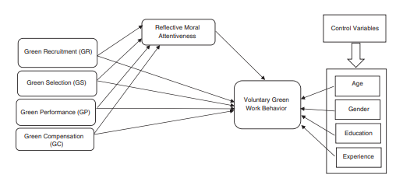

Figure 2.12: Michael Spence's theory
(Source: Garavanet al. 2022)
It is not available to all parties and businesses but it is important because it has reduced information assembly. As stated, that Na et al. (2020), the signalling theory has become an essential part that employees and dissertations have eliminated the business weakness. In that case, it has observed the knowledge gap and also the perspective of employees that it has many domains for human resources management. On the contrary Carliniet al. (2019) stated that, signalling theory has reduced information asymmetry and it has become an essential view. On the other hand, the organization has to follow this theory to develop its business status.

2.19Bureaucratic theory
The theory of management has a process that the best way to run the organization is to structure that into a rigid hierarchy. There is governed by strict rules and process that has helped to improve the brand status. As opined by Lee and Van Ryzin (2019), the Max Weber theory has followed the bureaucracy process that all the business has processed for the business task. It is the basis of division that has a task and it should divide a competency in the functional specialization. The workers will be well aware and it is the role of worth in the organization. As argued by Peeterset al. (2018), Bureaucrats have fulfilled an important role that has enforcing the legislative perception. It has the value that the breach has benefited society. And it has created a structure that helps to keep people productive and safe in an organization. It has created rigid policies and laws that must be followed to keep a safeguard.
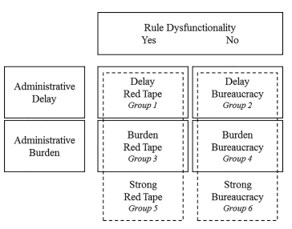

Figure 2.13: Bureaucratic theory
(Source: Hattkeet al. 2020)
There is a rule that has regulation in bureaucracy that is often and also rigid in inflexible which has helped to achieve the goal. According to Morgan et al. (2019), the rules frames to achieve the organizational objectives have become an end. In a bureaucratic organization that has stressed in a mechanical way that has done the entire process. On the contrary, Busuioc and Rimkutė (2020) stated that, bureaucracy theory has played an effective role in activating their goal and it is often rigid. In brand management, the value of the bureaucracy theory consumes a large part of business development.

2.20 Contingencymanagement theory
A contingency theory has been implemented in brand management that has developed the claim status and also fined the way to organize a corporation. As opined by Zafar et al. (2021), an organization has to lead to make decisions instead of the optimal action in external and internal situations. This contingency theory has provided managers with a wide range of ways to react to problems. It has given the significant decision-making that the business owner has to implement this theory. The managers have to bend the policy if the circumstances are in demand. As argued by Marques-Quinteiro et al.(2019), the major implication of the contingency theory has summarized managerial action. It must be consistent that has needed external forces and there is a primary advantage of this theory. It has provided a realistic theory that helped to view the management and organization. It has discarded the universal validity of the principles and the manager's situation-oriented thing. The contingency theory has increased the leader's effectiveness and it is contingent depending on the leadership style. It is an individual part that has developed an effective leader in one working circumstance. It has suggested the best leader for the organization and it depends on the specific situational factors. The practical application of the theory has a different way and has helped to determine the best candidate.
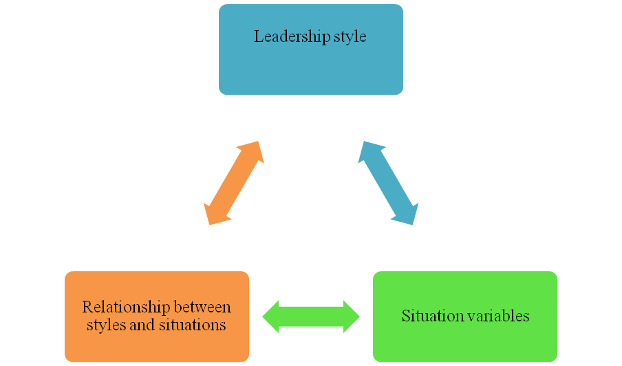

Figure 2.14: Contingency management theory
(Source: Created by author)
The contingency theory has developed the organization's swatters and also increased the brand value. As opined by Serrano-Sánchez et al. (2022), it is a time-saving process and also mitigates the damage that avoids negative presses. It has emphasized the best way to manage depends on various situational factors. The external environment, technology, and organizational characteristics have paled a vital role in contingency theory. The basic premise of the contingency theory has the best way to lead. There are too many external and international constrain that alter the way with best leads. As argued by Velinovet al. (2018), the organization has claimed that there is no best way to manage the corporation and also lead the company. It has made to lead a company to make the decision that has the optimal course in contingent. This contingency theory has been developed the organization work and also leave an impact on brand manager of the organization.

2.21 Definition of brand management and the essential strategies of brand management
Brand management has helped to manage the quality of the products and it has helped to increase the value of the organizations. As opined by Tien et al. (2019), brand management has helped in product and business management. Brands are the basic identification of a company and it has helped to develop the reputation of the company. The brands have developed the business segment in the market. Brand management is a function of marketing that helps to develop an organization. The brand management team has used a special technique to maintain the quality of the brand of organizations. Brand management has provided value to the companies and it has increased sales. The brand management process has related to the customers' loyalty and it has helped to maintain a strong image of the organization. As argued by Ramírez et al. (2019) brand management has to maintain the brand voice, brand identity, brand values, brand targeting, and brand promise. The brand management team has focused on the all-above element to manage the quality of the brands.
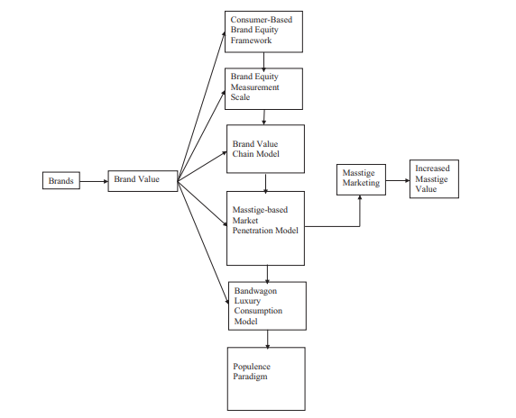

Figure 2.15: Brand management
(Source: Paul, 2019)
The management team has maintained the target marketing to develop the marketing quality of the brands. As stated by Bayighomoget al. (2020), the management team has maintained the brand culture and brand identity. Brand management has focused on brand loyalty, and brand awareness. The management team has adopted the multiproduct branding strategy, multi-branding, and private branding strategies. The brand management team has used the strategies to develop companies’ values, marketing programs, and brand reputation. As argued by Ramírez et al. (2019), the strategies have helped to analyse the brand performance and it has helped to monitor the brand's reputation. The management team has also used individual branding strategies and attitude branding strategies to improve the brand management process. Line extension and brand extension are essential to brand management strategies for designing a brand.

2.22Scientific management theory
The Scientific management theory has helped to develop the administration process in a brand management process. As opined by Paramboor and Ibrahim (2018), the theory has made a crucial role between employees and leaders and the theory has focused on the welfare of the employees. The significance of the theory is it strong the administrative process. As argued by Ramírez et al. (2019), the theory has helped to raise the profit and productivity of brands and it is very effective in brand management. The theory has included the resource management process, technology management, and cost management.
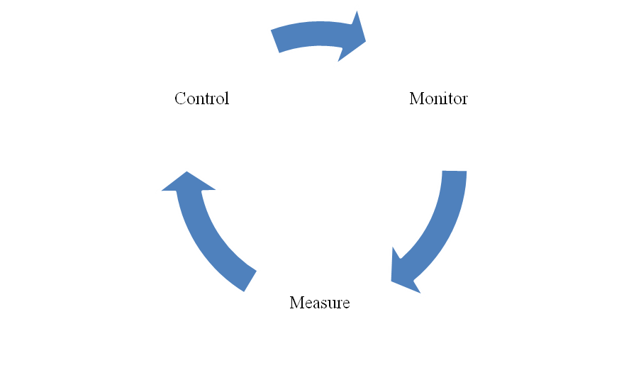

Figure 2.16: Scientific management theory
(Source: Created by author)
The theory has developed the process of operation control management and it has helped to improve labour relations. As stated by Tien et al. (2019), the theory has helped to0 motivate workers and develop the lead management process. On the other hand, the negative factor of the theory is it neglects the morals and ethical values of products and it has ignored the ultimate reality. The theory has helped in the brand management practice and it has helped to develop the economic factor of brands. As argued by Bayighomoget al. (2020), it has helped to motivate workers and it has focused on the respective duties of the workers. The methodology has played a significant role in the brand management process.

2.23 Conceptual framework
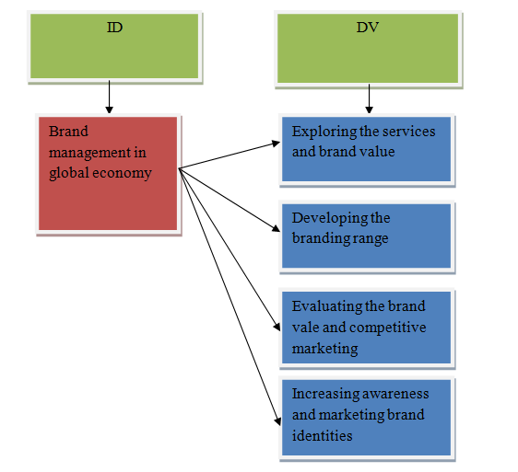

Figure 2.17: Conceptual framework
(Source: Created by author)

2.24 Literature gap
There is a lack of sufficient data that helped to complete the research for that reason; the research has used external data from different sources. The entire process is time-consuming to search the data and also analyse those data. In that case, the research paper is complicated due to the data crisis. In Google scholar, there is no sufficient article that has been used in this research, and for that reason, the researcher has faced trouble collecting this data. Proper data has provided authenticity to the research; in that case, the researchers are not able to get authentic data easily.

2.25 Summary
This chapter of the literature review has analysed brand management in the global economy and its influence. This chapter also summarised several implementations that have influenced the brand to create economic value in the market. The influence of marketing strategies has also been discussed here which has been considered the main reason for creating brand value and growing the economy. The importance of brand management has also been discussed here which has also inspired the economic growth of the brand in the global market. The positive and negative impacts of brand management have also been summarised in this chapter.

Chapter 3: Research methodology

3.1 Introduction
The section forwards with the research methodology and delivers the strategic theoretical techniques and functions that are used by the researcher. It also deals with the collection of relevant details and the chapter contains the authentic data that is detained within the study. The centre is also in the run to assume the data collection procedure and analyse the entire details of the work in the right manner. The section mentions logical justification and gains a better understanding of the study and also stimulates the following details of the work. It also confronts the crucial role of strategy in analysing the data process.

3.2 Research onion
The research onion offers a series of executing the possible demands of the study and executes within the conducting activities. The onion also based the work on dealing with the following stages by executing the appropriate time horizon. It also comes up with the stages by executing the representing benefits and better understanding of the project.
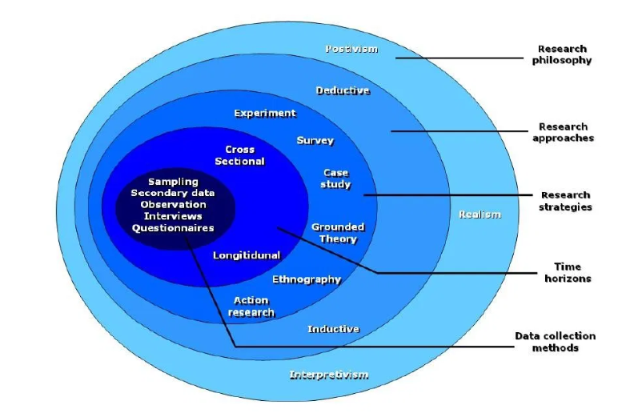

Figure 3.1: Research onion
(Source: Created by author)
The research onion comes up with the execution of illustrating the stages and also describing the variety of projects. The reach also confronts the understanding of the details stages and also applies its final execution of the process. As opined by Saunders et al. (2015), the layers of the research go on executing with the unwrapping of the steps and also proceed with the unwrapping of the onion layer. It also moves forward with the effective progression of the contexts. The research onion of Saunders mainly helps to also demonstrate multiple steps that are needed individually for achieving research goals. Thereby, in this particular research activity, researchers have worked hard for illustrating each and every method that are used for conducting dissertation. Moreover, the outermost research onion has been considered as the research philosophy as it has been identified as the centremost point of the onion as the tool. It has been helpful for analysing critically in respect of getting the best process to get the outcome. Research onion has been helpful to evaluate each and every layer of onion as effective tool for accomplishing the dissertation.
Thereby, it has been identified that research onion has been helpful to evaluate the layers such as approach, design, philosophy and also incorporating the data for determining various aspects of the research.The other layers of the research go on delivering the representation of the benefits to execute the data collection study and facilities within the activity to illustrate the main criteria of the function. As argued by Melnikovas (2018), further studies it implies the execution of the methods which come over the systemised model features and results in an efficient process. It also goes with the social ability and ideas on the claiming about the attributes of the future aspect. The onion helps to understand the series of stages by executing the different methods and data collection and illustrates more of the function details.

3.3 Research philosophy
Research philosophy moves forward with the analysis of the functions and also facilities with reality. Research philosophy can be identified as the process to analyse the strategies and ideas that are mainly associated with research. Research philosophy has been mainly performed as an effective tool of research for incorporating data in scientific method in respect to get an informed and better research development. Moreover, research philosophy has been helpful to infuse all sorts of data that would be helpful to accomplish the research by the researchers. It is a kind of system that induces the objectifying of the knowledge and also obtaining the main aspects of the study.

Figure 3.2: Research philosophy
(Source: Created by author)
The above figure deals with the execution of the research philosophy which helps out to execute the proper details of the related project. The research philosophy contains realism, positivism, pragmatism, interpretivism and post-positivism. In the following study, the research philosophy that has been used is Interpretivism. The case study has also been mentioned within the research to gain more details. As opined by Madden (2022), it also comes forth with the dealing choices and also applies the main purpose and methods to work out on the following projects. In several stages, it moves within the purpose of integrating with the stages of development of the deep study. In the case of interpretivism which comes up with the social theories and news more conduction and reality about the related topic. It goes on focusing on the reasons, opinions and motivations of the particular study. As argued by Moon et al. (2019), the main reason to go on dealing with the study is to get through the process of execution with the motivation and also come up with a conclusion. The more realistic feature of the study understands it comes up. The further process deals with the case study and executes proper information about the study.

3.4 Research approach
The following approach delivers the right details of the project and goes on to gain the legitimacy of the findings of the study. It provides an analysis of the plans and procedures for the related topic. It goes on dealing out the plans and reasoning about the following topic and gaining more understanding.

Figure 3.3: Research approach
(Source: Created by author)
The above-mentioned figure represents a research approach which is executed within the stream of dealing out the dynamic conditions. In research, it contains approaches such as abductive, inductive and deductive approaches. In this particular study, the inductive approach has been used to gain more understanding of the topic. As opined by Ditlmannet al. (2019), the main understanding of the inductive approach is the allowance of flexibility in the system, attending to the context and supporting the generation of the new theory. In the study, also deals with the process of executing the case study and illustrating more about the formulation. The inductive approach also formulates the process of executing the right amount of reasoning and also conducting out the facts. The study also induces specific information on better details. As argued by Dalati (2021), it deals with the proper observation of the system and gains more originality to the information contained. It also supports the process of dealing with the exact details of the work and gains more performance about the information. It also induces functions and other development programs.

3.5 Research design
Research design is induced with the formulation of executing the right method and also ensuring the methods of gaining better performance rates. The following cases come up with a procedure for collecting high-quality data, utilising credible sources and also drawing sustainable conclusions.

Figure 3.4: Research design
(Source: Created by author)
The above figure denotes the research design and execution with the process of analysing credible sources. The former design denotes the features and also encourages others to carry out the functions. The types of that design contain explanatory, exploratory and descriptive, which also form the process of gaining authentic information about the study. In this particular study, the former research design that has been used is exploratory. As opined by Antony et al. (2021), the main facts about the design are to analyse the study programmes and other processes. Exploratory goes through the process of executing with the beads to understand the depth and also instigate the functions. It also ensures the narrowing down of the topic formulation of the following hypothesis. It also impairs the main activity by dealing with the main function of supporting the scope of understanding the samples. As argued by Gayle et al. (2021), it also features the process of executing the indicative of the study. In the case of the pre-researches conducted that comes forward with the prior information and also detects the issues of the related topic. In numerous ways, the design conducts to get the definition of the work role and its execution.

3.6 Research Strategy
The following research strategy follows up the method of conducting the choice the data collection analysis and releasing more details about it. The further study also forms the strategy to indict the right form of analysing the research. As opined by Bobrovskij (2018), it also conducts the right process of dealing with the main functions and analysis of the related topic. The research strategy that they conduct on the basis of gaining the right procedure to formulate the direction, conduction of the study and its surveys. The following strategy is followed by the analysis of qualitative research with the case study data involved in the work process. The strategies involved the analysis of the supporting creation and other logical information. It moves forward with the action research phenomena to well conduct the process. In the following case study executes with the researcher can form relationships and other entities. As argued by Cerveny et al. (2020), the study also comes forward with the proper execution of fulfilling the entities and also provides the main insights about the business execution. The research strategy conveys the provision of the study in a more indulgent way and process. The entire feature comes up with a better understanding of the topic and also stimulates more features about the study.

3.7 Data collection
Data collection analysis covers the streams of gaming persuasiveness about the study and gains better features. The information has been collected with generations of explanations, methodology and other applied features. Two primary methods for performing data analysis have been identified as qualitative and quantitative analysis. These types of techniques of data analysis are mainly used independently in respect to combine other leaders in the business for making decisions in respect to acquiring the insights of business from multiple types of data.

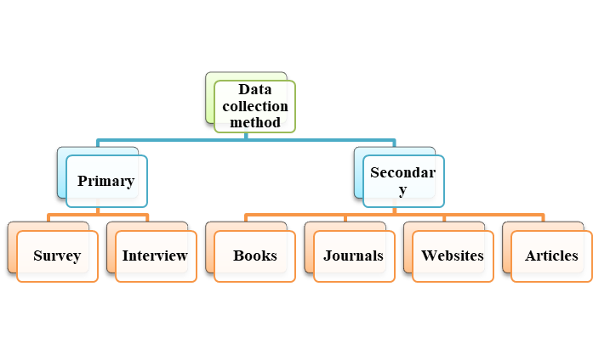

Figure 3.5: Data collection method
(Source: Created by author)
The above figure denotes the processes of the data collection method and how it initiates building up the process in the right manner. As opined by Lobe et al. (2020), it also conveys its process by aggregating the main dealings of the functions. In the following case, the data collection methods were analysed with the excision of the growing states and also presented the data collection analysis in the right manner. It also deals with supplemental material to convey all kinds of analysis. In the following study, qualitative research has been used with the proper prediction of the case study. The following method used provided more authenticity about the research and gives more analysis about the study. As argued by Aguiniset al. (2021), it indulges to execute the right kind of activity and also gives better explanations about the status. The details of the work and provide the study with a good structure about the entire process. In other ways, the method and its strategy is the main function to deal with better understanding.

3.8 Data analysis method
The method of data collection method has been considered as the systematic method for collecting authentic and accurate information from relevant and authentic sources. It can help to provide insight for getting an accurate answer. As opined by Al-Qurabat and Idrees (2018), method of data collection has been considered as one of the effective tools in the dissertation for accomplishing the data in research. It can also be stated that the method of a popular collection of data has been found as primary and secondary methods. The primary method of collection of data has been divided into quantitative and qualitative. Data analysis has been identified as the process to collect, model, and also analysing the data for extracting insights that can help to make decisions supportively. As stated by Krishnamurthi et al. (2020), there are several methods and techniques to perform analysis depending on the industry and the aim of the investigation. Another benefit that for which data analysis are performed is that it helps to provide great benefit in reducing costs. In respect of advanced technologies, in the form of predictive analysis, the business gets supported with the help of getting trends, patterns, and improvement opportunities and also in making a plan of the strategies respectively. It has been argued by Astolfi et al. (2020), that on this particular time and research, data analysis can also help to save resources and money for implementing proper strategies. It also helps to predict various scenarios such as helping to analyses the demand of the appropriate information and data.
All these various methods have been largely based on major core areas such as qualitative and quantitative research. This research method can help to practically analysed the type of data that has been collected (Al-Qurabat and Idrees, 2018). It helps to understand that whether the data has been quantitative or qualitative in nature, which means it is numerical or non-numerical. Secondary data in qualitative form are mainly collected in the form of information that are mainly collected from various reports and information tools. It helps to provide a wide variety of information and data. It includes newspapers, novels, government reports, diaries, letters and also from other possible tools.
In the method of data collection in primary qualitative, responses are collected by performing interviews and in the quantitative method; surveys are performed by performing questionnaires. Besides the primary ones, another data collection method that has been considered for doing this research has been the secondary data. In this particular process, it has been decided to collect all the information or data from books, journals, and other authentic sources (Blumenberg and Barros, 2018). Thereby, in this research, data collection has been performed in the secondary qualitative method. Data has been accumulated by collecting information from the authentic source of information and also from journals, government websites, articles and books.

3.9 Ethical consideration
Maintaining ethical considerations has been identified as one of the most effective and essential factors for completing a dissertation. In this particular context, the reliability of management has been considered as quite authentic as it can help to impact positively on the research. Moreover, it can be understood that researchers have tried to input all sorts of ethical considerations while performing research work. Moreover, it can also be understood that it has been required to incorporate research scope for conducting the research study. In this particular research work, all sort of collaborative work has been quite fair while having mutual understanding. Hence, in this particular research work, Act of Data Protection, 2018 has been mainly used for providing extra and depth protection for collected data (Legislation.gov.uk, 2022). Researchers have tried to ensure to provide and perform all sorts of paperwork for maintaining authenticity. Thereby, it has been analysed that for maintaining confidentiality, no sort of reflective matter has generally been performed to maintain confidentiality. Moreover, all sorts of notation have been used to conducting the research. All regulations and rules have been maintained for maintaining the activities and information that can help to conduct the research successfully. Thereby, all type of reliability and validity along with sources has been thoroughly checked by researchers.

3.10 Summary
Based on this research that has been performed, it has been summarized that the methodology chapter has been performed to evaluate information and data in a logical way for getting responses accurately. It has also helped to make illustrations that are based on several methods for conducting the dissertation. Hence in this chapter, the researcher has incorporated various data and methods throughout the entire research. Moreover, the chapter has helped to analyse research philosophy and onion for conducting the research.

Chapter 4: Results

4.1 Introduction
This chapter is going to present the results that researchers have got from the collected data. Researchers focused on the case studies and got information related to brand management in the global economy. Customer loyalty has been important for brand management and it can be increased by effective goods and services of the organisation. Market leadership has been effective for brand management in the global economy and managers and employees also make an impact on developing brand performance. The chapter is going to reflect the results that researchers have found from the collected data from the relevant resources and this chapter is important for getting answers to the research questions.

4.2 Secondary data analysis
Theme 1: Customer loyalty can be increased by differentiating the service and goods
Brand management has been very much impactful for the development of the business of the company and for that organisations need to focus on customer loyalty. Customer loyalty has been an important concept in brand management and a brand can be developed by increasing brand loyalty in the organisation. Customer loyalty can be increased by differentiating services and goods and customers get attracted by good quality products and services. As per the statement of Hoe and Mansori (2018), customer loyalty building has been a business strategy to boost loyalty and maximise the share of the customers. Brands nowadays focus on the demands of the customers and develop the service and products as per customer requirements as it has been important for brand development. As argued by Imbuget al. (2018), managers nowadays have been becoming increasingly aware of the requirement of customers and customer experience has been a crucial factor in brand management. Customer loyalty needs to be maintained for better brand management as it has been effective for organisations.
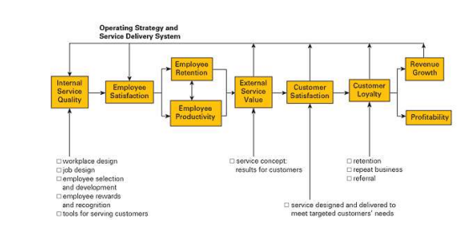

Figure 4.2.1: The links in the Service-profit chain
(Source: Haciyev, 2019)
Goods and services have been differentiated and brands focused on the service and the quality of goods to attract customers toward their brands. As opined by Haciyev (2019), customer satisfaction has been effective for customer retention so all the brands focused on customer satisfaction. Organisations nowadays focused on review taking related to their goods and service as it has been effective for customer loyalty. As argued by Pei et al. (2020), organisations continuously focus on maintaining long-term sustainable customer satisfaction and have maintained sustainability in the organisation. For example, it can be analysed that Tesco focused on giving reward points to loyal customers through transactions with their retailers. The company focused on the feedback of the customers and tried to improve the products and services according to their customers' choices for increasing customer loyalty.
Theme 2: Marketing leadership has been effective for brand management in the global economy
Market leaders have been effective and they possess strong brand values and better prestige. Marketing leadership has been effective in attracting new customers and retaining existing customers in the organisation. As per the statement of Afriyie and Ibn Musah (2019), leadership has been effective for a brand to improve the quality of the work and performance of the employees and market leaders bring innovation to the brand. Market leaders have been awarded the purchasing decisions that the consumer base made and access to the large datasets. As argued by Tien et al. (2019), brand image has not always coincided with a brand identity regarding marketing activities' influence. Marketing leaders focused on continuous innovation in the organisation and it helps to increase the brand value in the global economy.
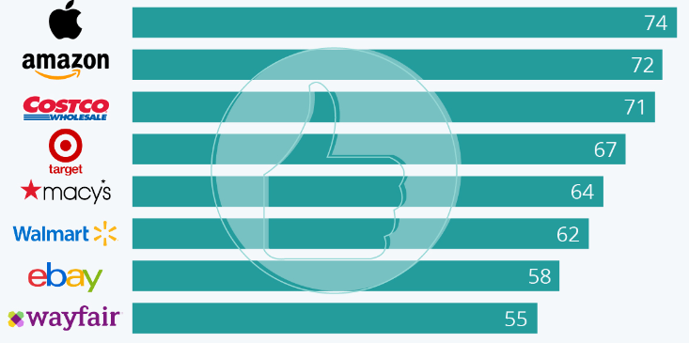

Figure 4.2.2: Apple and Amazon Lead in Customer Satisfaction
(Source: Statista.com, 2022)
Marketing leaders follow brand development in the organisation and try to build good relationships with the customers as it has been effective for brand development. Market leaders focused on the total market demand development, market expanding share and protecting market share as these have been general strategies of marketing leadership. As stated by Kalaignanam et al. (2021), marketing leaders give attributes to marketing agility and marketing leaders face various challenges and try to solve these with their capabilities. In apple and Amazon team leaders followed the marketing leadership and they focused on developing products and services to develop the brand. Apple and Amazon have been the market leaders in their respective markets and both have helped plan new strategies for brand advancement. On the contrary Jardon and Martinez-Cobas (2022) stated that the transformational leadership style has been most effective as it influenced the performance of the organisation. Apple has focused on product manufacturing and Amazon has been focused on providing good service to the customers as these have been effective to remain the market leader.
Theme 3: Managers and employees of the company can evaluate the brand value and develop a good brand
Managers and employees play effective roles to develop the brand performance of the organisation, and they increase the brand value of the organisation. Employees take part in presenting the brand and they focus on the perceived product and service. The company's reach can be enhanced by encouraging the employees to become ambassadors of the brands. As opined by Muharlisianiet al. (2019), employees by getting a bonus and reward-related awards can achieve the goal of brand development and the brands awarded the employees rewards. Managers play an effective role in brand management and the managers’ focus on various effective brand strategies to achieve the target of the brands. The brand development manager monitors various trends in the market and customers and makes campaign messaging that has been fit for the brand of the company. Managers focused on innovation and creativity and implemented innovation as these have been effective for brand development. As argued by Tien et al. (2019), brand managers need to find several ways to investigate the market to segment the market. Effective brand managers have been responsible for the marketing plans and implemented the plan to improve the quality of the brands. Therefore, employees and managers have been responsible and effective for a good brand.
For example, Tesla managers focus on the environmentally conscious and target that for branding and try to contribute in green. Tesla managers and employees tried to develop sustainability in the company and focus on customer service and customer experience to develop brand loyalty.
Theme 4: Brand value has helped to increase the economy of the country
The economic growth of any country has been mostly influenced by the assets of non-physical or physical grounds. Countries' economic growth has varied with many various aspects and brand value has been one of these aspects. The other invisible aspects of the country's growth have been defended or explained by various studies. As opined by Zahariet al. (2018), brand equity has usually been conceptualized from the customer's perspective and the financial approach. These various aspects have been considered one of the driving forces of the country's economic growth. Brand management or brand values have been of growing interest that has various requirements in the international market. The growing interest in brand management or brand value has increased the process of changing the marketing strategy and also changing the condition of the interrelated economy in the world. As per the statement of Öktenet al. (2019), the new form of economy has been associated with globalisation. The brands and their branding have been becoming more important for the economic growth of the country. This has created more competition for established brands and also for the stakeholders to upgrade their brand value to increase their country's economy.
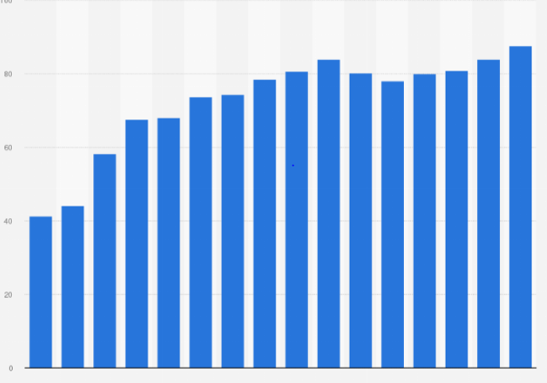

Figure 4.2.3: Coca cola brand value
(Source: Statista.com, 2022)
The growing national economy has helped to establish the brands that have been considered as powerful as global consumers. As per the statement of Ikram et al. (2019), the top-rated soft drink brand Coca-Cola has been the perfect example of boosting the country's economy through branding. Coca-Cola has a brand value of 87.6 million dollars in 2021. The brand has been offering jobs to the local people, paying taxes to the government and also buying goods, and types of equipment from the local supplier has helped to increase the economy of the country. The brand value has not only boosted the economic growth of the country it also increased the country's name in the global market.
Theme 5: Branding has been playing an important part in the global aspect of the business
Business branding has played an important part in the business aspects. The branding of a business has been more important than it looks. The brand not only the logo or the colour has been the full identity of any business. As opined by Tien et al. (2019), the brand and the branding have provided the personality of the brand. Branding has become one of the most important parts of the business. It has been becoming more important now than before. Social media has been one of the ways to brand products. Through social media, brands have been getting more exposure. As per the statement of Zameeret al. (2020), this exposure has been very important for the consumer who has been always looking for brands or searching the products on the internet. Consumers have been getting more exposure to the products or the brands that have a proper brand value. In today's world, brands or big companies have become more competitive as the brands have to increase their branding or marketing process to compete in the market.

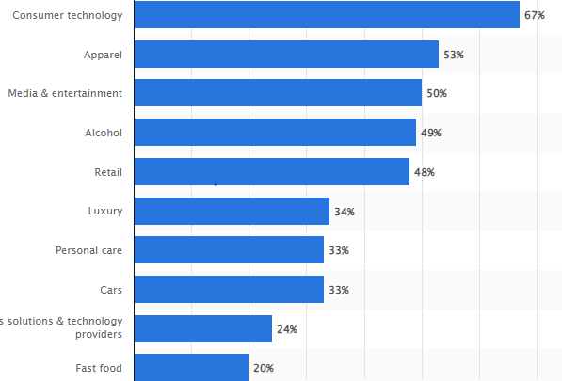

Figure 4.2.4: The brand value of brands through branding
(Source: Statista.com, 2022)
Brands have been creating strong brand value to attract the consumer's attention. Branding has helped to get more recognition in the market. Getting more recognition in the market has helped to attract more customers or consumers. The brand with strong branding has been able to build a healthy image in the market. As per the statement Tien et al. (2019) Branding has helped to build trust. Proper branding has helped to build trust as a healthy market mane has helped to attract the audience towards the brands. The trust of the consumers has been one of the most important business aspects of any business. Brands without proper branding have been unable to establish proper consumer trust. Business with proper branding has helped the business to show consumers that they have potential. With proper branding, the brands have been able to improve their advertisement. Businesses have been unable to make their name in the market without proper advertisement. Brands given advertising with proper branding has been missing many opportunities in the business growth.
Theme 6: Brand awareness has been playing an important role in the growth of a business
Brand awareness has been considered one of the important aspects of the growth of a business. According to a report, brand awareness has generated 20% of the growth of any business. Brand awareness has been the very first step in marketing any product. Brand awareness has helped people to recognize the brand. As per the statement Pramudyaet al. (2018),brand awareness has improved customer loyalty and it also helped the business to establish its name. Brand awareness has helped to keep the brand name in the audience's mind. People who know the brand name have become familiar with the brand and also get comfortable with it. Brand awareness has helped the business to achieve many business goals and objectives. The brand awareness has been to increase the audience, increase web trafficking on the websites, and increase or build brand affinity. As opined by Ansari et al. (2019), brand awareness has increased market share and sales. Brand awareness has been the first step in driving the performance marketing goal. Brand awareness has made people more aware of brands. Brand awareness has been very effective to attract high-quality audiences. Brand awareness has also increased the chance of generating more conversation rates and also increased the brand awareness that also affects sales. Brand awareness has also improved brand perception. Brand awareness not only established the mane on the market it also improved people's prospective about the brand.

4.3 Summary
In this chapter, it has been summarized that brand awareness has been one of the most important factors for any brand and its growth. Brand awareness has helped the business to establish a proper customer base and also helped customers to recognize the brand. The coca-cola company has been one of the examples of branding that has been increasing the country's economy. Brand awareness has been considered one of the factors that have increased brand value and also helped to establish a name on the global market.

Chapter 5: Discussion
The present world has started to shift rapidly as has been observed in the current global business scenario. This present situation has started to increase the core competitiveness within the market segment in the global business industry. In this particular context, it has been noticed that innovation and the basic decision-making for better business practices in the global market have started being associated with the maintenance of the basic economic ground. As it has been mentioned by Serrano et al. (2019), the prime achievement of a successful business is to derive economic succession by managing the financial assets of the respective business practice. In such a perspective, for the organisations present in the global market, the management of global and local needs has started to be seen as a challenging situation that has created a new edge in the competitive demonstration of business practice. In the current context of the global scenario, companies have started to confront multiple and different types of issues regarding the management of economic aspects. Therefore, brand management has started to be recognised as a prime aspect for achieving competitive advantage.
According to the statements of industrial specialists, product design while infusing several instinct features has been considered a crucial requirement for improving business effectiveness in the target market. The incorporation of such effectiveness in the business practice to improve brand image, an effective observation has to be implemented on the core group of audience and the target market facilities too. This has been helpful for the organisational professionals to uncover the unsatisfied needs of the target audience. This further can help in building resilience in the market focused on the satisfaction rate of the target audience. The organisations would have been able to create new ideas that could be transformed into solutions for future critical moments (Roggeveen et al. 2021). However, the design-centric approach has the requirement to be infused with both kinds of elements, such as ambiguous and familiar ones at the same time. In such a way the organisations have been able to reduce the risk regarding innovation infusion to produce better products in the existing market.
In the current context of the study, it has been already evaluated that brand is one of the prime elements of an organisation, especially in a global scenario. As per the view of Ryuet al. (2019), a positive brand image has been considered a crucial need of an organisation that can lead the business to success by infusing the customer perspective. In today's world order long-term involvement has been required for building a strong brand image while considering the significance of resourcing at the same time. It can be further found that, from the financial viewpoint, inverters generally prefer a company with a strong financial base as they are seen as less risky. On the other hand, it can be stated that if the brand can be built as a strong aspect of the business practice high degree of customer loyalty can be gained therefore, stability in sales can be witnessed by the organisation at the same time.
The global economy in the present situation has started to be shifted to a more dynamic concept where the designing of products has been determined as an essential attribute. This particular aspect has been identified as a primal one as it helps the product or brand to be distinctive among other subsidiary products. Furthermore, in recent decades, apart from distinctive designing, innovation has started to have similar importance to improve brand image in the global market (Sichtmannet al. 2019). In this perspective, the current business practices existing worldwide, brand management has been considered an extremely demanding approach that often seems costly too for the organisations’ perspectives.
Proper brand management could provide a better context and understanding of the positive and negative factors of the products. The critical analysis of all positive and negative reviews from the consumers will help the organisation to generate an overall perspective about the products. The informative knowledge about the products with a comparative analysis of the same products of the other brand will develop a greater outlook (Bacon et al. 2020). The similarity in other brands' products will lead to competition and pressure about the preference of the products of the particular brand. On the other hand, customising the products and providing extra benefits will enhance the greater selection of the products of that particular brand. The revenue and profit of a particular brand totally and partially depend upon the quality of the products, lucrative ads and discount offers. The seasonal offers with respective items could enhance the interest of the customers towards the products of that particular brand (Banaś and Utnik-Banaś, 2021). The availability of the products in a variant range of costs will attract customers of all income levels. The higher income level consumers will become dissatisfied if they have not been provided with adequate facilities and quality products. Stock maintenance has become a crucial factor for this type of customer as they will move towards the other brand if they are not provided with adequate support.
Customers from lower-income groups often prefer lucrative discounts, festive discount offers and low-cost delivery and service charges. As opined by Kundu (2021), they wait for a long time to avail of the discounts and they spend their valuable money after a long thinking and making plans. The availability of services for all and access to all could rapidly increase brand value and brand loyalty. The economy of a particular brand is dependent upon satisfying its customers so every brand tries its best to sustain the faith and trust of the brand. Digital marketing, social media marketing, content marketing, hoardings, ads and flying pamphlets could encourage more customers to sell their brands and facilities (Bala and Verma, 2018). The effective participation of previous customers with their positive reviews circulating and general experiences sharing attracts their relatives, and social networks to move towards the brand. The consumer's persona creation, negative reviews evaluation, and progress in the manufacturing mechanism will provide a strong standing position for the brand. The advantageous processing, procurement, manufacturing and investments will lead to more profit for the particular brand.
In this context, it has been discussed about brand management and its effectiveness in several ways. The researcher has also specified the growth of the global economy which has occurred by the brand management and also it has resulted appropriately. In this context, it has also been analysed and explained about the negative and positive impacts of brand management on the global economy. The researcher has also discussed several strategic findings and collected several data and information through secondary data analysis. The analysis has been done in an appropriate way to collect proper data and authentic information which has helped the research to complete in a good manner (Leijerholt, et al. 2019). Proper brand management has always influenced the global economy and its market. The global economy has been affected by negativity and positivity through brand management.
Brand management has been considered a subject of research which needs more time to analyse properly. Brand management has also been considered an excessive valuable part that has increased the market value and its competitors in the market. The managers, the leaders and the whole management system need to be more focused and need to give more time and value to create proper brand management. Productivity has been considered a crucial part of the brand management of an organisation which has helped to increase revenue and reputation. Interest and focus in the brand have increased and influenced as this concept and topic has developed from a product and its identifier and it has differentiated and divided the physical tool into an advanced strategic tool that has represented the social value (BayighomogLikoum et al. 2020). Brand management needs more time as it has to use more strategic implementation and application.
The strategic implementation has been considered as the vital part that helped the product to increase its value exceptionally as it has also inspired the development of the productivity of a brand. The technical implementation has also increased the brand value in the market and due to technical implementation; the brand has been able to set its place in the market. Brand management has also helped to increase the performance of the employees and it has increased the stock market also both nationally and internationally. Branding has been relatively and arguably innovative and developed in the social public sector (Leijerholtet al. 2019). Therefore, in this context, it has been suggested that the existing theories and models of brand management have not been fully changeable and transferable to this. Brand management has the power to be grounded as an intangible and appropriate asset for the organisation itself. It has taken a long gap of time to be able to make an innovative brand and to clear the path to success for further productivity. Brand management has also been made to manage customer satisfaction, and services and the income of the customer have also been dependent on brand management.
The influence of brand management on the global market contributes to a major role in the global economy. As per the opinion of Pamfilie and Croitoru (2018), the management of a company refers to the management process of this particular company in various regions. The strategy to strengthen the management system of a brand has to be eligible to handle the problems on the path to success. The strategy is likely to be global as well as an international method to promote branding. The purpose of this management procedure is to build a strong and impressive brand value in order to get recognition. On the contrary Tien et al. (2019) stated that, global branding refers to the perspective of the whole world. This method implies the expectation of the brand as an individual organization. It creates brand value and leads to brand loyalty of the brand in terms of improvement. This process of branding involves and directs the most effective ways to retain the position of a particular brand. It also intensifies the brand identity and its reputation in the international market. The strategies associated with global marketing need to be effective to get remarkable results. The necessity to implement the strategy and make the most of strategy is also important. Therefore, several ideas to implement the strategy are a matter of utmost importance and priority. However, there are a few challenges that the brand has to face in order to grow further. These obstacles have to be dealt with by several effective methods in the local market.
The local market deals with different kinds of brands, companies and their products and services. Therefore, it is difficult to gain popularity and thrive among local brands and organizations. As per the statement of Ozretic-Dosen et al. (2018), local competitors make it tough to acquire a significant place in the mind of consumers. The importance of a strong strategy to compete with the local suppliers and gain a remarkable place in the mind of the customer is huge. Therefore, a preventive measure to deal with the leading local brand is to tackle the issues of local recognition. On a contradictory note,BayighomogLikoumet al. (2020) stated that, transportation expenses also impose a great threat to the development of a brand in the global market. Furthermore, the usage of advanced technology in the marketing strategy is an unavoidable element. The emerging demand to digitize the marketing process makes it mandatory to digitize brand management and its operations. The rising demand for online transactions after the purchase has become prominent to gain recognition on the international level. Alongside this, the impact of the global brand and its management process often affects the culture and habits of the local people. Therefore, it is important to have knowledge about the local culture and traditions to follow the interest of the local people. It also results in the promotion of the local people as well as the customers are likely to show their interest in a particular brand.
The influence of brand management on the global market contributes to a major role in the global economy. As per the opinion of Pamfilie and Croitoru (2018), the management of a company refers to the management process of this particular company in various regions. The strategy to strengthen the management system of a brand has to be eligible to handle the problems on the path to success. The strategy is likely to be global as well as an international method to promote branding. The purpose of this management procedure is to build a strong and impressive brand value in order to get recognition. On the contrary Tien et al. (2019) stated that global branding refers to the perspective of the whole world. This method implies the expectation of the brand as an individual organization. It creates brand value and leads to brand loyalty of the brand in terms of improvement. This process of branding involves and directs the most effective ways to retain the position of a particular brand. It also intensifies the brand identity and its reputation in the international market. The strategies associated with global marketing need to be effective to get remarkable results. The necessity to implement the strategy and make the most of strategy is also important. Therefore, several ideas to implement the strategy is a matter of utmost importance and priority. However, there are a few challenges that the brand has to face in order to grow further. These obstacles have to be dealt with by several effective methods in the local market.
The local market deals with different kinds of brands, companies and their products and services. Therefore, it is difficult to gain popularity and thrive among local brands and organizations. As per the statement of Ozretic-Dosen et al. (2018), local competitors make it tough to acquire a significant place in the mind of consumers. The importance of a strong strategy to compete with the local suppliers and gain a remarkable place in the mind of the customer is huge. Therefore, a preventive measure to deal with the leading local brand is to tackle the issues of local recognition. On a contradictory note,BayighomogLikoumet al. (2020) stated that, transportation expenses also impose a great threat to the development of a brand in the global market. Furthermore, the usage of advanced technology in the marketing strategy is an unavoidable element. The emerging demand to digitize the marketing process makes it mandatory to digitize brand management and its operations. The rising demand for online transactions after the purchase has become prominent to gain recognition on the international level. Alongside this, the impact of the global brand and its management process often affects the culture and habits of the local people. Therefore, it is important to have knowledge about the local culture and traditions to follow the interest of the local people. It also results in the promotion of the local people as well as the customers are likely to show their interest in a particular brand.

Chapter 6: Conclusion

6.1 Conclusion
In this context, it has been concluded that the whole process of brand management, productivity and the global economy has been influenced by each other. It has also been concluded that the data that have been collected and analysed have been considered authentic which also made the whole research justified. The whole research has been done by a secondary data analysis method which has justified the analysis of business management and its effectiveness on the global economy. It has also been concluded that several strategic implementations and technical applications have made the process of brand management exceptional. The positive and negative impacts and the effectiveness of brand management have helped to increase the global economy properly.

6.2 Linking with objectives
Objective 1: “To promote, produce, and distribute effective services and goods that help to attract more consumers at both international and national levels”
In this research, it has been analysed the effectiveness of an appropriate service of any brand and it has also explained about the production and distribution. Chapter 2 has identified and explained the objective and explained about the link through which it has connected with the chapter. The effectiveness of consumer satisfaction has also been identified in this chapter (Isanti, et al. 2020). The marketing strategies and their implementation have also been discussed in this chapter which has also attracted customers at both national and international level.
Objective 2: “To infield the demand of business branding for supporting the sales efforts and marketing demand for developed and satisfying customers' needs”
The above objective has been identified in chapter 2 and it has also been linked with several points of view in chapter 2. This chapter has also discussed the customer need and demand through the negative and positive impact of brand management and its effectiveness (Van Nguyen, et al. 2020). In this chapter 2, the object has also been linked through the brand values and its economic importance which has increased and justified customer demand.
Objective 3: “To assess the social, ethical, and conventional responsibilities of managers and employees to explore the brand in the global economy and market”
The above objective has been portrayed in research where the objective has been linked with several perspectives and points. Brand management has also been explained through social ethical and conventional ways (Chancellor et al. 2019). The leaders and the manager have also been able to explore the global economy and its market value of it.
Objective 4: “To increase the customer's loyalty and business competition by differentiating the services and goods of different organisations”
The above objective has been found linked in chapter 2, where it has been explained about brand loyalty and customer loyalty. The market competitor and the marketing strategies have also been explained in this context (Varadarajan, 2020). This chapter has also explained the services and goods of several organisations.
Objective 5: “To establish the market leadership and critical literature review based on analysis of information”
The determined objective has been met in the developed themes that have been incorporated in the previous chapter in the later part. The objectives have been helped in order to consider the factors that generally contribute to establish market leadership (Alzoubiet al. 2022). Along with that literatures have been selected as per the selection criteria and analysed in a critical manner at the same time.

6.3 Recommendation
In the above research, the results of the analysis have come out with several recommendations that have been able to make further research appropriate.
- In this chapter, it has been recommended that more focus on the research and the audience could make the research appropriate. It has been also recommended that the behaviour of the customers has to analyse and research properly so that it could help understand the customer's requirements (Paul et al. 2021). The brand management system has to expand its discounts and offers which could attract customers and help to increase the global economy. Order focus on the audience could increase the customer and the process of brand management has to change in an appropriate way that the customers have to care.
- In this research, the business owner could know the culture of different countries that could help to increase the global economy. It has been recommended that the brand management has to be aware of global competitors (Tien et al. 2019). It could help the management to upgrade the production system and increase the global economy.
- The brand management system has to expand its discounts and offers which could attract customers and help to increase the global economy. This strategy could also help to increase productivity and revenue (Bala and Verma, 2018). It has also helped to increase the reputation of the organisation and the brand also.
- It has also been recommended that the brand management needs to find more strategies that could be technical and informative as it has made the result of the research more effective. In the research, more effective partners have to find it has made the research helpful (Anwar et al. 2020). A better understanding needs to be made between the two partners which have been considered helpful in brand management and have increased the global economy.

6.4 Future scope
In this research, several scopes have been provided by the researcher which could help the research to expand in future and it also gave several scopes to the future researcher. Several key areas have been provided by the researcher that has helped to expand the research. The market research that has been done by the researcher has been considered a helpful tool for the future researcher and it also made helpful for further research on this topic. Analysis and research on the brand have collected several pieces of information which have also helped the future researcher for further progress on this topic. An analysis of the strategy that has been implemented in this research has been considered helpful for further research. Great research on the customers' needs and marketing trends has also been considered as the support system for the future researcher which has helped to increase the global economy.

6.5 Research limitation
Several various types of limitations have been found in this above research. Based on this topic the research and the analysis have been done through a secondary analysis method as it has been considered appropriate though the research has to be done through secondary analysis. In this way to gather authentic information, it could be made more effective which has also made the result of the research more appropriate. The above research needs more time to do the analysis and the research properly which has made the result more appropriate (Taher, 2021). It has been done within very short time management which has not been considered appropriate.

Reference List
Abdullahi, S.I., 2020. Towards the creation of strong brand image of waqf institutions. In Challenges and impacts of religious endowments on global economics and finance (pp. 56-71). IGI Global.
Afriyie, S., Du, J. and Ibn Musah, A.A., 2019. Innovation and marketing performance of SME in an emerging economy: the moderating effect of transformational leadership. Journal of Global Entrepreneurship Research, 9(1), pp.1-25.
Aguinis, H., Hill, N.S. and Bailey, J.R., 2021. Best practices in data collection and preparation: Recommendations for reviewers, editors, and authors. Organizational Research Methods, 24(4), pp.678-693.
Al-Hawary, S.I.S. and Al-Fassed, K.J., 2022. The impact of social media marketing on building brand loyalty through customer engagement in Jordan. International Journal of Business Innovation and Research, 28(3), pp.365-387.
Al-Qurabat, A.K.M. and Idrees, A.K., 2018. Energy-efficient adaptive distributed data collection method for periodic sensor networks. International journal of internet technology and secured transactions, 8(3), pp.297-335.
Alzoubi, H., Alshurideh, M., Kurdi, B., Akour, I. and Aziz, R., 2022. Does BLE technology contribute towards improving marketing strategies, customers satisfaction and loyalty? The role of open innovation. International Journal of Data and Network Science, 6(2), pp.449-460.
Ananda, Y.P., 2022. Building And Communicating Brand By Micro, Small And Medium Enterprises (Msmes). Jees: Journal Of Economic Empowerment Strategy, 5(2), pp.68-81.
Ansari, S., Ansari, G., Ghori, M.U. and Kazi, A.G., 2019. Impact of brand awareness and social media content marketing on consumer purchase decision. Journal of Public Value and Administrative Insight, 2(2), pp.5-10.
Antony, J., McDermott, O. and Sony, M., 2021. Quality 4.0 conceptualisation and theoretical understanding: a global exploratory qualitative study. The TQM Journal. pp. 1-12
Anwar, M. and Ali Shah, S.Z., 2020. Managerial networking and business model innovation: Empirical study of new ventures in an emerging economy. Journal of Small Business & Entrepreneurship, 32(3), pp.265-286.
Astolfi, D., Castellani, F., Becchetti, M., Lombardi, A. and Terzi, L., 2020. Wind turbine systematic yaw error: Operation data analysis techniques for detecting IT and assessing its performance impact. Energies, 13(9), p.2351.
Bacon, E., Williams, M.D. and Davies, G., 2020. Coopetition in innovation ecosystems: A comparative analysis of knowledge transfer configurations. Journal of Business Research, 115, pp.307-316.
Bala, M. and Verma, D., 2018. A critical review of digital marketing. M. Bala, D. Verma (2018). A Critical Review of Digital Marketing. International Journal of Management, IT & Engineering, 8(10), pp.321-339.
Banaś, J. and Utnik-Banaś, K., 2021. Evaluating a seasonal autoregressive moving average model with an exogenous variable for short-term timber price forecasting. Forest Policy and Economics, 131, p.102564.
BayighomogLikoum, S.W., Shamout, M.D., Harazneh, I. and Abubakar, A.M., 2020. Market-sensing capability, innovativeness, brand management systems, market dynamism, competitive intensity, and performance: an integrative review. Journal of the Knowledge Economy, 11(2), pp.593-613.
Blumenberg, C. and Barros, A.J., 2018. Response rate differences between web and alternative data collection methods for public health research: a systematic review of the literature. International journal of public health, 63(6), pp.765-773.
Bobrovskij, I.N., 2018. How to select the most relevant roughness parameters of a surface: Methodology research strategy. In IOP Conference Series: Materials Science and Engineering (Vol. 302, No. 1, p. 012066). IOP Publishing.
Busuioc, M. and Rimkutė, D., 2020. The promise of bureaucratic reputation approaches for the EU regulatory state. Journal of European Public Policy, 27(8), pp.1256-1269.
Cardoso, L., Dias, F., de Araújo, A.F. and Marques, M.I.A., 2019. A destination imagery processing model: Structural differences between dream and favourite destinations. Annals of tourism research, 74, pp.81-94.
Carlini, J., Grace, D., France, C. and Lo Iacono, J., 2019. The corporate social responsibility (CSR) employer brand process: integrative review and comprehensive model. Journal of Marketing Management, 35(1-2), pp.182-205.
Cerveny, L.K., Derrien, M.M. and Miller, A.B., 2020. A research strategy for enhancing sustainable recreation and tourism on public lands. Gen. Tech. Rep. PNW-GTR-991. Portland, OR: US Department of Agriculture, Forest Service, Pacific Northwest Research Station. 102 p., 991.
Chancellor, S., Birnbaum, M.L., Caine, E.D., Silenzio, V.M. and De Choudhury, M., 2019, January. A taxonomy of ethical tensions in inferring mental health states from social media. In Proceedings of the conference on fairness, accountability, and transparency (pp. 79-88).
Cheng, Y. and Jiang, H., 2021. Customer–brand relationship in the era of artificial intelligence: understanding the role of chatbot marketing efforts. Journal of Product & Brand Management, 31(2), pp.252-264.
Crittenden, W.F., Biel, I.K. and Lovely III, W.A., 2019. Embracing digitalization: Student learning and new technologies. Journal of Marketing Education, 41(1), pp.5-14.
Dalati, S., 2021. Factors affecting Syrian female researchers’ experience during crisis: inductive approach. Business, Management and Economics Engineering, 19(1), pp.91-110.
DAM, S.M. and DAM, T.C., 2021. Relationships between service quality, brand image, customer satisfaction, and customer loyalty. The Journal of Asian Finance, Economics and Business, 8(3), pp.585-593.
Dastgerdi, A.S. and De Luca, G., 2019. Boosting city image for creation of a certain city brand. Geographicapannonica, 23(1), pp.15-20.
Ditlmann, R.K. and Kopf-Beck, J., 2019. The meaning of being german: An inductive approach to national identity. Journal of Social and Political Psychology, 7(1), pp.423-447.
Dwivedi, A., Nayeem, T. and Murshed, F., 2018. Brand experience and consumers’ willingness-to-pay (WTP) a price premium: Mediating role of brand credibility and perceived uniqueness. Journal of Retailing and Consumer Services, 44, pp.100-107.
Fernandes, T. and Moreira, M., 2019. Consumer brand engagement, satisfaction and brand loyalty: a comparative study between functional and emotional brand relationships. Journal of Product & Brand Management. 57(3), pp.943-965
Fetscherin, M., Guzman, F., Veloutsou, C. and Cayolla, R.R., 2019. Latest research on brand relationships: Introduction to the special issue. Journal of Product & Brand Management. 59(4), pp.94-96
Flores‐Hernández, J.A., Cambra‐Fierro, J.J. and Vázquez‐Carrasco, R., 2020. Sustainability, brand image, reputation and financial value: Manager perceptions in an emerging economy context. Sustainable Development, 28(4), pp.935-945.
Foroudi, P., 2019. Influence of brand signature, brand awareness, brand attitude, brand reputation on hotel industry’s brand performance. International journal of hospitality management, 76, pp.271-285.
Ganushchak-Efimenko, L., Shcherbak, V. and Nifatova, О., 2018. Assessing the effects of socially responsible strategic partnerships on building brand equity of integrated business structures in Ukraine. OeconomiaCopernicana, 9(4), pp.715-730.
Garavan, T., Ullah, I., O'Brien, F., Darcy, C., Wisetsri, W., Afshan, G. and Mughal, Y.H., 2022. Employee perceptions of individual green HRM practices and voluntary green work behaviour: a signalling theory perspective. Asia Pacific Journal of Human Resources. 26 (1-5), pp. 232-245.
Gayler, T., Sas, C. and Kalnikaitė, V., 2021, June. Sensory probes: An exploratory design research method for Human-Food Interaction. In Designing Interactive Systems Conference 2021 (pp. 666-682).
Haciyev, N., 2019. The Role of Customer Satisfaction in Increasing Sales in the Service Sector. Annals of Spiru Haret University. Economic Series, 19(4), pp.113-126.
Hadadzadeh, A., Baxter, C., Amirkhiz, B.S. and Mohammadi, M., 2018. Strengthening mechanisms in direct metal laser sintered AlSi10Mg: Comparison between virgin and recycled powders. Additive Manufacturing, 23, pp.108-120.
Handel, B. and Schwartzstein, J., 2018. Frictions or mental gaps: what's behind the information we (don't) use and when do we care?. Journal of Economic Perspectives, 32(1), pp.155-78.
Hattke, F., Hensel, D. and Kalucza, J., 2020. Emotional responses to bureaucratic red tape. Public Administration Review, 80(1), pp.53-63.
Herhausen, D., Miočević, D., Morgan, R.E. and Kleijnen, M.H., 2020. The digital marketing capabilities gap. Industrial Marketing Management, 90, pp.276-290.
Hoang Thanh, L., Ta Nhat, L., Nguyen Dang, H., Ho, T.M.H. and Lebailly, P., 2018. One Village One Product (OVOP)—A rural development strategy and the early adaption in Vietnam, the case of Quang Ninh Province. Sustainability, 10(12), p.4485.
Hoe, L.C. and Mansori, S., 2018. The effects of product quality on customer satisfaction and loyalty: Evidence from Malaysian engineering industry. International Journal of Industrial Marketing, 3(1), p.20.
Honarmandi, Z., Sepasi, S. and Azar, A., 2019. Comparing the impact of brand value on corporate profit in B2B and B2C businesses: A case study. Iranian Journal of Management Studies, 12(1), pp.121-147.
Ibrahim, B., 2022. Social media marketing activities and brand loyalty: A meta-analysis examination. Journal of Promotion Management, 28(1), pp.60-90.
Ikram, M., Zhou, P., Shah, S.A.A. and Liu, G.Q., 2019. Do environmental management systems help improve corporate sustainable development? Evidence from manufacturing companies in Pakistan. Journal of Cleaner Production, 226, pp.628-641.
Imbug, N., Ambad, S.N.A. and Bujang, I., 2018. The influence of customer experience on customer loyalty in telecommunication industry. International Journal of Academic Research in Business and Social Sciences, 8(3), pp.103-116.
Istanti, E., Sanusi, R. and Daengs, G.S., 2020. Impacts of Price, Promotion and Go Food Consumer Satisfaction in Faculty of Economic and Business Students of Bhayangkara University Surabaya. Ekspektra: JurnalBisnis dan Manajemen, 4(02), pp.104-120.
Japiana, M. and Keni, K., 2022, May. The Impact of Brand Identification, Social Media Marketing, and Brand Satisfaction Towards Brand Loyalty in the Indonesian Food and Beverage Sector. In Tenth International Conference on Entrepreneurship and Business Management 2021 (ICEBM 2021) (pp. 461-467). Atlantis Press.
Jardon, C.M. and Martinez-Cobas, X., 2022. Leadership and Marketing Capabilities in Small Businesses of Subsistence Marketplaces. SAGE Open, 12(2), p.21582440221079935.
Kalaignanam, K., Tuli, K.R., Kushwaha, T., Lee, L. and Gal, D., 2021. Marketing agility: The concept, antecedents, and a research agenda. Journal of Marketing, 85(1), pp.35-58.
Kasemsap, K., 2018. The roles of corporate marketing strategies and brand management in the global retail industry. In Digital Marketing and Consumer Engagement: Concepts, Methodologies, Tools, and Applications (pp. 294-325). IGI Global.
Khajeheian, D. and Ebrahimi, P., 2021. Media branding and value co-creation: effect of user participation in social media of newsmedia on attitudinal and behavioural loyalty. European Journal of International Management, 16(3), pp.499-528.
Khan, R.U., Salamzadeh, Y., Iqbal, Q. and Yang, S., 2022. The impact of customer relationship management and company reputation on customer loyalty: The mediating role of customer satisfaction. Journal of Relationship Marketing, 21(1), pp.1-26.
Krishnamurthi, R., Kumar, A., Gopinathan, D., Nayyar, A. and Qureshi, B., 2020. An overview of IoT sensor data processing, fusion, and analysis techniques. Sensors, 20(21), p.6076.
Kundu, N., 2021. Predictive analytics to offer profitable anticipatory shipping for E-commerce Companies. International Journal of Modern Agriculture, 10(2), pp.127-136.
Lee, D. and Van Ryzin, G.G., 2019. Measuring bureaucratic reputation: Scale development and validation. Governance, 32(1), pp.177-192.
Lee, Y.Y., Falahat, M. and Sia, B.K., 2019. Impact of digitalization on the speed of internationalization. International Business Research, 12(4), pp.1-11.
Legislation.gov.uk, 2022. Data Protection Act, 2018. Available at: https://www.legislation.gov.uk/ukpga/2018/12/contents/enacted [Accessed on 10.10.2022]
Leijerholt, U., Chapleo, C. and O’Sullivan, H., 2019. A brand within a brand: An integrated understanding of internal brand management and brand architecture in the public sector. Journal of Brand Management, 26(3), pp.277-290.
Li, M.W., Teng, H.Y. and Chen, C.Y., 2020. Unlocking the customer engagement-brand loyalty relationship in tourism social media: The roles of brand attachment and customer trust. Journal of Hospitality and Tourism Management, 44, pp.184-192.
Lobe, B., Morgan, D. and Hoffman, K.A., 2020. Qualitative data collection in an era of social distancing. International journal of qualitative methods, 19, p.1609406920937875.
Madden, A.D., 2022. A review of basic research tools without the confusing philosophy. Higher Education Research & Development, 41(5), pp.1633-1647.
Maiboroda, H. and Marchuk, A., 2021. Development of Ukrainian enterprises in crisis economy in brand management system. Green, Blue and Digital Economy Journal, 2(2), pp.37-46.
Majerova, J., Sroka, W., Krizanova, A., Gajanova, L., Lazaroiu, G. and Nadanyiova, M., 2020. Sustainable brand management of alimentary goods. Sustainability, 12(2), p.556.
Marques-Quinteiro, P., Vargas, R., Eifler, N. and Curral, L., 2019. Employee adaptive performance and job satisfaction during organizational crisis: the role of self-leadership. European Journal of Work and Organizational Psychology, 28(1), pp.85-100.
Melnikovas, A., 2018. Towards an explicit research methodology: Adapting research onion model for futures studies. Journal of Futures Studies, 23(2), pp.29-44.
Moon, K., Blackman, D.A., Adams, V.M., Colvin, R.M., Davila, F., Evans, M.C., Januchowski-Hartley, S.R., Bennett, N.J., Dickinson, H., Sandbrook, C. and Sherren, K., 2019. Expanding the role of social science in conservation through an engagement with philosophy, methodology, and methods. Methods in Ecology and Evolution, 10(3), pp.294-302.
Morgan, M.O., Okon, E.E. and Emu, W.H., 2019. A critique of the bureaucratic theory: the Nigerian civil service experience. Global Journal of Social Sciences, 18, pp.1-10.
Muharlisiani, L.T., Noerhartati, E., Karwanto, K., Chamidah, D., Wisnujati, N.S., Soewardini, H.M.D., Apriyanto, M., Khamidi, A., Andriati, R., Fitriani, D. and Indah, F.P.S., 2019. Public relations management through management by objective. Int. J. Sci. Technol. Res, 8(10), pp.1993-1997.
M'zungu, S., Merrilees, B. and Miller, D., 2019. Strategic and operational perspectives of SME brand management: A typology. Journal of Small Business Management, 57(3), pp.943-965.
Na, S., Kunkel, T. and Doyle, J., 2020. Exploring athlete brand image development on social media: The role of signalling through source credibility. European Sport Management Quarterly, 20(1), pp.88-108.
Niemelä, M., 2019. Brand management strategies of hotel chain sub-brands Sheraton Marriott and DoubleTree by Hilton. 19(3), pp.90-100.
Nosratabadi, S., Mosavi, A., Shamshirband, S., Zavadskas, E.K., Rakotonirainy, A. and Chau, K.W., 2019. Sustainable business models: A review. Sustainability, 11(6), p.1663.
Ökten, N.Z., Okan, E.Y., Arslan, Ü. and Güngör, M.Ö., 2019. The effect of brand value on economic growth: A multinational analysis. European research on management and business economics, 25(1), pp.1-7.
Ozretic-Dosen, D., Brlic, M. and Komarac, T., 2018. Strategic brand management in emerging markets: consumer perceptions of brand extensions. Organizations and markets in emerging economies, 9(1), pp.135-153.
Pamfilie, R. and Croitoru, A.G., 2018. Better brand management through design thinking. AmfiteatruEconomic, 20(12), pp.1029-1039.
Paramboor, J. and Ibrahim, M.B., 2018. Scientific Management Theory: a Critical Review from Islamic Theories of Administration. Al-Shajarah: Journal of the International Institute of Islamic Thought and Civilization (ISTAC), pp.321-336.
Paul, J., 2019. Masstige model and measure for brand management. European Management Journal, 37(3), pp.299-312.
Paul, J., Lim, W.M., O’Cass, A., Hao, A.W. and Bresciani, S., 2021. Scientific procedures and rationales for systematic literature reviews (SPAR‐4‐SLR). International Journal of Consumer Studies, 45(4), pp.O1-O16.
Peeters, R., Trujillo Jimenez, H., O'Connor, E., Ogarrio Rojas, P., Gonzalez Galindo, M. and Morales Tenorio, D., 2018. Low‐trust bureaucracy: Understanding the Mexican bureaucratic experience. Public Administration and Development, 38(2), pp.65-74.
Pei, X.L., Guo, J.N., Wu, T.J., Zhou, W.X. and Yeh, S.P., 2020. Does the effect of customer experience on customer satisfaction create a sustainable competitive advantage? A comparative study of different shopping situations. Sustainability, 12(18), p.7436.
Pramudya, A.K., Sudiro, A. and Sunaryo, S., 2018. The role of customer trust in mediating influence of brand image and brand awareness of the purchase intention in airline tickets online. JurnalAplikasiManajemen, 16(2), pp.224-233.
Prashanth, K.C. and Veena, M., 2022. ESSENCE OF RECOGNITION AND REWARD FOR BRAND IMAGE. EPRA International Journal of Multidisciplinary Research (IJMR), 8(7), pp.23-26.
Purwanto, A., Purba, J.T., Bernarto, I. and Sijabat, R., 2021. Effect of transformational leadership, job satisfaction, and organizational commitments on organizational citizenship behaviour. Inovbiz: JurnalInovasiBisnis, 9(1), pp.61-69.
Rahman, M., Rodríguez-Serrano, M.Á. and Lambkin, M., 2018. Brand management efficiency and firm value: An integrated resource based and signalling theory perspective. Industrial Marketing Management, 72, pp.112-126.
Ramírez, S.A.O., Veloutsou, C. and Morgan-Thomas, A., 2019. I hate what you love: brand polarization and negativity towards brands as an opportunity for brand management. Journal of Product & Brand Management, 28(5), pp.614-632.
Roggeveen, A.L., Grewal, D., Karsberg, J., Noble, S.M., Nordfält, J., Patrick, V.M., Schweiger, E., Soysal, G., Dillard, A., Cooper, N. and Olson, R., 2021. Forging meaningful consumer-brand relationships through creative merchandise offerings and innovative merchandising strategies. Journal of Retailing, 97(1), pp.81-98.
Ryu, K., Lehto, X.Y., Gordon, S.E. and Fu, X., 2019. Effect of a brand story structure on narrative transportation and perceived brand image of luxury hotels. Tourism Management, 71, pp.348-363.
Saunders, M.N., Lewis, P., Thornhill, A. and Bristow, A., 2015. Understanding research philosophy and approaches to theory development. pp. 1-5
Serrano, A.R. and García, A.N., 2019. Family business in transition economies: an exploratory study of private business. European Journal of Family Business, 9(1), pp.49-53.
Serrano-Sánchez, J., Zimmermann, J. and Jonkmann, K., 2022. Personality, behavioral engagement, and psychological adaptation of high school students abroad: A longitudinal perspective on between-and within-person dynamics. European Journal of Personality, p.08902070221124311.
Shafranskaya, I. and Potapov, D., 2018. An empirical study of consumer-based city brand equity from signalling theory perspective. Place Branding and Public Diplomacy, 10(2), pp.117-131.
Sichtmann, C., Davvetas, V. and Diamantopoulos, A., 2019. The relational value of perceived brand globalness and localness. Journal of Business Research, 104, pp.597-613.
Statista.com, 2022. Brand-value-growth-compared-to-the-previous-year-worldwide-by-sector. Available at: https://www.statista.com/statistics/267930/brand-value-growth-compared-to-the-previous-year-worldwide-by-sector [Accessed on: 11.10.2022].
Statista.com, 2022. Challenges of digital marketing. Available at :https://www.statista.com/statistics/1232766/challenges-digital-marketing-world [Accessed on 05.10.2022].
Statista.com, 2022. Challenges of fashion industry. Available at :https://www.statista.com/statistics/1326406/fashion-industry-main-challenges [Accessed on 04.10.2022].
Statista.com, 2022. Coca-cola-brand-value. Available at:https://www.statista.com/statistics/326065/coca-cola-brand-value [Accessed on: 11.10.2022]
Statista.com, 2022. Consumer loyalty to brands. Available at: https://www.statista.com/statistics/1077882/why-consumers-are-loyal-to-brands-worldwide/[Accessed on: 10.10.2022].
Statista.com, 2022. Global revenue of the brand. Available at :https://www.statista.com/statistics/267476/global-revenue-of-the-kering-group-by-brand [Accessed on 03.10.2022].
Statista.com, 2022. Online-customer-satisfaction-major-brands-united-state. Available at: https://www.statista.com/chart/26784/online-customer-satisfaction-major-brands-united-states. [Accessed on: 08.10.22].
Statista.com, 2022. World economic output. Available at: https://www.statista.com/chart/10184/world-economic-output-by-groups-of-states/[Accessed on: 11.10.2022].
Swaminathan, V., Sorescu, A., Steenkamp, J.B.E., O’Guinn, T.C.G. and Schmitt, B., 2020. Branding in a hyperconnected world: Refocusing theories and rethinking boundaries. Journal of Marketing, 84(2), pp.24-46.
Taher, G., 2021. E-commerce: advantages and limitations. International Journal of Academic Research in Accounting Finance and Management Sciences, 11(1), pp.153-165.
Tien, N. H., Vu, N. T., and Tien, N. V. 2019. The role of brand and brand management in creating business value case of Coca-Cola Vietnam. International Journal of Research in Marketing Management and Sales, 1(2), 57-62.
Tien, N.H., Hung, N.T. and Tien, N.V., 2019. The role of brand and brand management in creating business value-case of Facebook Vietnam. International Journal of Research in Marketing Management and Sales, 1(2), pp.124-128.
Tien, N.H., Phu, P.P. and Chi, D.T.P., 2019. The role of international marketing in international business strategy. International journal of research in marketing management and sales, 1(2), pp.134-138.
Van Nguyen, T., Zhou, L., Chong, A.Y.L., Li, B. and Pu, X., 2020. Predicting customer demand for remanufactured products: A data-mining approach. European Journal of Operational Research, 281(3), pp.543-558.
Varadarajan, R., 2020. Customer information resources advantage, marketing strategy and business performance: A market resources based view. Industrial Marketing Management, 89, pp.89-97.
Velinov, E., Vassilev, V. and Denisov, I., 2018. Holacracy and Obliquity: contingency management approaches in organizing companies. Problems and Perspectives in Management, 16(1), p.330.
Yan, B., 2019. Research on the influence of customer perceived value on brand equity. American Journal of Industrial and Business Management, 9(3), pp.609-626.
Yu, M., Liu, F., Lee, J. and Soutar, G., 2018. The influence of negative publicity on brand equity: attribution, image, attitude and purchase intention. Journal of Product & Brand Management.pp. 1-12
Zafar, Q.Z.C., Irum, S., Almulla, A.A., Almajid, A.N. and Ali, S., 2021. Leadership in times of natural crises-a systematic literature review. Journal of Management Info, 8(2), pp.149-165.
Zahari, A.R., Esa, E., Rajadurai, J., Azizan, N.A. and MUHAMAD TAMYEZ, P.F., 2020. The effect of corporate social responsibility practices on brand equity: An examination of malaysia's top 100 brands. The Journal of Asian Finance, Economics and Business, 7(2), pp.271-280.
Zameer, H., Wang, Y. and Yasmeen, H., 2020. Reinforcing green competitive advantage through green production, creativity and green brand image: implications for cleaner production in China. Journal of cleaner production, 247, p.119119.
Zeike, S., Bradbury, K., Lindert, L. and Pfaff, H., 2019. Digital leadership skills and associations with psychological well-being. International journal of environmental research and public health, 16(14), p.2628.
Zéman, Z. and Bogdan, A., 2019. Marketing strategy and building brand value on the Hungarian market. Ekonomicko-manazerskespektrum, 13(2), pp.1-9.
Zhang, Q. and Ma, Y., 2021. The impact of environmental management on firm economic performance: The mediating effect of green innovation and the moderating effect of environmental leadership. Journal of Cleaner Production, 292, p.126057.

