

Name: Shreyaben Radhey Patel
Student ID: 2242222
Module: Marketing Management (Assessment 1)
Module Code: LCMB7001
Lecturer: Tushara Balendran
Submission Date: 29/08/2023

MARKETING MANAGEMENT OF LOUIS VUITTON
(75%)
Table of Contents
Introduction 3
Company Background 3
Mission and Vision Statement of Louis Vuitton 3
Communication in marketing strategy 4
Communication model: Claude Shannon and Waren Weaver’s macro model 4
Integrated Marketing Communications 6
Principles of Integrated Marketing Communications 6
Benefits of Integrated Marketing Communications 7
New Promotional Strategies that Louis Vuitton can use to raise awareness of the brand 7
Branding and Brand Equity 9
Keller’s Brand Equity Model with Louis Vuitton 9
Advantages 11
Disadvantages 11
Customer Journey and Customer Touchpoints for Louis Vuitton 12
Pre-purchase Stage 12
Purchase Stage 12
Post-purchase Stage 13
Total Engagement Model in relation to Louis Vuitton 14
Recommendations 15
Conclusion 16
References 17
References 20

Introduction
Businesses in today's highly competitive market face a wide variety of obstacles that can only be overcome with careful strategic planning. Proactive measures are required to maintain a competitive advantage in the current environment, which is defined by fast-changing customer tastes, technology breakthroughs, and global connectedness. In such a competitive environment, companies that use successful marketing techniques have a far better chance of succeeding. Product awareness, customer loyalty, and market standing are just a few of the many outcomes that may be influenced by well-executed marketing initiatives (Katsikeas et al., 2020). This study focuses on Louis Vuitton on how the company can create innovative marketing strategies for raising awareness of the brand as well as managing the customer journey across a variety of communication channels to ensure current and future stakeholders' expectations.

Company Background
In 1854, Louis Vuitton opened his own company in Paris. He founded the firm to produce high-end travel trunks and leather products of unmatched quality and workmanship, so setting the groundwork for a worldwide luxury brand that is still well recognized and sought after today. Louis Vuitton, a brand with a history stretching back more than a century, now sells not just leather items but also ready-to-wear clothing, shoes, watches, jewelry, and perfume (Kai, 2021). The company has always been at the forefront of the luxury industry because of its commitment to excellence in both workmanship and design, and that commitment remains unchanged.

Mission and Vision Statement of Louis Vuitton
Mission: Louis Vuitton's mission is to epitomize the art of travel and luxury, crafting exceptional products that seamlessly blend tradition and innovation. The company strive to offer a unique and memorable experience, combining impeccable craftsmanship with timeless design, and to inspire a sense of elegance, adventure, and sophistication in every individual (Lai, 2022).
Vision: Louis Vuitton envisions itself as the global benchmark for luxury, recognized for its unwavering commitment to creativity, excellence, and sustainable practices. We aim to continually exceed expectations, shaping the future of luxury fashion and becoming a symbol of aspiration, authenticity, and cultural significance across generations and cultures (Lai, 2022).

Communication in marketing strategy
Communication in general terms is to send a message or information to the target audience. Similarly, communication in marketing strategy is related to promoting a product, service, or brand via the targeted broadcast of messages, information, and content is what we call "communication" in the context of marketing tactics. Advertising, public relations, social media, content production, and face-to-face encounters are just a few of the many avenues that fall under its umbrella. The goal of every good marketing or advertising campaign is to connect with potential buyers and explain what makes your product or service special (Vieira et al., 2019). Effective marketing techniques educate, persuade, and influence consumer behavior to increase brand recognition, customer retention, and revenue generation. Targeting particular audiences, catering to their wants and requirements, and shifting with the market are all essential components.

Communication model: Claude Shannon and Waren Weaver’s macro model
It was in 1948 when Claude Shannon and Warren Weaver, two giants in their respective disciplines, came up with the "Mathematical Theory of Communication," a pioneering model that revolutionized the way we think about information and communication (Botirova, 2023). The Shannon-Weaver model, as it is often known, significantly advanced our knowledge of communication processes and provided a theoretical basis for developing efficient communication techniques in a wide range of fields.
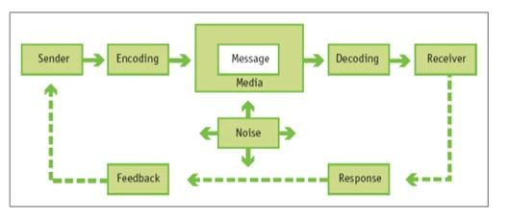
Figure 1: Claude Shannon and Warren Weaver macro model
Source: (Botirova, 2023)
The Shannon-Weaver model's core purpose is to give a systematic framework for understanding how information is transferred from a sender to a receiver, with the ultimate aim of enhancing communication efficiency and accuracy. The model dissects the communication process into its constituent parts, with special emphasis on the sender, the message, the channel, the receiver, and the feedback (Hilbert, 2020). Let's take a closer look at the model's constituent parts:
Sender: The message's creator is known as the "sender" and anyone or anything to disseminate knowledge is considered a communicator. The sender uses encoding to transform the message into a form that can be sent across the network (Hilbert, 2020).
Message: The message is the subject matter of the transmission and it might be written, visual, or auditory, or a mix of these. The message contains the meaning the sender intends to communicate to the recipient (Hilbert, 2020).
Encoding: Messages are encoded when they are converted into a code or signal that may be delivered through a particular medium. This procedure guarantees that the sent and received messages are in good shape (Botirova, 2023).
Channel: The channel is the means through which encrypted communication travels from the sender to the recipient. Communication may take place via a broad variety of channels, including words spoken aloud, printed text, technological impulses, visual clues, and more (Botirova, 2023).
Receiver: The receiver is the person to whom the communication is addressed. It's the entity that takes a message and figures out what it means, or "decodes" it (Botirova, 2023).
Decoding: The term "decoding" refers to the process by which an encoded communication is transformed back into a form that can be read and understood by its intended audience. If the message is successfully decoded, the recipient will understand it just as the sender intended (Hilbert, 2020).
Noise: In the context of communication, "noise" is any kind of interference or distortion. Physical interference, linguistic obstacles, technological problems, and diversions are all examples of noise that may degrade the quality of transmission.
Feedback: Feedback is the information sent from the receiver to the sender, closing the loop of communication. The sender may then determine whether their message was properly received and if not, take corrective action.
The importance of the Shannon-Weaver model goes beyond the scope of its theoretical foundations. Telecommunications, information theory, media studies, and even marketing may all benefit from it in one way or another. In particular, the approach has been used by marketers to develop efficient methods of dissemination of information (Hilbert, 2020). Marketers may improve the efficacy of their communications by taking into account encoding, channel selection, and decoding when crafting their messaging for specific audiences and selecting the most appropriate channels to deliver those messages.

Integrated Marketing Communications
Integrated marketing communications (IMC) is a method that aims to unify and streamline the many different ways in which a company communicates with its target audience. It's the process of ensuring that a brand's message comes through clearly and consistently across all of the marketing materials. IMC acknowledges that customers connect with companies across numerous channels and that a unified approach to communication increases the brand's effectiveness and audience participation (Kushwaha et al., 2020). Advertising, Public Relation, Direct Marketing, Social Media, content development, events, sponsorships, and other forms of promotion are all part of integrated marketing communications.

Principles of Integrated Marketing Communications
Consistency: IMC emphasizes the importance of maintaining a consistent and coherent brand message across all communication channels. Whether a consumer encounters the brand on social media, in a print ad, or at an event, the messaging should remain aligned and recognizable (Muhammedrisaevna et al., 2020).
Customer-Centric Approach: IMC places the consumer at the center of the strategy. It seeks to understand the preferences, behaviors, and needs of the target audience to tailor messages and content that are relevant and appealing (Rėklaitis and Pilelienė, 2019).
Channel Integration: IMC ensures that all communication channels are integrated seamlessly. This means that the messaging and tone are consistent regardless of whether the communication occurs through traditional media, digital platforms, or in-person interactions (Rėklaitis and Pilelienė, 2019).
Message Reinforcement: By delivering a consistent message through multiple channels, IMC reinforces the brand's key value propositions and benefits, increasing the likelihood of message retention and consumer engagement (Blakeman, 2023).
Efficiency and Cost-Effectiveness: IMC eliminates duplication of efforts and resources, allowing marketers to optimize their budget by strategically allocating resources to the most effective channels (Blakeman, 2023).
Measurement and Evaluation: IMC emphasizes the importance of measuring and evaluating the effectiveness of each communication channel. This data-driven approach enables marketers to refine their strategies based on real-time insights (Blakeman, 2023).

Benefits of Integrated Marketing Communications
Brand Cohesion: IMC helps build a strong and cohesive brand identity by ensuring that all communication efforts reflect a unified message and image.
Enhanced Customer Experience: A seamless and consistent communication experience enhances customer satisfaction and loyalty (Batraga et al., 2019).
Higher Impact: By delivering a consistent message across multiple channels, IMC increases the likelihood of reaching and engaging target audiences effectively.
Improved ROI: IMC optimizes resource allocation and reduces wastage, leading to a better return on investment for marketing efforts.
Adaptability: IMC allows marketers to adapt their strategies to changing market trends and consumer preferences while maintaining a consistent brand voice (Batraga et al., 2019).

New Promotional Strategies that Louis Vuitton can use to raise awareness of the brand
A premium clothing and accessories label with an extensive past like Louis Vuitton might benefit from trying out new forms of advertising to reach a larger demographic. Louis Vuitton can adapt to changing times and technological innovations while keeping its exclusive feel. If Louis Vuitton wants to increase brand recognition, it should think about using the following promotional strategies:
Virtual Experiences and Augmented Reality (AR):
Using augmented reality, Louis Vuitton can produce lifelike simulations. Customers may virtually attend fashion presentations, experiment with goods, and tour shop locations by using smartphone applications or specialized platforms. This method unites the inaccessible worlds of the Internet and brick-and-mortar retail by giving consumers a novel and exciting way to engage with the company's products (Goncharova et al., 2019).
Influencer Collaborations with a Purpose:
Louis Vuitton has found that successful collaborations with influencers who share the brand's values and style may have a significant effect. The brand's dedication to sustainability and charity may be shown by such partnerships, which may extend beyond the realm of fashion.
Limited-Edition Drops and Digital Scarcity:
Louis Vuitton might get in on the scarcity trend by releasing a line of unique digital items for use with avatars or in virtual worlds. This strategy taps into the rising tide of digital ownership, which may stimulate interest and demand (Goncharova et al., 2019).
Interactive Social Media Campaigns:
Inspiring social media initiatives that invite user input and originality are a great way to raise a company's profile. Louis Vuitton might promote user-generated content about the brand via competitions, challenges, or interactive filters.
Live Streaming Events:
Louis Vuitton can host live streaming events, providing viewers with exclusive access to the brand's creative process, artisanal processes, and collaborative efforts. Audiences might feel more connected to and appreciative of the brand as a result of this strategy (Goncharova et al., 2019).
Sustainable Fashion Initiatives:
Louis Vuitton may expand its eco-friendly clothing offerings to meet the rising demand for sustainable products. Socially concerned customers might be attracted by campaigns that support upcycling workshops, material source transparency, and circular economy activities.
Personalized Digital Shopping Experience:
It is possible to replicate the individualized in-store experience in the digital environment by enhancing the online shopping experiences with tailored suggestions, virtual stylists, and interactive product displays.
Interactive Fashion Apps:
Creating fashion-related applications that provide users access to information such as style advice, trend forecasts, and the latest news on Louis Vuitton's collections is a great way to attract and retain customers.
Louis Vuitton can continue to be a leader in the high fashion sector and at the forefront of innovation by adopting these modern methods of advertising and marketing. These methods combine antiquity and modernity, capturing Louis Vuitton's everlasting appeal in the modern day.

Branding and Brand Equity
Branding is the practice of giving a business, product, or service a name and logo that stands out from the competition. Branding is the process of influencing how customers think of a brand via a variety of channels, including visuals, words, core values, and in-person interactions. When done well, branding can set a company apart from the competition and evoke very particular feelings or connections in the minds of consumers (Hunt, 2019). It conveys to customers what they can anticipate from you and wins their confidence and loyalty.
However, brand equity refers to the immaterial and material assets that a brand has built up through time. The price difference between branded and generic goods that buyers are ready to pay. Brand equity is built via persistent branding efforts, excellent customer service, and a track record of delivering on promises. It entails knowing about a brand, like that brand, buying that brand, and sticking with that brand over time (Hunt, 2019). Solid brand equity helps a company attract and retain customers, opens doors to new markets, and protects against the ups and downs of the economy. It's an important factor in maintaining repeat customers and expanding market share.

Keller’s Brand Equity Model with Louis Vuitton
Keller's Brand Equity Model, established by marketing expert Kevin Lane Keller, lays out the components and factors that generate and sustain a brand's reputation (Shay and Van Der Horst, 2019). This framework works very well for assessing Louis Vuitton, a legendary premium brand with widespread popularity throughout the world.
Brand Identity
Louis Vuitton's iconic monogram pattern, refined elegance, and illustrious history combine to form a cohesive brand identity. This singular identity is the cornerstone of brand identification and uniqueness, making the brand instantly recognizable and memorable to customers (Shay and Van Der Horst, 2019).
Brand Meaning
The Louis Vuitton brand represents more than just its wares as luxury, status, and expert workmanship are all implied. The brand's symbolic importance and emotional resonance come from its longstanding affiliation with French artistic tradition and nobility (Shay and Van Der Horst, 2019).
Brand Response
The Louis Vuitton name evokes passionate emotions from shoppers so that customers have good feelings toward the company due to the quality of its items, the unique atmosphere of its stores, and the individualized service it provides. Many people associate Louis Vuitton with sophistication and high social standing (Akanji et al., 2023).
Brand Resonance
Louis Vuitton has reached the degree of brand resonance at which customers develop passionate brand allegiances. The appeal of a Louis Vuitton item goes beyond its physical qualities; it starts to symbolize the owner's aspirations and values. The passionate fan base of committed consumers and advocates demonstrates the brand's widespread appeal (Akanji et al., 2023).
Louis Vuitton has paid careful attention to each component of Keller's strategy, which has contributed to the brand's sustained success. As a result, customers have come to associate the brand with nothing but high standards of quality and opulence. Louis Vuitton is a cultural icon that is always adapting and growing thanks in part to its partnerships with prominent artists and designers.
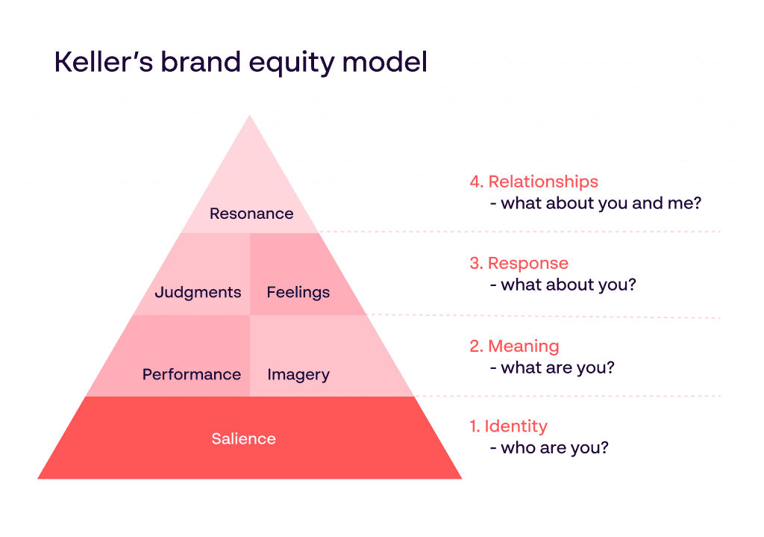
Figure 2: Keller’s Brand Equity Model
Source: (Akanji et al., 2023)

Advantages
Comprehensive Framework: Keller's approach offers a comprehensive and systematic framework for analyzing brand equity across identity, resonance, and other factors. By taking such a holistic view, marketers may better comprehend the complex web of influences that acts upon the thoughts and actions of their target audience (Stukalina and Pavlyuk, 2021).
Customer-Centric: To make sure that branding activities are in line with customer preferences and demands, the model highlights the significance of knowing consumer viewpoints and reactions. By focusing on the needs of the consumer, marketers can develop tactics that are more likely to be successful.

Disadvantages
Complexity: The model's complexity and difficulty to apply stem from its multidimensional character, which is particularly problematic for smaller enterprises with fewer resources. Addressing all of the potential factors may be difficult and call for specialized knowledge (Stukalina and Pavlyuk, 2021).
Subjectivity: There may be some room for interpretation when assessing factors like brand resonance and brand connections. Getting consistent and objective assessments of brand aspects may be difficult since customers may have varying perceptions of and reactions to such characteristics.

Customer Journey and Customer Touchpoints for Louis Vuitton
The customer journey for Louis Vuitton, a luxury fashion brand, comprises three main stages: Pre-purchase, Purchase, and Post-purchase (Ieracitano, 2023). Each stage is characterized by distinct customer touchpoints that contribute to shaping the overall brand experience.

Pre-purchase Stage
During this stage, potential customers become aware of Louis Vuitton's products and consider their options. Touchpoints in this stage include:
Advertising: Louis Vuitton's advertisements in high-end fashion magazines, billboards, and online platforms introduce the brand and its offerings to a wider audience (Ieracitano, 2023).
Social Media: The brand's official social media accounts showcase the latest collections, behind-the-scenes glimpses, and influencer partnerships, engaging potential customers.
Website: The official website serves as a hub of information, featuring product details, fashion shows, and stories that enhance brand desirability (Ieracitano, 2023).
Retail Stores: Upscale Louis Vuitton boutiques offer an immersive experience, allowing customers to physically engage with products and receive personalized assistance.

Purchase Stage
This stage involves the actual transaction where customers make a purchase decision. Touchpoints here include:
Retail Stores: The in-store experience includes interactions with sales associates, trying on products, and receiving personalized recommendations (Rudkowski et al., 2020).
E-commerce Platform: Louis Vuitton's online store provides a seamless shopping experience, enabling customers to browse, select, and purchase products from the comfort of their homes.
Customer Service: Accessible via phone, email, or chat, customer service assists with inquiries, addresses concerns, and provides additional information to aid the purchase decision (Rudkowski et al., 2020).

Post-purchase Stage
After the purchase, the brand focuses on fostering customer satisfaction and loyalty. Touchpoints in this stage encompass:
Product Quality: The product's quality, craftsmanship, and durability play a crucial role in shaping the overall brand perception and repeat purchases (Rudkowski et al., 2020).
Customer Service: Continued customer service support ensures that any post-purchase queries or issues are resolved promptly, enhancing customer satisfaction.
Follow-up Communication: Louis Vuitton can engage customers through follow-up emails, expressing gratitude for their purchase and sharing related content.
Exclusive Events: Invitations to exclusive fashion events, previews, or product launches provide opportunities for customers to deepen their connection with the brand (Rudkowski et al., 2020).
Social Media and Community: Customers may share their experiences on social media, participating in the brand's online community and reinforcing loyalty.
Louis Vuitton's commitment to opulence, uniqueness, and individualized experiences is evident in every one of these touchpoints. From the moment of first exposure, throughout the purchasing process, and even after the sale, these encounters set the stage for a frictionless, memorable, and aspirational customer experience.
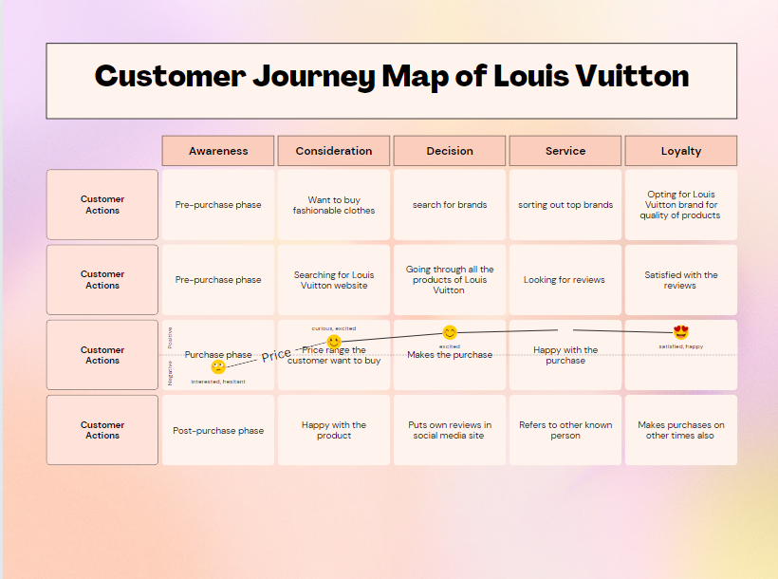
Figure 3: Customer Journey Map of Louis Vuitton

Total Engagement Model in relation to Louis Vuitton
Brand Touchpoints and Experiences: Louis Vuitton can leverage TEM by strategically managing and enhancing its brand touchpoints and experiences. This includes ensuring that every interaction, whether through its stores, website, social media, or customer service, consistently reflects the brand's luxury, exclusivity, and craftsmanship (Nagaraj, 2020).
Emotional Connection: TEM underscores the importance of creating emotional connections with customers. Louis Vuitton can achieve this by crafting narratives that resonate with the aspirations and values of its target audience. Storytelling around its heritage, craftsmanship, and innovation can evoke emotions and forge lasting bonds (Nagaraj, 2020).
Social and Community Engagement: TEM emphasizes the role of social engagement and community building. Louis Vuitton can curate exclusive events, workshops, or online platforms that bring customers together to share their experiences, stories, and love for the brand. This fosters a sense of belonging and strengthens customer loyalty (Nagaraj, 2020).
Personalization and Customization: The model highlights the significance of personalization. Louis Vuitton can offer bespoke experiences, personalized recommendations, and customized products, catering to individual preferences and enhancing the sense of exclusivity (Rahman et al., 2023).
Feedback and Collaboration: TEM encourages two-way communication. Louis Vuitton can actively seek feedback, listen to customer insights, and even collaborate with customers on limited-edition designs or product co-creation, enhancing engagement and customer ownership (Rahman et al., 2023).
Omnichannel Consistency: TEM stresses the need for seamless omnichannel experiences. Louis Vuitton can ensure that customers have a consistent and harmonious journey across all touchpoints, whether online or offline, creating a unified and immersive brand experience (Rahman et al., 2023).
Long-Term Relationships: TEM emphasizes cultivating long-term relationships. Louis Vuitton can extend engagement beyond individual transactions, focusing on building enduring connections through loyalty programs, rewards, and ongoing engagement initiatives (Rahman et al., 2023).

Recommendations
Digital Innovation: Embrace innovative digital strategies to engage a tech-savvy audience. Invest in augmented reality (AR) and virtual reality (VR) experiences that allow customers to virtually try on products or explore exclusive collections, enhancing the online shopping experience.
Omni-Channel Excellence: Focus on seamless integration across all channels, ensuring a consistent brand experience both online and offline. Implement features like "click and collect" to bridge the gap between e-commerce and brick-and-mortar stores.
Personalization: Leverage customer data to offer personalized recommendations and experiences. Utilize AI-driven algorithms to suggest products based on customer preferences, purchase history, and browsing behavior, enhancing customer engagement.
Sustainability Initiatives: Highlight the brand's commitment to sustainability. Launch eco-friendly collections, emphasize responsible sourcing, and share transparent information about the brand's efforts to reduce its environmental impact.
Collaborations and Limited Editions: Continue collaborating with artists, designers, and influencers to create limited-edition collections that generate buzz and excitement among fashion enthusiasts and collectors.
Exclusive Events: Host exclusive events and unveilings to engage loyal customers and maintain a sense of exclusivity. These events can include private previews, art exhibitions, and fashion shows.

Conclusion
The marketing approach used by Louis Vuitton strikes a balance between tradition, novelty, and exclusivity. The company's ability to tell a captivating story about its dedication to craftsmanship, creativity, and luxury is made possible by the strength of its unique brand name. Louis Vuitton's online and physical experiences are noteworthy for their painstaking attention to detail and focus on the consumer. The brand's capacity to respond to shifting consumer tastes and values is shown in its limited editions, partnerships, and sustainability efforts. The Total Engagement Model is what gets people talking to one other, which in turn builds trust and loyalty. Louis Vuitton's sustained success as a symbol of ambition, elegance, and timeless style may be attributed to the brand's strategic balancing act between tradition and modernity in the face of intense competition.

References
Akanji, A.H., Asare, C., Sekyere, K.N. and Warden, B.H., 2023. Consumer-Based Brand Equity in the Services Sector: A Systematic Literature Review. ADRRI Journal of Arts and Social Sciences, 20(2 (8), April, 2022-June), pp.58-82.
Batraga, A., Skiltere, D., Salkovska, J., Bormane, S. and Legzdina, A., 2019. Influence of integrated marketing communication tools upon consumers’ buying decisions in the context of sustainability.
Blakeman, R., 2023. Integrated marketing communication: creative strategy from idea to implementation. Rowman & Littlefield.
Botirova, S., 2023. MODELS OF MODERN COMMUNICATION. Mental Enlightenment Scientific-Methodological Journal, pp.74-84.
Goncharova, N.A., Solosichenko, T.Z. and Merzlyakova, N.V., 2019. Brand platform as an element of a company marketing strategy. International Journal of Supply Chain Management, 8(4), p.815.
Hilbert, M., 2020. Information theory for human and social processes. Entropy, 23(1), p.9.
Hunt, S.D., 2019. The ethics of branding, customer-brand relationships, brand-equity strategy, and branding as a societal institution. Journal of Business Research, 95, pp.408-416.
Ieracitano, S., 2023. The Chinese luxury market and digitalization: possible strategies for Western brands and Louis Vuitton as a case study.
Kai, X., 2021. Research on brand alliance strategy innovation based on the big data analysis of consumers’ attitude Take Louis Vuitton and supreme as an example. In E3S Web of Conferences (Vol. 235, p. 01075). EDP Sciences.
Katsikeas, C., Leonidou, L. and Zeriti, A., 2020. Revisiting international marketing strategy in a digital era: Opportunities, challenges, and research directions. International Marketing Review, 37(3), pp.405-424.
Kushwaha, B.P., Singh, R.K., Varghese, N. and Singh, V.N., 2020. Integrating social media and digital media as new elements of integrated marketing communication for creating brand equity. Journal of Content, Community & Communication, 11(6), pp.52-64.
Lai, C.S., 2022. The Strategy and Competitor Analysis of LVMH. In 2022 2nd International Conference on Financial Management and Economic Transition (FMET 2022) (pp. 549-557). Atlantis Press.
Muhammedrisaevna, T.M.S., Bayazovna, G.N. and Kakhramonovna, D.A., 2020. Goal and objectives of integrated marketing communications. Economics, (2 (45)), pp.5-7.
Nagaraj, S., 2020. Customer engagement by fashion brands: an effective marketing strategy. In Circular Economy and Re-Commerce in the Fashion Industry (pp. 161-175). IGI Global.
Rahman, M.S., Bag, S., Hossain, M.A., Fattah, F.A.M.A., Gani, M.O. and Rana, N.P., 2023. The new wave of AI-powered luxury brands online shopping experience: The role of digital multisensory cues and customers’ engagement. Journal of Retailing and Consumer Services, 72, p.103273.
Rėklaitis, K. and Pilelienė, L., 2019. Principle differences between B2B and B2C marketing communication processes. Organizacijø Vadyba: Sisteminiai Tyrimai, (81), pp.73-86.
Rudkowski, J., Heney, C., Yu, H., Sedlezky, S. and Gunn, F., 2020. Here Today, Gone Tomorrow? Mapping and modeling the pop-up retail customer journey. Journal of Retailing and Consumer Services, 54, p.101698.
Shay, R. and Van Der Horst, M., 2019. Using brand equity to model ROI for social media marketing. International Journal on Media Management, 21(1), pp.24-44.
Stukalina, Y. and Pavlyuk, D., 2021. Using customer-based brand equity model in the higher education context: simulating the current university’s brand. Business, Management and Economics Engineering, 19(2), pp.272-288.
Vieira, V.A., de Almeida, M.I.S., Agnihotri, R., da Silva, N.S.D.A.C. and Arunachalam, S., 2019. In pursuit of an effective B2B digital marketing strategy in an emerging market. Journal of the Academy of Marketing Science, 47, pp.1085-1108.

