The portrayal of Mary Magdalene in the four canonical gospels.

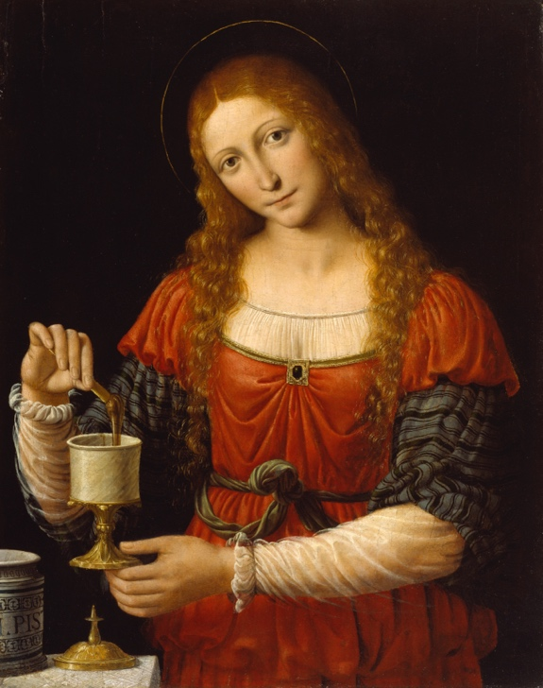
(Bernardino Luini, 1524)

Name | St. Mary Magdalene, also called Mary of Magdala
Flourished | First Century CE, Palestine
Feast day | 22nd July

St. Mary Magdalene, also called Mary of Magdala, flourished in First Century CE, Palestine. Her Feast day is 22nd July (Vatican, 2016). She is referred to as one of the women to follow Jesus in the Gospel of Mark and Luke (Luke 8:1-2, Mark 15:41). The accounts of Mary vary between each of the four Gospels.

The Gospels of Mark and Luke first name Mary Magdalene as being possessed by seven demons (Luke 8:2, Mark 16:9). In their gospels, as Jesus was passing through the village, he came across Mary, who has seven demons in her. He performed the miracle of ‘cleansing’ her from the demons. From that moment on she became a follower along with the twelve disciples and other women (Luke 8:2, Mark 16:9). Mary travelled with Jesus as he travelled from village to village (Luke 8:1-2). She is referred to have travelled with him around Galilee in Mark’s gospel (Mark 15:41). The women would provide resources to Jesus and the disciples (Mark 15:41, Luke 8:3). This brings into question the wealth and the role of the women that followed Jesus. Women took on an active role in the movement with Jesus.

We hear in John’s gospel that Mary was at the house of Lazarus with Jesus (John 12:1). John does not specifically name Mary as being Mary Magdalene, however, it is assumed in Christianity that the Mary named in the gospel is Mary Magdalene (BBC, 2011). Despite John’s gospel, Luke names the woman as a sinner from the city (Luke 7:27). It is often assumed that this woman was a Prostitute. To associate Mary Magdalene as being this woman implies that Mary Magdalene was a prostitute to which there is no evidence to back this claim. Because of John and Luke’s gospels being so vague, it has led to many assumptions being made. This claim of Mary Magdalene being a prostitute comes from a sermon by Pope Gregory the Great, who names her as a prostitute and names her as three women in the Bible who are known to be Prostitutes (BBC, 2011). This assumption was so damaging to the reputation of Mary that it lead to her not being declared a Saint until 1969 (BBC, 2011).

Mary is not referenced again in the Bible until the death of Jesus. Mary Magdalene is named by John and Mark as one of the women who was stood at the foot of the cross (John 15:25, Mark 15:40). Matthew writes that Mary was sat opposite the tomb as Jesus’s body was being put into the tomb (Matthew 27:61). He claims she was at the tomb during the earthquake on the first sabbath (Matthew 27:55–56). Mark’s account backs Matthew’s claim that she was with Mary the mother of Joseph when they laid Jesus’s body in the tomb (Mark 15:47). Mary Magdalene was one of the three women who first saw Jesus alive (Mark 16: 1-8, Matthew 28:1). This places Mary at a vital part of the Christian story.

According to John, Mary Magdalene was the one who saw the stone, that was over the tomb entrance, rolled away (John 20:1). Mary was named by Mark as being the first-person to hear and witness Jesus having been risen from the dead (Mark 16:5-9). According to Mark, a man in a white robe was at the tomb and told Mary Magdalene that Jesus had risen as Jesus predicted himself and that she should go and tell the others (Mark 16:9). Mary Magdalene did as the man instructed and went to tell the disciples about what she saw. The disciples refused to believe anything that Mary had told them (Mark 16:10). The two disciples, Simon Peter and another, ran to the tomb and saw the tomb was empty (John 20: 3-10). John refers to that moment being when Jesus came to her as she wept (John 20:11).

According to John, Jesus spoke to Mary after the disciples left, and when she returned to the group, she told the disciples what she saw (John 20:18). By Jesus appearing to Mary first and giving her the command, it elevates her status as she is the first recorded witness and the one chosen by Jesus to spread the news of the resurrection. This should have elevated her status in the Church but due to the amount of negative assumptions made about her, Mary is not portrayed that way in the church.

According to John, Simon Peter and another disciple ran to the tomb (John 20: 3-4). The accounts imply that the disciples did not believe Mary. In Mark’s account, he goes into detail of Jesus’s visit to the disciples. Mark writes of Jesus being upset with the disciples because they did not believe he had risen. Mary Magdalene understood that Jesus would be raised from the dead, as Jesus told them about his death and his resurrection, but the disciples did not believe as the doubted Mary when she told them (Mark 16:9-13). Mark’s gospel says that Jesus calls this a lack of faith and stubbornness (Mark 16:14, Luke 9: 21-28). The anger of Jesus was because he told them about the resurrection in Luke’s gospel (Luke 9: 21-28). Some of the disciples witnessed the Transfiguration of Jesus, which was an important moment that Jesus was the Son of God (Luke 9: 28-36). This shows a lack of faith within the disciples. However, this lack of faith is not seen in Mary Magdalene. Mary is presented as more loyal than the twelve disciples of Jesus as they denied, betrayed and refused to believe in the resurrection of Jesus. The actions of the Disciples elevates Mary’s role as a loyal and faithful follower.

Unlike the other gospels, Matthew’s account is very short and limited and has a main focus on the days in-between the death and resurrection. Matthew places Mary at all the events from the crucifixion to the resurrection. According to Matthew, Mary never left Jesus’s side even during his death (Matthew 28: 1-9). This gives the portrayal of Mary Magdalene as the ultimate disciple of Jesus as she remains a follower even when he died and during the hard times. Mary is portrayed as the perfect example of a follower of Christ. As Mary was the first-person Jesus appeared to after the resurrection, she is the first witness to what Christians see as the ultimate miracle, the miracle that cements Jesus as the Son of God. This is an important and vital event for Christian and for Mary to witness it first thing should have elevated her Status.

However, there is confusion on the story of Mary Magdalene. The Gospels of Mark, Matthew, Luke and John, vary on Mary’s account. An example of the confusion is the difference between John and Luke’s account of who washed Jesus’s feet (John 12:1, Luke 7:27) There are similarities amongst them that make certain elements more credible than others. It is the variation of accounts that leads to assumptions, such as Pope Gregory the Great’s assumption of her being a Prostitute. The gospels do make it clear that Mary Magdalene was a loyal and faithful follower of Jesus as she was with him all the way through the crucifixion and the resurrection.

Whilst focusing on the four canonical gospels to understand the portrayal of Saint Mary Magdalene, we can see that a lot of known about Mary comes from assumptions made about her. These assumptions had damaged the reputation of Mary and taken away her portrayal as a loyal and faithful disciple of Jesus who never doubted. Mary Magdalene’s portrayal in the gospels is as the ultimate disciple, a figure all Christians should aspire to be. It is known that she was there during the early church. The gospels do not tell us what happened to Mary Magdalene after the ascension. Anything that is known about Mary after the ascension is information that has been gathered from other sources or from the understanding of historical events at the time. The gospel’s main focus after the ascension is what happened to the twelve disciples.

The portrayal of Mary in the four canonical gospels is something that should be focused on more. The four canonical gospels portray Mary Magdalene as a loyal follower who, unlike the disciples, creates a greater understanding on who Jesus was. When we take away the negative assumptions of Mary Magdalene we can see that she represents the perfect follower of Jesus and who Christians should aspire to be.

Bibliography

- Bernardino Luini, 1524, Saint Mary Magdalene, Available at: https://art.thewalters.org/detail/37520/mary-magdalen/ (Accessed: 20th November 2023)
- The Vatican, 2012, The liturgical memory of Mary Magdalene becomes a feast, like that of the other apostles, 10.06.2016 Available at: https://press.vatican.va/content/salastampa/en/bollettino/pubblico/2016/06/10/160610b.html (Accessed: 23rd November 2023)
- BBC, 2011, Mary Magdalene, the clichés, Available at: https://www.bbc.co.uk/religion/religions/christianity/history/marymagdalene.shtml (Accessed: 23rd November 2023)
- New Revised Standard Version Anglicised Bible, (2021), Available at: https://www.biblegateway.com/versions/New-Revised-Standard-Version-Anglicised-NRSVA-Bible/ (Accessed: 20th November 2023)

