Discussion of operating systems and useful commands

Teifion Cellan Gibson - student id 2304294
Module - Computer architecture and operating systems - Module Id ACCA4022
Table of contents

Introduction 2
Section 1 - Key functions of general Operating Systems 3
Types of operating systems 3
Section 2 - Use of windows OS CLI commands 8
Section 3 - Use of Linux OS CLI commands 12
Section 4 - Use of Windows OS Scripts 16
Batch scripting 16
Powershell scripting 20
Section 5 - Use of Linux OS Scripts 26
Conclusion 31
References 32

Introduction
Within this essay I will be discussing a variety of different operating systems, I will also be discussing what the operating systems can do via commands. The Oxford dictionary defines an operating system as “The low-level software that supports a computer's basic functions, such as scheduling tasks and controlling peripherals”[1]. These definitions make it clear an operating system is a program designed for the management of multiple software on a machine.

Section 1 - Key functions of general Operating Systems

Types of operating systems
The first operating system I will be discussing is Microsoft's Windows 10. Windows 10 is an operating system released by microsoft on 29 July 2015 [5], this operating system is currently still being supported and updated by microsoft. Windows 10 is commonly used on home computers as well as interfaces across the world. according to satistia.com “Microsoft's Windows was the dominant desktop operating system (OS) worldwide as of July 2023” [6] showing that windows operating systems are the most popular operating systems on the market.

The next operating system I will discuss is linux, linux is an operating system first released on 17 September 1991 [10]. Linux is a kernel based operating system that is open sourced, it is often used in the IT industry as it is able to communicate and use hardware more directly than windows. It has a market share of around 3.1% [6]. Linux is commonly used for “web servers, database servers, file servers and email servers” [11] so it is essential to learn and understand linux machines and their commands to effectively work in the industry.

The next operating systems are mobile operating systems.Apple's iOS operating system, is an operating system that runs on mobile phones and tablets created by apple, and was first released by apple on june 29 2007 [7]. Ios is the 2nd most popular mobile device operating system having a 29.32% market share [8].

Another popular operating mobile operating system is google's android operating system. Android was released on 23 september 2008 [9]. Android is built off of a modified linux kernel. It is currently the most popular operating system in the world having a market share of 69.96% [8]

Key functions of operating systems
There are also many Key Functions of operating systems. According to bbc bitesize [2] there is a list of functions an operating system has including controlling hardware, managing software and providing the user interface.

Operating systems provide the system the ability to controls and manages how the software communicates to the hardware according to tutorchase.com “the OS determines which processes get access to the CPU, and for how long, in a process known as task scheduling” [3] which allows the computer to be able to more effectively manage multiple programs at once.

a key feature of an operating system is memory allocation, meaning how the memory is used on the computer, according to studysmarter “It involves tracking each byte in a system's memory and making allocation decisions to meet system requirements” [4] this allows the operating system to reduce the need for the user to manually input into the system.

Programs such as task manager allow the user to manage what programs are running on a machine. Additionally, the task manager allows the user to see how the open programs use the device's components. And stop active tasks on the machine.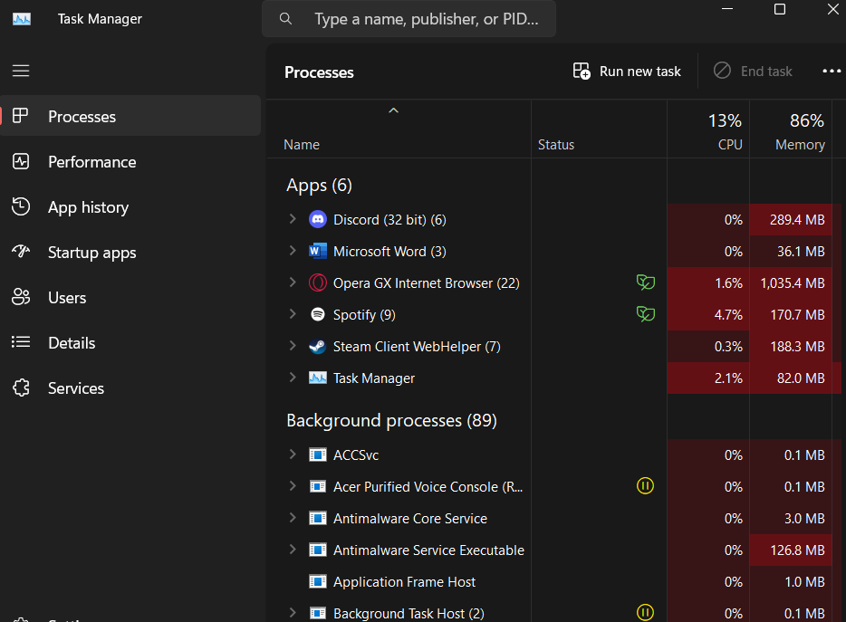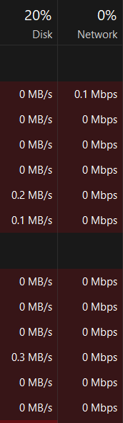
Fig 1 and 2 “task manager screenshots from windows 11”

The user can access the power user menu by inputting the windows key+X, this opens a list of shortcuts to a variety of management programs as shown below.
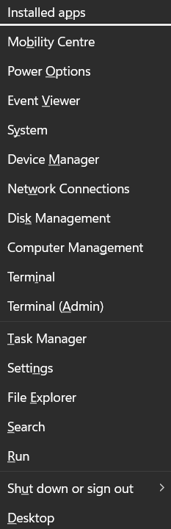
Fig 3 “windows power user menu”
Shown below is the event viewer, the event viewer allows a user of a pc to be able to have a more detailed view of active processes and computer systems memory usage.
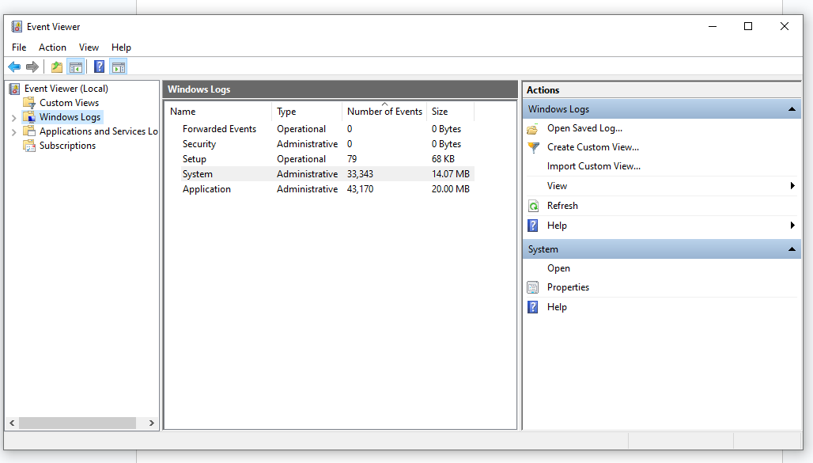
Fig 4 “event viewer”
The reliability monitor allows a user to view errors that have occurred on the operating system, additionally the reliability monitor allows the user to see more detailed information about these errors. It is a useful tool for identifying problems occurring on an operating system.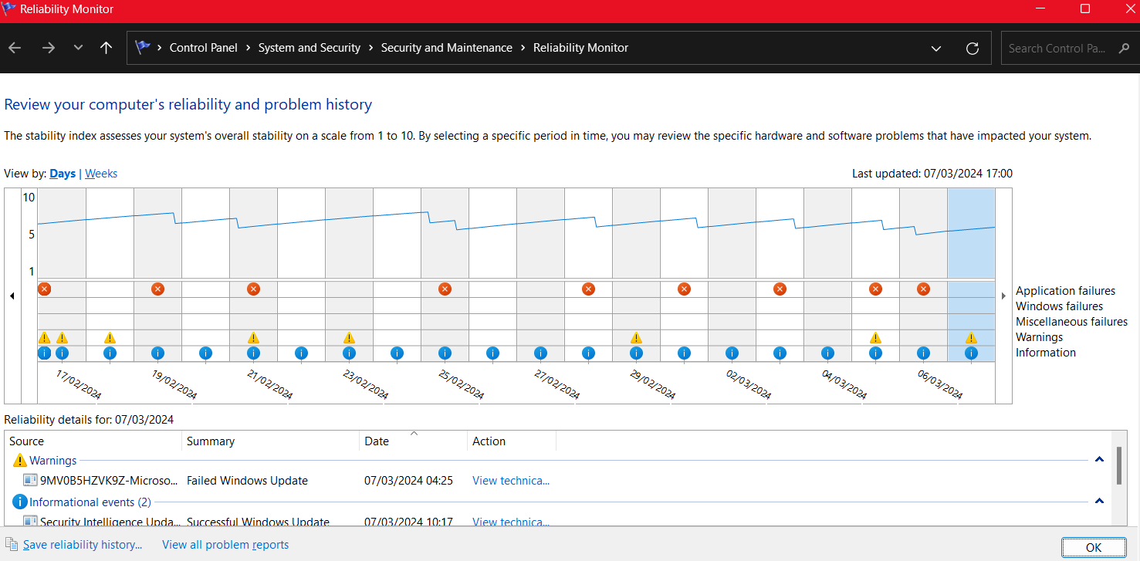
Fig 5 “reliability monitor”

The resource monitor allows a user to manage and see usage of a computer's resources, and allows the user to more effectively manage how the machine manages memory. Additionally it allows the user to have a view of average usage of a machens components.
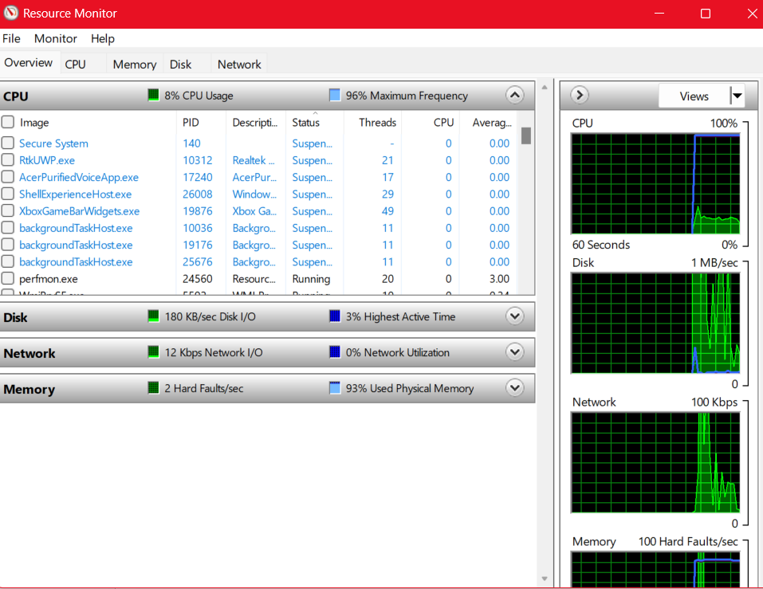
Fig 6 “resource monitor”
The user interface of an operating system is how the user interacts with a device [12]. The taskbar is an element present on most desktop operating systems. This allows the user to be able to quickly find and access programs the user may commonly use.
Fig 7 “windows 11 taskbar”

Section 2 - Use of windows OS CLI commands
Built into the windows operating system is the terminal command prompt. This allows us to run commands on a windows machine, within this section of the essay i will be discussing a small variety of windows command prompts and their uses.

The dir command allows a user to be shown a list of contents in a user directory. This allows a user to see what is contained in a users directory, it also informs us of when the data was last accessed and used. This allows a user to get a visualization of the directory of their machine, additionally it allows the user to see how many bytes are free on their system's hard disk.
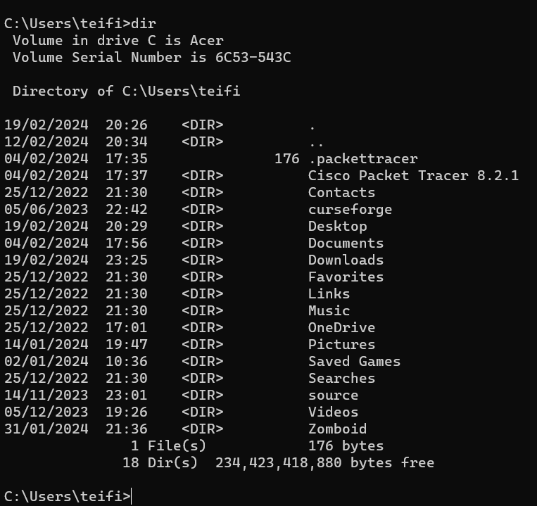
Fig 8 “dir command”
The help command allows a user to gain more information on what a command/ function will do. Below is an example of the help command with the prompt help dir, additionally the help command also shows what the command can do such as any filters a command may have access to and how the files are sorted on the output of the command line.
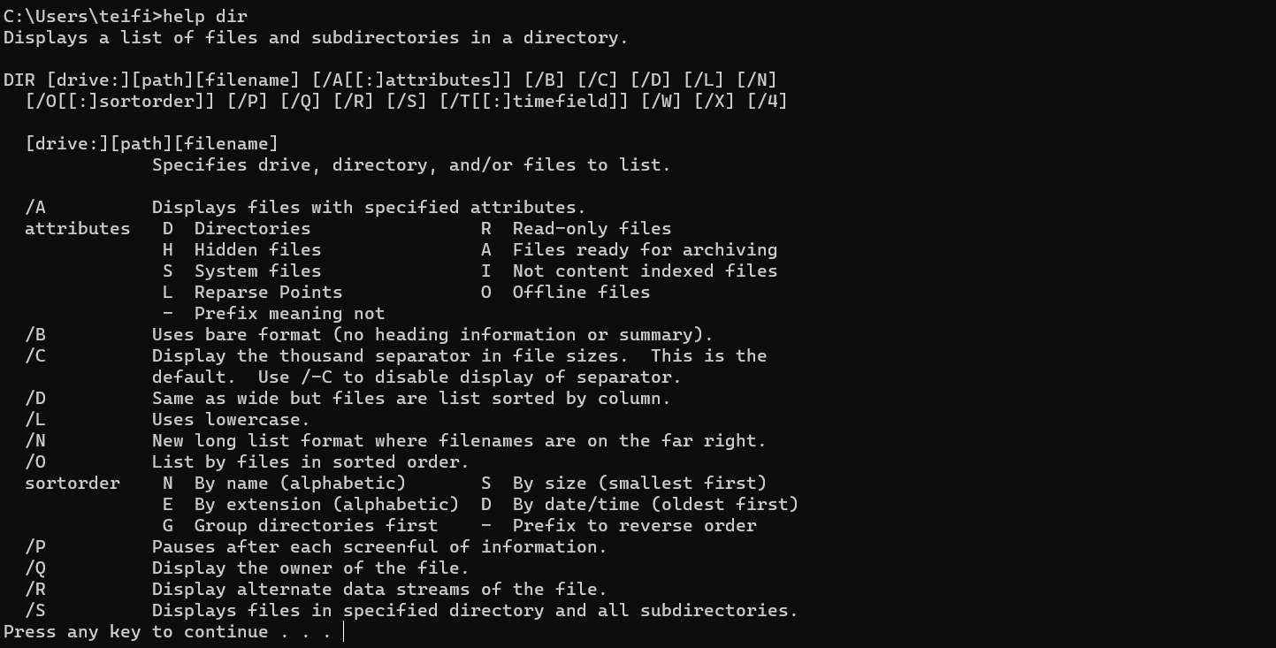
Fig 9 “help command”

Next command is cd this command allows us to manipulate the folder/directory that is being managed on the command line. cd .. allows us to be able to go back out of a directory back into the wider fileset.
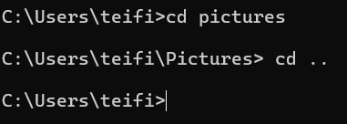
Fig 10 “cd .. command”
Mkdir creates a new folder on the operating system which can then be accessed and edited
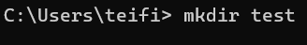
Fig 11 “mkdir command”

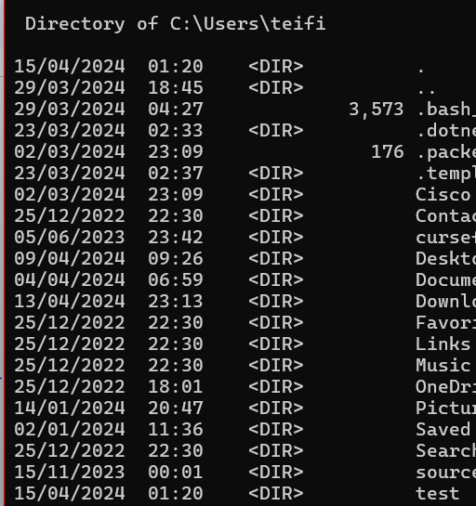
Fig 13 “Shown creation of test folder”
Rmdir deletes a folder in a directory as shown below. These commands allow for basic file management and manipulation on the user's machine.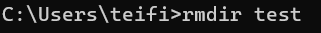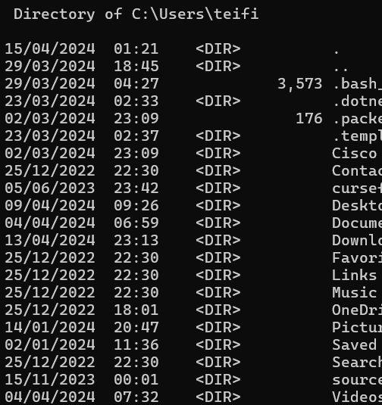
Fig 14 and 15 “deletion of a file using rmdir”
The echo command echos an inputted phrase. This allows the machine to display an output such as a variable on a command line.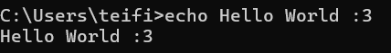
Fig 16 “echo command”
by using > we can create a file directly to a specific location. For example we can create a new file and input into it directly from the command line.
Fig 17 “writing to a file via command line”
Additionally we can open the file by typing the filename on the command line.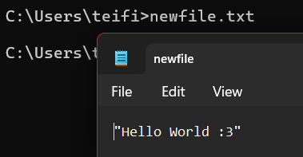
Fig 18 “opening a file via command line”
The type command displays the contents of a file such as a .txt file.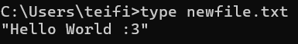
Fig 19 “displaying contents of a file”
We can use the tasklist command to list the currently active processes on the machine. This allows us to see what tasks are active and how much memory these tasks are using.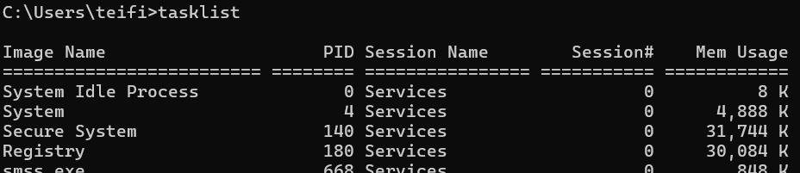
Fig 20 “Tasklist command”

Section 3 - Use of Linux OS CLI commands
The linux directories are used by the user for the same uses as windows commands, the Linux subdirectories contain a set of basic commands and functions used for the system.

First is /bin, this command allows the user to lay out the source code and binary of an application or file[13]. Another command is /ect which is the system's configuration files, these files manage and control how the operating system behaves[13]. Another subdirectory is /var which contains data such as the systems log files[13].

by typing in help we can access a set of commands that is available on the linux command line. In the section below I will be showing what some of these commands listed in help do.
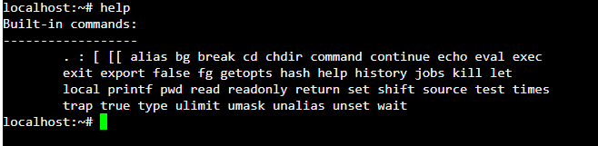
Fig 21 “help linux command line”
Pwd shows what directory is currently being inputted into.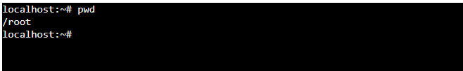
Fig 22 “pwd example”
ls shows the files within the directory and cd allows the user to be able to change the directory there in.
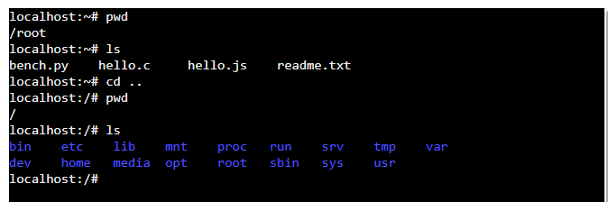
Fig 23 “ls and cd example”
By inputting touch and then file name and the extension we can create a file in the current directory.
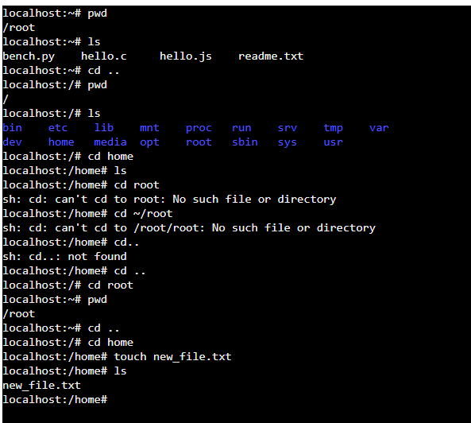
Fig 24 “touch example”
Printf is a basic command that allows the user to print text onto the command line..
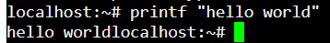
Fig 25 “printf example”
The clear command will clear the command line, this is helpful for clearing clutter on the screen.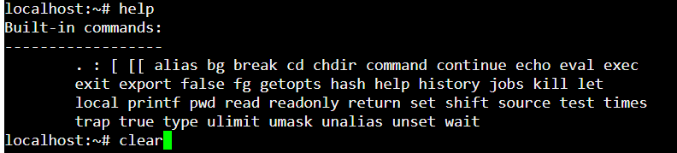
Fig 26 “clear command example”
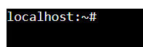
Fig 27 “Clear command line”
We can insert commands and text into a text file. This allows us to create and save scripts that can be run on later use.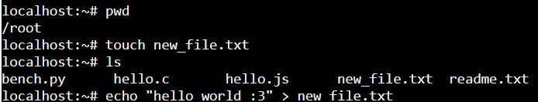
Fig 28 “writing into a text file example”
Then we can run the text file using the cat command.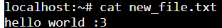
Fig 29 “running a script on command line”
To create a new user on a linux command line we use the sudo useradd command and then the username of the user as shown below. 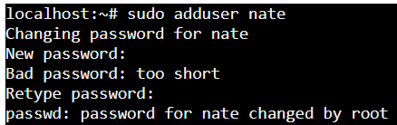
Fig 30 “adding a new user”
This allows for the creation of users and passwords for the users on the system. The command will create a home directory for the user on the linux system. This can be shown by using ls in the root directory.
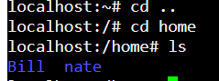
Fig 31 “looking at users on a system”
to use a user account and we use the Su - user command as shown below. This allows us to view and manage the command line as a user rather than an administrator. (by using a - we avoid having to login to the user account) this is useful for administration purposes.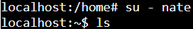
Fig 32 “using a user account”
We can confirm we are on a user account using the whoami command.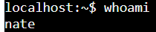
Fig 33 “Checking if account is a user”
And finally we can logout of a user by using the exit command.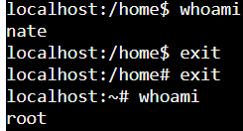
Fig 34 “exiting a user account”

Section 4 - Use of Windows OS Scripts

Batch scripting
Batch scripting is a programming language used to create command line programs, these files are saved to the machine using a .bat extension. These scripts are able to be run on command lines.

Shown below are the basic commands in bat and their usage in a program. First command we , as well as using the echo command which will print the output on the command line.

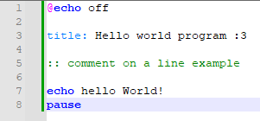
Fig 35 “Hello world batch script and echo command”
The set command allows us to set a variable name and integer. In bash no need to declare a variable unlike similar coding languages such as c. Shown below is an example of a set of variables saved into a bash script, This is then printed onto the command line. To create a variable in bash we type var____ , for example varnum.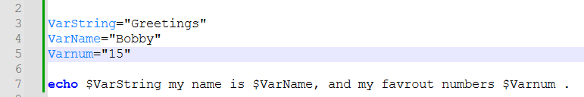
Fig 36 “Variables example”
Using the read command we can save an input to a variable, as shown below, this allows us to input data into a variable such as numbers or a string. for the read command to work as shown below.
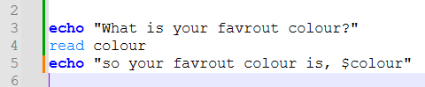
Fig 37 “Input script”
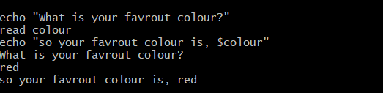
Fig 38 “input script being run”
Using a if statement we can create if else scripts in bash, for example we can ask a question and if the response is yes we can create a defined response else we can define a different result, an example of this type of script is shown below. Additionally to use if statements in bash we also need to add at the end of the if statement fi to end the if statement.
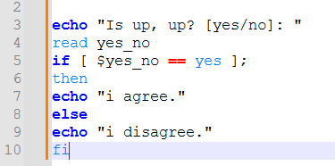
Fig 39 “if else script”
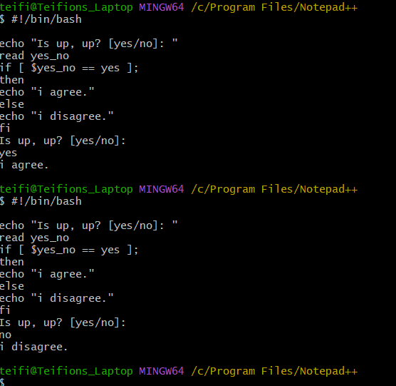
FIg 40 “if else if output” Fig 41 “if else else output
Using bat scripts it is possible to create for and until loops that repeat for x amount of times and until condition is met, this allows us to create conditions in the code for uses such as the printing of arrays and exiting an active loop in the code, examples of these scripts are shown below.
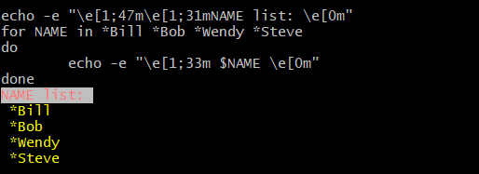
Fig 42 “for loop example”
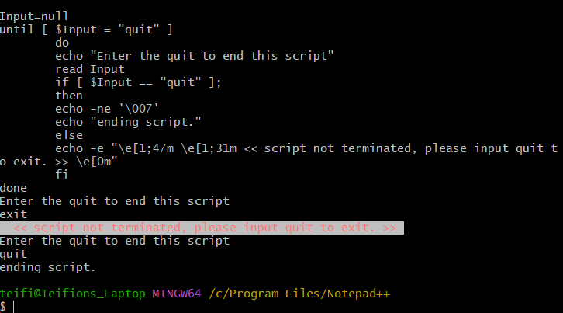
Fig 43 “while loop example”

Additionally bash allows for the usage of three types of arrays, these are one line arrays, where they are all declared on a single line, the second type of array is the multi line array where the individual values of the array are defined in multiple lines on the script. The final array is a defined array allowing the user to program associated values to the array, arrays have many applications such as tracking multiple values under the same name, example of these arrays are below.
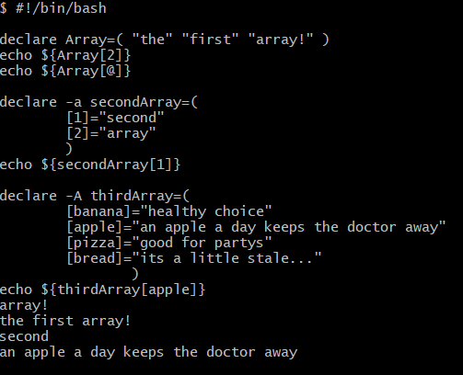
Fig 44 “arrays example”
Using case statements we can program in a set of responses based on different inputs, and use else cases.
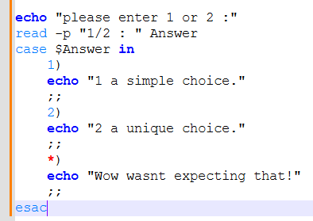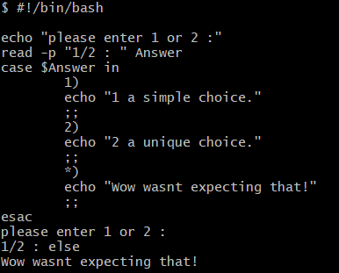
Fig 44 “switch case script” Fig 45 “switch case run”
bash allows for the creation of functions within a bash script which allows for the same script to be run multiple times. Shown below is a function running within a script.
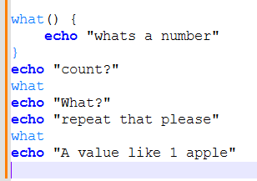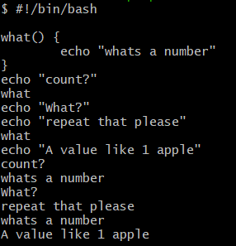
Fig 46 “function script” Fig 47 “function script run in command line”
Using these basic commands we can use them to create terminal systems such as menus.

Powershell scripting
Powershell is a command line scripting language that allows users to create scripts and run commands to control aspects of their operating systems, some basic commands and their uses are shown and discussed below.

In order to run commands we must be in either unrestricted mode or remote access mode. To check our permission level we can run the command GET-EXECUTIONPOLICY. If the policy is set to restricted we can set it to unrestricted. 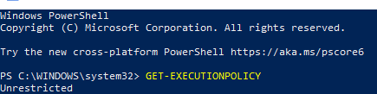
Fig 47 “Get execution policy”
To create and run variables we must type $var = “variable” using this we can write a hello world program shown below.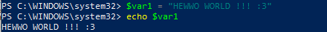
Fig 48 “variable example”
Next we use the ps command, like ps in bash it will allow us to get the currently active processes and display them to the user as shown below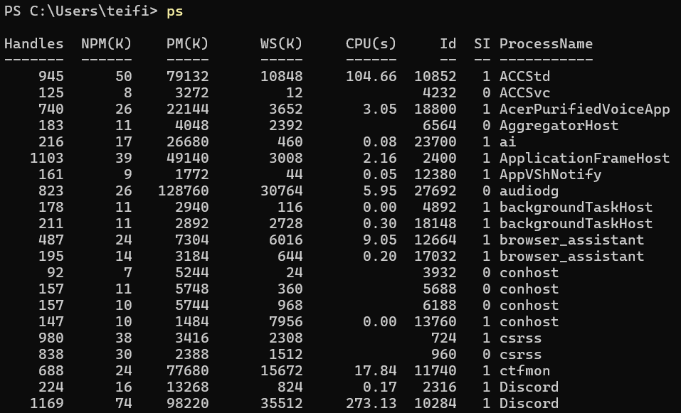
Fig 49 “ps example”
we can end a process via powershell by using taskkill or end-process for example powershell is being used below to close the program ms paint. This allows the user to be able to close programs that may not be able to be closed in a program such as task manager.
Fig 50 “Taskkill example”
To help improve visibility on the command line clear command will clear the command line, this is shown below on a command line that has just used the get-help command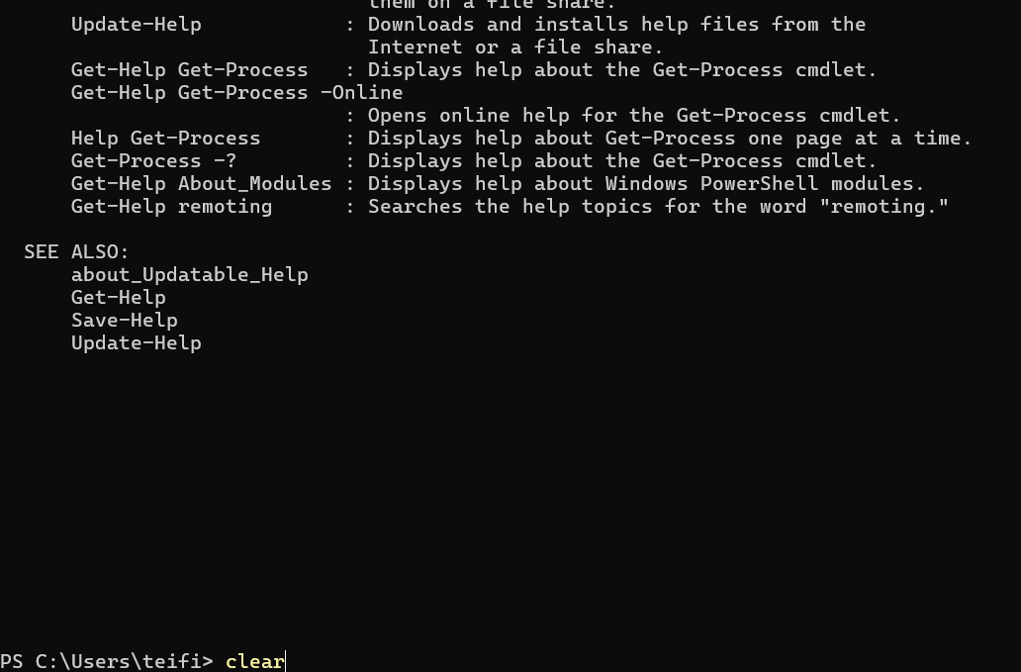Fig 51 “clear command example”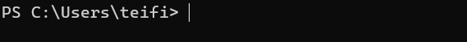
Fig 52 “cleared command line”
Using the get-help command we can get additional information on how to get information about using get help for a variety of commands. For example, we can type get-help get-process, this will display help about the process command in detail such as syntax and a description of what it does, as shown below.
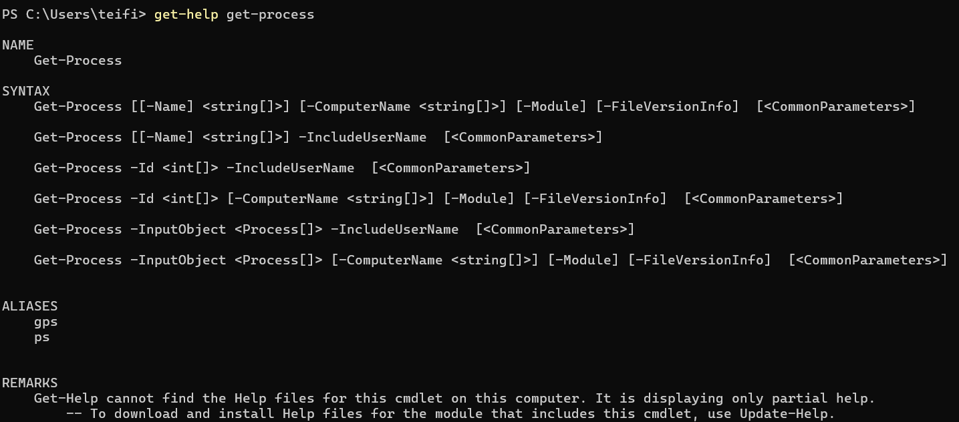
Fig 53 “get help example”
Now we will use the get process command to obtain additional information on a process.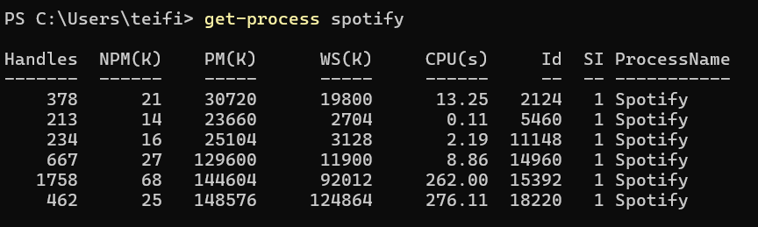
Fig 54 “get process example 1”
If you leave get process blank it will list all active processes on the machine.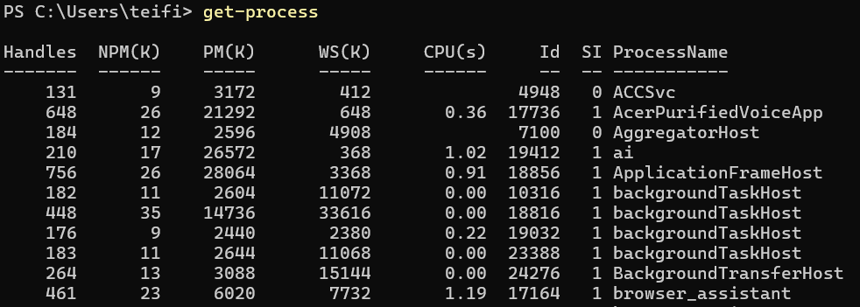
Fig 55 “get process example 2”
Get process will give us specific information, these are handles, which is the number of pointers a program has to memory, NPM is the non paged memory used by a program, PM is the paged memory that the program has used, WS is working set which is the pages of physical memory, VM is the virtual memory to a dedicated process and finally, CPU is the cpu usage measured in seconds, the NPM, PM and WS are measured in kilobytes.

Another useful command is the Get-NetIPConfiguration command, this command will retrieve all of a machine's ip information, this is useful for networking as it allows a user to identify issues with a machine's ip configuration settings.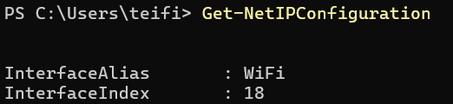
Fig 56 “get net ip configuration example”
We can create a new file by using the command New-File.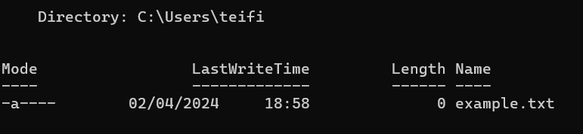Fig 57 “creation of a new file in powershell”
Fig 58 “file created on machine”

This allows us to use powershell to create and save files. We can also use powershell to manage files within the hard disk. Another useful command we can use via powershell is Get-Localuser and Get-Localgroup that allows a user on a machine to access the users on a local system and manage their permissions. 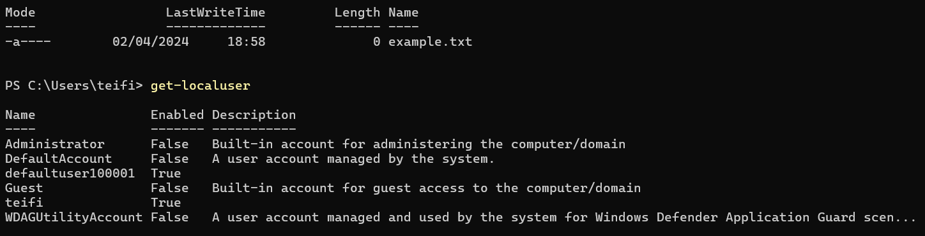
Fig 59 “get local user example”
Get local user also gives information about what the users do on the machine. Such as the administrator account and personal user.

Section 5 - Use of Linux OS Scripts

We will use nano text editor which will allow us to be able to write code directly onto the command line using the terminal, this will allow us to write scripts onto machines with no GUI. note like batch scripting we need to start the program with the command #!/bin/bash to set the location the program will be written into and executed on via the command line.

Shown below is code for a hello world program written into the nano editor. In order to enter the nano editor we need to type nano filename.sh this will allow us to create and run scripts in bash.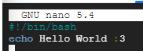
Fig 60 “script in nano editor”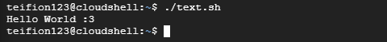
Fig 61 “hello world script run
(note that the user may have to elevate permissions on a file to run it if so type in chmod +x filename.sh)
Shown below is the creation of saved variables in powershell, variables do not need to be defined as numerical or strings in powershell, this will be useful for the creation of scripts such as menus and other terminal functions.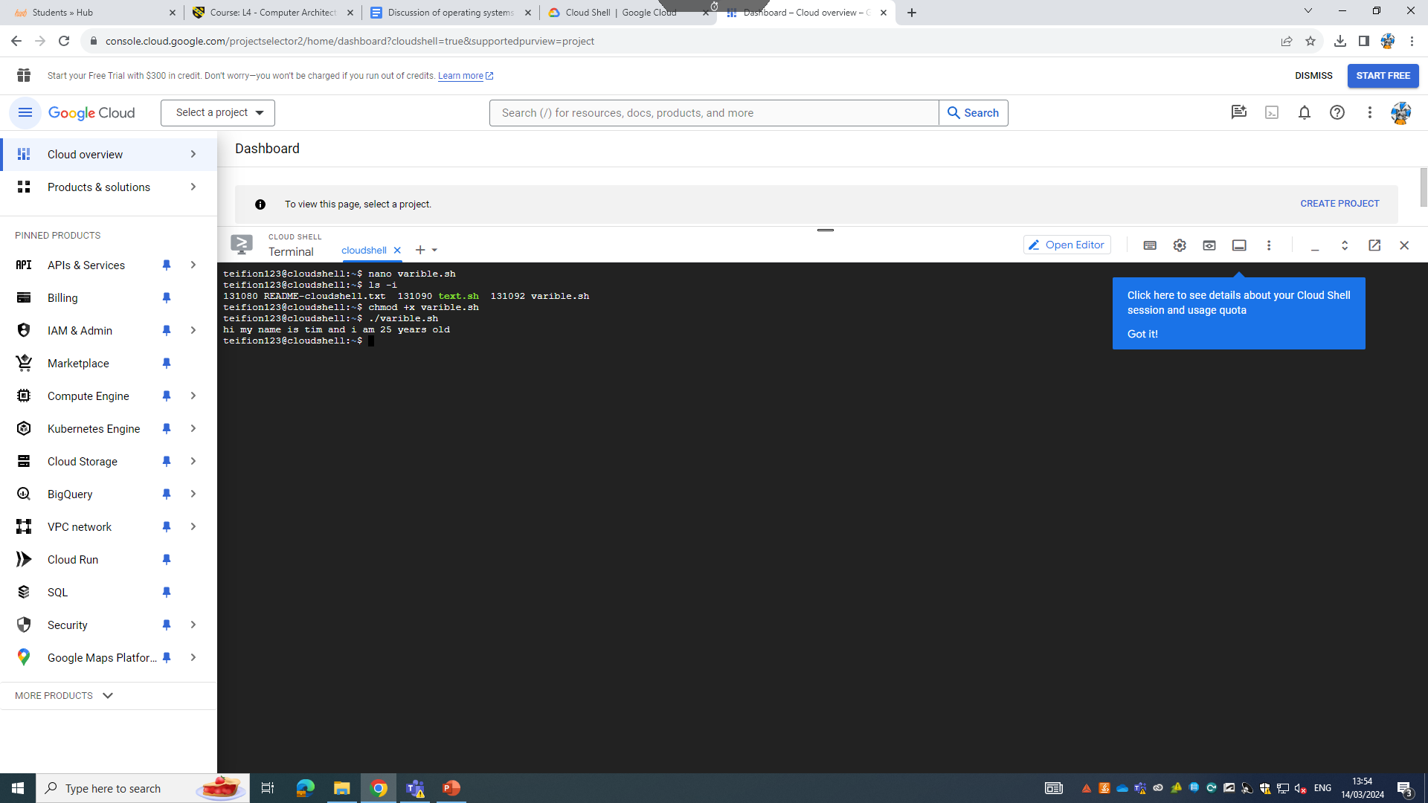Fig 62 “entering nano editor for variable script”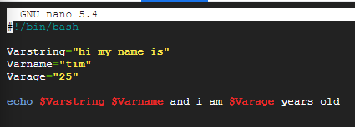Fig 63 “script in nano editor”

Fig 64 “variable script run”
The read function allows the user to input data into a variable.
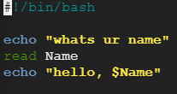
Fig 65 “script in nano editor”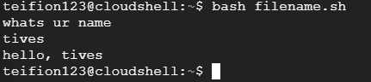
Fig 66 “input script example”
If and case statements allow us to add into the powershell script the ability to display one output or another using the if statement, and a variety of responses using a case statement, examples of if statements and case statements shown below.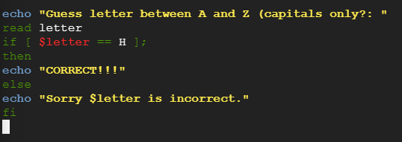
Fig 67 “script in nano editor”
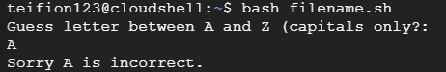
Fig 68 “if example 1”
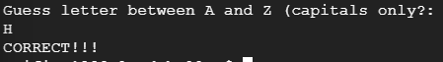
Fig 69 “if example 2”

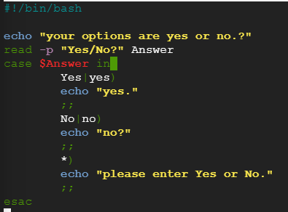
Fig 70 “script in nano editor”
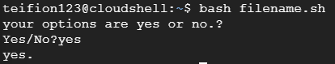
Fig 71 “case example 1”
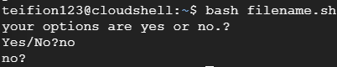
Fig 72 “case example 2”
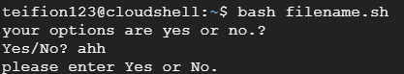
Fig 73 “case example 3”
Next we will be discussing how to create loops in bash. To create a loop we use the command until or while.the while function which will repeat the script while a function is not true, the until function repeats x times
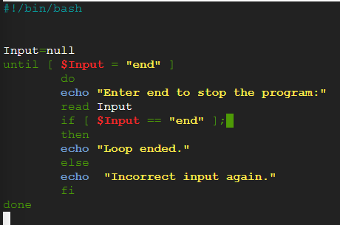
Fig 74 “script in nano editor”
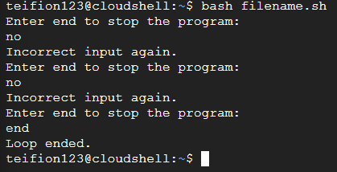
FIg 75 “while loop example”
The final basic function of bash that I will discuss are arrays and functions. Arrays allow multiple values/strings to be stored under the same name, such as three letters a b and c. Arrays can be used to help minimize time spent setting related variables. Functions allow for parts of a script to be called within the code and repeated, for example a function can take a user input and then return a value, then whenever the function is called within the code the user input can be taken again saving time writing lines of code. 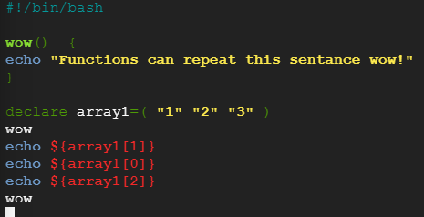
Fig 76 “script in nano editor”
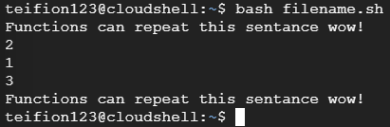
Fig 77 “Arrays and functions example”

Conclusion
In conclusion I have found that I have given a thorough analysis of key scripting functions across windows powershell and linux. Additionally throughout the creation of this essay i have further my knowledge on topics such as os scripting and additionally gained further information around operating systems and what's commonly used within the industry.

References
[1]“operating system - Quick search results | Oxford English Dictionary,” Oed.com, 2023. https://www.oed.com/search/dictionary/?scope=Entries&q=operating%20system (accessed Feb. 14, 2024).

[2]“Functions of operating systems - Computer systems - AQA - GCSE Computer Science Revision - AQA - BBC Bitesize,” www.bbc.co.uk. https://www.bbc.co.uk/bitesize/guides/zkkkw6f/revision/5
(accessed Feb 14, 2024)

[3]Tutorchase.com, 2023. https://www.tutorchase.com/answers/ib/computer-science/how-do-operating-systems-manage-hardware-and-software-resources
(accessed Feb 14, 2024)

[4]“Memory Management: Functions, Importance | StudySmarter,” StudySmarter UK, 2019. https://www.studysmarter.co.uk/explanations/computer-science/computer-systems/memory-management/#:~:text=Paging%20and%20segmentation%3A%20These%20are
(accessed Feb. 14, 2024).

[5]“Windows 10,” Wikipedia, Sep. 11, 2023. https://en.wikipedia.org/wiki/Windows_10#:~:text=Windows%2010%20is%20a%20major
(accessed Feb. 14, 2024).

[6]“Desktop operating system market share 2013-2023,” Statista. https://www.statista.com/statistics/218089/global-market-share-of-windows-7/#:~:text=Microsoft%27s%20Windows%20was%20the%20dominant
(accessed Feb. 14, 2024).

[7]“iOS version history,” Wikipedia, Apr. 16, 2024. https://en.wikipedia.org/wiki/IOS_version_history#:~:text=Apple%20announced%20iPhone%20OS%201 (accessed Feb. 14, 2024).

[8]StatCounter, “Mobile Operating System Market Share Worldwide,” StatCounter Global Stats, 2023. https://gs.statcounter.com/os-market-share/mobile/worldwide
(accessed Feb. 14, 2024)

[9]Wikipedia Contributors, “Android (operating system),” Wikipedia, Mar. 18, 2019. https://en.wikipedia.org/wiki/Android_(operating_system) (accessed Feb. 14, 2024)

[10]“History of Linux,” Wikipedia, Apr. 17, 2024. https://en.wikipedia.org/wiki/History_of_Linux#:~:text=1991%3A%20The%20Linux%20kernel%20is (accessed Feb. 14, 2024)

[11]“What is the Linux operating system?,” SearchDataCenter. https://www.techtarget.com/searchdatacenter/definition/Linux-operating-system#:~:text=Linux%20is%20used%20in%20the (accessed Feb. 14, 2024)

[12]F. Churchville, “What is user interface (UI)? Definition from SearchAppArchitecture,” SearchAppArchitecture. https://www.techtarget.com/searchapparchitecture/definition/user-interface-UI#:~:text=The%20user%20interface%20(UI)%20is (accessed Feb. 21, 2024)

[13]“Linux Directory Structure and File System Hierarchy | Linux Training Academy,” Linux Training Academy, 2019. https://www.linuxtrainingacademy.com/linux-directory-structure-and-file-system-hierarchy/
(accessed Feb. 22, 2024)

