Pharaoh’s, Phoenicians and Peoples of the Seas (AHAR4001): Assessment
1. Portfolio (Equivalent of 2000 words) (50%)
2. 2000-word essay (50%)
1. Portfolio: all elements must be completed (50% of module mark)
Section 1a) Map Exercise. Place the following places onto the map provided:
Abydos, Ajjul, Alexandria, Byblos, Ebla, Hierakonpolis, Kition, Knossos, Lefkandi, Megiddo, Memphis, Mycenae, Thebes (Egypt), Troy, Ugarit
Section 1b) Chronological Table. Please add the following to the correct column and give calendrical date (eg. First Palace Period, Crete)
Early Bronze Age, Middle Bronze Age, Late Bronze Age, Iron Age
Amarna period, Construction of Great Pyramid, Kushites, Raids of the Sea Peoples, Unification of Egypt, construction of Lefkandi heröon, destruction of Troy VI, Grotta-Pylos culture, Shaft Graves, Theran Eruption, Battle of Qadesh, Ebla Palace G, Mitanni as major power, Royal Tombs at Byblos,
(1a + 1b = 25% of portfolio mark)
 | Periods | Egypt | Levant | Aegean
3500 BC

3000 BC
2500 BC

2000 BC
1500 BC  1000 BC |  |  |  | First Palace Period  (1900-1700 BC)
950 BC

900 BC
850 BC

800 BC
750 BC

700 BC
650 BC

600 BC

Portfolio Section 2: Primary source analysis – 500 words (25% of portfolio). Choose one of the following archaeological images and discuss its main features (further guidelines given for specific images),
2a) 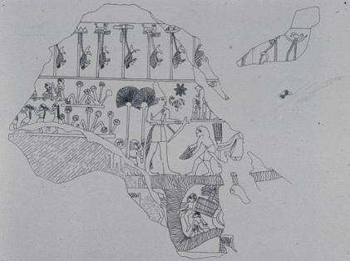
2b) 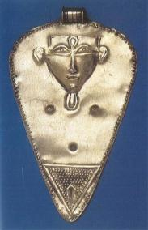 2c) 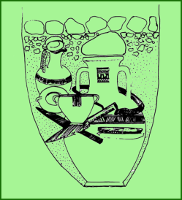
2a) This image is from an early Egyptian royal object. What might its iconography tells us about a specific event or ritual? Can we use it to write an Egyptian history?
2b) This object was found at Ajjul (ancient Gaza). What are the cultural affinities of this object and how might it have been used?
2c) This image illustrates an ancient burial from Athens. What can we ascertain about the funerary ritual and the individual buried from this object?
Portfolio Section3: Object analysis – 1000 words (50% of portfolio)
Choose an object from the display in the Ashmolean (from either the Minoan or the Egypt display). Analyse the object, considering its date, function and the significance it held in its ancient social context.

2. Essays: 2000 words (50% of module mark)
Choose one from the following:
- Outline the main characteristics of an urban centre. Illustrate how these characteristics are evident in a specific Middle Bronze Age town in the Levant.
- What can the Shaft Graves at Mycenae tell us about the emergence of kingship in Late Bronze Age Greece?
- What were the main functions of a Bronze Age palace? Illustrate your answer using EITHER the EBA palaces at Mari and Ebla OR the Minoan palaces at Knossos and Phaistos
- Outline the archaeological evidence for Phoenician expansion west in the early first millennium BC.
- Compare and contrast the politics, religion and art of the Amarna period with that of the earlier Eighteenth Dynasty. What was Akhenaten trying to achieve?
- Why do we speak of the Middle Kingdom renaissance? What was characteristic for the political and cultural direction of this time?

