Financial Management for the Hotel Industry
BMIH5007

Report Case Study: The City Hotel

Module Lead: Tristan Hawkins
Student id: 2239006
Student name: Irina-Diana Buture

Table of Contents
1. Introduction 3
2. Evaluation 3
2.1. Ratio results 3
2.2. Description 3
2.3. Industry trends 4
2.4. Analysis of the hotel 6
3. Recommendations 7
4. Conclusion 8
References 9
Appendix 11

- Introduction
Famous for its restaurant, bar and event spaces in a lively city location, the City Hotel has had a rough go of it recently. The once-thriving hotel is now struggling with falling profits, decreased bookings, and unhappy guests. There is reason to be concerned about the company's viability in the long run due to these concerning patterns. The owner has decided to get a professional opinion on the matter as soon as possible in order to find out if a turnaround plan can turn around the hotel's future. This study will analyse the hotel's financial data from the last three years, identify the causes of its falling profitability, and provide solutions to get it back on track. Through tackling these difficulties, the research seeks to reveal the best way forward, guaranteeing that the hotel remains relevant and competitive in a changing hospitality industry.
- Evaluation
  - Ratio results
Metric | 2021 Result | 2022 Result | 2023 Result
Gross Profit Margin | 92.16% | 92.43% | 92.35%
Operating Profit Margin | 12.65% | 12.71% | -52.41%
Current Ratio | 0.97 | 0.93 | 0.64
Quick Ratio | 0.95 | 0.92 | 0.62
Debt to Equity Ratio | 4.74 | 5.16 | 10.10
Net Profit Margin | 6.36% | 5.74% | -48.81%
Return on Equity | 14.8% | 11.8% | -80.4%
Return on Assets | 2.58% | 1.91% | -7.25%

  - Description
Analysing the financial situation, performance, and stability of a company depends much on financial ratios. Reflecting a company's effectiveness in controlling manufacturing costs relative to sales, the gross profit margin is the percentage of income remaining after deducting the cost of products sold. By removing interest and taxes, the operating profit margin—which reveals operational efficiency—measures the profitability of a company's fundamental activities (Drury, 2018). Liquidity ratios—that is, the current ratio analysing a company's capacity to satisfy short-term obligations using total current assets—and the quick ratio improving this analysis by removing inventory, which might not be readily sold (Seal et al., 2015). To evaluate long-term solvency, the debt to equity ratio compares total obligations to shareholder equity, therefore analysing a company's financial leverage. Calculating the proportion of income left as net income after all expenses, the net profit margin shows general profitability (Attrill and McLaney, 2018). While the return on assets gauges the effectiveness of asset use in producing income, the return on equity gauges how successfully a company makes profits from investments made by shareholders. Although financial analysis benefits much from these ratios, they have certain restrictions. Ratios are affected by accounting standards and depend on past data; so, they could impair comparability between companies or sectors (Attrill and McLaney, 2020). Furthermore, limiting their predictive capability are exogenous elements including market dynamics and economic situations which these measures fail to represent (Bhimani, 2006). While profitability ratios may not consider non-financial factors like customer happiness or brand value, liquidity ratios—for example—may ignore the timing of cash flows. Moreover, depending just on financial ratios without qualitative analysis could result in inadequate evaluations, which emphasises the need of including these instruments with more general contextual and strategic evaluations (Brealey et al., 2018). All things considered, financial ratios offer vital information about the financial situation of a business; but their limits call for careful interpretation and integration with other analytical techniques for wise decisions.
  - Industry trends
The latest drop in income, occupancy rates, and customer satisfaction at the City Hotel mirrors more general difficulties in the UK hotel market. The COVID-19 epidemic seriously affected travel and tourism, which resulted in notable declining hotel occupancy rates. Though the market has recovered, it has not quite restored to pre-pandemic levels (Peco-Torres, Polo-Peña and Frías-Jamilena, 2021). Though still below pre-pandemic levels, the market size of the UK hotel sector in 2023 was estimated at around £24.7 billion, up from £16.42 billion in 2022. Rising operational costs brought on by inflation and higher labour costs also challenge the sector (Statista, 2024). Indicating a 45.7% price increase since 2015, the Consumer Price Index for hotels, cafés, and restaurants in the UK hit 145.7 in the third quarter of 2024, surpassing the general inflation rate of 34.1% over the same period (Statista, 2024). Labour shortages have further taxed the industry; many businesses struggle to draw in and keep employees, which drives higher wages and operational difficulties. shifting consumer tastes—such as a move towards luxury experiences and environmentally friendly practices—also force hotels to modify their products to fit shifting expectations (World Economic Forum, 2024). The emergence of alternative lodging sites such as Airbnb has heightened competitiveness and driven traditional hotels to create new value propositions by means of innovation (Walker, 2021). Economic uncertainty including recessions and changing interest rates also influences consumer travel and leisure spending, therefore impacting hotel income. The City Hotel has to use strategic actions addressing operational efficiencies, cost control, and service quality if it is to remain competitive in changing surroundings.
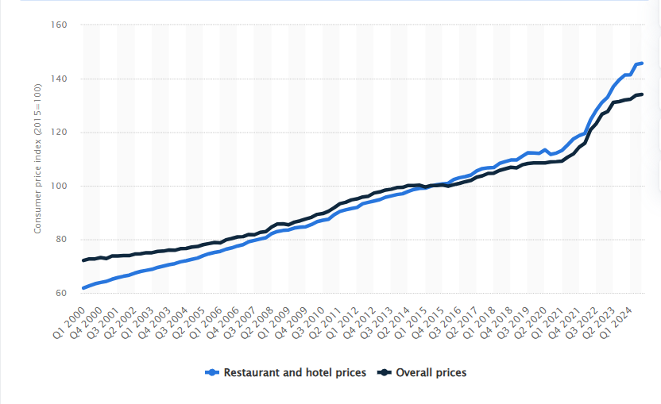
Fig 1. Statista (2024). Consumer Price Index for hotels, cafés, and restaurants in the United Kingdom
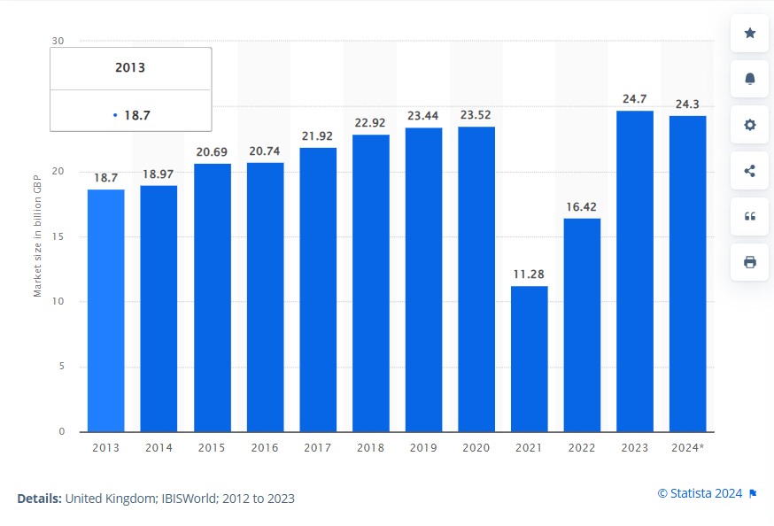
Fig 1. Statista (2024). Market size of the hotel industry in the United Kingdom from 2013 to 2023
  - Analysis of the hotel
The City Hotel's measured financial ratios during the past three years expose a number of significant operational and financial difficulties. Consistent above 92% from 2021 to 2023, the gross profit margin shows solid cost control over items supplied in relation to income. Usually, a high gross profit margin is favourable since it shows operational effectiveness in direct cost management (Atrill and McLaney, 2018). But this statistic by itself does not adequately reflect the larger operational inefficiencies exposed by other ratios, such the operating profit margin. From 12.65% in 2021 to 12.71% in 2022, the operational profit margin dropped; then, it fell to -52.41% in 2023, signifying significant running losses. This decrease points to either deteriorating revenue-generating efficiency or growing running expenses. Rising electricity prices, more labour expenses, and ineffective overhead management could all help explain this drop (Brealey et al., 2018). Negative operational profit margins over a long period are unsustainable and show how urgently revenue policies and expense control must be addressed. Both the current ratio and the quick ratio as well as liquidity measures show a declining trend. Well below the optimal level of 1.0, the current ratio dropped from 0.97 in 2021 to 0.64 in 2023, suggesting the hotel may find it difficult to satisfy short-term obligations with current assets (Weetman, 2019). Significantly limited liquidity was evident as the fast ratio—which excludes inventories from current assets—dropped from 0.95 in 2021 to 0.62 in 2023. These deteriorating liquidity ratios point to the company would have trouble keeping daily operations running and paying suppliers, which would sour supplier relationships and affect service quality (Bringham and Houston, 2013). Reflecting a rising reliance on debt funding, the debt to equity ratio climbed sharply from 4.74 in 2021 to 10.10 in 2023. Especially in an uncertain economic situation, this large leverage carries great dangers. Excessive debt lowers financial flexibility and raises the weight of interest payments, therefore compromising profitability even more. Businesses with high debt to equity ratios are more susceptible to economic downturns, according to Atrill and McLaney (2018) since they could find it difficult to pay debt commitments during low income times. Significantly net losses were indicated by the net profit margin falling from 6.36% in 2021 to -48.81% in 2023. Such low profitability emphasises how poorly the hotel can control expenses or create enough income. Equally, demonstrating weak returns for shareholders and a possible reduction in investor confidence, the return on equity dropped from 14.8% in 2021 to -80.4% in 2023. At last, the return on assets dropped from 2.58% in 2021 to -7.25% in 2023, indicating inefficiencies in asset use and a lack of sufficient returns on capital invested. These measurements taken together expose important flaws in profitability, liquidity, and financial stability. Rising debt, declining liquidity, and growing losses in the City Hotel immediately create hazards. Dealing with these problems calls for a multimodal approach encompassing financial restructuring to boost solvency and investor confidence, income generating projects, and cost-cutting ideas (Guilding, 2014).
- Recommendations
- Priority is cost control implementation. Examining running costs closely helps one find areas that might be cut without sacrificing the calibre of services. To match occupancy rates, this can call for renegotiating supplier contracts, maximising energy use, and simplifying staffing levels. Such steps can raise the operational profit margin and increase operational effectiveness (Drury, 2018).
- Improving income sources is also quite vital. Diverse service offerings help to draw in more customers and hence reduce income instability. Offering packages combining lodging with eating or event activities will attract to both leisure and business visitors (Getz and Page, 2016). Moreover, using digital marketing techniques to improve online visibility and interact with possible clients would help to generate bookings and raise occupancy rates.
- Dealing with liquidity problems calls for meticulous financial control. Enhanced cash flow management helps to improve the current and quick ratios. Stiffer credit control rules and early payment incentives help to improve cash inflows (Guilding, 2014). Investigating short-term financing choices—such as lines of credit—may offer the required liquidity to cover current liabilities.
- Long-term stability depends on lowing financial leverage. The hotel should review its financial structure and think about refinancing high-interest loans into better terms. Investigating equity financing choices helps to improve the balance sheet and lower dependence on debt (Seal, Garrison, and Noreen, 2008). Working with financial advisers to create a sustainable debt payback schedule will help to properly control liabilities.
- Putting money into staff development and training helps to raise service quality, hence increasing client satisfaction and repeat business. Encouragement of staff members to provide outstanding service can help the hotel to gain reputation and draw fresh guests (Walker, 2021). By means of important performance indicators, regular monitoring of financial performance enables rapid strategy revisions that guarantees the hotel stays sensitive to the state of the market.
- Conclusion
In conclusion, the City Hotel has operational and financial problems that require measures to bring its long-term sustainability and financial stability back. Using important ratios, this paper examined the financial situation of the hotel and found important problems like diminishing profitability, liquidity restrictions, and rising financial leverage. Rising operating expenses, labour shortages, and competitive pressures are among industry factors that compound these internal difficulties and highlight the need of a thorough turnaround plan. Recommendations were developed to properly handle these difficulties. First and most important are cost-control strategies, which call for an analysis of running costs to find chances for savings without sacrificing quality of services. Diverse service offers and using digital marketing to draw more customers would help to improve revenue generating. Liquidity problems need for better cash flow control and research of short-term finance solutions to satisfy immediate needs. Moreover, helping to stabilise the balance sheet and lower financial risks is financial restructuring, including investigating equity financing and refinancing high-interest debt. Additionally highlighted in the suggested actions are enhancing service quality by means of staff development and training, so fostering client loyalty and pleasure. Frequent financial performance monitoring utilising important indicators will enable quick changes to guarantee the hotel stays competitive in a market that is always changing.

References
Atrill, P. and McLaney, E.J. (2018) Management accounting for decision makers. Ninth edition. Upper Saddle River: Pearson.
Bhimani, A. ed., 2006. Contemporary issues in management accounting. Oxford university press.
Brealey, R.A., Myers, S.C., Allen, F. and Mohanty, P., 2018. Principles of corporate finance, 12/e (Vol. 12). McGraw-Hill Education.
Brigham, E.F. and Houston, J.F., 2013. Fundamentals of financial management. South-Western Cengage Learning.
Drury, C. (2018) Cost and management accounting. 9th edition. Andover: Cengage Learning.
Getz, D. and Page, S.J. (2016). Progress and prospects for event tourism research. Tourism Management, [online] 52(0261-5177), pp.593–631. doi:https://doi.org/10.1016/j.tourman.2015.03.007.
Guilding, C. (2014) Accounting Essentials for Hospitality Managers. 3rd Edition. London, Routledge
Peco-Torres, F., Polo-Peña, A.I. and Frías-Jamilena, D.M. (2021). The effect of COVID-19 on tourists’ intention to resume hotel consumption: The role of resilience. International Journal of Hospitality Management, 99, p.103075. doi:https://doi.org/10.1016/j.ijhm.2021.103075.
Seal, W.B., Rohde, C., Garrison, R.H. and Noreen, E.W. (2015) Management accounting. Fifth edition / Will Seal, Carsten Rohde, Ray H. Garrison, Eric W. Noreen. London: McGraw Hill Education.
Seal,W. Garrison, R.H., and Noreen, E. (2008). Management Accounting, McGraw Hill
Statista (2024). Hotel industry market size UK 2024. [online] Statista. Available at: https://www.statista.com/statistics/1364712/hotel-industry-market-size-uk/
Statista. (2024). UK CPI restaurants and hotels 2024. [online] Available at: https://www.statista.com/statistics/286440/restaurants-and-hotels-cpi-uk/.
Walker, J.R., 2021. Introduction to hospitality. Pearson.
Weetman, P., 2019. Financial and management accounting. Pearson UK.
World Economic Forum (2024). Tourism is back to pre-pandemic levels, but challenges remain. [online] World Economic Forum. Available at: https://www.weforum.org/press/2024/05/tourism-is-back-to-pre-pandemic-levels-but-challenges-remain/.

‌

‌

‌

Appendix
Gross Profit Margin= ((Revenue−Cost of Goods Sold)/Revenue) ×100
GPM (2021) = ((5,248,290-411,600)/5,248,290) ×100= (4,836,690/5,248,290) x 100=0.9216 x100= 92.16%
GPM (2022) = ((5,307,480-401,510)/5,307,480) x100= (4,905,970/5,307,480) x 100=0.9243 x 100= 92.43%
GPM (2023) = ((2,325,440-176,250)/2,325,440) ×100= (2,149,190/2,325,440) x 100=0.9235 x 100= 92.35%
Operating Profit Margin= (Operating Income/Revenue) ×100
OPM (2021) = (664,160/5,248,290) ×100=0.1265 x 100= 12.65%
OPM (2022) = (674,730/5,307,480) ×100= 0.1271 x100= 12.71%
OPM (2023) = (−1,218,850/2,325,440) ×100= -0.5241 x 100= (52.41)%
Current Ratio=Total Current Assets/Total Current Liabilities
CR (2021) =1,891,970/1,957,360=0.97
CR (2022) =1,965,340/2,107,750=0.93
CR (2023) =1,285,880/2,014,600=0.64
Quick Ratio= (Total Current Assets−Inventories)/Total Current Liabilities
QR (2021) = (1,891,970−35,230)/1,957,360=0.95
QR (2022) = (1,965,340−36,350)/2,107,750=0.92
QR (2023) = (1,285,880−29,470)/2,014,600=0.62
Debt to Equity Ratio=Total Liabilities/Total Equity
DER (2021) =10,684,940/2,256,180=4.74
DER (2022) =13,338,050/2,583,030=5.16
DER (2023) =14,243,390/1,410,580=10.10
Net Profit Margin= (Net Income/ Revenue​) x100
NPM (2021) = (333,930/ 5,248,290) x 100=0.0636 x 100=6.36%
NPM (2022) = (304,650/5,307,480) x100= 0.0574 x 100=5.74%
NPM (2023) = (-1,134,950/ 2,325,440) x 100=−0.4881 x 100=−48.81%
ROE= (Net Income/ Owner Equity) x 100
ROE (2021) = (333,930/2,256,180) x 100=0.148 x 100=14.8%
ROE (2022) = (304,650/2,583,030) x 100=0.118 x 100=11.8%
ROE (2023) = ( -1,134,950/1,410,580) x 100=−0.804x 100=−80.4%
ROA= (Net Income/ Total Assets) x 100
ROA (2021) = (333,930/12,941,110) x 100=0.0258 x 100=2.58%
ROA (2022) = (304,650/15,921,080) x 100=0.0191 x 100=1.91%
ROA (2023) = (-1,134,950/15,653,970) x 100=−0.0725 x 100=−7.25%

