The impact of Brexit-
A Global challenge for business
“F**k business” – Boris Johnson

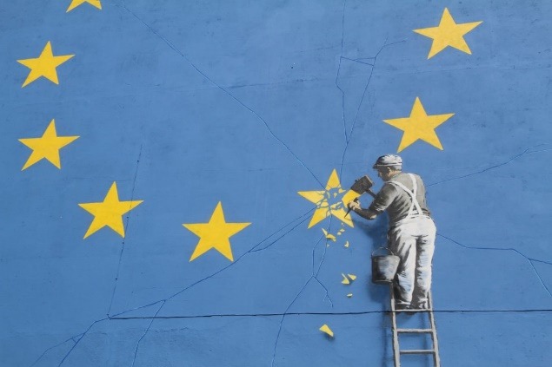
On 23 June 2016, The UK voted in a referendum on a potential exit from the EU: When the votes were counted it was found that 51.9% of voters were in favor of leaving the EU.
(Masters, 2017)
Although the UK did not officially cease being a member of the EU until 31 January 2020, the effect on the UKs economy, and the UKs global position was noted from pre ‘vote day’.
Pro-Leave campaigners argued that by leaving the EU, the UK could regain the full powers and status of a sovereign state, by not having to follow all EU rules, or being considered part of an EU voting ‘bloc’ by the World Trade Organization. Concerns were raised about the amount of money the UK paid into the EU, as well as immigration and refugees.
The Pro-Leave campaign was successful, (The Electoral Commission. 2019) and the UK looked forward to a positive, more prosperous future.
However, leaving the EU was a complicated process, taking 4 years and being overseen by two different prime ministers. Eventually a trade deal was reached. The ‘trade and cooperation agreement’ was designed to cover the trade, governance and expected co-operation that came into effect on January first 2021 (Ferrie et al., 2020). And this established that the UK was no longer part of the single market and customs union within the UK, rather, the trade agreement allows zero quotas and tariffs on goods that are traded while the goods comply with the rules of origin (Foreign, Commonwealth & Development Office, 2021).
So- a bright future for the UK, being free to make their own trade deals and increase their global powers? And how will the UK leaving the European Union affect the rest of the world?
If we fast forward to the present day, we find that “The number of people in employment in the UK has risen almost continuously since 2012. Just over three quarters of working-age people are in work, and this is the highest rate since comparable records began in 1971.” (Harari, 2020) however wages have stagnated, and this has led to a jobs rich/wage poor economy. The Brexit mantra of ‘British jobs for British workers’ has led to (as of July 2021) a crisis in the ‘just in time’ supply chain, a shortage of HGV drivers due to lack of EU drivers, and fresh food rotting in the fields due to lack of pickers. (Wall & Inman, 2021).
“The vast majority of economic studies from the May Government and others show that the higher the barriers to trading with the EU, the larger the negative impact on the UK economy. Potential trade-boosting deals with non-EU countries are not expected to make up for weaker trade flows with the EU. (These studies show that the economy will still grow, but not by as much.)” (Harari, D. 2020)
Brexit, in short, could be seen as a vote against globalization, against the “better together” mentality fostered by Europe after the second world war and cemented by the Heath Government who took the UK into the EU, it could be perceived as one small island ( and Northern Ireland) sticking two fingers up to the rest of the world, so it may be accurate that current prime minister Boris Johnson is widely quoted as saying “F**k Business” at a 2018 diplomatic gathering.
It could also be argued that the impact of Brexit is only felt in the UK, and this referendum did not, and will not have a global impact, however despite the UKs relatively small share of the worlds GDP (2.4% in 2016) the repercussions have had a wider ‘ripple effect’ on the worlds’ economy.
_____________________
The waters are muddied somewhat when it comes to looking at the real global impact of Brexit, due to an unprecedented global pandemic, but from what we can see the following real and potential impacts have arisen.
- Delays in ports when importing and exporting goods. This has a ripple affect down the supply chain and the cost of delays must be either passed on to the end consumer or be swallowed by the business. In fact the new controls triggered by Brexit have not yet been implemented, having been pushed back to 2022 yet delays are already occurring, with the government citing the Covid-19 pandemic as the reason. (Culbertson, 2021)
- Reduced investment in and within the UK. This can be evidenced by the fact that at least 10% of the total assets of banks and financial institutions had moved operations and offices out of the UK by January 2019 (Kottasová, CNN Business, 2019).as well as major manufacturers such as Dyson and Honda pulling out of the UK. A further example of the impact is that of British steel, which went into administration in May 2019, and blamed ‘Brexit related issues’ saying that “European customers were putting off purchases because of uncertainty over future trading arrangements.” (Mahmood, 2019). While this reduced investment in the UK is bad news for the UK itself, other countries, both in Europe and elsewhere stand to benefit and to boost their own economies.
There have been suggestions that capital may be drawn towards more ‘safe haven’ locations, such as the USA, and possibly Japan, which on the surface seems a positive for their economies, but this could have the effect of further lowering interest rates and putting increased pressure on the US and Japan, who risk an inflated currency and damage to their export sector, in particular this could damage Japan, who have been trying to reinvigorate their economy following decades of deflation. (Bain Insights, 2016) While the US are a stable economy, and regularly top ‘most powerful countries’ lists, they would do well to be mindful of the potential impact, although internal business may continue to thrive, they run the risk of losing out on external and global business to countries that are not experiencing inflation.
As the European central bank tried to map the effect of Brexit on the wider European economy, they stated in their 2020 report “The future economic and financial relationship between the UK and the EU27 may also affect the structure, development and integration of the EU27 financial system” (Bergbauer, 2020)
- A weakened sterling. this was seen globally as both a potential positive and a potential negative, A weak pound could be seen as a good thing for the rest of the world as it may make exports from Britain cheaper, this could increase competitiveness and strengthen partnership deals with importers of UK goods, however this is dependent on the ability of the UK to source raw materials at a costs that allows the benefits of the weak sterling to be felt by the rest of the world.
As of July 2021, Reuters reported that “British goods exports to the European Union rose to their highest since October 2019 in May, official data showed […], reversing a slump at the start of 2021 when Britain exited the bloc's single market and customs union.” (HummingZone/Reuters, 2021) But does this correlate to a weakened pound that has not recovered its pre-Brexit value. 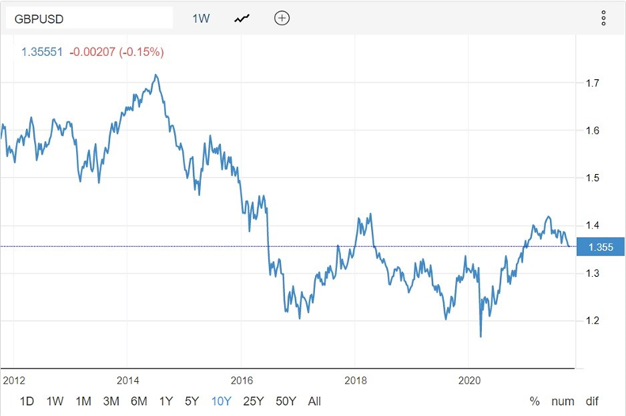
infographic from: tradingeconomics.com

- The problem of people and politics. In some ways, the world is an echo chamber, and the ‘leap of faith’ taken by the citizens of the EU in calling for Brexit could cause further fracturing of the EU over the next decade or so. Now the UK have been ‘guinea pigs’ and demonstrated that leaving the EU is possible there have been worries expressed that the Pew institute study of 2013 – which showed “approval ratings for the EU and its institutions have fallen sharply - in almost every country except Germany. In France, only 41% had a favourable view of the EU, which was less than the UK.” (Hewitt, 2013) could be a warning of further countries breaking away from the EU. if we look at the odds provided by UK bookmakers; Italy, Greece and France are top of the list of discontented countries, (Next Country To Leave European Union - OLBG.Com, 2021) while Hungary and Poland, despite being the two largest beneficiaries of EU funds, have been publicly renouncing the UK, with rumblings of a split away from the governance of the EU. (The Independent, 2021)
It seems relevant that while we are in a time of global change, right leaning governments have come to the forefront of many nations, not just the US Trump administration and the UK Conservative government, but the far right governments of Hungary, France, India and Brazil, these right leaning governments foster a separatist attitude, with rising racist, anti Muslim and anti LGBT attitudes in many of these nations. While this may seem like a sociological issue, it is clear that these ‘anti’ attitudes will serve to both drive a wedge between nations which hold different values, and impact on trade between nations, as political parties and governments play favourites and grant trade deals to politicly aligned nations. (Sen, 2019)
Being politically aligned does not necessarily guarantee good trade relations, when China, an authoritarian communist state (who are supportive of Pakistan, which has been a predominantly Muslim country since Partition and its formation in 1947) , accused India of breaching WTO principles, there were calls within India to boycott China and Chinese goods- “by all accounts states and public sector companies have been reportedly asked to desist from issuing new contracts to Chinese companies” (Inamdar, 2020) and bi-lateral trade has reduced by 15%. We must ask, would a country such as India, with a growing economy but a massive economic divide within itself, take the risk in shunning a power such as China, their second largest trading partner- if the Indian government were not confident that they had the support of other right leaning nations?

While China could be seen as the ‘good guy’ in our previous example, their business practices leave a lot to be desired. When Swedish Multi-national fast-fashion company H&M, which has a global presence, including branches in China; and other companies, raised concerns about alleged human rights issues in China, they found themselves ‘cancelled’ , removed from online platforms and internet maps. (BBC News, 2021)
Sadly, a statement on H&Ms website makes no mention of the human rights issues, and states that they are now working with their colleagues in China, hoping to “regain the trust and confidence of […]customers, colleagues, and business partners in China” and that they “comply with local laws and regulatory frameworks in all the markets where […] operate” (Saenz, 2021)

This reads as though maintaining a business relationship is more important than the human rights issues or maintaining H&Ms moral position, and while the UK have followed EU law on human rights, there is nothing to say that having broken away, the UK and other countries could proceed to reduce rights for workers, and action for climate change, in order to increase profits at the cost of everything else.
It appears relevant that the majority of right leaning nations with authoritarian governments are more invested in profits than people, leading to our next point.
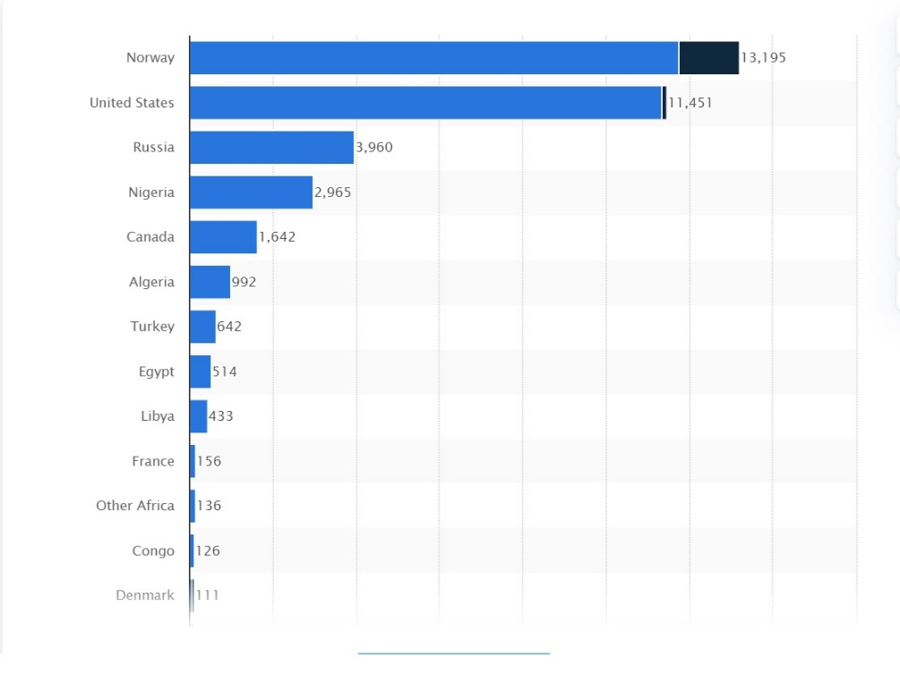
- climate and fossil fuels. Before Brexit, the UK had been “one of the most active European Union Member States in climate change policy and energy talks and it has often led the way forward. Some policies successfully implemented by the British legislation were later proposed by the European Commission for all the Member States to adopt” (Svoboda, 2017) and the UK state that they are still, and will remain committed to their policies of reversing climate change and reducing emissions as far as possible; Behind the scenes however, the UK have quietly given permission for the first deep coal mine in many decades, in West Cumbria, an area of Outstanding Natural Beauty, in a move that directly opposes the UKs climate goals, as despite the fact that the coke produced would not be used for power stations, it would be used in steel production, within blast furnaces; a process that “accounts for 7 to 9 per cent of all human-made CO2 emissions” (Peplow, 2021). The UK currently purchase the majority of their gas supply from Norway (an EU state, although not ‘in Europe’) the USA and Russia, and should costs from external supplier nations rise too high, the UK government could decide to U turn on their controversial decision to call a moratorium on fracking in England following increased campaigning from oil and gas groups who believe there is sufficient shale gas beneath the surface of the UK to meet demand for at least the next fifty years (Kirby, 2021) without the pressure of the UK as part of the EU, will other nations reverse their policies on climate change and fossil fuels in order to maximize profits.
_____________________
In conclusion, it seems clear that the Brexit referendum will have far reaching consequences for global business, some of which may not be realized for some time. Despite globalization marching ever onwards, further barriers (both physical and administrative) between nations will make trade, politics and relations more complex, and while it is all well and good to cry “buy British” – that is only possible if the UK manages to retain the very last of its industry, which has been eroded almost beyond repair over the last 30 years.
"eat all the strawberries we can this year, because next year English ones will be a rarity" was the advice given by an anonymous wholesaler (Staff, 2019) and either due to Brexit, or the Covid-19 pandemic which masked the consequences of Brexit, his words were found to be true. We would do well to remember that all countries globally, would do better if we are able to become a global community, rather than breaking apart.
Word Count:2304
(Statista.com) Origin countries of imported crude oil and natural gas liquids to the United Kingdom (UK) in 2020

References
Bain Insights. (2016, June 29). The Potential Impacts Of Brexit On The Global Economy. Forbes. Retrieved October 30, 2021, from https://www.forbes.com/sites/baininsights/2016/06/29/the-potential-impacts-of-brexit-on-the-global-economy/?sh=513ac91d7b48
BBC News. (2021, July 2). H&M: Fashion giant sees China sales slump after Xinjiang boycott. BBC News. https://www.bbc.co.uk/news/business-57691415
Bergbauer, S. (2020, March 3). Implications of Brexit for the EU financial landscape. European Central Bank. https://www.ecb.europa.eu/pub/fie/article/html/ecb.fieart202003_01%7E690a86d168.en.html
Culbertson, A. (2021, September 14). UK delays implementing post-Brexit border controls on agri-food imports from EU. Sky News. https://news.sky.com/story/uk-delays-implementing-post-brexit-border-controls-on-agri-food-imports-from-eu-12407652
Ferrie, D., Spinant, D., & Mamer, E. (2020, December 24). EU-UK Trade and Cooperation Agreement: protecting European interests, ensuring fair competition, and continued cooperation in areas of mutual interest. European Commission. Retrieved October 30, 2021, from https://ec.europa.eu/commission/presscorner/detail/en/ip_20_2531
Foreign, Commonwealth & Development Office. (2021, April). UK/EU and EAEC: Trade and Cooperation Agreement. https://www.gov.uk/government/publications/ukeu-and-eaec-trade-and-cooperation-agreement-ts-no82021
Harari, D. (2020). Slowing economic growth, Brexit and the productivity challenge. House of Commons Library. Published. https://commonslibrary.parliament.uk/slowing-economic-growth-brexit-and-the-productivity-challenge/
Hewitt, G. (2013, October 21). Europe’s discontent. BBC News. Retrieved October 30, 2021, from https://www.bbc.co.uk/news/world-europe-24607866
HummingZone. (2021, July 9). Reuters. https://hummingzone.com/uk-still-imports-more-from-outside-eu-than-bloc-but-gap-narrowing-by-reuters/
Inamdar, B. N. (2020, June 25). Can India afford to boycott Chinese products? BBC News. https://www.bbc.co.uk/news/world-asia-india-53150898
Ivana Kottasová, CNN Business. (2019, January 7). Brexit: Banks are moving $1 trillion out of the UK. CNN. https://edition.cnn.com/2019/01/07/investing/brexit-banks-moving-assets/index.html)
Kirby, D. (2021, October 8). Fracking industry urges Government to look again at shale gas with UK energy prices set to surge. Inews.Co.Uk. https://inews.co.uk/news/environment/fracking-industry-government-shale-gas-uk-energy-prices-surge-1240100
Mahmood, B. (2019, November 15). All the companies that have collapsed or moved abroad since Brexit. Metro. https://metro.co.uk/2019/09/23/companies-collapsed-moved-abroad-since-brexit-10795029/
Next Country To Leave European Union - OLBG.com. (2021, March 23). OLBG.Com - Let’s Beat The Bookies. Retrieved October 30, 2021, from https://www.olbg.com/blogs/next-country-leave-european-union#:%7E:text=%20Next%20Country%20To%20Leave%20European%20Union%20,Euro%2C%20and%20Climate%20Change%20are%20issues. . .%20More%20
Peplow, M. (2021, September 1). Why the UK doesn’t need a new coal mine. New Scientist. Retrieved November 2, 2021, from https://www.newscientist.com/article/mg25133501-100-why-the-uk-doesnt-need-a-new-coal-mine/#ixzz7B3myeBM9
Saenz, I. (2021, March 31). Statement on H&M in China. H&M Group. Retrieved October 30, 2021, from https://hmgroup.com/news/statement_hm_china/
Sen, B. (2019, October 22). Dig Beneath the World’s Far-Right Governments — You’ll Find Fossil Fuels. Resilience. Retrieved October 30, 2021, from https://www.resilience.org/stories/2019-10-22/dig-beneath-the-worlds-far-right-governments-youll-find-fossil-fuels/
Staff, O. M. (2019, June 10). Brexit could mean British fruit “becomes a rarity” next year. Oxford Mail. https://www.oxfordmail.co.uk/news/national/uk-today/17695648.brexit-mean-british-fruit-becomes-rarity-next-year/
Svoboda, J. (2017, April 5). The impact of Brexit on the UK’s climate change policy - Paris Innovation Review. Paris Innovation Review. Retrieved October 30, 2021, from http://parisinnovationreview.com/articles-en/the-impact-of-brexit-on-the-uks-climate-change-policy
Unknown Authour. (2019, September 25). Results and turnout at the EU referendum. Electoral Commission. Retrieved October 30, 2021, from https://www.electoralcommission.org.uk/who-we-are-and-what-we-do/elections-and-referendums/past-elections-and-referendums/eu-referendum/results-and-turnout-eu-referendum
Via AP news wire. (2021, October 1). Is it a bluff? Some in Hungary and Poland talk of EU pullout. The Independent. https://www.independent.co.uk/news/uk/politics/hungary-poland-viktor-orban-brussels-mateusz-morawiecki-b1926824.html
Wall, T., & Inman, P. (2021, August 29). Food, beer, toys, medical kit. Why is Britain running out of everything? The Guardian. https://www.theguardian.com/politics/2021/aug/29/food-beer-toys-medical-kit-why-is-britain-running-out-of-everything

Image ref-
Masters, E. (2017, May 8). [Photograph of Banksy mural]. https://edition.cnn.com/style/article/banksy-brexit-mural-eu/index.html

(infographic from https://tradingeconomics.com/united-kingdom/currency)
(https://www.statista.com/statistics/381963/crude-oil-and-natural-gas-import-origin-countries-to-united-kingdom-uk/)

(quote attributed to Boris Johnson at diplomatic gathering June 2018
https://www.bbc.co.uk/news/uk-politics-44618154)

