Williams, Matthew
HND Yr. 2: 2023
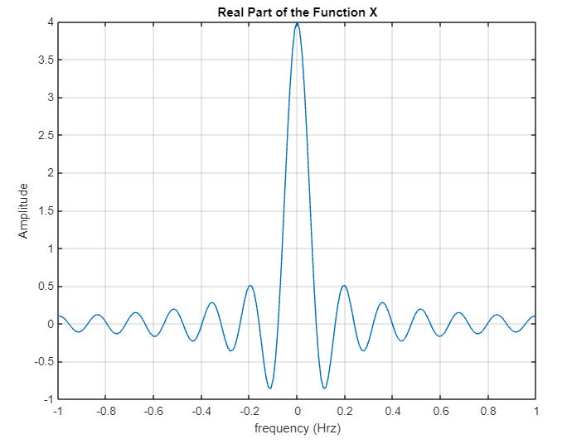
Wave analysis using matlab
HND Electrical & Electronic Engineering Electrical Principles Theory
Table of Contents
The Task 2
Task1: 2
Task2: Computing and plotting a sawtooth wave using MATLAB 6
Task3: Fourier Transforms of a Periodic pulse 10
Task4: Fourier transform of an infinite duration signal 15
References 23
Appendices 24
Appendix A – Task 2 Code 24
Appendix B – Task 4 Code 25

The Task
The Fourier Transform (FT) is used extensively in science and engineering. For example, it finds application in the solution of equations for the flow of heat, for the diffraction of electromagnetic radiation, and for the analysis of electrical circuits. The concept of the FT lies at the core of modern electrical engineering, and is a joining concept that connects seemingly different fields. The availability of commercial computer programs such as MATLAB allows the FT to be part of every technical person's toolbox.
In order to analyse system behaviour it is necessary to understand the harmonic content of the waveforms concerned. The tasks below demonstrate how to determine the frequency of the harmonic signals present.

Task1:

a) Write down an explanation for how one might differentiate simple periodic, complex periodic, impulse and noise waveforms by their shape.

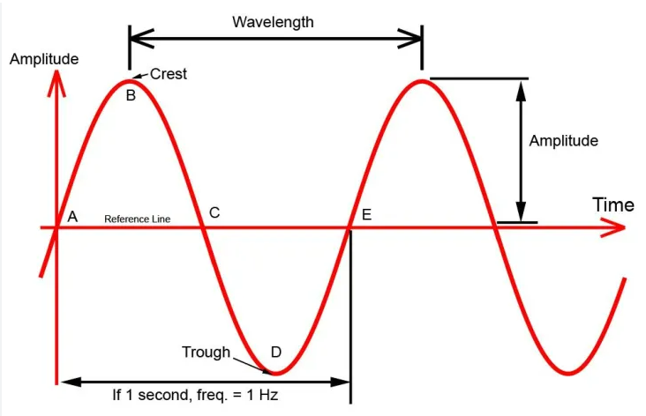
A simple periodic waveform is a sine wave with a single frequency plotting amplitude over time.
These are noticeable with a consistent repeating pattern that resembles an ‘S’ like shape. The shape stays smooth and well defined with predictable peaks and troughs. The waveform maintains a constant amplitude, frequency and phase. Examples include sine waves, square waves, and triangular waves. A sine wave with a single frequency is NOT complex, it is SIMPLE.

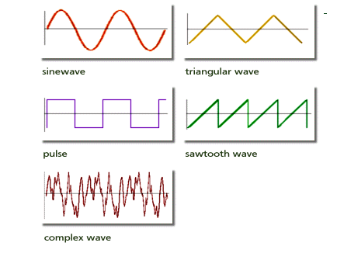
Complex Periodic Waveform: Complex periodic waveforms are composed of multiple simple periodic waveforms combined together. They display the following shape characteristics:
Multiple repeating patterns or cycles with varying frequencies and amplitudes, irregular shape with changing waveforms over time, a combination of simple waveforms such as harmonics, beats, or modulated signals. Examples include music signals, modulated signals like frequency modulation (FM), and signals with harmonics. In short, anything other than a simple sine wave is a COMPLEX waveform.
b) Define Fourier series and Fourier Transform. Explain the importance of Fourier Transform in the field of engineering.

Fourier series
The Fourier series is a way of representing a periodic function (possibly infinite) as a sum of sine functions and cosine functions. The Fourier series is a powerful tool in connection with various problems involving partial differential equations and provides a way to break down a complex periodic function into a sum of simpler sinusoidal components, which makes it easier to analyse and manipulate such functions.
(Vedantu, 2023)

Fourier Transform
Fourier Transform is a mathematical model which helps to transform the signals between two different domains, time domain to frequency domain, showing the amplitude and phase information associated with each frequency component. This allows us to manipulate signals in systems. Fourier transform has many applications in Engineering and Physics, such as signal processing.
(Byjus, 2023)

In the field of engineering, Fourier transform gives you answers to questions that are difficult or impossible to answer with other methods. It makes hard problems easy.
A recording contains a set of three musical notes. What are the notes? If you leave the recording as a set of amplitudes over time, this is not an easy problem. If you convert the recording to a set of frequencies over time, it’s really easy. If you want to change the pitch of a recording without changing its duration. How do you do this? It’s possible, but not easy to do, by just manipulating the amplitude of an input signal. But it’s easy if you know the frequencies that comprise the signal. Does the recording contain speech or does it contain music? Hard to do using only amplitude-based methods. But there are good solutions that guess the right answer nearly all of the time based on Fourier transform. Almost every question you’d like to ask about a digital sound is made easier by transforming the recording using a discrete version of the Fourier transform.
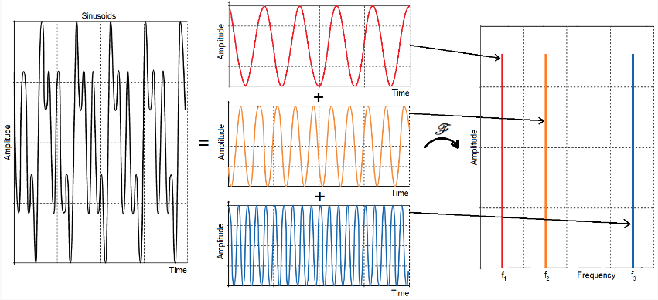
In practice, every modern digital audio processing device relies heavily on functions very similar to the Fourier transform.
Fourier Transform has many applications in Engineering, in fact any field that uses sinusoidal signals will make use of Fourier.

c) Discuss the limitations of using an FFT.

One of the limiting factors of using FFT is that when it transforms the structure of the waveform from the time domain into the frequency domain, it takes samples at pre-determined points of time, but the information about its condition in the intervals between these points is absent.

d) Write out definitions in your own words of the terms fundamental frequency, harmonic and spectrum.

Fundamental Frequency:
The Fundamental Frequency is the lowest frequency of a periodic waveform. It is also the first harmonic, and it is the predominant frequency in any complex waveform.

Harmonic:
A harmonic is a waveform that has a higher positive frequency than that of the Fundamental Frequency. In fact, where the fundamental frequency is called the 1st Harmonic, the other harmonics are known as Higher Harmonics.

Spectrum:
The spectrum is the distribution of data displayed, either in frequencies or wavelengths in a signal or wave. It visually shows the amplitude of different frequencies and a way to analyse complex signal.

e) Explain the amplitude relationship of the harmonics in triangular, sawtooth and square waveform.
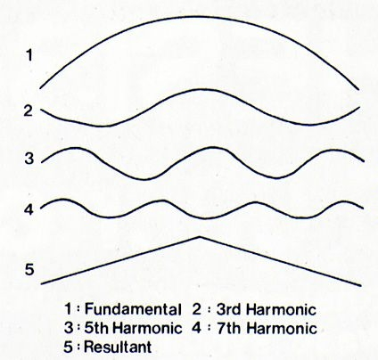
The Triangular Wave: This is the waveform produced by an integrator ramping alternately positive and negative by equal amounts and at the same rate. Analysis of its harmonics shows that it contains only odd multiples of the fundamental frequency.
The amplitude of each harmonic is inversely proportional to the square of its harmonic number, i.e. if the fundamental is at relative amplitude A, then 3f is at A/9, 5f is at A/25, 7f is at A/49.

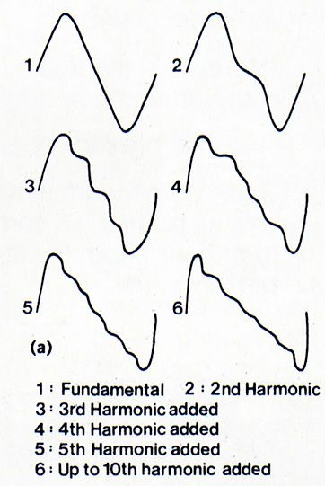

The Sawtooth Wave: This very useful waveform contains all odd and even harmonics. Their amplitudes are inversely proportional to the harmonic number, just like the square wave. In a good quality sawtooth up to about the thirtieth harmonic will be detectable.

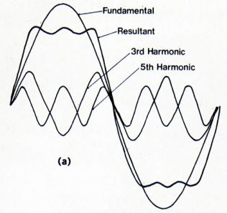
Square Waves: The square wave is a special case, a simple rule explains their harmonic content. The ratio of the proportions of high and low, or on and off is called the duty cycle. Thus a wave which is high for 50% of the time has a duty cycle of 50%. The reciprocal of the duty cycle is called the L-number, and for a duty cycle of 50% (=½), L=2. A square wave contains all the harmonics except those divisible by the L-number, in this case 2f, 4f, 6f, 8f…. etc. so it contains only odd harmonics.
Their amplitudes are inversely proportional to the harmonic number (3f=A/3, 5f=A/5 etc.). This means that the harmonics fall off.
(Flint, 1981)

Task2: Computing and plotting a sawtooth wave using MATLAB
Using MATLAB, compute and plot a Sawtooth waveform of angular frequency=1. Use a suitable time span so two periods of the waveform can be examined. Use subplots to show the graphs of the developing waveforms when one, three, five and ten harmonics of the sine waveform are used. Modify the M-file to show the graphs of the developing waveforms when you add more harmonics then discuss your finding.
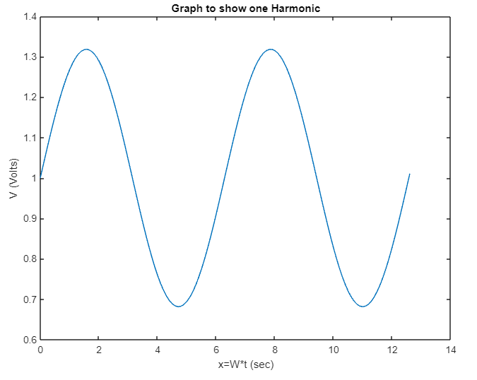
Waveform of angular frequency=1, with a time span of 12.6:
MATLAB Code:
% Task 2 - Assignment
a0=2;
W=1; % Angular Frequency = 1 (Omega = 1)
t=0:0.1:12.6; % timespan with increments of 0.1 from 0-->12.6(2 periods of 2*pi)
x=W*t;
y=a0*0.5+sin(x)/pi;
plot(x,y)
xlabel('x=W*t (sec)');
ylabel('V (Volts)');
title('Graph to show one Harmonic');
Developing waveforms when one, three, five and ten harmonics of the sine waveform are used:
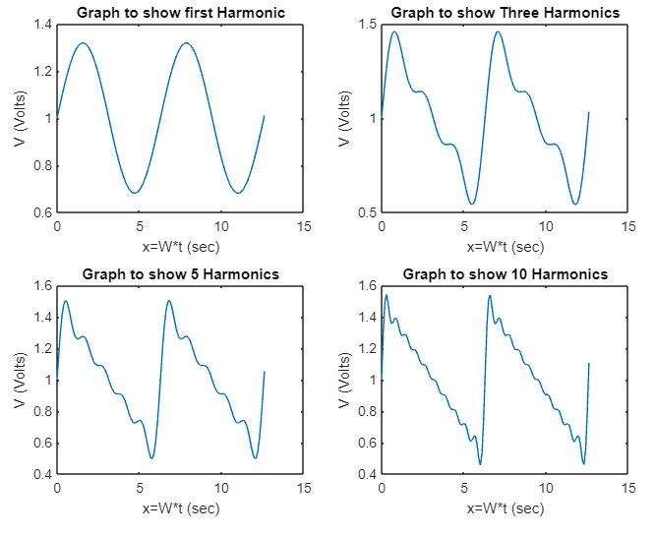
MATLAB Code:
clc;
clear;
% Task 2 - Assignment
a0=2;
W=1; % Angular Frequency = 1 (Omega = 1)
t=0:0.1:12.6; % timespan with increments of 0.1 from 0-->12.6(2 periods of 2*pi)
x=W*t;
y=a0*0.5+sin(x)/pi;
subplot(2,2,1) % 2 columns, 2 rows and in possition 1
plot(x,y)
xlabel('x=W*t (sec)');
ylabel('V (Volts)');
title('Graph to show first Harmonic');
y=a0*0.5+sin(x)/pi+sin(2*x)/(2*pi)+sin(3*x)/(3*pi); %2nd Harmonics 2*x and n pi (2*pi)
subplot(2,2,2)
plot(x,y)
xlabel('x=W*t (sec)');
ylabel('V (Volts)');
title('Graph to show Three Harmonics');
y=a0*0.5+sin(x)/pi+sin(2*x)/(2*pi)+sin(3*x)/(3*pi);
y=y+sin(4*x)/(4*pi)+sin(5*x)/(5*pi);
subplot(2,2,3)
plot(x,y)
xlabel('x=W*t (sec)');
ylabel('V (Volts)');
title('Graph to show 5 Harmonics');
y=a0*0.5+sin(x)/pi+sin(2*x)/(2*pi)+sin(3*x)/(3*pi);
y=y+sin(4*x)/(4*pi)+sin(5*x)/(5*pi)+sin(6*x)/(6*pi);
y=y+sin(7*x)/(7*pi)+sin(8*x)/(8*pi)+sin(9*x)/(9*pi);
y=y+sin(10*x)/(10*pi);
subplot(2,2,4)
plot(x,y)
xlabel('x=W*t (sec)');
ylabel('V (Volts)');
title('Graph to show 10 Harmonics');

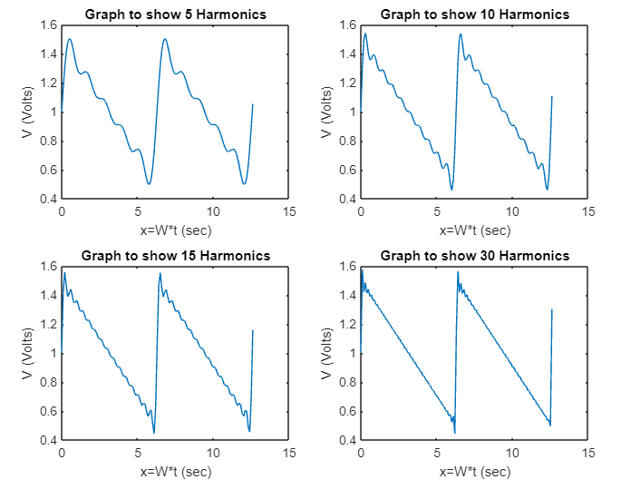
Plots of the developing waveforms when you add more harmonics:
Observations:
As we add more harmonics, the waveform becomes more complex, with multiple peaks and troughs within each cycle. The resulting sawtooth waveform starts to resemble a more complex shape. In the frequency domain, the spectrum would become increasingly populated with peaks. The amplitudes of these peaks determine the strength of each harmonic present in the waveform. Adding more harmonics allows us to create a wider range of complex sounds. By manipulating the amplitudes and phases of these harmonics, we can achieve different tones.
MATLAB Code:
clc;
clear;
% Task 2 – Assignment
a0=2;
W=1; % Angular Frequency = 1 (Omega = 1)
t=0:0.1:12.6; % timespan with increments of 0.1 from 0-->12.6(2 periods of 2*pi)
x=W*t;
y=a0*0.5+sin(x)/pi+sin(2*x)/(2*pi)+sin(3*x)/(3*pi);
y=y+sin(4*x)/(4*pi)+sin(5*x)/(5*pi);
subplot(2,2,1)
plot(x,y)
xlabel('x=W*t (sec)');
ylabel('V (Volts)');
title('Graph to show 5 Harmonics');
y=a0*0.5+sin(x)/pi+sin(2*x)/(2*pi)+sin(3*x)/(3*pi);
y=y+sin(4*x)/(4*pi)+sin(5*x)/(5*pi)+sin(6*x)/(6*pi);
y=y+sin(7*x)/(7*pi)+sin(8*x)/(8*pi)+sin(9*x)/(9*pi);
y=y+sin(10*x)/(10*pi);
subplot(2,2,2)
plot(x,y)
xlabel('x=W*t (sec)');
ylabel('V (Volts)');
title('Graph to show 10 Harmonics');
y=a0*0.5+sin(x)/pi+sin(2*x)/(2*pi)+sin(3*x)/(3*pi);
y=y+sin(4*x)/(4*pi)+sin(5*x)/(5*pi)+sin(6*x)/(6*pi);
y=y+sin(7*x)/(7*pi)+sin(8*x)/(8*pi)+sin(9*x)/(9*pi);
y=y+sin(10*x)/(10*pi)+sin(11*x)/(11*pi)+sin(12*x)/(12*pi);
y=y+sin(13*x)/(13*pi)+sin(14*x)/(14*pi)+sin(15*x)/(15*pi);
subplot(2,2,3)
plot(x,y)
xlabel('x=W*t (sec)');
ylabel('V (Volts)');
title('Graph to show 15 Harmonics');
y=a0*0.5+sin(x)/pi+sin(2*x)/(2*pi)+sin(3*x)/(3*pi);
y=y+sin(4*x)/(4*pi)+sin(5*x)/(5*pi)+sin(6*x)/(6*pi);
y=y+sin(7*x)/(7*pi)+sin(8*x)/(8*pi)+sin(9*x)/(9*pi);
y=y+sin(10*x)/(10*pi)+sin(11*x)/(11*pi)+sin(12*x)/(12*pi);
y=y+sin(13*x)/(13*pi)+sin(14*x)/(14*pi)+sin(15*x)/(15*pi);
y=y+sin(16*x)/(16*pi)+sin(17*x)/(17*pi)+sin(18*x)/(18*pi);
y=y+sin(19*x)/(19*pi)+sin(20*x)/(20*pi)+sin(21*x)/(21*pi);
y=y+sin(22*x)/(22*pi)+sin(23*x)/(23*pi);
y=y+sin(24*x)/(24*pi)+sin(25*x)/(25*pi)+sin(26*x)/(26*pi);
y=y+sin(27*x)/(27*pi)+sin(28*x)/(28*pi)+sin(29*x)/(29*pi);
y=y+sin(30*x)/(30*pi)
subplot(2,2,4)
plot(x,y)
xlabel('x=W*t (sec)');
ylabel('V (Volts)');
title('Graph to show 30 Harmonics');

Task3: Fourier Transforms of a Periodic pulse
- Show that the aperiodic signal x(t) has a Fourier Transform of $X\left(if\right)=4sinc(4πf)$ where :
$$x\left(t\right)=\left\{\begin{aligned}1 & -2≤t≤2 \\ 0 otherwise\end{aligned}\right.$$
And
$$X\left(if\right)=\int_{-∞}^{+∞}{x\left(t\right)e^{-j2πft}dt}$$
Solution……… $$X\left(if\right)=\int_{-2}^{2}{1 e^{-j2πft} dt}$$

Laplace…..

$$\frac{1}{-j2πf} {\left[e^{-j2πft}\right]}_{-2}^{2}$$

$$X\left(if\right)=\frac{1}{-j2πf} [e^{-j2πf\left(2\right)}-e^{-j2πf\left(-2\right)}]$$

$$X\left(if\right)=\frac{1}{-j2πf} [e^{-j4πf}-e^{j4πf}]$$

$$X\left(if\right)=\frac{1}{πf} \left(\frac{e^{j4πf}{ -e}^{-j4πf}}{+j2}\right)$$

$$=\frac{4}{4πf} \left(\frac{e^{j4πf}{ -e}^{-j4πf}}{+j2}\right)$$
“4sin in question, so sub to 4”
“sin$4πf$ in question”
$$=\frac{4}{4πf} 4sin (4πf)$$

$$sinc 4πf =\frac{sin 4πf}{4πf}$$
$$=4 \frac{sin 4πf}{4πf}$$
$$X\left(if\right)=4sinc(4πf)$$
Plot $X\left(if\right)=4sinc(4πf)$ as a real function using MATLAB.

% Real Part
clc
clear
f=-1:0.01:1;
X=4*sinc(4*pi*f);
plot(f,X);
xlabel('frequency (Hrz)');
ylabel('Amplitude');
title('Real Part of the Function X');
grid on

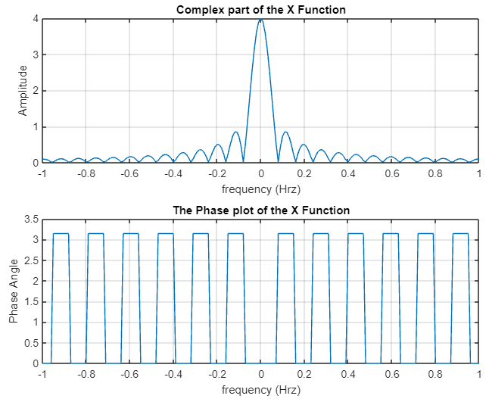
- Plot the above Fourier Transforms as a complex function by plotting the amplitude and phase spectrum separately.

% Complex Part AMPLITUDE (No negative parts
clc
clear
f=-1:0.01:1;
X=4*sinc(4*pi*f);
subplot(2,1,1)
plot(f,abs(X))
xlabel('frequency (Hrz)');
ylabel('Amplitude');
title('Complex part of the X Function');
grid on
subplot(2,1,2)
plot(f,angle(X));%Phase Angle
xlabel('frequency (Hrz)');
ylabel('Phase Angle');
title('The Phase plot of the X Function');
grid on

- Find the Fourier Transform of the exponential signal$y\left(t\right)=e^{-7\left|t\right|}$, using the time Fourier Transform formula:
$$Y\left(if\right)=\int_{-∞}^{+∞}{y\left(t\right)e^{-j2πft}dt}$$
Solution………
$$Y\left(if\right)=\int_{-∞}^{+∞}{e^{-7|t|} e^{-j2πft}dt}$$

$$=\int_{-∞}^{+∞}{e^{-7t -jπft} dt}$$

$$Y=\int_{-∞}^{0}{e^{-7t -jπft} dt}+\int_{0}^{+∞}{e^{-7t -jπft} dt}$$

$$Y=\int_{-∞}^{0}{e^{(7-jπf)t} dt}+\int_{0}^{+∞}{e^{-\left(7+jπf\right)t} dt}$$

$$=\frac{1}{(7-jπf)} \left[e^{\left(7-jπf\right)t}\right]+\frac{1}{-(7-jπf)} \left[e^{-\left(7+jπf\right)t}\right]$$
$$=\frac{1}{(7-jπf)} \left[e^{\left(7-jπf\right)t}\right]+\frac{1}{-(7-jπf)} \left[e^{-\left(7+jπf\right)t}\right]$$

$$\frac{1}{(7-jπf)}+\frac{1}{(7-jπf)}=\frac{7+jπf+7-jπf}{7^{2}-{(jπf)}^{2}}$$

$$So if \frac{1}{a+b}+\frac{1}{a-b}=\frac{}{a^{2}-b^{2}}$$

$$then………. =\frac{7+jπf+7-jπf}{7^{2}-{\left(jπf\right)}^{2}} =\frac{14}{7^{2}-{\left(jπf\right)}^{2}} or\frac{14}{49-j^{2}π^{2}f^{2}} ∴ Y\left(if\right)=\frac{14}{7^{2}-{(jπf)}^{2}}$$
- Perform the above integration in part (d) using the trapZ command in MATLAB.

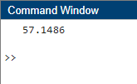
% integration in part using the trapZ command in MATLAB
clc
clear
t=-2:0.005:2;
f=0;
y=trapz(exp(-7*abs(t)-t*1i*2*pi*f));
disp(y)

- Plot the real part of the transform in part (d) over a range of frequencies.
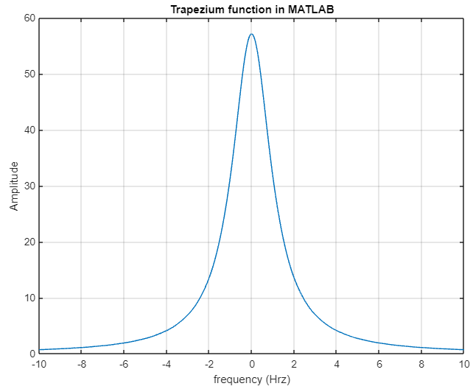

% integration in part using the trapZ command in MATLAB
clc
clear
t=-1:0.005:1;
f=-10:0.01:10;
for k=1:length(f) %Loop function for the length of the frequency
y(k)=trapz(exp(-7*abs(t)-t*1i*2*pi*f(k)));
ry(k)=abs(y(k));
end
plot(f,ry)
xlabel('frequency (Hrz)');
ylabel('Amplitude');
title('Trapezium function in MATLAB');
grid on

Task4: Fourier transform of an infinite duration signal

- Using MATLAB plot the amplitude spectrum of the signal below by creating a vector, x, with sampled values of the continuous time function (sample the signal every 0.0002 seconds and create a sequence of length 1000 or 0.2 sec)
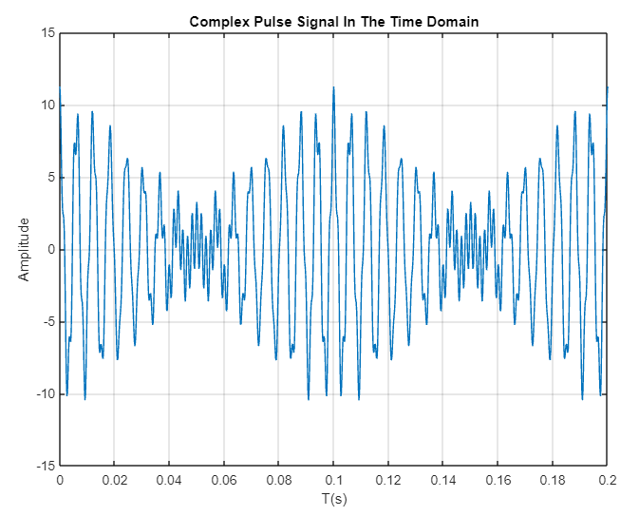
$$x\left(t\right)=5cos\left(2π160t\right)+4cos\left(2π170t\right)+0.75cos\left(2π580t\right)+1.5cos⁡(2π600t)$$
MATLAB Code:
% Task 4 a
% Generate a complex pulse signal x(t) in time domain
clear all; % Good Practice
clc; % Clears the command window
n = 1000; % Length of the spectrum sequence
Ts = 0.0002; % Sampling Period from the assignment
TT = n*Ts; % Time Total = Sampling time*length of the sequence
t = 0:Ts:TT;
x = 5*cos(2*pi*160.*t)+4*cos(2*pi*170.*t)+.75*cos(2*pi*580.*t)+1.5*cos(2*pi*600.*t);
xf = fft(x);
figure (1)
plot (t, x)
title ('Complex Pulse Signal In The Time Domain');
xlabel ('T(s)'); % label x-axis
ylabel ('Amplitude'); % label y-axis
grid on
- Use Fast Fourier Transform (FFT) to plot the Fourier transform of x(t) used in task 4a, by producing a sequence of samples of length N = 1000 spaced every Ts = 0.0002 seconds.

$$x\left(t\right)=5cos\left(2π160t\right)+4cos\left(2π170t\right)+0.75cos\left(2π580t\right)+1.5cos⁡(2π600t)$$
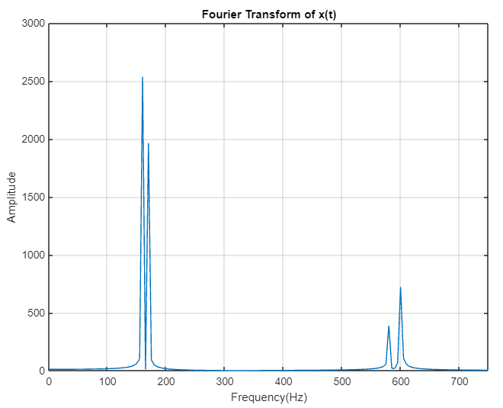
MATLAB Code:
% Task 4 a
% Generate a complex pulse signal x(t) in time domain

clear all; % Good Practice
clc; % Clears the command window
n = 1000; % Length of the spectrum sequence
Ts = 0.0002; % Sampling Period from the assignment
TT = n*Ts; % Time Total = Sampling time*length of the sequence
t = 0:Ts:TT;
x = 5*cos(2*pi*160.*t)+4*cos(2*pi*170.*t)+.75*cos(2*pi*580.*t)+1.5*cos(2*pi*600.*t);
xf = fft(x);
figure (1)
plot (t, x)
title ('Complex Pulse Signal In The Time Domain');
xlabel ('T(s)'); % label x-axis
ylabel ('Amplitude'); % label y-axis
grid on
% Task 4 b
% Fourier transform of x(t) and visualize the magnitude of x(t) in frequency domain.

figure (2)
nn=length (xf);
f=(0:n) * (1/TT);
nf=length (f);
plot (f, abs (xf))
title ('Fourier Transform of x(t)');
xlabel ('Frequency(Hz)');
ylabel ('Amplitude')
axis([0, 750, 0, 3000]); % set display range of x and y axis
grid on

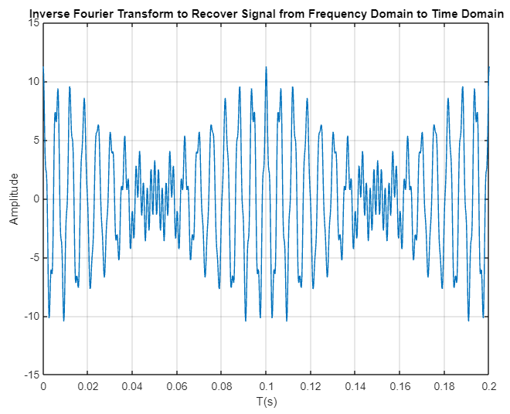
- Apply Inverse Fourier Transform (ifft) to recover the signal from frequency domain to time domain with all frequency components. Visualise the recover signal, compare with original signal and discuss the results.

MATLAB CODE:
% Task 4 a
% Generate a complex pulse signal x(t) in time domain
clear all; % Good Practice
clc; % Clears the command window
n = 1000; % Length of the spectrum sequence
Ts = 0.0002; % Sampling Period from the assignment
TT = n*Ts; % Time Total = Sampling time*length of the sequence
t = 0:Ts:TT;
x = 5*cos(2*pi*160.*t)+4*cos(2*pi*170.*t)+.75*cos(2*pi*580.*t)+1.5*cos(2*pi*600.*t);
xf = fft(x);
figure (1)
plot (t, x)
title ('Complex Pulse Signal In The Time Domain');
xlabel ('T(s)'); % label x-axis
ylabel ('Amplitude'); % label y-axis
grid on
% Task 4 b
% Fourier transform of x(t) and visualize the magnitude of x(t) in frequency domain.
figure (2)
nn=length (xf);
f=(0:n) * (1/TT);
nf=length (f);
plot (f, abs (xf))
title ('Fourier Transform of x(t)');
xlabel ('Frequency(Hz)');
ylabel ('Amplitude')
axis([0, 750, 0, 3000]); % set display range of x and y axis
grid on
% Task 4 c
% We apply inverse FT in frequency domain to recover the signal in time domain.
figure (3)
Y=ifft (xf); % take the inverse Fourier transformation
plot(t,Y); % visualize the signal in time domain
title('Inverse Fourier Transform to Recover Signal from Frequency Domain to Time Domain')
xlabel ('T(s)');
ylabel ('Amplitude');
axis ([0 0.2 -15 15]); % set display range of x- and y-axis
grid on
Observations:
The recovered signal closely matches the original signal, this indicates a successful inverse Fourier transform.
The quality of the reconstruction depends on factors such as:
- The number of frequency components
- The accuracy of the original frequency values
- Any noise present in the signal
- It's also important to ensure that the original signal was correctly transformed into the frequency domain before performing the IFFT.
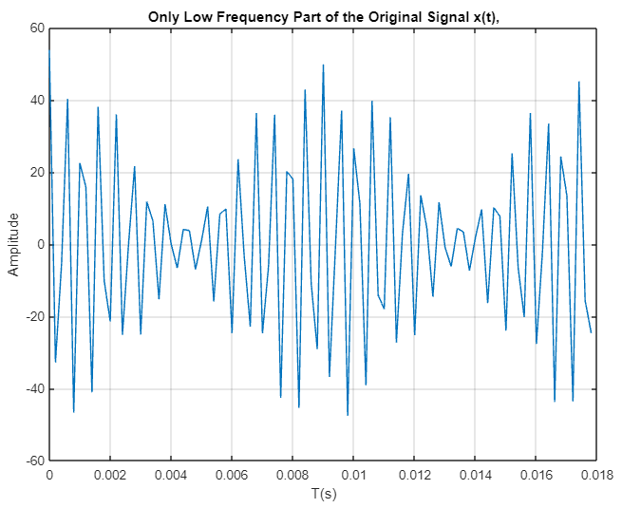
- Apply Inverse Fourier Transform (ifft) to recover the signal from frequency domain to time domain with partial frequency components (only the low frequency components of the signal. i.e. 160 Hz and 170 Hz). Visualise the reconstructed signal in time domain, compare with original signal and discuss the results.
Conclusions:
By applying Inverse Fourier Transform (ifft) to recover the signal from frequency domain to time domain with only the low frequency components of the signal we can see that the waveform has changed considerably. The biggest thing we notice is the amplitude of the signal has increased fourfold.

MATLAB CODE:
% Task 4 a
% Generate a complex pulse signal x(t) in time domain
clear all; % Good Practice
clc; % Clears the command window
n = 1000; % Length of the spectrum sequence
Ts = 0.0002; % Sampling Period from the assignment
TT = n*Ts; % Time Total = Sampling time*length of the sequence
t = 0:Ts:TT;
x = 5*cos(2*pi*160.*t)+4*cos(2*pi*170.*t)+.75*cos(2*pi*580.*t)+1.5*cos(2*pi*600.*t);
xf = fft(x);
figure (1)
plot (t, x)
title ('Complex Pulse Signal In The Time Domain');
xlabel ('T(s)'); % label x-axis
ylabel ('Amplitude'); % label y-axis
grid on

% Task 4 b
% Fourier transform of x(t) and visualize the magnitude of x(t) in frequency domain.
figure (2)
nn=length (xf);
f=(0:n) * (1/TT);
nf=length (f);
plot (f, abs (xf))
title ('Fourier Transform of x(t)');
xlabel ('Frequency(Hz)');
ylabel ('Amplitude')
axis([0, 750, 0, 3000]); % set display range of x and y axis
grid on

% Task 4 c
% We apply inverse FT in frequency domain to recover the signal in time domain.
figure (3)
Y=ifft (xf); % take the inverse Fourier transformation
plot(t,Y); % visualize the signal in time domain
title('Inverse Fourier Transform to Recover Signal from Frequency Domain to Time Domain')
xlabel ('T(s)');
ylabel ('Amplitude');
axis ([0 0.2 -15 15]); % set display range of x- and y-axis
grid on

% Task 4 d
% We select a part of the frequency domain and reconstructed that part of
% the signal to the time domain than
NRF=90; %upper reconstructed range
NRI=1; %lower reconstructed range
YY=xf(NRI:NRF);
FF=t(NRI:NRF);
fr=f(NRI:NRF);
length(YY);
length(t);
length (FF);
xrc=ifft(YY); %take the inverse Fourier transformation to part of the frequency domian spectrum
figure (4)
plot (FF, xrc)
title('Only Low Frequency Part of the Original Signal x(t),')
xlabel('T(s)')
ylabel('Amplitude')
grid on
yrc=fft(xrc);

% We select a range of the signal and reconstruct that part of the signal
% to the Frequency domain then we check the result.
figure (5)
plot(fr,abs(yrc))
title('Selected Rang of Fourier Transform Spectrum ')
xlabel('Frequency(Hz)')
ylabel('Amplitude')
axis ([0, 750, 0, 3000])
grid on
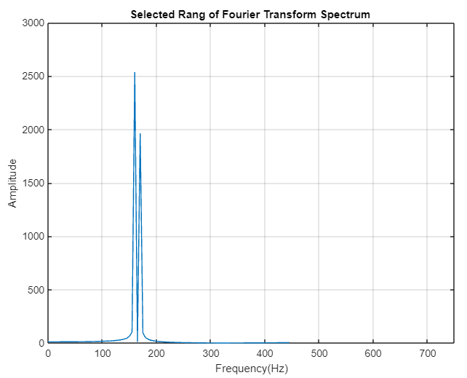

References
Byjus, 2023. Fourier Transform. [Online]
Available at: https://byjus.com/maths/fourier-transform/
[Accessed 26 February 2023].
Flint, E., 1981. Harmonics. [Online]
Available at: http://www.muzines.co.uk/articles/harmonics/2723#:~:text=The%20amplitude%20of%20each%20harmonic,by%2012%20dB%20per%20octave.
[Accessed 1 April 2023].
Vedantu, 2023. Fourier Series. [Online]
Available at: https://www.vedantu.com/maths/fourier-series
[Accessed 26 February 2023].

Appendices

Appendix A – Task 2 Code
clc;
clear;
% Task 2 - Assignment
a0=2;
W=1; % Angular Frequency = 1 (Omega = 1)
t=0:0.1:12.6; % timespan with increments of 0.1 from 0-->12.6(2 periods of 2*pi)
x=W*t;
y=a0*0.5+sin(x)/pi;
subplot(2,2,1) % 2 columns, 2 rows and in possition 1
plot(x,y)
xlabel('x=W*t (sec)');
ylabel('V (Volts)');
title('Graph to show first Harmonic');
y=a0*0.5+sin(x)/pi+sin(2*x)/(2*pi)+sin(3*x)/(3*pi); %2nd Harmonics 2*x and n pi (2*pi)
subplot(2,2,2)
plot(x,y)
xlabel('x=W*t (sec)');
ylabel('V (Volts)');
title('Graph to show Three Harmonics');
y=a0*0.5+sin(x)/pi+sin(2*x)/(2*pi)+sin(3*x)/(3*pi);
y=y+sin(4*x)/(4*pi)+sin(5*x)/(5*pi);
subplot(2,2,3)
plot(x,y)
xlabel('x=W*t (sec)');
ylabel('V (Volts)');
title('Graph to show 5 Harmonics');
y=a0*0.5+sin(x)/pi+sin(2*x)/(2*pi)+sin(3*x)/(3*pi);
y=y+sin(4*x)/(4*pi)+sin(5*x)/(5*pi)+sin(6*x)/(6*pi);
y=y+sin(7*x)/(7*pi)+sin(8*x)/(8*pi)+sin(9*x)/(9*pi);
y=y+sin(10*x)/(10*pi);
subplot(2,2,4)
plot(x,y)
xlabel('x=W*t (sec)');
ylabel('V (Volts)');
title('Graph to show 10 Harmonics');

Appendix B – Task 4 Code
% Generate a complex pulse signal x(t) in time domain
clear all; % Good Practice
clc; % Clears the command window
n = 1000; % Length of the spectrum sequence
Ts = 0.0002; % Sampling Period from the assignment
TT = n*Ts; % Time Total = Sampling time*length of the sequence
t = 0:Ts:TT;
x = 5*cos(2*pi*160.*t)+4*cos(2*pi*170.*t)+.75*cos(2*pi*580.*t)+1.5*cos(2*pi*600.*t);
xf = fft(x);
figure (1)
plot (t, x)
title ('Complex Pulse Signal In The Time Domain');
xlabel ('T(s)'); % label x-axis
ylabel ('Amplitude'); % label y-axis
grid on
% Fourier transform of x(t) and visualize the magnitude of x(t) in frequency domain.
figure (2)
nn=length (xf);
f=(0:n) * (1/TT);
nf=length (f);
plot (f, abs (xf))
title ('Fourier Transform of x(t)');
xlabel ('Frequency(Hz)');
ylabel ('Amplitude')
axis([0, 750, 0, 3000]); % set display range of x and y axis
grid on

% We apply inverse FT in frequency domain to recover the signal in time domain.
figure (3)
Y=ifft (xf); % take the inverse Fourier transformation
plot(t,Y); % visualize the signal in time domain
title('Inverse Fourier Transform to Recover Signal from Frequency Domain to Time Domain')
xlabel ('T(s)');
ylabel ('Amplitude');
axis ([0 0.2 -15 15]); % set display range of x- and y-axis
grid on

% We select a part of the frequency domain and reconstructed that part of
% the signal to the time domain than
NRF=90; %upper reconstructed range
NRI=1; %lower reconstructed range
YY=xf(NRI:NRF);
FF=t(NRI:NRF);
fr=f(NRI:NRF);
length(YY);
length(t);
length (FF);
xrc=ifft(YY); %take the inverse Fourier transformation to part of the frequency domian spectrum
figure (4)
plot (FF, xrc)
title('Only Low Frequency Part of the Original Signal x(t),')
xlabel('T(s)')
ylabel('Amplitude')
grid on
yrc=fft(xrc);

% We select a range of the signal and reconstruct that part of the signal
% to the Frequency domain then we check the result.
figure (5)
plot(fr,abs(yrc))
title('Selected Rang of Fourier Transform Spectrum ')
xlabel('Frequency(Hz)')
ylabel('Amplitude')
axis ([0, 750, 0, 3000])
grid on

