BMHP5014
Module: Changemakers: Creativity and Value Creation

Student Number: 2330361
Student Name: Sadia Hussain
Tutor Details: Dr Precious Igbinigie
Module Leader: Eleni Koutsogeorgou-Andreou

Table of Contents
Poster 1
Pitch 2
Title and Innovation Overview 2
The Issue in Health and Social Care 2
Target Audience and Impact 2
Implementation 2
Timeline 3
Development and Regulations 3
Technology Integration 3
Dissemination: How the Innovation Will Be Promoted 4
Conclusion 4
References 5

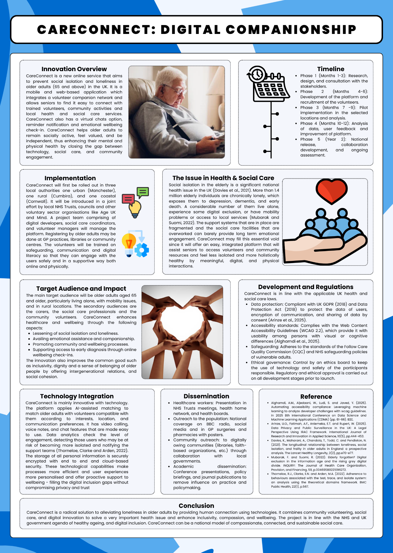
Poster

Pitch

Title and Innovation Overview
Care Connect is a new type of digital social care they have created while addressing the problem of loneliness and social isolation among adults of United Kingdom who are aged 65 years and above. Huge part of the older society cannot socialise due to the lack of mobility, loss of an individual or family and friends in immediate surround (Davies et al., 2021). Care Connect is the easy and readily available web-based tool that integrates both the older patients and the volunteers who are trained professionals, and the community life activities and resources.

The Issue in Health and Social Care
The problem of loneliness has been becoming a significant public concern within the UK and notably towards the elderly (Davies et al., 2021). Rather a significant number of elderly individuals live alone and lack social interactions, and this might lead to anxiety, depression and physical well-being deterioration. Despite the various attempts, the existing services available update on the ground are enslaved to acting in isolation, lack co-ordination, and do not take into consideration those in need of their services most (Mubarak and Suomi, 2022). The social informatics care providers areoverwhelmed,d, and large number of individuals are not digital fulfilled due to accessibility barriers or lack of digital literacy.

Target Audience and Impact
Care Connect focuses primarily on the older adults (65 or above) living in isolation or with limited mobility or having social isolation. The carers are also beneficiaries of the site since they get to know more on how to take care of the older people and the health and social care professionals, not to mention the volunteers who have to work with the older people of their local communities. Care Connect aims at improving mental conditions, emotional condition and social integration by providing companionship and regular communication.

Implementation
In its implementation, Care Connect will be undertaken together with the local councils, the NHS Trusts, the charitable organisations, such as the Age UK and the mind. To allow the system to consider diverse needs of the community, the pilot stage will be segmented under three areas- one urban (Manchester), one rural (Cumbira), one coastal (Cornwall). In line with it, the digital platform and trained volunteers will be selected in an attempt to establish consistent contact and offer or offer companionship, support, and encouragement. The service can be provided to aged people in which immediate assistance can be extended to those lacking in comprehension of technology via libraries or community centres within their local centres.

Timeline
The Care Connect will be developed and launched in a progressive twelve months. The platform and features in question will be structured in the three months soil on the principles of the stakeholder consultations and co- design as a partnership with older adults. During the months four through six, platform will also be developed and tested not to mention recruiting and training of volunteers. The piloting testing would be realized within weeks seven nine in the three selected areas where an engagement and user experiences would be carefully monitored. Between the 10th and 12th months, evaluation, refinement and improvement will be conducted. In the second year, considering the feedback, Care Connect will be able to have evidence-based expansion and sustainable expansion at a regional and national level.

Development and Regulations
To achieve user, data and ethical operation, Care Connect will be in full compliance with the regulations applicable to both the UK and in regard to professional standards (Arinze et al., 2025). The site will be open to negotiation of the UK regulation of the general data protection and the data protection act with an aim of preserving personal data. All the communication and passing of information will be encrypted with permission of the users. It will not forfeit access compliance requirements of Web Content Accessibility Guidelines to ensure that the system is usable by the people with visual, auditory or cognitive disability (Alghamdi et al., 2025). To tackle the vulnerable adults, care Quality Commission will be used to assure its standards of safeguarding.

Technology Integration
CareConnect success would be technology-based. The platform, in turn, involves the employment of the artificial intelligence as the platform is able to pair users and volunteers based on their interests, locations, and the channel of communication. It utilizes useful features such as video conferencing, voice mail, and chatting features that makes its deployment of a given degree of compression with the technology element. No part will lack data analytics to monitor user activity, which will help reveal the time when additional support is required (Thorneloe, Clarke and Arden, 2022). The data will be stored in secure and safe encrypted cloud systems. The technology is developed and aimed not to replace the human connection but provide an efficient and safe and inclusive digital environment in which the older individuals will be able to build meaningful connections.

Dissemination: How the Innovation Will Be Promoted
The Care Connect requires promotion and participation of individuals to make it successful. The program will be launched through support of national awareness program consisting of local councils, and voluntary organisations. The marketing content will be distributed to GP practices and pharmacies and libraries among the community events to recruit the volunteers and make the knowledge of the activity familiar to older people and draw the attention of the right individuals into the participant population. Good news and outcomes will be spread through use of media campaigns through radio, newspapers and social networking. Best practice will be disseminated academically using conferences and publications, trying to invite a follow-up of funding and venture afterwards.

Conclusion
Care Connect is a sensitive, effective, and novel solution to one of the biggest challenges in the ageing society loneliness in older adults. It integrates technology and face-to-face interaction, which can be a viable trend of mental health, mood, and involvement of the community. The project also meets the requirements of integrated, person-centred care, and the capability to enable older people to lead dignified, independent lives based on social fulfilment on the goals set by the national governments. Care Connect will positively influence the ageing process in the UK by partnering, innovative solutions and social engagement, and in states of ensuring that no person during his or her elder years feels lost and isolated. ￼

References
Alghamdi, A.M., Aljedaani, W., Ludi, S. and Javed, Y. (2025). Automating accessibility compliance: Leveraging machine learning to analyze developer challenges with wcag guidelines. In 2025 8th International Conference on Data Science and Machine Learning Applications (CDMA) (pp. 61-66). IEEE.
Arinze, U.O., Fatimah, A.F., Aniemeka, E.T. and Rupert, W. (2025). Data Privacy and Public Surveillance in the UK: A Legal Perspective Using IRAC Framework. International Journal of Research and Innovation in Applied Science, 10(5), pp.444-453.
Davies, K., Maharani, A., Chandola, T., Todd, C. and Pendleton, N. (2021). The longitudinal relationship between loneliness, social isolation, and frailty in older adults in England: a prospective analysis. The Lancet Healthy Longevity, 2(2), pp.e70-e77.
Mubarak, F. and Suomi, R. (2022). Elderly forgotten? Digital exclusion in the information age and the rising grey digital divide. INQUIRY: The Journal of Health Care Organization, Provision, and Financing, 59, p.00469580221096272.
Thorneloe, R.J., Clarke, E.N. and Arden, M.A. (2022). Adherence to behaviours associated with the test, trace, and isolate system: an analysis using the theoretical domains framework. BMC Public Health, 22(1), p.567.

