Programme: BSc (Hons) Cloud Computing
Module: Network Programmability Part 2
(ACCA5029_BIRM)
|StudentID:2026380|

Contents
I. Ansible 1
II. Advantages and Disadvantages: 2
III. INSTALLATION AND CONFIGURATION 4
IV. OpenSSH Daemon or server 5
V. SSH Configuration: 6
VI. SSH Keys: 7
VII. Ansible Configuration 9
VIII. Inventory File 9
IX. Ansible connection test. 10
X. MySQL Installation 11

Ansible
As mentioned in [1], Ansible, is a tool that enables you to automate processes to bring a system to the desired state. Defining a package that must be installed, specifying web server settings, or even putting up a whole deployment orchestration are all examples of tasks.
Enabling continuous integration and continuous deployment (CI/CD) with zero downtime is a significant problem in IT today. Working with several software packages has frequently needed substantial bespoke code to achieve this aim.
A potent open-source automation language is Ansible®. It is distinctive in that it is also a deployment and orchestration tool. While Ansible aims to address other significant unresolved IT problems, such as CI/CD, it also offers more effective drop-in replacements for many key features in previous automation systems.
In today's automated world, you can practically instantly launch a whole server with only one click. It will come with your preferred operating system, programs, security guidelines, hard drive space, and a plethora of personalized options. The server setup may be automatically duplicated dozens, hundreds, or even thousands of times whenever you need it. Hello and welcome to infrastructure as code, or IaC.
IaC is a procedure whereby you write a configuration script with all the necessary settings and modifications, and a provisioning tool will take care of the rest rather than manually configuring each server. Let's now examine infrastructure as a set of coding tools that will aid in this procedure.
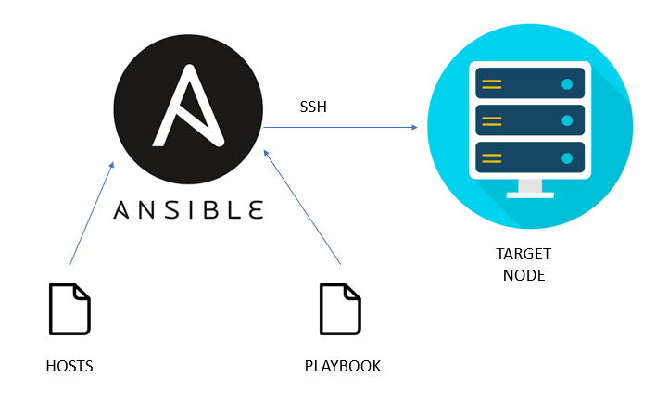
As illustrated in [3,fig 1]

Advantages and Disadvantages:
- Benefits of Ansible
Ansible may undoubtedly offer several benefits with its various simplifications. Let's examine this more closely!
- Easy to Learn
As mentioned in [2], The first benefit of Ansible to be mentioned is its simplicity. The simplicity is intended for both beginners and pros. Users might rapidly learn how to utilise Ansible and increase their productivity because it is simple to understand. Ansible is supported by thorough and simple-to-understand documentation.
As a result, you may quickly become familiar with the process and logic of Ansible operations. The absence of a dependency structure can indicate that Ansible jobs run sequentially and terminate when an error is detected. As a result, even while learning the basics of ansible, troubleshooting becomes much simpler.
- Python is an Easily Understandable Language
The language in which Ansible is written is another one of its key benefits. Python, which forms the foundation of Ansible, is a human-readable language. Python libraries are available by default on most Linux distributions, making it easier to install and operate Ansible.
Python is a very good substitute for administrative and scripting chores, which suggests that engineers and system administrators choose it more. The availability of Ansible modules, which can enhance its usefulness, is another intriguing element of Ansible. Any language may be used to create Ansible modules. The module should deliver data in JSON format, though, as that is the crucial issue here.
- No Agent Dependency
Ansible's agentless nature is the next significant improvement above other features. All master-agent communications are managed by Ansible using either the Paramiko module or Standard SSH. For controlling nodes, it is essential to use the Paramiko module, a Python implementation of SSH2. In order to ensure management, Ansible does not need any kind of agents deployed on distant computers. The outcome is With Ansible, maintenance costs and performance deterioration are greatly reduced.
- In YAML, playbooks are written.
As mentioned in [3], Another factor contributing to Ansible's significant benefits is the usage of Playbooks. Playbooks are Ansible configuration files that are written in the YAML language. The intriguing aspect of this situation is that YAML is a superior choice for automation and configuration management.
Ansible is a better configuration management and automation tool since YAML is superior to other formats like JSON. Ansible allows comments and makes it simple to read. The usage of anchors to refer to other objects is also included, which is of utmost importance.
- Affordable Galaxy
The Ansible Galaxy is mentioned in another noteworthy entry in the Ansible recommended practises. A site called Ansible Galaxy serves as the main hub for finding, using, and sharing Ansible-related material. The main benefit of Ansible Galaxy may be shown in the case of downloading reusable Roles for configuring servers or deploying applications. The downloads can significantly speed up deployment because they are perfect for inclusion in a specific user's playbooks.
- Disadvantages of Ansible
Let's focus on Ansible's drawbacks now that we have a strong understanding of its many benefits.
- Lackluster user interface
The first issue on the list of Ansible's downsides is the subpar user interface. Ansible was once only a command-line tool. The AWX graphical user interface was utilised in Ansible's first effort to develop a user interface. The third component of the UI was the REST endpoint, which was created to make managing infrastructure easier. The AWX later evolved into the Ansible Tower, an online management UI. Ansible Tower provides a team-based workflow tool as well as visual management tools. The Ansible Tower, however, needs significant changes. For instance, the UI can be used to do about 85% of operations that can be accomplished through the command line.
Another instance of Ansible drawbacks resulting from its UI may be found. Conflicting query results may come from a command line and GUI that are out of sync. Generally speaking, Ansible Tower is still under development and is unable to do all tasks identical to those performed by a command-line interface.
- Absence of State Notion
Another fundamental flaw with Ansible is the lack of any idea of state. Ansible doesn't have a concept of state, unlike other automation tools like Puppet. Simply said, Ansible runs consecutive tasks and terminates them when they are completed, fail, or experience any issues. There is no dependency tracking. For users who require the automation tool to keep a comprehensive catalogue for ordering, these characteristics are not appropriate. The catalogue can assist in getting to a particular state devoid of the impact of alterations in the surroundings. Ansible, however, is without it and is at a severe disadvantage.
- Windows Support is Limited
The second significant point among the drawbacks of Ansible is the incomplete Windows support. In addition to Linux/Unix nodes, Ansible version 1.7 supports Windows nodes. Ansible uses native PowerShell remoting rather than SSH when working with Windows systems. As a result, managing Windows hosts requires a Linux control machine. One of the major drawbacks of Ansible, a configuration management and automation tool, is its restricted support for Windows.
- Because Ansible lacks experience
Ansible's lack of business support experience lessens its appeal even further. Unlike its competitors Chef and Puppet, Ansible has less experience working with large enterprises (Read: Chef vs Puppet). Despite Ansible's promotion of the availability of enterprise-grade extended support options, Ansible's accountability is limited by a lack of practical experience.
- The Market is New to Ansible
As a notable drawback of Ansible, you might observe one of the most frequent entries in the pros and downsides of Ansible. Unlike its well-known competitors, Ansible is a newcomer to the market. Its developer and user communities are small as a result. Additionally, the debut of Ansible on the market raises the prospect of previously undetected defects, software problems, and edge cases.

INSTALLATION AND CONFIGURATION
The first thing we need to do is make sure Ansible is set up and functioning on our local PC. For this lesson, Ubuntu will be used. On the master node, Ansible installation will take place.
Using Hyper V to create virtual machines.
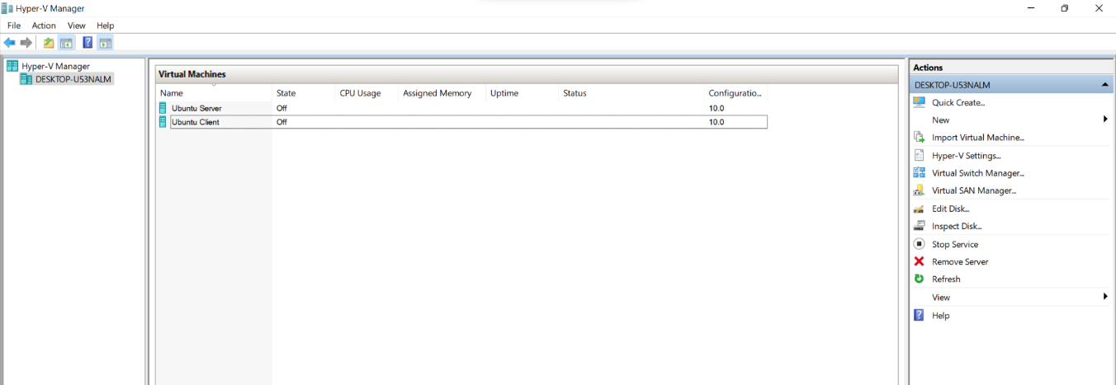
After the virtual machines have been created, we can continue to the next step and that’s going to be
Then, update the package index on your system so that it is aware of the packages present in the recently added PPA:
sudo apt-get update
sudo apt-get dist-upgrade -y

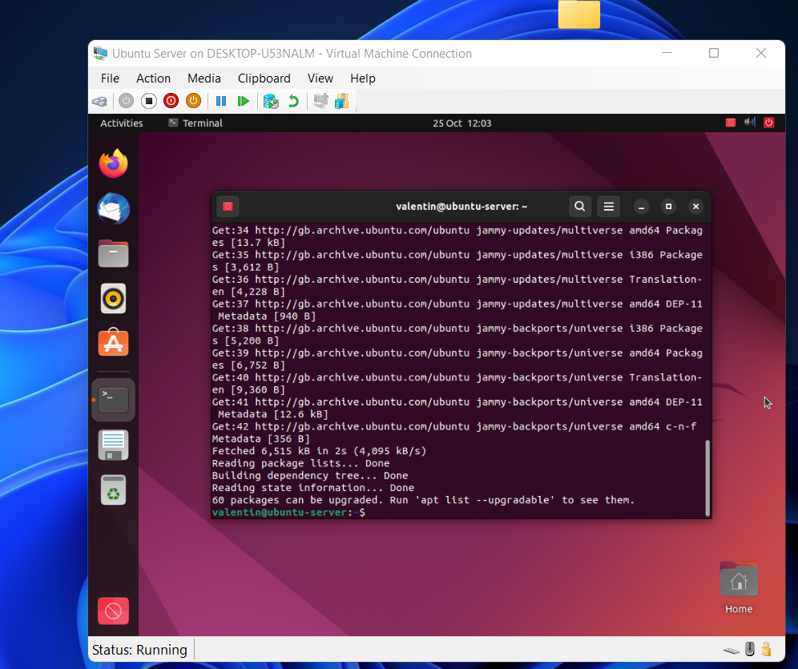

Playbook
The YAML format used to express playbooks uses the bare minimum of syntax. If you're not familiar with YAML, have a look at our overview of YAML Syntax and think about adding an add-on to your text editor (see Other Tools and Programs) to make it easier to write YAML in your playbooks with clear syntax.
One or more "plays" in an ordered list make up a playbook. Both "playbook" and "play" are sports metaphors. Each play runs one or more activities that contribute to the playbook's overall aim. Each task invokes a module of Ansible.



OpenSSH Daemon or server
Before we begin, it is important to comprehend how Ansible interacts with remote machines via SSH. For the purpose of specifying which remote servers Ansible will be managed, it comes with a default inventory file (/etc/ansible/hosts). Our authorized keys file on remote computers should contain our public SSH key.
From the Terminal we are running the command to install the OpenSSH:
sudo apt-get install openssh-server


By default, Ansible uses the user name you are logged in as on the control node to connect to all remote devices. You can choose a different user name for the connection if that one doesn't already exist on the remote device. Check out Understanding Privilege Escalation: A Guide if you only need to perform a few actions as a different user. become. The connection user can be set in a playbook:

SSH Configuration:
As mentioned in [5], You can configure the default behavior of the OpenSSH server application sshd by editing the /etc/ssh/sshd_config.xml file. For configuration directives used in this file, see the appropriate man page using the following command from a terminal prompt:
man sshd_config
The sshd configuration file has many directives that control things like communication settings and authentication modes. The following are examples of configuration directives that can be changed by editing the /etc/ssh/sshd_config file.
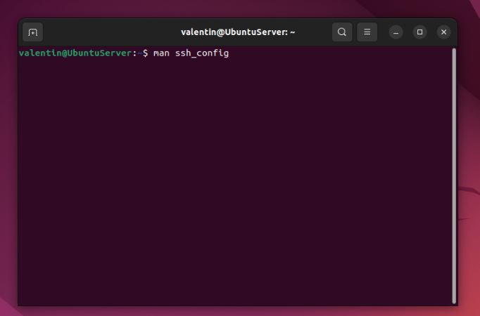
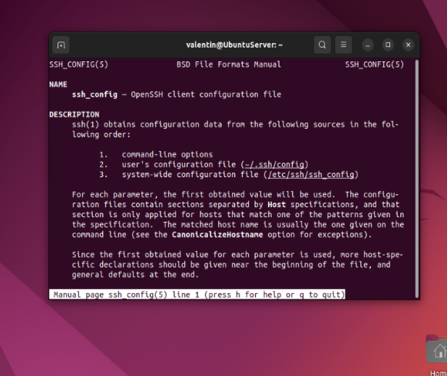
After making changes to the /etc/ssh/sshd_config file, save the file and restart the sshd server application to apply the changes using the following command at a terminal prompt:
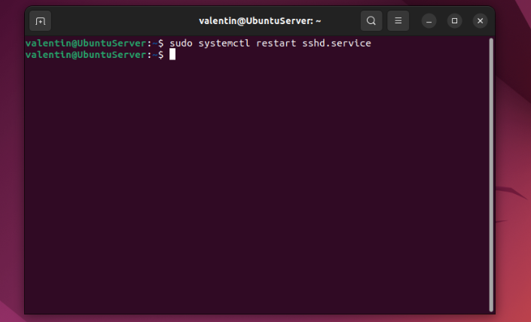
sudo systemctl start ssh

SSH Keys:
As mentioned in [6], SSH allows authentication between two hosts without the need of a password. SSH key authentication uses a private key and a public key.
To generate the keys, from a terminal prompt enter:
ssh-keygen -t rsa

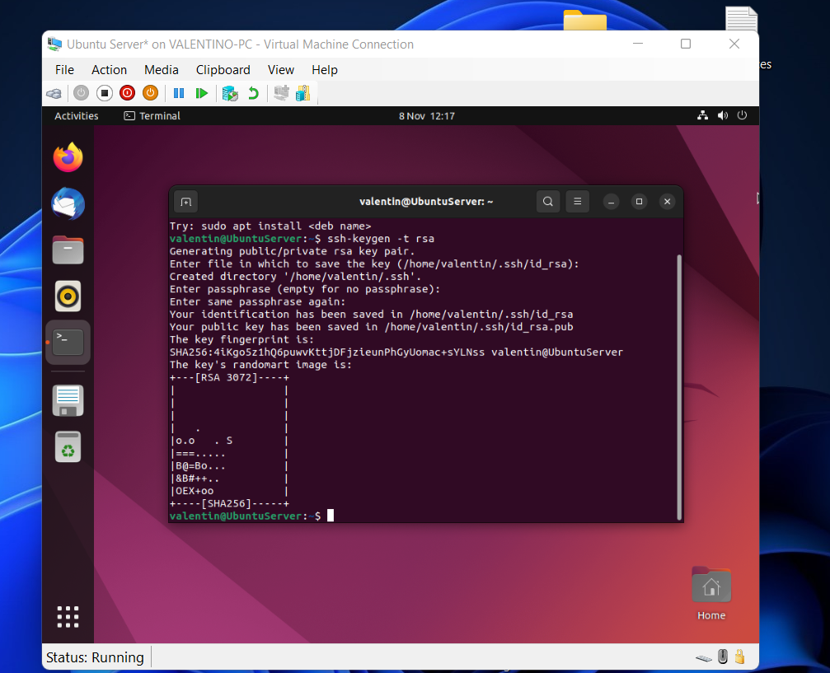
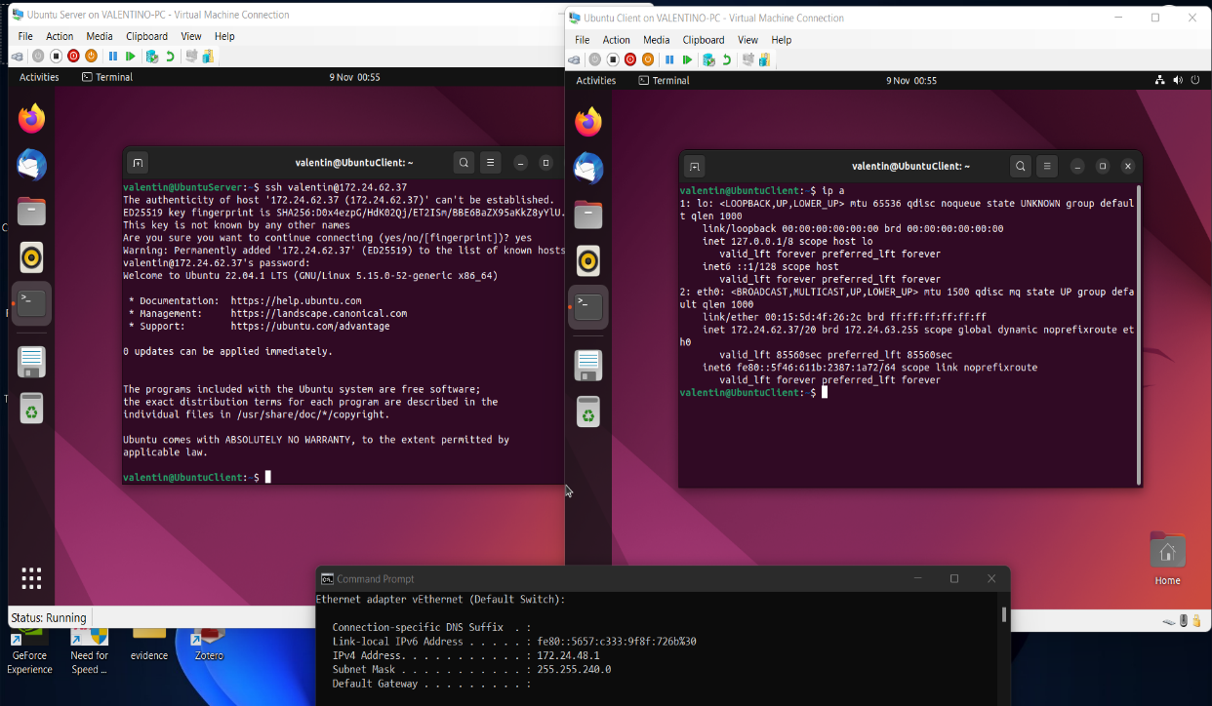
The RSA technique will then be used to generate the key. The generated key's current length is 3072 bits. With the -b option, you can alter the bit count. To create a 4096-bit key, for instance:
ssh-keygen -t rsa -b 4096
You will be required for a password during the procedure. When requested to generate the key, merely press Enter.
By default, the private key is kept as /.ssh/id rsa and the public key is saved as /.ssh/id rsa.pub. After that, attach the id rsa.pub file to /.ssh/authorized keys on the remote host by typing:
ssh-copy-id -i ~/.ssh/id_rsa.pub valentin@172.24.62.37
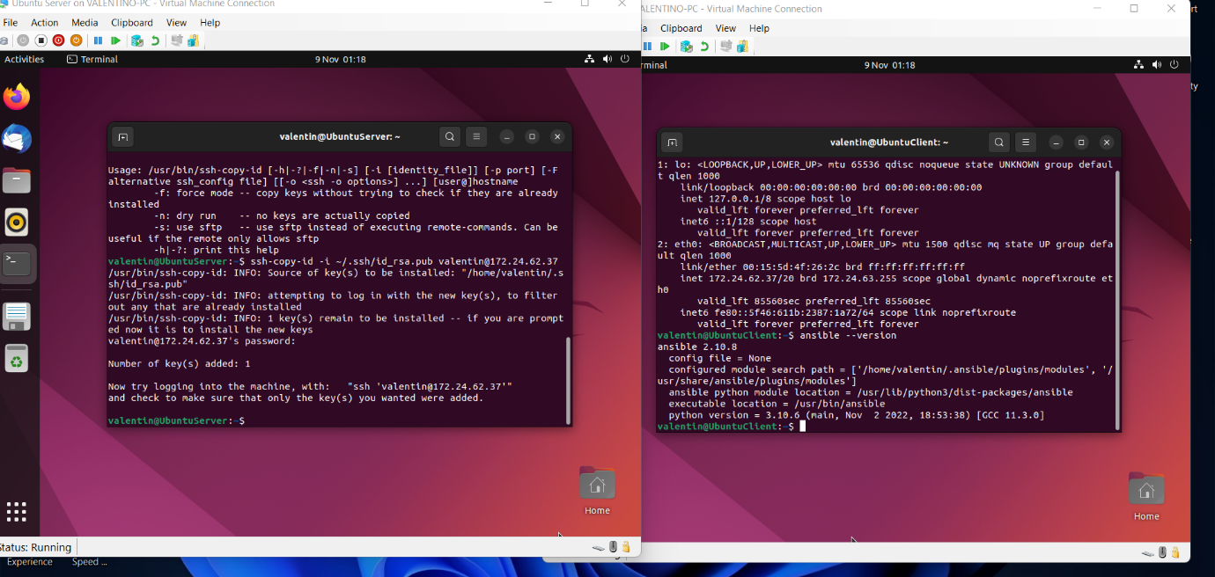

Ansible Configuration
Installing the Ansible software on the computer that will act as the Ansible control node is the first step in utilising Ansible to manage your server infrastructure.
After this upgrade, you can use the following to install the Ansible software:
sudo apt install ansible


All of the software needed to manage hosts is now included in Ansible. The process for adding your hosts to the control node's inventory file will then be covered so that it can manage them.

Inventory File
The hosts you'll use Ansible to manage are listed in the inventory file. Your inventory file can contain one to several hundred servers, and hosts can be divided into groups and subgroups. In order to use them in playbooks and templates, variables that are valid only for particular hosts or groups are frequently specified in the inventory file.
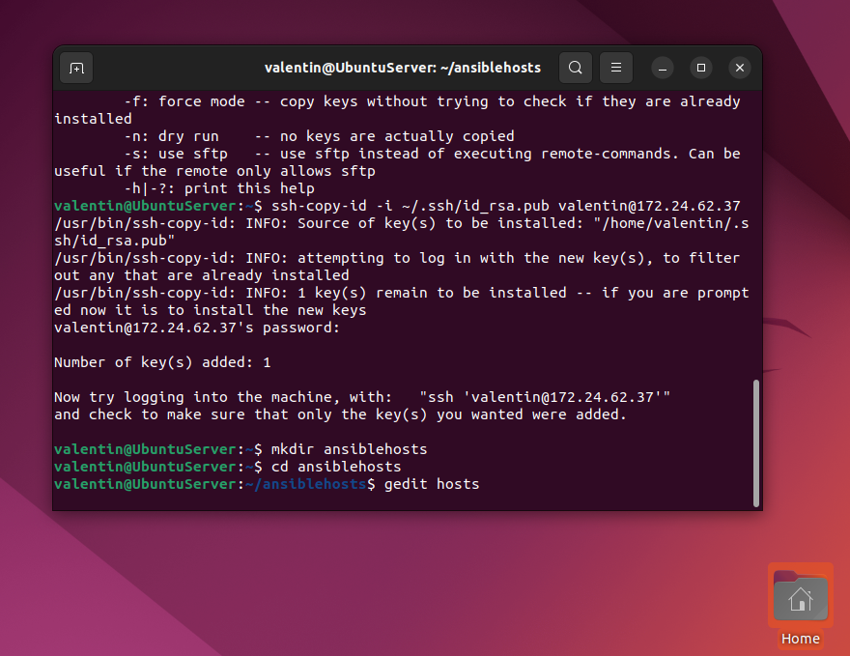
You can use a number of the examples in the default inventory file that comes with the Ansible installation as a guide for setting up your inventory. The example that follows defines a group called [default] that contains three distinct servers, each of which is designated by a unique alias. Make sure to use the IP addresses of your Ansible hosts in place of the highlighted IPs.

Ansible connection test.
It's time to see if Ansible can connect to your servers and execute commands over SSH after configuring the inventory file to include your servers.
We'll be utilising the Ubuntu root account for this instruction because it's often the only one that comes with freshly established servers by default. You are advised to utilise the usual sudo user that has already been set up on your Ansible hosts rather than creating a new one.
The remote system user can be specified using the -u parameter. Ansible will attempt to connect to the control node using the current system user if this information is not provided.
Run these commands from your computer or Ansible control node:


This command will connect as root and execute a connectivity test on each node in your default inventory using Ansible's built-in ping module. The ping module will examine:
if the hosts are reachable;
if you own legitimate SSH credentials;
whether hosts can execute Python-based Ansible modules.

MySQL Installation
MySQL is the go-to option for scalable online applications since it is included in the LAMP Stack, which is an Open-Source web application suite that comprises of Linux, Apache HTTP Server, MySQL, and PHP. Let's discuss a few key characteristics that make MySQL such a wonderful catch. Check out how you may switch from MySQL to PostgreSQL as well.
In order to install MySQL Run the following command to install MySQL Server:
sudo apt install mysql-server

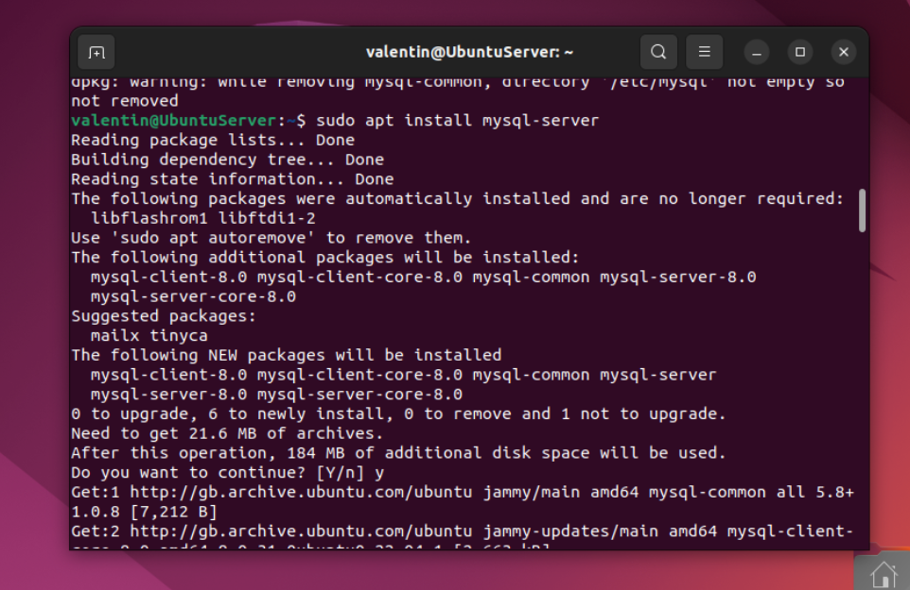
Answer "Y" when the system prompts you to continue the installation, then press the ENTER key. The final result should resemble this: The MySQL Packages will then be downloaded and installed on the computer you specified by the system.
You must execute DBMS's Included Security for newly installed instances of MySQL. This script will change a few of the less secure default settings for things like remote root logins and sample users. Use sudo to execute the security script as follows:
sudo mysql_secure_installation

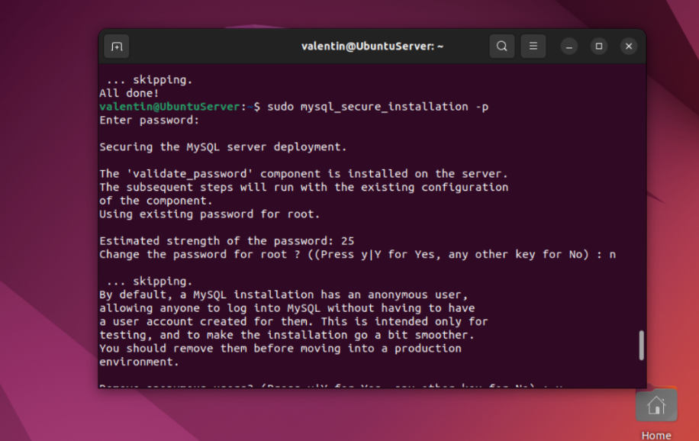
This will guide you through several prompts where you can modify the security settings for your MySQL installation. You'll be prompted to set up the Validation Service in the first message.
You will then be prompted to create a password for the MySQL root user. Enter your password of choice and follow the instructions to confirm it:
MySQL creates a root user account during installation, which you can use to control your database. With full privileges, this user can access all databases, tables, users, and other resources on the MySQL server. This account should only be used for administrative purposes as a result. This step describes how to establish a new user account and provide it access using the root MySQL user.
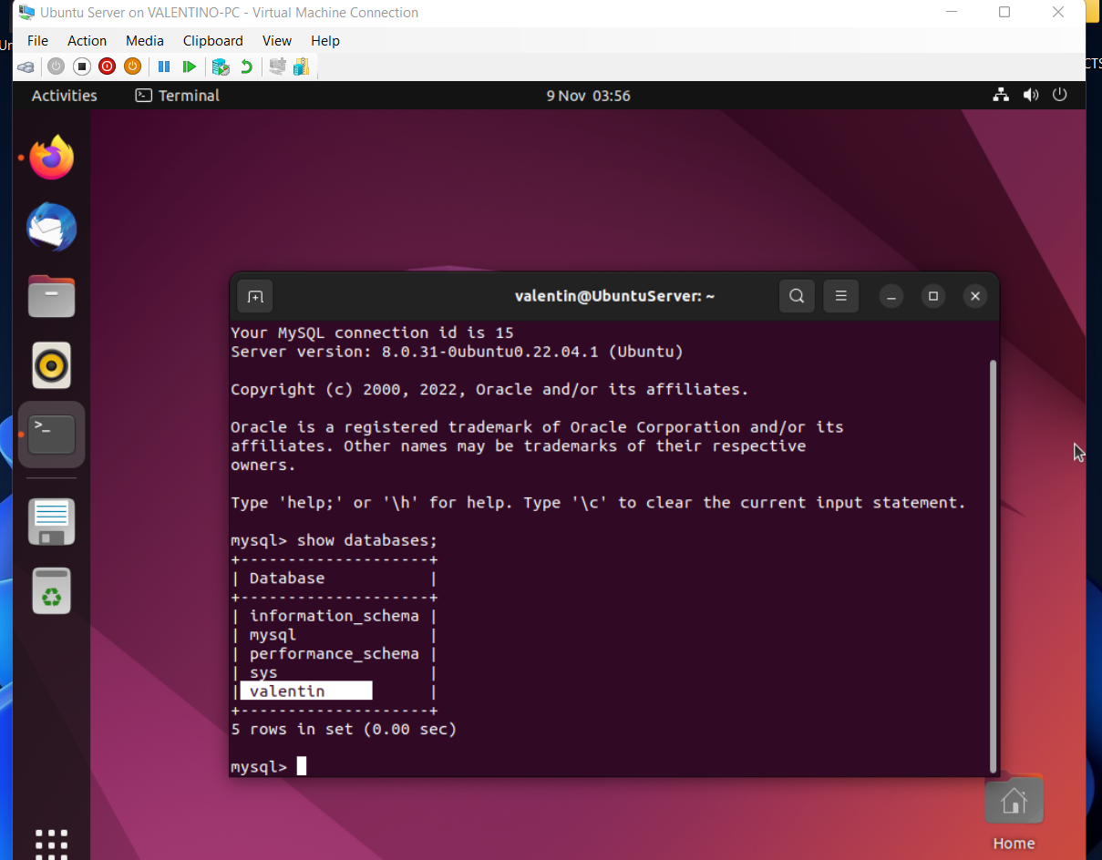

Installing Apache
Apache can be installed using customary package management tools because it is part of Ubuntu's usual software repositories.
Let's install the Apache on the Host and Client with the following command
ansible all -m apt -a name=apache2 –become –ask-beome-pass


Apt will install Apache and all necessary dependencies once the installation has been approved. It is important to change the firewall settings to permit external access to the default web ports before testing Apache. You ought to have a UFW firewall set up to limit access to your server, if you followed the requirements in the prerequisites.
In order to provide a few application profiles that can be used to permit or prohibit access to Apache through the firewall, Apache registers with UFW after installation.
Ubuntu 20.04 launches Apache after the installation procedure is complete. The web server ought to be operational by now.
Type the following command to verify that the service is active with the systemd init system:
sudo systemctl status apache2

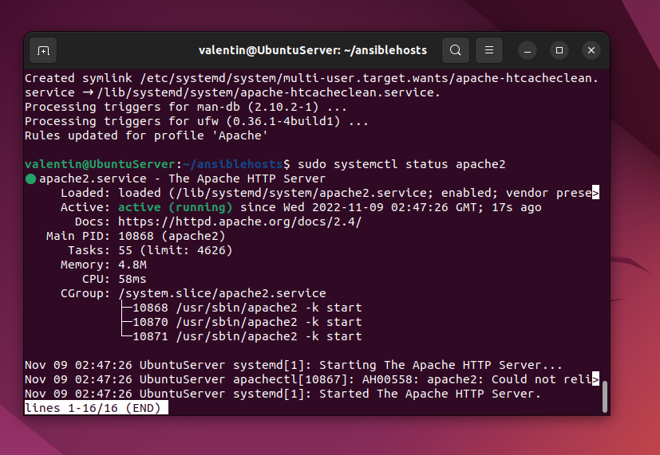
The service has successfully started, as shown by this output. The best way to test this, though, is to ask Apache for a page. Through your IP address, you can check that the programme is functioning properly by accessing the default Apache landing page. You can obtain your server's IP address from the command line in a few different ways if you are unsure of it.

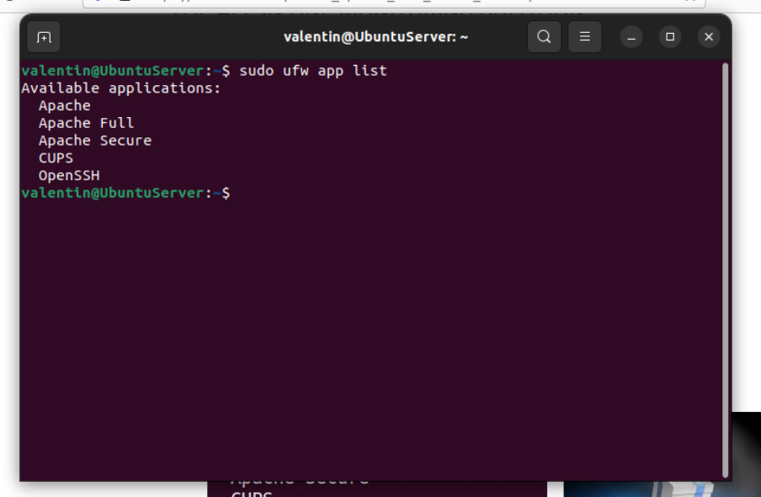
When you know your server's IP address, type it into the address bar of your browser like follows:

This page shows that Apache is operating properly. Additionally, it contains certain fundamental details regarding the locations of key Apache files and directories.

References
[1] Red Hat Ansible Automation Platform redhat.com https://www.redhat.com/en/technologies/management/ansible (Accessed 12/11/2022)
[2]Ansible, Red Hat, “How Ansible Works | Ansible.com,” Ansible.com, 2019. https://www.ansible.com/overview/how-ansible-works
[3] Cloudinary.com, 2022. https://res.cloudinary.com/practicaldev/image/fetch/s--BkF-uzLS--/c_limit%2Cf_auto%2Cfl_progressive%2Cq_auto%2Cw_880/https://dev-to-uploads.s3.amazonaws.com/uploads/articles/npb90i8qo6yknbw4mpxv.png (accessed Nov. 20, 2022).
[4] The new ubuntu server guide | ubuntu (no date). Available at: https://ubuntu.com/blog/ubuntu-server-guide (Accessed: November 20, 2022).
[5] “How to Configure SSH on Ubuntu Server [Beginner’s Guide],” https://itsfoss.com/. https://itsfoss.com/set-up-ssh-ubuntu/ (Accessed 20/11/2022)

[6] The new ubuntu server guide | ubuntu (no date). Available at: https://ubuntu.com/blog/ubuntu-server-guide (Accessed: November 20, 2022).

