SMART TECHNOLOGIES IN THE WORKPLACES

Table of Contents
Introduction 3
Assignment: 1st Part 3
The usage of technologies in the organisational workplace 3
Two providers of the technological applications 4
The benefits of the technological applications 5
The impact of web conferencing and cloud file storage to increase efficiency 6
The impact of technologies to enhance staff employability 7
Conclusion 8
Reference List 9

Introduction
The globalized business market of the modern world has procured intense competition for the business organisation that is excelled with the incorporation of the modern technologies in business practices. The proper use of technology in the workplace can be helpful to obtain sustainable competitive advantage for the business organisations. The use of technology can be helpful to manage compatibility with the trendy speed of global business. This particular assignment will deal with the technological option of cloud file storage and web conferencing as these can be used in the business workplace for the perpetual enhancement of the functions of the organisation. This assignment will elucidate the technological providers and the impact of these options to enhance employability and efficiency of workplace.

Assignment: 1st Part

The usage of technologies in the organisational workplace
Web conferencing is a prior technological collaboration based on online operations to host the functions like web seminars and meetings along with peer level conferences and meeting webcasts. The web conferencing setup requires the adequate software and hardware for proper operations in workplace. The online service of this application can be utilized by the business organisations in order to perform live meetings with the procurement of the TCP and IP addressed to sustain relentless connections. Time and distance problem to hold a conference can be avoided through the use of the web conferencing application (Attaran et al. 2014). The web conferencing can be used by the companies to make quick decision through collaborating the ideas of the employees by online meeting and presentations. The web conferences are also used for providing training to the employees by connecting the experts and trainers through online video connections.
The cloud storage is an integral part of the cloud computing that enables the organisations to store the digital data in the remote web based servers for better security and accessibility. The organisations can evade the conventional method of data storage in the hard drives of the computers through the use of cloud storage. The organizations mainly stores the data in the cloud server storage to generate ability to access the data from remote locations with the availability of internet connections. The different version of hardware and software are used by the organisations to foster the cloud file storage system. The company can upload the digital data in the cloud drive or online database that has an automatic ability to backup clones of the data to help in retrieving the data after erased from the server once (Campbell, 2014). The organisation can make encryption and provide the password to the competent people for allowing them to access the drive with password to get the information to use them in organisational purposes and decision making process.

Two providers of the technological applications
Web conference:
BigMaker and ACT Web Conferencing are the most popular providers of web conferencing applications as these are used by the companies for performing web conferences. The applications can provide uninterrupted services of web conferencing for the ease of business operations. The BigMaker is specially crafted with a platform of browser specification to perform web conferencing whereas the users can also record the visuals with strong line recording applications to shortlist the videos for downloading in future occasions. Apart from that, this provider was previously run with Adobe Flash Player but the modern browser configurations are well compatible with the requirements of web conferencing. The latest applications of this provider can be also used with the help of WebRTC for using the latest technologies of webcams and microphones with boom speakers to involve many people in the process of web conferencing as the provider is available for trial versions and paid subscription mode too (Chen et al. 2015). ACT Web Conferencing was initially a voice conferencing provider whereas it also provides visual conferencing in modern days in only subscription versions. The services are available in on-demand facility and self-service facility as the ACT Web Conferencing is also available with customized processing by the help of local dial network and international conferences of multimedia module. The regional carriers like ART are used for the use of ACT Conferencing whereas the provider version is dependent on the usage of AAPT, PCCW and Rogers Telecom portals. The changes in supported providers create variation in the speed of the web conferences that is comparatively cost effective than other providers.
Cloud computing:
Microsoft Azure is the most popular name of cloud file storage providers along with tough competition from the AWS or Amazon Web Services. The cloud data is used for running the Microsoft Azure based on the operations of the programming languages in order to maintain the virtual storage with ease. This is run by a system of PaaS to manage the organisational big data whereas the storage is very much dependent on the APIs of the SDK and REST language. The blob services also help in storing the unstructured texts with the enabling of the NoSQL database on non-relational programming. The cloud storage queue services are also important in Azure to procure provision for asynchronous messages to foster communication with the help of the SMB protocols to safeguard file storage (Croteau et al. 2011). The Amazon Web Services is also an important provider that operates on the on-demand facility for cloud file storage whereas the subscribers can store and access big data within a few seconds even with a standard and minimum system requirements. The storage services of Amazon can be accessed from any kind of interfaces as the services of glacier facility is also effective to store the data for long term storage with the availability of systematic backup for contingencies of data cost.

The benefits of the technological applications
Web conferencing
This technological application enables the organisation to make visual and verbal process of communication in the workplace to help the employees to build coherent decisions through uniform conversations. The applications of the web conferences can be sheer helpful in saving the important times of the business companies to make arrangements of an offline conference. The budget can be reduced for travelling to attend the conferences with the help of web conferencing as an arrangement of a meeting requires huge budget allocation and web conferencing can help in saving that money (Davenport, 2008). The web conferencing application is very much flexible as it can be performed as per the desired time of the employees whereas the web conferencing also helps in selecting the best talents through the facility of remote accessing that procures ease for candidates to communicate with the organisation with ease. It also helps companies to get in touch with customers in regular basis to procure effective relationship with target market to do promotion of services. Thus, the web conferencing can be sheer helpful to interject efficiency among the skills and workplace operations of the employees.
Cloud file storage
There are diverse benefits for the use of cloud file storage in business as the different kind of usability is prior for procuring convenience for storing the data in digital server with drag and drop process. The organisations with the cloud file storage generally can work with a large radius as it can help to send web links through mail instead of attaching all the files in mail that takes huge time to be completed. The remote access facility of cloud storage is advantageous as it can be accessed from any location with internet by putting the password. In case of data storm or data lost, the cloud storage can be helpful to retrieve the lost data from the backup. The cloud file storage also saves huge cost by diminishing the annual cost of maintaining the internal storage of information (Ercan, 2010). The cloud storage also allows the remote office trend to help employees work from anywhere and the cloud storage does not need of any maintenance cost for the healing abilities of the servers. Any employee with least knowledge of computers can use the cloud storage and move the information very easily for the firewall of cloud storage to safeguard the stored information.

The impact of web conferencing and cloud file storage to increase efficiency
Web conferencing application
The main help of web conferencing is to enhance the collaborative aspect of the workplace by allowing the different departments and employees to interact and communicate with each other easily. This collaborative approach is very much helpful for the employees to make coherent business decisions for the company. A department of a company can make web conference with another department of a different market to draw information from them to make a decision for procuring sheer efficiency in the market actions. The web conferencing also provides intense field support to the staffs as the staffs can make conference with their seniors in the office to know the process of solving practical issues faced in the time of field work that can be helpful to enhance their operational efficiency (Hollander et al. 2011). As example, a market agent can make web conferencing while visiting a customer dealership for the contract of supply in order to discuss with the superior authority about the establishment of implied terms and expressed conditions of the agreement between two parties to incur efficiency in his actions.
Cloud storage:
The application of cloud file storage also can bring sheer efficiency in the IT outsourcing process through efficient maintenance of the IT working frame. Apart from that, the file storage in cloud server can boost the connectivity in the workplace to perpetuate the information sharing among all the employees to help them in making informed decisions to procure efficiency in the business operations. The cloud data storage enhances the server flexibility to help the companies to get adoptive to the external business condition of the market. It also enhances the efficiency of the decisions through allowing the usage of the latest market and internal information of the business. The remote and easy access of the database of cloud storage is also helpful to take appropriate decisions in no time (Senn et al. 2010). The cloud store can be helpful to solve the problems like lack of availability of information about the market and the competition to bring efficiency in the process of decision making. The organisational management can avail the information to know about the positivity and negative approaches of the organisation to procure compatible decisions that can maintain the efficiency in operations.

The impact of technologies to enhance staff employability
Web conferencing:
The knowledge of knowing web conferencing can have a great impact on the employability of the staffs. The staffs with ample knowledge of web conferencing can be effective in enhancing the aptitude of the employees to increase the eligibility of the employees to get further employment opportunities. The web conferencing can have perpetual impact on the employee skills through the provision of the online training sessions (Tapscott et al. 2011). The ability of the staffs for using web conferencing can be eventful for the employability of the staffs to use this skill as a special attribute for future employment perspectives. There are trends of employing web conferencing trainers in the market and this skill can be helpful in employability to avail the chances of professional career.
Cloud storage:
The cloud file storage knowledge can be considered as a pivotal skill for the eligibility of the employees seeking jobs. It is very fruitful for the purpose of employability but the cloud file storage can cause negative result for the employability rate and employment opportunities. The cloud file storage minimises the requirement of many employees to manage the data that can be a negative trend for employability rate (Warkentin et al. 2010). The staff ability to use cloud storage can be attributed to the skills for employability for opting for employment chances in future career. This can be effective in value creation as the employees can earn future skills with it and earn salary for working with the technology.

Conclusion
This particular piece has discussed about the cloud storage and web conferencing with their different process of use in the workplace. Apart from that, it has depicted the different providers of those applications along with their comparisons. The benefits of incorporating those applications in workplace are also discussed with real time example. This piece has also discussed the process of imbuing efficiency in organisational operations through the technologies in addition with the impact of them on the employability of the employees.

https://www.facebook.com/PERI-PERI-SHOP-394628954305599/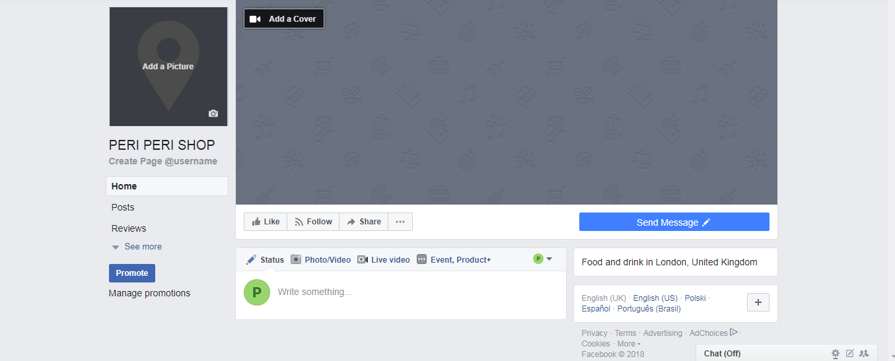
https://twitter.com/SHAKIRACHY1
https://www.linkedin.com/in/shakira-choudhury-2ba234156/

Reference List
Attaran, M., 2014. Exploring the relationship between information technology and business process reengineering. Information & Management, 41(5), pp.585-596.
Campbell, J.R., 2014. Entry, exit, embodied technology, and business cycles. Review of economic dynamics, 1(2), pp.371-408.
Chen, M., Zhang, Y., Li, Y., Hassan, M.M. and Alamri, A., 2015. AIWAC: Affective interaction through wearable computing and cloud technology. IEEE Wireless Communications, 22(1), pp.20-27.
Croteau, A.M. and Bergeron, F., 2011. An information technology trilogy: business strategy, technological deployment and organizational performance. The journal of strategic information systems, 10(2), pp.77-99.
Davenport, T.H. and Short, J.E., 2008. The new industrial engineering: information technology and business process redesign.
Ercan, T., 2010. Effective use of cloud computing in educational institutions. Procedia-Social and Behavioral Sciences, 2(2), pp.938-942.
Hollander, A., Denna, E. and Cherrington, J.O., 2011. Accounting, information technology, and business solutions. McGraw-Hill Higher Education.
Senn, J.A., 2010. Information technology in business: principles, practices, and opportunities. Prentice-Hall, Inc..
Tapscott, D. and Caston, A., 2009. Paradigm Shift: The New Promise of Information Technology. McGraw Hill, Inc., Professional Book Group, 11 West 19th Street, New York, NY 10011.
Warkentin, M.E., Sayeed, L. and Hightower, R., 2010. Virtual teams versus face‐to‐face teams: an exploratory study of a Web‐based conference system. Decision Sciences, 28(4), pp.975-996.

