Neighbourhood Policing Strategic Plan 2024-2027
Julian Hart

Srategic Management in PoLicing BMPO004D
2024

Executive Summary

This report has been compiled to support and develop the new Humberside Police Neighbourhood Policing Strategic Plan. It is intended to provide both strategic understanding and oversight for the department for the next three years. In the absence of a current strategic overarching plan, it will align line with both legislation The Crime and Disorder Act (1998) and the Chief Constables vision and tenure. This period has been chosen as it dovetails with the forthcoming PCC elections and will clearly outline the departments’ purpose, plans and actions to compliment and co-exist with the wider organisation’s other departmental strategic plans.
As such the report contains reference to; -
- academic concepts, models, and references
- theories and research including stakeholder consideration and engagement.
- the need for and benefits of a strategic plan
- recommendations and conclusions.
The report is broken down into component parts and is supported by graphical appendices illustrating some strategic modelling including how the theory is intended to be practically implemented.

Contents
Executive Summary 1
Introduction 3
What is Strategy? 3
How is Strategy used? 4
Strategic concepts and theories 5
Strategic Management 8
Strategic Planning & who should be involved in the planning stages. 11
Strategic Analysis, Evaluation & Implementation 16
What should a strategic plan include? 19
Culture & Communication 20
Conclusions 21
Recommendations 23
Appendices 24
References 30

Introduction

Having taken the head of Neighbourhood Policing post Inspector Hart discovered that departments’ previous strategic plan required a refresh and was out of date. Insp Hart has compiled this report, the development and design of a strategic plan, this report will highlight why it is important and necessary in an organisation. The report will outline some of the relevant key concepts and theories in what is a saturated space, including reference to academic argument, strategic management in policing and, also other areas of strategy including management, planning, analysis, and performance. The areas deemed necessary to support the aims of this paper. The report will also cover where politics and partnerships sit within a strategy. At the conclusion, the report will make several recommendations based on research for considered implementation.

What is Strategy?

Firstly, let us consider what strategy actually is we know it as a high-end term widely used in corporate conversations but what is it?
Whilst there are many definitions of what strategy is the one that perhaps fits best within a policing context and the one which the author recommends adoption is ‘the determination of the long-run goals and objectives of an enterprise and the adoption of courses of action and the allocation of resources necessary for carrying out these goals’ Chandler (1962). This is more relatable to Neighbourhood Policing as it references both goals, objectives, and allocation of resources to meet those goals. It is therefore not strictly about gaining a competitive strategy as per the definition set out by Porter (1986) whom highlights differentiating yourself from competitors and so relates more to business and profit-based organisations, not that there is no place for Porters’ definition in the public sector.
It is suggested that the concept of strategy has been adopted from military origins and is intended to bridge the gap between means and ends as per Nickols (2012). Therefore, we accept that strategy is medium to long term and suitable for our plan which runs for three years. The College of Policing (2024) states that strategy is a plan that sets out a high-level overview and does not get drawn into tactical or operational detail. We will now move on to discuss what strategy is used for.

How is Strategy used?

Now we understand what strategy is; we must look at how strategy is used particularly for the purpose of this report and in a policing context.
To simplify how strategy is used and considering it in a competitive or sporting context the following definition is relevant ‘Strategy is the process of creating a set of well aligned activities with the aim of occupying a valuable position in a competitive landscape’ as defined by Boulet (2019). This fits perfectly with the game of chess and quickly illustrates how strategy can be used to achieve aims, i.e., to win the game or achieve its strategic intent, which is desired set objectives, goals, priorities or circumstances and actions and tactics to achieve said objectives.
Strategic decisions are about the mid to long term scope and direction of a company. They cover a range of actions which includes for example gaining market share or how a company manages to gain an advantage or undercut another industry or sector competitor. The are used to support changes in the internal and external environs, support growth whether that be financially or other performance metrics. They serve to support the needs of stakeholders, investors with setting direction and purpose of the organisation. They tend to be complex, whether made in slow or quick time, and should be adaptive both operationally and strategically, whilst helping to shape business level changes in which ever area they are required – bridging the gap of where we are and where we want to go as per Johnson et al (2008).

Strategic concepts and theories

In their article Collis and Rukstad (2008) ask the question Can You Say What Your Strategy Is? The article outlines that most executives could not summarise or articulate the objective, scope, and advantage of their business and if they could not then neither can anyone else in their organisation. They go on to suggest that companies that don’t have a simple and clear strategy of statement are likely to fail in the execution of their strategy.
The article highlights a hierarchy of company statements which are-.
- Mission statements – Relating to goals and purpose of the organisation, such as ‘What business are we in?’. A Mission statement helps to keep managers focused on what is central to their strategy.
- Vision – Whilst also being linked to goals, these are more concerned with the scope of the future of the organisation, it is aspirational seeking to answer the question what do we want to achieve in the future.
- Objectives – These are specific goals / milestones of what an organisation wants to achieve within a timeframe, a crime / ASB reduction within Neighbourhood Policing for example would be the context for this statement.
- Values – What we want to be. Statements of corporate values communicate the underlying and enduring core ‘principles’ that guide an organisations strategy and culture as well as defining the way that the organisation should operate. For Policing I would suggest that the College of Policing Code of Ethics (2024) is used.
Each statement should include three main themes, goals, scope, advantage.
Whilst this may seem more relevant to the world of commerce it also serves well to the Police service to be able to define its purpose in any specific area.
Conversely in his article ‘Do you really need a mission statement?’ Krohe (1995 p.16) suggests that there is no direct correlation to the bottom line including at the time several large US Corporations that did not have them at the time but were highly successful. He infers that whilst there is no proof, they do or do not work they are the adopted and “written in corporatese!”. Nonetheless in the absence of evidence that Misson Statements do or do not work there is value in articulating the direction and intent of an organisation in the absence of other direction this report will suggest that they are adopted for our plan.
The three horizons for strategy set out by Baghai et al (2000) are principally focused on growth and expansion of a profit-making business and entrepreneurs typically at the outset of their venture. Whilst this is relevant to some extent to public bodies it is perhaps less suited to a strategic plan that is designed to cater for short to mid-term before a further review additionally this is because a single police force is constrained by its geography, budgets and make-up around officers per capita and similarly equivalent staffing ratio, there is no growth or expansion opportunities and service users are restricted by locale rather than choice and thus increase in market share is irrelevant in case of policing.
The Exploring Strategy Framework by Johnson et al (2011) (figure1) is a three-part model that encompasses issues of economics and people equally. It includes understanding the strategic position of an organisation, assessing strategic choices for the future, and managing strategy in action. The circles are interlinked due to the practice of strategic elements not always following a linear sequence there is the scope to for the model to have flexibility i.e. sometimes choices have to be made before the position is fully understood, so the model supports Mintzberg’s’ (2017) theory regarding a non-linear emergent approach (see emergent strategy below) and strays away from rigidity of other academic definitions on strategy. The framework can be used in many contexts including small businesses, multinationals, family businesses public sector and not-for profit organisations it poses 16 strategic questions as per figure 2 The strategy checklist.
Widely regarded as one of the leading strategists Mintzberg (1987) developed Five P’s for Strategy, outlining that the world of strategic management cannot afford to rely one single definition for strategic success and suggests in his article five interrelated definitions form the basis of a sound strategic conceptual model, each of which is outlined below.
The 5Ps of Strategy consist of five components:
1. Plan: This is the traditional aspect of strategy involving deliberate planning, goal setting, and structured decision-making. It represents the intended strategy.
2. Ploy: Ploy refers to detailed options or choices, & manoeuvres support a competitive edge over rivals. It is often reactive and may involve deception or surprise.
3. Pattern: Patterns emerge from a company’s actions over time. These are realized strategies that may differ from the intended plan and represent what the organisation does.
4. Position: Positioning includes finding a unique and sustainable market space within its scope of operation.
5. Perspective: Perspective relates to values, culture, and beliefs within an organisation. It influences how decisions are made and strategies are implemented.
In his Journal of strategy and management article Khalifa (2023) both challenges and opposes Mintzberg’s 5Ps for strategy stating that strategy has become stripped of all that makes it specific and useful concept, effectively stating that the field of strategic theory is now too faded or undefined based on the five Ps and strategy in its purest form is no longer specific but more generic. However, the opposing view is one view, and research conducted by the author suggests that Mintzberg’s 5Ps has stood the test of time and is still a highly regarded concept among academics.

Strategic Management

In his 2018 book Lynch defines Strategic Management (2018 p.9) as “the identification of the purpose of the organisation and the plans and actions to achieve that purpose”. Lynch goes on to clarify that the definition implies that it is possible to plan strategy in advance and then carry out the strategy over time, this can also be known to be Prescriptive Strategy (deliberate)
Lynch determines within this definition consisting of two parts;1 the corporate level strategy and 2; the business level strategy. He goes on to suggest that at business level strategic management is concerned with customer growth and return on investment including competitive advantages against competitors, therefore the author reads this as being about increasing market share or to put simply in business terms expansion.
Whilst in their book Fundamentals of strategy Johnson et al (2011) suggest that strategy at corporate level is about the overarching reach of a business and how real world as opposed to financial value to the constituent company holistically, regardless of sector. Business-level Strategy is more how one industry type should operate and compete within its own field of operation, for example one retailer against another in the same line of operation such as supermarkets pitted against one another.
Mintzberg (2017) takes an opposing view stating when challenging the prescriptive strategy. He suggests that most will determine those that set strategy as being grandiose visionaries or those atop of organisations with a clear and credible background, but these are then implemented by the workforce or doers. He articulates that pre-planning is key but there is still room for strategies to be born naturally during process delivery thus emergent and deliberate.
Emergent Strategy
Whilst the prescriptive strategy is both purposeful and strategic it is perhaps inflexible to bend to new and emerging and future uncertainties, this is perhaps most suited to Neighbourhood Policing as whilst some elements of strategy can be pre-planned we know that there are often many issues that arise from global, national and local events that effect policing but particularly communities examples of this recently are Covid-19 pandemic, Black Lives Matter movement and Just Stop Oil protests. Each one of these had different origins yet impacted on Policing massively and with different scales on Community Policing.
In her article on Emergent Strategy James (2018 pp.1-10) provides an outline on emergent strategy “Emergent strategy centres on the concept of the non-static environment where complexity and change is situation normal”.
The article suggests that Emergent strategy is different to deliberate strategy because it focuses on strategic learning, this is to say that an organisation is able to receive and interpret information and messaging from its operational environment in a dynamic way which allows it to adapt actions and directions if necessary and therefore building in a contingency. It also suggests that forward facing deliberate strategies can be too rigid and inflexible to adapt to changing macroeconomic factors within an organisation internal or externally for which a change of direction is required. This is also more aligned to bottom-up management and concept rather than the strategy being purely set at from top down, it can include in internal and external factors to drive change and adapt and give birth to emerging factors from a practitioner perspective. See Figure 4 for how emergent strategy works.
Is the Emergent Strategy fool proof? In their article Neugebauer et al (2016) outline the emergent approach does have its drawbacks. For instance, Carter et al (2008) argue that it is as management lead as deliberate strategy is, others criticize that it lacks coherence (Idenburg, 1993 pp.135-137). Suggests the emergent perspective on strategy” leaves the door wide open for all kinds of irrational mechanisms”. Nonetheless, many academics suggest that the emergent approach is particularly relevant for practice (Hendry, 2000); (Lowe & Jones, 2004); (Martitz, et al., 2012)
Cognisance is also required regarding Strategic Drift, which is when the strategy pursued by a business no longer fits with the environment around it or it fails to adapt to is surroundings in a wider environment.

Strategic Leadership and direction are of course a key component part of Strategic Management. According to Finkelstein et al (2009) they suggest that Strategic management is fundamentally a social and political activity, and that leadership and decision makers are informed and influenced inside and outside of an organisation. They go on to note that leaders are influential on both groups too, and whilst not all decisions are made at the apex of the organisation strategies come from the top but they also bubble up and accrete from below, this suggests that there is a humanistic element to a leaders influence, openness & creativity particularly when setting or directing strategy which is more than just a leaders position within the organisation it is also about the person too, consider successful organisations with influential leaders such as Richard Branson, Virgin Ingvar Kamprad Ikea, Steve Jobs Apple. These leaders can inspire not only those within their organisations but those external to buy their products, invest in their stock and to partner with their companies as part of a wider strategic management and direction.

Strategic Planning & who should be involved in the planning stages.
Planning is a key component within any strategy both are intrinsically linked. There is a clear need to have a plan to complete and any strategic execution. It is clear though that planning, and strategy are not the same. Whilst planning is one element of an overarching strategy is alone is insufficient for success.
The key to ensuring and effective strategic plan is to first understand the wider context and environment, within which the organisation operates, your role within this, which the salience may impact on which decisions are made and why, and of course to scope any cater for outcomes of decisions which are positive or otherwise.
In most organisations the ‘strategists’ will be those at the top, or executive level there is likely to also be input from external parties such as non-executive directors. If we consider our plan within policing, then we would consider our strategy is set by the Chief Constable and COG. Indeed, most forces will have a strategic planning department which is concerned with and have formal responsibility for the overarching strategic process of the force. There are now also an increasing number of outsourcing companies available to contribute to strategy development such as Accenture (2024). We must consider what roles and skills the strategists must have to succeed.
It is believed that there are three qualities senior managers need to contribute to high-level strategy making which include are understanding of theories, concepts and techniques, skills to help influence the workforce, and operational competence.
In a hierarchical organisation such as the Police service the author does question where this knowledge is gained from i.e. generally speaking Police leaders are promoted from within due to and positioned in strategic positions according to rank / role – therefore their expertise is developed experientially or through academic attainment, for the mere fact that a leader occupies a role does not automatically guarantee the above skills, especially when considering academia – particularly pertinent to 1 & 3. Whilst there are suitable skills development for those in top-level positions within policing such as the Police Leadership Programme provided by the College of Policing (2024) middle management occupies a critical space in the delivery of the strategy.
This includes -
- Knowledge and experience regarding application
- Putting the strategy into action and lifting it from the plan helping others understand it and see it.
- Responding to changes in direction of strategy as they occur in a practical application.
- Highlighting flaws, and real-world limitations on strategy and as such suggesting new ideas where either challenges or blockers are seen in an operational context.
Hence why those lower middle managers (Insp & above) are crucial to the planning stages.
In their article Roleau & Balogun (2010 ) highlight the importance of conversation and scene setting by those in middle management, and argue that strategic making and sense giving is embedded and constituted through the middle managers ability to order and deploy their knowledge of the situation through the appropriate words in a specific context in order to influence others. Figure 5 – illustrates Strategic sensemaking and middle managers’ discursive competence.
In a policing context in their strategic planning activity article Elliott et al (2020 ) outline both the relevance and importance of whom should be involved in the planning of strategy for police forces. Included in the article there is reference to whether private sector models are easily implanted or indeed helpful in public management practice due to the complexity and multiplicity of stakeholder relationships (Williams & Lewis, 2008) but perhaps most notably the article highlights the importance of the classification of middle managers and stakeholder salience.
Whilst Strategic planning in profit making organisations may be focused largely internally for the purpose of competitive advantage, the same cannot be said for non-profits or government agencies, this is because there are several key stakeholders which must be consulted or involved either through legislative requirement or political engagement. Some of the necessary stakeholders for the Neighbourhood Policing Strategy include Community Safety Partnerships, Independent Advisory Groups, MP’s, PCC’s, Staff and Chief officer group. Stakeholders are described by Lynch (2018 P.9) as “individuals and groups who have an interest in the organisation and therefore, may wish to influence aspects of its Mission, objectives and strategies”. Lynch also comments on the balance of power with regard to stakeholders which may be conflicting within the group for example McDonalds shareholders will be focused on profits, whereas staff will want higher wages which eats into profits. If we consider stakeholders within the Police Service then we must also consider the salience of stakeholders, for example we may lead to satisfying one stakeholder over another particularly if that stakeholder is influential more politically or financially which in turn may allow for potentially more resource uplift to achieve the strategy for example. One key stakeholder for the Neighbourhood strategy is the community, how can a group of people so pivotal to success and influence not be included in the strategy planning and setting. Figure 6 illustrates a proposed illustration of stakeholders for the Neighbourhood Policing Strategic Plan.
There are clear benefits to the planning stages which can include opportunities for involvement, a sense of ownership, security to managers and assurance for managers and stakeholders that the strategy is logical. There are also challenges which include confusing managing strategy with planning, detachment from reality, paralysis by analysis, over-complex planning process and the dampening of innovation.
Strategy workshops are a good platform to develop strategy, among other benefits they include: -
- Employing strategy concepts and tools, using specialist facilitators
- Are symbolic in terms of communicating strategy change.
- Enjoy the visible support of the workshop sponsor which signifies organisational buy-in and commitment both financially and from a resource perspective.
- Remove the functional and hierarchical roles and are usually informal and encourage creativity.
- Establish mid-long term project groups.
Agree a list of actions which are then circulated.
Studies have shown there is argument to support the use of a series of strategy workshops within strategic practice, such as the study conducted by the University of Zurich (2010) which suggests that hosting only a one-off workshop is unlikely to affect organisational change over the longer term and have sustained momentum. It also offers a view that when a workshop is featured as a host of pre-planned meetings that these are more liable to succeed, this is because they offer attendees to be both presently connected to change whilst also being able to opt to attend or not remaining at least culturally connected to the process. The study also suggests that when there is a series of pre-planned workshops that care should be taken to consider the term, frequency, and salience of attendees also. Whilst this is not a recipe for success, it does suggest that this method aids the position that workshops are likely to succeed and deliver the necessary outcome within. Therefore, the design, process and implementation of such workshops all have a significant weighting when considering structure.

Strategic Analysis, Evaluation & Implementation
Perhaps at least sequentially Analysis should be the starting point in the development of any strategic planning / building exercise. Strategic Analysis is: -
1.) the process of gathering data that helps an organisation to decide upon its priorities and goals that shape a long-term strategy for the organisation.
2.) A process that can help an organisation to better understand their goals, what obstacles might get in the way and how to overcome them.
3) The process of conducting research on a company and its environment to formulate a strategy. Analysis needs to understand what the organisation is, what it represents, what it wanted to achieve and how to assemble its, staff stakeholders and values.
From a process perspective analysis must consider several component parts including internal and external environments, how they sit in line with the current strategy assessment. Then consider goals and future performance and consider strategic alternatives and make recommendations, these should be based on the most viable options including costs. The process should then cycle through a repetition process for evaluation i.e., to ascertain whether it is still relevant.
Horizon scanning is a critical part of planning around analysis it allows us to consider our position and environments from several perspectives including politically, environmentally, socially, and then allows for a change of direction strategically. avoid key challenges and organisational surprises that may otherwise become emergent issues. It also allows the foundation for strategic issues to be laid.
Whilst there are several (8) well known strategic analysis frameworks the two which this paper will focus on are SWOT and PESTLE analysis frameworks.
SWOT
This model focusses on Strengths, Weaknesses, Opportunities and Threats (Johnson, et al., 2014). Whilst the SWOT framework focuses on strengths and weaknesses that are internal and opportunities and threats are external the model itself lacks the analysis element and data can be deemed to be too simplified ‘paralysis by analysis’. It is also based on assumption, lacks a detailed structure and the process requires constant repetition to be successful end to end.
PESTLE
In their book Exploring Strategy; Text and Cases Whittington et al (2020) detail PESTLE as a framework that is used to identify macroenvironmental influences on an organisation, each of which component factor Political, Economical, Social, Technological, Legal & Environmental (see figure 7) can have an influence either internally or externally on the strategy . The separate factors can be taken either up or down in terms of their critical influence, for example Political can be taken at a higher level that affects national or international political policy and how that can affect neighbourhood policing, consider for example how the current conflict in Gaza / Israel can affect local community policing – likewise the same factor can be drilled down to locality within a specific area of policing such as how local council or MP elections can change the landscape of policing. Each factor is scalable and therefore more objectively based on an environmental viewpoint as opposed to SWOT which is more concerned with largely internal or external capability on a subjective viewpoint. The model itself acts as a ready-made blueprint of notable considerations within any strategic planning and analysis aspect, it also supports the consideration of scenario planning in an organisational environment where there are high levels of uncertainty.
The advantages of the PESTLE framework include -
- providing additional context for direction and planning
- quickly identifies external threats and opportunities.
- understands the impact of risks on strategy.
- can be combined with other analytical frameworks.
Likewise disadvantages include: -
- data gathering can be overwhelming, not a one-off task.
- limited validity (the landscape changes quickly!)
- accuracy is reliant on data available to the organisation.
Whilst there are clearly both advantages and disadvantages for either model PESTLE is more suited and aligned to a Neighbourhood Policing arena given its range of considerations and therefore is the one model the author will recommend.
In their book Marshall & Broome (2017 ) outline that whilst leaders focus on the development of a strategic plan, the implementation is an area of challenge. For the completion of the plan alone is nothing without putting it into action, several leaders have been guilty of dusting off an old plan, modifying it and re-purpose it to their needs, this suggests that a strategic plan is there to satisfy a bureaucratic element of strategic management. A method used to practically employ and implement a Strategic planning implementation outlined by (Uzarski, 2019), the illustration highlights particularly in Phase IV the road map for implementation and includes Communications Planning throughout. (The College of Policing, 2024)

What should a strategic plan include?

Whilst this report has covered some of the concepts, theories and research into the development of a Strategic Plan for Neighbourhood Policing there is no hard and fast off the peg simplified design template, although there are lots of templates available on-line, no single template will suit all uses and each one should be bespoke, indeed the College of Policing National Decision Model (2024) does serve as a short term strategic plan in its own right. The author suggests the below are considered for inclusion in the plan as a minimum.
- Statements (Mission, Vision, Objectives, Values)
- Analysis
- Resource and capability requirements (including Finance)
- Business model
- Strategic options
- Proposed strategy (overarching and component parts)
- Additional resources (inc specialist)
- Key changes in structures
- Systems and cultures
- Milestones – KPI’s – (inc Timeframes)
- Evolution & Review

Culture & Communication

Whilst all the information contained within this report is relevant to the formulation of an effective strategic plan development, perhaps the most important element is people, for without effectively including people on the journey the rest of the plan fails at the first steps. Widely credited with quoting “Culture Eats Strategy for Breakfast” Peter Druker (2000). The author questions whether in a hierarchical organisation culture is as important as knowledge.
In his research article the ‘Impact of organisational culture on strategic planning’ Panda (2022) highlights that leadership within and organisation can affect both strategic planning and organisational culture. Also, that management should entwine organisational culture alongside strategic planning. It should also be noted and considered that the that planning, and culture must be tightly linked but this is to somewhat dependent on being driven by effective leadership, this is related to the personal value balance. (Bruno & Lay, 2008). The article suggests a clear and linked relationship between people qualities and attributes and the planning process.
We can therefore assert that there is a co-interdependence between organisational culture, leadership effectiveness and planning (Kwantes & Boglarsky, 2007). Leadership influences group members and their characteristics (Sogunro, 1999).
There are alternate views such as that posed by Balfas et al (2004) whom concludes in their paper on Understanding the complexities of organisational culture and climate are a difficult and time-consuming task. Efforts should therefore be focused on assessing the essential core values that will have an impact on the design of a Knowledge Management (KM) Scheme.
The author supports the views of the former as opposed to the later – highlighting how important culture is by way of co-existence with successful strategy development. It is clear how important active and engaged leadership is especially with regard to vision leaders are instrumental in ensuring ‘people see and pursue it and help others see it’ Maxwell (1993)
The author believes that communicating the strategy in a simplistic graphic instead of a large report also supports adoption better. This is true for the statements and the objectives; a simple single page document is better understood by the workforce (such as Humberside Police Plan on a Page) than a 60 page one that is hard to retain and remember. This needs to be delivered by the leaders for credibility and buy in at the outset.

Conclusions
The scope of this report was to highlight the important and underpinning theories, research, and approaches to develop a Strategic plan for Neighbourhood Policing in Humberside Police.
In a world where policing is becoming more complex is more sensitively scrutinised on a wider platform, particularly when Policing is deemed to be at fault in the media spotlight. It has never been as important to ensure that the bedrock of long-term strategic policing decision making is made on a foundation of appropriate academic research and theory and includes and involves a wider stakeholder co-hort. Therefore, this report should provide the basis of the development of a strategic plan, however as always, the development of the strategic plan is only the starting point.
In addition to the recommendations the author encourages liaison with.
- Local University to support ongoing enhanced academic research.
- Consultation with other Police supportive services such as Knowledge Hub to support https://knowledgehub.group to establish what works from an evidence-based perspective.
- The College of Policing Authorised Professional Practice documents https://www.college.police.uk/app (Neighbourhood Policing, Risk Principles, Engagement and Communication, Finance)
- Engagement with HMICFRS https://hmicfrs.justiceinspectorates.gov.uk/ and understand the PEEL position to overlay the strategy.

Recommendations
- Adopt Chandlers definition of strategy & Mintzberg 5Ps of Strategy.
- Including stakeholders establish and agree suitable strategy statements (suggest this is facilitated via a strategy seminar and includes LLMM)
- Use a combination of both Deliberate and Emergent strategies.
- Base the Neighbourhood Policing Strategy on sound analysis using PESTLE model.
- Select an appropriate performance framework to monitor continuous evaluation.
- Communicate the completed strategy to stakeholders at launch event & online.
- Publish a simple easy to follow strategy guide / infographic.
- Subject the strategy to continuous stress testing & review along the journey.
- Seek academic partnership support.
- Invite strategic challenge from invested parties and stakeholders.

Appendices
Figure 1
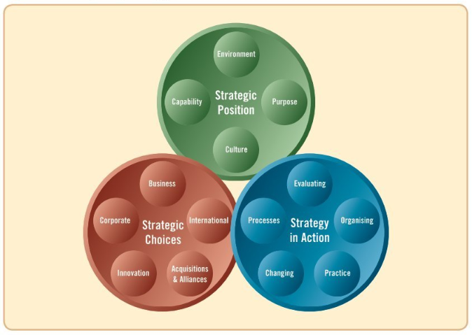
The Exploring Strategy Model (Johnson, et al., 2008)

Figure 2
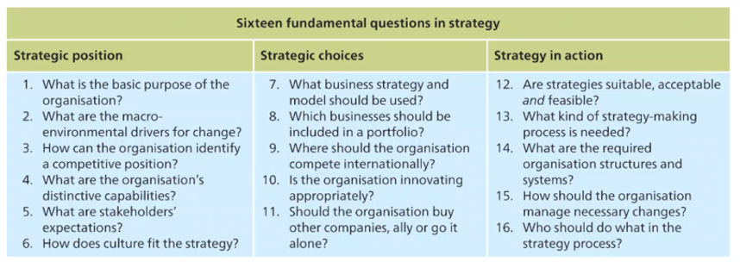

The Strategy Checklist (Johnson, et al., 2011)

Figure 3

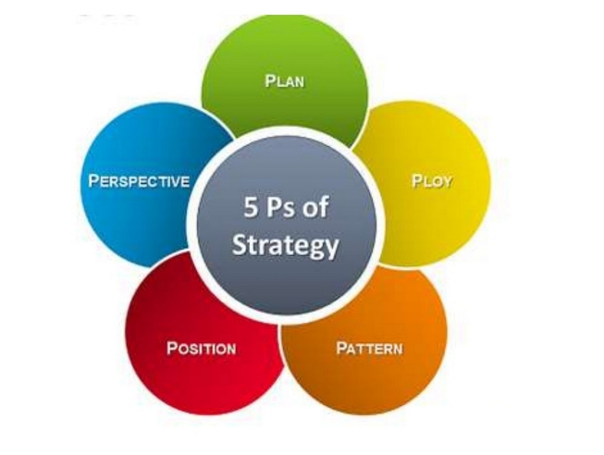
Mintzberg 5Ps of strategy (1987).

Figure 4
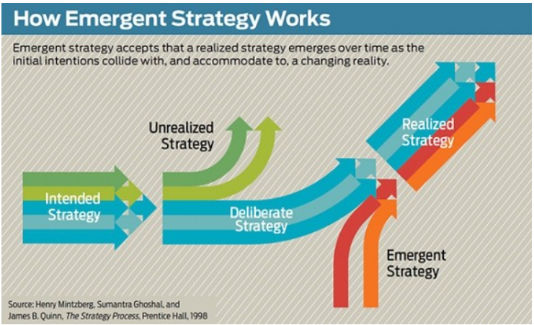

How Emergent Strategy works. (Mintzberg, et al., 1998)

Figure 5
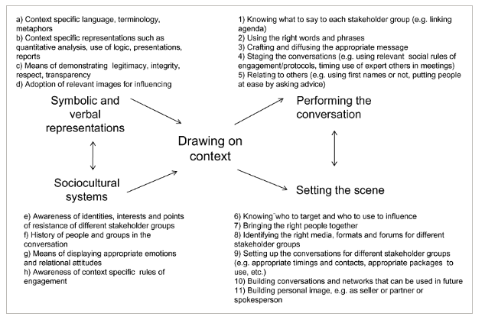
Strategic sensemaking and middle managers’ discursive competence. (Roleau & Balogun, 2010 )

Figure 6
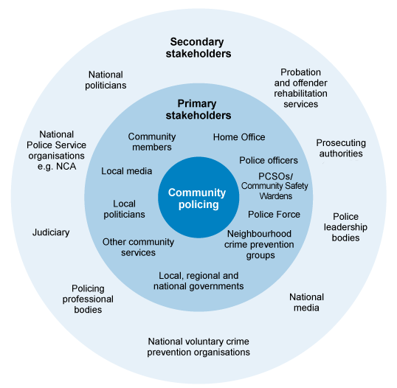

Stakeholders in Community Policing (The Open University, 2024)

Figure 7
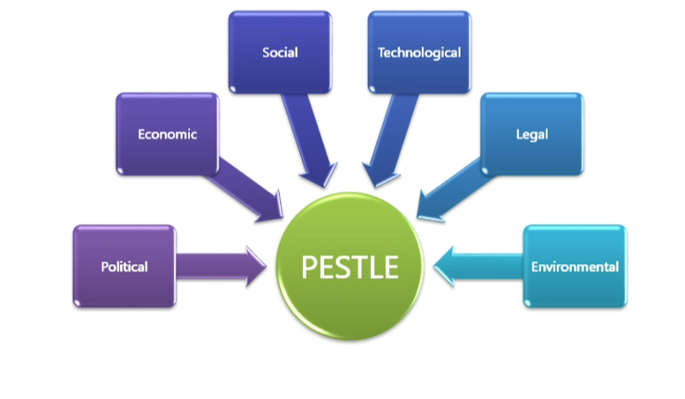
PESTLE analysis framework (Whittington & al., 2020)
Figure 8
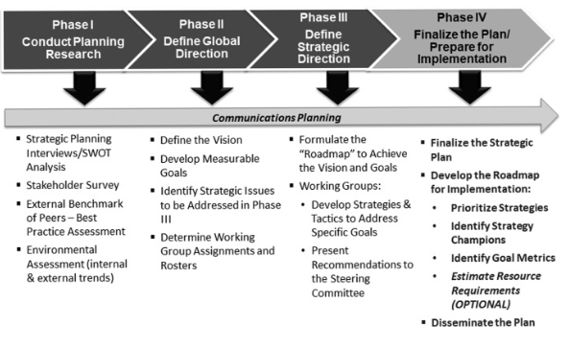
Strategic Planning Implementation (Uzarski, 2019)

References
Accenuture, 2024. Accenture. [Online]
Available at: https://www.accenture.com/gb-en/services/strategy-index
[Accessed 24/3/24 March 24/03/24].
Baghai, M., Coley, S. & White, D., 2000. The Alchemy of Growth . In: s.l.:Texere .
Balfas, P., Jackson, T. & Dawson, R., 2004. Deploying knowledge management and securing future sponsorship witin a highly hierarchical 'role-based' organisational culture. International Journal of Knowledge, Culture and Change Management , Volume 4, pp. 643-652.
Boulet, A., 2019. What is Strategy. [Online]
[Accessed 12 March 2024].
Bruno, L. & Lay, E., 2008. Personal Values and leadership effectiveness. Journal of Business Research, 61(6), pp. 678-683.
Carter, C., Clegg, S. & Kornberger, M., 2008. Strategy as Practice?. In: Strategic Organization. s.l.:s.n., pp. 83-99.
Chandler, A. D., 1962. Stratgy and structure. s.l.:Cambridge NIT.
Druker, P., 2000. Culture Eats Strategy for breakfast. s.l.: s.n.
Elliott, G., Day, M. & Lichenstein, S., 2020 . Strategic planning activity, middle manager divergent thinking, external stakeholder salience, and organisational performance; a study of English and Welsh police forces. Public Managemenr Review, Volume 22, pp. 1581-1602.
Finkelstein, S., D.C, H. & Cannella, A., 2009. Strategic Leadership; theory and research on executives, top management teams and boards. s.l.:Oxford Universtiy Press .
Hendry, J., 2000. Strategic Decision Making discourse, and strategy as social practice. Journal of Management Studies , Volume 37, pp. 955-978.
Idenburg, P., 1993. Four Styles of Strategy Development. In: Long Range Planning. s.l.:s.n., pp. 132-137.
James, M., 2018. Emergent Strategy. The international encyclopedia of strategic communication, pp. 1-10.
Johnson, G., Scholes, K. & Whitington, R., 2008. Exploring Corporate Strategy 8th edition. s.l.:s.n.
Johnson, G., Whittington, R. & Scholes, K., 2011. Fundamentals of Strategy. s.l.:Pearson Prentice Hall.
Johnson, G., Whittington, R., Scholes, K. & Duncan, A., 2014. Exploring Strategy; text and cases. Tenth ed. Harlow: Pearson.
Khalifa, A. S., 2023. Contesting Minztberg's five P's for Strategy; it is time for a product recall. Journal of Strategy and Management, 16(1), pp. 112-117.
Krohe, J., 1995. Do you really need a mission statement. Across the board, Volume 32, p. 16.
Kwantes, C. & Boglarsky, C., 2007. Perceptions of organisational culture, leadership effectiveness and personal effectiveness across six countires. Journal of International Management, 13(2), pp. 204-230.
Lowe, A. & Jones, A., 2004. Emergent Strategy and the meaasurement of performance;the formulation of performance indicators at the micro level. s.l.:s.n.
Lynch, R., 2018. Strategic Management. 8th ed. Harlow, United Kingdom: Pearson Education Limited.
MacIntosh, R. et al., 2010. Unpacking the effectivity paradox of strategy workshops: do strategy workshops produce strategic change? Cambridge Handbook of Strategy as Practice. Zurich: Cambridge University Press.
Marshall, E. S. & Broome, M. E., 2017 . Transformational Leadership in Nursing. Second ed. New York : Springer Publishing Company.
Martitz, R., Pretorius, M. & Plant, K., 2012. Exploring the interface between strategy-making and responsible leadership. Journal of Business Ethics, Volume 98, pp. 101-113.
Maxwell, J., 1993. Developing The Leader Within You. Nashville: s.n.
Mintzberg, H., 1987. The Strategy Concept I; Five P's for strategy. California management review, Issue 30, pp. 111-24.
Mintzberg, H., 2017. The Aesthetic Turn in management. In: s.l.:Routledge, pp. 477-486.
Mintzberg, H., Ghoshal, S. & Quinn, J. B., 1998. The Strategy Process. s.l.:Prentice Hall.
Neugebauer, F., Figge, F. & Hahn, T., 2016. Planned or emergent Strategy making. In: Business Strategy and the environment. s.l.:s.n., pp. 232-336.
Nickols, F., 2012. Deifnitions and meanings. Distance Consulting. s.l.:s.n.
Panda, D., 2022. Impact of organizationa culture on strategic planning. Management Decision, 60(5), pp. 1349-1368.
Porter, M., 1986. Competetive Strategy. s.l.:s.n.
Roleau, L. & Balogun, J., 2010 . Middle Maangers, Strategic Sensemaking and Discursive Competence: Middle Managers and Strategic Sense making. Journal of Management Studies, Volume 48, pp. 953-983.
Rukstad, D. J. C. M. G., 2008. Can You Say What Your Strategy Is?. Harvard Business Review, 86(4), pp. 82-90.
Sogunro, O., 1999. Leadership effectiveness and personality characteristics of group members. Journal of Leadership and Organisational studies, 5(3), pp. 26-40.
The College of Policing , 2024. College of Policing - Police Leadersip Programme. [Online]
Available at: https://www.college.police.uk/career-learning/learning/courses/police-leadership-programme-stage-5-executive-leaders
[Accessed 24 March 2024].
The College of Policing, 2024. College of Policing Code of Ethics and Principles. [Online]
Available at: https://www.college.police.uk/ethics/code-of-ethics/principles
[Accessed 18/3/2024 March 2024].
The College of Policing, 2024. College of Policing Strategic Planning. [Online]
Available at: https://www.college.police.uk/app/operations/operational-plannig/strategic-planning
[Accessed 11 April 2024].
The College of Policing, 2024. National Decision Model. [Online]
Available at: https://www.college.police.uk/app/national-decision-model
[Accessed 11 April 2024].
The Crime & Disorder Act 1998, 1998. Legislation.gov.uk. [Online]
Available at: https://www.legislation.gov.uk/ukpga/1998/37/part/I/chapter/I/crossheading/crime-and-disorder-strategies
[Accessed 5th March 2024].
The Open University, 2024. The Open University. [Online]
Available at: https://www.open.edu/openlearn/mod/oucontent/view.php?id=65965&section=3.2
[Accessed 11 April 2024].
Uzarski, D., 2019. A Leadership Framework for Implementation of an Organization's Strategic Plan. Journal of Professional Nursing, 35(1), pp. 12-17.
Whittington, R. & al., e., 2020. Exploring Strategy; Text and Cases. 12 ed. Harlow: Pearson.
Williams, W. & Lewis, D., 2008. Strategic management tools and public sector management. Public Management Review , Volume 10, pp. 653-671.

