Student Name: Yuqian Fu

P Number: 2108598

Programme of Study: BA on Graphic Design

Module: ADAD4018 Ways of Thinking

Tasks in the order I received them:

Task One: Semiotic Analysis = 526 word

Task Two: Manifesto = 535 word

Task Three: Practice-based writing = 528 word

Task One: Semiotic Analysis

Symbols have been used since the beginning of human civilization, are a very important part of human culture (Cassirer 1955). However，with the modernization of human civilization, skeptical readers constantly doubt the quality and authenticity of signs (Diepeveen 2019) leading to the belief that “truth has many faces.” (Abramson.2007.p105). In such an information age, how can we deconstruct the facts and mistruth behind the pictorial narration through the application of semiotics. The purpose of this assignment is to effectively combine semiotics and advertising, deconstruct a representative modern advertising campaign, and try to provide a new interpretation of the advert itself.

Studies have shown that human beings have the ability to recognize the meaning of signs and link them with emotion in early childhood when the language system is not perfect. (Myers & Liben 2012). For example, when we see blue, we will think of sadness. Everything within the scope of human cognition has its corresponding elements, Outside human cognition, signs without meaning will only be an empty shell (Perice.1933). Therefore, people need the ability to decode signs to interpret their cultural significance.

” Meanings are within people, and they can vary widely.” (Watzlawik,2013 p516.) In the process of growing up, people modify their cognition of symbols through continuous experience and finally reach a general consensus (1875. P161). Halliday believes that any visual communication medium should express people's cognition of the world and their attitude towards cognition (1978). In order to better explore the impact of symbols on human understanding, we need to combine Pierce's definition of symbols: 1. The meaning that is intended from a sign, 2. Where there is a relationship between the signifier and signified (Charles & Hoopes 1991). We will present the publicity poster of Street Association Children's privacy protection as the application object (see Fig 1).
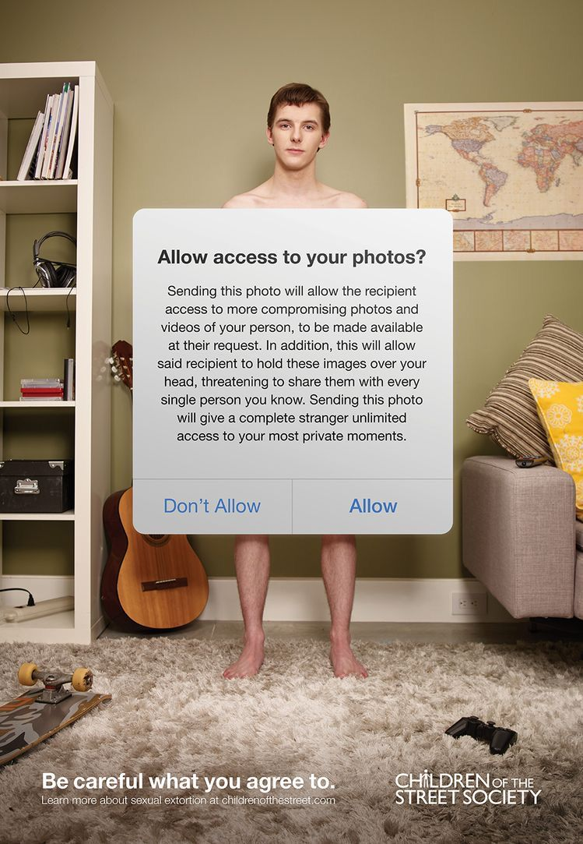
Fig. 1, Be careful what you agree to, Children Of The Street Society, 2017

The poster focuses on warning minors to protect their privacy on the Internet, in order to enhance the transmission of this information, Indexical signs indicating the theme of the information can be seen everywhere in the poster. The world map on the poster implies that information theft occurs all over the world. The sofa at home also implies that privacy theft is everywhere, and the scattered game consoles, guitars and skateboards around the boy are symbols based on the cognition of a boy's daily leisure life, which has also been widely recognized by society. This anchorage text strongly express a kind of information: The boys' daily interests and hobbies may be stolen as may their personal private information when recording these activities. Semiotics attracts readers by strengthening the receiver's emotional response to the media (Gannon-Cook, & Ley. 2021), the poster uses a naked person to stand behind the prompt box and uses connotation in the symbolic structure to remind people of themselves, so as to trigger thinking about themselves. This strengthens the receiver's emotion for the media and deepens people's impression of it. In addition, Saussure's structural model is still widely used, that is, language is a paradigm system that can convey and strengthen the meaning of the speaker (Gasparov, 2012). Therefore, when people read the logo sentence in the poster, it is not difficult to decode the encoding in the words (pay attention to the disclosure of personal information).

This form of analysis is widely used in semiotics. Through the application of analysis methods, the masses can better decode the signified behind the application of signs in life and identify the denotation and connotation of signs.

Bibliography
Abramson, J. L. (2007) Artful Deceptions: Verbal and Visual Trickery in French Culture. South Central Review. [Online] 24 (2), p105

Cassirer, E. et al. (1955) The philosophy of symbolic forms. Vol. 1, Yale University Press.

Diepeveen, L. (2019) Modernist fraud : hoax, parody, deception. New edition. Oxford: Oxford University Press.

Gannon-Cook, R. & Ley, K. (2021) Engaging learners with semiotics : lessons learned from reading the signs. Leiden, The Netherlands : Brill Sense.

Gasparov, B. (2012) Beyond Pure Reason : Ferdinand de Saussure’s Philosophy of Language and Its Early Romantic Antecedents. [Online]. New York, NY: Columbia University Press,.

Halliday, M. A. K. (1978) Language as Social Semiotic: the Social Interpretation of Language and Meaning, London, Edward Arnold.

Lewes, G. H. (1875) Problems of life and mind : being the first series, entitled The foundations of a creed, v 1 and 2. 3 ed. London: Trubner.

Myers, L. J. & Liben, L. S. (2012) Graphic Symbols as ‘The Mind on Paper’: Links Between Children’s Interpretive Theory of Mind and Symbol Understanding. Child development. [Online] vol 83 (1), p186–202.

Peirce ,C. (1934) Collect Papers of Charles Sanders Peirce. Vol.5 pragmatism and pragmaticism. Edited by Charles Hartshorne and Paul Weiss. Cambridge, MA: Belknap Press of Harvard University Press.

Peirce, C. S. (Charles S. & Hoopes, J. (1991) Peirce on Signs Writings on Semiotic by Charles Sanders Peirce. Chapel Hill: University of North Carolina Press. P141-142

Watzlawik, M. (2013) Do you believe in magic? Symbol realism and magical practices. Culture & psychology. [Online] 19 (4), pp.506–517.

List of Figures
Figure 1: Be careful what you agree to, Children Of The Street Society, 2017 Accessed: Children of the Street Society Print Advert By Cossette: Rec Room | Ads of the World™ (Accessed on 26th October, 2021)

Task Two: Manifesto
- Instead of going to church to listen to the prayers of the world, it's better to ask how many tears and personal attachments the walls of the hospital have witnessed.
- Materialism is the philosophical category of objective reality. This objective reality exists through human perception, does not depend on our feelings, and is copied, photographed and reflected work.
- Excessive freedom will break up order and lead to chaos. Excessive order will lose creativity and lead to stagnation
- Aesthetics should not focus on the absolute conditions of beauty, but on the balance conditions between opposites. From experience, we can note that the "aesthetic point" is not permanently fixed, but a dynamic state of balance in a complex network of "dialectical axioms".
- Practice is the only criterion for testing truth.
- To pursue a more lasting and democratic form of communication: from pure product promotion to exploring new social significance. Although consumerism is indisputably popular, we hope to criticize and question it, at least in part by using visual language and design resources.
- After all, human beings are our final customers, and all our designs are people-oriented.
- The aesthetics of simply emphasizing national style is narrow. We should promote the internationalization of expression. It should be a diversified art integrating practicality and functionality and aspects of German Expressionism, Russian Constructivism and Dutch style.

Keywords & Images
Objective reality
Chinese realistic meticulous painting
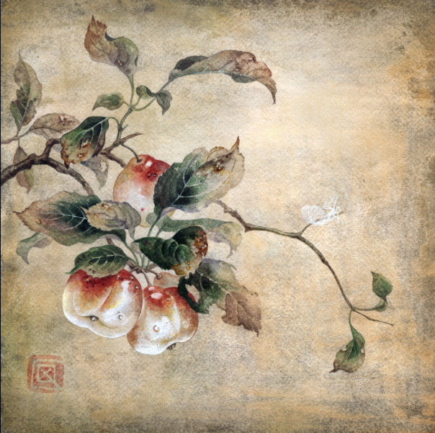
Fig. 1, In a moment before, 2010

2. Materialism is the philosophical category of objective reality. This objective reality exists through human perception, does not depend on our feelings, and is copied, photographed and reflected work.
In recent years, materiality, as a key term, has been developing continuously. In many disciplines such as anthropology, art, religion and cognitive science, the use meaning of materiality goes far beyond its original basic definition (Pongratz-Leisten, et al. 2015 p.3). Materiality shows that all human subjective and dynamic conscious feedback is based on objective facts (Yates, & Cohen, J. 2016). All human imagination activities are based on the cognition of objective things in the world. As a master of Chinese realistic painting, Qi Baishi declared in the interview that he would never paint anything unseen. He devoted his whole life to restoring the expression of what he saw and felt to the extreme. He interpreted nature with the true temperament he believed in (Hongliang 2017), and his materialist thought was perfectly implemented in Chinese realistic paintings (see Fig 1). Since the 1840s, after the proletarian struggle and the development of natural science, future generations have critically absorbed the core of Hegel's dialectics and Feuerbach's materialism, based on which they have established the theoretical system of historical materialism and realized the organic unity of materialism and dialectics. So far, nature and human society, the theory of the most general law of thinking development has laid the foundation - the basic attribute of matter is objective reality (Jameson. 2016).

Key words：Aesthetics balance
4. Aesthetics should not focus on the absolute conditions of beauty, but on the balance conditions between opposites. From experience, we can note that the "aesthetic point" is not permanently fixed, but a dynamic state of balance in a complex network of "dialectical axioms".
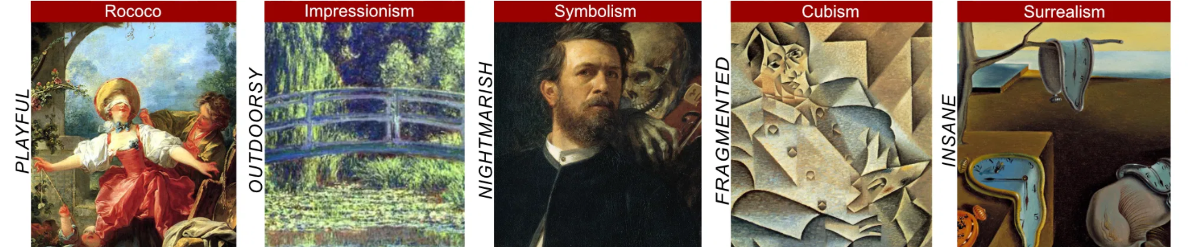
Fig. 2, Timeline of Art History – Art Movements and Styles,2021

The idea of beauty was first put forward by the so-called fathers of the church because they sought a synthesis between the biblical text and Greek philosophy. The more open interpretation of the evolved Greek and Roman culture emphasizes the direct and objective value of beauty, and holds that beauty firstly by the proportion and harmony between various parts (Giovannelli, 2021). But in fact, since prehistoric times, human's examination of beauty has been quietly developing (Maynard, 2018). From the earliest marks on cave walls to complex technical diagrams that make the modern world possible, from cartoons and the first efforts of preschool children, to the works of skilled draftsmen and the greatest artists, East and West. With the development and evolution of history, the human definition of beauty is constantly changing (see Fig. 2). What remains unchanged is the exploration of balance since prehistoric times. “The appearance is trendiness— but the essence is timeless” (Margolin, 2015). If the purpose of graphic design is to clearly convey meaning, aesthetics is to pursue visual balance and opposition in the process of communication.

Key words：Aesthetics of internationalization
- The aesthetics of simply emphasizing national style is narrow. We should promote the internationalization of expression. It should be a diversified art integrating practicality and functionality and aspects of German Expressionism, Russian Constructivism and Dutch style.
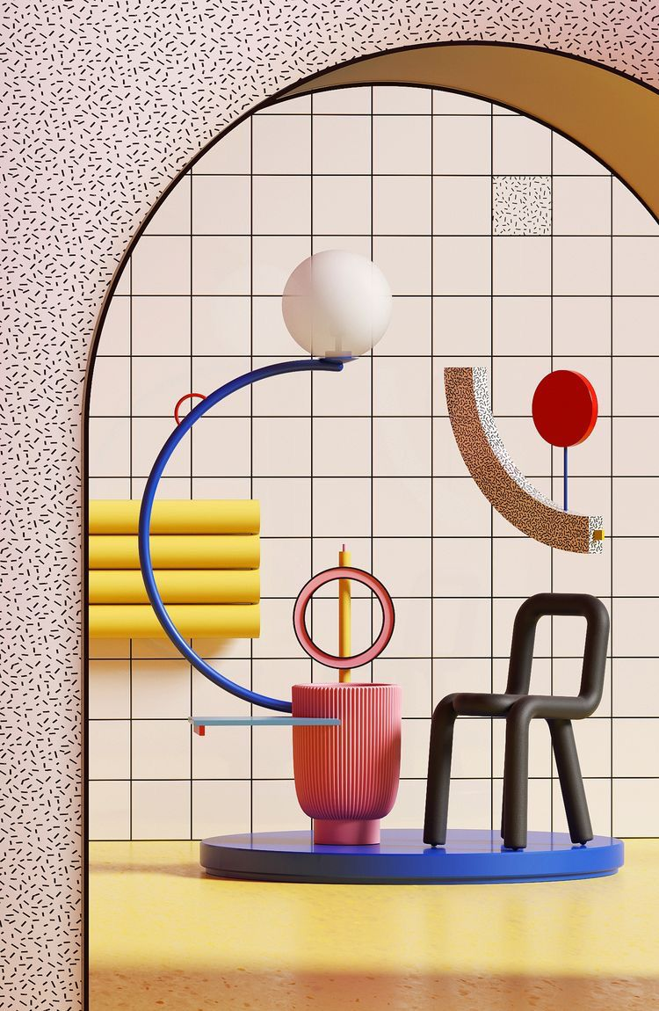
Fig. 3, ARCH ⍧,2018

As early as the early 20th century, before the Bauhaus era, many experimental art education methods appeared in Germany, including diversified art education, which aims to cultivate students' personal creative expression (Barnstone. 2016 p82). After that, Bauhaus developed the diversified artistic aesthetics to a vigorous stage. The most striking influence is that when people in today's era mention modernist style, they will inevitably combine it with functionalism (Jameson, 2016 p139), which shows its far-reaching impact on future generations. With the advancement of the globalization and transnational era, people no longer have a single and limited understanding of art, but pay more attention to the unity of diversity, and oppose the limited understanding of creativity as pure innovation (Svasek, & Meyer, 2016). In response, Nastia, as a pioneer designer of the times, creates works not limited to a single production software, style and creativity, but combines a variety of artistic ideas to create a unique and distinctive artistic style (see Fig 3).

Bibliography

Barnstone, D. A. (2016) Beyond the Bauhaus : cultural modernity in Breslau, 1918-33. Ann Arbor: University of Michigan Press. P81-108

Giovannelli, A. (2021) Aesthetics : the key thinkers. Second edition. London: Bloomsbury Academic. P33-44

Hongliang, W (2017) ‘The True Charm of Nature. SOME NOTES ON QI BAISHI AND HIS ART ’ Chinese painting, Available at: https://www.tretyakovgallerymagazine.com/articles/3-2017-56/true-charm-nature-some-notes-qi-baishi-and-his-art (Accessed on 17th November, 2021)

Jameson, F. (2016) Marxism and Form : 20th-Century Dialectical Theories of Literature. First Princeton paperback edition. [Online]. Princeton, NJ: Princeton University Press,. P137-179

Klevgaard, T. (2020) The New Typography in Scandinavia : modernist design and print culture. London: Bloomsbury Visual Arts.

Maynard, P. (2018) Drawing Distinctions : The Varieties of Graphic Expression. [Online]. Ithaca, NY: Cornell University Press,.

Margolin, V. (2015) PabloDesign is One: Lella and Massimo Vignelli. Design issues. [Online] 31 (2),p 101–103.

Pongratz-Leisten, B. et al. (2015) The materiality of divine agency. [Online]. Boston, [Massachusetts] ;: De Gruyter. P3-6

Svasek, M. & Meyer, B. (2016) Creativity in transition : politics and aesthetics of cultural production across the globe. New York, [New York] ;: Berghahn Books.

Yates, J. & Cohen, J. J. (2016) Object oriented environs. [Online]. Brooklyn, NY: punctum books.

List of Figures
Figure 1: In a moment before, Sidemaze, 2010 Accessed: In a moment before by Sidemaze on DeviantArt (Accessed on 17th November, 2021)
Figure 2: Timeline of Art History – Art Movements and Styles, Identifythisart, 2021 Accessed: Timeline of Art History - Art Movements and Styles (identifythisart.com) (Accessed on 17th November, 2021)
Figure 3: ARCH ⍧, Ibragimova N,2018 Accessed: ARCH ⍧ on Behance (Accessed on 17th November, 2021)

Task Three Practice-based Writing (will depend on research strand)
Reflection on the practice of integrating the concept of wabi-sabi into the design of aging housing

In last year's interior design study, I need to transform the house with a specific theme. I lock the user group in the elderly, because the aging population is becoming one of the main problems of the current era（Kendig 2016）. The reform of aging nursing is rising and setting off an upsurge in the world. When it comes to the rapid aging of the population, I think of the Japanese wabi sabi aesthetic which has become popular again recently (Mastroeni,T 2020). Therefore, I chose the aging residence as the theme, and integrated the wabi sabi aesthetics into the design.

Wabi sabi is an ancient aesthetic philosophy rooted in Zen Buddhism，is the beauty of imperfect, impermanent and incomplete things (Koren, L 2020). This is just in line with the old man's spiritual outlook. The faded and yellow handkerchiefs and old and rusty watchbands are shining in their eyes because they are endowed with unique meaning by time. In the aesthetics of wabi sabi, less is more（Abercrombie. S 2001）. Therefore, I try to reduce too many and cumbersome decorations in the indoor soft decoration design, and choose more simple geometric shapes in the selection of furniture. The threshold stone of each room is removed to facilitate the elderly to walk around the house. This can better meet the activity needs of the elderly. With the growth of age, physical function declines. For the elderly, housing should pursue refined and concise design (Peace, S. 2001).

The whole house also adopts warm gray color, which is full of the warm atmosphere of the family. The yellow wall retains a strong cement texture is more warm than the new bright white varnish wall (Havenhand, L. 2019). The overall soft decoration also adopts old things with years of precipitation. The furnishings in the space have no boundaries of style. The terracotta figures of the Tang Dynasty, medieval tapestries, exquisite ceramics, dried flowers and notched bowls all achieve harmony and unity here. The cultures of different times and regions blend here, just like the core pursued by wabi sabi, reflecting the static passage of time (Juniper, A. 2003). However, while pursuing the integration of wabi sabi style and aging, it also encountered a certain bottleneck: the choice of indoor light source intensity. Because I overemphasize the overall pessimistic view of wabi sabi on things and stubbornly believe that the lighting atmosphere should be weak, but obviously it is very unfriendly to the living needs of the elderly (Adrian, G. 2020). Because of my rigid pursuit of wabi sabi, my scheme did not satisfied the user group well in the first draft.

After combining many cases of integrating silence into the design concept in the past, I soon realized that pursuing of Zen thought of wabi sabi should not be single and rigid, and some changes should be made in combination with the actual situation (Stupples, P. 2017). Finally, I hid the lamp belt as the main light source, and dotted it with point light sources where light and shadow need to be strengthened, such as Zuyuan lamp, etc. After this experience, I understand that a single theory can not solve problems well sometimes. In the future design planning, I will tend to pursue the flexible balance between concept and practical application.

Bibliography
Adrian, G. et al. (2020) Proceedings Of International Conference Building Services And Energy Efficiency : Modernizing and increasing performance of Building Services. [Online]. Warsaw ;: Sciendo,.

Abercrombie. S (2001) Wabi Sabi: A New Look at Japanese Design / Wabi Sabi Style. Interior Design 72 (8) p.125–.

Havenhand, L. K. (2019) Mid-century modern interiors : the ideas that shaped interior design in America. First edition. [Online]. London ;: Bloomsbury Visual Arts.

Juniper, A. (2003) Wabi sabi the Japanese art of impermanence. 1st ed. Tokyo ;: Tuttle Pub.

Kendig, H. et al. (2016) Population ageing and Australia’s future. Acton, Australian Capital Territory: Australian National University Press.

Koren, L. (2020) Wabi-Sabi for Artists, Designers, Poets & Philosophers. New York: Upfront books

Mastroein, T. (2020) What Is Wabi-Sabi Design? Your New Favorite 2018 Interior Design Trend Available at: https://www.mymove.com/home-inspiration/decoration-design-ideas/wabi-sabi-design-new-favorite-interior-design-trend/ (Accessed in：3 December 2021)

Peace, S. & Holland, C. (2001) Inclusive Housing in an Ageing Society Innovative Approaches. Bristol: Policy Press.

Stupples, P. & Venis, J. (2017) Art and design : history, theory, practice. Newcastle upon Tyne, England: Cambridge Scholars Publishing.

