Porters Five Forces Class Exercise (Turnip Farming) - Answer
Figure 2 – Porter's Five Forces Example: Buying a Turnip Farm
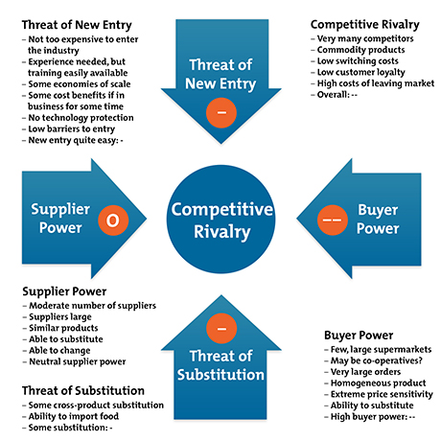

This worries him:
- The threat of new entry is quite high: if anyone looks as if they're making a sustained profit, new competitors can come into the industry easily, reducing profits.
- Competitive rivalry is extremely high: if someone raises prices, they'll be quickly undercut. Intense competition puts strong downward pressure on prices.
- Buyer Power is strong, again implying strong downward pressure on prices.
- There is some threat of substitution.
Unless he is able to find some way of changing this situation, this looks like a very tough industry to survive in. Maybe he'll need to specialize in a sector of the market that's protected from some of these forces, or find a related business that's in a stronger position.

