A Miracle Drug: The Role and Legacy of Penicillin in the Second World War.
The Second World War (1939-1945) was a pivotal global event of the twentieth century and marked the most catastrophic conflict in human history (Hall, 2019). The description of penicillin as a ‘miracle’ drug was first used in 1944 by the media as evidence of its effectiveness grew (Shama, 2017). One of the most widely used antibiotics for bacterial infections (Yip, 2024), it was first discovered by Professor Alexander Fleming in 1928 (Tan and Tatsumura, 2015), proving effective against various infections, including combat injuries and venereal diseases. It was the first agent capable of eliminating bacteria in the body safely and effectively (Kardos and Demain, 2011; Fazal, 2024, p. 69). The impact of discovering and developing penicillin and its effect on the Second World War was reflected in 1945 when Fleming, Howard Florey and Ernst Chain were awarded the Nobel Prize for Medicine (IWM, 2024; MacDonnell and Hatfield, 2016).
This essay will outline penicillin's significant advantages to the Allied forces in treating infections and critique whether it can be considered a 'miracle drug'. Government-funded research and collaboration enabled large-scale manufacturing and supply to the military, saving lives and allowing personnel to return to duty faster, which was vital to the Allies' victory. This advantage over the Axis forces, reliant on sulfa drugs, was evident on D-Day when mass production provided ample penicillin for the wounded. Its use greatly improved medical care and recovery, enhancing military morale. While penicillin marked the start of the antibiotic era, its overuse has raised global concerns about antimicrobial resistance since the war. Additionally, advancements in military medicine during this time, often overlooked, played a crucial role in personnel care. The essay will also consider potential parallels between the urgent need for penicillin during the Second World War and the recent COVID-19 pandemic.
War and disease have historically caused immense suffering, with infectious diseases thriving in wartime chaos, affecting both soldiers and civilians. During the Napoleonic Wars, the British army lost eight times more soldiers to illness than combat injuries. In the American Civil War, around two-thirds of the approximate 660,000 military fatalities were due to diseases like pneumonia and typhoid, which prolonged the conflict by two years (Connolly and Heymann, 2002). During the First World War, bacterial infections from contaminated shrapnel and shells caused significant loss of life among soldiers, many of whom could have survived with antibiotics (Runcie, 2015). By 1915, medical standards had improved, with field dressings being a standard issue and every battalion having a medical officer and field hospitals nearby. While vaccines for typhoid were common, gas gangrene and cholera still posed severe threats, with no effective remedies available once infections progressed (Rowe, 2020). During the Gallipoli Campaign, for every ten Anzac soldiers killed, five died from infections, highlighting the limited medical advancements despite progress in surgery (Ferreiro, 2022, pp. 277-278; Rowe, 2020). Before the 20th century, infectious diseases caused high morbidity and mortality worldwide, with the average life expectancy in industrialised nations only 47 years (Adedeji, 2016). Infectious diseases ranked as the primary cause of mortality, with few effective treatments. Minor cuts could be fatal due to bacterial infections, and physicians mainly used antiseptics for prevention (Rowe, 2020). In the 1930s, synthetic sulfa drugs were developed in Germany. However, bacteria quickly became resistant to these drugs, rendering them ineffective for treating conditions such as syphilis (Kardos and Demain, 2011). By early 1944, with the availability of penicillin, sulfa drugs were widely considered obsolete (Fazal, 2024, p. 69; Conniff, 2013; NLM, 2012).
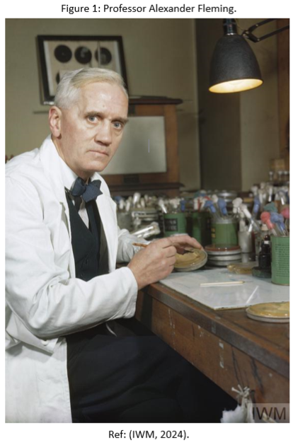
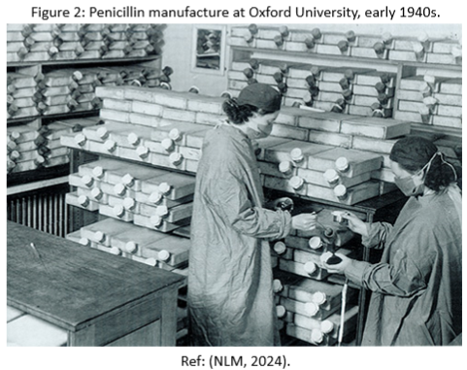
Penicillin marked the start of the antibiotic era, effectively treating infections like pneumonia and gonorrhoea that had previously left doctors powerless. Discovered in 1928 by Alexander Fleming (See Figure 1), a Bacteriology professor in London, it emerged when he noted that the mould Penicillium notatum inhibited Staphylococcus bacteria growth. Fleming published his discoveries in 1929, emphasising penicillin's ability to differentiate between sensitive and resistant bacteria, igniting further research interest (American Chemical Society, 1999). Fleming struggled for ten years to isolate penicillin from an unstable compound, sending samples of his Penicillium mould to others in hopes of success. By the early 1930s, interest faded, and he concluded that developing a usable medication was impractical, shifting his focus to other issues (Gaynes, 2017; Rowe, 2020). In 1939, Ernst Chain discovered Alexander Fleming’s 1929 article and collaborated with Howard Florey to isolate penicillin. Florey and Norman Heatley cultivated Penicillium and purified penicillin, testing it on mice with positive results. To meet demand, they designed a fermentation vessel for weekly production and hired 'penicillin girls' to convert the Oxford laboratory into a production facility, but their output was still insufficient (See Figure 2) (American Chemical Society, 1999). In February 1941, they treated a police officer experiencing a severe infection, but although initially successful, limited supply hindered complete treatment, and he later passed away.
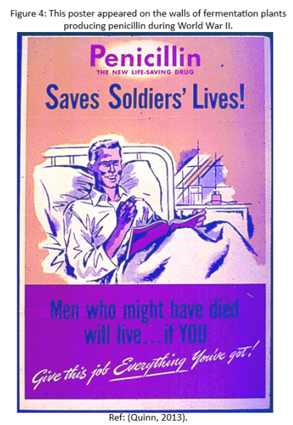
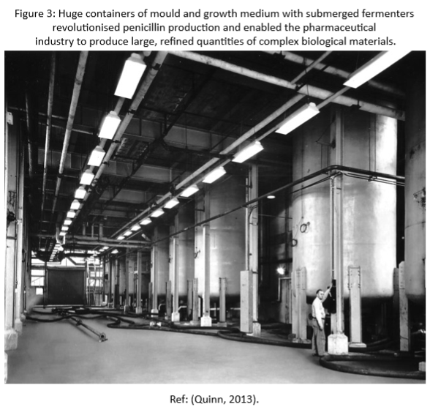
Despite some successful cases, British pharmaceutical companies could not mass-produce penicillin due to the Second World War, leading Florey to seek help from the United States (U.S.) (Gaynes, 2017). Florey recognised the need for significant penicillin supplies for clinical trials but knew Britain’s wartime priorities hindered large-scale production. Despite initial interest, U.S. pharmaceutical companies did not investigate Fleming's mould further until the summer of 1941, when American officials recognised its potential (Quinn, 2013). In 1941, Florey and Norman Heatley went to the U.S. with support from the Rockefeller Foundation. Yale physiologist John Fulton introduced them to mycologist Robert Thom at the Northern Regional Research Laboratory in Illinois, pivotal for large-scale penicillin production (American Chemical Society, 1999). Florey collaborated with American officials to create a network that provided the military with high-quality penicillin. In five years, production shifted from a labour-intensive method to large-scale fermentation in 10,000-gallon tanks, leading to the widespread availability of this medical breakthrough (See Figures 3 and 4). U.S. military leaders emphasised penicillin's significance, leading to resource mobilisation and scientific collaboration coordinated by the Office of Scientific Research and Development until 1943. The War Production Board (WPB), established in 1942, managed penicillin production for the war effort, partnering with 21 companies, five academic institutions, and various government entities to ramp up large-scale production (Quinn, 2013).
In 1943, following a report on penicillin's effectiveness for war wounds, the British Army Medical Services aimed to provide this treatment to soldiers. With the British Army focused on North Africa and Italy, a Penicillin Control Unit was established to distribute the drug, educate medical staff, and conduct studies. Penicillin significantly improved wound recovery and reduced mortality rates, especially for severe injuries and gas gangrene (Jeffrey and Thomson, 1944; Conniff, 2013; Cassell, 2020). Penicillin significantly impacted the Italian campaign, improving the loss exchange ratio for Allied forces against German defenders. Its availability allowed soldiers to recover and return to combat, considerably contributing to the Allies' success in Italy (Fazal, 2024, p. 60). By 1944, further clinical trials confirmed penicillin’s effectiveness in military medicine, increasing demand (American Chemical Society, 1999). Penicillin's development marked a significant success in Anglo-American science, while Germany struggled with research due to inadequate urgency and coordination. Allied intelligence noted the lower effectiveness of German research and its reliance on sulphonamides, which hampered the mass production of penicillin despite some awareness of its limitations (Gilbert & Reinarz, 2002). This setback is notable given that the British Broadcasting Corporation broadcasted discussions on penicillin's possibilities and effectiveness throughout Europe (Conniff, 2013).
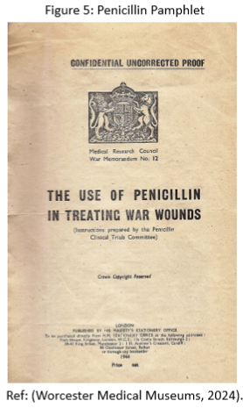
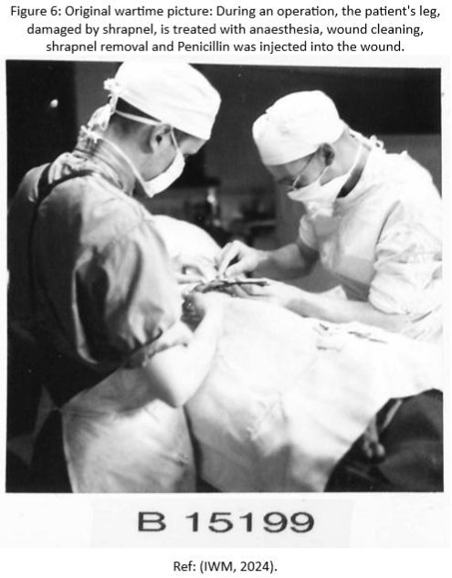
From May to June 1944, penicillin production surged (Quinn, 2013), with the key objective being to ensure enough penicillin was available for the planned invasion of Europe by Allied Forces (American Chemical Society, 1999). The Allied Forces launched the largest amphibious assault in military history on the 6th of June 1944, known as D-Day or Operation Overlord (Cowling, 2012), which represented the outcome of planning that had started in September 1940 (Ferreiro, 2022, p. 230). American penicillin sent to Britain was shared among all the Allied forces before the D-Day invasions. As the soldiers landed on the beaches and parachuted behind enemy lines, field hospitals, hospital ships, and hospitals in Britain were supplied with enough penicillin to care for all the injured (Ferreiro, 2022, p. 285). The Normandy invasion involved 8,000 doctors and 600,000 doses of penicillin. British Royal Army Medical Corps (RAC) medics were issued pamphlets on administering penicillin for treating wounds (See Figure 5) covering burns, soft tissue injuries, gas gangrene, and fractures. While local treatment was sufficient for burns and superficial wounds, severe cases required injections. A pathology penicillin officer managed the limited supply, and a surgical officer oversaw its use in operational theatres (Mohr and Seville, 2023). In the first two hours, 156,000 Allied soldiers landed, paving the way for an army of over two million. Planners expected high casualties, but invading mainland Europe was essential to defeat the German Army (Cowling, 2012). By the fifth day, 326,547 Allied soldiers had landed at Normandy. Casualty figures remain unofficial due to the chaos and rapid movement of units and injured personnel (Phipps, 2012). About 406,000 admissions occurred in the 21st Army Group Medical units between D-Day and the war's end, including 182,000 battle casualties. Of these, 100,000 patients received penicillin, mainly wounded soldiers (See Figure 6) (Fleming, 1946, p. 162). As Allied forces advanced through Europe, penicillin saved 95% of treated soldiers and reduced the mortality rate of gas gangrene from 15% to nearly zero (Ferreiro, 2022, p. 285; Atkinson, 2016; Phipps, 2012). The RAMC reported on their activities from D-Day to the war's end in ‘Penicillin therapy and control in 21 Army Group,’ documenting 50,201 cases with 2,564 fatalities, achieving a 94.9% recovery rate (Mohr and Seville, 2023). Between D-Day and May 8, 1945, approximately 175,000 American soldiers in the European Theatre were treated for infectious diseases, leading to 314 deaths (0.02%). In comparison, 393,987 soldiers received treatment for battle injuries, resulting in 12,523 fatalities (3.2%). These figures were historically low, mainly due to the extensive use of antibiotics, which treated and prevented infections in combat injuries (Groeneveld, 2022). The significance of penicillin to the Allies' efforts can be inferred from this quote by an unknown author, ‘The results achieved led to a saving of manpower and reduction in wound-complications and recovery in hospitals, in supplies of drugs and equipment, in surgeons and nurse time which it is impossible either to compute or to appreciate’ (Fleming, 1946, p. 163). Throughout most of the Second World War, both Allied and Axis forces used sulphanilamide powder on wounds, but it often proved ineffective, leaving doctors struggling with severe injuries (MacDonnell and Hatfield, 2016). The introduction of penicillin was a game-changer for military surgeons. It allowed them to inspect wounds more carefully on the operating table rather than rushing through inspections. This led to better cleaning, medication application, and stitching, resulting in faster recovery and improved patient outcomes. Gangrene affected 1.5 cases per thousand among Allied forces, with a lower mortality rate compared to the war's early years. In contrast, German prisoners, primarily receiving sulfa drugs due to penicillin shortages, had a gangrene rate of 20 to 30 cases per thousand (Conniff, 2013).
Interestingly, there are indications that a physician gave penicillin to Hitler after an assassination attempt on July 20, 1944. Without intervention, Hitler might have died, possibly prompting Germany to negotiate for peace (Wainwright, 2004). Sulphonamides saved Churchill's life during pneumonia in Cairo in 1943, raising intriguing questions about the war's course had he not survived (Alharbi et al., 2014).
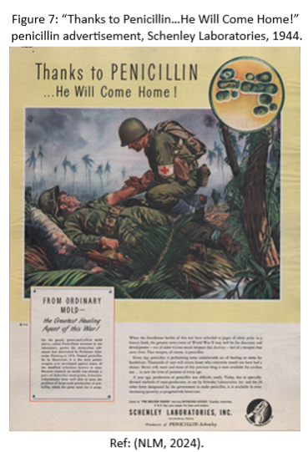
Penicillin not only treated infections in the injured but also allowed soldiers with syphilis and gonorrhoea to recover much faster than previously (Fazal, 2024, p. 60). During wartime, sexually transmitted diseases (STDs) were prevalent, leading to debates on whether to prioritise treatment for injured soldiers or those with infections. Preference was given to treating infected soldiers, which was considered practical for quicker recovery and military effectiveness. German soldiers had similar STD rates but lacked effective treatment. Historian Gilbert Shama suggests this health disparity may have given the Allies a significant advantage in later battles (Conniff, 2013; Cassell, 2020). In the North African campaign, this meant Allied soldiers with syphilis received penicillin before those with combat injuries (Walker, 2020). Penicillin was crucial in preventing thousands of soldiers from dying from infections like gangrene and sepsis, but its greatest impact was in treating gonorrhoea and syphilis, improving recovery times and maintaining military strength (Fazal, 2024, p. 60; George, 2019).
The development of penicillin during the war served as critical Allied propaganda, showcasing medical advancements and a commitment to saving lives. It boosted front-line morale by improving survival rates and assuring soldiers they would receive care if injured (See Figure 7).
Other advancements in medical treatment and care also played a crucial part. Dr Angus Campbell Derby's memoir ‘Not Least in the Crusade: the Memoirs of a Military Surgeon’ highlights penicillin's significant role in reducing hospital mortality rates during the Second World War. However, he notes that Professor Trueta's surgical techniques from the Spanish Civil War significantly improved wartime care by emphasising quick wound debridement to prevent infection and reduce bacterial growth. While penicillin played a role, Trueta's methods notably enhanced survival rates for injured soldiers (Angus, 2006). Additionally, George Archibald Grant Mitchell, in 1941, co-authored a study on infection rates among 700 wounded soldiers, highlighting that antibiotics could not replace meticulous surgical practices (Mohr and Seville, 2023). Other advancements include plasma, the primary treatment for blood loss, but by 1945, serum albumin had become more effective. Streptomycin was also widely used to fight bacterial infections. Military personnel with combat fatigue, now known as Post-Traumatic Stress Disorder, had secure recovery places, resulting in a 90% return to duty. Malaria concerns in the Pacific led to the use of atabrine, and vaccinations were administered based on deployment locations (Vergun, 2020). The application of metal plates for the treatment of fractures originated from the military medical services in Germany and was disclosed to the Allies by captured soldiers needing X-rays. Medical staff were surprised that German troops healed and returned to duty in half the usual time (Tobey, 2018).
Fleming's initial discovery of penicillin caused challenges in becoming a drug, partly due to his lack of prioritisation and limited enthusiasm at scientific meetings. It took the creativity and expertise of Oxford scientists to produce enough penicillin for patient treatment (George, 2019). Penicillin was not the result of a single brilliant mind or an isolated national effort, nor was it the first antimicrobial drug introduced. Its story is part of a larger 20th-century movement focused on developing therapies that target bacteria while protecting human and animal cells. Penicillin was not the first widely used antibiotic; that distinction belongs to Prontosil, discovered by Gerhard Domagk, who won the Nobel Prize in Medicine in 1939. During the Second World War, sulfa drugs like Prontosil were more commonly used for both civilians and soldiers than penicillin (Kirchhelle, 2016).
This significant wartime effort is a prime example of successful government-funded research, demonstrating an effective transition from research to large-scale manufacturing (Neushul, 1993). After the war, civilians benefited from penicillin, as governments and pharmaceutical companies collaborated to ensure its availability (Lotysz, 2014). By March 15, 1945, it became available in U.S. pharmacies. The price per 100,000 units was twenty dollars in 1943, but by 1949, it had fallen to under ten cents. It finally became available by prescription in the United Kingdom on 1st June 1946 (American Chemical Society, 1999).
This important antibiotic might have gone undiscovered without Fleming's discovery of penicillin, potentially delaying other antibiotics and advancements in modern surgeries. It was not purified for medical use until the early 1940s, with no evidence suggesting anyone else was close to this discovery (Alharbi et al., 2014; Kardos and Demain, 2011). After the war, there was misplaced confidence in miracle drugs to combat bacterial resistance despite early warnings since the 1930s. By the late 1950s, these drugs were widely used, while efforts to promote rational use and hygiene were met with complacency (Kirchhelle, 2016). By the late 1960s, penicillin was ineffective against about 80 percent of staphylococcus aureus infections (Angus, 2019). While penicillin revolutionised military injury care, some bacteria remain resistant. Increased antibiotic use can diminish their effectiveness, as bacteria reproduce rapidly and pass on their resistant traits (Hay, 2018). The rise of antibiotic-resistant superbugs poses a severe threat, worsened by pharmaceutical companies' reluctance to invest in new antibiotics. The World Health Organization warns we are nearing a post-antibiotic era, emphasising the need for alternative treatments (Grose, 2017). Antimicrobial resistance (AMR) caused 1.27 million deaths in 2019, surpassing HIV and malaria, and could lead to 10 million deaths annually by 2050 if not addressed. While complete eradication is unlikely, urgent action from the global community is essential (Kumar et al., 2023). The importance of collaboration in developing new antibiotics becomes clear as existing treatments lose effectiveness, leading to untreatable infections (Gaynes, 2017).
The Second World War’s penicillin production and the COVID-19 pandemic highlight unique pressures and opportunities for innovation. Despite potential conflicts over ownership, both crises inspire actions for the greater good. Lessons from penicillin are reflected in the COVID-19 response, particularly in collaborative research, accelerated manufacturing, and rapid distribution of vaccines and treatments (Gross and Sampat, 2021). The alliance on penicillin highlights a time when science operated within a unique ethical framework emphasising civic responsibility. Rather than concentrating on economic goals, a diverse group of scientists from various sectors prioritised scientific objectives to address wartime needs swiftly. Consequently, penicillin transitioned from a scientific curiosity to a widely manufactured medication in just a matter of years (Quinn, 2013).
This essay has established that the introduction of penicillin significantly contributed to saving countless lives during the Second World War. By effectively addressing wound infections and sexually transmitted infections among military personnel, penicillin provided the Allied forces with a crucial strategic advantage over the enemy. The significance of the collaboration in the research and mass production of penicillin during this time demonstrates what can be achieved when science, government, and business unite against a common enemy and can be compared to the global reaction to COVID-19. Penicillin’s ability to kill bacteria set a new medical standard and introduced a new era of antibiotic development. The discovery paved the way for additional antibiotics, drastically transforming the treatment of infectious diseases and reshaping contemporary medicine. Penicillin's effectiveness improved surgical practices, as infections that followed surgery could now be managed, decreasing deaths from previously fatal infections. However, it is essential to note that while penicillin is highly effective against many bacterial infections, it does not treat all infections. This limitation emphasises the need for a broader range of antibiotics and challenges the notion that penicillin alone is a universal cure. Over time, the overuse and misuse of penicillin and other antibiotics have led to antibiotic resistance, where certain bacterial strains no longer respond to the drug. This has led to the rise of antibiotic-resistant superbugs and reduced the overall efficacy of antibiotics, making the ongoing development of new treatments essential. Penicillin primarily targets bacterial infections but cannot address other significant health issues. Therefore, while it made a transformative impact, its effects were not all-encompassing. Penicillin was undoubtedly a groundbreaking medication in its time, significantly enhancing the treatment of bacterial infections and saving millions of lives. The question addressed in this essay is whether penicillin can be considered a ‘miracle drug.’ While it has made significant contributions to medicine, its limitations in effectiveness, the rise of antibiotic resistance, and the necessity for alternative medications indicate that we should evaluate its status as a miracle drug by considering its successes and shortcomings. Overall, the discovery of penicillin remains one of the most significant milestones in the history of medicine, with far-reaching effects that continue to influence healthcare today.

REFERENCES
Adedeji, W. (2016) ‘The treasure called Antibiotics’, Annals of Ibadan Postgraduate Medicine, 14(2), pp. 56-57. Available at: https://pmc.ncbi.nlm.nih.gov/articles/PMC5354621/ (Accessed: 6 November 2024).
Alharbi, S. et al. (2014) 'What if Fleming had not discovered penicillin?', Saudi Journal of Biological Sciences, 21(4), pp. 289–293. Available at: https://doi.org/10.1016/j.sjbs.2013.12.007
American Chemical Society (1999) The discovery and development of penicillin 1928-1945. Available at: https://www.acs.org/education/whatischemistry/landmarks/flemingpenicillin.html#:~:text=The%20WPB%20controlled%20the%20disposition,Kingdom%20and%20the%20United%20States (Accessed: 5 November 2024).
Angus, C.D. (2006) 'War: a crucible for advances in surgery', Canadian Medical Association Journal, 175(11), pp. 1411-1413. Available at: https://www.proquest.com/docview/204819677?pq-origsite=primo_ra&accountid=130472&sourcetype=Scholarly%20Journals (Accessed: 3 November 2024).
Angus, I. (2019) ‘Superbugs in the Anthropocene: A Profit-Driven Plague’, Monthly Review, 71(2), pp. 1–28. Available at: https://research-ebsco-com.ezproxy.uwtsd.ac.uk/c/onvpsy/viewer/pdf/ujpgrts26z?route=details (Accessed: 5 November 2024).
Atkinson, R. (2016) Projecting American Power in the Second World War. Available at: https://www.marshallfoundation.org/wp-content/uploads/2016/01/Atkinson-2016.pdf (Accessed: 5 November 2024).
Cassell, K. (2020) 'Plants Go to War: A Botanical History of World War II: An Interview with Judith Sumner, PhD', The Yale Journal of Biology & Medicine, 93(2), pp. 375–379. Available at: https://www.proquest.com/docview/2724694041?accountid=130472&sourcetype=Scholarly%20Journals (Accessed: 3 November 2024).
Conniff, R. (2013) 'Penicillin Wonder Drug of WW2', Military History, 30(2) pp. 38-43. Available at: https://www.proquest.com/docview/1355014088?accountid=130472&parentSessionId=luDVXlT3tDhcveydhGYIVLizbDkP4lAIPE3qafCfgeY%3D&pq-origsite=primo&sourcetype=Magazines (Accessed: 3 November 2024).
Connolly, M.A. and Heymann, D.L. (2002) ‘Deadly comrades: war and infectious diseases’, The Lancet (British edition), 360, pp. s23–s24. Available at: https://doi.org/10.1016/S0140-6736(02)11807-1
Cowling, N. (2012) ‘Operation Overload – A synopsis of the D-Day Landings’, Scientia Militaria : South African Journal of Military Studies, 24(2). Available at: https://www.ajol.info/index.php/smsajms/issue/archive/3 (Accessed: 4 November 2024).
Fazal, T.M. (2024) Military Medicine and the Hidden Costs of War. United States: Oxford University Press, Incorporated.
Ferreiro, L. D. (2022) Churchill’s American Arsenal. United States: Oxford University Press.
Fleming, A. (1946) Penicillin: It’s practical application. 1st edn. London: Butterworth. Available at: https://archive.org/details/penicillin0000unse/page/162/mode/2up (Accessed: 6 November 2024).
Gaynes, R. (2017) ‘The Discovery of Penicillin—New Insights After More Than 75 Years of Clinical Use’, Emerging Infectious Diseases, 23(5), pp. 849-853. Available at: https://doi.org/10.3201/eid2305.161556
George, A. (2019) Myth about how science progresses is built on a misreading of the story of penicillin. Available at: https://theconversation.com/myth-about-how-science-progresses-is-built-on-a-misreading-of-the-story-of-penicillin-120990 (Accessed: 10 November 2024).
Gilbert, S., and Reinarz, J. (2002) 'Allied intelligence reports on wartime German penicillin research and production', Historical Studies in the Natural Sciences, 32(2), pp. 375-379. Available at: https://www.jstor.org/stable/10.1525/hsps.2002.32.2.347?read-now=1&seq=21#page_scan_tab_contents (Accessed: 5 November 2024).
Groeneveld, R. (2022) Antibiotics use in the ETO during WW2 by the US Army. Available at: https://www.pattonsbestmedics.com/antibiotics-use-in-the-eto-during-ww2-by-the-us-army/ (Accessed: 5 November 2024).
Grose, T. K. (2017) 'Rx for Superbugs’, American Society for Engineering Education, 27(2), pp. 32–36. Available at: https://research-ebsco-com.ezproxy.uwtsd.ac.uk/c/onvpsy/viewer/pdf/iu7b7gnms5?route=details (Accessed: 3 November 2024).
Gross, D. and Sampat, B. (2021) ‘Crisis innovation policy from World War 2 to COVID-19’, Entrepreneurship and Innovation Policy and the Economy, 1(1), pp. 135-181. Available at: https://www.nber.org/system/files/working_papers/w28915/w28915.pdf (Accessed: 8 November 2024).
Hall, M. (2019) World War 2. A Resource Guide. Available at: https://guides.loc.gov/ww2#:~:text=World%20War%20II%20(1939%2D1945,most%20destructive%20war%20in%20history (Accessed: 8 November 2024).
Hay, A. (2018) Penicillin was discovered 90 years ago – and despite resistance, the future looks good for antibiotics. Available at: https://theconversation.com/penicillin-was-discovered-90-years-ago-and-despite-resistance-the-future-looks-good-for-antibiotics-100684 (Accessed: 10 November 2024).
IWM (2024) Original wartime picture: During an operation, the patient's leg, damaged by shrapnel, is treated with anaesthesia, wound cleaning, shrapnel removed, and Penicillin injected into the wound. Available at: https://www.iwm.org.uk/collections/item/object/205414634 (Accessed: 6 November 2024).
IWM (2024) Professor Alexander Fleming. Available at: https://www.iwm.org.uk/collections/item/object/205188777 (Accessed: 5 November 2024).
Jeffrey, J. S., and Thomson, S. (1944) ‘Penicillin in Battle Casualties’, The British Medical Journal, 2(4356), pp. 1–4. Available at: http://www.jstor.org/stable/20345710 (Accessed: 5 November 2024).
Kardos, N., Demain, A.L. (2011) 'Penicillin: the medicine with the greatest impact on therapeutic outcomes', Applied Microbiology and Biotechnology, 92, pp. 677–687. Available at: https://doi.org/10.1007/s00253-011-3587-6
Kirchhelle, C. (2016) Myths, miracles and magic bullets – the dramatic tale of penicillin’s development. Available at: https://www.oxfordmartin.ox.ac.uk/blog/myths-miracles-and-magic-bullets-the-dramatic-tale-of-penicillins-development (Accessed: 9 November 2024).
Kumar, M. et al. (2023) 'Wars and Pandemics: AMR Accelerators of the 21st Century?', Environmental Science & Technology Letters, 10(4), pp. 289–291. Available at: https://doi.org/10.1021/acs.estlett.3c00020
Lotysz, S. (2014) ‘A “Lasting Memorial” to the UNRRA? Implementation of the Penicillin Plant Programme in Poland, 1946-1949’, Icon, 20(2), pp. 70–91. Available at: http://www.jstor.org/stable/43488021 (Accessed: 9 November 2024).
MacDonnell, M., and Hatfield, A. (2016) 'Lest We Forget: Medical Care and Anaesthesia during the Second World War in the Pacific. The Interaction and Cooperation Between New Zealand, Australian and American Armed Forces', Journal of Anaesthesia History, 2(4), pp. 127–132. Available at: https://www.sciencedirect.com/science/article/abs/pii/S2352452915300256 (Accessed: 5 November 2024).
Mohr, P. D., and Seville, S. (2023) 'Professor George Archibald Grant Mitchell (1906–1993): his work with penicillin during World War II', Journal of Medical Biography, 31(1), pp. 32–40. Available at: https://doi.org/10.1177/09677720211012184
Neushul, P. (1993) 'Science, Government, and the Mass Production of Penicillin', Journal of the History of Medicine and Allied Sciences, 48(4), pp. 371–395. Available at: http://www.jstor.org/stable/24623264 (Accessed: 3 November 2024).
NLM (2012) How Sulfa drugs work. Available at: https://www.nih.gov/news-events/nih-research-matters/how-sulfa-drugs-work (Accessed: 5 November 2024).

NLM (2024) “Thanks to Penicillin…He Will Come Home!” penicillin advertisement, Schenley Laboratories, 1944. Available at: https://www.nlm.nih.gov/exhibition/fromdnatobeer/exhibition-making-yellow-magic.html (Accessed: 5 November 2024).
Phipps, J. (2012) The Cost of Battle. Available at: https://d-dayrevisited.co.uk/d-day-history/d-day-landings/cost-of-battle/#:~:text=Taking%20a%20wider%20view%2C%20during,amongst%20the%20Allied%20air%20forces (Accessed: 5 November 2024).
Quinn, R. (2013) ‘Rethinking Antibiotic Research and Development: World War II and the Penicillin Collaborative’, American Public Health Association, 103(3), pp. 426-434. Available at: Available at: https://doi.org/10.2105/AJPH.2012.300693
Rowe, D. (2020) ‘Penicillin and the Antibiotic Revolution’, Global History of Capitalism Project. Available at: https://globalcapitalism.history.ox.ac.uk/files/case18penicillinv2pdf (Accessed: 7 November 2024).
Runcie, H. (2015) ‘Infection in a Pre-Antibiotic Era’, Journal of Infectious Diseases & Preventive Medicine, 3(2). Available at: https://www.longdom.org/open-access/infection-in-a-preantibiotic-era-12446.html (Accessed: 5 November 2024).
Shama, G. (2017) ‘Miracle near 34th street: Wartime penicillin research at St John’s University NY’, Endeavour, 41(4), pp. 217-220. Available at: https://doi.org/10.1016/j.endeavour.2017.09.003
Tan, S. and Tatsumura, Y. (2015) ‘Alexander Fleming (1881-1955): Discoverer of penicillin’, Singapore Medical Journal, 56(7), pp. 366-367. Available at: https://pmc.ncbi.nlm.nih.gov/articles/PMC4520913/ (Accessed: 6 November 2024).
Tobey, R. (2018) Advances in medicine during wars. Available at: https://www.fpri.org/article/2018/02/advances-in-medicine-during-wars/ (Accessed: 8 November 2024).
Vergun, D. (2020) Medical improvements saved many lives during World War 2. Available at: https://www.defense.gov/News/Feature-Stories/story/Article/2115192/medical-improvements-saved-many-lives-during-world-war-ii/#:~:text=By%201945%2C%20serum%20albumin%20had,of%20the%20wounded%20became%20available (Accessed: 8 November 2024).
Wainwright, M. (2004) ‘Hitler’s Penicillin’, Perspectives in Biology and Medicine, 47(2), pp. 189–198. Available at: https://www.proquest.com/docview/233168099?accountid=130472&parentSessionId=m6eB4Nh%2FBVtI3sE4GvOdkzO0Tg8Cfck%2BvW9ybQEzHnY%3D&pq-origsite=primo&sourcetype=Scholarly%20Journals (Accessed: 3 November 2024).
Walker, P. (2020) ‘Triage in a Pandemic; Equity, Utility, or Both?’, Ethics & Medicine, 36(3), pp. 147–131. Available at: https://www.proquest.com/docview/2577805941?accountid=130472&parentSessionId=h6cnaZ2ZAbeoVG2AMBIlpiRJ%2BWAq1OOwsIHhNsXTY%2Bc%3D&pq-origsite=primo&sourcetype=Scholarly%20Journals (Accessed: 5 November 2024).
Worcester Medical Museums (2024) Penicillin Pamphlet. Available at: https://medicalmuseum.org.uk/penicillin-pamphlet (Accessed: 5 November 2024).
Yip, D. (2024) Penicillin. Available at: https://www.ncbi.nlm.nih.gov/books/NBK554560/ (Accessed: 6 November 2024).

