Applying Principles and Practices of Data Security, Governance, and Compliance in the Context of the NatureGarden Scenario

Summary
With the acceleration of digitalization today, enterprises are increasingly dependent on network technology to drive their business. This transformation not only fosters economic growth for enterprises but also underscores the urgency of protecting information security. In response to this need, several information security management frameworks and standards, including ITIL, ISO 27000 and COBIT, have been developed. These play a pivotal role in ensuring information security. The aim of this article is to take an in-depth look at the key characteristics and differences of these frameworks and standards. Specifically, for the NatureGarden case, this article will use the principles of ITIL, ISO 27000 and COBIT to identify and analyze various information security threats and vulnerabilities. Additionally, the paper will offer specific strategies and recommendations on managing enterprise user access rights, maintaining information assets, building a security architecture, and formulating effective risk contingency plans. These measures aim to ensure the security, management efficiency, and regulatory compliance of enterprise information systems.

Introduction
In the current context of accelerating globalization and automation, the information technology industry is experiencing unprecedented growth. Businesses and organizations are increasingly recognizing that IT systems and information assets are central to their long-term strategic objectives. IT governance is a work system and arrangement aimed at realizing the value of IT in business, and it ensures the continuous improvement of outcomes in all aspects during the entire information construction process, from planning and design to implementation. In 1996, Segars, Varun, and Grover, James proposed that IT governance comprises a set of models and processes for managing and optimizing IT resources[1]. In 2000, Sambamurthy, V., and Zmud, R. W., suggested that IT governance involves building a management platform for organizational IT activities through IT governance capabilities, programs, and structures[2]. Kakabadse, A., Korac, and Kakabadse, N., in 2001, defined IT governance as the process of structuring and using IT resources rationally, improving IT value by controlling IT risks, and realizing governance objectives[3]. Schwarz, A., and Hirschheim, R., in 2003, proposed that IT governance is a structural model that guides and manages IT activities in alignment with the business situation and strategic objectives of an enterprise[4]. In 2004, Mcginnis, S. K., Trimmer, K., and Wiggins, C., proposed that IT governance is a systematic plan and deployment of work to complete enterprise development strategy and IT business support management. Finally, in 2005, De Haes, S., and Van Grembergen, W., suggested that IT governance is a management mode where the top management of an organization integrates IT resources and activities based on strategic goals[5].
The effective implementation of IT governance is closely linked to the rational utilization of IT governance tools. By understanding and researching various IT governance tools, IT departments can tailor appropriate strategies for targeted governance ideas and implementation plans, specifically for NatureGarden. By focusing on the unique issues and characteristics of NatureGarden's governance, selecting the appropriate IT tools becomes a crucial step in better implementing IT governance[6]. This paper will detail three IT governance tools: the ITIL model, the ISO 27000 standard, and the COBIT model.
ITIL, which stands for Information Technology Infrastructure Library, has become a globally recognized model for IT service management. It offers a comprehensive and consistent set of best practices for IT service management, providing solutions for enterprises to use information technology effectively and efficiently[7]. ITIL originated in the United Kingdom in the late 1980s, initiated by research organized by the CCTA (Central Computer and Telecommunications Agency) of the British government. After the CCTA was merged into the UK government's OGC (Office of Government Commerce), the OGC eventually handed over the continued development and management of ITIL to the ITSMF (IT Service Management Forum) [8]. ITIL provides 'best practice' guidance covering all aspects of the 'end-to-end' IT service management process, encompassing the full range of people, processes, products, and partners involved.
ISO 27000 family of standards is currently the most widely utilized set of international guidelines and best practices for information security management systems. According to the latest statistics available on the ISO website, by the end of 2013, there were a total of 22,293 ISO 27000 certification bodies worldwide, involving more than 100 countries, with the number of certifications maintaining a double-digit growth rate annually[9]. In 2008, the key standards of the ISO 27000 family, namely ISO 27001:2005 and ISO 27002:2005, were adopted as Chinese national standards GB/T 22080-2008 and GB/T 22081-2008, respectively. These standards are used for the development and certification of information security management systems in domestic organizations[10].
The COBIT model, first published by ITGI (Information Technology Governance Institute) in 1996, has undergone years of continuous evolution and updates in both academic and research fields. It has been developed and iterated by foreign research institutions and is primarily used to assist senior management and decision-makers in enterprises to manage and control IT resources and systems[11]. By 2007, the COBIT framework's structure was revised to form the latest version, COBIT 4.1. The COBIT model has evolved from its initial use as a user IT audit tool to become a best practice specification for IT governance. It provides a standardized model architecture system for the construction of comprehensive IT governance planning solutions, enabling management within an organization to establish a set of targeted governance solutions based on the COBIT model[12].
In this study, we selected NatureGarden as a case study to analyze the challenges it encountered in the field of information security based on its leading position in the global market. NatureGarden serves customers worldwide who connect to the company's online platform through a variety of personal electronic devices. Since the majority of the company's business depends on the Internet, data security becomes a critical issue. The risk of data breaches not only threatens customer privacy, but can also lead to disruption of company operations. In addition, in the face of cyber attacks, the company's billions of dollars of intangible intellectual property assets are also at risk of theft or leakage. In accordance with international standards such as ISO 27000, COBIT and ITIL, this study will propose comprehensive measures to improve information security, including raising employees' awareness of information security, strengthening user password protection, implementing strict information classification and access control, ensuring encryption of internal data transmission, updating firewalls and content filtering technologies, and improving information security. And develop a comprehensive information security strategy. The purpose of these measures is to build a comprehensive information security monitoring system and rapid response mechanism for the company to enhance NatureGarden's overall defense capability in information security.

Information security framework and model
ITIL
ITIL4, the latest version of ITIL, introduces the Service Value System (SVS) and a four-dimensional model, and it outlines five distinct approaches. As depicted in Figure 1, the SVS forms the core architecture of ITIL4. On the left side, the input comprises opportunity or demand, while the output on the right is the generated value. Based on the input, service providers deliver outputs that are valuable to customers. The components of the SVS include guiding principles, governance, the service value chain, practices, and continual improvement. The service value chain, a central element of the SVS, represents the service/product's production process[13].
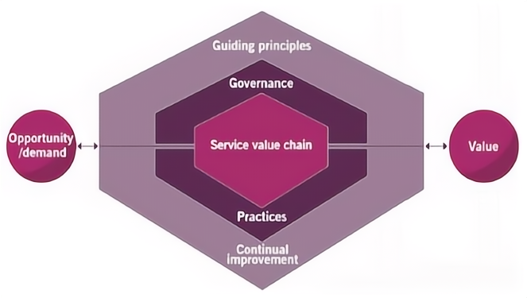
Fig.1 ITIL4 Service value system
The four-dimensional model, illustrated in Figure 2, details four dimensions of service management: organization and people, information and technology, partners and suppliers, and value streams and processes. The focus is on managing IT services to extract business value through these four dimensions. Fundamentally, it describes five variables that influence external value creation in IT organizations, and any change in these variables can affect the quality of IT services[14].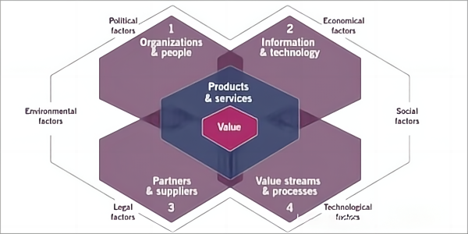
Fig.2 ITIL4 four-dimensional model
ITIL4 introduces five methods: CDS, DSV, HVIT, DPI, and DITS. These methods guide IT in identifying opportunities and needs, pinpointing user problems and pain points, delivering IT services/products in a High-Velocity IT (HVIT) manner, and directing the planning and improvement of IT management processes. Moreover, these methods are instrumental in developing IT strategy.
ISO 27000
The ISO 27000 family of standards, an international suite for information security management systems (ISMS), aims to assist organizations in safeguarding their information assets. These standards offer a framework to establish, operate, monitor, and continually improve ISMS. Key to this suite is ISO/IEC 27001, which sets out requirements for establishing and maintaining information security through policies, risk management, and various controls and procedures.
Additionally, ISO/IEC 27002 provides detailed guidelines on information security control measures, often referenced in ISO 27001, guiding the selection and implementation of security controls. Other standards like ISO/IEC 27003 (ISMS Implementation Guide), ISO/IEC 27004 (Performance Measurement), and ISO/IEC 27005 (Risk Management) cover the gamut from risk assessment to security metrics. The overarching goal is to ensure the confidentiality, integrity, and availability of information assets, enhancing trust among stakeholders and ensuring compliance with regulations, thus safeguarding the organization's reputation.
COBIT
The COBIT model presents a comprehensive system tailored to different organizational structures and levels within an enterprise, providing various levels of normative guidance. Within the COBIT framework, governance objectives are linked to Evaluate, Direct, and Monitor (EDM), while management objectives correspond to Align, Plan and Organize (APO), Build, Acquire and Implement (BAI), Deliver, Service and Support (DSS), and Monitor, Evaluate and Assess (MEA) [15], as illustrated in Figure 3. This model further subdivides the management and process activities across these five areas, encompassing a total of 40 IT processes, as depicted in Figure 4.
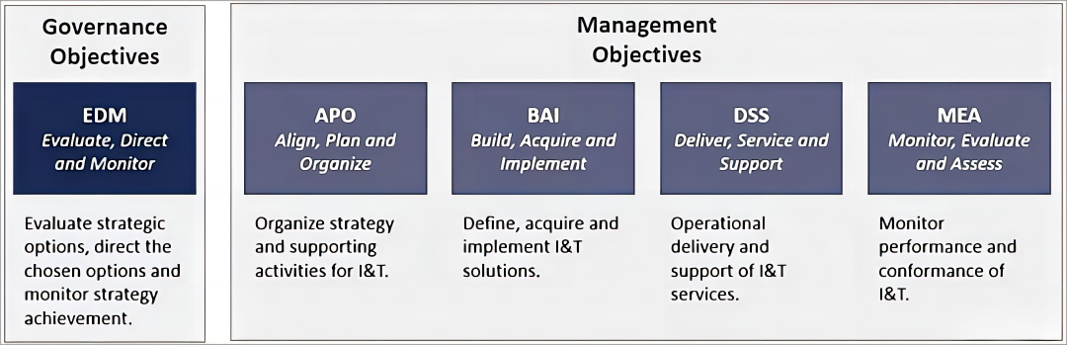
Fig.3 COBIT governance and management objectives
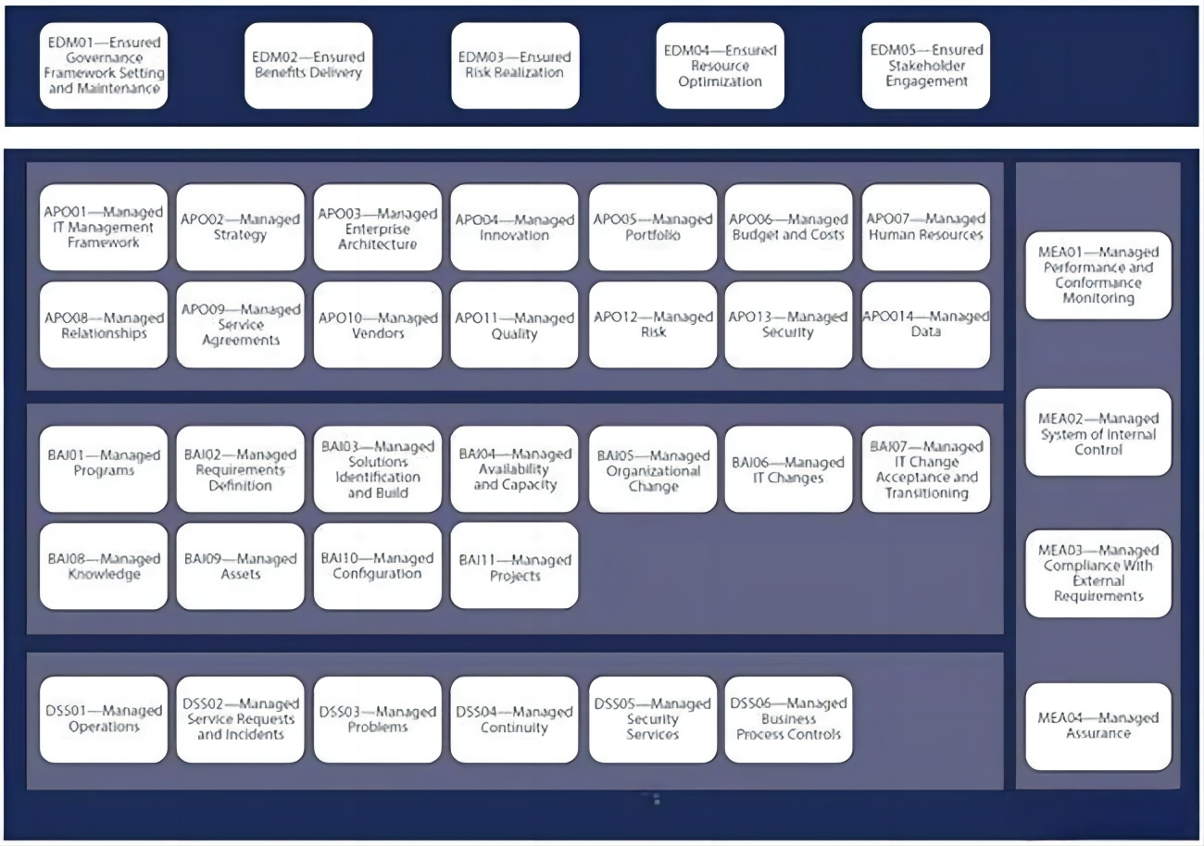
Fig.4 COBIT core model
The COBIT system model's design and features are characterized by four key aspects: a focus on the business core, attention to business processes, clear target control, and performance evaluation. This design reflects the principles of business and IT strategic planning, IT governance management, IT tactical and operational planning, and the manageability of IT activities (processes, performance, maturity, etc.).
Case study for NatureGarden Company
As a globally renowned brand, NatureGarden operates an extensive network spanning businesses and employees worldwide. The company delivers IT services to its workforce and clientele via cloud computing, predominantly relying on wireless networks. Emphasizing online marketing, NatureGarden actively engages in promoting its products and brand across various social media platforms and websites. Concurrently, the company confronts the potential threat of cybercrime targeting its valuable intellectual property, underscoring the critical need for robust information security protocols.
Risk Analysis
NatureGarden, renowned in the global market for healthy living products, confronts complex information security challenges. With nearly 95% of the company's network reliant on wireless technology, this presents various security risks. For instance, if one of the company’s wireless access points is compromised by an unauthorized user, it could lead to sensitive data, such as customer information and internal communications, being accessed illegally or stolen.
This risk is further heightened as the company permits employees and customers to use personal devices for network access. Imagine an employee’s personal computer at home, lacking the latest security updates, which could make it susceptible to malware attacks. Once connected to the corporate network, such malware could potentially spread throughout the company's entire network.
Regarding social media, while NatureGarden actively promotes its brand on various online platforms, this strategy is not without risks. A major social media account hack, for instance, could result in the publication of misleading information, damaging the company's reputation. In extreme cases, this might lead to diminished customer trust and a reduction in market share.
Protecting intellectual property is another significant concern. If a competitor were to obtain a crucial research report or product design from the company, it could severely disadvantage NatureGarden in the market and even lead to the loss of critical trade secrets.
Additionally, the company faces security challenges in its supply chain. Reliance on multiple suppliers and partners can create vulnerabilities to cyberattacks. A security breach in a key supplier's system, for example, could disrupt NatureGarden's production and distribution network.
Another key area is employee safety training and awareness. Inadequate security awareness among staff could inadvertently facilitate cyber attacks. Actions such as clicking on malicious links or downloading unverified attachments could expose the company’s network to cyber threats.
NatureGarden must also prioritize compliance, especially with data protection regulations. Breaches of personal data could have legal and financial repercussions, along with eroding customer trust.
The absence of a comprehensive information security management system means NatureGarden might struggle to respond effectively to emerging cyber threats. For instance, a lack of a robust plan for ransomware attacks could result in critical data being compromised.
Finally, security management in the use of cloud services is crucial. A data breach at a cloud storage service provider could expose sensitive data, affecting the company’s operations and customer trust. Figure 5 below is a summary of information security risk analysis.
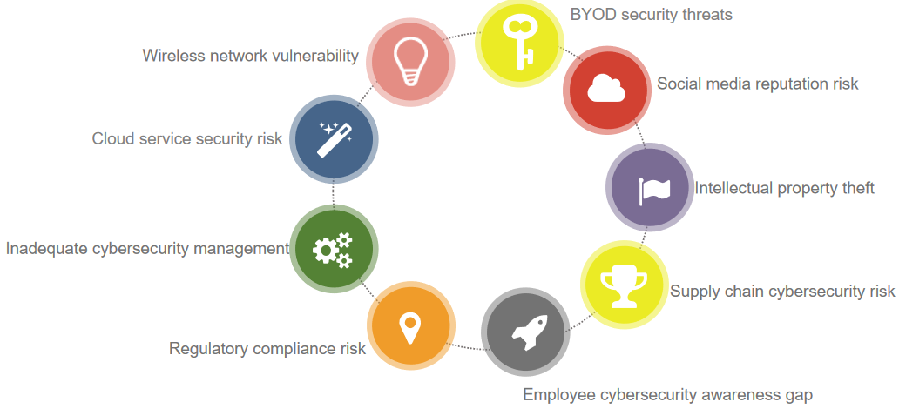
Fig.5 Summary diagram of information security risk analysis
In summary, the multifaceted information security challenges faced by NatureGarden span technical vulnerabilities to policy gaps. The company must develop a comprehensive strategy to address these issues, ensuring the security of its information, maintaining its brand reputation, and protecting customer trust.
Countermeasures
NatureGarden's leading role in the global market for healthy living products brings complex information security challenges that necessitate a multilayered approach to security measures. Firstly, addressing wireless network security is crucial, especially given the heavy reliance on wireless technology in the company's network infrastructure. Implementing advanced encryption protocols like WPA3, along with intrusion detection systems, is essential to thwart unauthorized access. For instance, if an intrusion at a wireless access point is detected, the system can promptly trigger an alert and initiate necessary counteractions.
The reality of employees and customers accessing the network via personal devices has led NatureGarden to adopt a stringent BYOD (Bring Your Own Device) policy. This policy mandates the installation of security software on all personal devices and requires regular security audits. For example, should an employee's personal computer lack the latest security updates, the BYOD policy ensures that such devices are thoroughly checked for security vulnerabilities before connecting to the company’s network.
In the realm of social media management, enhancing account security is critical. The company has bolstered its defenses by enabling two-factor authentication and enforcing regular password changes. Additionally, ongoing employee training programs are conducted to heighten awareness about potential social media threats. Such measures prove invaluable, especially in scenarios where a significant social media account is compromised, enabling swift recovery and minimizing reputational damage.
Protecting intellectual property is another priority. The company employs end-to-end encryption and stringent access controls to safeguard sensitive data, including key research documents and product designs. Concurrently, supply chain security is addressed by establishing robust security collaborations with suppliers and conducting routine assessments, ensuring the integrity of the entire supply chain.
Moreover, comprehensive information security training for employees is implemented to enhance their ability to identify and tackle cyber threats effectively. With regards to regulatory compliance, particularly concerning data protection laws like GDPR, the company takes rigorous steps to ensure adherence. Given the extensive use of cloud services, regularly assessing the security of these services and negotiating contracts with stringent security provisions with cloud providers forms a crucial part of the company’s security strategy.
In summary, NatureGarden's strategic approach to information security not only fortifies its defenses against current threats but also positions the company to effectively handle potential future challenges in cybersecurity. This comprehensive approach is integral to protecting the company's data security, maintaining its brand reputation, and securing customer trust. Figure 6 below is a summary diagram of countermeasures.
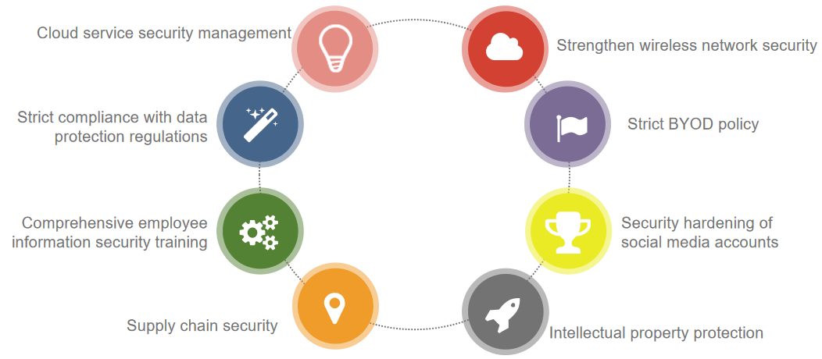
Fig.6 summary diagram of countermeasures
new or updated regulations and standards
Information security frameworks and models such as ISO 27000, COBIT and ITIL are constantly updated and evolved. The complex information security challenges faced by NatureGarden in the global healthy living products market necessitate the continual updating and improvement of its regulatory model framework. As emerging technologies like cloud computing and the Internet of Things (IoT) evolve, alongside the changing landscape of cyber attack methods, the company is confronted with escalating security risks. These evolving technologies introduce new challenges and vulnerabilities, requiring the company to integrate more advanced management and protection measures into its regulatory framework. This integration is essential to effectively counter emerging security threats. Concurrently, the evolving global data protection regulations, especially stringent international regulations such as the GDPR and CCPA, compel NatureGarden to continuously refine its data processing and storage practices to ensure compliance.
In response, NatureGarden is required to proactively strengthen its regulatory framework. This involves a consistent effort in monitoring regulatory changes, providing regular security training to its workforce, implementing ongoing cybersecurity monitoring, and conducting thorough security audits. Such strategic measures are crucial not only in addressing current information security challenges but also in ensuring that the company remains agile and responsive to future changes in technology and regulatory requirements. This approach is key to safeguarding both company and customer data, maintaining NatureGarden's competitive stance in the market, and preserving its reputation.
Conclusion
This article takes an in-depth look at information security frameworks and models, particularly ITIL, ISO 27000 and COBIT, providing a comprehensive introduction, comparison and analysis of them. Taking NatureGarden as an example, this study analyzed in detail the information security risks faced by the company in various aspects such as wireless network security, personal device use, social media use, intellectual property protection, employee security training, and cloud service management. Based on the in-depth analysis of these fields, the article further makes use of ITIL, ISO 27000 and COBIT frameworks to put forward a series of targeted recommendations and specific implementation measures for NatureGarden.
Finally, the paper emphasizes that in the progressive information technology environment, information security is a dynamic and relative concept, rather than an absolutely unchanged state. As a result, information security frameworks and models, related regulations and standards must be continually updated and evolved to keep pace with the pace of technological development and emerging new threats. In addition, in order to maintain the effectiveness and foresight of information security, a long-term security architecture development strategy must be formulated to ensure the continuity and adaptability of information security management. Such strategic thinking and constantly updated practices are key to ensuring that organizations remain safe and ahead of the game in an increasingly complex digital environment.
References
[1]. Segars A H, Grover V. Designing company-wide information systems: Risk factors and coping strategies. Long Range Planning, 1996, pp. 381-392.
[2]. Sambamurthy V, Zmud R W. Research Commentary: The Organizing Logic for an Enterprise's IT Acticities in the Digital Era- A Prognosis of Practice and a Call for Research. Information Systems Research, 2000, pp. 105-114.
[3]. Kakabadse A, Korac - Kakabadse N. IS/IT governance: need for an integrated mode. Corporate Governance International Journal of Business in Society, 2001, pp. 9-11.
[4]. Schwarz, A., and Hirschheim, R. Corporate Governance: Some Theory and Implications. Economic Journal, 2003, pp. 678-689.
[5]. De Haes S, Vab Grembergen W. IT Governance Stryctures, Processes and Relational Mechanisms: Achieving IT/Business Alignment in a Major Belgian Financial Group, 2005.
[6]. Jianrong, Y., Zhihao, T., Chunyang, J. Research on IT governance import model. Chinese management informatization, 2008, pp. 82-84.
[7]. Qiang, S., Tianzu, Z. Wei, L. IT Service management: Concept, understanding and implementation. China Machine Press, 2004, pp. 23-28.
[8]. Wei, W. A comparative study of the main internal control models of IT governance. Channel science, 2010, pp. 110-128.
[9]. ISO/IEC 27001:2013. Information Technology—Security Techniques—Information Security Management Systems—quirements. Geneva: International Organization for Standardization, 2013.
[10]. ISO/IEC 27002:2008. Information technology—Security techniques—Information security risk management. Geneva: International Organization for Standardization, 2008.
[11]. Yuzhou, L., Jia L., Ke, K. Analysis and reconstruction of internal control of enterprise accounting information system based on COBIT. Finance and accounting newsletter, 2009, pp. 25-27.
[12]. Simonsson M, Johnson P. Assessment of IT Governance - A Prioritization of Cobit, 2006, pp. 82-89.
[13]. AGUTTER CLAIRE. ITIL 4 Creat, Deliver and Support: Your companion to the ITIL 4 Managing Professional CDS certification. IT Governance Publishing, 2021.
[14]. AGUTTER CLAIRE. ITIL 4 High-velocity IT: Your companion to the ITIL 4 Managing Professional HVIT certification. IT Governance Publishing, 2021.
[15]. Yuxiao, X., Chenxu, Q. Research on information technology internal control system of telecom enterprise based on COBIT framework. Telecommunication science, 2009, pp. 30-35.

