Fundamentals of Electrical and Electronic Systems (ACDA4018)

Circuit Build Logbook

By Jesamy Kellow (2030428)
L4 Ordnance, Munitions and Explosives (OME) Apprenticeship
I declare that this report is the product of my own work and is not being submitted for any other degree etc.

Table of Contents
1. Experimental Objective 2
1.1. Circuit Description 3
2. Proteus Simulation 3
2.1. Schematic of Circuit 3
2.2. Results and Calculations 3
2.2.1. Graph 4
2.2.2. Timing Measurement Tables 4
2.2.3. Analysis of results 5
3. Practical experiment 5
3.1. Breadboard planning 5
3.2. Apparatus list 6
3.3. Equipment layout diagram 6
3.4. Method for Building the Breadboard 7
3.5. Issues and fault finding 7
3.6. Finished Breadboard 7
4. Conclusion 8
References 9
Appendices 10

Experimental Objective
The objective of this logbook is to ‘perform electrical and/or electronic measurements, record and analyse data and produce a report’. More specifically the requirement is ‘to build and test the astable 555 timer circuit’ [1].

Circuit Description
The circuit which is going to be built is a 555 timer. Depending on the mode used, it could be used in an ordnance, munitions and explosives (OME) context.
In monostable mode, it could be used to provide a delay in an electric fuse for arming an explosive. Monostable mode outputs a single pulse of current for a certain length of time, which is sometimes referred to as a ‘one-shot pulse’. The time the output stays ‘on’ depends on the values of resistors and capacitors connected to the 555 timer [2].
In astable mode, the 555 timer generates a square wave. The frequency of the wave can be adjusted by changing the values of the resistors and capacitors connected to the 555 timer. This mode can be used for tone generation, flashing lights and security alarms [3].

Proteus Simulation
Proteus design suite is used for the simulation of electronic design. It can be used to create schematics to test and send to manufacturers to print the circuit boards [4].

Schematic of Circuit
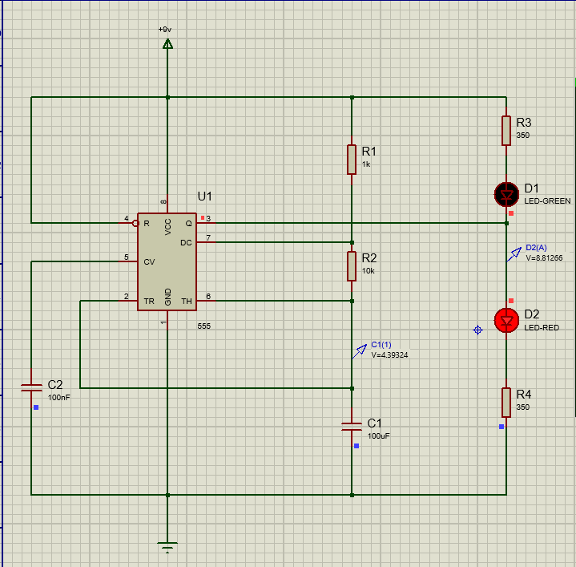
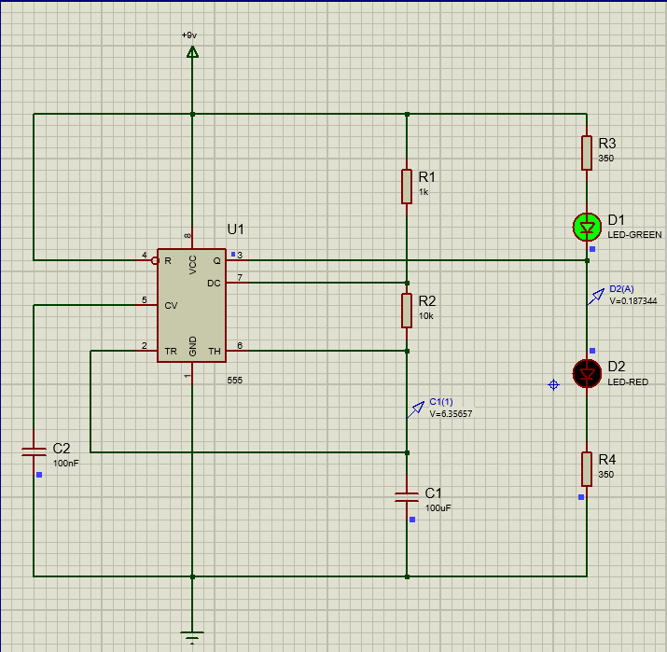
The schematics in figure [1] and figure [2] below show the two states of simulation, with the green LED illuminated and then with the red LED illuminated.
Figure [1] schematic of 555 timer with green LED Figure [2] schematic of 555 timer with red LED illuminated illuminated

Results and Calculations
The following sections of this logbook will show the results of the proteus circuit design on the 555 circuit.

Graph
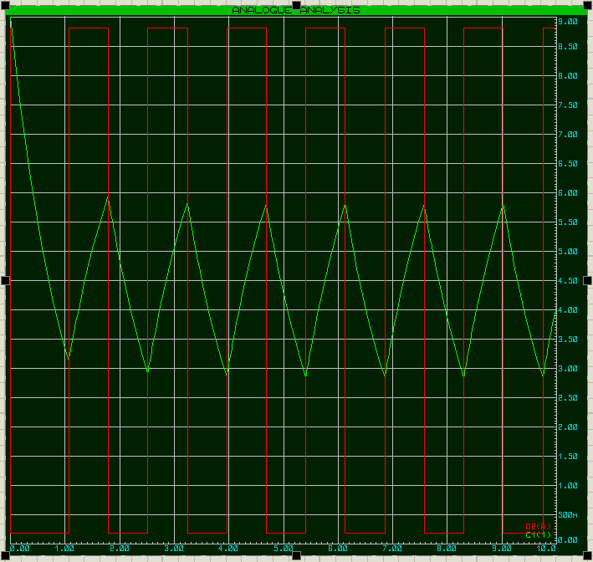
The following graph in figure [3] is analysing the output voltage (the red graph) and the capacitor voltage (the green graph) with respect to time. The green graph has an initial charge of zero, so acts as an open circuit. This shows that the voltage drop across he capacitor is at a maximum.

Figure [3] – graph displaying output voltage and the capacitor voltage with respect to time

Timing Measurement Tables
The following table in figure [4], shows the values calculated and measured for the graph. Calculated and measured values have been found for the resistance of R₃ and R₄, the on-time, the off-time, the period and the frequency.
Formula | Calculated | Proteus Measurements
Find the resistance of R₃ and R₄ using Ohm’s law rearranged as:  $$R=\frac{V}{I}$$ | $$\frac{9v-2v}{20mA}=350 ohms$$ | 350 ohms – chosen using calculated results.
$$On-time=Ln2 x \left(R_{1}+R_{2}\right) x C$$ | $$Ln2x\left(1000+10000\right)x\left(100x{10}^{6}\right)$$  = 0.7625 s | 1.7904 - 1.0666 = 0.7238 s
$$Off-time=Ln2 x \left(R_{2}\right) x C$$ | $$Ln2 x 10000 x \left(100x{10}^{6}\right)$$  $=$ 0.6932 s | 2.5143 – 1.7904 = 0.7239 s
$$Period=On-time+Off-time$$ | 0.7625 + 0.6932 = 1.4557 s | 0.7238 = 0.7239 = 1.4477 s
$$Frequency= \frac{1}{Period}$$ | $\frac{1}{1.4557}=0.6870$ s⁻¹ | $\frac{1}{1.4477}=0.6908$ s⁻¹
Figure [4] – table showing calculated vs measured values from the graph

Analysis of results
Resistance – Resistance has been calculated using Ohm’s law [5]. The voltage is the circuit’s voltage of 9+ volts minus the 2v from the LEDs. And the current rating of the circuit is 20mA which is found from the data sheets of the components.
On-time – It is evident from the results that the calculated value for on-time is slightly longer by 0.0387 s than the on-time which has been measured on Proteus. This difference from results is most likely due to inconsistencies and tolerances in circuit components.
Off-time – It is evident from the results that the calculated value for off-time is slightly shorter by 0.0307 s than the off-time which has been measured on Proteus. As previous, this difference from results is most likely due to inconsistencies and tolerances in circuit components
Period – The periods are both very similar to each other. This can be explained as to find the period, the on-time and off-times must be added together to make the full cycle. As previously discussed, the on-time is slightly longer than the measured by 0.0387 s and the off-time is slightly shorter by 0.0307 s, these differences almost cancel each other out giving a very close period value, with only a small difference of 0.008 s.
Frequency – Similarly to the period, the frequency gives a very similar answer with a small difference of 0.0038 s as the periods have worked out to be very similar values.

Practical experiment
The proteus simulation is now complete so the circuit can now be replicated on a temporary circuit board, called a ‘breadboard’.

Breadboard planning
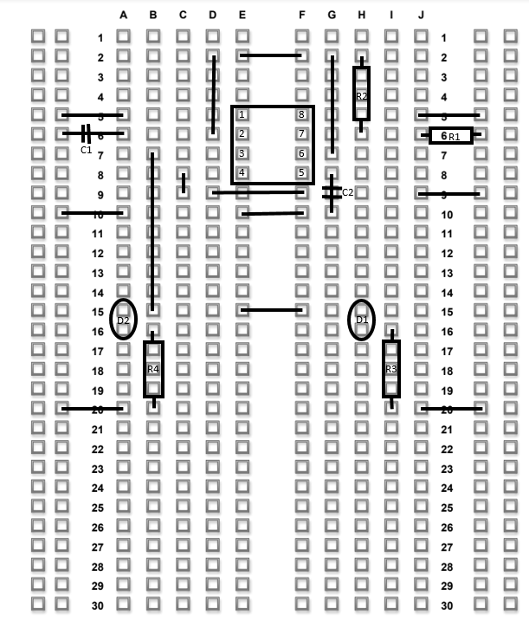
Before making the breadboard, it is crucial to plan the arrangement as it prevents future mistakes and makes building the breadboard quicker. To do this, a breadboard planning sheet has been used and can be seen below in figure [5] and the original planning sheet can be found in appendix [1]. To complete this, it is easier to start with the largest component (most pins) in the middle, in this case the 555, and work outwards to ensure there is enough space.

Figure [5] – Breadboard planning sheet

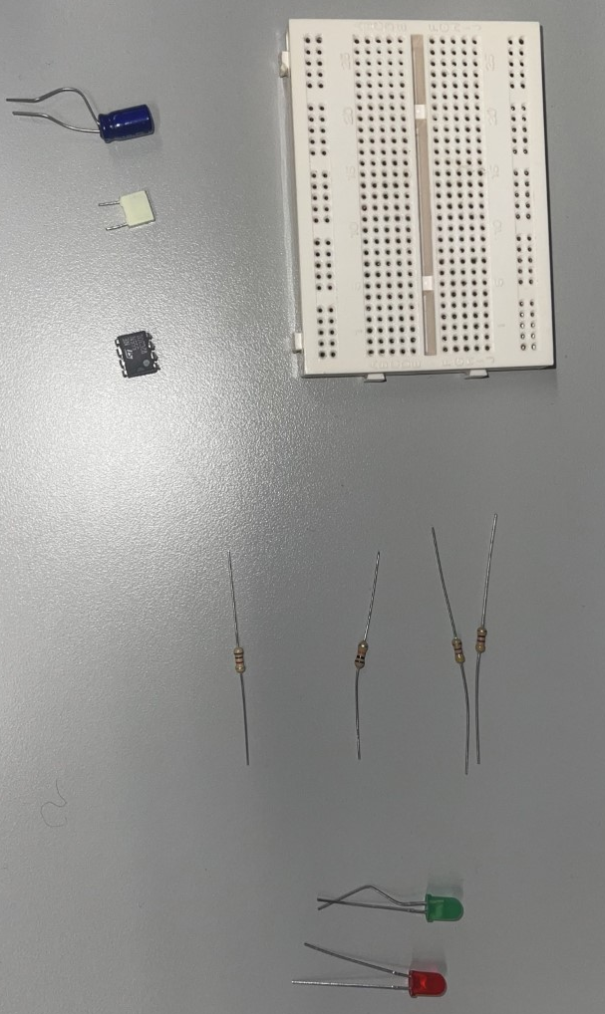
Apparatus list
The first step of building the breadboard is to gather the required apparatus. The apparatus required is shown in the list below as well as in figure [6] showing the components:
Breadboard
Resistors
LEDs

Capacitors
555 chip

Figure [6] – Image showing apparatus required
The apparatus list:
- Breadboard
- Resistors – 2 x 470 ohm, 1 x 1k ohm and 1 x 10k ohm
- Capacitors – 1 x 100 micro-farads and 1 x 100 nano-farads
- 555 chip
- LEDs – Red and Green
- Cables

Equipment layout diagram
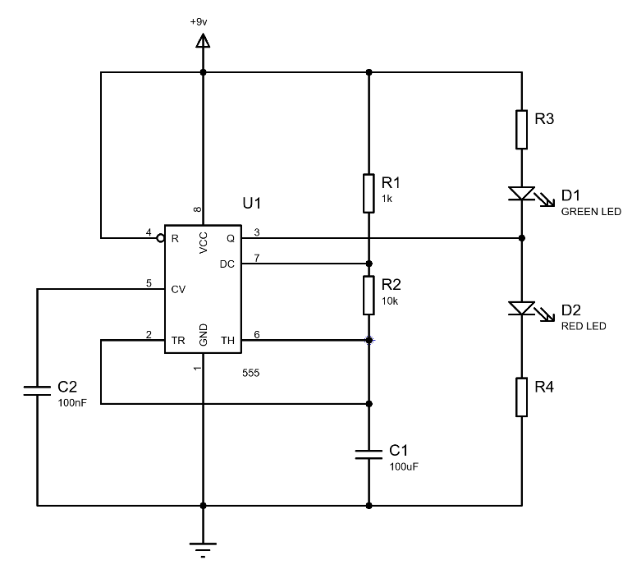
To make the circuit using the breadboard, the diagram has been taken from the assignment brief [1] as well as using the proteus design from Figure [1] and figure [2]. In the following circuit design which is needed to be tested in figure [7], there is a difference that has to be made.

Figure [7] – Schematic of the circuit required for testing
The resistor values of R₃ and R₄ were calculated in figure [4] as being 350 ohms. However, the nearest available resistor value to be used is 470 ohms so this resistor has been chosen to be used for the two calculated resistors instead.

Method for Building the Breadboard
The following method was used to build the circuit board. All components are placed in the same place as specified in the planning sheet
- Gather components required.
- Place the 555 chip into the board.
- Using the colours on the resistors, work out which resistors are required.
- Trim the resistors and place the resistors in their places, ensuring the correct resistors are in the correct places.
- Trim the capacitors, noting which side is positive and which is negative and place them into the circuit with the positive side connected to power [6].
- Trim the LEDs, again noting which side is positive and which is negative and place them into the circuit.
- Trim some cable, strip the ends and them place in the circuit until all components are connected.
- Finally, strip two pieces of cable and place them in the ground and 9+ volt lines. These can be connected to a power source to power the circuit.
- To tell if the circuit is working as intended, the lights should be alternately turning on and off at opposite times for around 1 second in time.

Issues and fault finding
While building the circuit, a couple of issues arose, however, these were easily remedied by moving some components about.
- The first issue was some confusion while making the board. As the numbers and letters on the planning sheet and the numbers and letters on the breadboard mirrored each other. There was an attempt to mirror the breadboard by matching up the numbers, the circuit however didn’t work as the chip couldn’t be mirrored and so wasn’t connected in the circuit properly. This was fixed by removing all of the components, starting again by placing them in their right places by following the squares on the breadboard and not the numbers and letters to place them in the right place.
- Once all the components were in place, the breadboard was connected to power but only one of the LEDs was flashing. To solve this each of the components leading to the disconnected LED was gone through to double-check all of the connections. The issue was that one of the resistors was misaligned so the circuit was broken, so, it was put where it should be and then the circuit was re-tested and working as expected.

Finished Breadboard
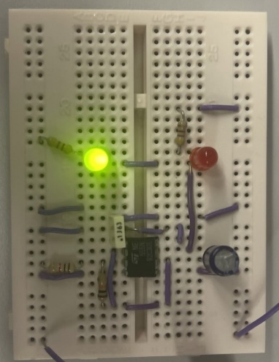
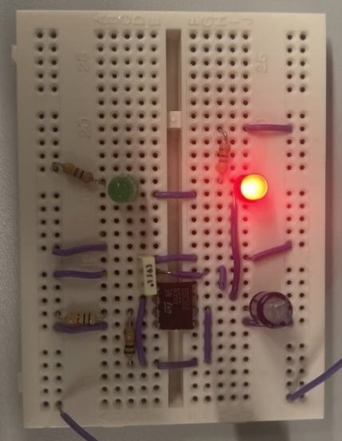
The following images, figure [8], figure [9] and figure [10] show the final breadboard design with working components. It can also be seen that the LED lights are illuminating alternately in figure [8] and figure [9].

Figure [8] - Breadboard with red LED illuminated figure [9] – Breadboard with green LED illuminated
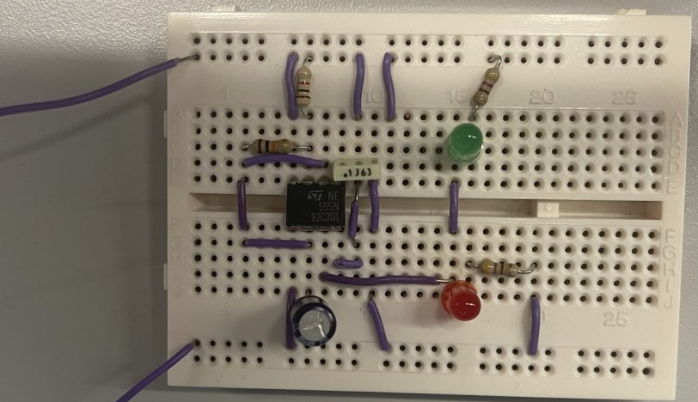
Figure [10] – Completed breadboard design

Conclusion
So, in conclusion, the proteus design software was used to make a theoretical 555 circuit. This then produced a graph which has been analysed and compared to calculated circuit results. This proteus circuit has then been designed and built into a breadboard circuit which has successfully been put together and is in working order as the desired result of alternating illuminated LEDs has been achieved.

References
- S. Mosey, Fundamentals of Electrical and Electronic Systems (ACDA4018) Assignment Brief, Swansea, 2022.

- S. Campbell, “555 Timer Basics - Monostable Mode,” [Online]. Available: https://www.circuitbasics.com/555-timer-basics-monostable-mode/. [Accessed 13 December 2022].

- S. Campbell, “555 Timer Basics - Astable Mode,” [Online]. Available: https://www.circuitbasics.com/555-timer-basics-astable-mode/#comments. [Accessed 13 December 2022].

- Labcenter Electronics, “PCB Design & Simulation Made Easy,” 2022. [Online]. Available: https://www.labcenter.com/. [Accessed 13 December 2022].

- S. Khan, “Introduction to Circuits and Ohm's Law,” Khan Academy, [Online]. Available: https://www.khanacademy.org/science/physics/circuits-topic/circuits-resistance/v/circuits-part-1#:~:text=Ohm%27s%20Law%20is%20V%20%3D%20IR,resistance%20is%20in%20the%20circuit. [Accessed 13 December 2022].

- E. Robledo, “Everything You Need to Know About Capacitors (2022 Update),” 04 November 2022. [Online]. Available: https://www.autodesk.com/products/fusion-360/blog/everything-need-know-capacitors/#:~:text=The%20positive%20side%20always%20gets,US%20schematic%2C%20Standard%20and%20Polarized.. [Accessed 13 December 2022].

Appendices
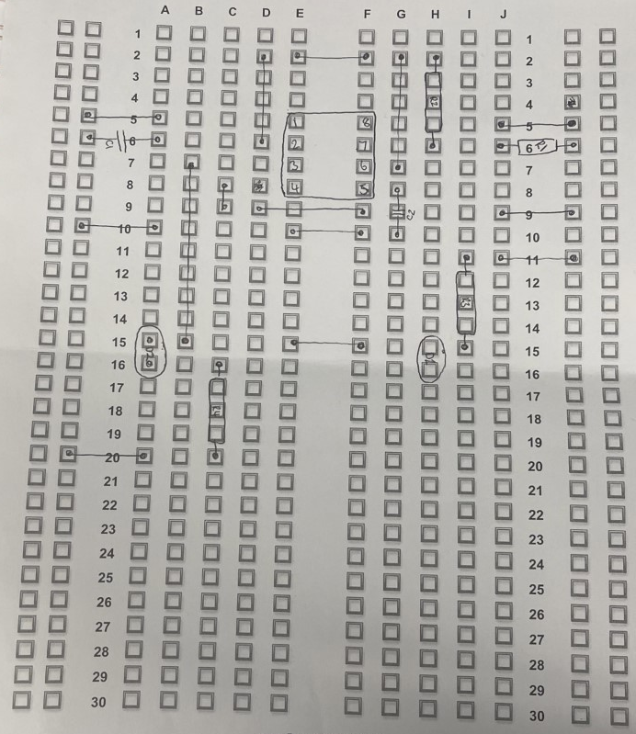
Appendix [1]:

