

ADAA7000 Coexistent Perspectives Module
Name: __Diying Zhu_________
Student number: __2025037_________
Word Count: __4319_________

- Please keep all drafts of your essay. You may be asked to produce these as evidence of your writing process.

- Please ensure you follow the AI guidance on the assessment brief and note when and how you are able to use AI.

- Please also note the guidance regarding plagerism on your assessment brief also refers to referencing the source of your material and that includes the use of AI.

For this assessment,
I confirm that I have not used Generative AI to support me in structuring my submission, including creating a draft argument structure, identifying parts and headings.
I confirm that I have not used Generative AI to create text for my submission.
I confirm that I have not used Generative AI for creative materials, such as images.
Student Signature: ___________

Abstract

This essay explores how contemporary superhero intellectual properties use time, memory, and archives in different ways, using Batman and Ne Zha: Birth of the Demon Child as two case studies. The essay focuses on how repetition, breaks in time, slow development, and non-linear timelines are used to shape superhero stories in Western and Eastern cultural contexts.
The essay argues that superhero narratives are not mainly shaped by character personality or story type, but by how time-related systems are designed. These systems decide which memories are repeated, how the past affects the present, and how official histories are formed. In the Batman franchise, time is often flexible and changeable. Stories are restarted, repeated, or placed in different timelines. Important memories, such as the death of Batman’s parents, are mostly private, and archives can be reused and changed across films, comics, and other media. This allows the character to be constantly rewritten.In contrast, Ne Zha: Birth of the Demon Child presents time as closely connected to fate and karma. Nezha’s life follows a fixed time structure, and individual actions cannot easily change the final outcome. Memory in the film is strongly influenced by collective views, while archives function as public and authoritative records that are difficult to challenge.
By comparing these two cases, the essay shows that time, memory, and archives reflect different cultural values about responsibility, choice, and social order. These elements play an important role in shaping how heroism is understood in different societies.

Keywords: Time, Memory, Archive, Superhero Narratives, Batman, Nezha, Cultural Difference

07/01/2026

Coexistent Perspectives （ADAA7000）
Question 4, Time, Memory and the Archive: in what ways do contemporary artists and designer reimagine time, memory, and archival practice, whether through repetition, rupture, slowness, or non-linear temporality? How do these temporal aesthetics intersect with cultural, technological, or historical concerns?

Submission Date: Wednesday, 7th January 2026
Word Count: 4319

Differences in Time, Memory, and Archive Design Between Eastern and Western Superhero IPs—Taking Batman and Nezha from "Ne Zha" as Examples

1. Introduction
1.1 Superhero IPs and Modern Popular Culture
Superhero IPs have become one of the most lasting narrative forms in modern popular culture. Unlike traditional myths or single texts, superhero stories are often rewritten and expanded in serialized, cross-media ways, appearing repeatedly in movies, animations, comics, games and other forms. This long-term narrative model makes superhero IPs not just about telling a complete story, but gradually forming a narrative system that constantly adjusts around time, memory and history.
In this system, the core of the narrative is no longer just the plot itself, but how the character’s past is preserved, modified or reset. Questions like whether time can be skipped or rewritten, which memories are repeatedly emphasized, and which experiences are regarded as "official history" directly affect the character’s actions and the audience’s understanding. Therefore, analyzing from the perspective of time, memory and archives helps reveal the internal logic formed by superhero narratives in long-term development.
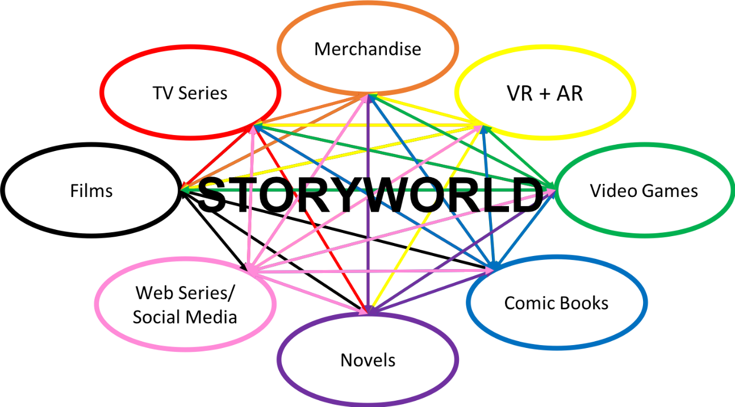
Figure 1: The development logic of successful IP essentially lies in multi-channel layout and repeated expansion and refinement. On the basis of the core setting, it continuously expands content and iterates and revises to achieve long-term fermentation

This paper selects Batman and Nezha as research objects, first based on their high popularity and commercial success in their respective cultural contexts. Since entering the mainstream American comic market in the 20th century, Batman has been one of the most influential superheroes. His film and television adaptations have achieved remarkable box office results in the United States and around the world, forming a mature industrial system. In contrast, Nezha’s influence in contemporary Chinese popular culture is mainly reflected in the success of the animated film "Ne Zha: Birth of the Demon Child". The film gained wide attention after its release, making Nezha one of the most representative local superhero images in recent years.
In addition to market influence, the differences in their narrative structures make them highly comparable. Batman is a superhero without superpowers. His actions rely on technology, rational judgment and personal decisions. Time in his story is something that can be planned, interrupted and corrected. His core memory of "parents’ death" is private, and related archives and information are strictly controlled. In contrast, Nezha in "Birth of the Demon Child" is incorporated into the order of heaven and karma from birth. The three-year countdown of the heavenly calamity curse is an unavoidable process. His identity is not only shaped by personal memory, but also influenced by the collective cognition of the people of Chentang Pass, and his experiences are placed in an open order system.
By comparing these two narrative models, this paper tries to explore how superhero IPs in different cultural backgrounds respond to core issues such as responsibility, choice and fate through the design of time, memory and archives. This paper does not seek to evaluate the pros and cons of the characters, but focuses on how the narrative mechanism shapes the action boundaries and meaning-making methods of the hero images. 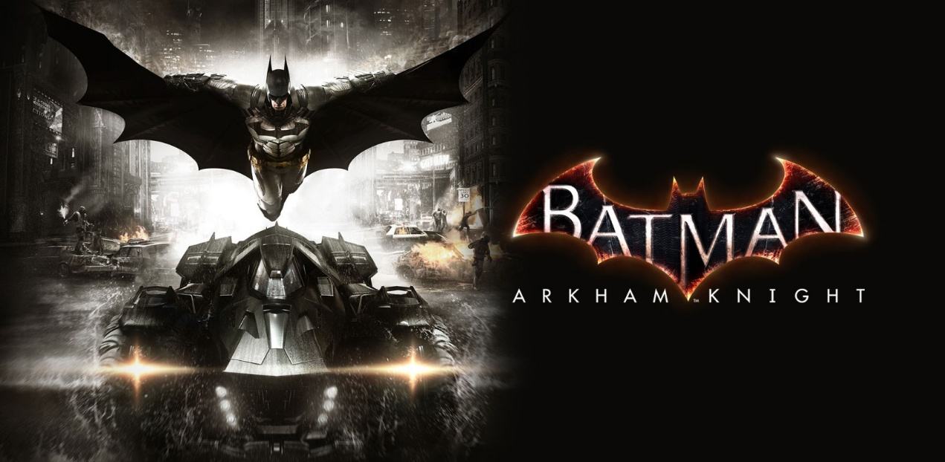
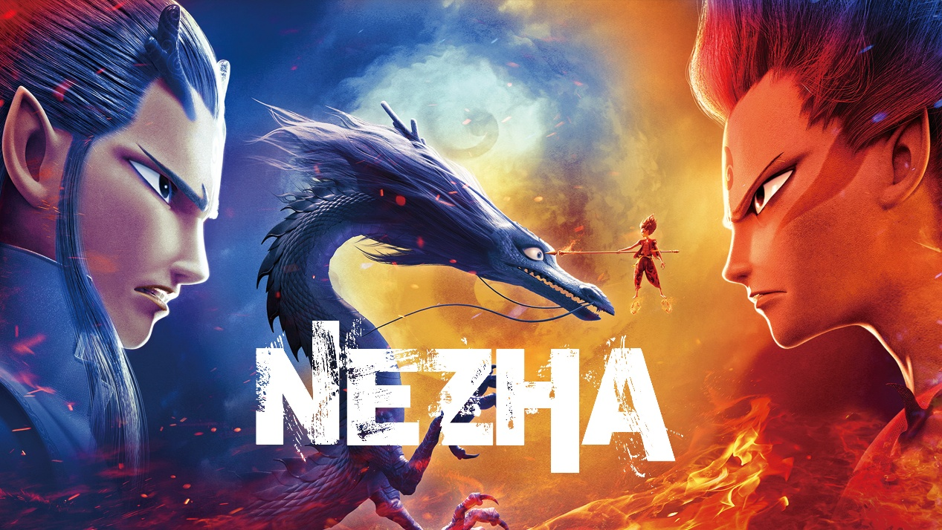
Figure 2-3: Visual poster of Batman and animated film Nezha.
2. Theoretical Background
This study focuses on the design methods of time, memory and archives in superhero IPs. To clearly analyze the cases, only theoretical views directly related to the research questions are selected as analytical tools, without attempting a systematic review.

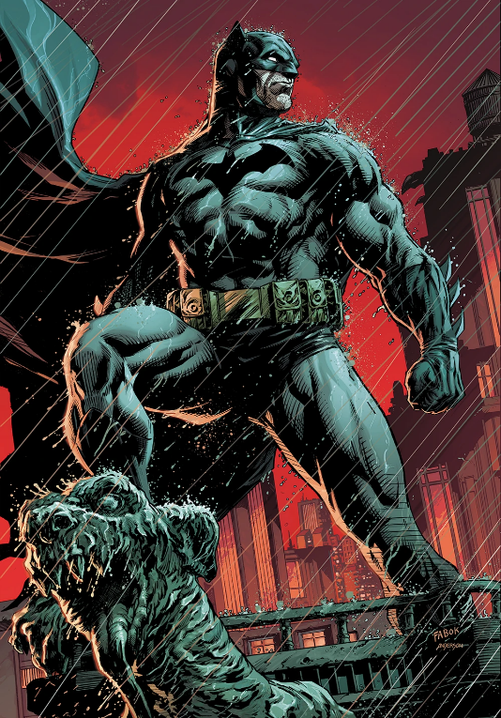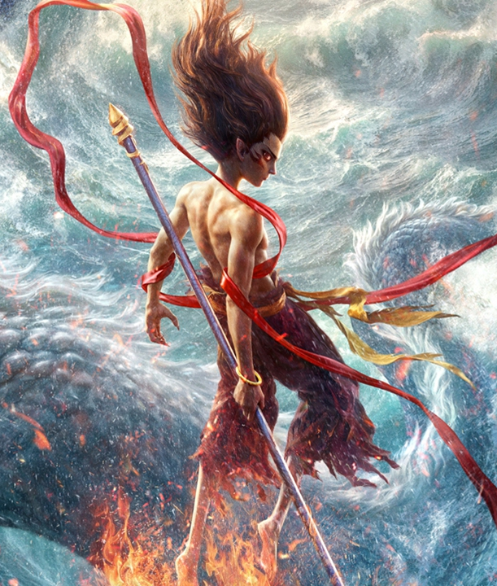
Figure 3-4: Batman and Nezha as representative superhero figures in Western and Chinese popular culture.

2.1 Temporal Aesthetics: Time as an Experiential Structure
2.1.1 Time is More Than a Counting Clock
In daily cognition, time is an objective existence that flows linearly. But in narrative research and philosophical discussions, it is closely related to human actions and experiences. The perception and use of time directly affect the narrative structure and character behavior logic.
Martin Heidegger proposed (Heidegger, 1962) that time is not an external measure independent of humans, but deeply connected to the way "Dasein" exists. His core view is very inspiring for this paper: the meaning of time lies not in measurement, but in human actions and choices in time. This paper only uses this idea to understand the design and experience logic of time in superhero narratives.

2.1.2 "Objectification of Time" in Technical Narratives
In many modern superhero works, time is often portrayed as something that can be intervened through technology, experiments or extreme events, such as time travel and restarting the timeline. In such narratives, time is more like a "problem", and the hero’s core task is to solve it.
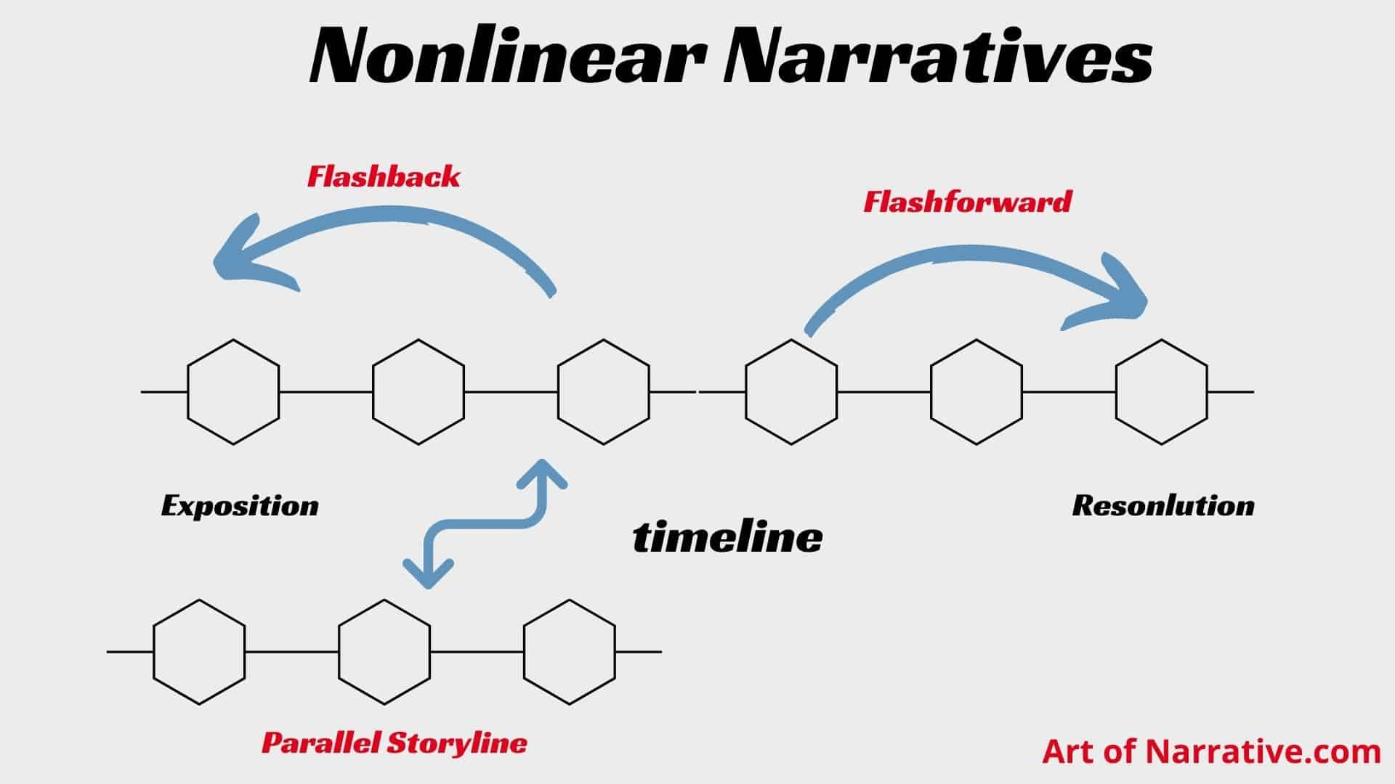
Figure 5: Explain several types of nonlinear narratives

Represented by Batman-related works, time is regarded as a manageable and correctable resource. It is no longer an irreversible process, but a variable that can be adjusted through rational judgment and technical means, reflecting a value orientation that emphasizes action efficiency and result orientation.

2.2 Hero Narrative Paradigm: Similar Structures, Different Foci
Joseph Campbell summarized the hero’s journey (Campbell, 1949) into three broad stages in his book "The Hero with a Thousand Faces"—Departure, Initiation, and Return. In these stages, the protagonist leaves the ordinary world, undergoes trials and transformation, and finally returns to the familiar world with new insights or powers.
In Batman’s story, the death of his parents is the triggering event for "Departure", becoming a vigilante is the core of "Initiation", and the final sacrifice, self-restraint or assumption of responsibility constitutes "Return". This process highly emphasizes individual choice. The focus of the narrative is not on "whether there is fate", but on "how to respond to choices".
Although Nezha’s narrative can correspond to the "Departure-Initiation-Return" structure, the focus is significantly different. "Departure" is the predetermined fate of reincarnating as a spirit pearl and a demon pill. "Initiation" is the experience of being misunderstood and excluded. "Return" is facing the heavenly calamity head-on. The hero does not shape fate through choices, but completes self-cognition within the framework of fate, emphasizing responsibility and endurance more.

2.3 Cultural Power Structures and Archive Logic
2.3.1 Power Distance and Information Control
According to Hofstede’s cultural dimensions theory (Hofstede, Hofstede and Minkov, 2010), power distance refers to the extent to which less powerful members of organizations and institutions accept and expect unequal power distribution. Societies with low power distance are more likely to question authority, while those with high power distance accept hierarchical structures and centralized information control.
In Batman’s narrative, archives and information are controlled by individuals or small groups, showing a highly privatized logic. 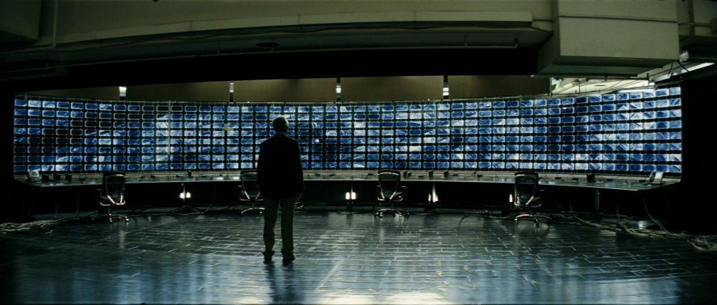
Figure 6: Nolan's Batman live-action movie stills-- A key highlight of Batman's stories lies in the various dilemmas and challenges he faces regarding his social identity, the law and morality as a superhero.
In "Birth of the Demon Child", Nezha’s fate and information about the heavenly calamity are placed in an open order, and individuals can hardly change the results by manipulating information.

2.3.2 The Relationship Between Archives, Time and Memory
Archives, time and memory interact with each other: archives determine which memories are preserved, and also affect the understanding and narrative of time. Based on this perspective, this study analyzes the specific differences in the design of time, memory and archives between Batman and Nezha.

3. Case 1: The Design of Time, Memory and Archives in Batman
Batman’s narrative does not follow a fixed timeline, but continues to restructure through long-term serialization, restarting and cross-media adaptations, making it a typical case for analyzing the narrative design of superhero IPs. This chapter analyzes from three aspects: time, memory and archive practices. The time design of the Batman IP is essentially a carrier of "social memory + archive iteration". Over the decades of cross-version time span from the 1989 Burton version to the 2012 Nolan trilogy, Batman’s core archives have never been broken. Instead, the connotation of the archives has been continuously enriched through the social memory of different eras.

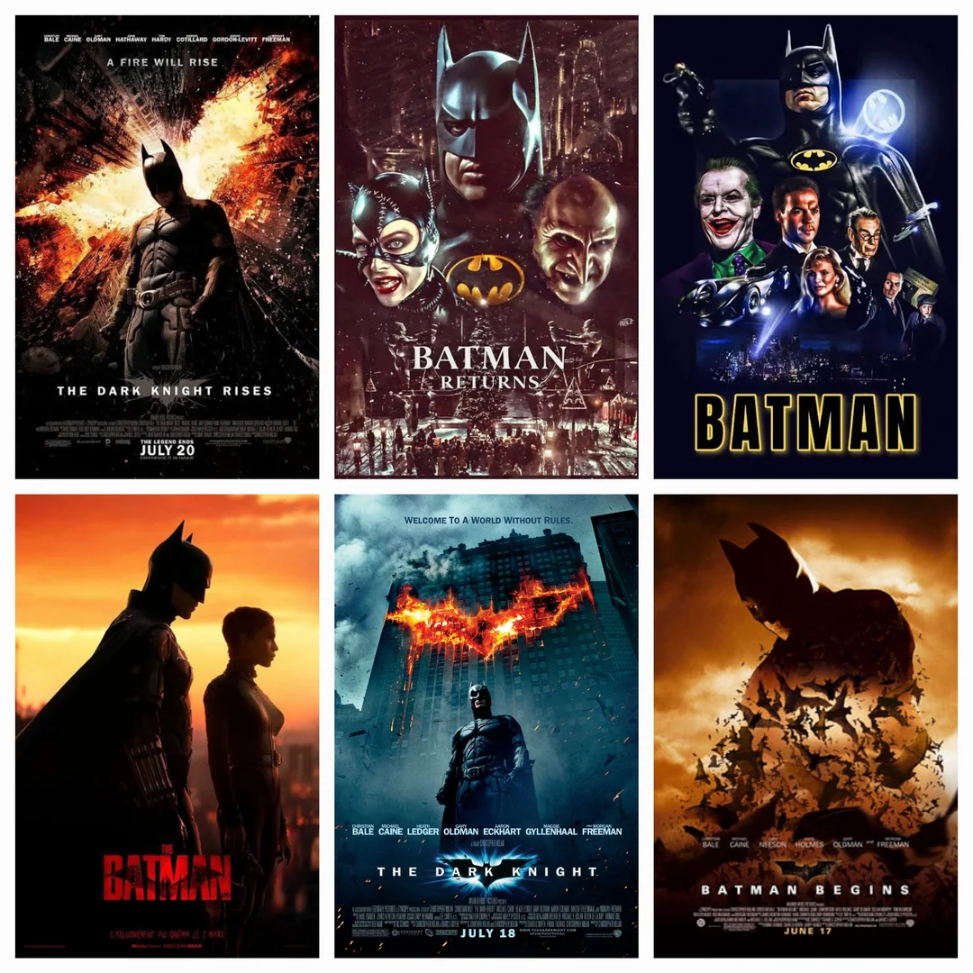
Figure 7: The continuous changes of Batman’s on-screen iterations in recent decades
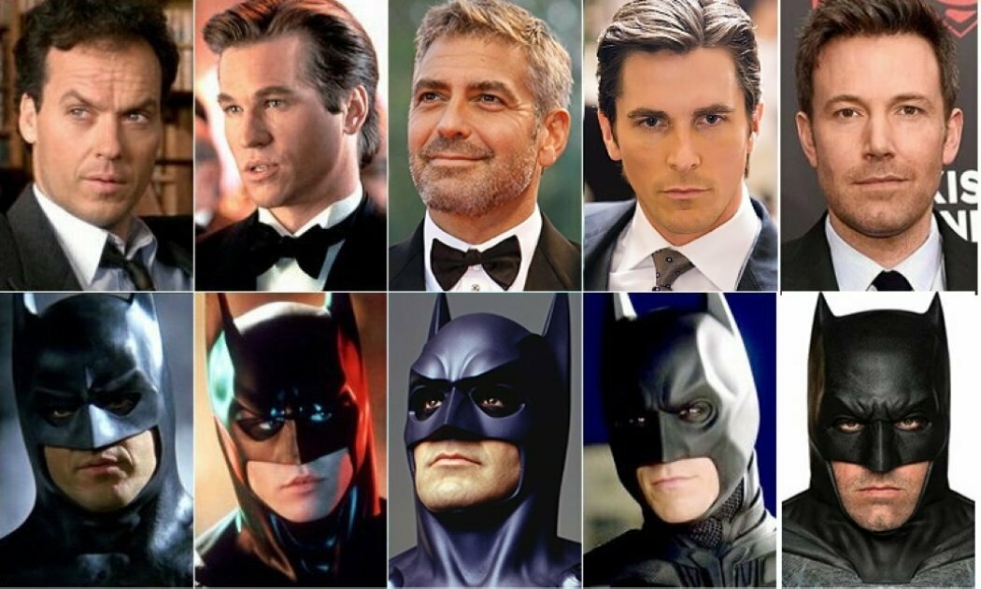
Figure 8: The evolution of Batman’s successive actors and on-screen personas

3.1 Batman’s Time Design
In Batman’s narrative, time constantly returns to the same "starting point"—the event where Bruce Wayne witnessed his parents being shot and killed in his childhood. This scene is repeatedly presented in comics such as "Batman: Year One", Nolan’s "The Dark Knight" trilogy and derivative works. These are not supplementary plots, but settings of the time structure: the story always starts here, and the character’s actions are constantly pulled back to this moment, forming a circular structure. This not only strengthens the stability of identity, but also deeply binds the hero’s actions to the past.

Coexisting with repetition are a lot of time rupture designs. In some comics and cross-work linkages, time is directly cut off or skipped. For example, in multi-universe and time travel plots, characters may enter an altered future or another timeline. This kind of rupture appears abruptly, making the original time logic temporarily invalid, strengthening the uncertainty of the world view, and reflecting a narrative attitude that regards time as an "adjustable variable".
At the level of character shaping, time shows a slow characteristic. Batman gradually forms his hero identity through long-term training, continuous actions and accumulation of physical and mental pressure. This process is often presented through montages, memory fragments or long-term narratives. Here, time emphasizes accumulation and consumption. The hero needs to be constantly "tempered" in time, endowing him with distinct human characteristics.
In the long-term operation of the IP, Batman does not have a single unchangeable timeline. Different comic, movie and animation versions are independent yet interrelated, making time non-linear, with multiple "legitimate versions" existing at the same time. For the audience, Batman’s time is a network composed of multiple timelines, and the concept of "official history" is relatively open, facilitating creators to reorganize the character’s experiences.

3.2 Batman’s Memory Design
At the memory level, Bruce Wayne witnessed the murder of his parents in his childhood, filled with guilt and revenge. This childhood experience made him eager to become the "fear" of criminals. This traumatic memory has become the core psychological root of his transformation into Batman. Batman’s birth is the result of the development of Wayne’s psychological consciousness. Wayne’s dual identity—rich young master during the day and vigilante at night—both carries his emotions and beliefs, and also tells the audience: the past is always part of the core anchor of the character’s present.
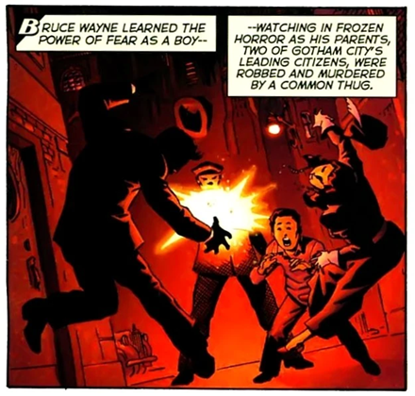
Figure 9: The murder of his parents is one core issue Batman can never get around.
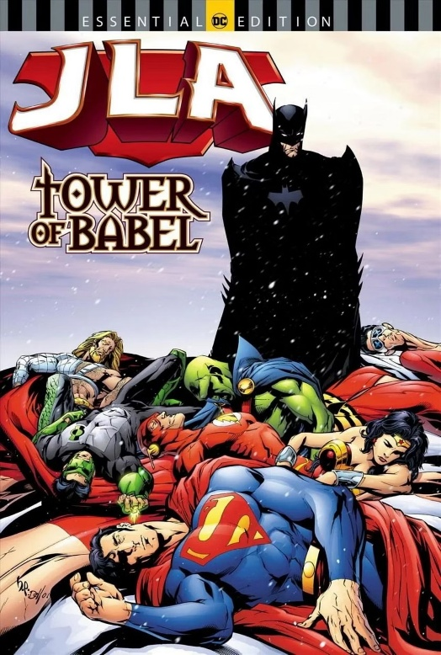
In some works, this is manifested in Batman’s emotional isolation or avoidance of interpersonal relationships, making it difficult for the character to "get out of the past". He pushes himself to the edge of being superhuman. However, his relentless drive has made him practically psychotic—he is a harmless psychotic but barely functional as a person. Just like his obsession with the past, skepticism and sharp perception of danger in the "Superman/Batman" comic series, they are essentially "defensive ethics" transformed from traumatic memories. This kind of ethics makes his memory show a "depositional" characteristic: time has not healed the trauma, but has deeply bound the trauma with ethics, becoming a highly recognizable core point of his hero identity.
Figure 10: In certain storylines, Batman maintains vigilance toward those around him and devises threatening schemes, even his closest allies.

Following the same design idea, in some games and animations, authors choose to intersperse Batman’s memory in real-life plots in a fragmented way. Hallucinations, imaginations and real memories are intertwined, making it difficult for the audience to distinguish the time levels, further weakening the stability of time and making the character’s experience highly subjective.

3.3 Batman’s Archive Practice Design
It must be noted that due to the coexistence of multiple versions of the long-standing Batman IP over decades, the archives of different works are not completely compatible, making the archives multiple parallel systems rather than a continuous history. However, despite the fractures, the overall world view of the Batman IP has gradually enriched through long-term accumulation. Character relationships, urban settings and moral issues are continuously supplemented in different works, and the archives show a slow growth characteristic. These results are essentially due to the design logic of action memory of this IP—using symbols. As Bruner said, "play is memory in action". Individuals interact with symbolic actions, making memory transcend simple emotional residues and become a stable identity anchor. Superhero play involves role-playing and imagination. Cognitively, pretending a piece of fabric is a cape, using objects as props, or imagining villains all require symbolic thinking. Just putting on a cape can be enough for a child to take on various roles that make him or her feel strong and powerful.
The essence of Batman’s archive practice is to drive the reorganization of symbols. Batman’s origin, personality and core settings are regarded as repeatedly callable archive resources. Different creators will continue to return to these archives for re-creation in new works. His core archives include three major elements: revenge symbolizing the initial symbol, the moral code of not killing, and the past of his parents. These archive resources are repeatedly reorganized in conflicts. Finally, he transforms revenge into hope through reorganizing archive symbols—Batman’s cape, bat logo and other symbolic archives are reconstructed from tools of fear into carriers of hope. The process of archive reorganization is exactly the process of solving design conflicts. Its effect is reflected in film and television: Batman’s live-action adapted movies have gone through five generations in more than 30 years, from Burton’s Gothic dark style, Nolan’s realistic police and gangster style, to Snyder’s classical tragedy style, and then to Reeves’ contemporary retro noir style. Each generation of directors explores, deconstructs and reconstructs this IP.
In summary, the Batman IP does not pursue absolute narrative continuity, but maintains character plasticity through various time strategies, providing a highly flexible space for long-term operation.

4. Case 2: The Design of Time, Memory and Archives in "Ne Zha: Birth of the Demon Child"
Unlike Batman, the hero narrative of "Ne Zha: Birth of the Demon Child" is rooted in karma, heavenly principles and ethical order. Nezha is incorporated into an established rule structure from birth. Analyzing from three aspects of time, memory and archives helps understand how Eastern mythological hero IPs limit individual action space through design and emphasize responsibility and commitment.

Figure 11: Visual poster of Nezha

4.1 Nezha’s Time Design
In "Birth of the Demon Child", time is a structure that continuously exerts pressure. Nezha’s growth is always constrained by the logic of karma, rather than a tool to create dramatic reversals.
At the beginning of the film, the setting of the "Primordial Pearl splitting" into a spirit pearl and a demon pill directly establishes the time structure of reincarnation and rebirth. In this framework, Nezha’s birth is not a one-time event, but a link in the cycle system, implying that his life experience has been incorporated into a recurring time cycle.
At the beginning of the film, the sudden event of the demon pill’s reincarnation makes Nezha’s life break away from the "normal growth path" from the starting point, and he is marked as a dangerous existence. The film tells the audience at the beginning that this rupture does not bring new possibilities: for safety reasons, others close Nezha’s social identity in advance.
In the film, the history of the Primordial Pearl does not disappear with the passage of time, but continuously affects Nezha’s real situation. The past is not clearly divided into a "concluded" stage, but always exists in the present as a background force, influencing the character’s fate. This is reflected in the fact that as the plot progresses, Nezha shows that although he is born with powerful strength, he still needs to gradually complete through long-term learning and practice. Here, time plays a role in allowing the character to complete a change in understanding through repeated experiences.
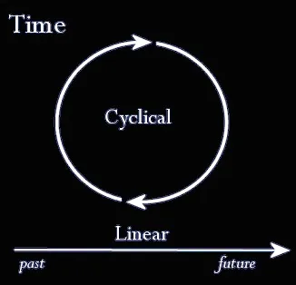
This is a state of back-and-forth interweaving, rather than linear progress. This non-linear time structure is closer to a "folded" time form. The past and the present act simultaneously, further strengthening the sense of destiny presented in the film as a whole.
Figure 12: Time loop

4.2 Nezha’s Memory Design
Time determines what Nezha "must experience", while memory determines how he "is viewed". Nezha’s memory design is a dual construction of "collective label memory and family love memory". He is labeled as a "monster" by the public because of "demon pill reincarnation". This collective prejudice memory becomes the core motivation for his resistance against fate. Meanwhile, the unconditional love of his parents makes him adhere to filial piety and responsibility in rebellion. These two kinds of memories jointly shape his behavior logic. In the climax of the film, Nezha’s cry of "my fate is determined by myself, not heaven" and his experience of fighting against fate make him actively construct resistance memory. Multiple memories promote him to seek identity recognition.
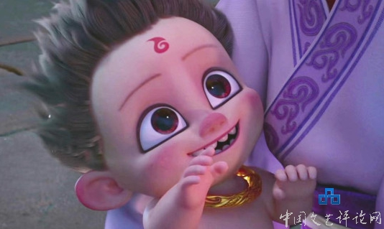
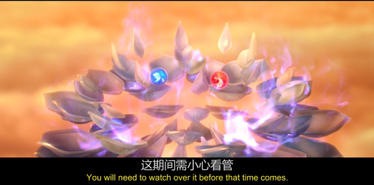 Figure 13: In the movie, a powerful, authoritative divine destiny accidentally decrees a horrific future for the protagonist, while the interplay of ruthless celestial order and flexible human nature alters his character arc.

Nezha’s memory is the result of the joint action of the collective, family and self. Individual resistance always aims at gaining collective recognition, reflecting the memory logic of Eastern cultural IPs acting on "individual awakening under the leadership of collective memory".

4.2.1 Broken Memory Design
In the middle of the film, Nezha once saved a little girl in a critical moment, but this act was not understood as a kind act by the local villagers, but quickly regarded as a new act of violence. This plot does not stem from lack of information, but is related to the collective memory formed by the people over a long time. For the local residents, Nezha has always been regarded as the incarnation of the "demon pill", a cognition that has long been fixed in time and has not changed with the development of specific events. 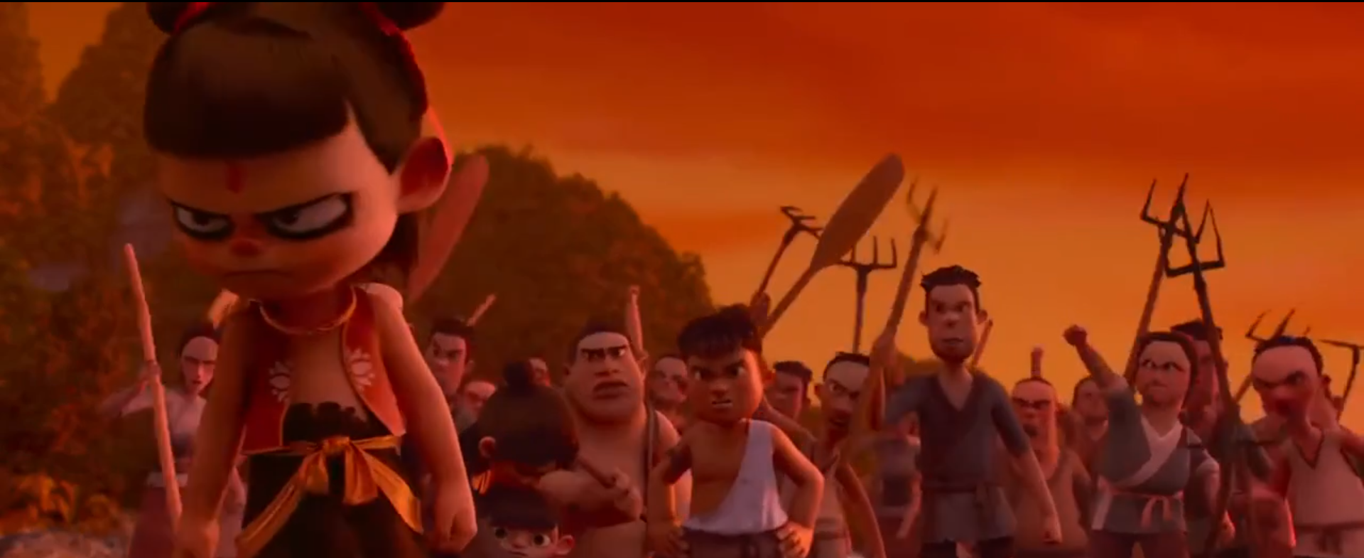
Figure 14: character conflict film stills

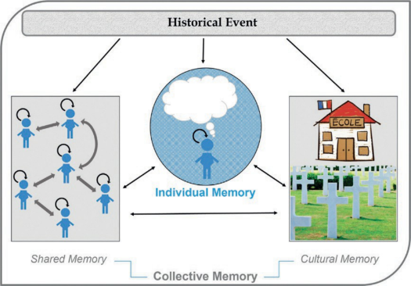
Figure 15: The interaction between the environment, collective memory and individual memory

Because the cognition of both parties remains at the past memory node, the ongoing behavior cannot enter the new memory judgment framework. Nezha’s current actions are not understood as independent events, but directly fitted into the existing negative impressions. In other words, although time moves forward, the memory system has not been updated simultaneously.
In this case, the break of memory suppresses the present nature of time. Nezha’s attempt to improve relations through doing good deeds not only fails to repair the existing cognition, but further intensifies the contradiction between him and the people due to misunderstanding, making the originally tense relationship continue to deteriorate.

4.2.2 Slow Memory Design
In the film, Nezha’s single good deed is difficult to change the overall evaluation of him by the environment, and his good deeds need long-term repetition and persistence. This phenomenon shows that the update speed of collective memory is extremely slow. The slow update of collective memory makes Nezha in a negated social environment for a long time. The continuous state of not being recognized not only limits his possibility of establishing normal relationships with others, but also accumulates pressure psychologically, which undoubtedly increases the character’s sense of isolation.

4.2.3 Non-linear Memory Design
In the film, Nezha does not fully inherit the memories of his previous life. Unlike continuous and clear memory inheritance, information related to the previous life only appears briefly in fragments in specific situations, especially in the climax of the story, which is reawakened as a supplement to the character’s abilities or fate settings. The non-linear memory structure naturally weakens the stability of the character’s self-cognition. Since he cannot rely on complete past experiences to understand his own position, Nezha can only gradually form an understanding of himself in incomplete and intermittent memories, which also increases the uncertainty in his identity recognition process.

4.3 Nezha’s Archive Practice Design
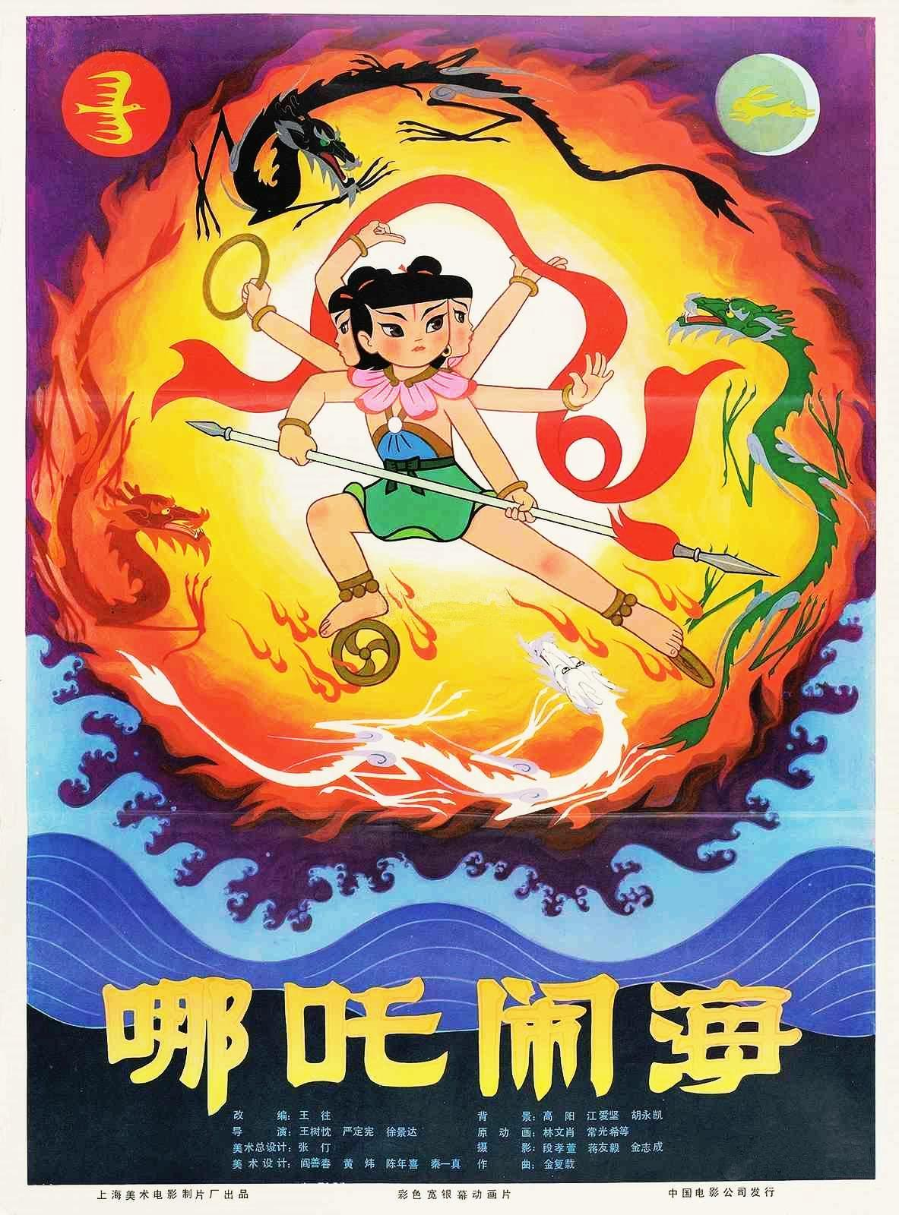
In "Birth of the Demon Child", archives are part of public order, not private resources. Nezha’s archive practice reflects the distinct characteristics of Eastern IPs—"fixed core cultural archives + innovation in form and connotation". His core archives—traditional symbols such as the Red Silk Sash, Golden Hoop, and Lotus Rebirth, as well as the core narrative of resisting fate—are always rooted in traditional Chinese culture and have never wavered due to adaptations. However, the form and connotation of the archives have achieved modern reconstruction: his image has changed from a dignified divine boy to an "ugly and cute demon child", the Golden Hoop has changed from a "righteous artifact" to a "shackle and weapon to suppress demon nature", and the connotation has changed from "passively accepting destiny" to "actively challenging fate". Nezha’s archive innovation never deviates from the core cultural foundation. The subversion of form is to better convey traditional values, reflecting the "publicity and fixity" characteristics of Eastern IP archives.
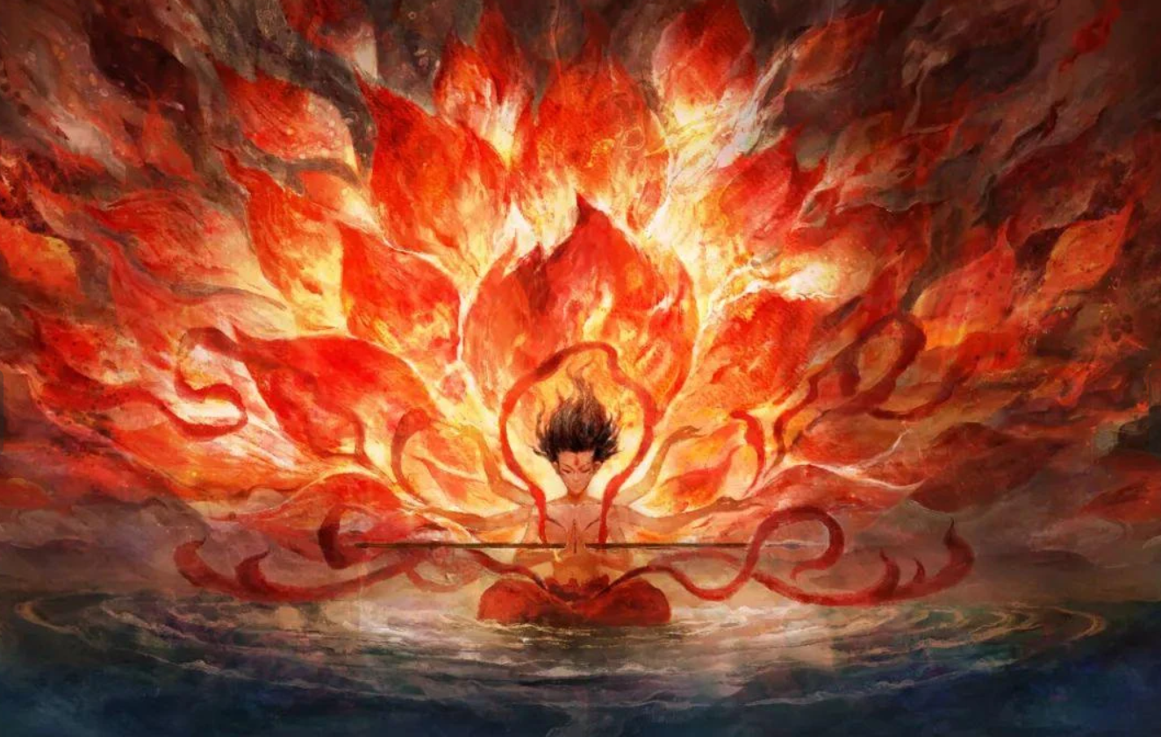
Figure 16: By preserving and transforming the iconic symbols of traditional story roles, story innovation is achieved.（

4.3.1 Broken Archive Design: Once Qualified, Hard to Revoke
At the beginning of the film, a basic point of the whole story is determined: the identity of the demon pill is officially confirmed by the gods in heaven, which has absolute authority. Moreover, the archive exists before the behavior, making it difficult for the individual actions of the character to overthrow the established records.

4.3.2 Slow Archive Design: Continuous Recording of the Practice Process
In the film, the practice arranged by Nezha’s parents and master is clearly regarded as a long-term process, not a task that can be completed in a short time. The value of Nezha’s behaviors and abilities can only gradually appear through time accumulation.
This setting reflects the slow update rhythm of archives. The results of the character’s practice will not be quickly corrected by a single behavior, but the direction of change will be judged through long-term recording. Here, archives play a role in making the audience pay more attention to the continuity of the process.

4.3.3 Non-linear Archive Design: Cross-life Call from the Perspective of Heavenly Principles
From the perspective of heavenly principles, Nezha’s archives do not strictly distinguish between previous lives and present lives, but integrate different life stages into the same system. The karmic relationship of the previous life does not disappear with the end of life, but continues to play an important role in judging the fate of the present life.
Therefore, the arrangement of archives does not take time sequence as the main standard, but revolves around ethical relationships and karmic logic. Time sequence is not the primary principle here. The past and the present are called and connected at the same time, making the archives show obvious non-linear characteristics.

4.4 The Cultural Context of the Nezha IP: Collective Order and Archive Publicity
Looking at the Nezha IP, its unavoidable time, collective memory labels, and open archive order correspond to the inevitable natural disasters, demon-like identity and heavenly records in the film. It is rooted in China’s cultural traditions of "karmic ethics" and "collective harmony", forming a distinct East-West cultural mirror image.
In summary, Nezha in "Birth of the Demon Child" cannot freely rewrite his own history. This IP emphasizes that individuals must complete growth within the established order through multiple restrictions.

5. Conclusion
By comparing Batman and Nezha from "Ne Zha: Birth of the Demon Child", this paper analyzes two different superhero narrative models from three perspectives: time, memory and archives.
The research shows that the differences between them are not mainly due to different character personalities or story types, but more about how to handle the relationship between the past, present and future in the narrative process.
First, this paper holds that the shaping of modern superhero IPs does not only depend on the character images themselves, but to a large extent through time-related designs. For example, the arrangement of time structure, whether memories are repeated or preserved, and whether the character’s experiences can be used as callable materials all directly affect the presentation effect of superhero images. In the cases of Batman and Nezha, time, memory and archives are not just simple background information, but also directly affect the character’s behaviors and the development direction of the story. This shows that modern creators constantly update and maintain the vitality of superhero IPs by adjusting time-related design ideas.
Second, the research finds that in the practical application of time-related design ideas, obvious East-West differences can be seen between Batman and Nezha. In terms of time design, Batman’s story tends to regard time as adjustable, changing the plot direction through restarting the story or setting multiple timelines. In contrast, Nezha’s time structure pays more attention to karmic relationships, emphasizing that some results are unavoidable. In terms of memory, Batman’s key memories are mainly his own personal experiences, which are rarely widely discussed. In contrast, Nezha’s image is more easily influenced by collective memory. Even if he does good deeds at the moment, it is difficult to quickly change people’s inherent views of him. In terms of relevant setting records, Batman’s historical settings can be repeatedly used and modified in different versions, while Nezha’s fate-related records are more public and authoritative, which is difficult for individuals to change.
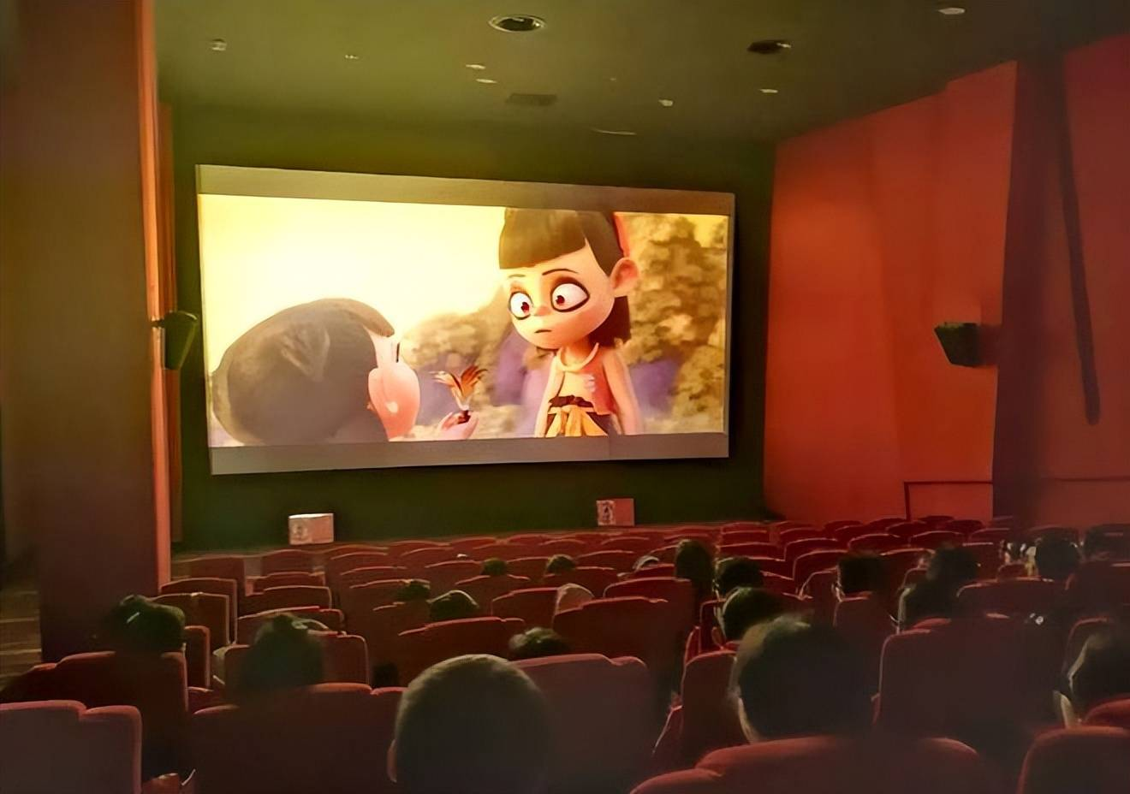
Figure 17: DC Batman-themed pop-up stores have been established all over the world.
Figure 18: Nezha has brought a new round of movie-watching craze to cinemas
Through the above comparison, this paper further raises a question: are the East-West differences in the time design ideas of modern superhero IPs only due to different modern communication media, or are they related to long-term historical narrative traditions? To clarify this question, the paper briefly reviews the relevant historical narrative clues.

In traditional Chinese myths and historical stories, time is often closely related to the establishment and maintenance of order. This can be better understood by comparing with Western myths. For example, in the Greek myth of the Golden Fleece, the hero’s actions are mainly personal adventures and the pursuit of honor, and success or failure mainly affects the hero’s own status.
Figure 19: The story "Golden Fleece" with a touch of Western traditional mythology
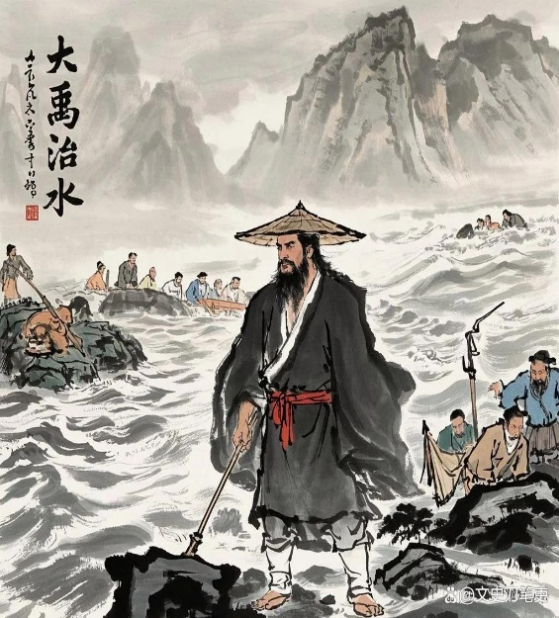
In contrast, traditional Chinese myths such as Gun and Yu controlling floods emphasize the restoration of social and political order. In myths, flood control is often assisted by mythical beasts. In historical records, Yu inherited the leadership position after successfully controlling floods, and his personal achievements were incorporated into a larger political system. In such stories, time is not only the background for adventures, but also the process by which order is established.
Figure 20: The story of Yu the Great Controlling the floods with a strong flavor of Eastern traditional culture

This view of time can also be confirmed by changes in mythological figures. Take the Queen Mother of the West as an example. Her image has gradually changed from a wild god in the early stage to a goddess symbolizing order, and later connected with royal power and human governance. This shows that mythological stories have become more orderly and standardized. In this process, time is no longer just a stage for mythological events, but also an important condition for making order legitimate and sustainable.
In general, choices in narrative such as whether time can be changed, who controls memory, and whether relevant setting records are public all affect the hero’s behavior and the audience’s understanding of the hero’s meaning. Through this comparison, this paper holds that time, memory and archives are not only neutral narrative tools, but also important factors closely related to cultural background and values.
Do you need me to further simplify the structure of this paper (such as reducing the number of subheadings) or adjust the length to better fit the academic requirements of college students?

Bibliography
References:
Amponpeerapan, M. and Singhakowinta, J. (2022) ‘Confrontations and exchanges of virtue ethics: A study of dialectical friendship between Superman and Batman in comic books’, Journal of Graphic Novels and Comics, 13(3), pp. 408–431. Available at: https://www-tandfonline-com.ezproxy.uwtsd.ac.uk/doi/full/10.1080/21504857.2021.1925719 (Accessed: 7th January 2026).
Campbell, J. (1949) The hero with a thousand faces. Princeton: Princeton University Press.
Du, Q. (2019) ‘An analysis of Joker’s transmedia narrative: Taking DC Comics and the movie The Dark Knight as examples’, Media Forum, 2(24), pp. 155–157. Available at: https://chn.oversea.cnki.net/KCMS/detail/detail.aspx?dbcode=CJFD&dbname=CJFDLAST2020&filename=CMLT201924111&uniplatform=OVERSEA (Accessed: 7th January 2026).
Hao, J. (2016) ‘A study on cultural identity in superhero film series: Taking Superman, Batman and Spider-Man as examples’, Film Theory, (18), pp. 86–88. Available at: https://chn.oversea.cnki.net/KCMS/detail/detail.aspx?dbcode=CJFD&dbname=CJFDLAST2016&filename=DYPJ201615017&uniplatform=OVERSEA (Accessed: 7 January 2026).
Heidegger, M. (1962) Being and time. Translated by J. Macquarrie and E. Robinson. Oxford: Blackwell. (Original work published 1927)
Hofstede, G., Hofstede, G. J. and Minkov, M. (2010) Cultures and organizations: Software of the mind. New York: McGraw-Hill. Available at: https://openlibrary.org/books/OL24523760M/Cultures_and_organizations (Accessed: 7 January 2026).
Kong, D. (2022) ‘Where lies the “novelty” of The Batman: The pinnacle of auteur cinema and the end of image criticism’ [online]. Semantic Scholar. Available at: https://www.semanticscholar.org/paper/A-Psychoanalysis-on-Internal-Conflict-of-Bruce-as-Masyhur-Fithratullah/7cf6b0b3a1d71720120b9b0dac20ba2c9ed2aeff (Accessed: 7 January 2026).
Krakowski, P. (2012) ‘Museum superheroes: The role of play in young children’s lives’, Journal of Museum Education, 37(1), pp. 49–58. Available at: https://doi.org/10.1080/10598650.2012.11510717 (Accessed: 7th January 2026).
Li, Q. Q. and Zhang, Y. Y. (2025) ‘From Ne Zha Conquers the Dragon King to Ne Zha: Birth of the Demon Child: Deconstruction and reconstruction in character design’, Shoes Technology and Design, 5(17), pp. 18–19. Available at: https://chn.oversea.cnki.net/KCMS/detail/detail.aspx?dbcode=CJFD&dbname=CJFDLAST2025&filename=WHXU202510017&uniplatform=OVERSEA (Accessed: 7th January 2026).
Liang, B. (2025) ‘Anti-identity construction from the perspective of Peirce’s semiotics: Taking the animated film Ne Zha: Birth of the Demon Child as an example’, Culture Journal, (10), pp. 71–74. Available at: https://chn.oversea.cnki.net/KCMS/detail/detail.aspx?dbcode=CJFD&dbname=CJFDAUTO&filename=YSCY202502009&uniplatform=OVERSEA (Accessed: 7 January 2026).
Masyhur, M. A., Fithratullah, M. and Kasih, E. N. E. W. (2023) ‘A psychoanalysis on internal conflict of Bruce Wayne as seen in Matt Reeves’ The Batman (2022) movie’, Teknosastik, 21(1), pp. 8–22. Available at: https://www.semanticscholar.org/paper/A-Psychoanalysis-on-Internal-Conflict-of-Bruce-as-Masyhur-Fithratullah/7cf6b0b3a1d71720120b9b0dac20ba2c9ed2aeff (Accessed: 7th January 2026).
Trinacty, C. (2025) ‘Bacchic Batman?: Batman: Killing Time and Euripides’ Bacchae’, Journal of Graphic Novels and Comics, 16(1–2), pp. 335–351. Available at: https://www-tandfonline-com.ezproxy.uwtsd.ac.uk/doi/full/10.1080/21504857.2024.2358997 (Accessed: 7th January 2026).
Zhang, J. (2024) ‘The self-shaping, other-shaping, and influence of traditional Chinese culture in Nezha: Birth of the Devil and Mulan’, Comparative Literature: East & West, 8(1), pp. 129–149. Available at: https://www-tandfonline-com.ezproxy.uwtsd.ac.uk/doi/full/10.1080/25723618.2024.2376300 (Accessed: 7th January 2026).

