Stadia and Sports Facilities MGT

  - M5X01429

Assignment One
Name: Cerys Grigg
Student Number:1900559

Contents
Task One 2
Freedom Leisure 2
Acting today for an active tomorrow 3
International Association for Sports and Leisure Facilities Article 3
Facilities for future generations 4
Liberty Stadium 5
Task two 7
Reference list 8
Appendix 10

Task One

According to the Cambridge University only dictionary (2021) the meaning of the words ‘Development’ is the course in which something or someone grows or “Changes and becomes more advanced”.
An example of a planned future development would be Wales Online reported recently in November 2020 of confirmed plans to bring a multi-use game area along with a 3D pitch to where they describe as a “deprived area of Swansea”. The plans were confirmed after donations of £111,000 from the Garfield Weston foundation and the Johann Cruyff foundation. The article states that Swansea City council will also give funding of £25,000. This plan is an excellent sport development plan to help get younger people from deprived areas more active.

Freedom Leisure
In October 2018, “Not for profit leisure trust” Freedom leisure partnered with Swansea City Council to take over the management of their seven leisure centres and sports complex on behalf of them. Since the takeover Freedom leisure state on their website that they have been renovating and updating the leisure centres and sports complex. Their next project on behalf of Swansea City council is fully update Cefn Hengoed leisure centre. The renovation will include flexible spaces, fitness studio, café and a new indoor 3G pitch. The purpose of the project is to “develop the sports and community facilities to benefit the local community and the school”. The facilities will be available for the leisure centre use, wider community and school to all use. Due to the Coronavirus pandemic plans to start the renovation have been put on hold until the Leisure facility is allowed to open again.
A global trend that has come online due to lockdown restrictions are dance trends. The Times Newspaper(2021) reported that many people practically women are taking up the trend because of how enjoyable and fun they are. A suggestion to Freedom leisure centre after the lockdown would be to host more dance work out classes such as Zumba life the previously did after the success of this global trend.
Freedom also run the LC, with is the biggest leisure complex in Swansea. The LC attracts thousands of visitors a year especially during school holidays. After BREXIT there was hope for the LC to gain even more visitors with more people having stay cation, but when lockdown restrictions from the current Covid-19 pandemic are lifted, although more people with be vacating out of the country on holiday it’s still likely to receive more visitors than usual.

Acting today for an active tomorrow
In March 2014, Sport Wales published a report by the name of ‘Acting today for an active tomorrow’ in order to impact sporting policy moving forward from now until 2026. The report identifies four possible future outcomes. The more realistic outcome for the Swansea area is the Talk the Walk outcome which includes a massive health and wellbeing agenda, wide range of activities and Sport Wales making supporting physical activity and sport a public. The explanation for this belief of the most realistic outcome is because of the Coronavirus pandemic. Due to the coronavirus pandemic and lockdowns being put in place more people are taking up exercise to help with their mental health and wellbeing after not being able to go many places due to lockdown. Supporting this claim the NHS reported during the first lockdown that just over one million people over the UK downloaded the fitness app Couch to 5K, an app designed to give new and beginning runner a plan. Dr Nikki Kanari, the national director of primary care for the NHS reported people seeing a many great benefits for general wellbeing, mentally and physically. To also back the realistic outcome claim, in a survey by Sport England in the first lockdown, they reported that 63% of people took up exercise to help with their mental health struggles in the first lockdown. With all this information in mind it’s clear that the Talk the Walk future outcome is more realistic because people are now taking their health more seriously and appreciating the time they spend outside of the house.

International Association for Sports and Leisure Facilities Article

In 2020, the International Association for Sports and Leisure Facilities produced an article in which they suggest ideas in which future Sport and leisure facilities should be based around. The first point of the article is the ‘idea of multifunctional and safe public space, the association suggest that workplaces must combine ‘facilities for physical activity’. There are many people in Swansea who work desk jobs, an idea for Swansea to follow the idea from the association is for Freedom leisure who run seven leisure centres in Swansea on behalf of Swansea Council, to partner with the office companies and offer discounted memberships or free trial classes in order to help increase the workers of the office company’s activity levels.
The second point in the article by the International Association for Sports and Leisure Facilities is the idea of ‘Infrastructure for gentle activity’. The article expresses their concern for the rising levels of inactivity and obesity, and explains that the levels won’t drop by introducing them to “Traditional Sport” but instead suggest that gentle activity should be introduced. An idea that Swansea could take on this idea is to build a children’s play centre similar to an indoor playground, with sensory skill equipment and facility’s and play equipment for disabled children and adults. Another suggestion for this idea is to have staff supervising and staff available to help and teach those who haven’t learnt sensory skills in early childhood.
The centre must have reasonable and affordable prise in order for low income families to be able to attend.
The next point that is written in the article by the International Association for Sports and Leisure Facilities is Expand accessibility. The article goes on to explain that this means that there is a growing demand and need for sports and leisure facilities for wheelchair users. By researching it was found that there are a number of classes available for people with disabilities but there a very few classes suitable for wheelchair users. A project that could be put in place to enforce the suggested idea by the International Association for Sports and Leisure Facilities is to build a centre that specialises in classes for wheel chair users and disabilities, this project could be allegeable for funding by a number of charities.

Facilities for future generations

In 2015 Sport Wales facilities for future generations, the first point that is suggested called the ‘Designs for future generation’ is that a number of sports facilities across Wales need updating in order to have more attractive infrastructure. As mentioned previously Freedom leisure are currently doing this point by updating or planning to update the entire seven leisure centre cites taken over from Swansea City Council in order to appeal and attract more customers.
The next message that is suggested in the report is that sport and leisure facilities need to be able to facilitate the needs of the community. As mentioned previously Swansea does have a lot of sport facilities that meet the needs of the majority of the community, but it was shown that there was a lack of facilities available for wheelchair users so there was a suggested future project for Swansea for them to be able to facilitate more of the community.
The next message aimed at facility providers, suggest that more investment needs to be put into specialist sports facilities in the sector of Higher Education in Wales. Also there is a suggestion of “Growth in private sector investment”. The message goes on to explain how the private sector along with universities should be backed and recognised as a “Key future partner” in catering competition and sports training facilities as well as “specialist facilities for physical activity”. In Swansea, Fair Woods training ground belonging to Swansea City Football club is a great example of a specialist facility but it’s the only of that kind in the area of Swansea. A future project that would take on board the suggested message is that if a private company such as David Lloyd or Virgin Active built a centre in Swansea designed more multiple sports providing specialist facilities for upcoming athletes or retired athletes who want to maintain their fitness. With this facility available it could influence children in the Swansea area to want to become a professional athlete because the facilities are near.

Liberty Stadium

The Liberty Stadium is home to Swansea City AFC and Ospreys Rugby team. In 2018 Swansea City AFC took full ownership of the Liberty Stadium from Swansea city council so that they could more control over the stadium and fined more ways to bring in revenue. (Wales Online 2018)
Although the main use of the stadium is for football and rugby matches, their hospitality suits are also used for a number of other events such as a Wedding Venue, Major Events, Conferences, Live Music/ Concerts, Parties – Birthday/ Christmas/ Proms and Commercial Enterprise. With that entire list in mind it’s clear that the Liberty Stadium is a signature facility for Sport, Tourism, leisure and Events.
In 2019, Swansea City hospitality won two awards which are ‘Match day Hospitality at a medium sized stadium’ and ‘Overall match day Hospitality 2019, regardless of size’. Due to the current Coronavirus pandemic the Liberty Stadium is facing a massive loss in revenue, but staff are working on major improvements to attract as many visitors as possible when they are allowed to return. By researching on their website future projects that need to be done to maintain that signature facility name, is renovation, the stadium needs to be kept as modern looking as possible to attract visitors. In a possible 30 years’ time the stadium will need a full outside renovation to keep up with other stadiums. Stadiums such as White Hart lane have already received massive renovations and insane technology and facilities; it’s likely because of these renovations other stadiums will follow.

Task two

In the region of Swansea Bay, which includes the area of Pembrokeshire, Carmarthenshire Swansea and Neath Port Talbot a city project deal has been funded the Welsh and UK government along with the public and private sector. The City deal projects are positioned around the key themes of Smart manufacturing, energy, wellbeing and life science and economic acceleration. Each area of the regions has one project based on the key themes assigned to them
The City deal project will help boost the ‘regional economy by £1.8bn and provide around 10,000 high quality new jobs over the next 15 years. Different
A leisure centre for the disabled community comes underneath the key theme of Life science and well-being. The Swansea Bay City deal has a plan no plans to build anything specifically for the disabled community but all of their plans to build facility villages will all be disability friendly.
Similarly to the Swansea Bay City deal the leisure centre for the disabled community will bring job opportunities to the area. There’s a possibility for students from Swansea University and UWTSD who are studying to work with the disability community to have their placements and possible future jobs there.
Along with the Swansea Arena that’s a part of the Swansea bay deal, the centre will help attract more stay-cationers partially from the disability community. This will happen once more people see the range of events and facility for the disabled community. This project will fit in well with the Swansea bay deal because the purpose of it is to offer more sport facilities to the community.
Given the size of the project and the amount of money it will cost this facility is in need of building because there are a shortage of sports facility centres available for and suitable for people with disabilities of all ages.

Reference list
2018. [online] Available at: <https://www.walesonline.co.uk/sport/football/football-news/swansea-city-finally-take-full-14302712> [Accessed 25 February 2021].
Dictionary.cambridge.org. 2021. development. [online] Available at: <https://dictionary.cambridge.org/dictionary/english/development> [Accessed 20 February 2021].
England, N., 2021. NHS England » Around one million downloads of fitness app during lockdown as people stay fit. [online] England.nhs.uk. Available at: <https://www.england.nhs.uk/2020/07/around-one-million-downloads-of-fitness-app-during-lockdown-as-people-stay-fit/> [Accessed 20 February 2021].
Freedom Leisure. 2018. City and County of Swansea Council. [online] Available at: <https://www.freedom-leisure.co.uk/partners/city-and-county-of-swansea-council/> [Accessed 21 February 2021].
Freedom Leisure. 2019. Exciting investment at Cefn Hengoed Leisure Centre. [online] Available at: <https://www.freedom-leisure.co.uk/centres/cefn-hengoed-leisure-centre/investment/> [Accessed 21 February 2021].
Iaks.sport. 2021. [online] Available at: <https://iaks.sport/sites/default/files/downloads/Best%20practices/2019-02/Future%20Trends%202020%20EN.pdf> [Accessed 25 February 2021].
Sargent, E., 2021. Why at-home dance workouts are good for body and soul. [online] Thetimes.co.uk. Available at: <https://www.thetimes.co.uk/article/why-at-home-dance-workouts-are-good-for-body-and-soul-mnm3hzsmr> [Accessed 25 February 2021].
Sport England. 2020. Surge in appreciation of exercise and activity during lockdown | Sport England. [online] Available at: <https://www.sportengland.org/news/surge-appreciation-exercise-and-activity-during-lockdown> [Accessed 21 February 2021].
Sportsmanagement.co.uk. 2021. Building Issues | Sports Management. [online] Available at: <https://www.sportsmanagement.co.uk/Sport-features/53781/34421?utm_source=dlvr.it&utm_medium=twitter> [Accessed 25 February 2021].
Sportsthinktank.com. 2014. [online] Available at: <https://www.sportsthinktank.com/uploads/sport-wales-future-foundation.pdf> [Accessed 24 February 2021].
Sport.wales. 2015. [online] Available at: <https://www.sport.wales/download/file/148/> [Accessed 25 February 2021].
Swansea Bay City Deal. 2021. About. [online] Available at: <https://www.swanseabaycitydeal.wales/about/> [Accessed 25 February 2021].
Swanseacity.com. 2019. Swans' success at Hospitality & Events awards | Swansea. [online] Available at: <https://www.swanseacity.com/news/swans-success-hospitality-events-awards> [Accessed 25 February 2021].
Youle, R., 2020. Sports facilities to be transformed at this school in Swansea. [online] WalesOnline. Available at: <https://www.walesonline.co.uk/news/wales-news/sports-facilities-transformed-comprehensive-school-19339314> [Accessed 20 February 2021]

Appendix
Planned Location
Fabian Way, Swansea
Operator: Seren Centre
Value: £5million
Cost: £1 million

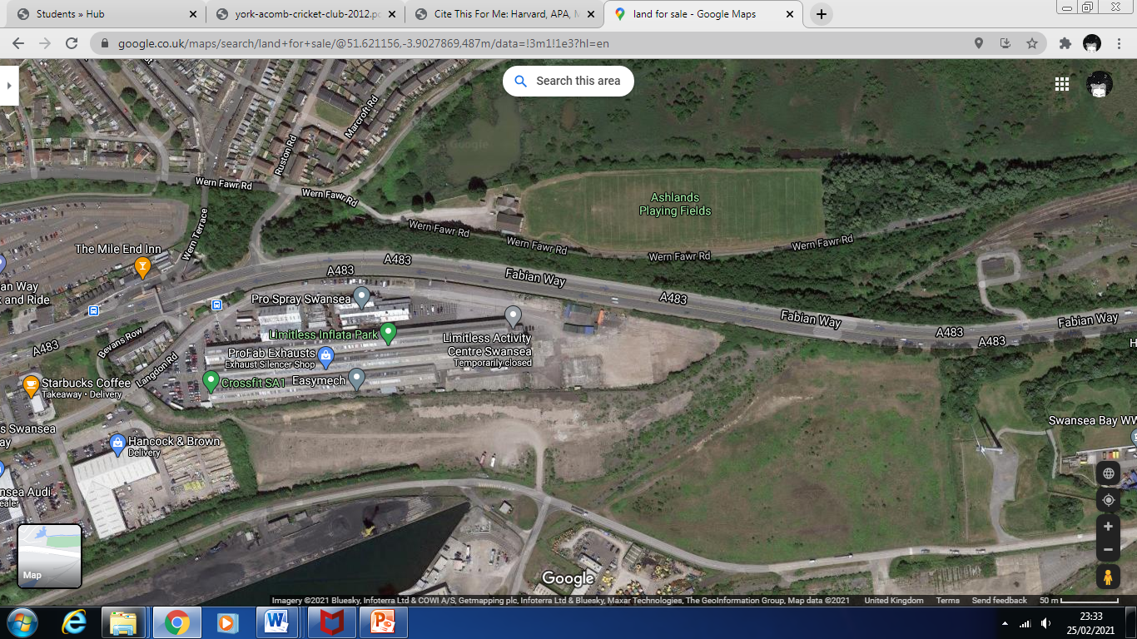

Seren Centre is being built in the Port Tennant are of Swansea. This project comes after a lack of sport facility centres that can accommodate for the needs of people from the disabled community. The centre will also give families the opportunity to meet others in similar positions. SEN Schools can also book sessions in the Seren Centre. Any of the facilities can be booked for birthday parties
The Centre will include two sports halls to offer a variety of classes such as sensory play and other that meet their needs to insure that they also as active as they can. Family member can also join in with their disabled family member.
There will also be a swimming pool with three mobility chairs to help wheelchair users into the pool with full support from professionals. Families will be able to join their family member that has a disability in the pool. Similarly to the Sports hall there will be session’s available to book. There will also be a soft room where the whole room is padded and cushioned in order to protect the participants from injury; the soft play room will be used to do floor activities.
Another room will be playing area is similar to the picture below where the area is wide enough for wheelchairs to be pushed around freely. Families and care providers will be able to book session in the play area any time in-between 10am-7pm…

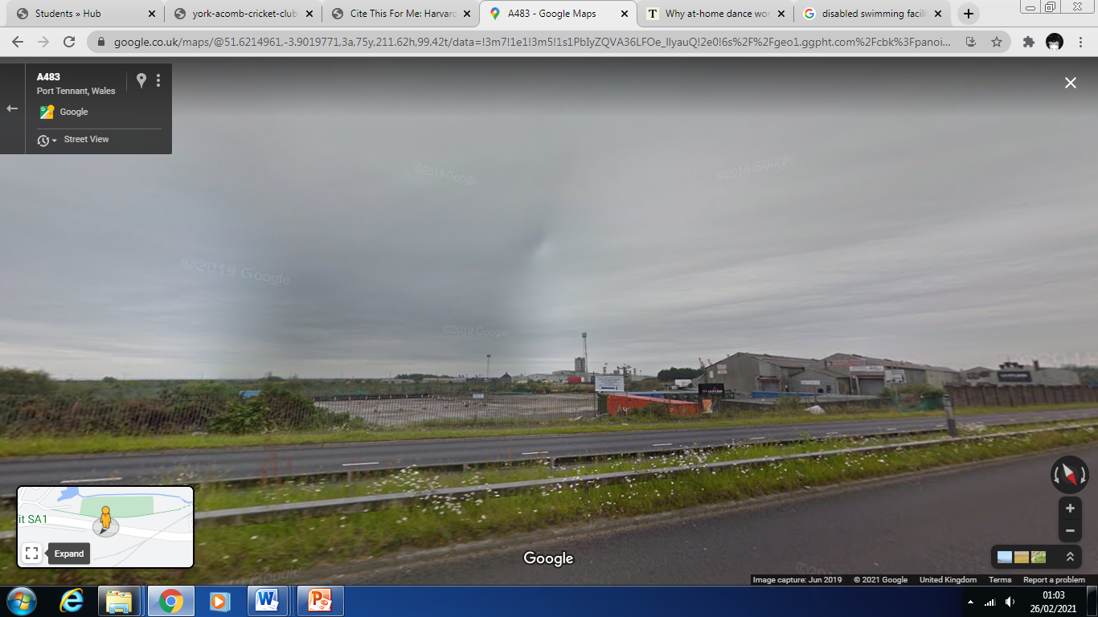
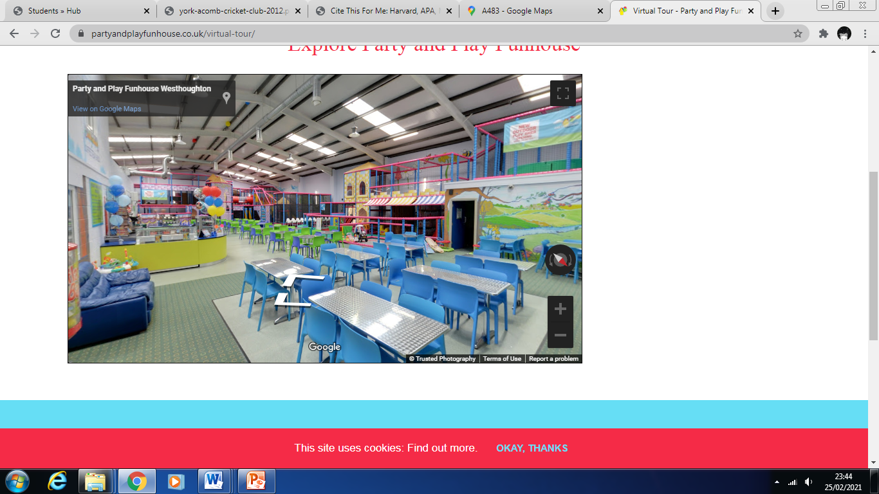
More information …
The car park will have mostly disabled parking spaces with large spacing to remove equipment from cars if needed. The entrance will be all flat so there will not be a need for ramps to access the building
Funding
Funding for the Seren Centre will be granted by a number of different charities and organization. The Welsh government and Swansea council will offer a grant sum of £500,000 in-between the both of them. Sport Wales have offered a grant sum of £100,000. The National Lottery has offered a donation of £200,000. The remaining £200,000 has been donations from the public as well as eight different charities that raise money for the disabled community.
Ownership Structure
The centre will be run by a not for profit trust meaning all money that is made will be to pay staff, building costs and the rest will be put back in towards funds for new and improved equipment

