Module 3
Student Number: 2246292
Name: Aramat Arnheim Sharon
Word count: 6526

Context

As a singer and Voice teacher with no qualifications in Essential Oils (EOs), users of EOs are sometimes my clients. Questions like do singers use EOs to improve their singing, and do they find it useful? Arise. Also, are there considerations for singers who want to use EOs? To answer this, I will conduct an online study, reaching out to singers and voice teachers worldwide through voice organizations and colleagues, reviewing the usage of EOs in mixed-methods approach, discussing gaps, safety protocols and ideas for future studies.

Justification

There is only anecdotal evidence and limited scholarship surrounding the effectiveness of EOs and its safety. While prescribed medications or some OTC (Over the counter) medications require studies prior distribution, EOs is labelled as food supplement and has less regulations and studies (Searl, 2001).
In an online search for peer reviewed papers, I found only two reviews on EOs for voice users (Calcinoni et al., 2021; Searl, 2001), those discuss chemical compositions and medical reports without communicating with users. Mavraj et al. (2022) was the only one I found that directly interacted with singers, but the focus was on Cannabidiol oil (CBD - marijuana active ingredient). CBD is considered a non-psychoactive oil, which means it does not alter the perception of reality; however, it is not distributed in some countries and is being studied (Schouten et al., 2023). Prescribed or regulated medication like CBD require finance for research, unlike oils presented in this project that are available OTC. The data collection will use both quantitative and qualitative approach, to present percentage of users accompanied with their experiences.

Intended Impact

Usage of supplements and OTC products for voice users and singers of different musical backgrounds can relate to stress (Mavraj et al., 2022b), understanding reasoning be it mental or physical health might guide singers to ask important questions prior usage. Ultimately, the singer knows their own physical and mental conditions, and these individual sensitivities will always affect the success or failure of any type of treatment. I hope this work will encourage education, communication and perhaps future studies and improved regulation systems for voice care and EOs.

Methods and Project Design and Timeline
Literature review will be used as a comprehensive source of information regarding possible risks and benefits of EOs and regulation status in the world (Osaili et al., 2023). The review will focus on peer-reviewed work and will reflect on findings considering the health needs of singers. My view as voice teacher and singer familiar with both positive and negative feedback for Eos will address gaps and questions that can be studied further. Online anonymous questionnaire will review the past usage and personal experiences looking both for EO users and non-users including validated SVHI (Singers Handicap Index) (Cohen et al., 2007, 2009; Sobol, Sielska-Badurek and Osuch-Wójcikiewicz, 2020). Thematic Analysis will be used to reflect on choices and impact. Though analysis may be subjective, the data collection will focus strictly on word coding and repeated patterns in answers.

The Project Timeline is in this following chart:

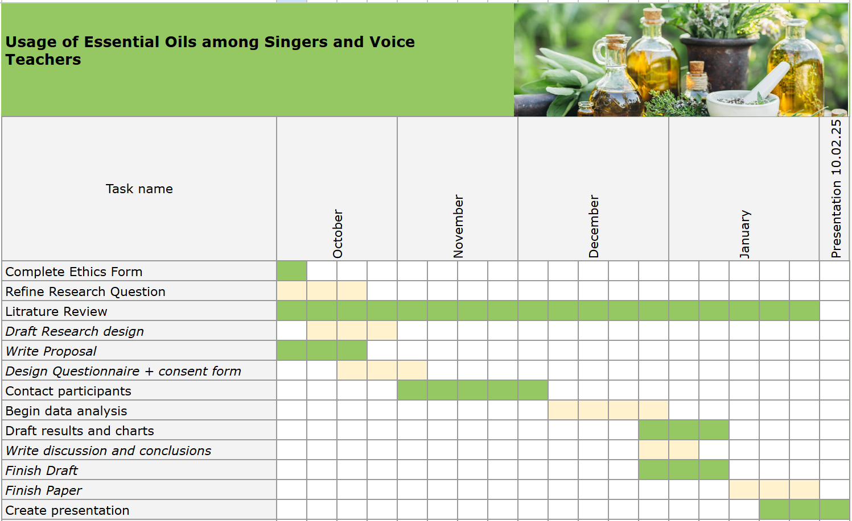

Ethics and Insider Research
As a researcher I will openly discuss my involvement in the community, as possible benefit knowing singer needs but also carefully considering any bias by including quantitative methods. The questionnaire is anonymous, there will be no attempt to encourage or discourage usage and simply review current choices, products and reported symptoms. Participants who agree to participate will be free to leave the form at any point and be made aware of that agreement.

Individual Learning outcomes

- Educating myself to give responsible advice regarding products for voice.
- Create guidelines for singers and voice teachers that will help them ask more accurate questions and seek appropriate professional guidance.
- Raise awareness to both negative and positive influence of EOs.
- Offer ideas for future studies and improved regulation.

USAGE OF ESSENTIAL OILS BY SINGERS AND VOICE TEACHERS

Introduction
This study engages with the topic of essential oils (EOs) in voice care, specifically singers and voice teachers, employing a mixed-method approach that combines a literature review, anonymous questionnaire, and thematic analysis. The question raised in this paper is whether EOs are being used by singers to improve their voice for performance or health maintenance and what are the risks and benefits. The literature review based on peer reviewed articles regarding EOs and herbal supplements, reflects that some herbs must be avoided and that all oils carry toxins that are potentially dangerous depending on how they are produced or taken into the body. Some specific oils have multiple benefits such as antibacterial qualities which is supported by a global trend of alternative care. However, improved regulation and more studies are needed alongside well-educated professionals who can offer advice on proper usage of EOs. Singers and voice teachers experiences were reflected based on an online questionnaire with 93 participants. The inductive analysis compared to literature offers preliminary safety protocols regarding EOs and their usage, as well as suggestions for future studies.

Review
Singers and professional voice users need to manage significantly more phonation time than regular voice users (Zuim et al., 2021; Titze, Švec and Popolo, 2003). Professional singers are sometimes required to perform day after day, singing accurately and stable, regardless of their physical situation which may include, illness or vocal fatigue (Kitch and Oates, 1994). As such, they need to maintain their voice and body to stay healthy and avoid illness, injuries, or other causes of hoarseness or voice instabilities. According to Reiter et al. (2015), hoarseness can be caused by multiple factors ranging from laryngitis to reflux or vocal fold injuries. These assessments are rarely treated with medicine, besides the use of PPIs (Proton pump inhibitors) for reflux or if the illness requires a type of antibiotics. Therefore, it is not surprising that singers may look for additional solutions that can assist in their day-to-day maintenance (Keservani, Sharma and Kesherwani, 2019).

Regulations and Requirements
In 2001, (Caulfield and Feasby), reflected on the growing market of CAM (Complementary and Alternative Care), and referred to some of it as ‘potions’ or false promises that are being adopted by both physicians and unregulated professionals. Naturopathy is a big field which includes much more than EOs. Snider and Zeff (2019) explain the regulatory journey that began in the 1970’s and later became the American Association of Naturopathy. Among many supporters and opponents of naturopathy, one of the biggest critics is a former ND (Naturopathic Doctor) Britt Hermes. Hermes (2018) writes about her experience witnessing lethal cases, in which negligent and unauthorized materials (not necessarily EOs) were used causing tragic losses. She brings an important critical voice to confront the attempts of the American Association of Naturopathy to establish a regulatory system. Malpractice has existed for years in the regulated medical field as well. As much as hospitals, physicians and regulatory systems try to avoid it, mistakes happen often (Localio et al., 1991). Therefore, with the importance of critic, consideration of risks should exist in all fields of medicine. The attempts to regulate and formalize a system for alternative care are global. Osaili et al.(2023) possible benefits of EOs and the need for global regulation that is gradually taking place while countries with no regulations, simply follow the WHO - World Health Organization, and the FAO – Food and Agriculture Organization of the United Nations. The World Naturopathic Federation also forms guidelines and keeps track of education and regulation in the field (World Naturopathic Federation, 2023). The events of the last 20 years suggest that a framework that may accept EOs and other types of Naturopathy is on the way. It seems some consumers, and some physicians are interested in alternative care. However, the EOs journey has a long way to go, and products are not regulated as other medicines yet.
EOs and herbal remedies are usually sold OTC or via naturopaths (licensed or non-licensed). Within local regulations, they may be considered a dietary supplement or nutraceuticals (Matera, Lucchi and Valgimigli, 2023). As such, the manufacturers do not adhere to pharmaceutical requirements and remain in the frame of complementary alternative care. The following chart presents the differences between the regulations of pharmaceuticals and nutraceuticals.
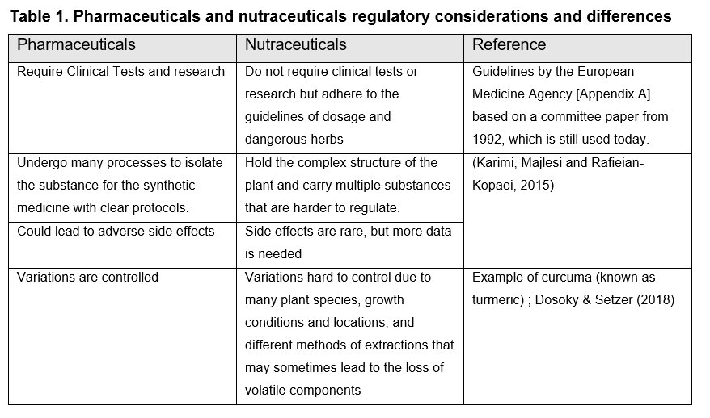
Herbal remedies, how and where they are manufactured impact many aspects that may cause inconsistencies and make it hard for any type of regulation to follow. Having said that, if EOs are considered a dietary supplement, it makes one wonder of the equivalents in the food industry like chemicals added to preserve food that today we know are not healthy. As an example, the raising awareness to benefits of wholewheat bread versus regular bread (Arvola et al., 2007). In herbal remedies since the plant materials are not isolated, we may be getting the advantage of the “whole plant” which may be a healthier composition in our body. If singers are looking for a healthier choice, this may be part of the logic, but more studies are needed to validate it.

Risks and Inappropriate Use
According to Nasri & Shirzad (2013), around 100,000 patients die every year in US hospitals because of toxicity from synthetic drugs, and that does not include the total of 8% of population admitted to the hospitals due to adverse reaction to drugs. Though herbal remedies still don’t hold a category in the United States national poison control centers, there is no knowledge of reports of death directly related to the oral intake of herbal remedies.
There have been a few reports that present danger in EOs or herbs. First example by Halicioglu et al. (2011) of oral intake of sage oil to infant leading to seizures, a second example of cardiogenic shock of a 64 year old man, likely caused by supplements (Gianfagna et al., 2020), and a more comprehensive letter report by Lam et al. (2021) reviewing many cases of toxicity by Chinese medicine over the course of 11 years in two emergency rooms in hospitals in Hong Kong. Though eventually rare cases led to severe outcomes, it was concluded that more education on identification of the toxicity and supervision on prescription of herbs should be encouraged, specifically aconite poisoning and methyl salicylate found in winter green oil. These reports are key in understanding which herbs can lead to physical damage, yet even within an 11-year period of a busy emergency room, findings were rare, and the two other reports were single case studies which may relate to irresponsible use of sage oil with a baby or overuse of supplements by an adult.
Searl (2001), created a comprehensive review of the possible risks of using supplements in general including EOs. This next chart summarizes the risks of certain supplements he collected in this review with the addition of poisoning review by Woolf (1999) and by Botma et al. (2001) regarding a single case example of laryngeal oedema.
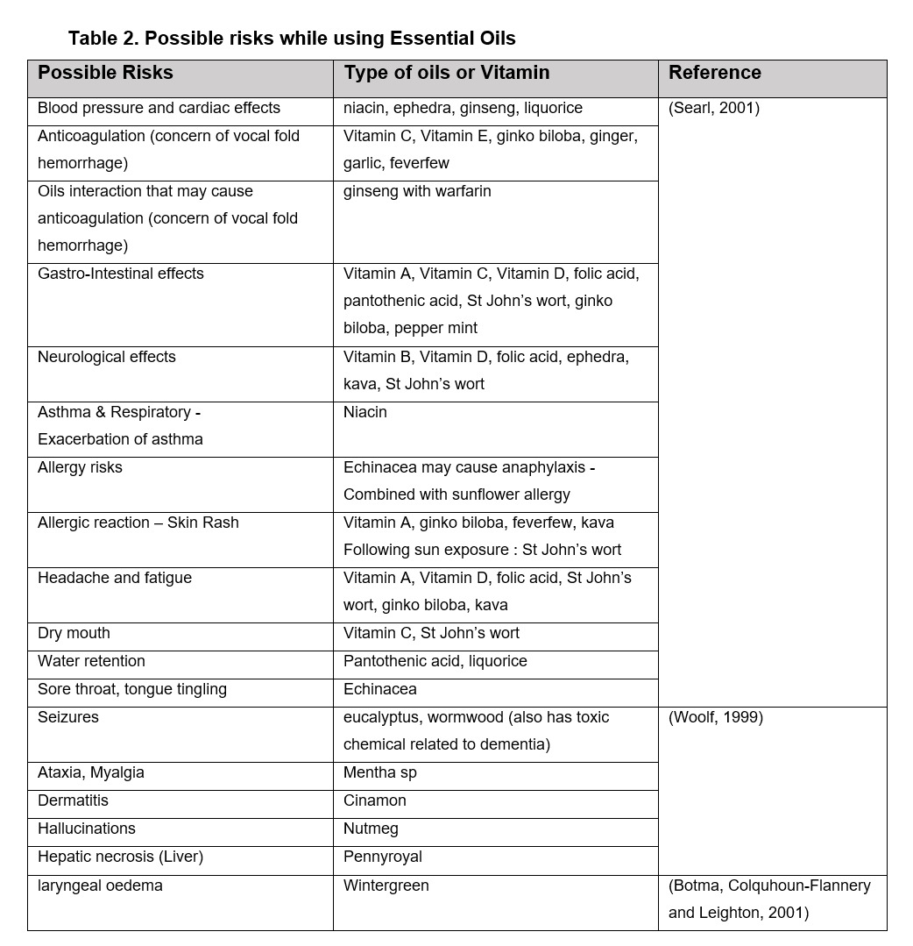
EO through inhalation
Singers and voice users are exposed to air particles that may carry chemicals or viruses daily. Be it from the aerosols, cigarettes, stage smoke, oils vaped in kitchens in bars that do not use appropriate air filtering, all which can be dangerous to inhale (Zhai and Albritton, 2020). Even E-cigarette vapes is known to have fatal lung disease complications due to Vitamin E carrier (Boudi et al., 2019) and everyday air fresheners may cause damage to the lungs (Kwon et al., 2013; Wolkoff and Nielsen, 2017). EOs are usually inhaled using air purifiers and indoor usage may have reaction to existing oxidants and form toxins (Angulo-Milhem et al., 2021), there is no specific article on residue that may accumulate in devices but singers who use them should consider cleaning them regularly and ventilate the room. Nevertheless, vapors have benefits such as myrtle oil reducing coronavirus, bacterium E, fungus A and coli (Kalaiselvan et al., 2022), thyme and peppermint EOs also showed to reduce viruses and contamination (Witkowska and Sowińska, 2013). In addition, specific oils show nerve reactions that may induce relaxation and “aromachology” may be a more appropriate term for the low doses consumed in EOs (Herz, 2009). There seem to be a general perception that natural remedies maybe less affective but also less risky than pharmaceutical drugs, and more likely to be used (Green, Horne and Shephard, 2013). This might support usage of oils for health and sanitization, but like synthetic drugs that are considered safe, singers should remember that any medicine may cause damage. The singers should use any product and any medication with caution and awareness and not rely only on the words of one seller, therapist, or doctor. That includes the advice of any trusted authority of teachers like me, that are lacking the professional knowledge to give advice regarding natural remedies. I am aware that suggestions by a person of authority can impact the client judgment; words and how they are transmitted may even affect the pain or concerns of the client and affect the success of the natural medicine that they choose (Koban et al., 2017). Furthermore, Chen et al. (2019) explains placebo affects through socially transmitted messages, in which even the doctor expressions can be part of the successful or unsuccessful treatment in the overall scheme. This is an ethical issue that physicians face day-to-day and is probably the reason why most doctors do not want to recommend drugs or natural medicine that has not gone through rigorous research.
A popular oil that came up in the questionnaire was eucalyptus. Sadlon and Lamson (2010), created a comprehensive review regarding eucalyptus oil both in human clinical trials, in animals and in lab. They also referred to tea tree oil and in their discussions of the many attributes of these EOs especially for airway diseases such as asthma and rhinitis, mostly in oral intake but also through inhalation. Risks were shown, with a single case of midlife female eucalyptus inhalation that caused a throat pain and possible vocal fold dysfunction which was later reduced as the treatment diminished and breathing exercises were introduced, suggesting that dosage should be addressed, and treatment should be tailored to individual needs especially in inhalation. Other negative reactions, including neurotoxicity, were noted among children, which reinforces more education on responsible usage is needed. In the summary they suggested that with proper dosage, eucalyptus oil offers multiple benefits despite minimal information regarding inhalation.

Immune System and Anti-Inflammatory Effects
Studies regarding specific herbs and their immune or anti-inflammatory effects that can be valuable to singers in oral intake. One example of a benefit to the immune system, found by Ciesielska-Figlon et al. (2023), was from the oil of Nigella sativa, showing strong immunomodulatory reactions on the lymphocytes of Hashimoto Thyroid patients. Nigella sativa acts on immune cells and could accompany treatment of immune-related diseases, such as autoimmune syndromes or allergies. Allergies are considered a risk for voice problems (Prebil, Hočevar Boltežar and Šereg Bahar, 2020). Singers who suffer from allergies are commonly prescribed with antihistamines which has a side effect that dries up the vocal fold tissues causing more throat clearing and possible coughing (Benninger, Murry and Michael M. Johns, 2016). Alternative care that does not cause dryness could be a potential benefit. Black seed oil (Nigella sativa) by Al-Azzawi et al. (2020), with 100 Chronic obstructive pulmonary disease patients (mild to moderate condition), showed significant improvement using the oil suggesting it may improve pulmonary functions, oxidant-antioxidant imbalance, and inflammation, and is a potential complementary treatment. Half of the patients received the additional oil treatment as an oral dose, and the other half received the regular medicinal treatment with no additions. Among many studies this was a particularly large group and the implication on the pulmonary system in general may be valuable to singers who rely on healthy pulmonary functions with high demands of air regulation during phonation.
Pelvan et al. (2022) offered a comprehensive review of extracts with anti-inflammatory and immunomodulatory bioactive components. The oils were extracted by the following 11 herbs: marjoram, black cumin, lemongrass, sage, bay laurel, thyme, clove, peppermint, lemon balm, rosemary, and fennel. Zhang et al. (2020) reviewed and studied 6 traditional Chinese medicine herbs (Myrrh,Frankincense, , Matricaria chamomilla, Syzygium aromaticum, Jasminum sambac and Radix aucklandiae) and after investigating the chemical structure and performing tests on mice, showed they have anti-inflammatory response and may offer a replacement to common steroidal anti-inflammatory drugs (SAIDs) and non-SAIDs (NSAIDs).
Oregano oil have been shown to have antibacterial mechanisms that may have antibiotic properties and furthermore can inhibit the genetic process MRSA (Meticillin-resistant Staphylococcus aureus) that make our body resistant to synthetic antibiotics (Cui et al., 2019). This was only tested in lab conditions, and it would be interesting to expand the tests to people suffering from MRSA and see if similar results can be found in different forms of intake. In addition, the use of oregano oil was studied in a pig farm as part of their diet (Ranucci et al., 2015), sweet chestnut wood extract combined with oregano essential oil was found useful in increasing the pig antioxidant levels. Another study by Grondona et al. (2014) of anti-inflammatory properties of the oregano (Origanum vulgare) on a mouse airway inflammation, found the oil has strong anti-bacterial, antioxidant, chemo preventive properties and potential of bio protector activity due to the terpenes (plant-based compounds in the formula) that can interact with microorganisms. This could be a potential prevention of illness that will help singers stay healthy and require future experimental studies but will always face the ethical obstacle of substance usage on human subjects therefore lab tests are a safe start.
While chronic illnesses are difficult to treat, Rufino et al. (2015) performed a new cell specific study investigating the EOs E. duriaei subsp. juresianum and L. luisieri with their anti-inflammatory potential. The results suggested using the active ingredients may assist in treating inflammatory bowel disease (IBD) and osteoarthritis (OA). Singers who use EOs are advised to find up to date studies for specific herbs as more can be found on each oil. Professional singers that have high vocal demands need to have a general physical endurance throughout long rehearsal days and shows. If health conditions impact the joints or cause pain and discomfort it will interfere with the singer ability to perform, and that is again a reason why singers look for alternative care. Digestive illnesses also weaken the body and need deeper consideration, this is addressed in the following section.

Digestive Impacts on the Singing Voice
Though cases of EOs reactions in Hong Kong emergency rooms (Lam et al., 2021) were rare, the reaction in many of the cases involved vomiting and stomachache, matching with symptoms of poisoning and reactions of the digestive system. On the other hand, the in-cell models in the study by Rufino et al. (2015) showed potential in helping a chronic digestive illness. Digestive illnesses in general are more widespread recently and impact the longevity and quality of life (Gong et al., 2024). Singers in particular want to stay healthy and strong and should be aware of their diet and the products they consume. (Searl, 2001) mentioned possible digestion issues that can occur from misusing herbal remedies, among them he raised the possible connection between peppermint and reflux, and the issues that singers may have due to reflux or any digestion problem that may reduce the effectiveness of breath control. Reflux may cause swelling or injury of the vocal folds (Lechien et al., 2019), muscle tension (Kandogan, Aksoy and Dalgic, 2012) and even chronic laryngitis (Witt et al., 2014). Reflux and the clinical implication or the diagnosis itself is controversial among professionals (Sataloff, Hawkshaw and Gupta, 2010), however whether the diagnosis itself is accurate or not, it makes sense that heartburns or digestion issues may interfere with effective singing. It has been suggested that diet changes specifically related to reduction of alcohol, caffeine, tomato and fried or spicy foods improves the reflux symptoms significantly (Tosetti et al., 2021). The question is, will supplements in the form of EOs trigger digestion problems or help reduce it. From a clinical point of view, as shown by some examples in our participants later, there are singers that have negative reactions to certain herbs or EOs but no formal data on that matter. This brings up again, the importance of careful self-care and awareness to any discomfort a singer may feel, specifically as a reaction to an EO, and the importance of a knowledgeable professional that will advise and inform the singer about dosage and best personalized choice of oil.

Herbal Remedies and the Voice Users
Calcinoni et al. (2021) created a valuable database for voice users about herbal remedies. She mentioned an interesting herb known as the “singer’s plant”, the official name is Sisymbrium officinale, or in English hedge mustard, but the traditional name from ancient Greek means something like – “I save Sing”. This illustrates how long-ago solutions for singing and voicing were part of the culture, specifically with herbs. Her report also shows many other recent studies relating to the anti-inflammatory and other benefits of this specific plant including improving comfort in the vocal tract. Her database is available to the public, among 40 plants, 5 EOs are: Eucalyptus, olivella dei Carpazi, menta piperita and sage.

Methods
Alongside the literature review presented in this article thus far, a questionnaire was sent to voice teachers and singers worldwide. While the questionnaire was anonymous, it was sent through colleagues and voice organizations and likely to reach mostly UK, USA and Israel. Within a 3-week period of sending it, 93 participants took part, all of them either singers or voice teachers or both. Experiences were analyzed in mixed quantitative and qualitative measures, including TA – Thematic Analysis and inductive coding (Clarke and Braun, 2017).
In addition, a short SVHI - Singers Voice Handicap questionnaire was used to evaluate personal voice perception. The SVHI was validated in multiple studies as a useful tool to assess singers who are particularly sensitive about their voices (Cohen et al., 2007, 2009; Sobol, Sielska-Badurek and Osuch-Wójcikiewicz, 2020), it was also translated and validated to other languages among them persian (Ghaemi et al., 2020) and Spanish (García-López et al., 2010). In contrary to most validation studies Longo et al. (2023) found SVHI is not useful for distinguishing healthy versus dysfunctional voices, however the demographic in his study were not professionals, and among many validations two others suggest a strong correlation between the grades and physical condition (Baracca et al., 2014) and Kannada language (Gunjawate et al., 2017).

Results
Out of 93 participants, only two personal data categories were collected: age and profession details that could potentially provide deeper insights comparing years of experience or musical style to voice-care choices. The questions were divided into two groups of EO users and non-users. Overall, professional data and age did not show significant difference between groups. The age average was slightly higher for the EO users, but that was due to one specific older participant. Except one that did not share exact age, the age of total 92 participants ranged between 20 to 72, with an average of 41 and standard deviation of 13.5.
This questionnaire was designed for voice teachers and singers, most of them identified as both teachers and singers. The chart below shows 66.7% were both singers and voice teachers, with an additional 12.9% who are only voice teachers and currently don’t work as singers and 20.4% who are only singers.
CHART 1. Profession of the Participants
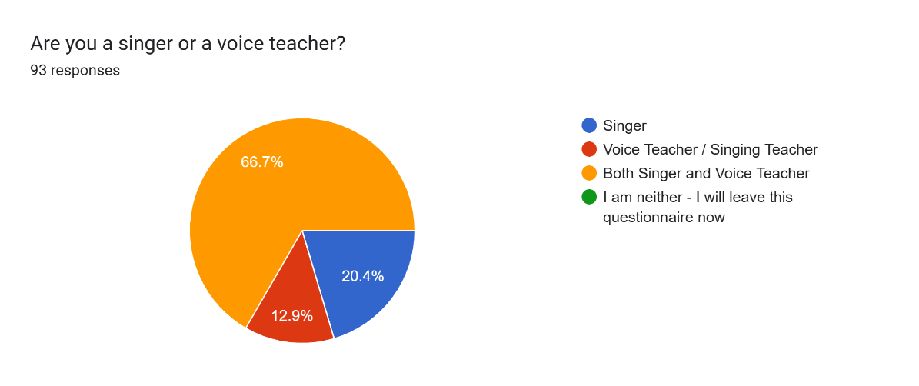
Looking at the scope of work, chart 2 demonstrates that over half of the participants (51.7%) work as singers or teach over 20 hours a week or as a full-time job while 34% work 10 -20 hours a week. The rest of the participants were part time singers or teachers. Both groups of EO users and non-users had relatively high averages on their scope of work between half-time to full-time job.

CHART 2. Scope of Work
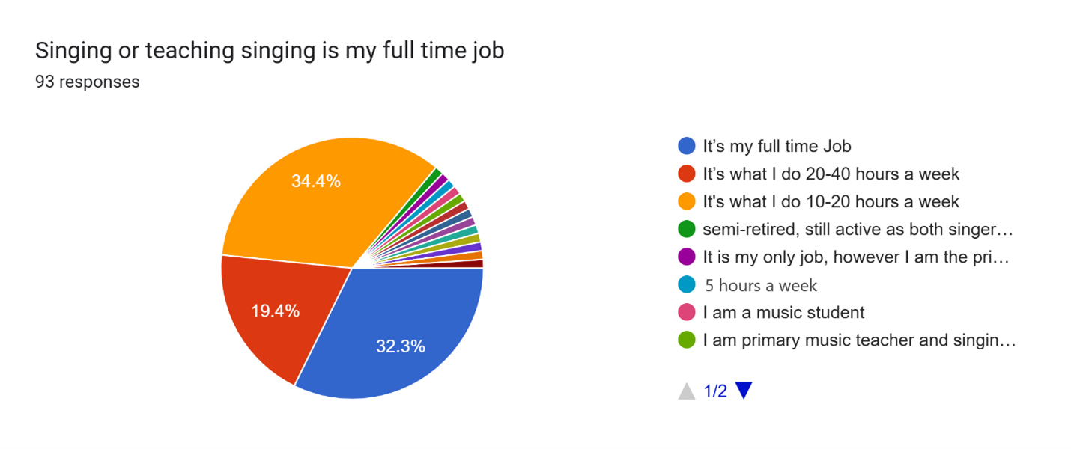
Among 59 non-users most of them were engaged in CCM, musical theatre or other contemporary styles and 9 added classical to their style combination, 6 were focused only on classical singing and 2 were working with acting voice. Among the 34 users most were CCM and musical theatre but 7 of them did both classical and contemporary while 4 were mostly classical or choral professionals. Therefore, professional style did not feature any significant difference between the two groups, overall styles shown in Graph 1.
Graph 1. Musical Styles relevant to the work
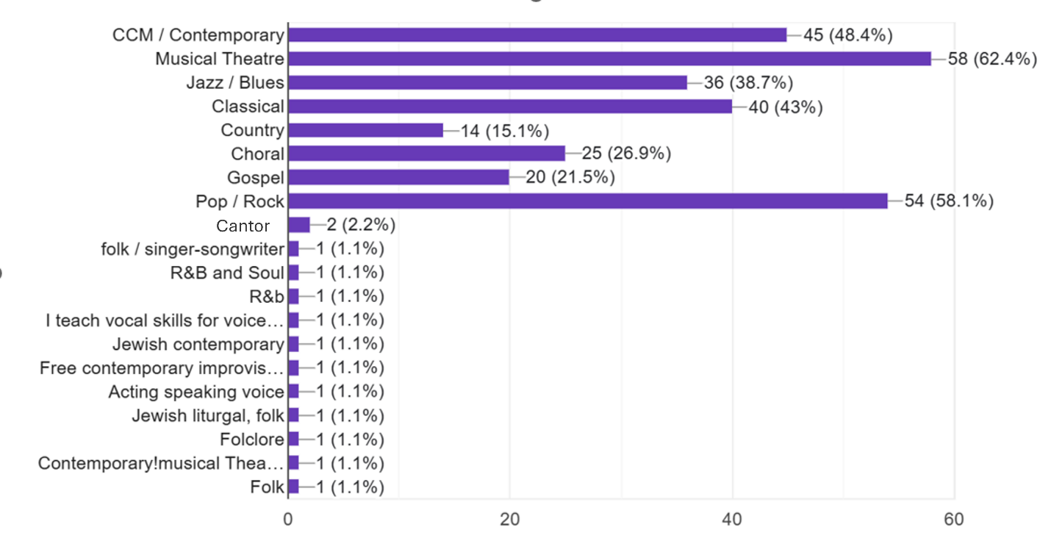
Out of 93 participants, 59 were non-users, and 34 were using EOs in different ways. Among the non-users, some have tried EOs in the past, and as we review individual experiences in Thematic Analysis (Clarke and Braun, 2017), we will discuss those results as well.

The SVHI results should reflect the self-perception of each singer or teacher voice. Difficulty or struggles can be expressed by a computed mark as high as 40 and comfort can be low as 0. The following graph reflects the distribution of SVHI results divided between users and non-users. Interestingly in both groups the ones who said it is their full-time job, which would indicate higher demand for their voice, had a positive average score of SVHI: 8.1 for users and 8.7 for non-users.

Graph 2. SVHI Results Distribution of EO users and non-users
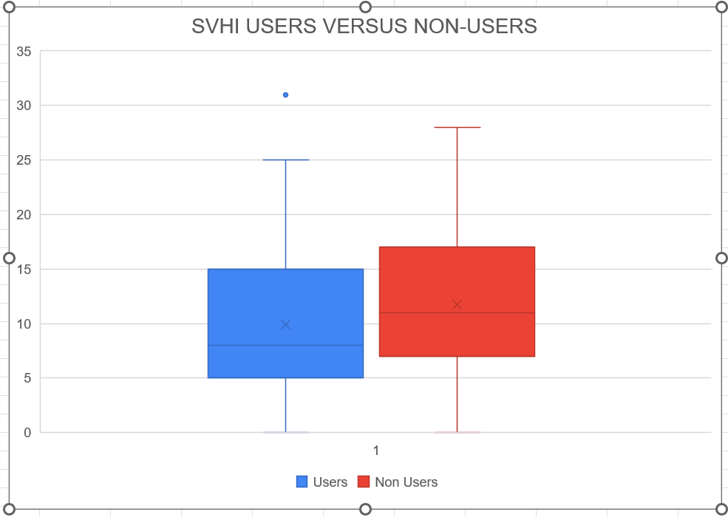
While the average of EO users (9.9 with standard deviation of 7.2) is slightly lower than the average of non-users (11.7 with standard deviation of 6.6), it is hard to say that those results reflect any substantial benefit to the use of EOs. Even the outlier in the EO users group did not skew the data enough if removed, and t-Test review showed that this difference is not significant. If one were to think that those who experience more voice difficulties will be the ones using alternative solutions like EOs, this specific distribution does not show that, it could be the opposite, that EO users take care of their well-being in many ways and improve their lifestyle which makes them feel slightly better regarding their voice. However, this data does not offer any direct link to EOs benefit and may be a result of specific population that participated.

Non-Users Experiences
Out of 59 non-users, 22 participants have tried EOs in the past. Their written experiences were divided into 4 types: positive feedback, disappointment, bad feedback and critical feedback. 8 participants shared positive feedback using words like ‘nice experience’, but most of them either used it for relieving stress, bedtime or illness through scent and humidifiers. One participant who did use it orally shared a positive experience and quoted friends who said it “magically opened their voice”. The types of oils mentioned by this group were lavender, peppermint, eucalyptus and vetiver, in addition brand names like DoTerra, Simfonus2000 and U-Cali were mentioned. Disappointment type by 7 participants included this one quote: ‘a friend suckered me into it’ while others shared it had no effect on them. One did use EOs for their voice and wrote they paid a lot of money for products that did not work, and another could not use products due to allergies. The bad feedback type by 2 participants related to increased reflux following usage, one was containing oregano oil. Lastly, 3 participants were the critical type, one was concerned and wrote ‘I am frankly shocked that you are bothering to attempt to study something that is reckless and potentially dangerous for singers’. Another participant wrote ‘In my opinion it just gets the vocal cords used to things that are not always needed’, and the last one wrote ‘I used them during yoga, but I would NEVER use them or recommend them as a voice treatment. There is no evidence for their efficacy and actually evidence against their efficacy’. The Critical feedback group and the bad feedback group correlates with critic I shared from the literature regarding regulation, recommendations by authority and reinforces the ethical concerns for future experiments with human subjects. It also reinforces studies that found some oils may cause reflux for individuals.

EO Users Experiences
Users of EOs shared the name of oils used, the most common ones were Lavender with 13 mentions, Peppermint with 11 mentions and Eucalyptus or Eucalyptus Globus with 10 mentions.
The Graph below shows all the mentions made by users, one of the users even shared a recipe they use of Spearmint and Lavender in 3 to 5 ratio. Brand names or trends associated with certain smells, availability of herbs in a local region, and marketing are all potential influencers on singer choices, perception or in shaping user experiences. However, as mentioned earlier, some of these oils have shown benefits that may also contribute to their popularity.

Graph 3. Number of Mentions for Each Essential Oil Used
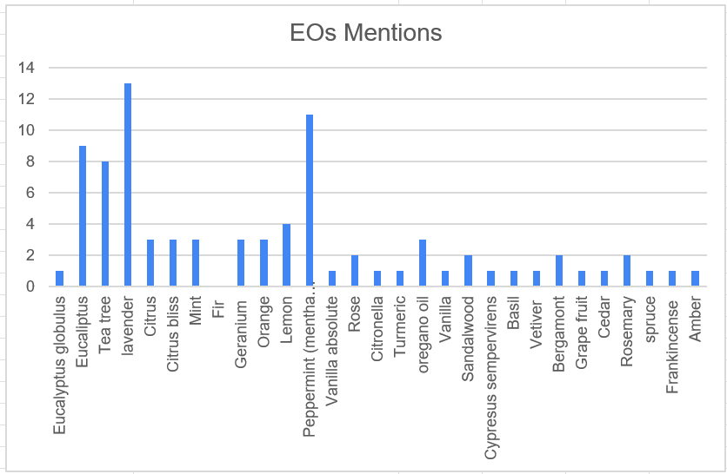

Brands and Products
Out of 16 Brands mentioned, only 6 promote their products as supplements that are taken orally and not just for external use or Aromatherapy. Every brand follows different regulations as they are manufactured and sold in different locations in the world. This data is based solely on what the companies publish on their websites. Participants also mentioned two nasal sprays (Alkalol, Xlear Rescue) that contain EOs or tablets containing EOs (GeloMyrtol). Taw, Nguyen and Wang (2022) reflected on the trends of holistic alternative treatments surrounding Rhinosinusitis and concluded that these years are bringing a shift in paradigm that includes a wider approach in which they also include complementary care that includes EOs. This is yet another good example of the medical world trying to adapt and recognize new trends in self-care and CAM. The GeloMyrtol for example is registered and patented, that is a rare find in the EOs industry considering there is peer reviewed literature about the product itself (Paparoupa and Gillissen, 2016).
This brings up the discussion regarding financial issues that may be part of the reason we do not see much peer reviewed literature on brands or specific products. The EOs industry will never be as rich as the prescribed drugs industry, and that will always lead to less papers and less science, unless brands link GeloMyrtol will find ways to patent their work. This could lead to more science and accuracy but might make some of those natural solutions less accessible for self-care.
When it comes to self-care, according to some responses in the questionnaire, the users still have a lack of awareness of difference between EOs and Homeopathy. For example, one participant mentioned the products of Dr Reckeweg, which are well known Homeopathic drops. It is important to raise awareness of the difference between those two forms of care. Homeopathy is not always based on herbs and has little to no active ingredients. In addition, many of the brands mentioned by participants are promoted as Aromatherapy which means they should only be used as a scent product. Understanding that some oils are only used for room scent and not for skin or direct inhalation is important. As mentioned earlier in this review there is very little information about the inhalation of EOs. Between benefits or risks, EOs that are regulated as supplements can be consumed and may be safer with carful dosage. One of the participants, who is a user, shared a cautious tale of a lethal case of eucalyptus high dosage with a singer. I tried to find literature about it but had no success in the peer reviewed literature. However, it suggests that this is a cautious user and aware of risks. The table below offers the list of brands mentioned by participants, the number of mentions and how the products are promoted in terms of usage.

Table 3. Mentions of Brands Used and How These Are Promoted
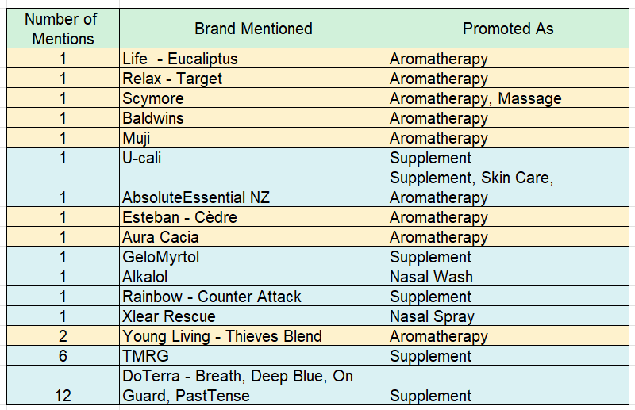

Reasons and Usage
When asked what the motivations were to start using EOs the answers seemed to split into 2 main types: for health or for fragrance and relaxation. Out of 34 Users, 18 use EOs for general health like colds and sore throat, among them 3 mentioned the words voice and singing, one specifically explained how the oils help avoid sickness, as maintenance that indirectly help the singing voice. The remainder 16 users were mostly using diffusers or other fragrance methods for relaxation. One uses it in the teaching studio, others mostly at home. Among them 9 mentioned they do not use it for voice, and I will quote one of them that was concerned about usage that goes beyond Aromatherapy “I use perfume solids or sprinkle of oils as occasional perfume only. I'm medically trained and don't believe that oils generally are good for voice or lungs. Lungs should be a sterile field, steam-nebulizer only. Eucalyptus mildly helpful for sinus infections but otherwise I discourage clients from using or relying on sprays and inhalations”. Below is a graph of common words that were used in the shared experiences, many of them related to health issues. Words like cold, sick, flu, virus, throat, pain were generally shared in many of the experiences throughout the responses.
Graph 4. Mentions of Health or Relaxation in different words
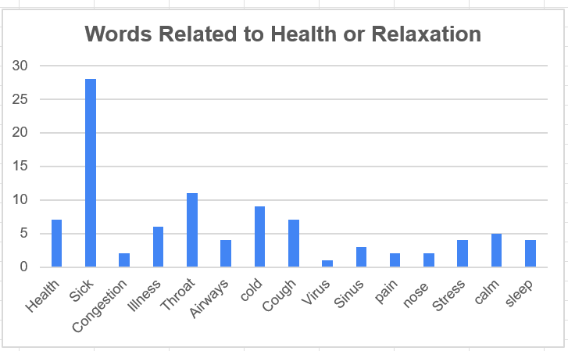
It is important to mention that though users of EOs seem to be almost 40% of 93 participants, looking at the usage itself reveals that those who use it for health reasons and not just for fragrance, are more around 19%. In addition, the Aromatherapy users are cautious and raise important concerns. One of them mentioned using the diffusers at home sometimes dries up their throat. On the other hand, and in contrary to a couple of non-users bad experiences related to initiation of reflux after using Oregano or other blends, one of the users mentioned that lemon EO helps them relieve reflux. As mentioned earlier on possible reflux by specific oils, this reinforces the importance of matching to individual needs, learning self-care and body responses and professional advice regarding EOs choices.
Participants were asked when they choose to use oils, the most common reply was to avoid or heal from sickness or stress. The questionnaire offered multiple options and participants could add their own. The answers shown in the following graph are the responses which were most prominent on either home usage or when feeling sick.

Graph 5. When EOs Users Use the Oils
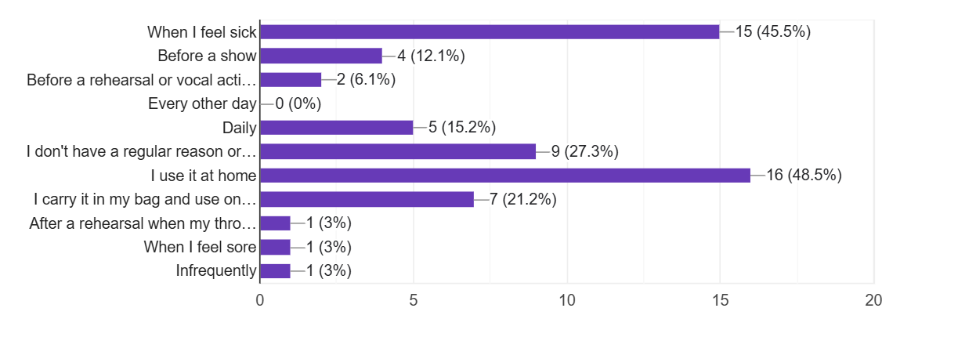
Lastly, the users were asked to share any positive or negative experiences. Out of 34 users, 22 shared their experiences. Those included 3 types of experiences, health, relaxation, and another type emerged, a more ambiguous experience in which participants mentioned they were not sure if it helps physically or more mentally. In total out of 22 experiences 5 were on the ambiguous type and another one was a combination of all 3 types and was a positive experience. For relaxation, only one shared both negative and positive feedback, they mentioned that if a pupil does not enjoy the scent, they turn off the diffuser in the studio. The other relaxation feedback included health feedback as well; it was overall positive usage of oregano oil for sickness. All other responses were regarding health, only 3 shared negative experiences and two more shared both positive and negative. One negative response was from a user who normally only uses the oils as Aromatherapy and mentioned overusing it negatively affects their airways, the second one was similar, the user who felt dryness from using Aromatherapy and the third was the previously mentioned cautious tale about overuse of eucalyptus. The last one to mention both negative and positive experiences referred to how the oregano oil was helpful but another blend from an unmentioned name brand included instructions to inhale from a bottle of boiling water which once came into their mouth. All those negative experiences are somehow connected to misuse, overuse, lack of responsible guidelines and the issue of Aromatherapy that is not regulated as a supplement and may not be healthy to directly inhale. Furthermore, even for regulated supplements, there is hardly any regulation and lack of information when it comes to inhalation. And while studies confirm effective inhalation by vapors in CBD oil (Javadi-Paydar et al., 2019), it is hard to find any short term or long-term effect on airways or on the throat in studies.

Based on the risks reflected in this paper, Appendix B and Appendix C include a strategy and protocol to help to guide the singer to ask important questions before using EOs. Afterwords it includes guidelines to gradual and controlled usage in case the singer chooses to use EOs. All these guidelines are based on the literature found in this article, and the experiences. All of these should help singers consider risks and physical reactions to herbs, possible allergies and toxics, health conditions specifically of digestion (Welling, 1996) and gradual exposure as an important precaution (Supartini, Maharani and Waluyo, 2021). This may serve as a temporary tool but a bigger shift the paradigm is needed for future responsible care with EOs including studies to determine effectiveness.

Study Limitations
There are two major limitations in this study that could be addressed in future research. First, the lack of literature and experiments that directly connect professional voice users with EOs benefits or risks in human subjects make it hard to reach a conclusive answer regarding EOs efficacy. Second, while some correlations between existing literature and experiences can be made and even amplify both the concerned opinions and the positive feedback, a bigger outreach to more participants would offer better understanding of usage. The careful approach in this study was able to suggest discussions during the growing global trend of alternative care, specifically among voice users.

Conclusions
In summary, while well studied treatments such as steam for hydration of the vocal folds have been proved to be effective (Vermeulen et al., 2021), singers still turn to more solutions in alternative care. Some EOs show potential in improving the immune system, perhaps as antibacterial agents or a good substitute to steroids or non-steroids anti-inflammatory medicine, and some may even solve the resistance that was developed in the body to antibiotics. These may be valuable qualities that can potentially benefit singers and help reduce hoarseness and prevent sickness of the upper airways. However, a strong caution should be taken, the issue of how to take the oils, the quality of the oils, the choice of herb and the dosage require more investigation. Without it, the danger of misuse and toxicity exists. While governments look at EOs as a supplement and not potential medicine, the market may be full of variations that can risk singers and their voices. Singers should be careful and consult with established herbalists and while considering different suggestions or begin any type of self-care by EOs, they need to acknowledge the difference between Aromatherapy and Supplements, follow protocols of careful choices and gradual use and stop using EOs at any sign of discomfort. The information presented in this article with the additional guidelines and protocols may help singers and voice users to make educated decisions and responsible usage or avoidance, but these are just the beginning. This study shows that some singers and voice teachers use EOs for their voice health, therefore experimental future studies are important. Furthermore, global or local organizations of naturopathy and EOs could use their influence and connections to promote studies working along with governments and advance the regulations.

References
Al-Azzawi, M.A. et al. (2020) ‘Therapeutic effects of black seed oil supplementation on chronic obstructive pulmonary disease patients: A randomized controlled double blind clinical trial’,

Heliyon, 6(8). Available at: https://doi.org/10.1016/j.heliyon.2020.e04711.
Angulo-Milhem, S. et al. (2021) ‘Indoor use of essential oils: Emission rates, exposure time and impact on air quality’, Atmospheric Environment, 244, p. 117863. Available at: https://doi.org/10.1016/j.atmosenv.2020.117863.

Arvola, A. et al. (2007) ‘Consumers’ beliefs about whole and refined grain products in the UK, Italy and Finland’, Journal of Cereal Science, 46(3), pp. 197–206. Available at: https://doi.org/10.1016/j.jcs.2007.06.001.

Baracca, G. et al. (2014) ‘Validation of the Italian version of the Singing Voice Handicap Index’, European Archives of Oto-Rhino-Laryngology, 271(4), pp. 817–823. Available at: https://doi.org/10.1007/s00405-013-2658-y.

Benninger, M.S., Murry, T. and Michael M. Johns (2016) The Performer’s Voice. 2nd edn. Plural Publishing.

Botma, M., Colquhoun-Flannery, W. and Leighton, S. (2001) Laryngeal oedema caused by accidental ingestion of Oil of Wintergreen, International Journal of Pediatric Otorhinolaryngology. Available at: www.elsevier.com/locate/ijporl.

Boudi, F.B. et al. (2019) ‘Vitamin E Acetate as a Plausible Cause of Acute Vaping-related Illness’, Cureus [Preprint]. Available at: https://doi.org/10.7759/cureus.6350.

Calcinoni, O. et al. (2021) ‘Herbs for Voice Database: Developing a Rational Approach to the Study of Herbal Remedies Used in Voice Care’, Journal of Voice, 35(5), pp. 807.e33-807.e41. Available at: https://doi.org/10.1016/j.jvoice.2019.12.027.

Caulfield, T. and Feasby, C. (2001) ‘Potions, promises and paradoxes: complementary medicine and alternative medicine and malpractice law in Canada.’, Health law journal, 9, pp. 183–203.

Chen, P.-H.A. et al. (2019) ‘Socially transmitted placebo effects’, Nature Human Behaviour, 3(12), pp. 1295–1305. Available at: https://doi.org/10.1038/s41562-019-0749-5.

Ciesielska-Figlon, K. et al. (2023) ‘The Impact of Nigella sativa Essential Oil on T Cells in Women with Hashimoto’s Thyroiditis’, Antioxidants, 12(6), p. 1246. Available at: https://doi.org/10.3390/antiox12061246.

Clarke, V. and Braun, V. (2017) ‘Thematic analysis’, The Journal of Positive Psychology, 12(3), pp. 297–298. Available at: https://doi.org/10.1080/17439760.2016.1262613.

Cohen, S.M. et al. (2007) ‘Creation and Validation of the Singing Voice Handicap Index’, Annals of Otology, Rhinology & Laryngology, 116(6), pp. 402–406. Available at: https://doi.org/10.1177/000348940711600602.

Cohen, S.M. et al. (2009) ‘Development and validation of the singing voice handicap‐10’, The Laryngoscope, 119(9), pp. 1864–1869. Available at: https://doi.org/10.1002/lary.20580.

Cui, H. et al. (2019) ‘Antibacterial mechanism of oregano essential oil’, Industrial Crops and Products, 139, p. 111498. Available at: https://doi.org/10.1016/j.indcrop.2019.111498.

García-López, I. et al. (2010) ‘Validation of the Spanish version of the voice handicap index for vocal singing (SVHI)’, Acta Otorrinolaringologica (English Edition), 61(4), pp. 247–254. Available at: https://doi.org/10.1016/S2173-5735(10)70045-4.

Ghaemi, H. et al. (2020) ‘The Singing Voice Handicap Index (SVHI): Validation and Adaptation Into Persian’, Journal of Voice, 34(1), pp. 158.e17-158.e23. Available at: https://doi.org/10.1016/j.jvoice.2018.07.025.

Gianfagna, S. et al. (2020) FIT Clinical Decision Making SNAKE OILS AND SHOCK: SUPPLEMENT AND ESSENTIAL OIL INGESTION LEADING TO ANTHRACYCLINE-LIKE TOXICITY AND CARDIOGENIC SHOCK.

Gong, S. et al. (2024) ‘Study on the burden of digestive diseases among Chinese residents in the 21st century’, Frontiers in Public Health, 11. Available at: https://doi.org/10.3389/fpubh.2023.1314122.

Green, D.W., Horne, R. and Shephard, E.A. (2013) ‘Public perceptions of the risks, benefits and use of natural remedies, pharmaceutical medicines and personalised medicines’, Complementary Therapies in Medicine, 21(5), pp. 487–491. Available at: https://doi.org/10.1016/j.ctim.2013.07.007.

Grondona, E. et al. (2014) ‘Bio-efficacy of the Essential Oil of Oregano (Origanum vulgare Lamiaceae. Ssp. Hirtum)’, Plant Foods for Human Nutrition, 69(4), pp. 351–357. Available at: https://doi.org/10.1007/s11130-014-0441-x.

Gunjawate, D.R. et al. (2017) ‘Adaptation and Validation of the Kannada Version of the Singing Voice Handicap Index’, Journal of Voice, 31(4), pp. 507.e7-507.e11. Available at: https://doi.org/10.1016/j.jvoice.2016.10.012.

Halicioglu, O. et al. (2011) ‘Toxicity of salvia officinalis in a newborn and a child: An alarming report’, Pediatric Neurology, 45(4), pp. 259–260. Available at: https://doi.org/10.1016/j.pediatrneurol.2011.05.012.

Hermes, B. (2018) ‘An Inside Look at Naturopathic Medicine: A Whistleblower’s Deconstruction of Its Core Principles’, in Pseudoscience. The MIT Press. Available at: https://doi.org/10.7551/mitpress/10747.003.0011.

Herz, R.S. (2009) ‘Aromatherapy Facts and Fictions: A Scientific Analysis of Olfactory Effects on Mood, Physiology and Behavior’, International Journal of Neuroscience, 119(2), pp. 263–290. Available at: https://doi.org/10.1080/00207450802333953.

Javadi-Paydar, M. et al. (2019) ‘Vapor inhalation of cannabidiol (CBD) in rats’, Pharmacology Biochemistry and Behavior, 184, p. 172741. Available at: https://doi.org/10.1016/j.pbb.2019.172741.

Kalaiselvan, P. et al. (2022) ‘Ability of Essential Oil Vapours to Reduce Numbers of Culturable Aerosolised Coronavirus, Bacteria and Fungi’, Antibiotics, 11(3), p. 393. Available at: https://doi.org/10.3390/antibiotics11030393.

Kandogan, T., Aksoy, G. and Dalgic, A. (2012) ‘Effects of Omeprazole Over Voice Quality in Muscle Tension Dysphonia Patients With Laryngopharyngeal Reflux’, Iranian Red Crescent Medical Journal, 14(12), pp. 787–91. Available at: https://doi.org/10.5812/ircmj.2292.

Keservani, R.K., Sharma, A.K. and Kesherwani, R.K. (2019) Nutraceutical and Functional Foods in Disease Prevention. Edited by Raj K. Keservani, Anil K. Sharma, and R.K.
Kesharwani. IGI Global. Available at: https://doi.org/10.4018/978-1-5225-3267-5.

Kitch, J.A. and Oates, J. (1994) ‘The perceptual features of vocal fatigue as self-reported by a group of actors and singers’, Journal of Voice, 8(3), pp. 207–214. Available at: https://doi.org/10.1016/S0892-1997(05)80291-7.

Koban, L. et al. (2017) ‘What’s in a word? How instructions, suggestions, and social information change pain and emotion’, Neuroscience & Biobehavioral Reviews, 81, pp. 29–42. Available at: https://doi.org/10.1016/j.neubiorev.2017.02.014.

Kwon, J.-T. et al. (2013) ‘Cytotoxic Effects of Air Freshener Biocides in Lung Epithelial Cells’, Natural Product Communications, 8(9). Available at: https://doi.org/10.1177/1934578X1300800929.

Lam, R.P.K. et al. (2021) ‘Traditional Chinese medicine poisoning in the emergency departments in Hong Kong: Trend, clinical presentation and predictors for poor outcome’, World Journal of Emergency Medicine. Second Affiliated Hospital, Zhejiang University School of Medicine, pp. 143–150. Available at: https://doi.org/10.5847/WJEM.J.1920-8642.2021.02.010.

Lechien, J.R. et al. (2019) ‘Association between laryngopharyngeal reflux and benign vocal folds lesions: A systematic review.’, The Laryngoscope, 129(9). Available at: https://doi.org/10.1002/lary.27932.

Localio, A.R. et al. (1991) ‘Relation between Malpractice Claims and Adverse Events Due to Negligence’, New England Journal of Medicine, 325(4), pp. 245–251. Available at: https://doi.org/10.1056/NEJM199107253250405.

Longo, L. et al. (2023) ‘Looking for an Objective Parameter to Identify Early Vocal Dysfunctions in Healthy Perceived Singers’, Indian Journal of Otolaryngology and Head & Neck Surgery, 75(3), pp. 1839–1846. Available at: https://doi.org/10.1007/s12070-023-03726-0.

Matera, R., Lucchi, E. and Valgimigli, L. (2023) ‘Plant Essential Oils as Healthy Functional Ingredients of Nutraceuticals and Diet Supplements: A Review’, Molecules, 28(2), p. 901. Available at: https://doi.org/10.3390/molecules28020901.

Mavraj, G. et al. (2022a) ‘Alternative and Complimentary Medication Use in Singers: A Pilot Survey’, Journal of Voice [Preprint]. Available at: https://doi.org/10.1016/j.jvoice.2022.08.021.

Mavraj, G. et al. (2022b) ‘Alternative and Complimentary Medication Use in Singers: A Pilot Survey’, Journal of Voice [Preprint]. Available at: https://doi.org/10.1016/j.jvoice.2022.08.021.

Nasri, H. and Shirzad, H. (2013) Toxicity and safety of medicinal plants, Journal of HerbMed Pharmacology Journal homepage: J HerbMed Pharmacol. Available at: http://www.herbmedpharmacol.com.

Osaili, T.M. et al. (2023) ‘A Status Review on Health-Promoting Properties and Global Regulation of Essential Oils’, Molecules, 28(4), p. 1809. Available at: https://doi.org/10.3390/molecules28041809.

Paparoupa, M. and Gillissen, A. (2016) ‘Is Myrtol® standardized a new alternative toward antibiotics?’, Pharmacognosy Reviews, 10(20), p. 143. Available at: https://doi.org/10.4103/0973-7847.194045.

Pelvan, E. et al. (2022) ‘Immunomodulatory effects of selected medicinal herbs and their essential oils: A comprehensive review’, Journal of Functional Foods, 94, p. 105108. Available at: https://doi.org/10.1016/j.jff.2022.105108.

Prebil, N., Hočevar Boltežar, I. and Šereg Bahar, M. (2020) ‘Risk Factors for Voice Problems in Professional Actors and Singers’, Slovenian Journal of Public Health, 59(2), pp. 92–98. Available at: https://doi.org/10.2478/sjph-2020-0012.

Ranucci, D. et al. (2015) ‘Dietary effects of a mix derived from oregano (Origanum vulgare L.) essential oil and sweet chestnut (Castanea sativa Mill.) wood extract on pig performance, oxidative status and pork quality traits’, Meat Science, 100, pp. 319–326. Available at: https://doi.org/10.1016/j.meatsci.2014.09.149.

Reiter, R. et al. (2015) ‘Hoarseness-causes and treatments.’, Deutsches Arzteblatt international, 112(19), pp. 329–37. Available at: https://doi.org/10.3238/arztebl.2015.0329.

Rufino, A.T. et al. (2015) ‘Differential effects of the essential oils of in cell models of two chronic inflammatory diseases’, Pharmaceutical Biology, 53(8), pp. 1220–1230. Available at: https://doi.org/10.3109/13880209.2014.970701.

Sadlon, A.E. and Lamson, D.W. (2010) ‘Immune-modifying and antimicrobial effects of Eucalyptus oil and simple inhalation devices.’, Alternative medicine review : a journal of clinical therapeutic, 15(1), pp. 33–47.

Sataloff, R.T., Hawkshaw, M.J. and Gupta, R. (2010) ‘Laryngopharyngeal reflux and voice disorders: an overview on disease mechanisms, treatments, and research advances.’, Discovery medicine, 10(52), pp. 213–24.
Schouten, M. et al. (2023) ‘Cannabidiol and brain function: current knowledge and future perspectives.’, Frontiers in pharmacology, 14, p. 1328885. Available at: https://doi.org/10.3389/fphar.2023.1328885.

Searl, J.P. (2001) ‘Peer-reviewed Article Potential Adverse Effects of Herbs and Vitamins on Voice and Speech’, Voice and Speech Review, 2(1), pp. 254–268. Available at: https://doi.org/10.1080/23268263.2001.10761476.

Snider, P. and Zeff, J. (2019) ‘Unifying Principles of Naturopathic Medicine Origins and Definitions.’, Integrative medicine (Encinitas, Calif.), 18(4), pp. 36–39.

Sobol, M., Sielska-Badurek, E.M. and Osuch-Wójcikiewicz, E. (2020) ‘Normative values for singing voice handicap index – systematic review and meta-analysis’, Brazilian Journal of Otorhinolaryngology, 86(4), pp. 497–501. Available at: https://doi.org/10.1016/j.bjorl.2018.12.004.

Supartini, Maharani, R. and Waluyo, T.K. (2021) ‘Screening of Three Species of Pasak Bumi (Bitter Charm) for Potential Toxicities as Active Drugs’, in. Available at: https://doi.org/10.2991/absr.k.210408.055.

Taw, M.B., Nguyen, C.T. and Wang, M.B. (2022) ‘Integrative Approach to Rhinosinusitis’, Otolaryngologic Clinics of North America, 55(5), pp. 947–963. Available at: https://doi.org/10.1016/j.otc.2022.06.004.

Titze, I.R., Švec, J.G. and Popolo, P.S. (2003) ‘Vocal Dose Measures’, Journal of Speech, Language, and Hearing Research, 46(4), pp. 919–932. Available at: https://doi.org/10.1044/1092-4388(2003/072).
Tosetti, C. et al. (2021) ‘Elimination of Dietary Triggers Is Successful in Treating Symptoms of Gastroesophageal Reflux Disease’, Digestive Diseases and Sciences, 66(5), pp. 1565–1571. Available at: https://doi.org/10.1007/s10620-020-06414-z.

Vermeulen, R. et al. (2021) ‘The Effect of Superficial Hydration, With or Without Systemic Hydration, on Voice Quality in Future Female Professional Singers’, Journal of Voice, 35(5), pp. 728–738. Available at: https://doi.org/10.1016/j.jvoice.2020.01.008.

Welling, P.G. (1996) ‘Effects of Food on Drug Absorption’, Annual Review of Nutrition, 16(1), pp. 383–415. Available at: https://doi.org/10.1146/annurev.nu.16.070196.002123.

Witkowska, D. and Sowińska, J. (2013) ‘The effectiveness of peppermint and thyme essential oil mist in reducing bacterial contamination in broiler houses’, Poultry Science, 92(11), pp. 2834–2843. Available at: https://doi.org/10.3382/ps.2013-03147.

Witt, D.R. et al. (2014) ‘Detection of Chronic Laryngitis due to Laryngopharyngeal Reflux Using Color and Texture Analysis of Laryngoscopic Images’, Journal of Voice, 28(1), pp. 98–105. Available at: https://doi.org/10.1016/j.jvoice.2013.08.015.

Wolkoff, P. and Nielsen, G.D. (2017) ‘Effects by inhalation of abundant fragrances in indoor air – An overview’, Environment International, 101, pp. 96–107. Available at: https://doi.org/10.1016/j.envint.2017.01.013.

Woolf, A. (1999) Essential Oil Poisoning, Clinical Toxicology. Available at: www.dekker.com.
World Naturopathic Federation (2023) Naturopathic Education Accreditation Standards Comparison. Available at: www.worldnaturopathicfederation.org.

Zhai, S.R. and Albritton, D. (2020) ‘Airborne particles from cooking oils: Emission test and analysis on chemical and health implications’, Sustainable Cities and Society, 52, p. 101845. Available at: https://doi.org/10.1016/j.scs.2019.101845.

Zhang, L. et al. (2020) ‘Six herbs essential oils suppressing inflammatory responses via inhibiting COX-2/TNF-α/IL-6/NF-κB activation’, Microchemical Journal, 156, p. 104769. Available at: https://doi.org/10.1016/j.microc.2020.104769.

Zuim, A.F., Stewart, C.F. and Titze, I.R. (2021) ‘Vocal Dose and Vocal Demands in Contemporary Musical Theatre’, Journal of Voice [Preprint]. Available at: https://doi.org/10.1016/j.jvoice.2021.08.006.

Appendix A
Public Statement
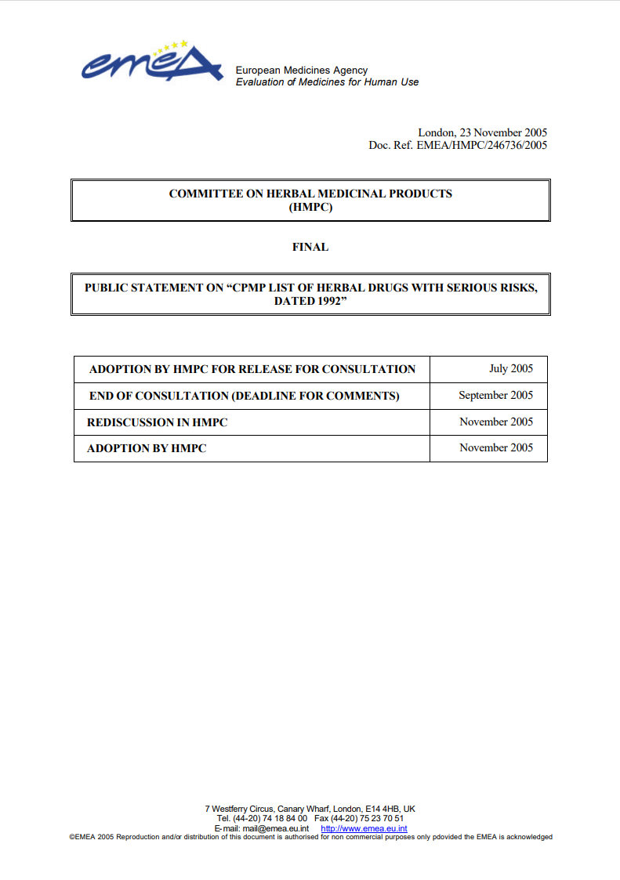

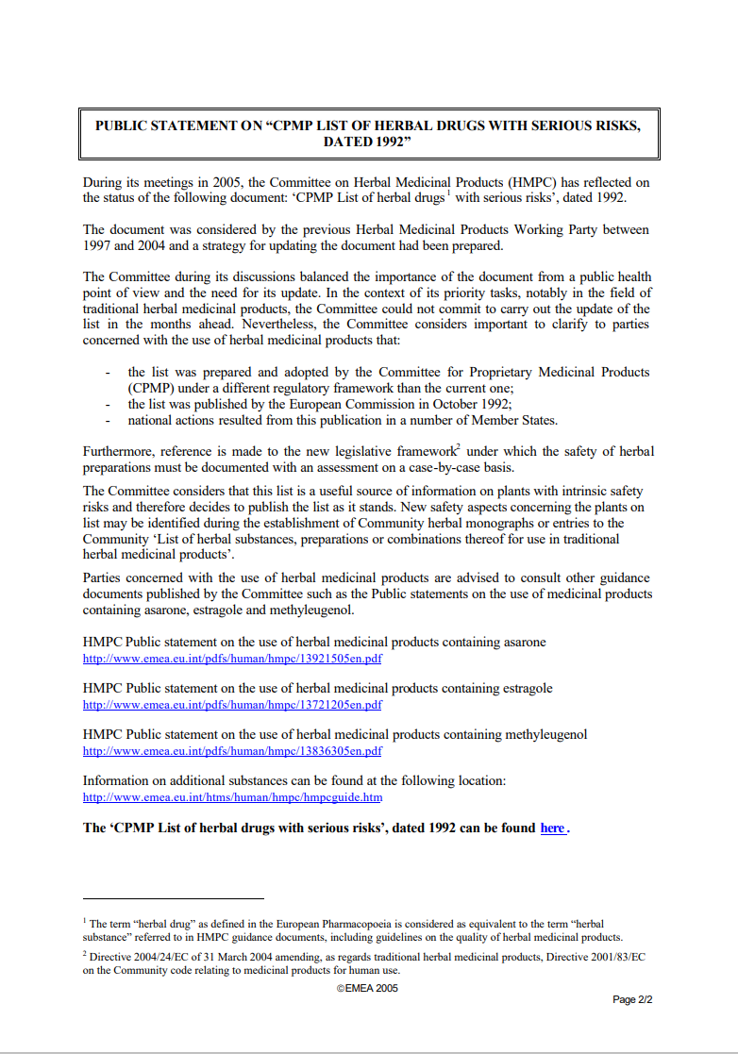

Official links from the Public Statement:
HMPC Public statement on the use of herbal medicinal products containing asarone:
http://www.emea.eu.int/pdfs/human/hmpc/13921505en.pdf
HMPC Public statement on the use of herbal medicinal products containing estragole: http://www.emea.eu.int/pdfs/human/hmpc/13721205en.pdf
HMPC Public statement on the use of herbal medicinal products containing methyleugenol: http://www.emea.eu.int/pdfs/human/hmpc/13836305en.pdf
Information on additional substances can be found at the following location: http://www.emea.eu.int/htms/human/hmpc/hmpcguide.htm

The ‘CPMP List of herbal drugs with serious risks’, dated 1992 can be found here .

Appendix B – Suggested Protocol and Questionnaire before using EO:
Before attempting to use EO, review the following yes or no questionnaire, for answers you might need to look at the chart from this study, it is also attached in this appendix. The more positive answers you get, the safer it is to use the oil, ideally all of them will be positive, aspire for 7/7 in the yes column.
Have you educated yourself about the company and factory producing the EO; are they supervised by the ministry of health, and do they keep record of plant species and the source used for each batch? | Yes | No
Are the EO’s have food grade or food supplement stamp? In other words, are they approved for oral intake or just as Arometherapy? | Yes | No
Have you advised with a professional naturopath that the EO is suitable for your condition? | Yes | No
Have you reviewed the ingredients to make sure the there are no dangerous substances in the EO? | Yes | No
Have you made sure that the medicine or supplements you take regularly do not have a known reaction with one of the herbs in the EO? | Yes | No
Have you made sure you do not have a condition that has a known reaction with one of the herbs in the EO? | Yes | No
Are you aware that changing the company product you use, could mean that the herb production and growing conditions is different? (If you change company product it is suggested you follow this protocol and questions from the beginning). | Yes | No
Were there any clinical tests for the product that checked for possible side effects? | Yes | No

The chart in the following page includes some of the guidelines regarding herbs and supplements. Use it to review the product herbs you want to use.
After that move to Appendix B for guidelines and protocol for gradual usage.

Possible Risks | Type of oils or Vitamin | Reference
Blood pressure and cardiac effects | niacin, ephedra, ginseng, liquorice | (Searl, 2001)
Anticoagulation (concern of vocal fold hemorrhage) | Vitamin C, Vitamin E, ginko biloba, ginger, garlic, feverfew | (Searl, 2001)
Oils interaction that may cause anticoagulation (concern of vocal fold hemorrhage) | ginseng with warfarin | (Searl, 2001)
Gastro-Intestinal effects | Vitamin A, Vitamin C, Vitamin D, folic acid, pantothenic acid, St John’s wort, ginko biloba, pepper mint | (Searl, 2001)
Neurological effects | Vitamin B, Vitamin D, folic acid, ephedra, kava, St John’s wort | (Searl, 2001)
Asthma & Respiratory -  Exacerbation of asthma | Niacin | (Searl, 2001)
Allergy risks | Echinacea may cause anaphylaxis - Combined with sunflower allergy | (Searl, 2001)
Allergic reaction – Skin Rash | Vitamin A, ginko biloba, feverfew, kava  Following sun exposure : St John’s wort | (Searl, 2001)
Headache and fatigue | Vitamin A, Vitamin D, folic acid, St John’s wort, ginko biloba, kava | (Searl, 2001)
Dry mouth | Vitamin C, St John’s wort | (Searl, 2001)
Water retention | Pantothenic acid, liquorice | (Searl, 2001)
Sore throat, tongue tingling | Echinacea | (Searl, 2001)
Seizures | eucalyptus, wormwood (also has toxic chemical related to dementia) | (Woolf, 1999)
Ataxia, Myalgia | Mentha sp | (Woolf, 1999)
Dermatitis | Cinamon | (Woolf, 1999)
Hallucinations | Nutmeg | (Woolf, 1999)
Hepatic necrosis (Liver) | Pennyroyal | (Woolf, 1999)
laryngeal oedema | Wintergreen | (Botma, Colquhoun-Flannery and Leighton, 2001)

Appendix C - Protocol and Guidelines for gradual usage.
Once you decide to use the oil, go over the protocol guidelines of gradual usage.

- Make sure you are hydrated and drink the recommended amount of water during the day.
- Do not take the oil on an empty stomach in the first week. And on future attempts, if you decide to try it on an empty stomach, check for any unusual reactions in your digestion such as pain, heartburn, or nausea.
- If you experience any symptoms that could indicate misuse or food poisoning (vomiting, heartburn, nausea, stomach pain) stop using it. If the symptoms continue, go to a hospital or medical care center. You can advise with a professional naturopath regarding the symptoms and adjustments that can be made but listen to your body and if the problems are not resolved with professional guidance, stop using them completely.
- Use a small amount or even just one drop in the first attempt and if after 24 hours you did not notice any reactions, you can try taking the dosage suggested by a professional.
- Note that it is not recommended to try new supplements during pregnancy and if you have used it before it is always good to educate yourself whether it is smart to continue using during pregnancy and what are the risks.
- With kids, as with most drugs, it is less recommended to use and better to avoid. If you received a recommendation, be mindful that dosage is always lower, consult with a professional and check for additional substances that may contain alcohol or toxins and beware of misuse, especially with toddlers. Avoid oral intake in younger ages and if the oil was not clinically tested refrain from using it.
- If you decide using EO’s through mist, with diffusers or nebulizers, clean the device and dry it after every use and open the windows to freshen the air in the room after every use. During the usage, keep a window slightly open or some entry of fresh air from the outside, do not put the EO inside the device, only near the mist. For adults only, you can try putting a drop or two in your mouth and immediately inhale the mist with the oil that may be carried with the mist from your mouth.
- Notice that any product that causes dryness is problematic for voice users, check the chart for products like vitamin C that may cause a dry mouth, and remember to compensate with hydration. Also schedule to take it after singing or prologued voicing and not right before.

Appendix D – Ethics Form Approved for This Study


