The importance of coaching, relative to other forms of learning interventions, including mentoring, in post-Covid workplaces

Student Name: Vlad Timpau
Student Number: 2208334
Module Tutor: Julie Thomas
Module: Coaching and Mentoring

Table of Contents

Description | Page
Introduction | 3
COVID-19 Pandemic and Transport Industry | 4-5
Coaching and Mentoring | 6-7
Personal Analysis | 8-10
Personal Development Plan | 11
Conclusions | 12
Reference List | 13-15

Introduction
In the words of Palmucci and Santoro (2024), coaching has become an essential element in modern workplaces, especially in the post-COVID era, where employee development and well-being have gained significant attention. In this reflective analysis assignment, we will conduct a performance evaluation based on a previous peer coaching exercise and use relevant reflective cycles to assess personal strengths and areas of improvement. This evaluation will be structured around the importance of coaching compared to other learning interventions, and identify the key skills required to be a great coach. Additionally, insights from the current workplace will be integrated to help examine how coaching is utilised and how it could be further leveraged to support personal and workforce development.

COVID-19 Pandemic and Transport Industry

The year 2020 saw the start of a global pandemic caused by a highly contagious and transmissible coronavirus, also known as COVID-19, which spread through respiratory droplets or aerosols when infected individuals came into close contact with others (Gayatri & Irawaty, 2022). This outbreak resulted in unique disruptions across various sectors, including the transport industry.

Due to the rapid propagation of COVID-19, many governments worldwide, including the United Kingdom, have implemented measures to impede the spread of the virus. On the 23rd of March 2020, the UK government announced a national lockdown, marking a major event in an unprecedented shift from our typical daily routines to a world in which wearing masks, adhering to social distancing guidelines, and experiencing continual uncertainty became customary practices (Dotan et al., 2022, Auerbach et al., 2022).

The measures, including travel restrictions and reduced travel mobility, led to a decrease in passenger kilometres across all modes of transport. According to the UK Government, in 2020, people in England made 739 trips across private and public sector modes, meaning that the distance travelled by taxis, cars, and vans, decreased by 28% compared to 2019.

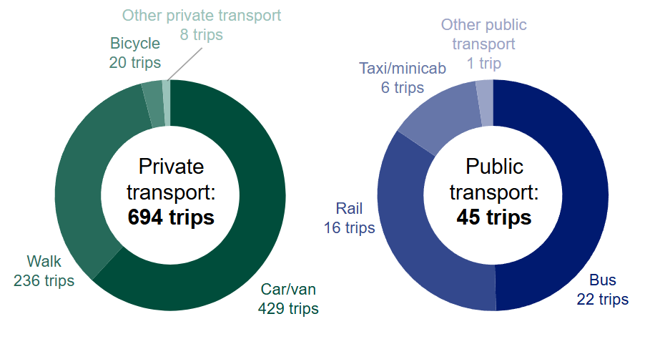
Image 1.0 - Average number of trips made by persons in England in 2020
(UK Government, 2021)

During the pandemic, my experience as an Uber driver was marked by considerable challenges, reflecting the wider battles faced by the transportation sector. With restrictions in place and mobility drastically reduced, the number of customers using taxi services dropped (as shown in Image 1.0), meaning I had days when I could barely complete a few rides. This became routine, and the occupational and financial stress was overwhelming. On top of that, the constant fear of contracting COVID-19 took over me.

Even with following all protective measures such as mask-wearing, disinfecting the car after each ride, and ventilating frequently, the riskiness never disappeared. Eventually, I contracted COVID-19, which was a physically and emotionally draining experience. However, during my recovery, I had time to reflect on the importance of health, resilience, and safety in such unpredictable times. My experience not only highlighted the challenges of the pandemic but also offered me awareness of the need for rapid adaptation, resilience, and emotional support in the transportation sector. It became clear that continuous personal and professional development is vital, especially when facing increased personal risks.

Therefore, coaching has since emerged as a vital element in my industry because it helps drivers manage stress, develop coping mechanisms, and adapt to ongoing changes (Junger et al., 2021; Edgerton and Palmer, 2022). As a driver, my role goes beyond just transporting people. It's about maintaining high standards of safety, communication, and professionalism (Zheng et. al, 2021). Therefore, coaching can help professionals like me refine these skills, ensuring safer and more positive customer experiences. The lessons learned from the pandemic stress the importance of investing in the development of the people who are the foundation of this essential industry.

Coaching and Mentoring
According to Viera (2021) and Palmucci and Santoro (2024), coaching and mentoring have become an essential tool in modern workplaces, especially in the post-COVID-19 era, where employee development and well-being have gained serious attention.

In the words of Sabock (1985), a coach is an individual who provides guidance, support, and encouragement to help individuals or teams achieve their personal or professional goals. Sabock’s definition is strengthened by Ives (2008), who describes a coach as a person who works with a coachee, a person or group, to unlock their potential, enhance their skills and achieve superior performance by exploring available internal and external resources. In other words, coaching can be seen as a collaboration between a coach and coachee, aiming to challenge awareness and inspire growth to achieve personal and professional potential (Sabock 1985; Viera, 2021). This is because the process involves setting clear goals, identifying obstacles, and developing solutions and strategies to overcome the obstacles, differentiating coaching from other interventions like therapy, which typically focuses on addressing past issues rather than future goals (Beinema et. al, 2021; Latham, 2023).

In the words of Ivey and Dupre (2022), a mentor is an experienced individual who serves as a trusted advisor, offering guidance and support to a mentee to foster their personal and professional growth. Ivey and Dupre’s (2022) definition is strengthened by Rowley (1999), who described a mentor as a person who provides guidance, support, and advice to a less experienced individual, referred to as the mentee. Moreover, both Rowley (1999) and Ivey and Dupre (2022) also argue that mentoring relationships are often informal and focus on long-term career development, personal growth, and leadership skills. Additionally, (Viera, 2021) adds to this by stating that mentoring helps mentees navigate challenges, build confidence, and make informed decisions about their life and career trajectories.

Coaching and mentoring share several essential skills, making it sometimes difficult to differentiate them. Both require the ability to build a trusting connection, which is foundational for a coachee's or mentee’s progress. As Carl Rogers (2004) emphasises, trust is built on respect and unconditional positive regard. This means that self-awareness and self-management are critical skills required from a coach or mentor. Additionally, active listening, and asking open-ended questions are other critical skills needed because they encourage the coachee or mentee to explore solutions to their problem. Moreover, coaches must also be adaptable, adjusting their approaches to suit the needs and context of each coachee.

In coaching, emotional challenges often arise, including managing criticism and unrealistic expectations. Therefore, an effective coach aims to navigate these challenges with empathy, active listening, and a non-judgmental attitude. (Morris-Williams & Grant, 2010). To build a great coaching and mentoring relationship, it is also essential that the coach or mentor avoids prioritising their own needs over the coachee or mentee's development as this could lead to a toxic coaching / mentoring relationship. To conclude, avoiding toxic behaviour as a coach or mentor is vital in fostering positive and ethical coaching/mentoring practices.

Personal Analysis
To enhance personal coaching style, we conducted a peer coaching exercise using the “Instant Payoff” coaching model (Landsberg, 2015), and performed the role of a coach for 15 minutes, a coachee for 15 minutes, and an observer for 15 minutes. The Instant Payoff coaching model is a results-oriented coaching approach focused on delivering instant and palpable benefits to the coachee after each session (Landberg, 2015). The model is centred around defining the coachee problem, establishing the ideal outcome, assessing the nature of the barriers, brainstorming solutions and implementing viable solutions. With this in mind, I aimed to use the model, to better as a coach, with my coachee named Flavius. Images 2.0 - 6.0 (see below) show the feedback received from the observer after the coaching session.

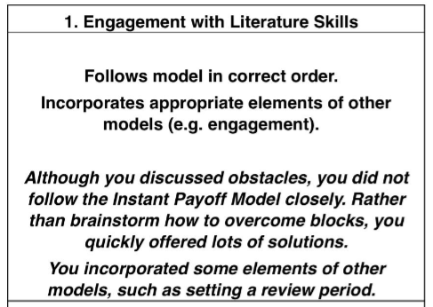
Image 2.0 - Engagement with Literature Skills Feedback

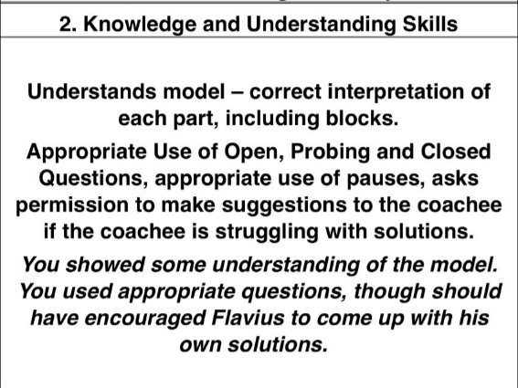
Image 3.0 - Knowledge and Understanding Skills Feedback

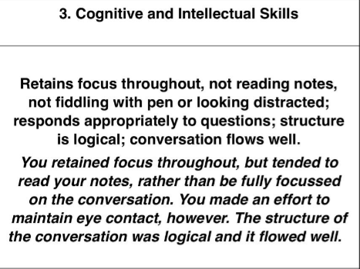
Image 4.0 - Cognitive and Intellectual Skills

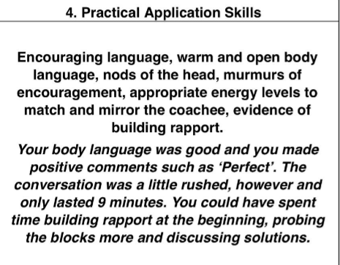
Image 5.0 - Practical Application Skills Feedback

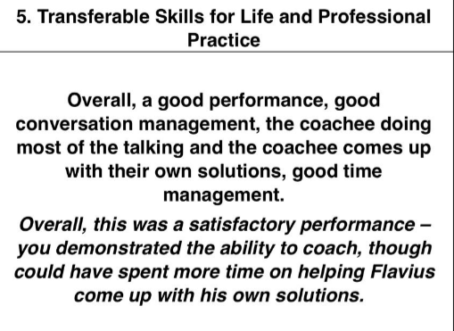
Image 6.0 - Transferable Skills Feedback

Based on the feedback received, and with consideration of the SWOT analysis framework, a personal and business strategic planning tool which identifies strengths, weaknesses, opportunities and threats, I have identified the following strengths and weaknesses. Strengths and weaknesses are internal factors which I can control. In terms of strengths, I demonstrated effective use of verbal and non-verbal body language to enhance communication with Flavius. Additionally, I provided constructive feedback by using positive language and reinforcement to help encourage Flavius. Another strength of mine was that I made notes throughout the session to track the key points made by Flavius. However, there were also weaknesses and areas which require improvement and my future attention. At times, I found myself distracted, which may have affected my ability to remain fully present in the conversation with Flavius. Secondly, I also noticed moments of impatience, which could have influenced the flow of Flavius’ session. Finally, I didn’t fully apply the coaching model, which impacted the effectiveness of the overall approach I had with Flavius.

Personal Development Plan
Following the interpretation of the feedback received from the peer coaching exercise and as a result of identifying my strengths and weaknesses, I developed the following Personal Development Plan to improve my coaching skills:

Vlad - Personal Development Plan
Action | Method | Requirements | Success Indicator | Review Date
Guide coachees to identify their roadblocks and solutions | Use a wide set of questions, including reflective questions to help coachees uncover their barriers. | Have a mental checklist of questions for my coachee.  Creating a supportive environment | Coachees articulate their challenges and solutions | After each session
Empower the coachees to take ownership of their development before offering suggestions | Utilise active listening and longer pauses to give the coachee space and time for a deeper reflection | Creating a supportive environment  Internalise key patterns | Coachee’s confidence in implementing their own strategies | After each session
Improve my presence and engagement during the coaching sessions | Dedicate more time to build rapport at the start of the coaching session | Learn open-ended questions and mirroring techniques  Use mental check-lists during the sessions | Improved rapport and engagement levels based on coachee feedback | After each session

I believe this Personal Development Plan will strengthen my coaching skills by targeting personal areas of improvement and preparing me with the necessary instruments to foster a dynamic partnership with my future coachees, particularly, enabling me to guide them in identifying their obstacles, developing effective strategies, and achieving higher performance levels.

Conclusions
In conclusion, this reflective analysis provides a valuable understanding of the significance of coaching as a professional development tool, particularly in the post-COVID-19 era. Through my personal experience in the transport industry over 6 years and the peer coaching exercise, I have found my strengths and areas for growth in my coaching journey. The challenges faced during the COVID-19 pandemic accentuated the importance of resilience, adaptability, and continuous learning, qualities that coaching helps to cultivate.

By engaging with the Instant Payoff coaching model, I gained an understanding of how structured coaching frameworks can empower individuals to overcome obstacles and enhance their performance. My strengths, including effectual communication and positive reinforcement, serve as a solid foundation for my coaching practice and skills. However, recognising my tendencies toward distraction and impatience highlights areas that require my future attention to become a great coach.

The Personal Development Plan I have developed provides a tangible roadmap for improving my coaching journey. By concentrating on developing active listening, rapport-building, and guiding coachees toward self-discovery, I aim to elaborate my approach and create a more inspirational coaching environment. Ultimately, this reflection reinforces the idea that coaching is not only about supporting others but also about personal growth. As I continue to develop my skills, I am confident that coaching will remain an invaluable asset in both my professional and personal journey.

Reference List
Viera, D. (2024). The importance of coaching and mentoring in modern workplaces. Management Development.
https://www.emerald.com/insight/content/doi/10.1108/md-02-2024-0233/full/html

Department for Transport. (2021). Transport statistics: Great Britain 2021. [online] https://www.gov.uk/government/statistics/transport-statistics-great-britain-2021/transport-statistics-great-britain-2021

Latham, S. (2020). The impact of COVID-19 on the transport sector. Journal of Transport and Tourism, [online] 18(4), pp. 249-265. https://www.tandfonline.com/doi/full/10.1080/17521882.2020.1831563

Bines, A., and Owen, R. (2022). Understanding organizational dynamics and leadership. In: G. Smith, ed. Handbook of Business Development. 1st ed. Hoboken: Wiley, pp. 1-12. https://onlinelibrary.wiley.com/doi/abs/10.1002/9781119835714.ch1

Chen, Y., et al. (2020). Emerging technologies and future workforce development. ScienceDirect, [online] https://www.sciencedirect.com/science/article/abs/pii/S2214367X20302222

Li, J., and Thompson, P. (2020). Evaluating mentoring approaches: An international perspective. International Journal of Mentoring, [online] 6(2), pp. 75-84. https://radar.brookes.ac.uk/radar/file/ed490c36-e4c1-4263-ad7b-24cc99b97b04/1/vol06issue2-paper-08.pdf

Pidgeon, N. (2020). Navigating the changing dynamics of leadership. Professional Leadership Review, [online] https://onlinelibrary.wiley.com/doi/abs/10.1002/pfi.21993

Forster, L. (2021). The evolving landscape of employee engagement. In: A. Davidson, ed. Business Psychology Handbook. 2nd ed. London: Wiley, pp. 112-126. https://onlinelibrary.wiley.com/doi/abs/10.1002/9781394320769.ch5

Cooper, D. (2021). Workplace dynamics post-COVID: A study on adaptation strategies. ScienceDirect, [online] https://www.sciencedirect.com/science/article/pii/S0747563221001102
Hawkins, P., and Smith, T. (2020). The role of mentoring in leadership development. Journal of Leadership Studies, [online] 14(2), pp. 58-68. https://journals.sagepub.com/doi/abs/10.1177/0894845320957737

Radford, C. P. (2015). What makes a good mentor?. [online] https://carolpelletierradford.com/wp-content/uploads/2015/07/M1-good_mentor-article.pdf

BURSA.RO (2023). OCOACH- TENDINŢE ŞI PROVOCĂRI ÎN DOMENIUL COACHINGULUI Piaţa de coaching din România este impulsionată de COVID 19. [online] Available at: https://www.bursa.ro/

Leader Coach (2020). Coaching pentru angajați. Când compania are nevoie de ajutorul unui coach?. [online] Available at: https://www.leadercoach.ro/
Bright Goals (2024). Ce inseamna COACHING?. [online] Available at: https://www.brightgoals.ro/

KNOLSKAPE (2021). How-to Guide: Implementing Coaching & Mentoring in the workplace post COVID-19. [online] March 23. Available at: https://www.knolskape.com/

Unknown Author (2021). The role of mentoring in a post-pandemic world. [online] Available at: https://www.unknownauthor.com/

Unknown Author (2024). Coaching vs Mentoring: Differences, Benefits & Opportunities. [online] 6th March. Available at: https://www.unknownauthor.com/

AoEC (2024). The five hottest coaching skills you need to master. [online] February. Available at: https://www.aoec.com/

UK Coaching (2018). Skills and Qualities of a Coach. [online] April. Available at: https://www.ukcoaching.org/

Clutterbuck, D. (2022). Coaching and Mentoring. Routledge.

Landsberg, M. (2015). The TAO of COACHING. 2015 edition. [online] Available at: https://www.taocoaching.com/

Ziglar, Z. (n.d.). See You at the Top (Motivational series). [online] Available at: https://www.ziglar.com/

Downey, M. (2003). Effective Coaching: Lessons from the Coach's Coach. [online] Available at: https://www.wiley.com/

Rogers, J. (2004). Coaching Skills: A Handbook. [online] Available at: https://www.wiley.com/

CoachHub (n.d.). The Digital Coaching Platform. [online] Available at: https://www.coachhub.io/

McDermott, I., and Jago, W. (n.d.). The Coaching Bible: The essential handbook. [online] Available at: https://www.coachingbible.com/

Turas (n.d.). The skills coaches and mentors need. [online] Available at: https://www.turas.co.uk/

