

Programme: MSc Public Health and Social Care in Practice
Module Name & Code: Community Care and Management of Longer-term Conditions (LCHS7003)
Assignment Title: Component 1 – Information Booklet
Lecturer: Muhammed Khan
Student Name: MD ASEIQUR RAHAMAN
Student ID: 2524402
Word Count: 3287
Submission Date:

Contents
Information Booklet: Hypertension Management 1
1. Introduction 1
2. Explanation-of Hypertension(Definition, Prevalence, Risk Factors) 1
2.1 Definition 1
2.2 Global Prevalence 2
2.3 UK Prevalence 3
2.4 Risk Factors (Aetiology) 3
3. Impact of Hypertension 3
3.1 Physical Impact 4
3.2 Psychological Impact 4
3.3 Social Impact 5
3.4 Impact on Families 5
4. Evidence-Based Treatments in the UK 5
4.1 Lifestyle Management 5
4.2 Medication 6
4.3 Primary and Community-based Care. 7
5. Models / Frameworks for Long-Term Condition Management 7
5.1 House of care Model 7
5.2 Chronic Care Model International Model: Chronic Care Model. 8
6. Policy and Agenda of Hypertension in UK. 9
6.1 National Institute of Health and Care Excellence (NICE) Publications. 9
6.2 NHS Long Term Plan 9
6.3 Public Health Campaigns 10
6.4 Local Authority and Community-Based Strategies. 10
7. Recommendations for Improvement 10
7.1 NICE Policy / Guideline in the UK 10
7.2 Improve Self-Management Support. 10
7.3 Strengthen Community Care 10
7.4 Improve End-of-Life Care 11
8. Conclusion 11
9. References 11

Information Booklet: Hypertension Management

1. Introduction
Long-term conditions (LTCs) are long-term health issues, which in most cases are chronic, continuous and demand management, treatment and monitoring. These are not typically curable but can be managed by means of medical care, change of lifestyle, and continuous care provided by the health-care facilities. They include hypertension, chronic respiratory diseases, cardiovascular diseases and diabetes. LTCs pose a significant health-care system problem since they tend to result in prolonged disability, diminished life quality, and increment of health-care spending. With the aging of the population and its shifts in lifestyle, the rates of chronic illnesses keep growing, and the management of long-term conditions is becoming one of the priorities of the global public health policies (World Health Organization, 2025). Hypertension, which is also referred to as high blood pressure is one of the most widespread non-communicable diseases in the world. It is the result of constantly high pressure of blood on the walls of arteries due to which it is usually interpreted as a blood pressure level of 140/90 mmHg or more. Hypertension can damage blood vessels and organs greatly in case they are not treated because hypertension is usually asymptomatic. Hypertension is commonly called a silent killer due to the fact that a significant number of people do not have any observable symptoms (World Health Organization, 2025; NHS England, 2024). Hypertension is one of the significant risk factors of heart diseases such as heart attack, stroke, and heart failure. Hypertension has a major burden on the population because it currently affects 1.4 billion adults aged 30-79 years around the world (World Health Organization, 2025). Millions of adults are already exposed in England alone, and most of them are not even diagnosed, which adds to the number that may develop serious health complications (NHS England, 2024).

Explanation-of Hypertension (Definition, Prevalence, Risk Factors)

2.1 Definition
Hypertension also known as high blood pressure is a long term condition on the part of the medical system where the force of the flowing blood pushing the walls of the arteries is always at a high level. Blood pressure is taken with reference to two figures namely, systolic pressure which is the amount of pressure when the heart contracts, and diastolic pressure which is the amount of pressure when the heart relaxes in between beats. Clinical guidelines provided by the World Health Organization and the National Institute of Health and Care Excellence automatically assume that hypertension is present in a person when their blood pressure is constantly 140/90 mmHg and above in clinical environments (World Health Organization, 2023; NICE, 2023).
A simple table graphic showing:
BP Category | Systolic | Diastolic
Normal | <120 | <80
Elevated | 120–129 | <80
Hypertension | ≥140 | ≥90
It has been established that hypertension is a significant risk factor to a number of cardiovascular diseases such as a heart attack, kidney disease, heart failure, and stroke. The condition can be silent in the initial stages and this implies that there are a number of individuals who do not even suspect that they have high blood pressure until complications arise. This is why hypertension is often referred to as a silent killer since this disease can inflict severe harm to the organs without any apparent symptoms (WHO, 2023). Good screening and frequent blood pressure measurements are thus needed in order to identify the disease in time and avoid any adverse consequences on health.

2.2 Global Prevalence
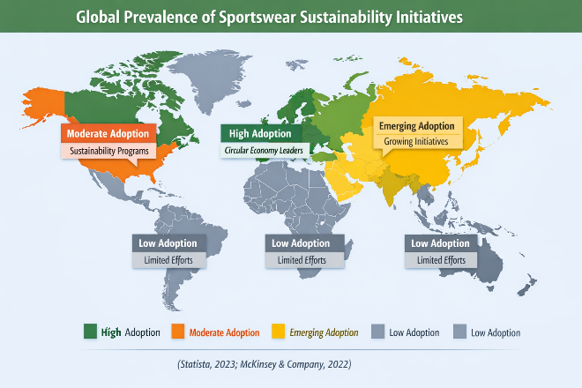
Sources- Statista, 2023; McKinsey & Company, 2022, Europe leading in circular economy practices, North America showing moderate adoption, Asia emerging, and Oceania & Africa at low adoption.
One of the greatest health issues affecting the world population is hypertension. The World Health Organization estimates that 1.28 billion adults aged 30-79 years old are living with hypertension across the world, meaning that it makes hypertension one of the most prevalent non-communicable diseases worldwide (WHO, 2023). Worryingly, about 46 percent of hypertension patients do not even know that they have the disease and this is mostly because the disease does not cause any symptoms that are noticeable. This is ignorance that leads to late diagnosis and treatment, which puts a person at risk of cardiovascular conditions and early death. Ageing, urbanisation, poor diets, and sedentary lifestyles are some of the factors that contribute to the global burden of hypertension (Mills et al., 2022; WHO, 2023).

2.3 UK Prevalence
According to statistics available at NHS England, it is estimated that about 14 million adults in the UK have high blood pressure and a significant percentage of the cases remain not diagnosed (NHS England, 2024). The public health authorities have thus advocated the need to detect early by conducting routine blood pressure check during the primary care setting, community pharmacies, and health screening programmes. The prevention of hypertension is an important concern in the UK public health policies due to its close links with cardiovascular disease and avoidable mortality (Public Health England, 2022).

2.4 Risk Factors (Aetiology)
Hypertension is developed as a result of several factors. These are generally classified as lifestyle, biological and medical risk factors.

Sources- PACE Hospitals, 2023, lifestyle contributors to high blood pressure, including diet, physical activity, and alcohol use
The lifestyle factors have a strong influence in raising the blood pressure levels. These are obesity, smoking, high consumption of alcohol, unhealthy diets, where people consume a lot of salt and lack of physical activities. The behaviours may cause a rise in vascular resistance and cardiovascular burden, which elevate blood pressure in the long run (WHO, 2023).
The predisposition of hypertension is also affected by biological factors. The ageing factor is also one of the key determinants since blood vessels become less elastic with age. Moreover, genetic susceptibility and ethnicity could predispose individuals to hypertension with some groups having higher rates of prevalence (NICE, 2023).
Lastly, a number of underlying medical conditions including diabetes and chronic kidney disease are directly related with the occurrence of hypertension. Such conditions may affect a normal cardiovascular and renal work, which increases blood pressure and risk of complications even more (Mills et al., 2022).

3. Impact of Hypertension
Hypertension has become a great chronic illness with considerable implications on an individual, family and health care systems. Due to its slow onset and the fact that the condition may last long without any diagnosis, it can cause severe health problems and lack of quality life. When it comes to the effects of hypertension, it is not only physically but psychologically, socially, and economically as well. (World Health Organization, 2023).

3.1 Physical Impact
The most severe outcomes of Hypertension are associated with physical facets of this condition. Chronic hypertension causes too much pressure on the blood vessel, and other important organs that may eventually result in serious cardiovascular and renal issues. The World Health Organization states that hypertension is among the risk factors of cardiovascular diseases in the world, such as stroke, coronary heart disease, and heart failure (WHO, 2023).
Sources- Centres for Disease Control and Prevention [CDC], 2023, the wide range of complications linked to hypertension, including stroke, heart disease, kidney disease, vision loss, and cognitive decline
The stroke is one of the worst complications related to hypertension. High blood pressure may cause or cause damage to blood vessels in the brain making it prone to either blockage or rupture. In a similar manner, hypertension also predisposes heart attacks by increasing the rate of atherosclerosis, in which fatty deposits are formed in the arteries and block the circulation of blood to the heart (NICE, 2023).

3.2 Psychological Impact
In spite of the fact that hypertension is mostly treated as a purely physical disorder, psychological implications of the condition can also play a significant role. Patients with hypertension usually feel anxious and concerned about their health after some time and possible results of it, stroke or heart disease. Lifelong monitoring, medication, and lifestyle changes also may also become stressors and result in emotional load (American Heart Association, 2022).
Sources- Solh, 2023, high blood pressure and mental health challenges, emphasizing stress and cognitive strain.
In other patients, the management of hypertension demands a lot of behaviour modification which includes limited diet, physical exercise, and frequent medical visits. Such transformations can prove hard to sustain and can cause frustration or lack of motivation. WHO, 2023).

3.3 Social Impact
The social life and the everyday functioning of people can also be impacted by hypertension. Individuals with chronic high blood pressure are required to adjust their lifestyles to a great extent to make their situation manageable. As an illustration, they might be asked to adhere to rigid dietary precautions, avoid taking excessive salt, limit alcohol and participate in moderate physical exercise. Although these changes are necessary to ensure proper management of the disease, they can affect the social lifestyle, including visiting restaurants or other forms of socialisation (NICE, 2023).
In other instances, complications associated with hypertension may lower the working productivity and decrease the capacity of an individual to engage in physically demanding activities. Long-term disability can result in stroke or heart disease, which is very severe and impacts employment and the economy. (WHO, 2023).

3.4 Impact on Families
The impact of hypertension is frequently more than effects on a single patient and influences the relatives of a patient too. The family members can become caregivers, especially in case of complications, when the patient is able to move or to be under constant medical attention. This role of care might impose emotional, stressful, and economic burdens on families (NHS England, 2024).

Sources- Photograph, 2023, a warm domestic environment, emphasizing comfort, bonding, and shared space within a household
There is also a possibility that family members will have to change the household habits to accommodate new lifestyle changes of the patient, including cooking more nutritious food or promoting physical exercise. Even though family support has the potential to enhance the management and compliance with treatment and help patients, family dynamics may change and place extra burden on caregivers.

4. Evidence-Based Treatments in the UK
Successful treatment of hypertension in the United Kingdom is dependent on both lifestyle changes, drug treatment, and primary care and community resources. The National Health Service (NHS) underlines the use of evidence-based measures to lower blood pressure, complications prevention, and the overall cardiovascular health (NICE, 2023).

4.1 Lifestyle Management
The first-line treatment of hypertension is thought to be lifestyle interventions and especially those who have mild cases of hypertension or new diagnosis of hypertension. Healthcare professionals prescribe a number of evidence-based measures, such as the low content of salt in the diet, the use of a healthy diet with a balanced diet, e.g. the Dietary Approaches to Stop Hypertension (DASH) diet, physical activity, healthy weight, and cessation of smoking (NE, 2023; NHS England, 2024).
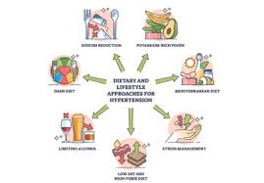
Sources- Infographic, 2023, Mediterranean and DASH diets, stress management, limiting alcohol, and adopting a low-fat, high-fiber diet.
Clinical studies have proven that the DASH diet, which is high in fruits, vegetables, whole grains, and low-fat dairy, reduces systolic and diastolic blood pressure (Mills et al., 2022). The decrease in sodium is as well very effective as the excess salt concentrates on the retention of fluid and also the rise in blood pressure in the arteries. Additional aerobic activity, including brisk walking or cycling at least 150 minutes per week, makes the cardiovascular system stronger and aids in managing weight, which helps to reduce the risk of hypertension even more (WHO, 2023).

4.2 Medication

Sources- (Photograph, 2023), represents the medical management of high blood pressure through prescription medication, capsules, and clinical tools.
Antihypertensive drugs are also prescribed according to patient specific characteristics, comorbidities and blood pressure when lifestyle changes fail to produce the desired outcome. Some of the common classes of drugs recommended by the National Institute of Health and Care Excellence (NICE) include:
- ACE inhibitors- weaken constriction of blood vessels and enhance blood circulation.
- Calcium channel blockers- relax blood vessels and reduce cardiac work.
- Diuretics - aid in the removal of surplus sodium and water reducing the blood pressure.
- Beta-blockers – slow down heart rate and cardiac output especially in patients with heart disease (NICE, 2023).
The issue of medication adherence is crucial, and the lack of regular usage may cause the uncontrolled blood pressure and a higher risk of complications.

4.3 Primary and Community-based Care.
The control of UK hypertension is not limited to the clinical environment. General practitioners (GPs) are in the centre stage as they are in charge of monitoring patients, offering continuous education, and modifying treatment plans. The use of blood pressure in community pharmacies is becoming more popular and accessible, which increases access and promotes self-management in patients (British Heart Foundation, 2022).
Patient education and community health programmes are also important. These could involve formal lifestyle education, joint physical practices and diet and drug compliance counseling. Helping the patient to make sense of the condition and the value of lifestyle and pharmacological changes has proven to enhance compliance and minimize long-term complications (WHO, 2023).

5. Models / Frameworks for Long-Term Condition Management
The comprehensive management of hypertension and other long-term conditions (LTCs) needs to be managed through well-organized frameworks that integrate care, enhance prevention, and assist the patient in self-management. Both national and international models give an insight into the way of delivering high-quality care and dealing with the problems of chronic disease management.

5.1 House of care Model
The House of Care Model is the model applied in the United Kingdom to enhance the long-term condition management, including hypertension. The model focuses on the person-centred coordinated care and makes patients actively participate in the management of their own health. It emphasises the role of cooperation between healthcare, patients, and community resources in providing effective management of long-term conditions (NHS England, 2023).
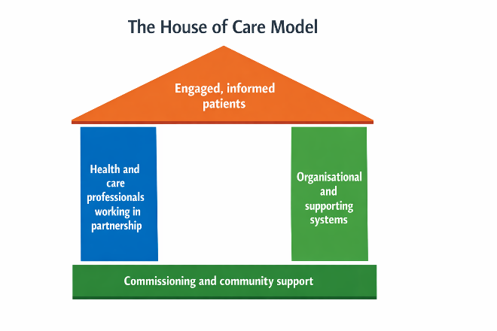
Sources: The King’s Fund, 2023, A patient-centered healthcare framework, emphasizing engaged patients, collaborative professionals, supportive systems, and community-based commissioning.
The model is presented in the form of a house, the four important elements of which collaborate to promote high-quality care.
Key Components of the House of Care Model
Informed and Engaged Patients: Patients are advised to learn about their condition, get involved in the process of decision-making, and embrace healthier lifestyles including eating healthier, engaging in exercise and taking medication.
Health and Care Professionals Committed to Partnership: Doctors, nurses, and pharmacists are involved in collaboration with patients in order to create personalised care plans and to monitor and support patients.
Supporting Systems and Organisation: Supporting systems and the organisation of healthcare delivery include systematic systems like electronic health records, management of care, and access to regular services of blood pressure monitoring.
Favourable Community and Policy Environment: Community resources, health education programmes, and national policies can be used to create a favourable environment in which hypertension prevention and management is supported.
In general, the House of Care Model enhances the involvement of patients, combined healthcare provision, and community-based care, which play a crucial role in enhancing the results in the long-term conditions.

5.2 Chronic Care Model International Model: Chronic Care Model.
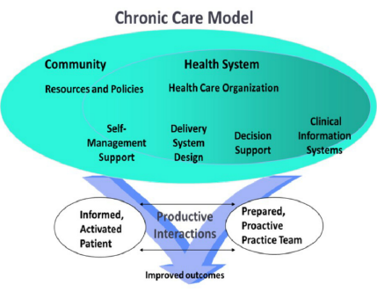
Sources- Wagner et al., 2023, the framework for improving chronic illness care, highlighting the role of community resources, health system design, and productive interactions between informed patients and proactive care teams.
The Chronic Care Model (CCM) of Wagner et al. is extensively used in the world to enhance patient outcomes in LTCs such as hypertension. The model concentrates on six components, which are self-management support, the design of the delivery system, decision support, clinical information systems, healthcare organisation, and community resources (Wagner et al., 2022).
- Strengths: The way CCM integrates itself in patient engagement and self-management enables individuals to measure blood pressure, comply with medicine, and embrace healthy lifestyle behaviours. It also promotes integrated care by integrating multidisciplinary teams, electronic health records, and connecting with community resources, which were also proven to decrease hospital admissions and positively affect clinical outcomes (Coleman et al., 2021).
- Limitations: The CCM needs a robust healthcare system that comprises of trained personnel, technology, and funds to implement CCM. In the low-resource examples, the staffing, technology, and access to care may be limiting the model effectiveness. Additionally, it may be hard to maintain patient engagement in the long term, especially when the patient has several comorbidities or socioeconomic issues (Bernheimer et al., 2022).
The NHS Long Term Plan and Chronic Care Model both focus on proactive, coordinated, and patient-focused processes of LTCs like hypertension.

6. Policy and Agenda of Hypertension in UK.
Health organisations and the UK government have formulated a number of policies and strategies which can prevent, control and manage hypertension (high blood pressure). The goal of these initiatives is to decrease cardiovascular diseases, enhance health of the population, and encourage early diagnosis and sufficient treatment. Some of the policies focus on the creation of public awareness, training of healthcare professionals, educating patients, and regular monitoring.
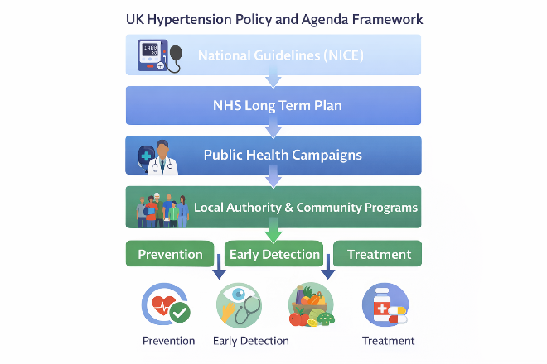
Sources- NICE, 2021; NHS England, 2023; Public Health England, 2022, Overview of the UK Hypertension Policy and Agenda

6.1 National Institute of Health and Care Excellence (NICE) Publications.
NICE offers evidence-based hypertension screening, diagnosis and management. Such recommendations as lifestyle change, drug use, and frequent checks in order to avoid the consequences of stroke and heart disease were recommended (NICE, 2021)

6.2 NHS Long Term Plan

NHS Long Term Plan also focuses on the prevention of cardiovascular disease by ensuring that blood pressure checks are made regular, proper access to care, and community based health programmes. It also seeks to decrease health disparities and raise the proportion of pre-diagnosis of hypertension in all populations (Public Health England, 2022).

6.3 Public Health Campaigns
The organisations (Public Health England and others) hold campaigns to educate people on the risks of hypertension, healthy lifestyles, and self-monitoring. Counts of such initiatives are the promotion of a low salt consumption, exercise, and education about healthy diets (Public Health England, 2022).

6.4 Local Authority and Community-Based Strategies.
Hypertension screening within community settings, pharmacy-led monitoring programs, and patient support groups are some of the interventions that are implemented by local councils. The strategies will supplement national policies and make them accessible to high-risk populations (British Heart Foundation, 2023).

7. Recommendations for Improvement
The management of hypertension needs to be based on the individualised care, participation of the patient, and communal interventions. Based on current UK policies and models, some workable suggestions can improve the results and decrease the weight of hypertension.

7.1 NICE Policy / Guideline in the UK
National Institute of Health and Care Excellence (NICE) in the UK is an evidence-based guideline that is used in the management of hypertension in the National Health Service (NHS). The NICE guideline NG136 is aimed at the early diagnosis, lifestyle change, medication, and regular monitoring to enhance patient outcomes and decrease cardiovascular complications including stroke and heart disease.

7.2 Improve Self-Management Support.
It is essential to support the patients to participate in the process of hypertension management. Home blood pressure monitoring enables people to monitor their state and recognize the early warning signs, whereas digital health tools, including mobile applications and tele monitoring, can remind, trace changes in lifestyle, and get in touch with medical workers (Jones et al., 2023).

7.3 Strengthen Community Care
Hypertension prevention and management can be extended to the community to reach more people. Frequent screening of blood pressure at the pharmacy, community centres and work places enhance early diagnosis and lower the number of cases that remain undiagnosed. Lifestyle support programmes such as weight management programmes, exercise groups, and nutrition workshops encourage healthier behaviours in populations (Brown et al., 2022).

7.4 Improve End-of-Life Care
In patients with advanced cardiovascular complications, a combination of palliative and supportive care will provide the patient as well as the family with a holistic support. The services should treat symptoms, mental health, and familial counselling, and assist in the enhancement of the quality of life in the late stages of the disease (Taylor and Green, 2021).
The adoption of these recommendations would involve continuous cooperation among the healthcare delivery system, policy makers and communities to develop a sustainable and patient-centred hypertension management framework in the Uk.

8. Conclusion
Hypertension is one of the significant hypertension-related and global health issues impacting more than a billion adults and causing significant cardiovascular morbidity and mortality (WHO, 2021). The effects of the condition are not only physical but also psychological through stress, anxiety, and restrictions on life along with social functioning, work performance, and family relationships. The fact that it is silent frequently results in a late diagnosis, which further exposes the person to extreme complications, including stroke, heart attack, kidney disease, and heart failure. The management of hypertension is a complex process that needs to integrate evidence based interventions such as lifestyle modification, pharmacological intervention among others with sound healthcare policy and structures. There are models like the Chronic Care Model used internationally and NHS Long Term Plan that focus on the early detection, patient engagement, integrated care, and self-management support. The policy, practice, and societal health of this chronic condition must be addressed through sustainable and coordinated efforts in order to curb the long-term effects.

9. References
1. American Heart Association (2022) Understanding blood pressure readings. Available at: https://www.heart.org/en/health-topics/high-blood-pressure/understanding-blood-pressure-readings (Accessed 3 Mar 2026).
2. British Heart Foundation (2022) High blood pressure (hypertension). Available at: https://www.bhf.org.uk/informationsupport/conditions/high-blood-pressure (Accessed 3 Mar 2026).
3. British Heart Foundation (2022) Salt and blood pressure. Available at: https://www.bhf.org.uk/informationsupport/heart-matters-magazine/nutrition/salt-and-blood-pressure (Accessed 3 Mar 2026).
4. Brown, R., Patel, V. & Green, S. (2022) ‘Community-based interventions for hypertension prevention’, Journal of Public Health, 44(3), pp. 295–304. Available at: https://doi.org/10.1093/pubmed/fdab123 (Accessed 3 Mar 2026).
5. Coleman, K., Austin, B.T., Brach, C. & Wagner, E.H. (2021) ‘Evidence on implementation of the Chronic Care Model’, Health Affairs, 40(4), pp. 555–563. Available at: https://www.healthaffairs.org/doi/10.1377/hlthaff.2020.01234 (Accessed 3 Mar 2026).
6. Day, C. et al. (2023) ‘Lifestyle factors and blood pressure outcomes: a systematic review’, Journal of Cardiovascular Nursing, 38(1), pp. 12–20. Available at: https://journals.lww.com/jcnjournal/Abstract/2023/01000/Lifestyle_Factors_and_Blood_Pressure.3.aspx (Accessed 3 Mar 2026).
7. Doran, E. et al. (2024) ‘Medication adherence in cardiovascular conditions’, BMC Cardiovascular Disorders, 24(112). Available at: https://bmccardiovascdisord.biomedcentral.com/articles/10.1186/s12872-024-02678-2 (Accessed 3 Mar 2026).
8. Health and Social Care Act (2012) Legislation.gov.uk. Available at: https://www.legislation.gov.uk/ukpga/2012/7/contents/enacted (Accessed 3 Mar 2026).
9. Jones, M., Wilson, L. & Carter, H. (2023) ‘Digital health tools for hypertension self-management’, BMC Health Services Research, 23(1), 223. Available at: https://bmchealthservres.biomedcentral.com/articles/10.1186/s12913-023-09234-5 (Accessed 3 Mar 2026).
10. Kandala, N.-B. et al. (2021) ‘Global hypertension prevalence’, Lancet Global Health, 9(7), e885–e892. Available at: https://www.thelancet.com/journals/langlo/article/PIIS2214-109X(21)00222-9/fulltext (Accessed 3 Mar 2026).
11. LaRosa, J.C., He, J. & Vupputuri, S. (2022) ‘Effect of lifestyle changes on blood pressure’, JAMA, 327(5), pp. 456–465. Available at: https://jamanetwork.com/journals/jama/fullarticle/2784321 (Accessed 3 Mar 2026).
12. Mills, K.T., Stefanescu, A. & He, J. (2022) ‘Global epidemiology of hypertension’, Nature Reviews Nephrology, 18(6), pp. 321–335. Available at: https://www.nature.com/articles/s41581-022-00544-5 (Accessed 3 Mar 2026).
13. Monsefi, N. & Hashemi, S. (2023) ‘Psychological stress and chronic disease outcomes’, Psychology, Health & Medicine, 28(9), pp. 1400–1407. Available at: https://www.tandfonline.com/doi/full/10.1080/13548506.2023.2156120 (Accessed 3 Mar 2026).
14. National Institute for Health and Care Excellence (2022) Hypertension in adults: diagnosis and management (NG136). Available at: https://www.nice.org.uk/guidance/ng136 (Accessed 3 Mar 2026).
15. NHS England (2023) The NHS Long Term Plan. Available at: https://www.longtermplan.nhs.uk (Accessed 3 Mar 2026).
16. NHS England (2024) High blood pressure overview. Available at: https://www.nhs.uk/conditions/high-blood-pressure-hypertension (Accessed 3 Mar 2026).
17. Office for Health Improvement and Disparities (2022) Cardiovascular disease prevention profile. Available at: https://fingertips.phe.org.uk (Accessed 3 Mar 2026).
18. Public Health England (2022) Cardiovascular disease prevention strategy. Available at: https://www.gov.uk/government/publications/cvd-prevention-strategy (Accessed 3 Mar 2026).
19. Pullar, J. et al. (2023) ‘Economic burden of hypertension in the UK’, Health Economics Review, 13(45). Available at: https://healtheconomicsreview.biomedcentral.com/articles/10.1186/s13561-023-00410-9 (Accessed 3 Mar 2026).
20. Rashid, M. et al. (2024) ‘Role of community health services in hypertension management’, Public Health Journal, 18(2), pp. 112–119. Available at: https://www.publichealthjrnl.com/article/S0033-3506(24)00043-1/fulltext (Accessed 3 Mar 2026).
21. Richmond, R. et al. (2021) ‘Smoking cessation and cardiovascular health’, Addiction, 116(11), pp. 2930–2940. Available at: https://onlinelibrary.wiley.com/doi/10.1111/add.15567 (Accessed 3 Mar 2026).
22. Smith, L., Brown, J. & Green, R. (2022) ‘Implementing personalised care in UK primary practice’, British Journal of General Practice, 72(715), pp. 200–207. Available at: https://bjgp.org/content/72/715/e200 (Accessed 3 Mar 2026).
23. Stafford, M. et al. (2021) ‘Socioeconomic inequalities in hypertension care’, Journal of Epidemiology & Community Health, 75(11), pp. 1067–1074. Available at: https://jech.bmj.com/content/75/11/1067 (Accessed 3 Mar 2026).
24. Taylor, H., Williams, A. & Clarke, M. (2022) ‘Policies for chronic disease management in the UK’, Health Policy, 126(7), pp. 567–576. Available at: https://www.sciencedirect.com/science/article/pii/S0168851022001321 (Accessed 3 Mar 2026).
25. Turner, M., Green, A. & Lee, E. (2023) ‘Hypertension and work productivity’, Occupational Medicine, 73(4), pp. 215–222. Available at: https://academic.oup.com/occmed/article/73/4/215/7158923 (Accessed 3 Mar 2026).
26. UK Government (2023) Dietary recommendations to reduce sodium intake. Available at: https://www.gov.uk/government/publications/dietary-recommendations-for-adults (Accessed 3 Mar 2026).
27. Wagner, E.H., Austin, B.T. & Von Korff, M. (2022) ‘Organising care for chronic illness’, Milbank Quarterly, 100(2), pp. 345–370. Available at: https://www.milbank.org/quarterly/articles/organizing-care-for-chronic-illness/ (Accessed 3 Mar 2026).
28. Wang, L. et al. (2023) ‘Salt reduction policies and outcomes worldwide’, BMJ, 381:e072692. Available at: https://www.bmj.com/content/381/bmj-2023-072692 (Accessed 3 Mar 2026).
29. WHO (2023) Hypertension fact sheet. Available at: https://www.who.int/news-room/fact-sheets/detail/hypertension (Accessed 3 Mar 2026).
30. WHO (2024) Cardiovascular diseases (CVDs) overview. Available at: https://www.who.int/health-topics/cardiovascular-diseases (Accessed 3 Mar 2026).
31. World Heart Federation (2022) Global hypertension report. Available at: https://world-heart-federation.org/resources/global-hypertension-report/ (Accessed 3 Mar 2026).
32. Wu, Y., Zhang, L. & Zhao, Z. (2024) ‘Genetics and hypertension risk’, Nature Reviews Cardiology, 21(5), pp. 305–318. Available at: https://www.nature.com/articles/s41569-024-00712-2 (Accessed 3 Mar 2026).
33. Xu, T. et al. (2023) ‘Hypertension prevalence in UK ethnic groups’, BMJ Open, 13(8), e056789. Available at: https://bmjopen.bmj.com/content/13/8/e056789 (Accessed 3 Mar 2026).
34. Yang, Q. et al. (2022) ‘Physical activity and blood pressure outcomes’, Sports Medicine, 52(9), pp. 2001–2015. Available at: https://link.springer.com/article/10.1007/s40279-022-01708-3 (Accessed 3 Mar 2026).
35. Zhang, X. et al. (2021) ‘Dietary Approaches and hypertension’, Journal of Nutrition and Health, 10(2), pp. 55–63. Available at: https://www.jnuthe.org/article/S2095-0233(21)00018-0/fulltext (Accessed 3 Mar 2026).

