UNIVERSITY OF WALES TRINITY SAINT DAVID
BA(Hons) Business Management

Module Name :International Financial Communication
Module Code: LCBB60002
Student Name: Daniela Gabriela Lisenche
Student Number:2029607
Module Leader: Taye Osadiya

Table of Contents
Introduction: 3
Discussion 3
Microsoft: 3
Importance of international financial management (IFM) to the corporation: 4
Challenges Microsoft corporation experiencing in different international financial markets: 4
Dividend distribution policy: 5
Efficient market hypothesis theory 6
Methods of appraising projects: 7
Conclusion: 8
Reference list 9

Introduction:
Multinational Corporation is a company that has business operations in more than two countries besides its home country. It has branch or offices and transaction from other countries. Multinational corporation plays a great role in the economy. The range of Multinational Corporation is very wide (Stopford & J., 2020). The operations, transactions and popularity of a multinational corporation brings pride for its home country. It can also represent a country. It has to pay taxes to countries it operates. The structure of multinational corporation is well designed and very much complicated (Helpmann & E., 2021). This type of business conduct in various languages in various countries. The main purpose of multinational corporation is to gain more profit and keep growing. After completing the demand of its home country, it goes for global market. Because of operating in other countries, the growth of its market share reaches globally. It creates an image worldwide and well known to its customers. There are four types of multinational corporations:
- A Decentralized Corporation
- A Centralized Global Corporation
- An International Division Within a Corporation
- A Transnational Corporation

Discussion
Microsoft: Microsoft is an American multinational corporation which was founded by Gates and Paul on April 4,1975. It is well known for its software products. Microsoft's best worldwide famous product is its windows line of operating systems. We all know about windows like windows xp,7,8,10,11 etc. (Nesterov & D.A., 2022). It is also considered as one of the top five American information technology Corporations. Most of the people of all over the world use windows as their operating system. Windows operating system is very user friendly and not complicated to use. That's why people prefer windows than any other operating systems. The headquarter of Microsoft is situated in Redmond, Washington. From 1975 till now 48 years, they served worldwide and established their business. It’s not easy to maintain a multinational corporation like Microsoft. But they succeed in ensuring service to their customers and to make their business globally big. Now everyone knows about Microsoft. It was the world’s top software maker corporation by revenue as of 2022.

Importance of international financial management (IFM) to the corporation:
International financial management is the management of operations of finance in different markets over the world. It is very important for a corporation in order to get in track and managing their transactions correctly. Financial system is the backbone of a company. Money is considered as liquid of the market (Shapiro et al,2023). From where to get the money and where to invest or use it is the operation of finance. If the financial management is good of a company, it is a plus point for the company. Because the global market is very competitive and cluttered (Aubert et al,2021). In that situation if you can’t maintain a good financial management system than its impossible to create business globally. International financial management is also very important for Microsoft. It helps the company in achieving more efficiency and effectiveness in all markets. IFM also helps in taking financial decisions. IFM make sure that:
- Microsoft is able or capable of doing operations
- It has positive cash flow to deal with long term debt
- And the upcoming operational expenses and short-term debt.
Now if we look at the importance of IFM in Microsoft we can say that:
- It helps to manage the financial operations in different market because Microsoft is a worldwide operational corporation
- It helps to take the right financial decision according to different markets
- It helps in growth of worldwide trade
- It makes sure the finance stability of the company
- It manages the funds and helps in doing the right investment.

Challenges Microsoft corporation experiencing in different international financial markets:
Challenges are very usual for a multinational corporation. There is no company which didn’t face any challenges in their company. There are many challenges to face to reach the ultimate goal. Like operational challenges, financial challenges, organizational challenges, international financial market challenges etc. Microsoft also facing international financial market challenges (Ibrahim &A.A., 2020). The operations in different market are not similar to each other. They have to follow different strategy in different markets. Because customers choice, need, economic and finance situation is different from each other. They have to analyses the market and set strategy according to customers culture and demand. For this Microsoft has to face many challenges in international financial markets. Like,
- Increase of interest rate: It hampers their market share value. Stability in financial market brings stability in share market.
- Inflation: Because of high inflation rate the value of money is decreasing. Which is not good for their investment (Saunders et al,2022). The more inflation rates the more economic imbalance happens. And economic growth and balance is very essential for a company like Microsoft.
- Economic growth dampens globally: For a multinational corporation economic growth of global is very important. Dampen of economic growth decreases the effectiveness and profit of the company. Because multinational company is very much dependent on global economy.

Dividend distribution policy:
Dividend policy is how a company will distribute its dividends to shareholders. Dividend policy is very essential for a company (Hajjar et al,2022). The way of distributing of dividend plays a great role in satisfying the shareholders. If shareholders get satisfied by the dividend distribution the price of share rises. Information technology Corporations do not always pay a dividend but Microsoft pays dividend (Avanza & B., 2020). It considers as a reward to shareholders. For this the price of Microsoft shares always rises every year. Shareholders can easily invest in Microsoft and get their dividend as expectations.
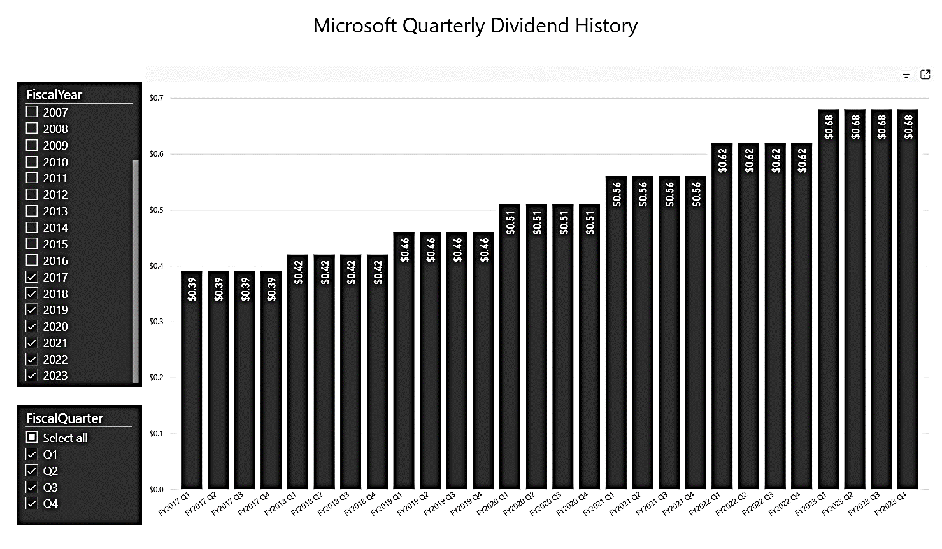
Source: (Pennesi & E., 2023)
This chart shows the dividend distribution data of Microsoft from 2017-2023. We can see the rising level of dividend in every year. It’s because of their business growth and profitability. The more profit the company earns the more dividend they distribute to their shareholders. From this data we can say that Microsoft can be a better and safe option to buy shares or invest money.

Efficient market hypothesis theory
The efficient market hypothesis theory states that the share prices indicate all information of the company. The stock exchanges at fair value in trade market (Naseer et al,2021). No shareholder will sell their stock at low price from market value.

Source: (WallStreetmojo, 2022)
Microsoft always maintain efficient market hypothesis theory. They update their latest information of the company with the new share price of the market. They also maintain and strictly avoid insider information out. Because if any insider shares with anyone the upcoming downfall of the share price, then the shareholder will immediately sell the share at present price. It can destroy the company’s reputation and growth. for example, if the price of today’s share is $80 (WallStreetmojo, 2022). Someone from insider shares that the company isn’t able to make the new project and the share price will be down soon. From taking insiders advice the shareholder sold the share at $80. Next week the price fall at $60. So here the loss of the new shareholder will be $80-$60=$20, if he sells it now.

Methods of appraising projects:
Project appraisal is setting a structured way of assessing the project by some analysis. Microsoft also follows some analysis steps of project appraisal.
- Economic analysis: Economic situation is very important for a company. They have to run their project according to the economy situation. That’s why Microsoft analysis the economic situation like inflation rate, interest rate, globalization, economic growth or downfall. It helps them in picking the right project in right market and gain profit from the project.
- Financial analysis: Microsoft analyses their financial sector to bring more effectiveness and efficiency (King & T., 2020). Financial system of a company is very essential for growth. From where the fund will be collected and where will be invested is the decision they can take from financial analysis. Financial analysis helps a company to take the right financial decision and ensure the profitability of fund investment in the project.
- Market analysis: Market analysis is also very essential in project analysis. Microsoft company do research in their market and collect data from the customers. From this they can know about the demand and need of a customer. They try to fulfill their demands and needs in the project. Business is all about providing what customer needs. If a company can do that then there is no looking back. That’s why Microsoft do market analysis.
- Managerial competence: Well management is required everywhere. An average project can be done like e top project if the management is good and top notch. That’s why Microsoft always ensure the proper and accurate management of every project. It helps them to do their project accurately and bring more efficiency in the project.

Conclusion:
From this assignment we knew about the Multinational corporations and operations of multinational companies. We also knew about the challenges a multinational company faces and the strategies they use to reach their goal. The journey of the multinational corporation is very wide and complicated to run the operations. But the effect of multinational corporations in the world is undoubtedly priceless. In economy, society, culture and other sectors have benefited because of the multinational companies. Their CSR (Corporate Social Responsibility) program creates positive vibe in the society and wellness for the people who needs help. Every year they donate and help many people through many CSR programs (Garg et al,2023). So multinational corporations are needed to create better future and better life of the people. We should encourage people and students who are the future of the world to focus on building businesses and dream to make it worldwide.

Reference list
Aubert, F. and Gudinski, G., 2021. The impact and importance of mandatory adoption of International Financial Reporting Standards in Europe. Journal of International Financial Management & Accounting, 22(1), pp.1-26.
Avanza, B., 2020. Strategies for dividend distribution: A review. North American Actuarial Journal, 13(2), pp.217-251.
Garg, H. and Strobl, E., 2023. Multinational companies and indigenous development: An empirical analysis. European Economic Review, 46(7), pp.1305-1322.
Hajjar, B. and Taksa, M., 2022. Optimal dynamic portfolio selection for a corporation with controllable risk and dividend distribution policy. Quantitative Finance, 4(3), p.315.
Helpmann, E., 2021. Multinational corporations and trade structure. The Review of Economic Studies, 52(3), pp.443-457.
Ibrahim, A.A., 2020. The rise of customary businesses in international financial markets: an introduction to Islamic finance and the challenges of international integration. Am. U. Int'l L. Rev., 23, p.661.
King, T., 2020. Economic Development Projects and their Appraisal.
Naseer, M. and Bin Tariq, D.Y., 2021. The efficient market hypothesis: A critical review of the literature. The IUP Journal of Financial Risk Management, 12(4), pp.48-63.
Nesterov, D.A., 2022. History of Microsoft (Doctoral dissertation, Sumy State University).
Pennesi, E., 2023. Mapping the brain's genes: a Microsoft dividend.
Pennesi. (2022). Efficient Market Hypothesis. [online] Available at: https://www.wallstreetmojo.com/efficient-market-hypothesis/ [Accessed 27 Jul. 2023].
Saunders, A., Cornett, M.M. and Reheats, O., 2022. Financial markets and institutions.
Shapiro, A.C. and Hanoian, P., 2023. Multinational financial management. John Wiley & Sons.
Stopford, J., 2020. Multinational corporations. Foreign Policy, pp.12-24.

