Effective team working and communication Assignment 1
Class: BMSW4002
Academic report

Carlotta Cantone
Student number: 1914739
Lecturer: Timothy Hopkins
University of Wales Trinity Saint David
02 May 2020

- Table of contents

- INTRODUCTION
  - Definition of communication……………………………….……….p.2
  - Verbal communication………………………………………………p.2
  - Non-verbal communication………………………………………....p.2
- SECTION ONE
  - How communication can be made effective in a business organization……………………………………………………….....p.3
  - How communication works between managers and employees….p.3
- SECTION TWO
  - Relevant theories and methods …………………………………….p.5
  - One-way communication scheme…………………………………..p.6
  - Two-ways communication scheme………………………………....p.6
- SECTION THREE
  - The important of effective communication in hospitality management…………………………………………………………p.7
  - How effective communication affects my workplace..…………….p.7
  - Conclusion…………………………………………………………...p.7
  - Bibliography…………………………………………………………p.8

1

Introduction

Definition of communication
Communication is a complex phenomenon and a fundamental component of society; culture exists because human beings interact with each other (Giri, 2006). To be more precise, communication is the exchange of cultural and spiritual goods, such as opinions, ideas, feelings, and intuition. Furthermore, it is the act of conveying meaning from one source to another through the use of selected, arbitrary symbols, which we call words and gestures to represent "things”. It is through these symbols that we can express our thoughts and feelings (Maund, Schriek and Tinkler, 2015, p.47) The action of communication requires at least one sender, one receiver and content.
Firstly, the sender encodes the message through symbols in the form of words, pictures, and gestures within a communication medium. For instance, the message can be oral, digital, non- verbal. Secondly, the sender chooses the transmission medium or channel to send the message to the receiver and also the destination or decoder who decodes the message.
Verbal communication
The use of verbal statements is one of the most usual ways people use to interact with each other. It is the highest form of awareness because it requires the use of written or spoken words and it is mainly when each individual pays more attention. Naturally, when we want to express ourselves, we try to choose carefully the words we want to say, adapting our vocabulary to our receiver. For instance, if we were attempting communication in a formal context or attending a work meeting, we would use a refined vocabulary; On the other hand, if we were to convey a message in an informal environment, we would choose a more straightforward language (Maund, Schriek and Tinkler, 2017, p.68). Despite that, there can be multiple interpretations of the same message and misunderstanding can quickly occur for various reasons because people do not always know the exact intent of one’s comment or do not factor in cultural differences.
Non-verbal communication
Importantly, when a person expresses a verbal message unconsciously, an equally crucial process is taking place on a non-verbal level. Non-verbal language includes all those ways we communicate without the use of words, such as smiling, posture, eye contact and anything that contributes to conveying a non-written or non-spoken meaning (Maund, 2017, p.49). This particular cognitive process takes place rapidly and often outside of the realm of awareness.
An accurate perception of non-verbal communication helps the listener understand the intent of the speaker and it is strongly linked to social intelligence and interpersonal sensitivity. This report is going to show how effective communication influences the workplace.
2
Section one

How communication can be made effective in a business organization
- Poor communication has led to several failings and has affected businesses performance (Wells, 2017). To avoid catastrophe, it is essential to implement effective practices that will encourage effective communication. Once in place, the communication strategies, combined with an action plan, will enable the organization to reach their goal and meet their targets.
There are various ways through which communication can be made useful in a business organization. Firstly, it is essential to allow open communication within the organization (Adler, 2016, p. 45). A work environment will result sterile and unproductive if the managers and employees are afraid to speak their minds out of fear of facing backlash from the executive leadership. Open dialogues involving constructive criticism should be encouraged since they help establish a more connected working environment. Staffs develop trust once they are aware that they can openly voice their concerns, resulting in improvement for the entire organization. Furthermore, making planning inclusive can ensure effective communication within the organization. For instance, holding a closed-doors meeting gives the impression that the discussion should not concern lower management and workers. As a result, some might feel excluded because their input is no longer valued since they do not contribute to decisions. Employees feel more valued when invited to attend a meeting, as this generates a trustworthy environment (Adler, 2016, p. 46). When executives understand and accept new ideas from employees, the results are reflected on better external and internal performances. Additionally, focusing on result-driven communication during meetings will enable effective communication. Through this process, employees can participate in discussions aimed at improving methods of execution and consequently obtaining better results. Moreover, encouraging feedback allows the employees to feel comfortable sharing their concerns and posing questions, ultimately turning the communication a two-way.

How communication works between managers and employees
Managers play a crucial role in establishing clear lines of communication within the organization. Leaders in the workplace make a full use of communication, using specific and helpful tools to enhance the effectiveness. Knowing how to assess relational layers is a crucial skill to have in pursuit of professional excellence and it is also useful in building a strong relationship between managers and employees (Maund, Schriek and Tinkler, 2017). Communication between management and employees works in various ways. The tone or choice of language differs depending on the person receiving the message. If the leaders are talking to their juniors, they will utilize an authoritative tone and the language exhibited will be formal. However, when speaking to colleagues at the same level, the language will be informal and the tone will be neutral (Maund, Schriek and Tinkler, 2017, p.68).
The tone and language choice encourage people to share ideas freely and come to better conclusions on how to achieve organizational goals and objectives (Morgan, 2017, p.13).
Another key to achieve effective communication between managers and employees is through active listening. Hersey, Blanchard, and Johnson (2001) point out how easy, for an average person is, to fall into a "listening gap" since the brain listens faster than the other can talk. This gap allows the mind to wander, to think unrelated thought, or to judge the sender, influencing the ability of the receiver to decode the message accurately. Active listeners suspend judgment; they do not compare themselves with the speaker in order to avoid jumping to conclusions and offering pre-mature advice (Maund, Schriek and Tinkler, 2017). Moreover, active listening is a form of art, and it demands empathy, understanding, and attempting to get into the speaker’s shoes (Covey, 2004, p.238). Although written communication seems to be a far superior method to obtain information, through active listening, we can perceive more details. Paying attention to posture is the first thing to consider when practicing active listening as it helps to put the focus on what is being said; S.O.L.E.R. (Maund, Schriek and Tinkler, 2017, p.53). Another powerful skill that can be applied to build trust and understanding is paraphrasing. In other words, it is the action of re-states the message that was communicated to clarify and confirmed accurate information. Finally, probing is the third skill that promotes active listening. (Maund, Schriek and Tinkler, 2017, p.53).
3
Furthermore, non-verbal communication between management and employees can show through proxemics. Proxemics refers to the study of how individuals apply physical space to pass on a message. In terms of communication, distance can be of two types: social and public (Morgan 2017, p.256). Also kinesics is a type of non-verbal communication that deals with the study of the body’s physical movement, including posture, gestures, and facial expressions (Morgan, 2016, p. 34). Through kinesics, one can interpret the body language and connect with the message being conveyed. Additionally, personal awareness enables the management and employee to become more comfortable with each other so that they can interact with genuine kindness and confidence. This happens because personal awareness allows them to discover how their emotions, behaviours, and thoughts affect them, making the other individual an integral part of the dialogue.

4

Section two

Relevant theories and methods: Shannon Weaver, Berlo’s, and Schramm’s model.

Communication theories developed through the years, have aided the communication process, including the Shannon Weaver model, Berlo’s SMCR model, and Schramm’s model.
Shannon Weaver's model is referred to as the mother of all models because the other models stemmed from it.
All aspects of communication are described through the use of these models, including the presence of ‘noise’ between decoded and encoded messages. In this context, the type of noise is not the environmental noise that is experienced majorly among people engaged in a conversation as described in Shannon and Weaver's model, but instead, noises created by different educational, social, and language difficulties as demonstrated in Berlo and Schramm models (Adler 2016 p. 98). During communication, encoding and decoding have proven to be the most critical factors of effective communication.

Decoding
Encoding
Message

Noise

(Source: the author)

5

The other aspect exhibited in these models is the concept of high and low context. The kind of information passed between the sender and the receiver has some weight, and the outcome of the interpretation affects the communication flow.

Primarily, the receiver is expected to interpret the information conveyed in the desired form the sender wants and provide feedback accordingly. This element is enhanced in Berlo and Schramm model. However, in the Shannon and Weaver model, the receiver plays a passive role during the conversation as the sender plays the primary role in conveying the message.
Different communication methods apply when a person can use either two way or one-way communication. The two-way communication process happens when the sender gets feedbacks from the receiver. This style is exhibited both in Schramm and Shannon and Weaver models. During this process, the receiver is expected to interpret correctly the information being conveyed, to meet the intended meaning of the sender.

However, there is another form of the communication process, and that is the linear-communication. This form of communication transpires when the sender plays the active role of sending the information while the receiver does not provide feedback (Belbin, 2012 p. 42). This appears in the Berlo's model. Overall, the different aspects discussed in these models enable an organization to have effective communication processes in place in order to guide daily operations towards improving performances and productivity.

One-way communication process
Receiver
Sender
Message

(Source: the author)

Two-way communication
Message
Receiver
Sender

Source: (the author)

Feedback
6

Section 3
The important of effective communication in hospitality management Communication is one of the essential tools in the process of management as it influences every function of it. Managers at various levels use the communication system to plan, organize, direct, and control activities as well as managing the team and monitoring effort. In addiction, communication is vital in any industry, but it is especially important in the hospitality sector due to the high interaction with people (Samoszuk, 2020). Undoubtedly, every organization should implement the most productive mode of communication possible in order to for facilitate job performance and promote satisfaction among people. My substantial background in the management hospitality sector has helped me in developing the conceptual skills essential in communication and in managing people effectively. Baker (2009) claims that this detailed knowledge is sound for the position of an assistant manager because it uncovers the ways of seeing, analysing, and diagnosing an entire concept to find a creative solution. Besides, the opportunities to lead a team over a long period despite the pressures indicate my expertise in managing people, hence communicating with them effectively towards a specific task. For instance, my first experience in Mc Donald’s gave me the ability to communicate and engage effectively and professionally with people from many different cultures. What is more, I gained the ability to handle demanding customers by being able to keep calm and to be patient so that I could perform under pressure and work as a mediator between the front and back of the house. Further experience in the hospitality management enhanced my leadership skills, as I had to organize and promote teamwork, receive, and give person-focused feedback to staff to improve the quality of service through adequate supervision, recruitment, and training. Managers, play a crucial role in nurturing positive working relationships with staff between management and employees, as well as it requires flexibility and the ability to understand the importance of team member, keeping the moral happy by allocating them based on their personal needs, goals and skills. This can be successfully achieved through constant active listening practise and assertiveness.

Conclusion

In conclusion, communication is not a complicated practice: the flexibility in use to the content, to the context and interlocutors, it is functioning to the efficiency of itself.

7

Bibliography
Adair, J., 2013. Effective Communication. [London]: Pan.

Adler, R.B., Rodman, G.R. and Du Pré, A., 2016. Understanding human communication (Vol.
10). Oxford University Press.
Baker, M.J., 2009. Personal professional development. The Marketing Review, 9(2), pp.99-113.
Belbin, M.R. (2012) Team roles at work. 2nd edn. Oxford: Butterworth-Heinemann.
Covey, S., 2004. The Seven Habits Of Highly Effective People. 15th ed. Salt Lake City: Franklin Covey Co, p.238.

Giri, V., 2006. Culture And Communication Style. [online] Taylor & Francis. Available at: <https://www.tandfonline.com/doi/abs/10.1080/15358590600763391?src=recsys&journalCode=rroc20> [Accessed 10 April 2020].

Maund, A., Schriek, M. and Tinkler, P., 2017. Certificate In Higher Education: Skills For The Workplace. London: Sage, pp.45-100.

Morgan, P., 2016. The Business Student's Guide to Study and Employability. Sage Publications. Morgan, P., 2017. The Business Student's Guide to Study and Employability. Sage Publications. Samoszuk, S., 2020. Communication Skills In The Hospitality Industry. [online] Study.com. Available at: <https://study.com/academy/lesson/communication-skills-in-the-hospitality-industry.html> [Accessed 25 April 2020].
Wells, K., 2017. 6 Business Impacts Of Poor Communication In The Workplace - Field Service Digital - The Field Service Blog. [online] Field Service Digital - The Field Service Blog. Available at: <https://fsd.servicemax.com/2017/11/08/6-business-impacts-poor-communication/> [Accessed 16 April 2020].
8

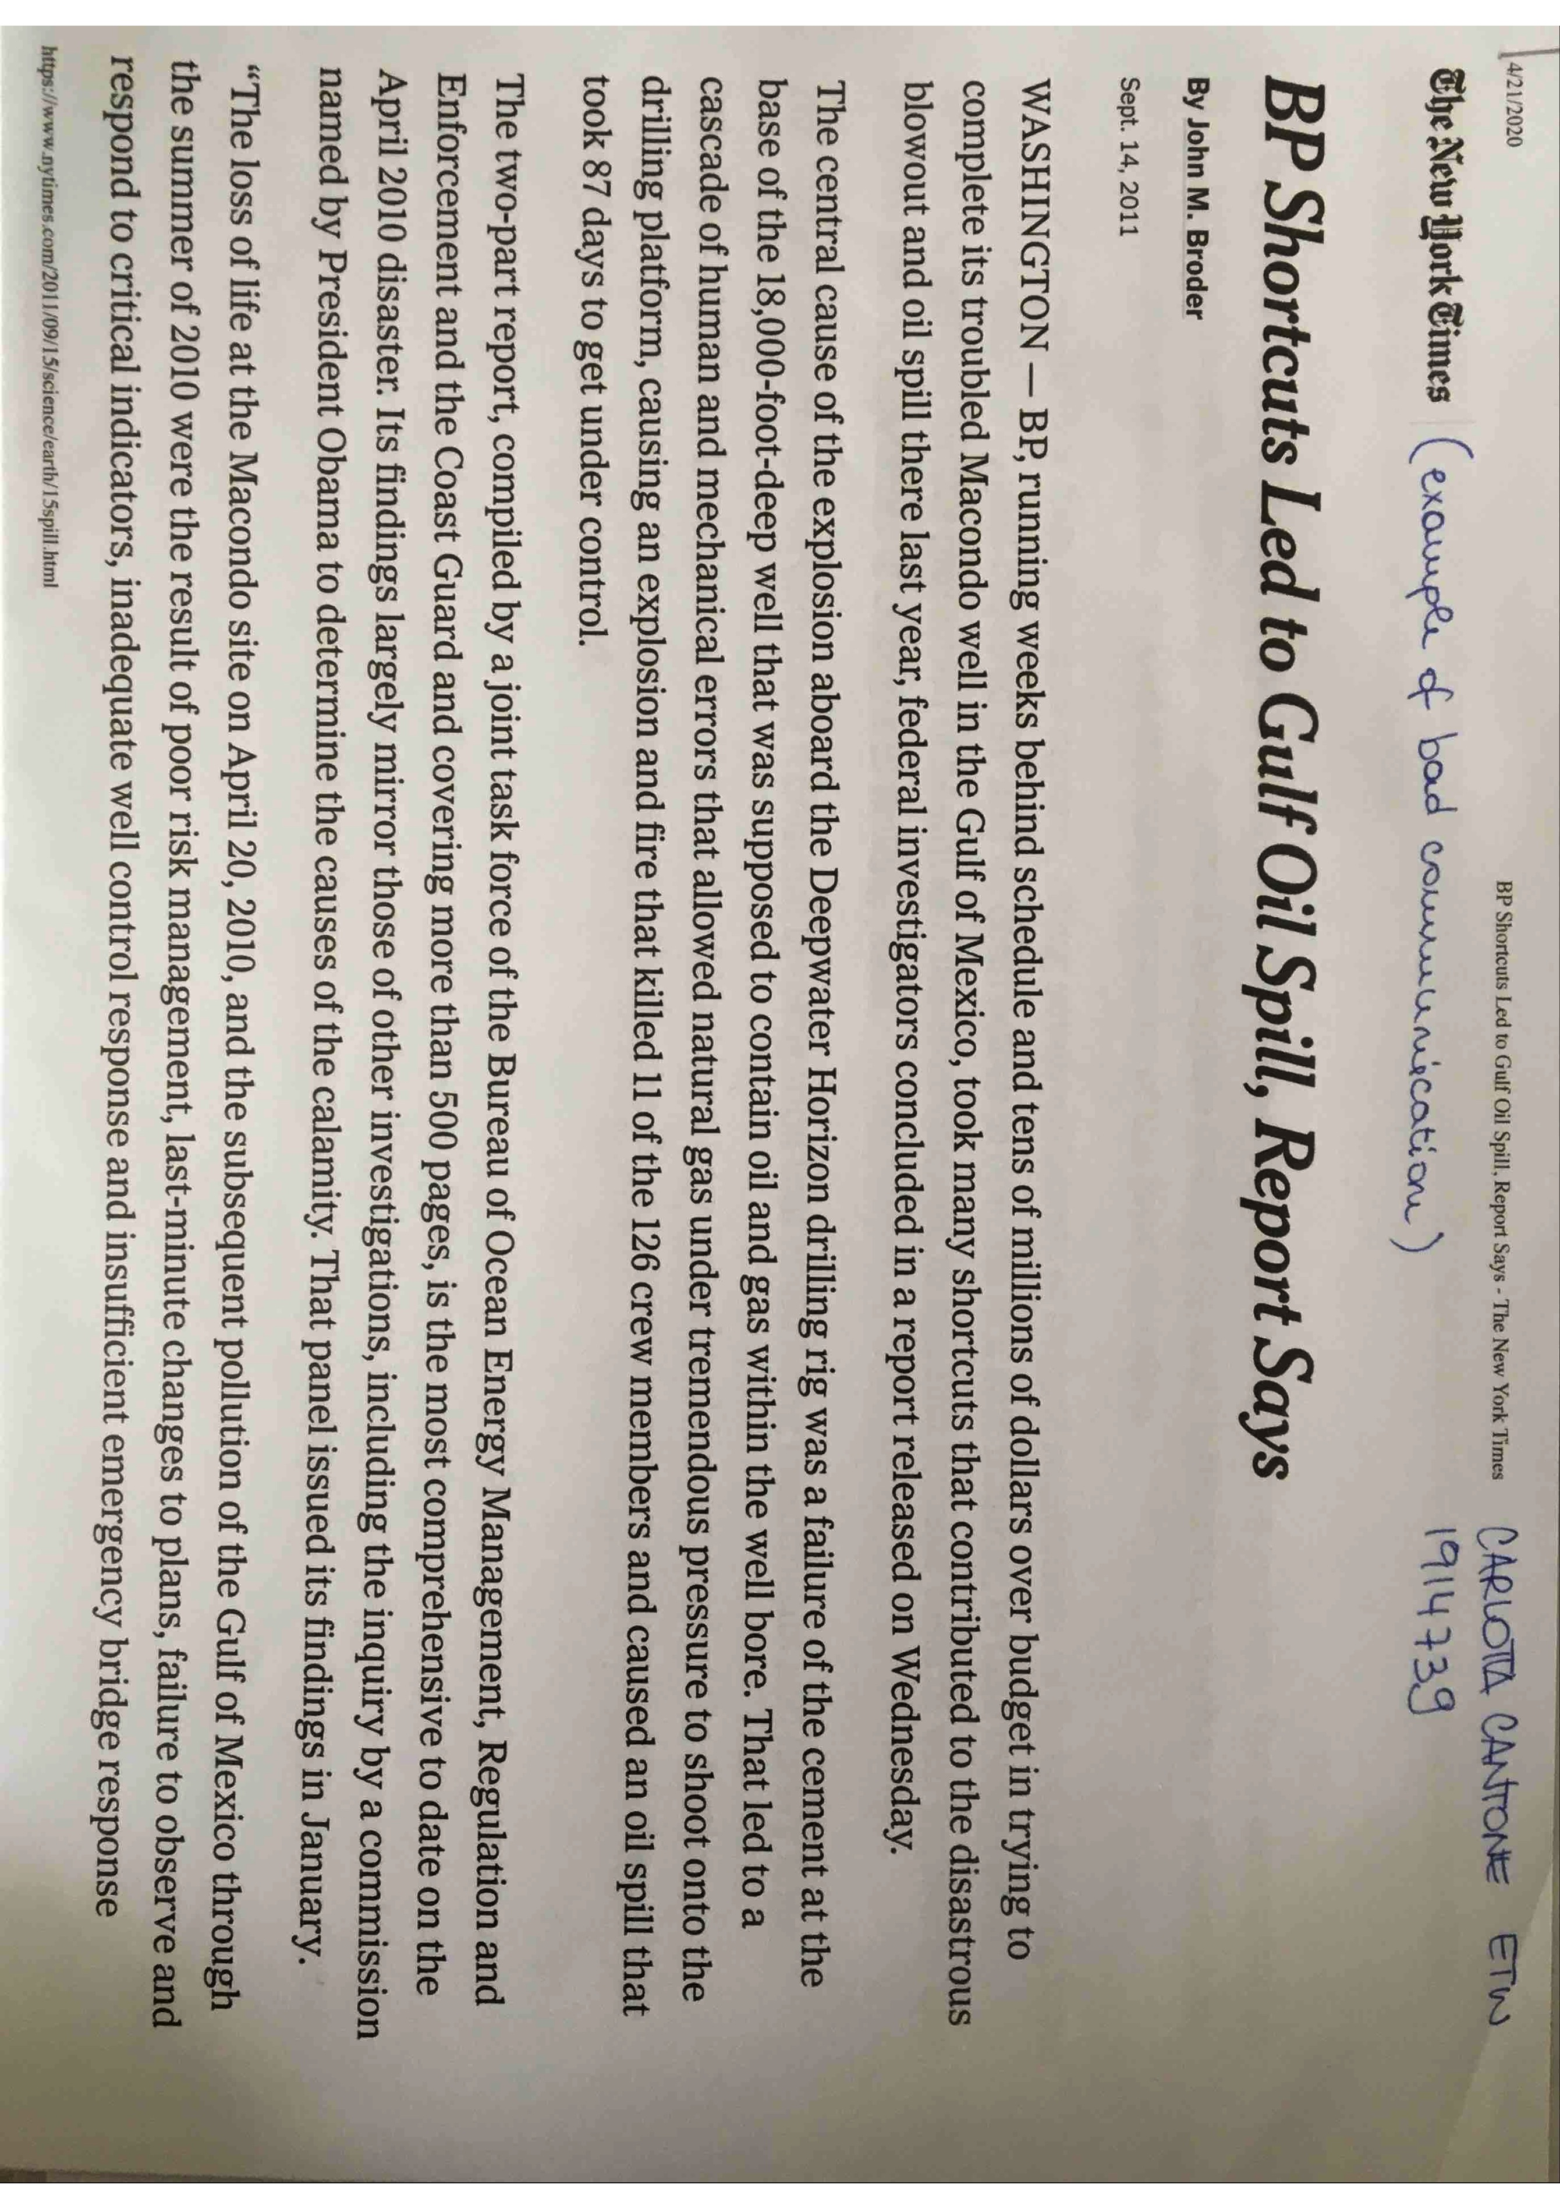
9
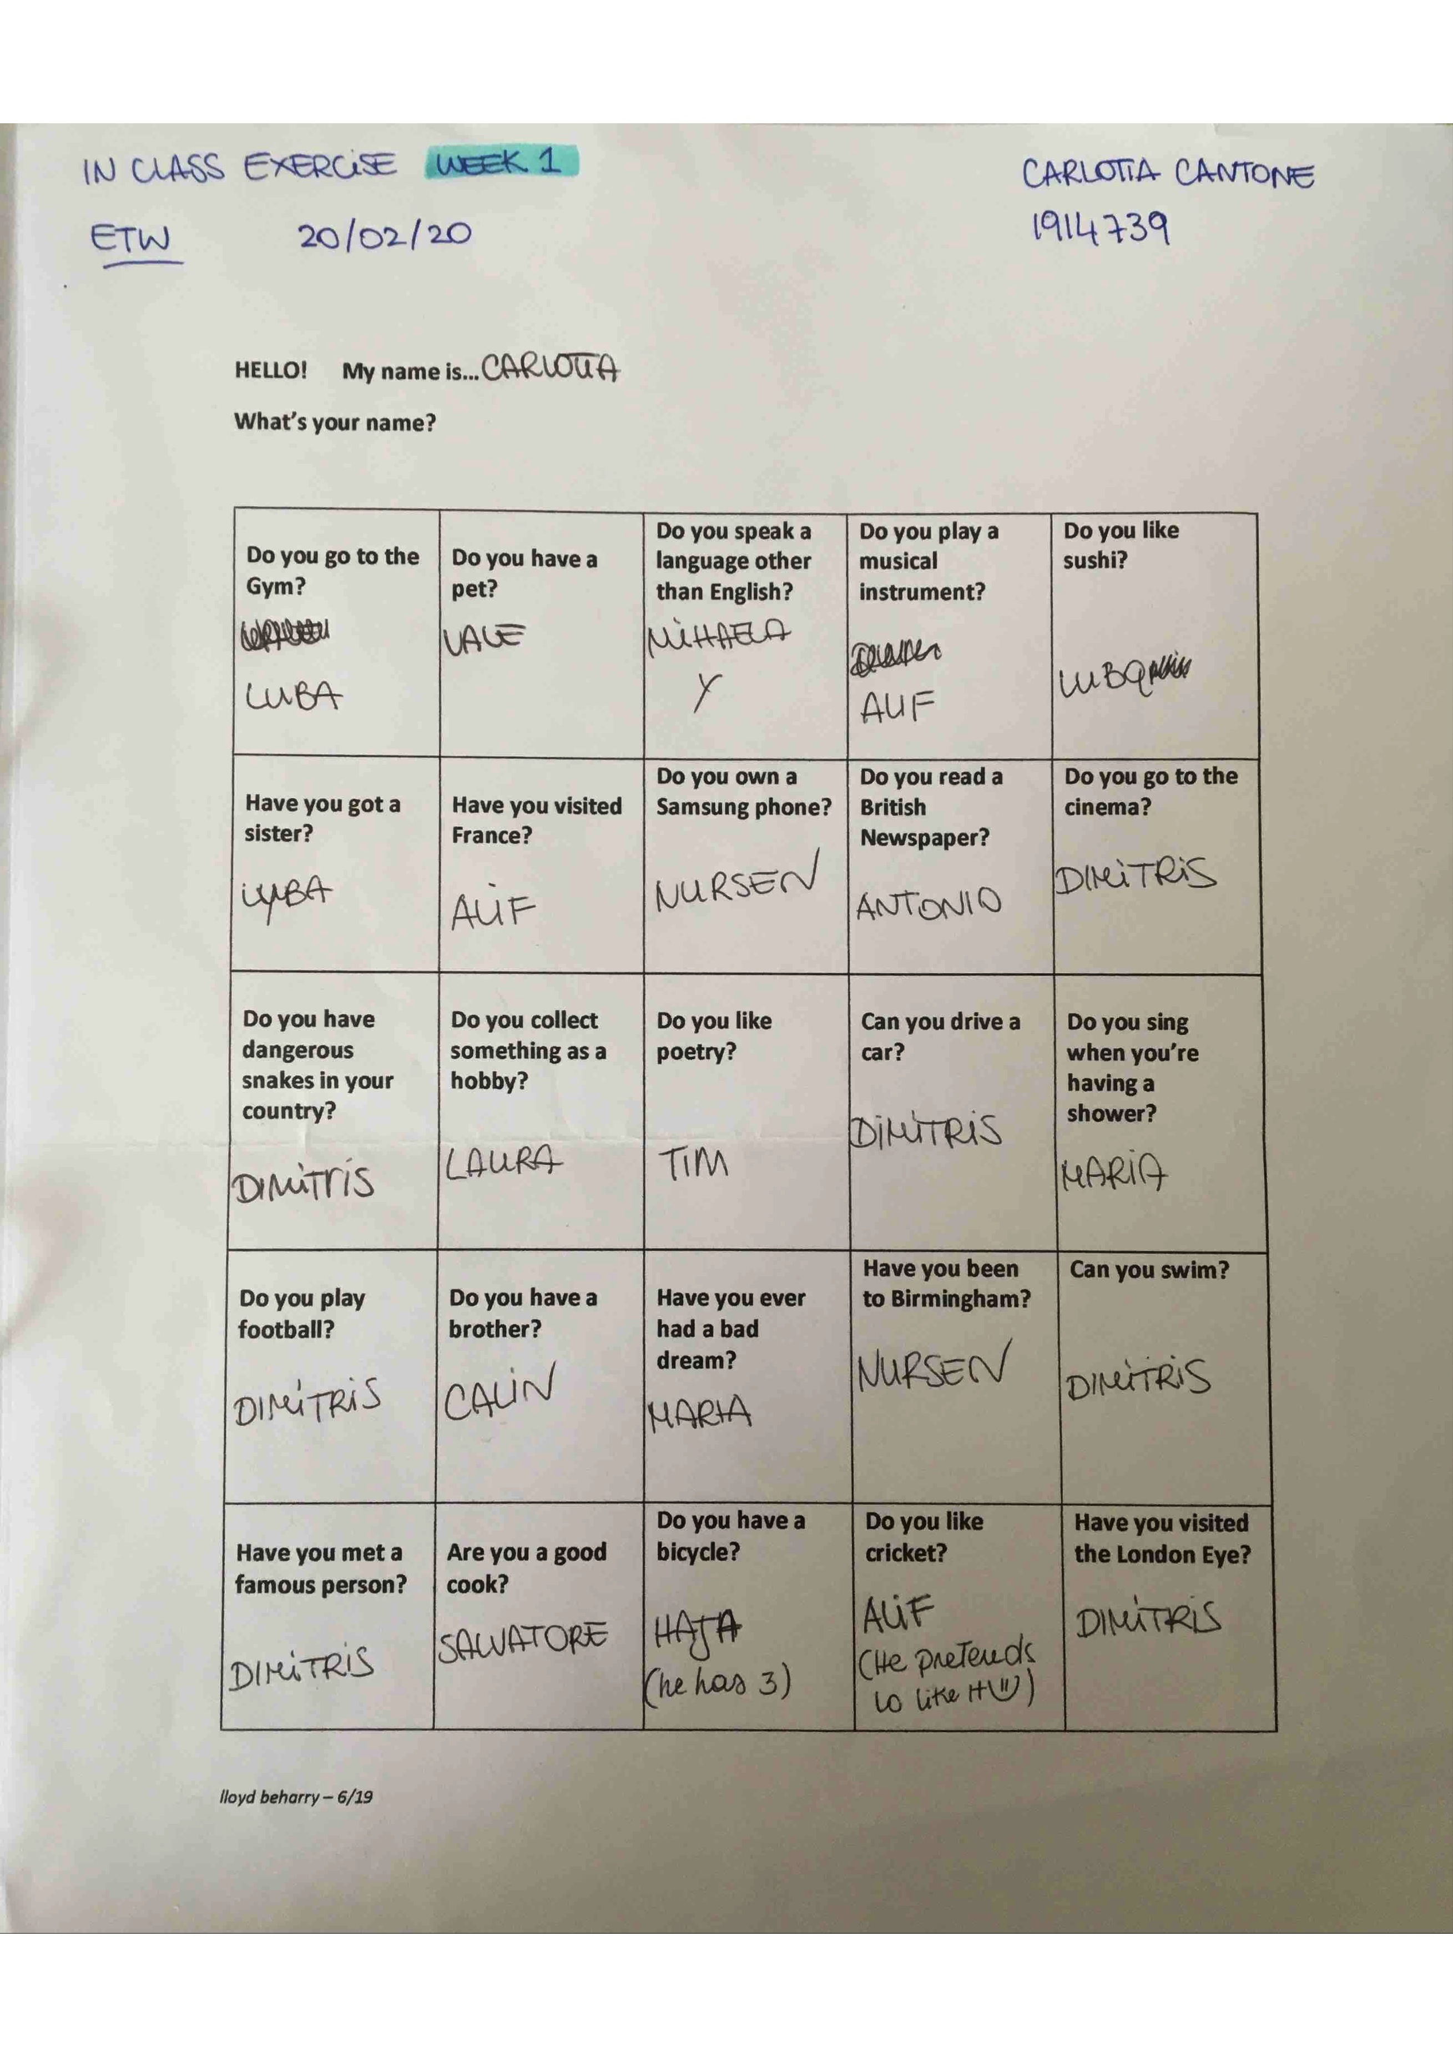
10
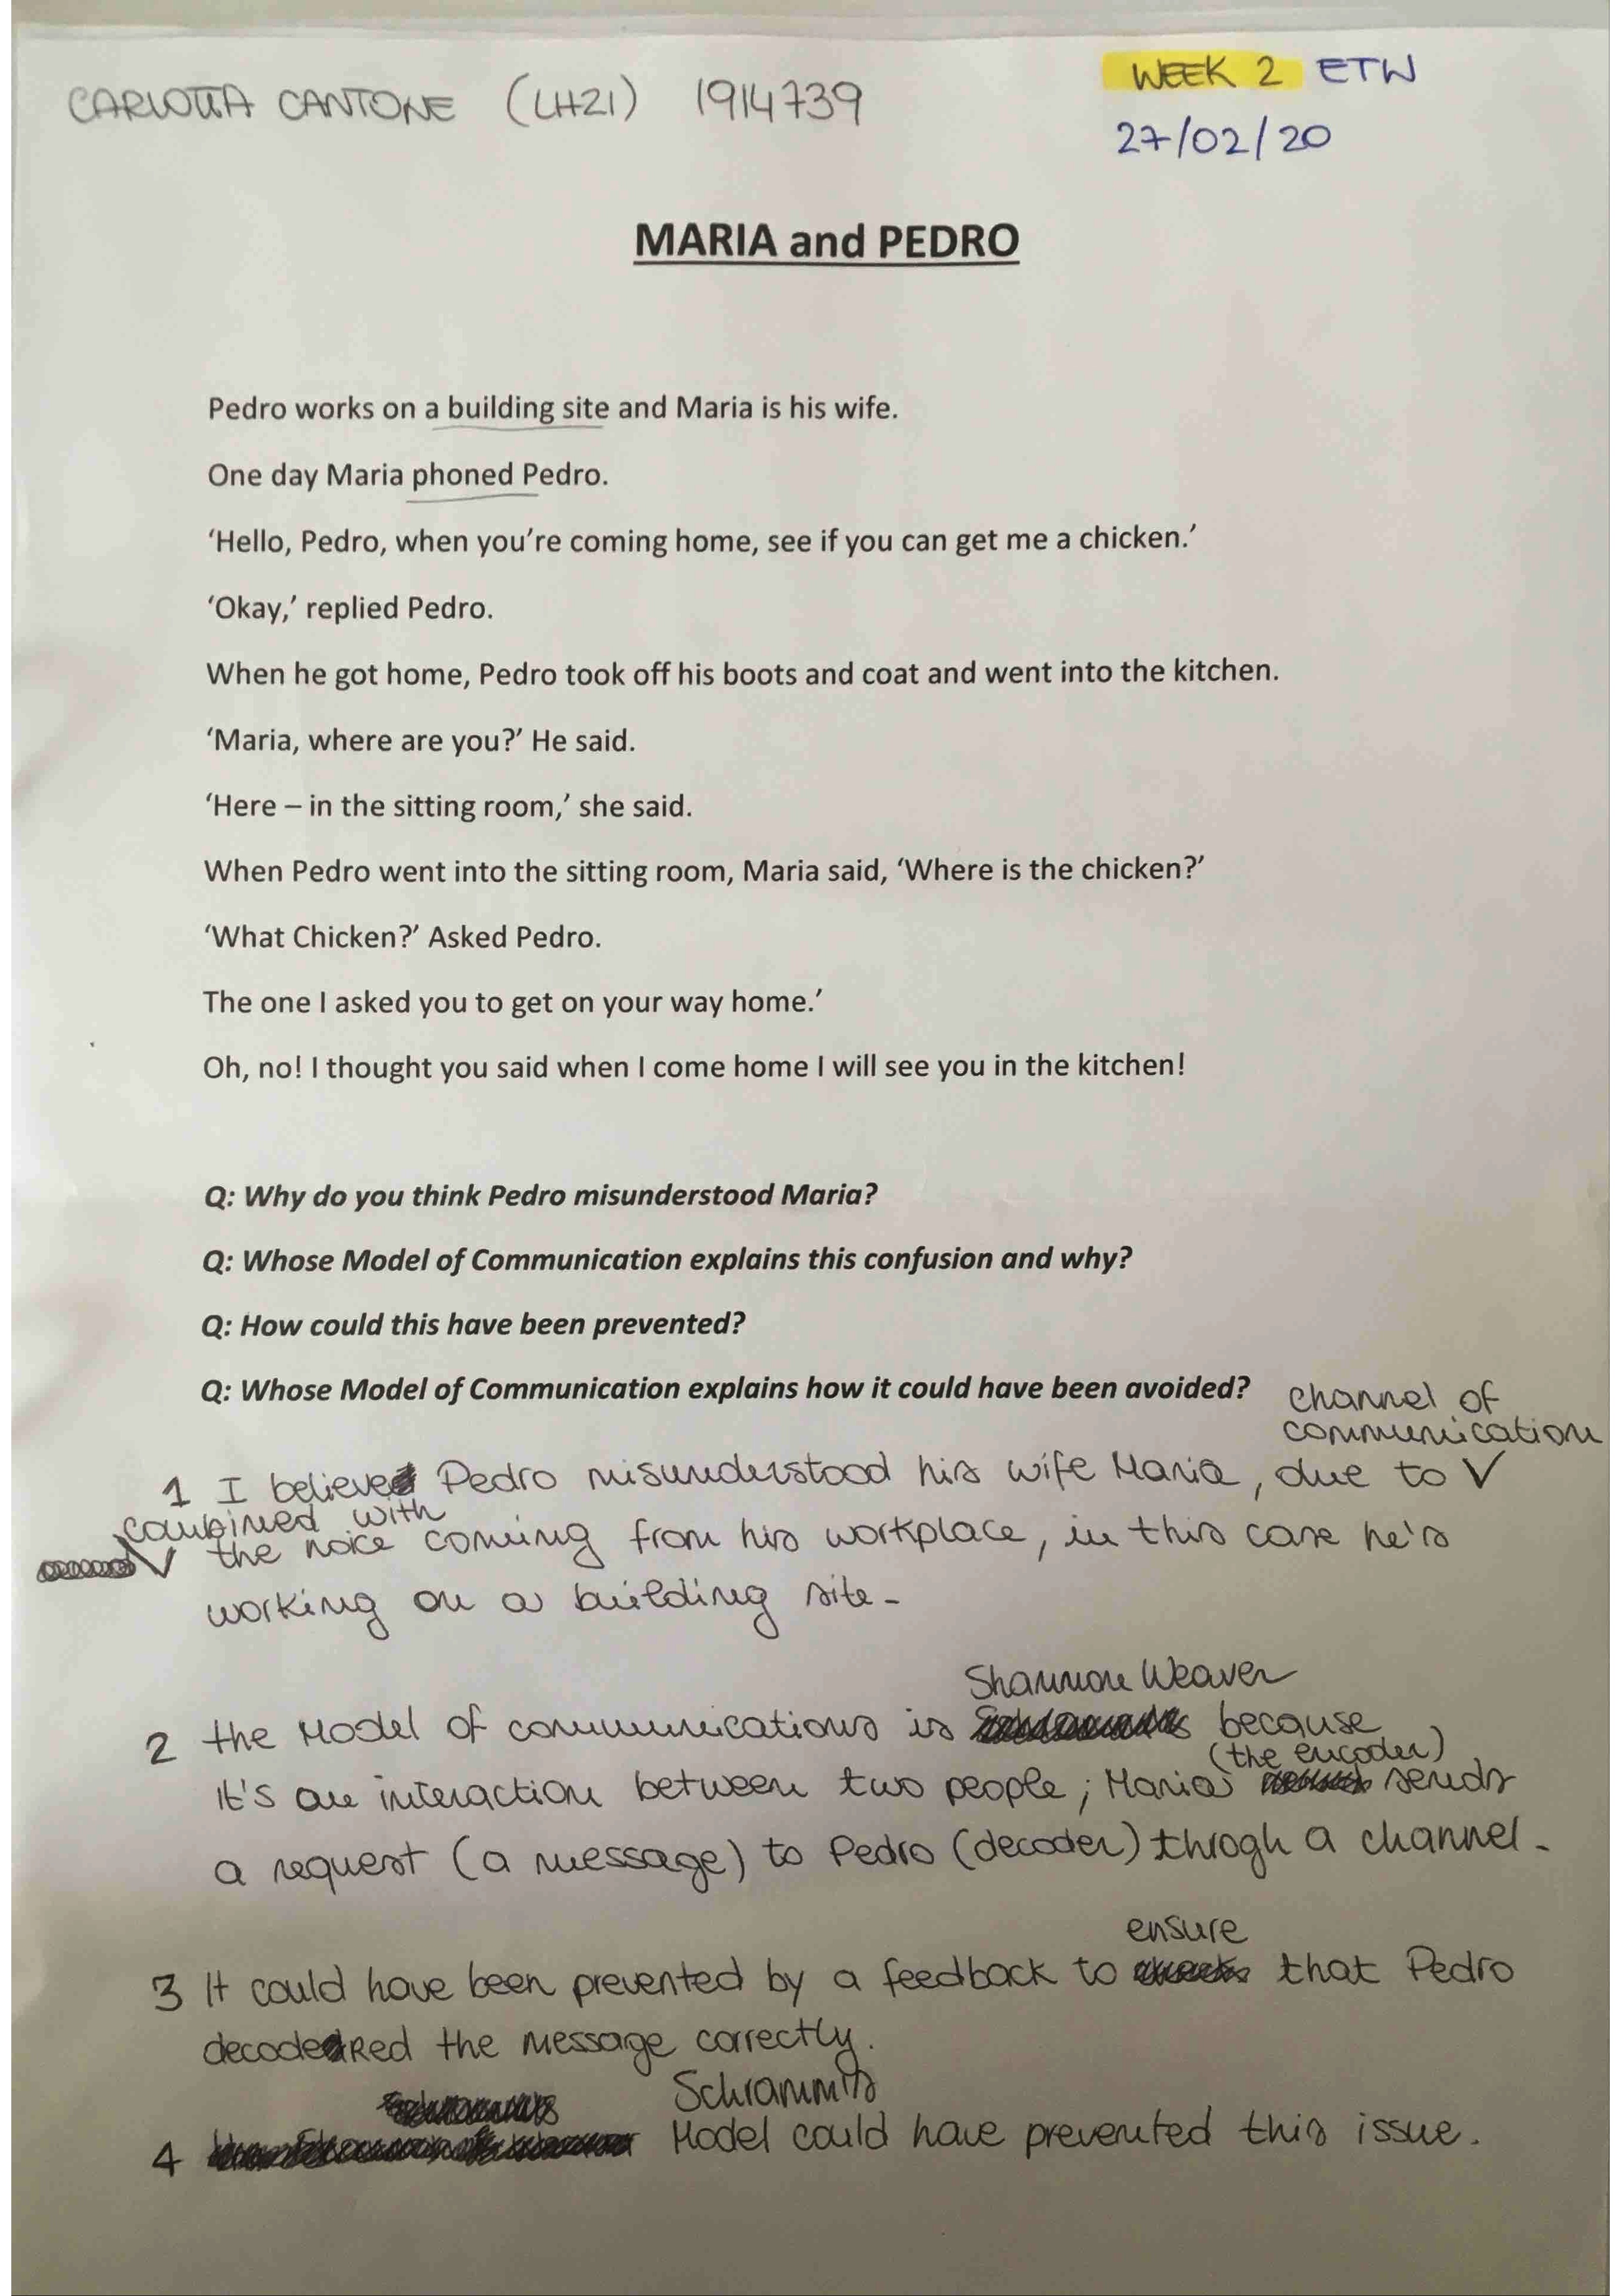
11
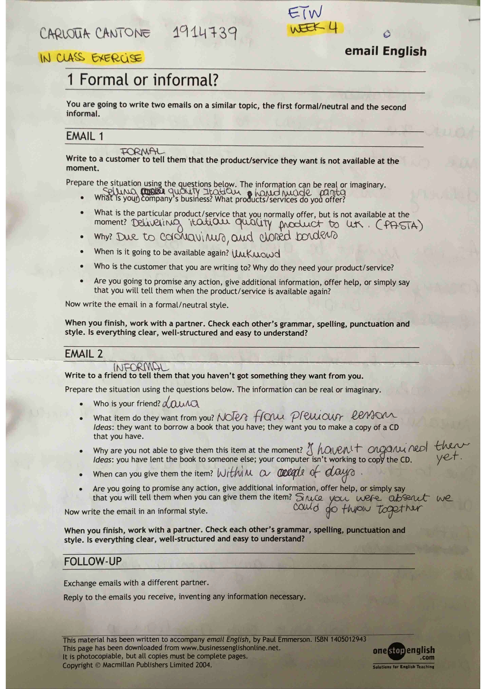
12
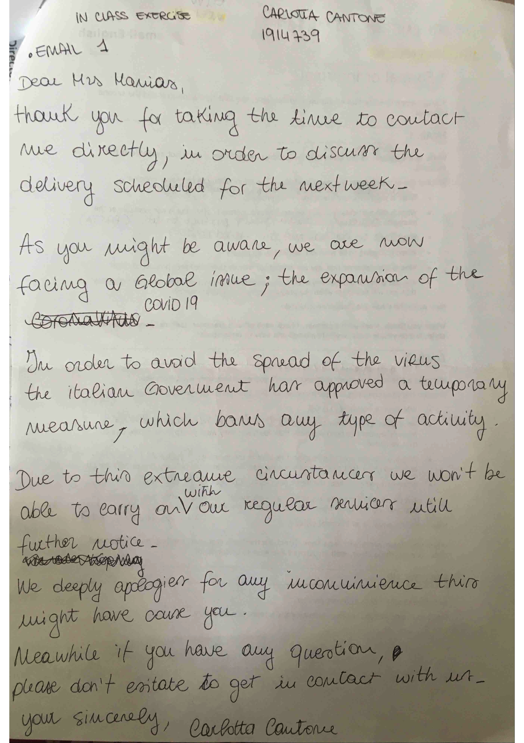
13
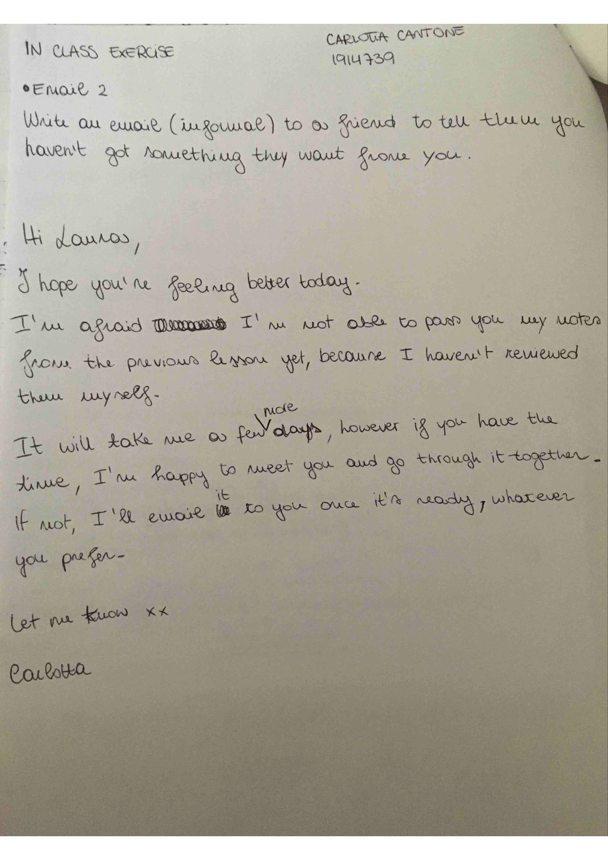
14
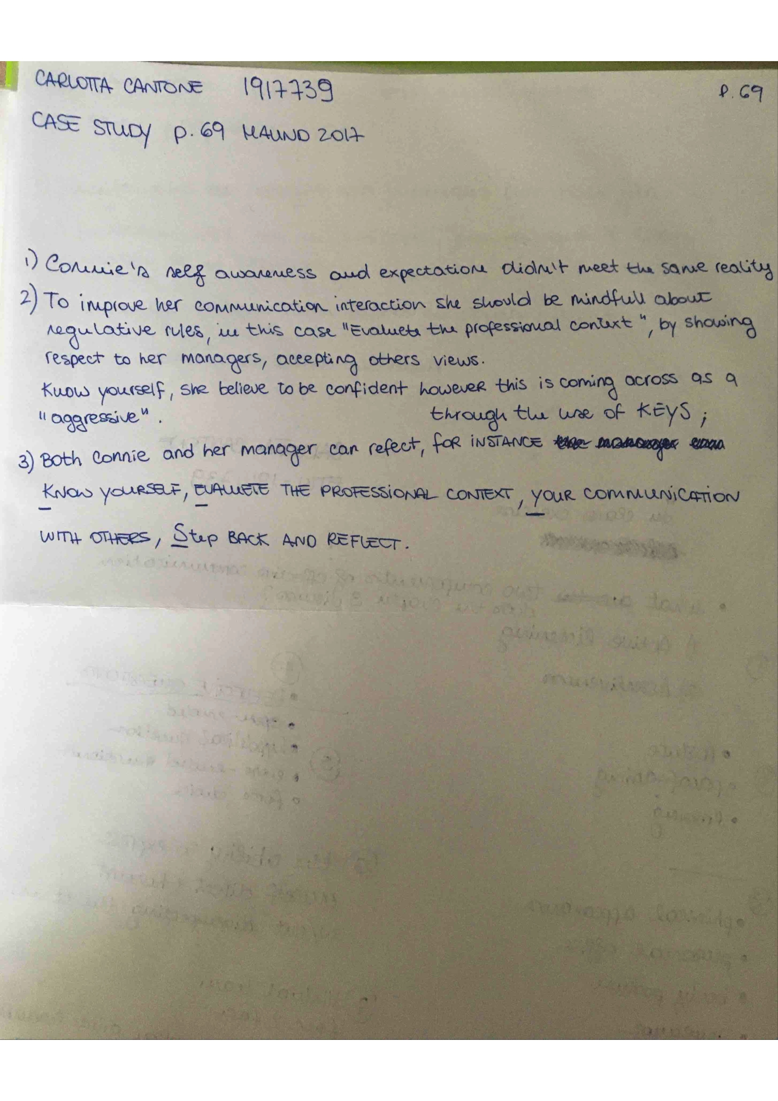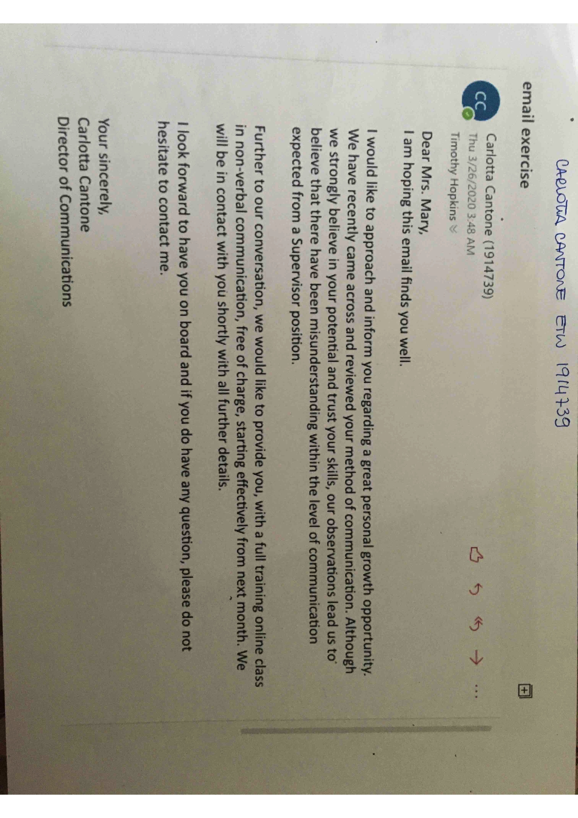
15
16
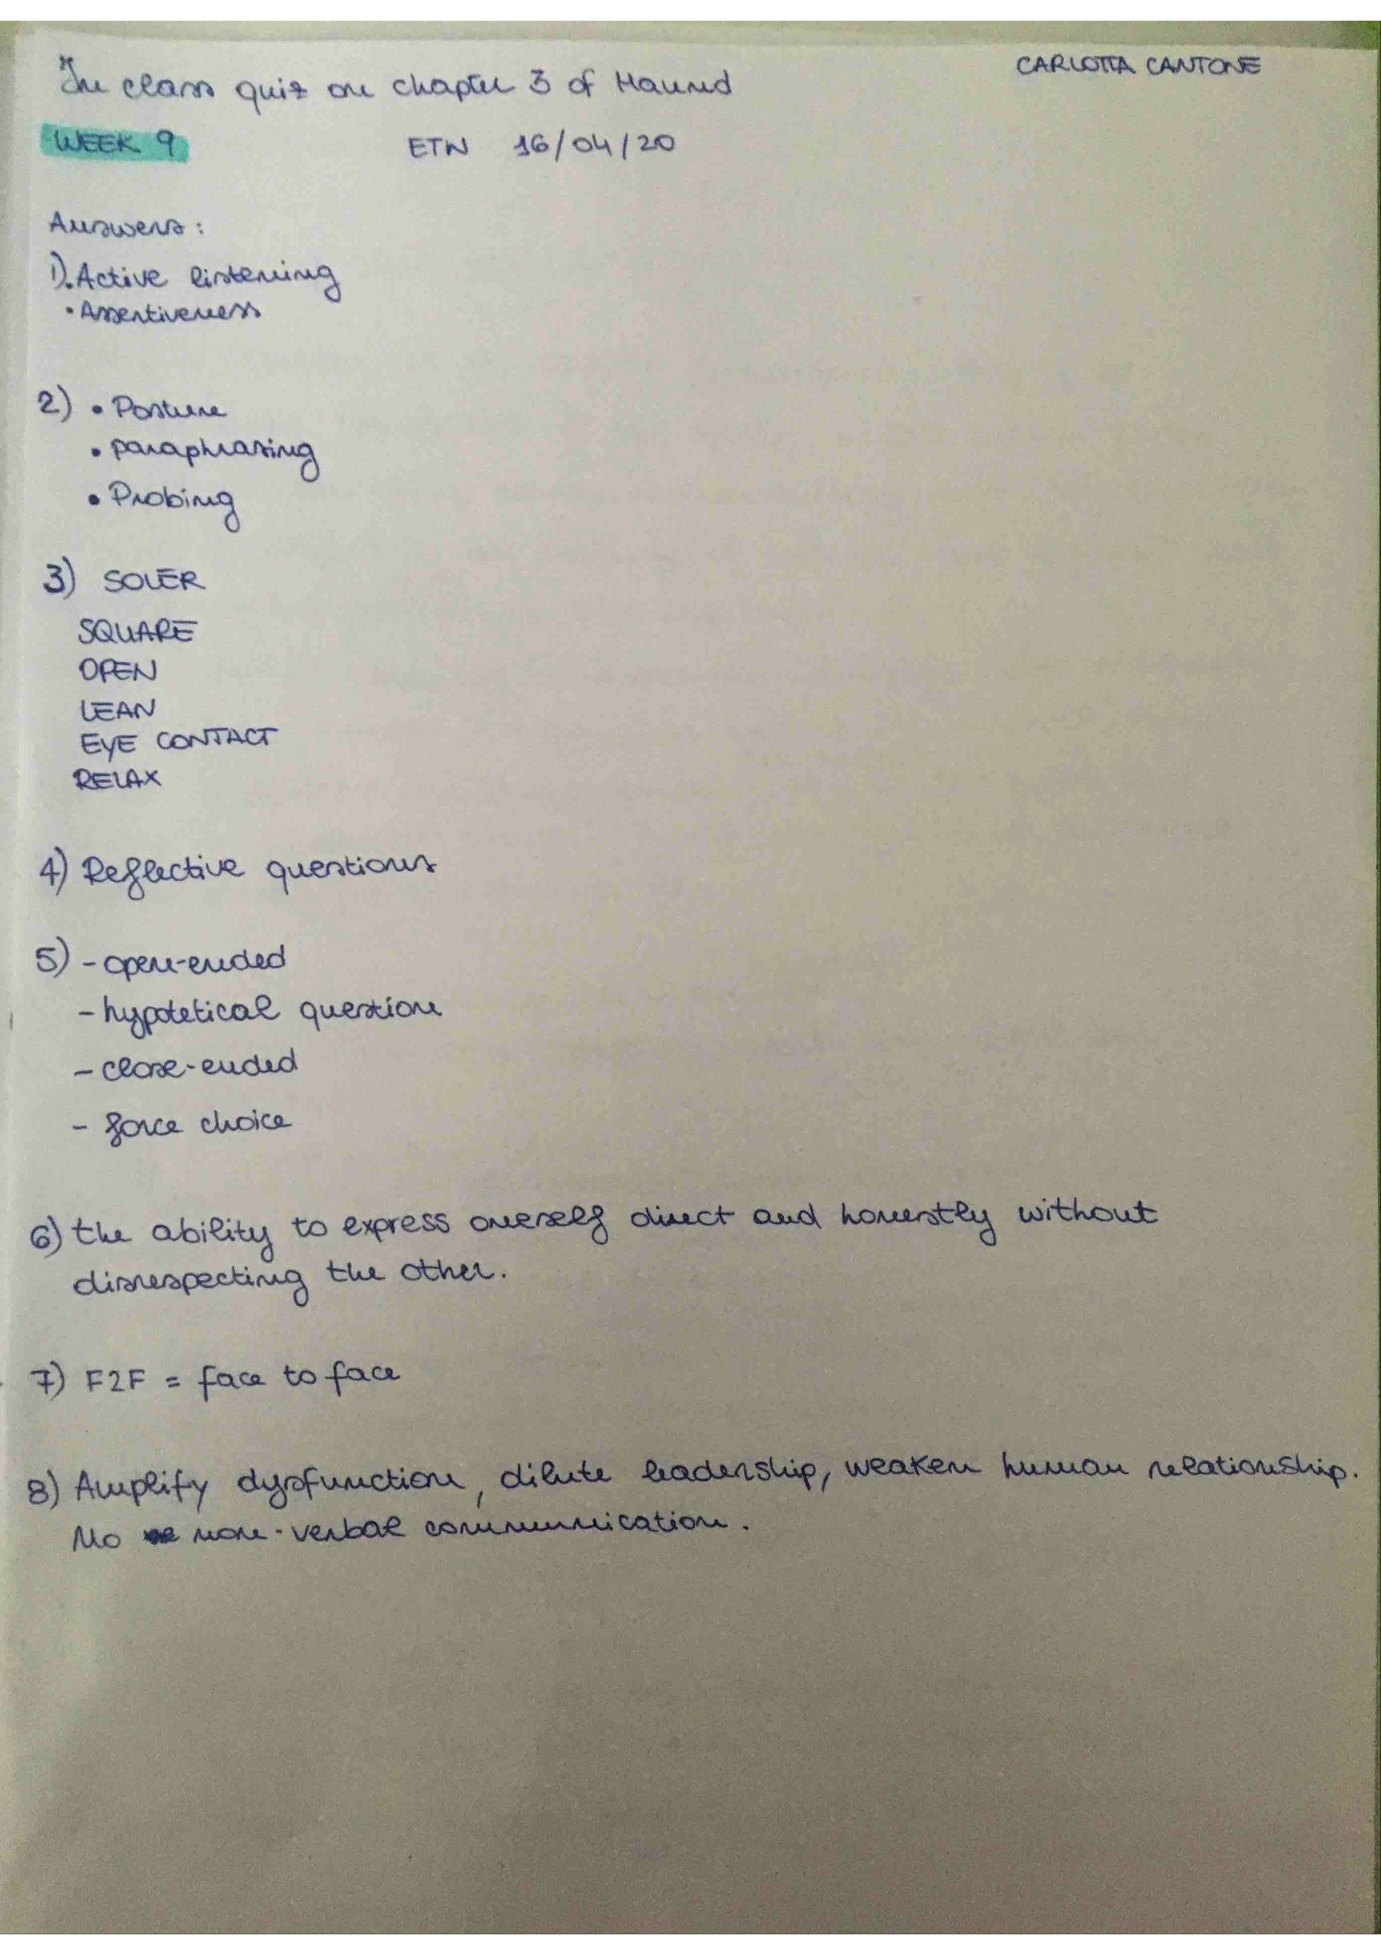
17
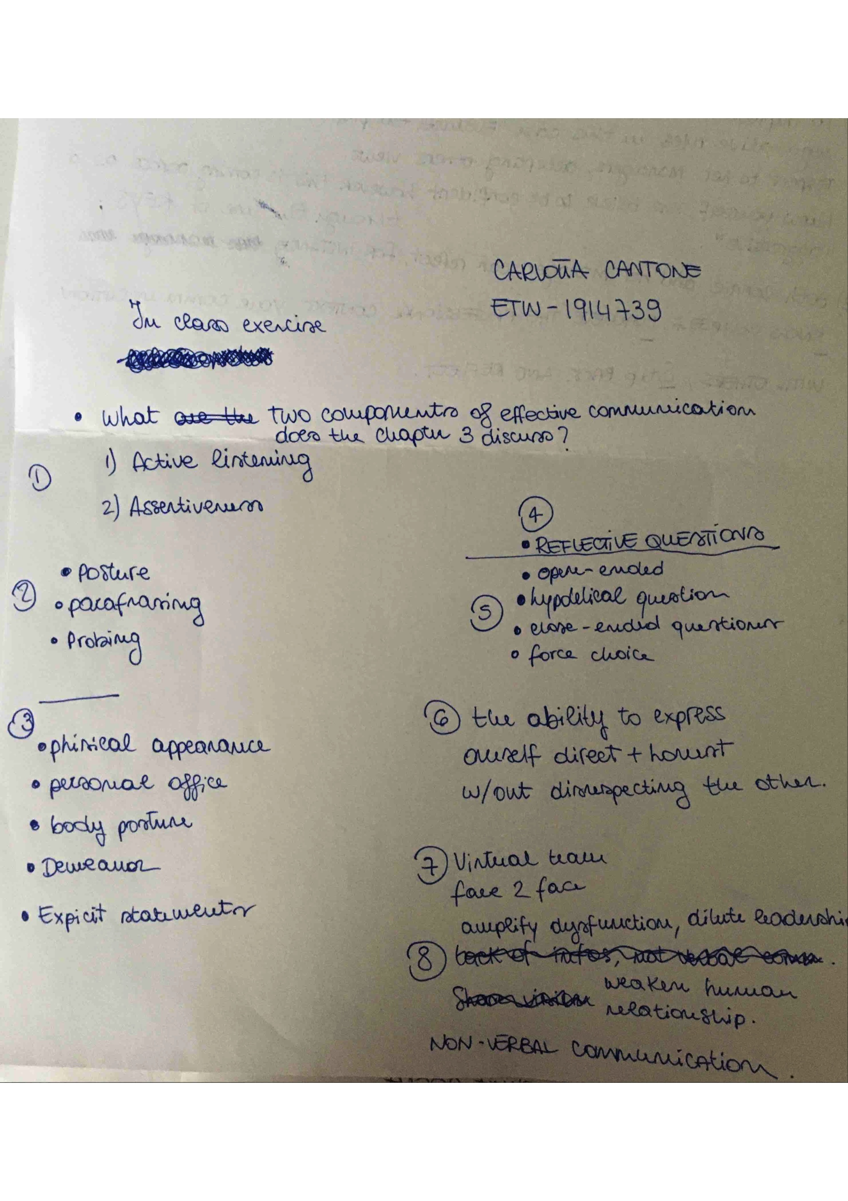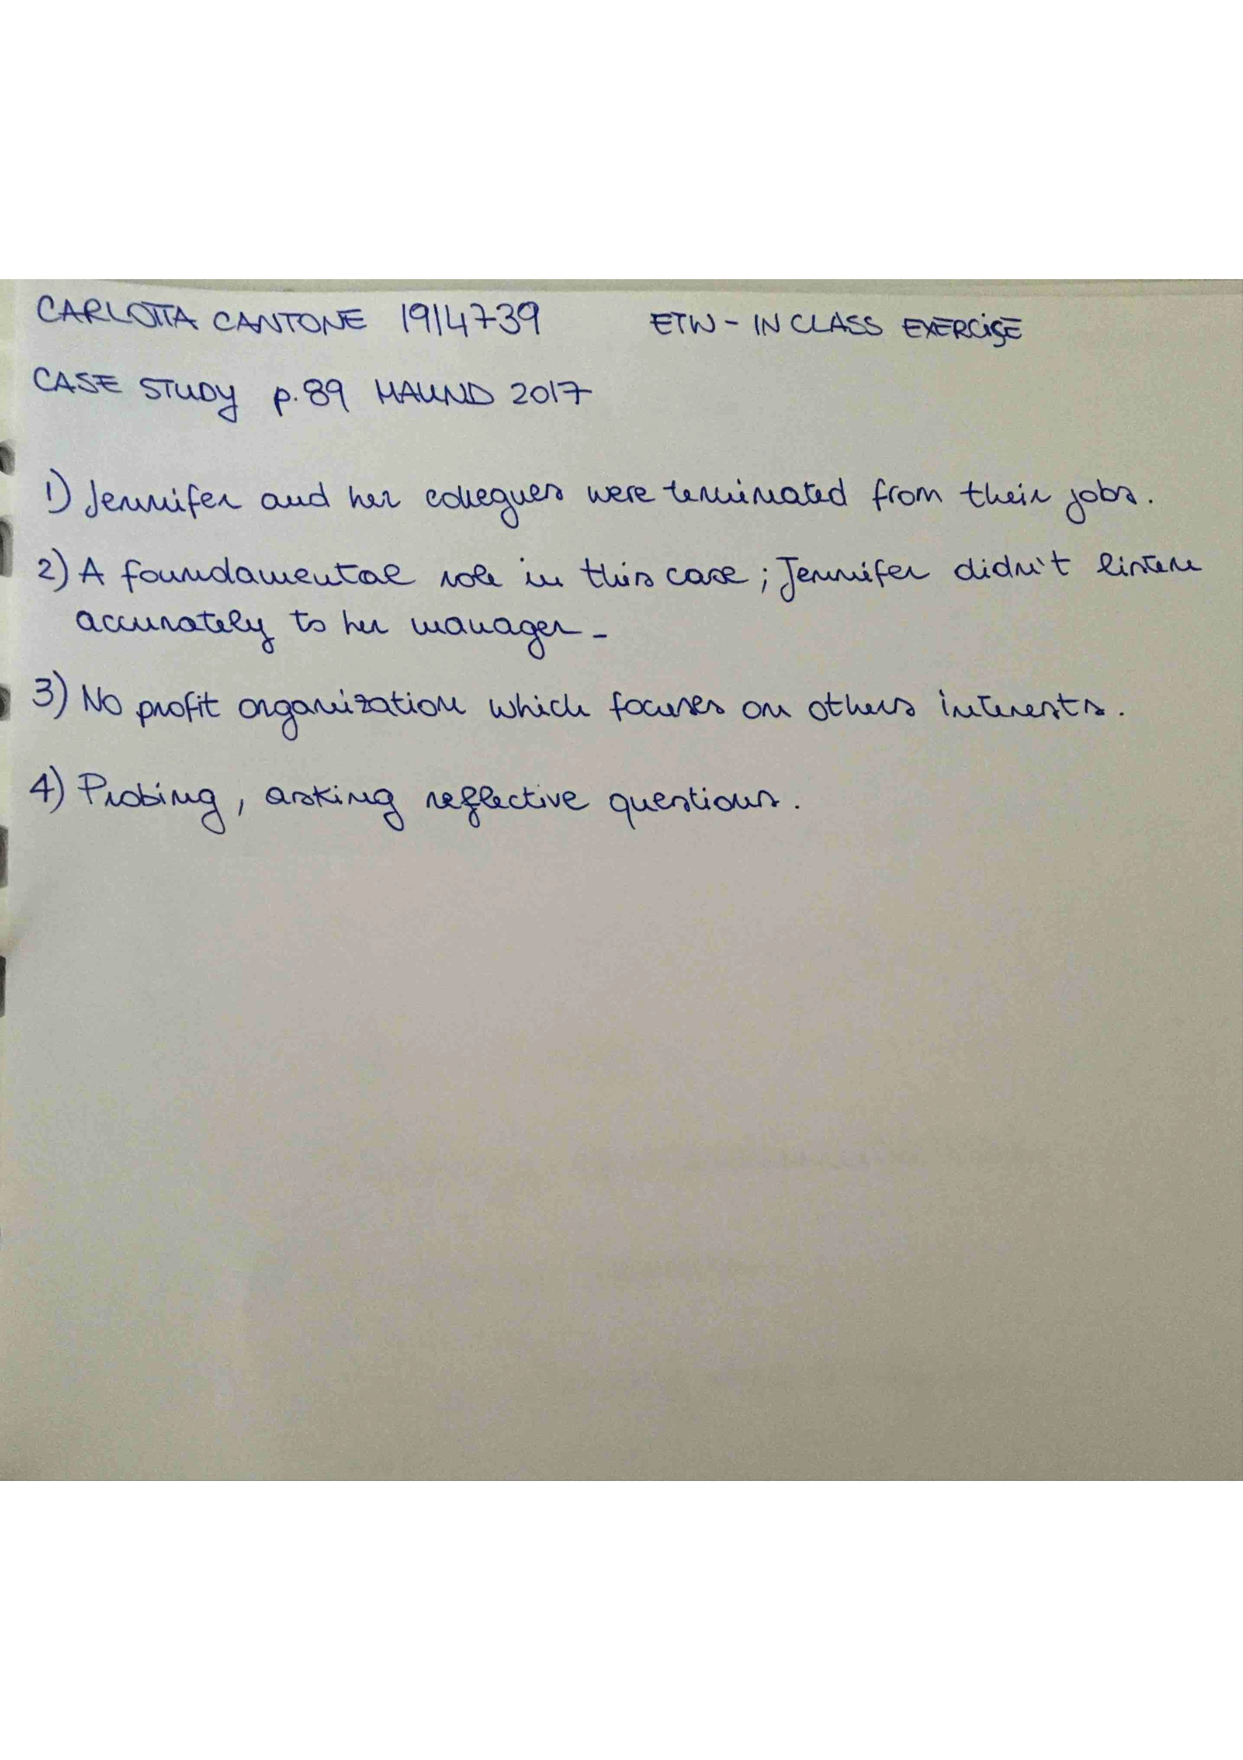
18
19

