Supporting young children in
Early Years
During transition

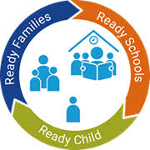

(Source: Herts for learning)

The Early Years Practitioner’s
Guide to supporting young children
through transition

Contents

Introduction to Transitions 3

The Role of the Adults 5

The Needs of the Child 9

Partnerships 12

Interventions 14

Proposed Outcomes 16

Reference List 18

Introduction

Purpose

The purpose of this handbook is to provide early years practitioners in the Nursery setting with the knowledge and understanding of the importance of supporting young children during times of transition. For some children coming into Nursery school at the age of 3, this will be the first time they are leaving their parents or creche and entering the school environment. The handbook will focus on how the role of adults plays a very important part of transition, the importance of communication with families and other professionals, and the learning environment to which the child will become a part of.

What is transition?

Transitions are the moves children and young people make from home to an early learning and childcare setting, from there to primary, from primary to secondary, between schools and further education and beyond. (Parent zone Scotland, 2021).

According to (Dunlop and Fabian, 2006, p. 61) children’s experience of transition can be somewhat traumatic, for this reason it is vital practitioners in early years, parents and setting managers are aware of the importance of providing children with support during these times. Furthermore, Brocker (2002, cited in Alingham, 2011, p.7) believes that children experience many transitions during the early years, and this will include several changes and new experiences that they would not have experienced earlier on and therefore would not be prepared for.

Croner-I (2019) believes that children leaving the home environment and joining early years settings is often an emotional time for parents and children. Though starting school is very exciting, children will be leaving the safety and familiarity of the home and entering a strange new environment with adults and other children that are not familiar to them. With this in mind, it is important that practitioners are knowledgeable in how to support children and put policies and procedures in place to ensure transitions are effective and positive experiences.

According to the Welsh Government (2018) the role of the early year’s practitioner is key to supporting children and their family during transition and for that reason it is vital practitioners have a clear vision of the needs of the child as individuals and are equipped to provide a warm, safe, welcoming environment for children to enter the setting with support in place with the aim for a successful transition.

The role of the adult

Early years practitioners

Becoming an outstanding practitioner in early years is to be enthusiastic about working in the childcare setting and having a passion for working with children. Practitioners will be knowledgeable but reflective and willing to further own development to provide the best possible provision for all children. (Burnham, 2016, p. 3). Furthermore, practitioners will keep 4 principles at the centre of each approach when working with children. These are -

1 All children are individual and learn everyday regardless of need or ability.

2 Developing positive relationships with children enable them to become
resilient, strong capable learners.

3 When children experience changes their emotions can be managed
successfully when the new setting has a warm, welcoming enabling environment.

4 Children develop and learn at different rates depending on developmental
needs of each child.

The Welsh Government’s (2021) guidance on enabling pathways forms part of the curriculum for Wales and has been devised to support early years practitioners for planning, designing, and introducing an outstanding curriculum for children. The role of the enabling adult is to create a warm, and welcoming learning environment that is emotionally safe, which in turn will support children with changes, learn to manage and express emotions and prepare learners for transitions, enabling them to manage changes that can occur daily.

(Brooker, 2008, p. 118) claims that actively listening to children is the foremost method of assessment and even more so during transition. Furthermore, the foundation of this idea is that listening and assessing children is the same principle, enabling children to have power and control over their learning which in turn allows them to accept and adapt to strange environments and new challenges. In addition to this, Smidt (2005) believes that to assess children successfully practitioners need to discuss strategies together during regular meetings. Moreover, assessment and observations are a cycle including, actively listening, and watching, taking notes, reading through and thinking critically and the outcomes, sharing views with colleagues and coming to mutual agreements about changes for future provision.


Attachment theory

Bronfenbrenner and Morris (2006, quoted in Hayes et al, 2017, p. 65) identified the theory of attachment around the various layers of a child’s environment as having the potential of influencing a child’s development. Moreover, the relationship between biological family and environment in which a child will grow is what drives and influences how a child will develop.
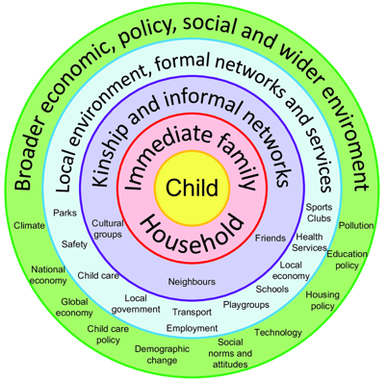

(Source: Researchgate)

The model Bronfenbrenner based his theory on was that the child is at the very centre of the ecological system. The four parts of this model are –

Microsystem
Immediate surroundings of the child with which the child has regular interactions that will have the biggest effect that will include - environment, people, and home life.

Mesosystem
Interactions outside the familiarity of immediate surroundings such as early years setting, community area, extended family, and friends.

Exosystem
Settings outside of child’s immediate environment however still have an impact on a child’s development. For example, a parent’s place of work, neighbouring houses, or buildings

Macrosystem
Far outside of the child’s immediate environment, includes culturally, economically, socially and ideology.

Attachment is an emotional connection which is formed between young children, parents, and carers. It is vital for practitioners to form an attachment with children entering their setting to enable attendees to feel safe, secure, and ready for the school day. Additionally, all adults connected to the child have an important part of providing the right provisions where children can thrive and grow into global citizens. This takes time and practitioners must consider the needs of the child. (Early years matters, 2007).

Children learn early, from babies to use attachment strategies to keep them safe and to keep parents close to enable them to feel secure. Furthermore, it is the fact that the child feels in danger that is the problem rather than attachment being the detrimental factor. That is why early years practitioners are in a unique position to build positive relationships and form attachments with children to enable them to feel comfortable enough to adapt to their new learning environment. (Beacons house, 2020).

Parents and Carers

Parents are seen as primary educators in the lives of their children, (Parents International, 2017) also that being a parent and educator are closely linked. Furthermore, fundamental for children’s wellbeing, social, emotional, physical, and cognitive development is parents, being the first educators and having the ability to
provide the best start for children at home and for the family. However, when the time comes for children transition from home to an early year setting, working in partnership with parents is vital for positive outcomes.

Pacey (no date) believes that practitioners and parents working together is at the core of providing the best start to a child’s journey in the early years. What is more, is that communication between setting and home from the beginning, is very important and that practitioners are flexible in their approach when communicating. For example, a parent may have difficulty using the English language to communicate, learning need, or it may not be the right time. It is important to take in to account the individual need of the family. In addition to this, building positive relationships with parents and carers is important and to remember that parents are leaving in the care of practitioners their most precious individual - their child, and so to build a trusting positive relationship is vital between home and in doing so it enables practitioners to deliver positive outcomes.

The needs of the Child

Every child is an individual with individual needs that learns every day from their environment and the people in involved with their care. In addition to this, children will become strong and resilient through the positive relationships built with parents, carers, and early years practitioners. Furthermore, to enable children to learn in line with their developmental need practitioners must ensure the early years setting provides a warm, welcoming, and safe learning environment with resources that stimulate and enrich learning opportunities through playful teaching and a playful environment. (Early Education, 2012).

With this in mind (Early Education, no date) suggests when children feel safe and happy in the early years setting, they will be confident to leave their parents with the knowledge they will return later in the day. Similarly, parents and carers feel confident to leave children at the setting, children should be phased into the new learning environment, children’s social and emotional needs will be met when upset or crying, children will be listened to and comforted in times of sadness.

According to Maslow’s Hierarchy of Needs (1943) people have 5 categories of needs.

Self - actualization
Realising one’s own capabilities and reaching one’s own potential

Esteem
Recognising one own strength, and have confidence in one’s own abilities

Love and belonging
The need for love and to give love with family and friends.

Safety needs
Health and wellbeing, financial security, feeling safe and secure.

Physiological needs
Food, warmth, water, home, clothing, and life.

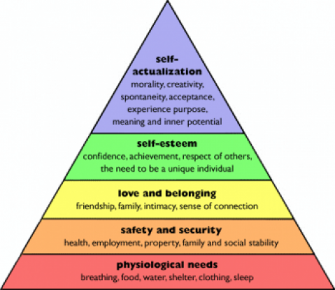

(Source: Bassetti, 2018)

Learning to communicate is very important to young children. Human beings begin learning to communicate as babies by crying when they are wet or hungry, cooing and smiling when they are happy, and babbling when they are beginning to form sounds and moving their mouths to make noises. This very early stage of communication enables babies to have their needs met. A fundamental aspect of learning to communicate as they grow from babies to young children is interactions between care givers. By the time young children enter the Nursery School setting at the age of 3 children have developed the ability to communicate their emotions, express their needs, and feelings by using their face, body, simple verbal communication and hand movement. As practitioners in the early years, you will have knowledge that some children entering the setting for the first time will be the first time they are leaving the familiarity of the family home. Children may become visibly distressed upon arrival at the strange new environment and will be distraught about leaving their family. It is important to remember not all children are able to verbalise how they are feeling or a reason why and it the skills of the practitioner that will comfort and enable the child to feel safe, secure and begin to build an attachment with adults within the setting, thus developing their communication abilities over time as the child becomes more trusting and settled in the early year’s environment. (ResearchBrief, 2013)

Play is a very important part of all children’s lives. Giving the opportunity for children play allows learning, brain development, develops social, language and communication skills. The United Nations convention on the rights of the child (UNCRC) has devised 54 articles outlining children’s rights regardless of their race, gender, religion, or country of birth. This agreement is legally binding with 196 countries signed up and applies to all children across the world under the age of 18. Included within these rights are the children’s right to an education which nurtures and develops children’s abilities and talents. Children must be at the centre of all decision making, that their wellbeing is priority in any aspects that affect them. All children have the right to share their voice and express their feelings and all children have the right to play and take part in leisure activities. It is therefore important that the UNCRC are taken into consideration during transition and included in policies and planning enabling practitioners to implement into the early years setting. (UNICEF, no date).

Partnerships

When working with children in early years it is important for practitioners to keep children at the centre of the approach. This is particularly important during times of transition and the process is much easier when working in partnership parents, carers, extended family, or other professionals. Working in partnership with parents and carers historically was never seen as an important aspect in developing children’s learning until the education act 1944, (Wilson, 2016, p. 7). Moreover, it was this education act that parental involvement was included as one of the key principles of legislation.

Urie Bronfenbrenner firmly believed to understand the development of a child practitioners and other professionals must observe at the immediate environment and equally important is environment’s outside of the home and how children interact in various situations. Bronfenbrenner’s model for ecological systems theory shows a person’s environment split into five separate systems. Using this model shows and takes into consideration the wider influencing factors and that there are several aspects in a child’s life that affect and interact the child. (Aubrey and Riley, 2019, (A) p. 150 )
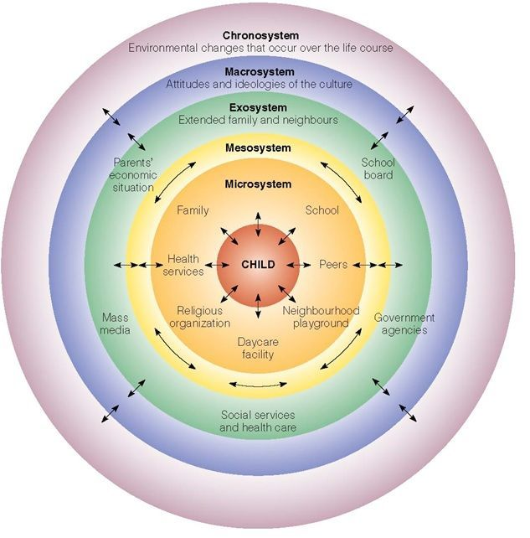

(Source: Simply psychology 2020)

Multi agency working and partnerships with families is fundamental to understanding child development and planning to meet the needs of individual children. Building and maintaining positive, strong relationships with all involved with a holistic approach is vital for positive outcomes during this time. Early years practitioners are in a unique position to observe and plan with the child at the centre and maintain contact with those involved with the children. (Welsh Government, 2016).

Early years careers (2016), suggests that the relationship between practitioners and parents is fundamental in setting foundations for development. Moreover, when children observe the positive partnership between parents and key workers, it enables them to build key social skills with peers by observing respectful and positive interactions.

Interventions

Supporting the transition process is an important aspect of building positive relationships with children and their families. There are several interventions practitioners can utilise to build links with home and get to know the child before their journey in Nursery begins.

In school playgroup

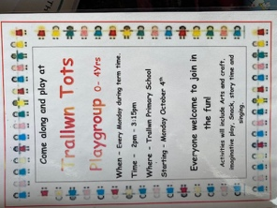
Some Primary Schools offer a playgroup session run by Nursery teaching assistants aimed at babies from 0- to 4-year-olds and invite families from the community into the school environment. This allows the young children who attend to become familiar with the school, join in fun activities and become familiar with staff. This enables the child to get to know staff and begin to build a relationship, similarly it enables parents to get a feel for the school, ask any questions and get to know staff.

Home visits

Visiting the family home is a useful way of collecting information and gives practitioners the opportunity to identify any sensitive issues and put effective strategies in place. This gives parents the opportunity to share any concerns with practitioners and allows for observations to be made that will support children for their transition to school. Furthermore, lays the foundation for building positive, trusting relationships between school and home. (Welsh Government, 2016).

My new class booklet


Providing families with a transition booklet is another effective way of introducing children to their nursery environment. Including photographs of the nursery yard, cloakroom, classroom, activity areas and pictures of nursery staff. Simple captions on each page giving a brief explanation of each area and who’s who. Using this booklet at home to support transition gives children and families a visual tool enabling them to become familiar with the nursery environment.

All about me

All about me books are a useful way of finding out about children starting nursery school. The books can be filled in during home visit by parents or by practitioners during a visit to the nursery prior to the child’s start date. Making the book personal by including a photograph or self portrait of the child and contain information such as name, age, favourite toy, likes and dislikes. Using a resource such as this allows practitioners to become familiar with the child prior to joining the setting and will help in the process of transition. Little Swans (no date).

Setting visit

Most early years settings arrange visits and include this in policies. Whilst practitioners will be used to facilitating visits it may not be something parents are used to and so it is vital practitioners bare this in mind. It is important to inform parents what the purpose of the visit is and to be prepared with information such as welcome pack, letters with relevant information and important calendar dates. During the visit the early years setting should be an inviting, warm, and exciting environment with activities suitable for the age of the children. Practitioners should engage with children and parents enabling them to feel safe, valued, and welcome. Using this opportunity to begin to develop that important home school relationship. (Wilson, 2016, p. 49, 50)

The purpose of interventions to support transition is the on basis that every child and their parents have the most positive experience and emotional support during every step through transition, with the aim to provide the best experience of changes, develop and nurture the wellbeing and support development and learning. (Country background report Wales, 2018).

Proposed Outcomes
The proposed outcomes for children to have a positive experience during transition is to provide a warm, safe, welcoming, and exciting environment to nurture and enhance children’s learning. The principles for positive outcomes are –

1 To ensure children have rich learning experiences where their feelings
views and rights are respected.
2 All children are treated fairly and as individuals with their own interests and
strengths are taken into consideration and valued.
3 Interventions are used to support children to prepare for transition and
practitioners are consistent in delivering a child centred approach.
4 Practitioners value the knowledge and skills of parents during their child’s
transition and parents are supported emotionally during this process.
5 Early years settings are committed to developing positive relationships
between parents and other mult agencies to support children during
transition successfully. (Tower Hamlets, no date).

According to Tickell (2011), the early years in a child’s life are most crucial for child development and positive outcomes. In addition to this, the future for the child’s wellbeing, resilience, relationships and becoming global citizens is guided greatly by the influences, love and care the have during their development in early years. Furthermore, early years practitioners are an important influence on child development and ensuring the best possible early years environment and experiences for children to learn and grow has the potential for a big impact on gaining long term outcomes.

Kolb (cited in Aubrey and Riley, (B) 2019) believed that people learn through experiences rather than observation or reading alone. Moreover, experiential learning enables people to learn at their best being fully engaged in experiences that later allow them to reflect upon using thought, feelings and questioning. Similarly, John Dewey believed that people learn and develop through interactions and exploration of their environment using a hands-on approach. Therefore, it is vital that practitioners in the early years allow children to investigate through play and independence in an enabling environment. This stretches their knowledge and understanding, using the superior knowledge of practitioners to enable children to make sense of the world around them. (Robinson, A. 2018).

The aim is to ensure children and their families are at the centre of each approach during transition, positive relationships are developed and maintained, observations are undertaken effectively to ensure children are settling well in the learning environment and the importance of transitions being planned to take into consideration the needs of the child and family to support transition and learning. (Welsh Government, 2017).

Reference list

