Gareth Jenkins. 99091195.
HPHE6003. 22 February 2026.
Discuss the issue of authenticity in relation to military memorials, in particular the cemeteries and memorials of the Commonwealth War Graves Commission.
War memorials are constructed to recognise a specific conflict, to celebrate a victory or to remember individuals who have lost their lives during a war, and they serve as evidence of just how important it is to accurately express the emotions of the communities that constructed them (CWGC, 2022). The Commonwealth War Graves Commission (CWGC), formerly the Imperial War Graves Commission (IWGC), which was established under Royal Charter in 1917 was set up to respond to the public's mounting discontent with how the dead were treated during World War One (Crane, 2013, p.97; CWGC, 2018, p.14.). The Commission was set up with the very noble intentions of ensuring that all soldiers of the then ‘Empire’ would be buried with dignity, without discrimination through nationality, faith or rank and the site of their burial recorded for future disclosure to family members who may wish to visit (Longworth, 2003, pp. 1-28; Crane, 2013; Summers, 2014, pp.18-19). Nevertheless, the Commission would encounter hostility, opposition, and disagreement towards its objectives, and has been embroiled in controversy even to this day with the manner it has undertaken its work (Braybon, 2008, pp.32-39; Crane, 2013, pp.96-118; CWGC, 2021; Longworth, 2003, pp.29 – 55; Parsons, 2025; Summers, 2014, pp. 14-16).
This essay will discuss the CWGC’s role in commemorating the fallen of both World Wars and will examine the criticisms it has received it relation to its objectives and allegations of misogyny, imperialism and racism that may have clouded its judgement in achieving those objectives (CWGC, 2021; Parsons, 2025). In doing so the question of the authenticity of the CWGC memorials will be considered.
British Army personnel who lost their lives in conflict prior to the First World War were frequently buried in mass graves that were essentially unmarked and forgotten (Francis, 2014, p.12; Longworth, 2003, p. xx; Summers, 2014, pp.7-11). The First World War resulted in casualties within the British Army of the time on an unforeseen and unprecedented scale, with 704,803 killed from the British Isles alone, 251,900 from other Commonwealth Countries, and with a further 2,272,998 wounded (Bowdler, 2019, p.31; Summers, 2014, p.13; UK Parliament, 2026). What followed was the largest public demonstration of distress and sorrow that had ever been seen, which led to the government adopting a more direct and sympathetic approach to the commemoration of its fallen, and ultimately led to the formation of the Imperial War Graves Commission (Summers, 2014, p13).
It all began in September 1914 when a British Red Cross mobile ambulance unit (Figure 2), headed by a former journalist and civil servant Fabian Ware (Figure 1), arrived on the Western Front to assist with the recovery of the wounded on the battlefield (CWGC, 2026a). Ware noticed the makeshift manner with which the deceased were buried and their graves recorded and persuaded his superiors into allowing his unit to become a specialised detachment responsible for the collection of the dead and the recording of their place of burial (CWGC, 2026a; Summers, 2014, pp.15-16). Ware and his team had already begun to record the exact location and details of any graves that they found during their work along the Western Front (Summers, 2014, pp.15-16).

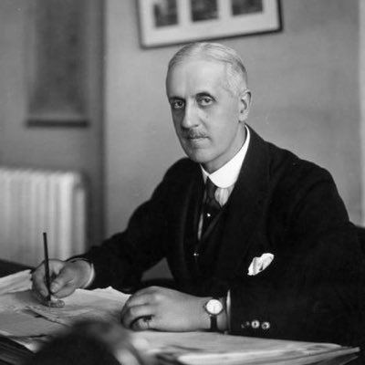
Figure 1, Fabian Ware (https://alchetron.com/Fabian-Ware, 2026).

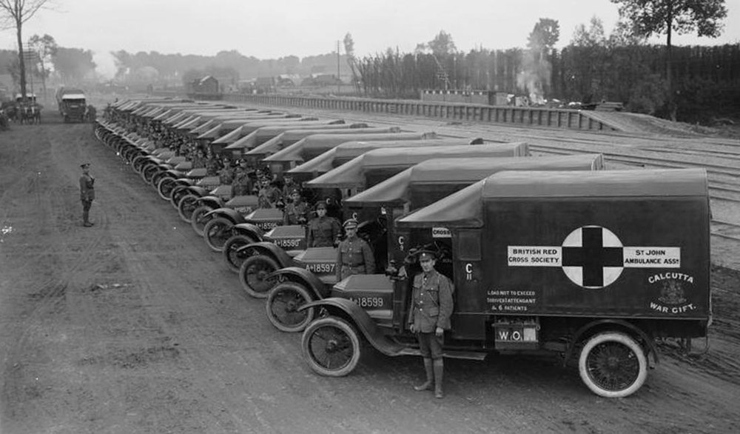
Figure 2, British Red Cross mobile ambulance unit on the Western Front (CWGC, 2026a, © IWM (Q 2644)).
Upon the agreement of the War Office, Ware’s unit transferred from the Red Cross to the British Army and was redesignated as the Graves Registration Commission (GRC) (CWGC, 2026a; Longworth, 2003, p.6; Summers, 2014, pp.16-17). The importance of Ware’s work was noted by Field Marshall Haig (Longworth, 2003, p. 6-7).
“The mere fact that these officers visit day after day the cemeteries close behind the trenches, fully exposed to shell and rifle fire, accurately to record not only the names of the dead but also the exact place of burial, has a symbolic value to the men that it would be difficult to exaggerate.” Field Marshal Douglas Haig, March 1915 (CWGC, 2026a; Longworth, 2003, p.6-7).
By 1916 the GRC’s role had broadened to deal with requests for information from grieving relatives and was renamed the Directorate of Graves Registration and Enquiries (DGRE) (CWGC, 2026a; Longworth, 2003, p.17). This role also involved searching for the bodies of the missing, the identification of bodies that they found and the moving of solitary graves and small plots of graves to larger cemeteries (CWGC, 2026a).
Ware had by this time been given the military rank of Major General, and together with the Adjutant-General of the British Expeditionary Force a Major General Neville Macready, who was himself sympathetic towards the fate and treatment of the allied war dead, they began negotiations to acquire land from the French Government to create larger cemeteries for the fallen (Longworth, 2003, p.11; Summers, 2014, pp.15-17). This is seen as the first step in the development of the blueprint for the cemeteries of the IWGC (Summers, 2014, p.16).
The thought of men being buried overseas did not sit well with everyone in Britain, and some influential people pressed for the return of the fallen to local cemeteries (Summers, 2014, p.16). Even though the repatriation of the dead was banned by both the British and French authorities there were numerous instances of covert repatriation being undertaken (Longworth, 2003, p. 14). In one such instance through the influence of some prominent figures, the body of a British Officer, grandson of W.E. Gladstone had been exhumed and returned home (Crane, 2013, pp. 70-74; Longworth, 2003, p.14; Summers, 2014, p. 17). The heated debate on the subject of the repatriation and burial of the fallen would continue throughout the war and well after it had ended, with many people of the opinion that it was their absolute right to have the bodies of their family members returned home and buried in their own cemetery (House of Commons Debates, Vol.123, 1919).
Ware saw it otherwise and with Macready’s assistance declared that for reasons of hygiene and on grounds of impartiality with regard to the social standing of the bereaved families no further repatriations should be considered (Summers, 2014, p.17). This idea of uniformity for the dead became another of the principal themes for the IWGC (Summers, 2014, p.17). Ware was also aware that after the war, the responsibility for the care of the dead and their graves would stop being that of the army and therefore the DGRE, and as negotiations with the French authorities had indicated they would only deal with one organising body, a special organisation was needed to take over from the DGRE (CWGC, 2026a, Longworth, 2003, pp. 24-28).
The Imperial War Graves Commission was founded by Royal Charter on May 21, 1917 (Crane, 2013, pp.96-97; CWGC, 2026a; Longworth, 2003, p.27). The Commission’s President was the Prince of Wales, the Secretary of State for War became its Chairman and Ware became its Vice-Chairman (CWGC, 2026a; Longworth, 2003, p.27; Summers, 2014, pp. 17-18). Figure 3 below is a copy of the Charter of the Incorporation of the Imperial war Graves Commission.
Major General Neville Macready, the High Commissioners of Australia, Canada, New Zealand, and South Africa were given positions on the board as were representatives from India and Newfoundland (Longworth, 2003, p 27; Summers, 2014, p. 18). Rudyard Kipling was appointed literary advisor (Summers, 2014, p.18).
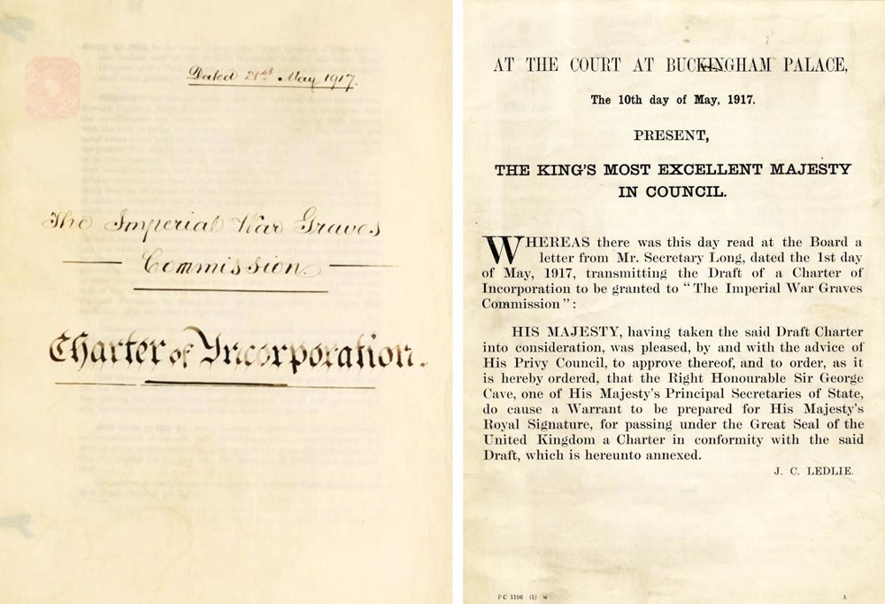
Figure 3, Charter of the Incorporation of the Imperial war Graves Commission (CWGC, 2026a).
The Commission was responsible for the care of all members of the Armed Services of the British Empire who had ‘died of wounds inflicted, accident occurring or disease contracted while on active service whether on sea or land’ (Longworth, 2003, p.27; Summers, 2014, p.18). It was entrusted with burying the dead, standardising the cemeteries, building memorials to the missing, maintaining records and registers of graves and with the maintenance of these sites forever (CWGC, 2026a; Summers, 2014, pp. 18-19).
A working group from the Commission visited the Somme battlefields in July 1917 to decide on the overall layout of the official graves and memorials (CWGC, 2018, p.20; CWGC, 2026a). This group included Rudyard Kipling, gardener Arthur Hill of Kew Gardens, architects Edwin Lutyens, Herbert Baker, and Reginald Bloomfield, all of whom had different perspectives for the cemetery' design (CWGC, 2026a; Durrell, 2022; Longworth, 2003, p. 32; Willay,2024, p.5). However, they did agree on certain aspects including in order to accommodate all religions, the headstones were to have a round top and a simple style (Durrell, 2022; Willay, 2024, p5). Lutyens, Bloomfield and Baker became the official architects of the Commission (CWGC. 2026a). Later that year Ware decided to create a committee headed by Sir Frederick Kenyon Director of the British Museum to advise on the various proposals put forward for the designs of the cemeteries (Longworth, 2003, p.32). Kenyon published a report in 1918 outlining the policies of the IWGC, entitled ‘War Graves: How the Cemeteries abroad will be designed,’(Braybon, 2008, p.32; Kenyon, 1918; Low et al, 2012, p.121-124). It this report Kenyon reinforced the principles of the Commission that of ‘equal treatment of the war dead’ (Low et all, 2012, p.123).
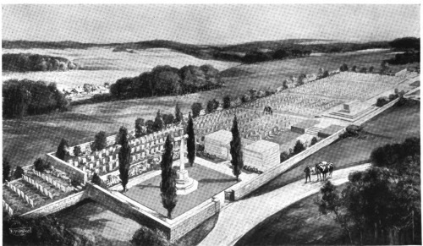
In 1919, Rudyard Kipling published The Graves of the Fallen with the intention of providing details of the Commission’s proposals to a wider audience (Braybon, 2008, p.32; Kipling, 1917; Willay, 2024, p.3). It contained illustrations showing what the cemeteries would look like and explaining key elements such as the Cross of Sacrifice, the Stone of Remembrance and the shape of the headstones, hoping it would placate the opposition to the Commission’s plans (Braybon, 2008, p.33; Kipling, 1917). Figures 4,5,6,7 and 8 are copies of some of the illustrations that Kipling used in his book.
Figure 4 Design for a war cemetery with permanent memorials (Kipling, 1917, p3).
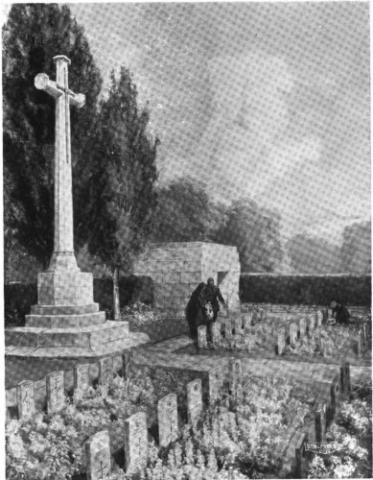
Figure 5 The Cross of Sacrifice (Kipling, 1917, p. 4).
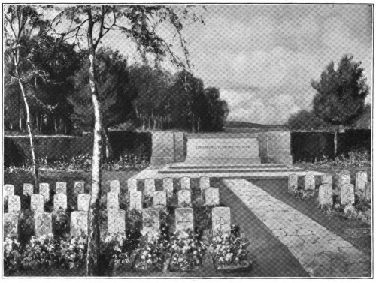
Figure 6 The Stone of Remembrance (Kipling, 1917, p. 5).

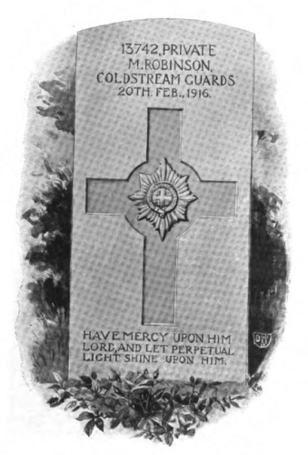
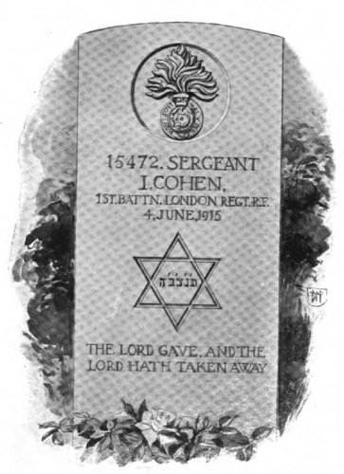
Figure 7 Specimen of a Regimental Headstone (Kipling, 1917, p.5) Figure 8 Specimen of a Jewish Headstone (Kipling, 1917, p.8).
Kipling claimed in his book that “the overwhelming majority of relatives are content that their kin should lie – officers and men together- in the countries that they have redeemed” Kipling, 1917, p.8; Willay, 2024, p.3). However, what followed was a surge in public dissatisfaction driven by campaigns organised by the Daily Mail and the Spectator, and which culminated in a debate in the House of Commons in May 1920 (Braybon, 2008, p.32; Longworth, 2003, p.46). During this heated debate in Parliament agreement was reached and the Commission was allowed to take its proposals forward, although its opponents vowed to carry on fighting their cause (Crane, 2013, p.164; Longworth, 2003, pp. 54-55; Willay, 2024, p.9).
One of the major grievances during the debate on the work of the IWGC is that there were no women on the Commission even though some women’s organisations had requested to be included (Crane, 2014, pp.160-161; House of Commons Debate 128, 1920; Longworth, 2003, p.29). At the beginning of World War One the conventional understanding of women's role in society had prevented them from entering the political arena as they were perceived as being morally, emotionally, intellectually, and physically inferior to males (BBC, 2026). It was believed that women could not be relied upon to vote rationally, and these Victorian sentiments were ingrained in the majority of the commissioners (BBC, 2026; Longworth, 2003, p. 29). They rejected the idea that mourning wives and mother’s ought to have a say in policymaking and did not acknowledge women's contributions and sacrifices to the war effort (Longworth, 2003, p.29).
The deliberate omission of women to the Commission became one of the main arguments against its formation, with claims that it was a wholly male dominated organisation (Willay, 2024, p.3). One Canadian mother who had lost her son during the conflict called it “the most tyrannical and autocratic body of men that has existed since England lost the North American colonies” (Durie 1925, quoted in Willay, 2024, p.3). The Commission's power to deal with the bodies of the fallen in any way that they chose was one of its biggest criticisms (Willay, 2024, p.3). Another distressed mother Ruth Jervis claimed, “it surprises me how a commission composed of say a handful of men dare to arrive at these decisions” and added “without having obtained the wishes of parents […] the country took him, and the country should bring him back” (Jervis, 1918, quoted in Willay, 2024, p.3 and p.11).
However, it is not only allegations of misogyny that have clouded the Commission’s principles and possibly the authenticity of its sites of commemoration, in 2019 a Channel 4 documentary highlighted the lack of equality in the commemoration of East African soldiers in WW1(Parsons, 2025, p. 18). The documentary criticised the IWGC’s assertion that all of those who fell in war serving the Empire should be treated with equality whatever their ethnicity or social standing, since it fell short when it came to the fallen soldiers of East Africa, where evidence suggests that they were separated from the European graves and were not cared for in perpetuity (Parsons, 2025, p. 19). There are claims that this emphasises how the IWGC was an expression of its time and was completely in accordance with colonial European policies that presumed African racial inferiority (Parsons, 2025, pp.19-20). The documentary by demonstrating the failure of the IWGC to live up to its promises of equality in death and remembrance reveals the underlying racism that lay beneath the ‘western imperial project’(Parsons, 2025, p.19).
This ill-treatment of fallen military personnel from Africa was again highlighted following the Second World War (WW2) when it was revealed that even as it retrieved the bodies of European troops for reinterment in military cemeteries, IWGC's policy was to not retrieve the graves of African war dead (Parsons, 2025, pp. 1-3).
In response to these allegations the CWGC established a Special Committee to examine historical injustices in commemoration (CWGC. 2021; CWGC, 2021a; Parsons, 2025, p.19-22). The committee's main finding was that not every casualty had received the same level of commemoration (CWGC, 2021a). It estimated that between 116,000 and 350,000 military personnel, predominantly of African, Indian or Egyptian decent who died in WW1 were not remembered on CWGC memorials (CWGC, 2021a). Up to 54,000 who were commemorated were deliberately given unequal commemoration compared to that of European service personnel (CWGC, 2021a). The reasons identified for these omissions were put down to the practicalities of dealing with these issues at the time, however, they were also found to be due to deliberate omissions based on imperial dogma within the IWGC (CWGC, 2021a).
In a further report the Special Committee found that for some combatants, especially those from African and Indian communities, decisions made during World War II, whilst not deliberate, also resulted in unequal commemoration (CWGC, 2025c).
In the CWGC’s response to the reports the Director General, Claire Horton, said “….the events of a Century ago were wrong then and are wrong now. We are sorry for what happened and will act to right the wrongs of the past” (CWGC, 2021a).
The CWGC implemented a non-commemoration programme to address its failings and has begun a series of reconciliatory strategies based on ten recommendations made by the Special Committee (CWGC, 2021). These recommendations include.
1. Ongoing commitment to continue the search for the unnamed war dead and those potentially not commemorated
2. A commitment to transparency -The CWGC should be upfront about this difficult history across its website and should highlight and share its progress in putting right the wrongs of the past
3. Flexibility in evidence criteria for specific non-commemoration cases
4. Establish an appropriately diverse independent consultative committee with a global reach to advise the CWGC on points of history, policy and outreach
5. Community engagement and education that highlight the sacrifices made by communities currently underrepresented through commemoration
6. Digital rather than physical commemoration to reach new generations and connect them with this difficult history, and encourage broad, global participation
7. Context panels for existing memorials to explain why some memorials do not carry names
8. Inscription of recovered names on existing memorials for casualties who were ‘sent missing’ and assigned to nameless memorials
9. Adoption of third-party memorials not held by the CWGC and add the names to its casualty database
10. New memorials or commemorative structures for particular groups that cannot be served by an existing memorial (CWGC, 2021).
These recommendations alone provide an uneasy indictment of the historical principles of the Commission and bring into question the authenticity of their methods of commemoration (CWGC, 2021, pp. 49-50; Willay, 2024, p.8).
The CWGC have published annual reviews to outline the progress of their non-commemoration programme, with the latest review for 2024-25 claiming to have identified over 11,600 servicemen who were not previously commemorated (CWGC, 2025b).
In addition to the non-commemoration programme the Commission has made increased effort to evidence their new, more modern and diverse approach to commemoration by designing a new Commission logo to replace the older Imperialist themed images (CWGC, 2026b). The previous IWGC logo, Figure 9, and the well-known CWGC logo Figure 10, have been replaced in favour of a modern and more inclusive design as seen in Figure 11 (CWGC, 2026b).


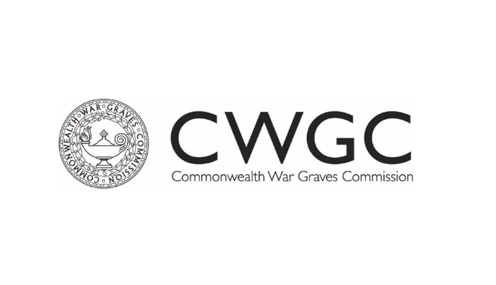
Figure 9 on the left shows the Imperial War Graves Commission logo (SJMC, 2024). Figure 10 on the right the logo of the Commonwealth War Graves Commission (Never Such Innocence, n.d.).



Figure 11 is the new logo for the CWGC (CWGC, 2026b)

On their website when promoting this new logo the Commission declared “The new logo draws on the symbol of the Commonwealth, a core part of our identity. The pillars represent our six member nations standing together in a common cause. The curved top is reminiscent of the headstone shape we’re known for, yet it’s interrupted in the middle, just as two generations were during the World Wars” ( CWGC, 2026b).

War memorials have frequently generated heated discussion, especially among those who argue that they just serve to glorify conflict (Borghi, 2021, p567). National war cemeteries and memorials enable the families of the deceased to express their grief for their loved ones individually as well as collectively (Borghi, 2021, p. 567). They might even be needed to preserve a society's spiritual foundations, and the political history of a nation (Mayo, 1988, p.75). Although commemorating and remembering the fallen is their main objective, war memorials are often shaped by the desires and interests of particular individuals and organisations and thus their authenticity must then be questioned (Wong, 2022, p6).
The CWGC has its origins deeply rooted in Edwardian Imperialist standards and was therefore heavily influenced by those standards irrespective of their promise that the fallen of the Empire would be commemorated equally (Braybon, 2008, pp. 30-39; Longworth, 2003, p.254). These standards have resulted in the Commission’s work being embroiled in accusations of misogyny and racism (BBC, 2026; Crane, 2014, pp.160-161; House of Commons Debate 128, 1920; Longworth, 2003, p.29; Parsons, 2025; Willay, 2024).
The Commission recognises their historical shortcomings and are reconciling the failings of the past with a renewed effort to ensure that their core principles are maintained for the future (CWGC, 2021; CWGC, 2021a; CWGC, 2025b; CWGC, 2025c). Today the CWGC cares for 200 war memorials and 23,000 cemeteries containing 1.1 million graves in 150 countries around the world, which were created to remember the casualties from the Commonwealth who died during the world wars (CWGC, 2022; Summers, 2014, p.62).
Although questions can be asked about their misguided beginnings, in his history of the CWGC Longworth, (2003, p. 254), reminds us that “…its labours demonstrate that there are criteria other than measurable ‘usefulness’, that there is something left for the spirit”…… “the Commission carry out a task on behalf of all of us”.

