Application Development

Student Number: 1701603
Student Name: Daniel Davies
Module Name: Application Development
Date: 19/11/2018
Table of Contents

Contents | Page Number
Introduction | 3
Application Development Concepts | 4-6
Requirements | 7
Design | 8
Implementation | 9-16
Evaluation | 18-19
References | 20

Introduction
The following reports has been created for the purpose of describing, showing and the creation of the website which has been created within Visual Studio. Within the website there are 6 relevant and related pages. The final website has been created as a professional looking, user friendly, interactive website which can be used by all users no matter their computer knowledge. The website will be fully functional on all browsers, monitors, laptop, tablets and phones.
Within the report design principles for creating the website will be outlined and looked at, and a brief on what the website is about will be gone over. Some of the main functions for the website will also be looked at along with the final website itself.

Application Development Concepts
Design Principles
What are design Principles?
Design principles are a set of loose rules which are followed for the design stage. They are made to reflect some of the goals of a design and to also give designers some rules to follow so that they are all working in the same direction.

Example of Design Principles

Proportion
Make sure that all elements looks natural to each other. What is meant by this is that that all elements of the website is at a good relative size so that nothing looks out of place. This gives the website a more professional looking finish.

Sensible Scale
Things are designed to a sensible scale. What is meant by this is that nothing is too small so that users cannot read/see everything, or an element is to big that it is all the user can see. If everything is scaled correctly then user will be able to read and see everything how its meant to be seen.

Easy to Use
Make things easy for users. What is meant by this it to not overcomplicate the website by flooding the user with lots of information and links. But to give the website a nice flow with only giving the user a limited amount of information at a time. This makes the website more appealing for users who may not be very good with computers.
Less is More

Keep information and pictures as minimal as possible. What is meant by this is that a design can look over done by overdoing too much information and pictures, by keeping the design simple and keep the information and pictures to a minimal then it will make the final website more appealing and professional.

Repeat Elements
Use the same elements multiple times. What is meant by this is maybe use the same colours and background throughout the website. This will give the website a more professional finish and will give the website some harmony.

Stability
Provide a stable environment for the website. What is meant by this is that elements should not be moving or changing in a way that is inconvenient or distracting. This makes the website more convenient to use and gives the website a more professional finish.

Fit for Purpose
Designs are suited to their purpose. What is meant by this is that the goals and constraints of the various users must be taken in to consideration and the design will be made with these in mind.

Stay Out of the Way
There does not need to be any unnecessary rules, steps and procedures. What is meant by this is that people should be allowed to do / go where they like on the website. Users should not be forced to do anything that they don’t want to do.

Welcoming Design
Make designs decorative, interesting and visually pleasing. This makes the website more welcoming, also if a design is welcoming then users are more likely to come back.

Attractiveness Principle

A design cannot be created to appeal to all users. This means that trying to please everyone is a mistake and the design should be focused on the target audience.

Mobile Compatible

The design needs to be compatible with phones. This is so that the website can be used by more people.

What is UX Design?
UX design is the process of designing a product (this can be either digital or physical) so that the product is useful and easy to use. UX is all determining what the users experience with the product will be like and trying to create a product with the users in mind. UX design is also about making a product which is fun to interact with. UX is all about making a product as intuitive, smooth and pleasant to interact with.
UX is going to be very important to think about when creating the website. The way the user is going to interact with the website is very important and needs to be easy and as smooth as possible.

Requirements
The website which was created is a modern professional looking website. It give the users information on different car brands, these included:
- Audi
- BMW
- Fiat
- Ford
- Vauxhall
If any users want to find information on different brands they will have to do lots of research, this wastes the user’s time and makes this is why the website has been created. On each page an overview of the brand is looked at, some different car models and a look at the history of the brand.
The target audience is any car lovers, the website has been created to appeal to teenagers and adults. As neutral colours has been used any genders will also be the target audience. As there are many car lovers this gives the website a massive audience making it very popular.
The website is relevant as it puts all the information of the different brands in one location, this saves the user’s time and effort as they won’t need to browse the internet for hours and hours to find information on cars.

Design
The design stage is very important when creating a website, this is because it allows the planning of the website ahead in time, this makes the website more thought through and often makes the final product a lot better than if no design stage was undertaken. For the design of the website a few design principles were followed to make the website look professional and modern.
For the creation of the website a few design principles are going to be followed, some of these design principles include:
- Fit for Purpose – So the website is fit for purpose, the website will give the users information on the different car brands
- Stay Out of the Way – The users are going to be able to do what they want and go where they want at any point of their visit on the website.
- Welcoming Design – The design is going to look professional from the second the user loads up the page, this is going to be done through the use of pictures and the colour scheme.
- Mobile Compatible -The website is going to be compatible with phones, this increases the websites audience.
- Proportion – All text and pictures are going to look natural with each other and nothing is going to look out of place.
- Sensible Scale – All text and pictures are going to be scaled correctly so that everything can be seen how it is intended to be seen.
- Easy to Use – The website is going to be easy to use for everyone even for users who are not very good with computers.
- Less is More – Not to many pictures and text will be used, and the pages will not be cluttered. Only important necessary text will be used.
- Repeat Elements – The design of the website will be the same throughout the website, the navbar will be at the top, then the main section for the information, then the footer will be at the bottom. The colour scheme will stay the same throughout the website.
- Stability– None of the elements are going to be moving in a way which might distract the user. Users will be able to read and see all the pictures without having to interact with the website, accept to change to the correct page.
All these design principles are going to be very important for the creation of the website, this is because if all these principles are followed then the final outcome of the website will be a professional looking fully functional website which will make users want to come back again and again.

Implementation
Main Classes
Throughout the website various classes were used to give the website its main functionality, in this section some of these main classes will be looked at and discussed.
One of the most used ones is the card-home-advert class, this class was used for the pictures for the various car models and the text over the pictures. The class also gives the format for the text so that it appears over the picture.
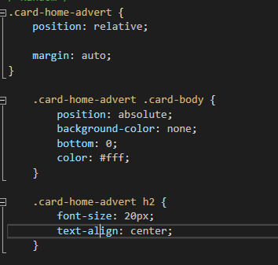
The next class which was used for the formatting of the website was the main section classes, these were used to format the various backgrounds. This include the background of the overall website and also the background of the content.
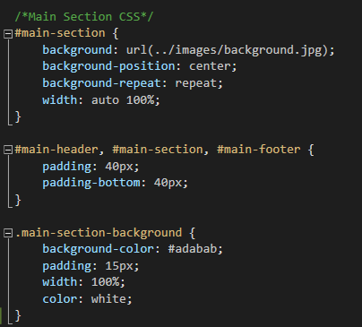

This is the class for the footer, this gives the format of the footer. This formats the text, titles, and background colours for the footer. It is also for the wave effect which is seen in the footer.
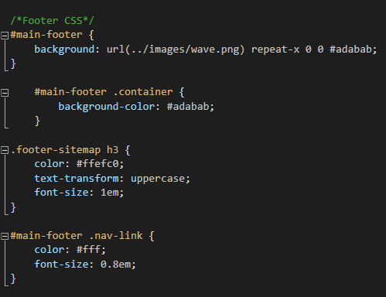

Home Page
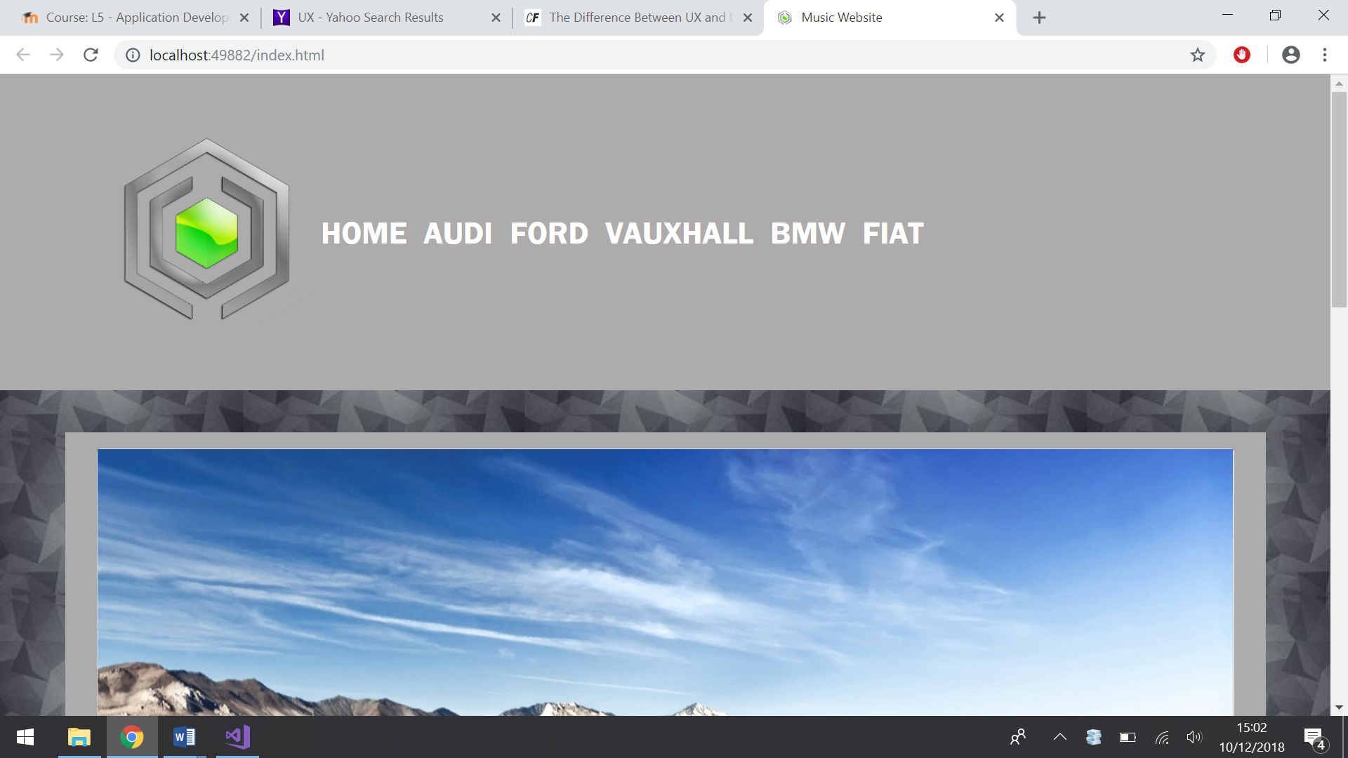
Page Content
Navigation Bar
Logo

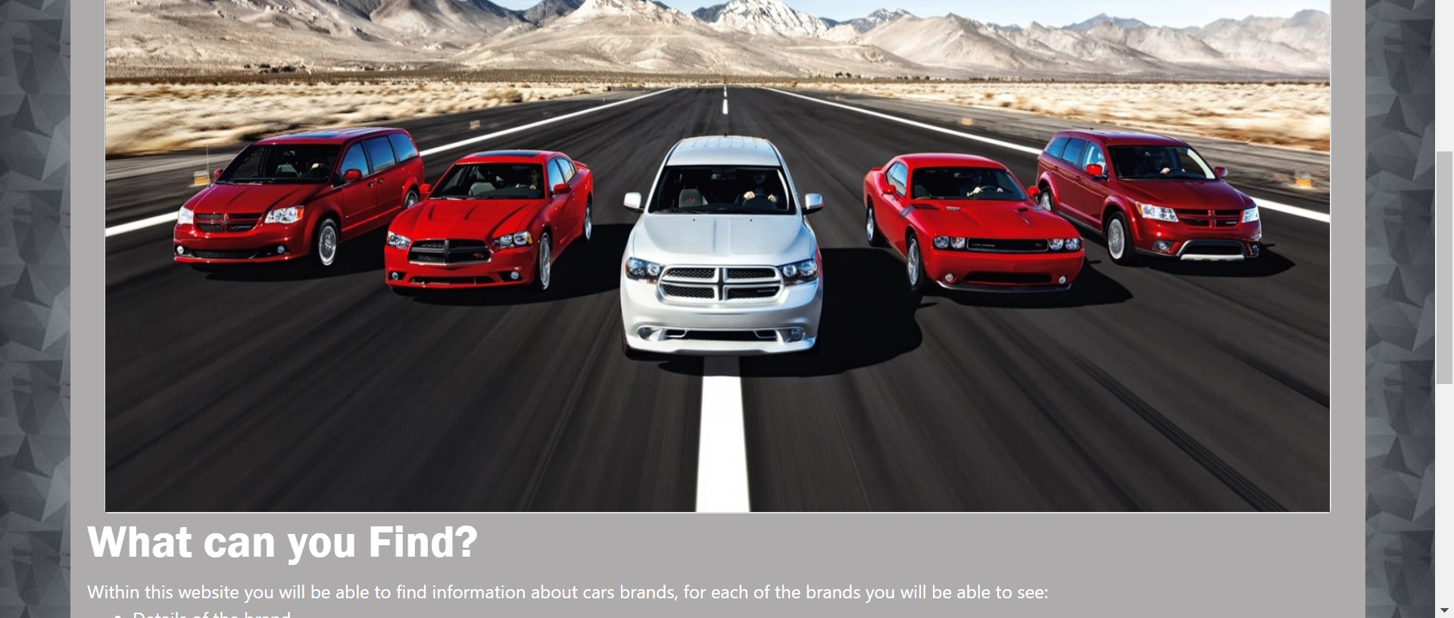
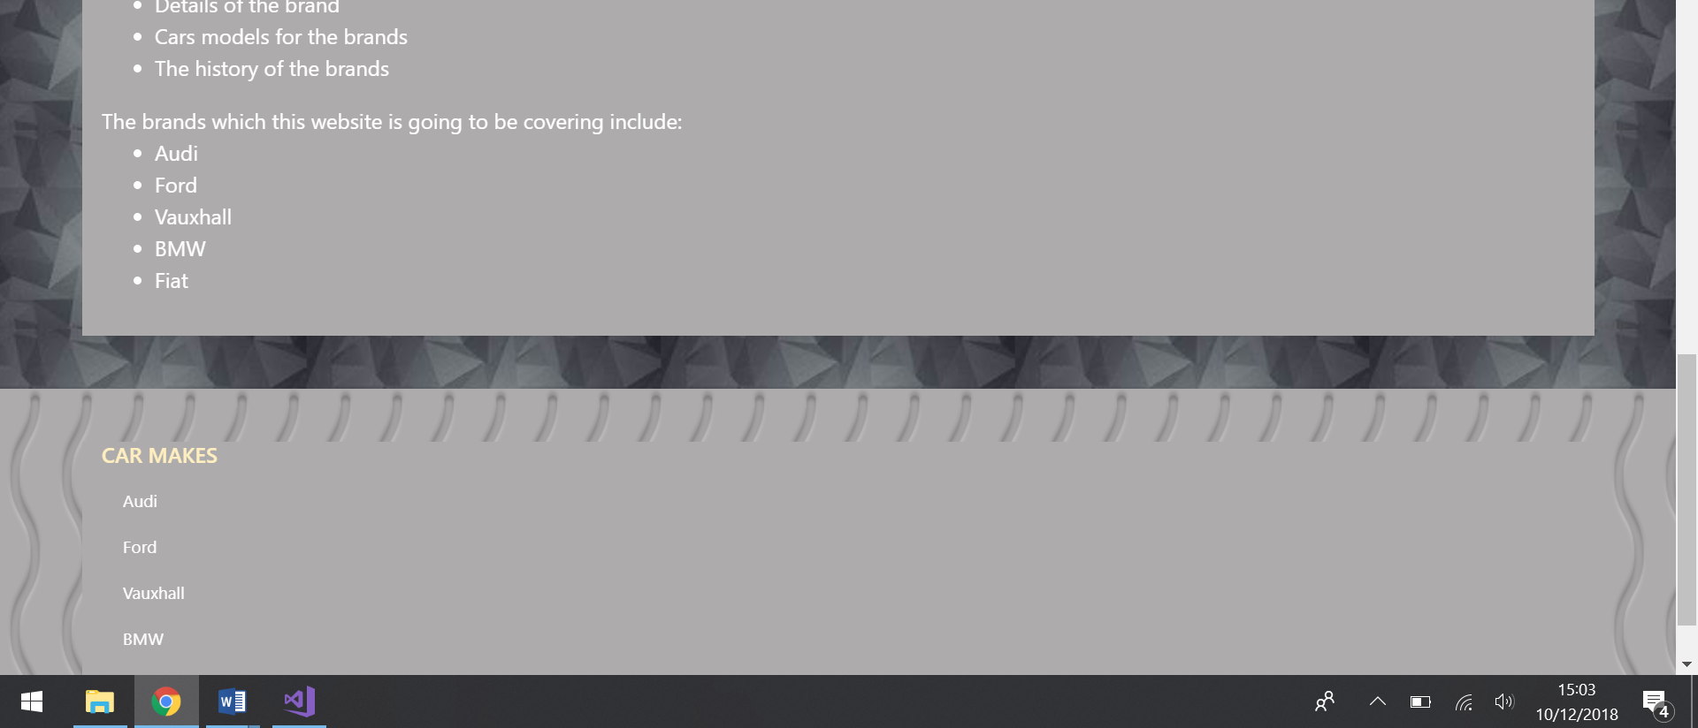
Footer

Audi
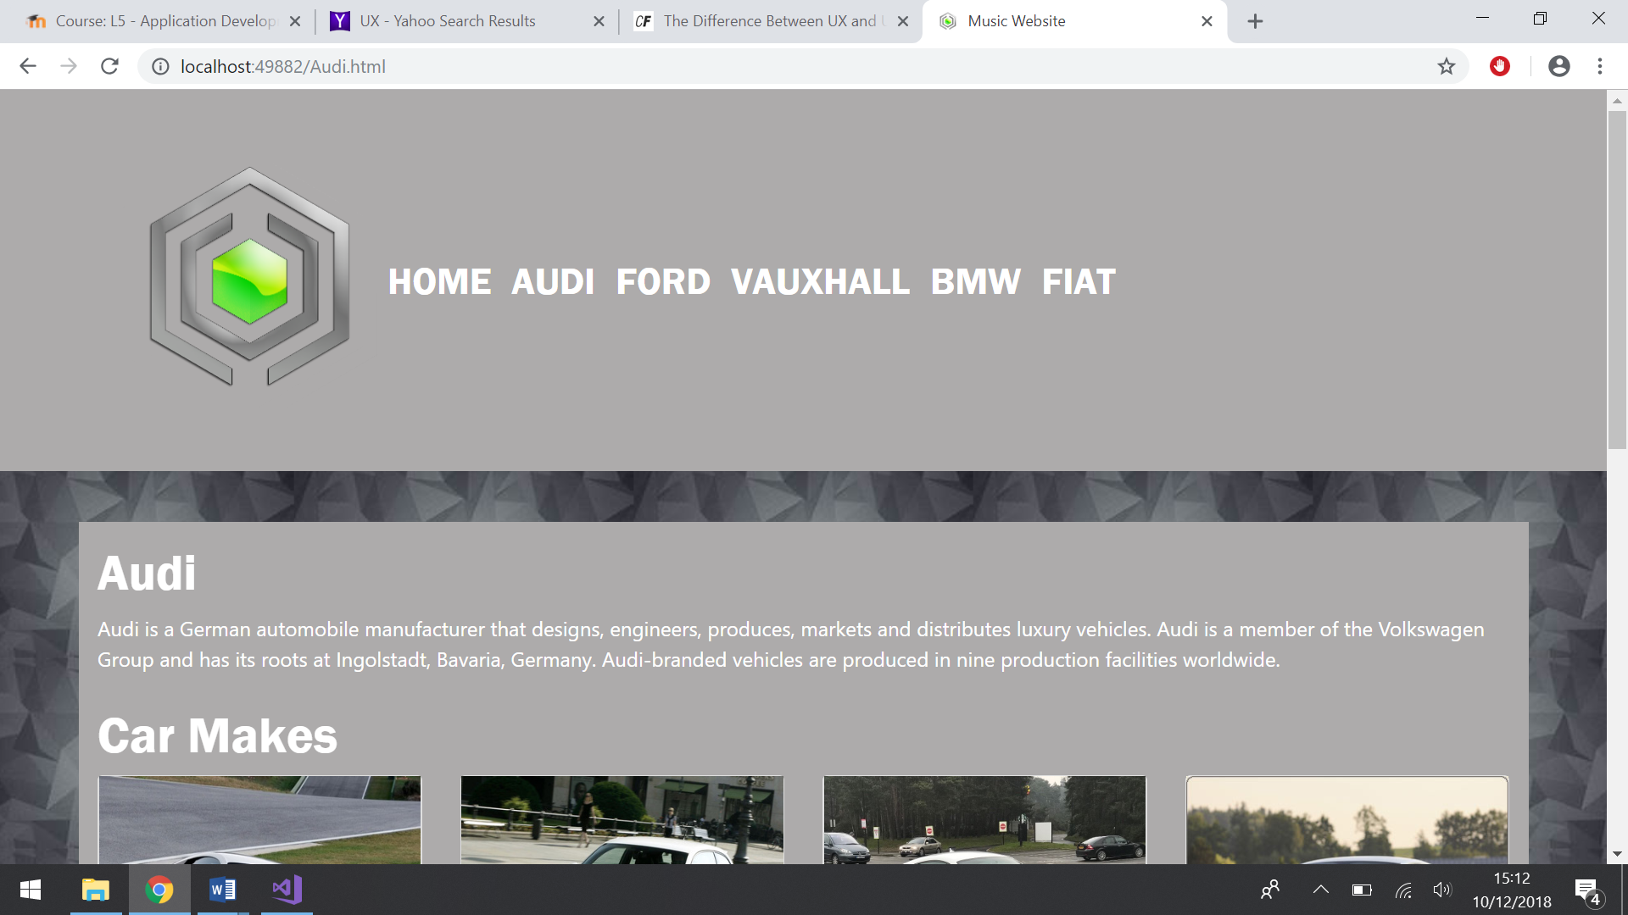
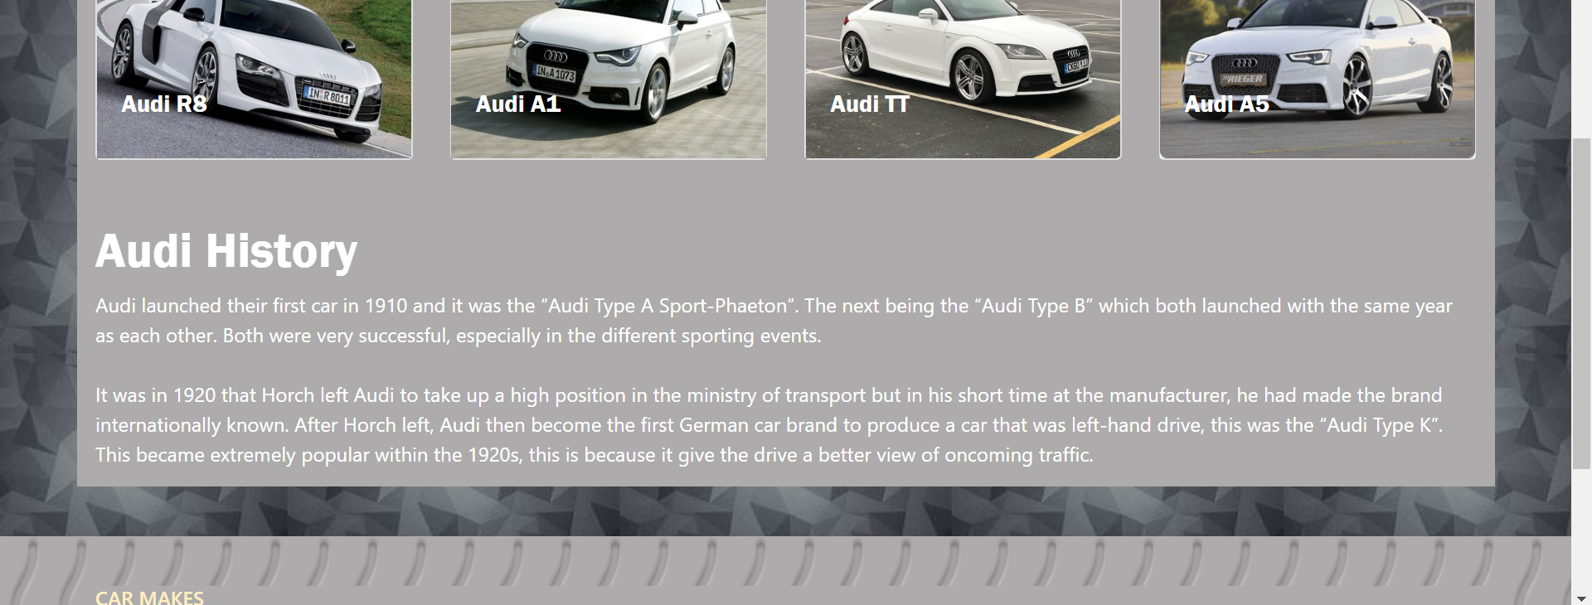
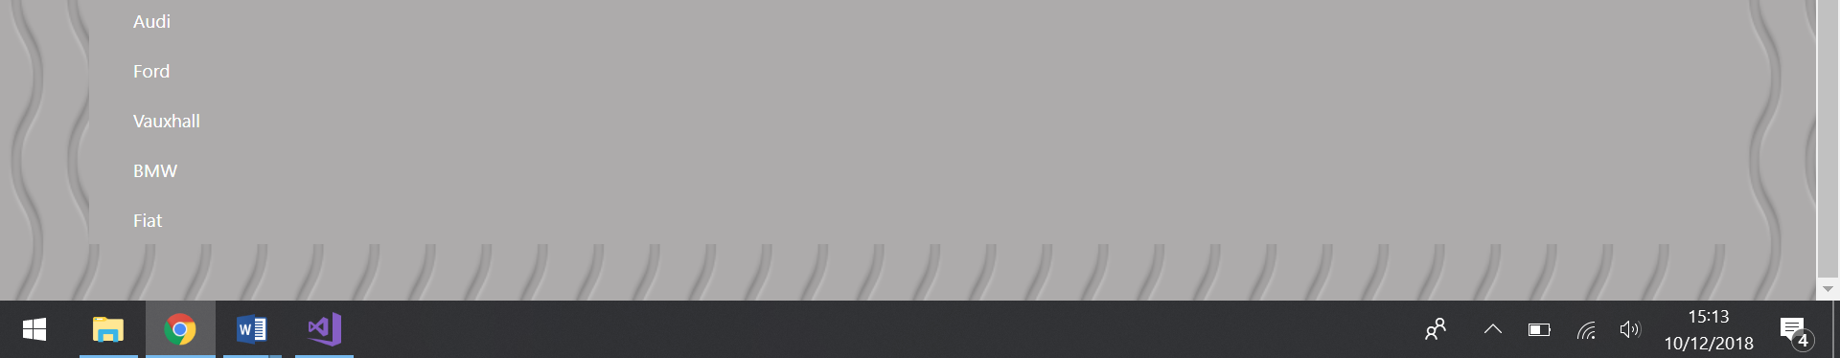

Ford
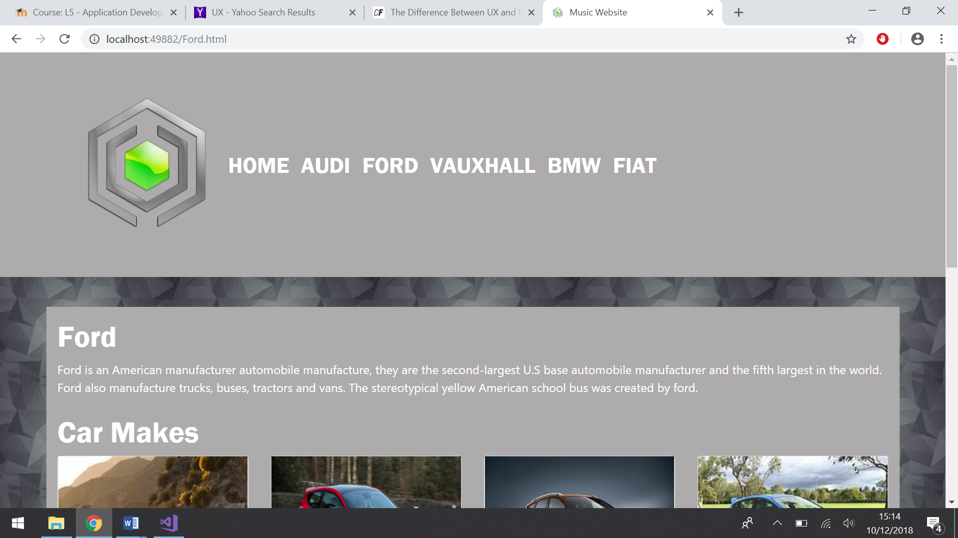
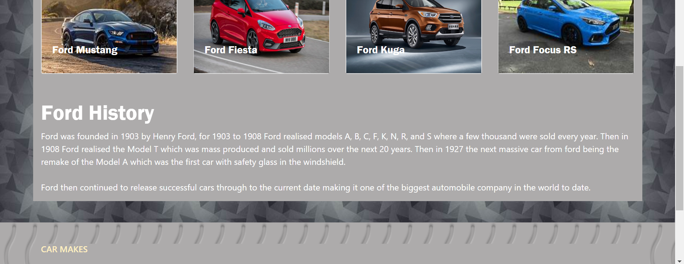
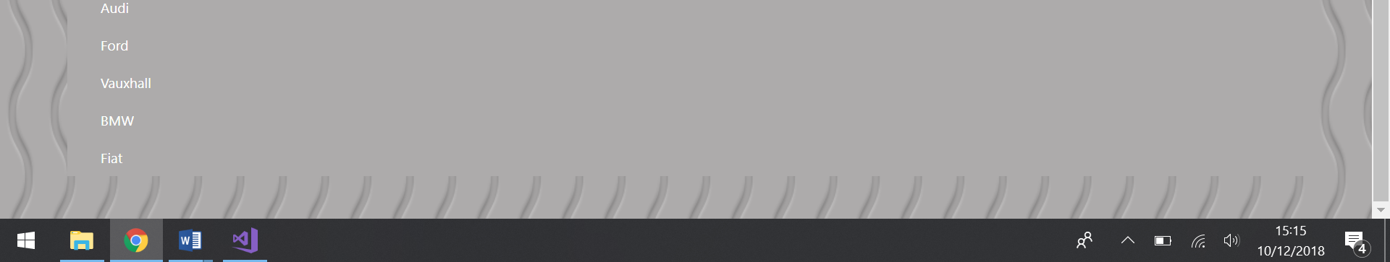

Vauxhall
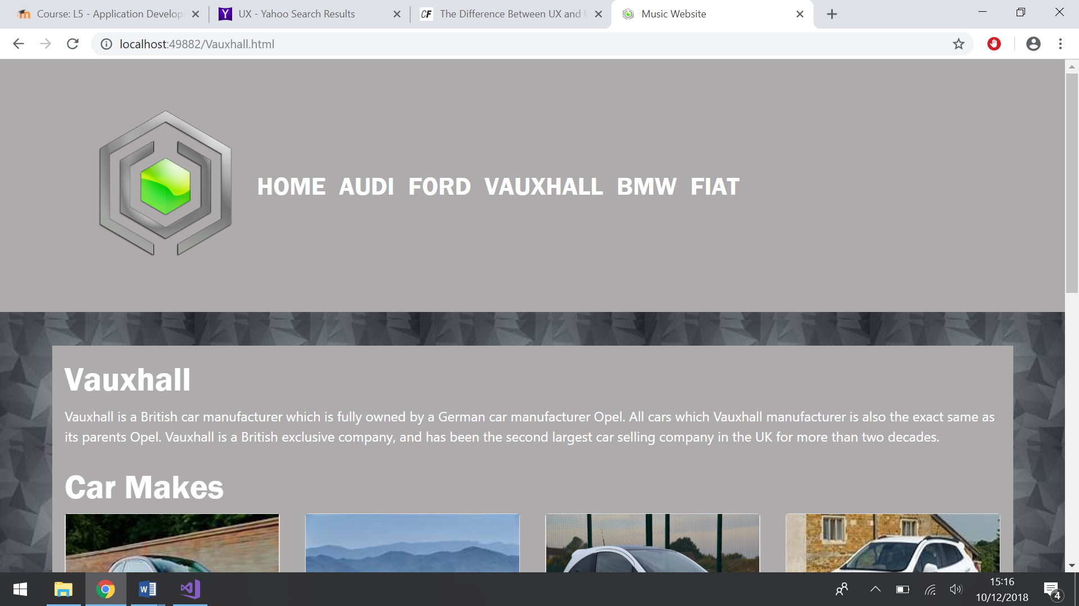
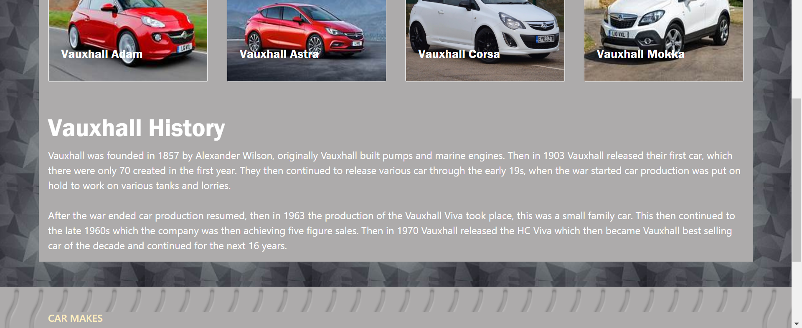
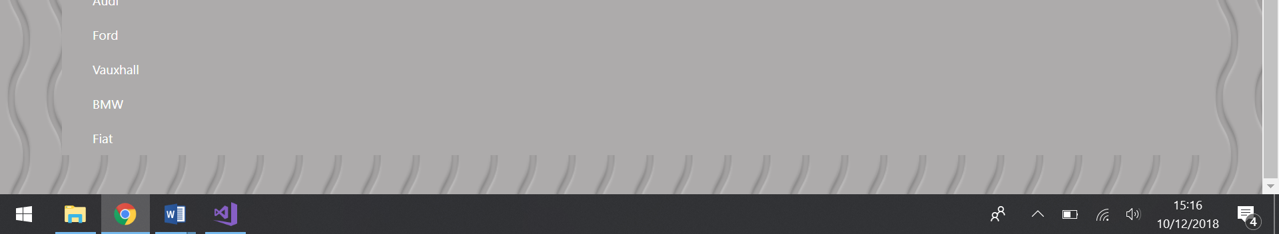

BMW
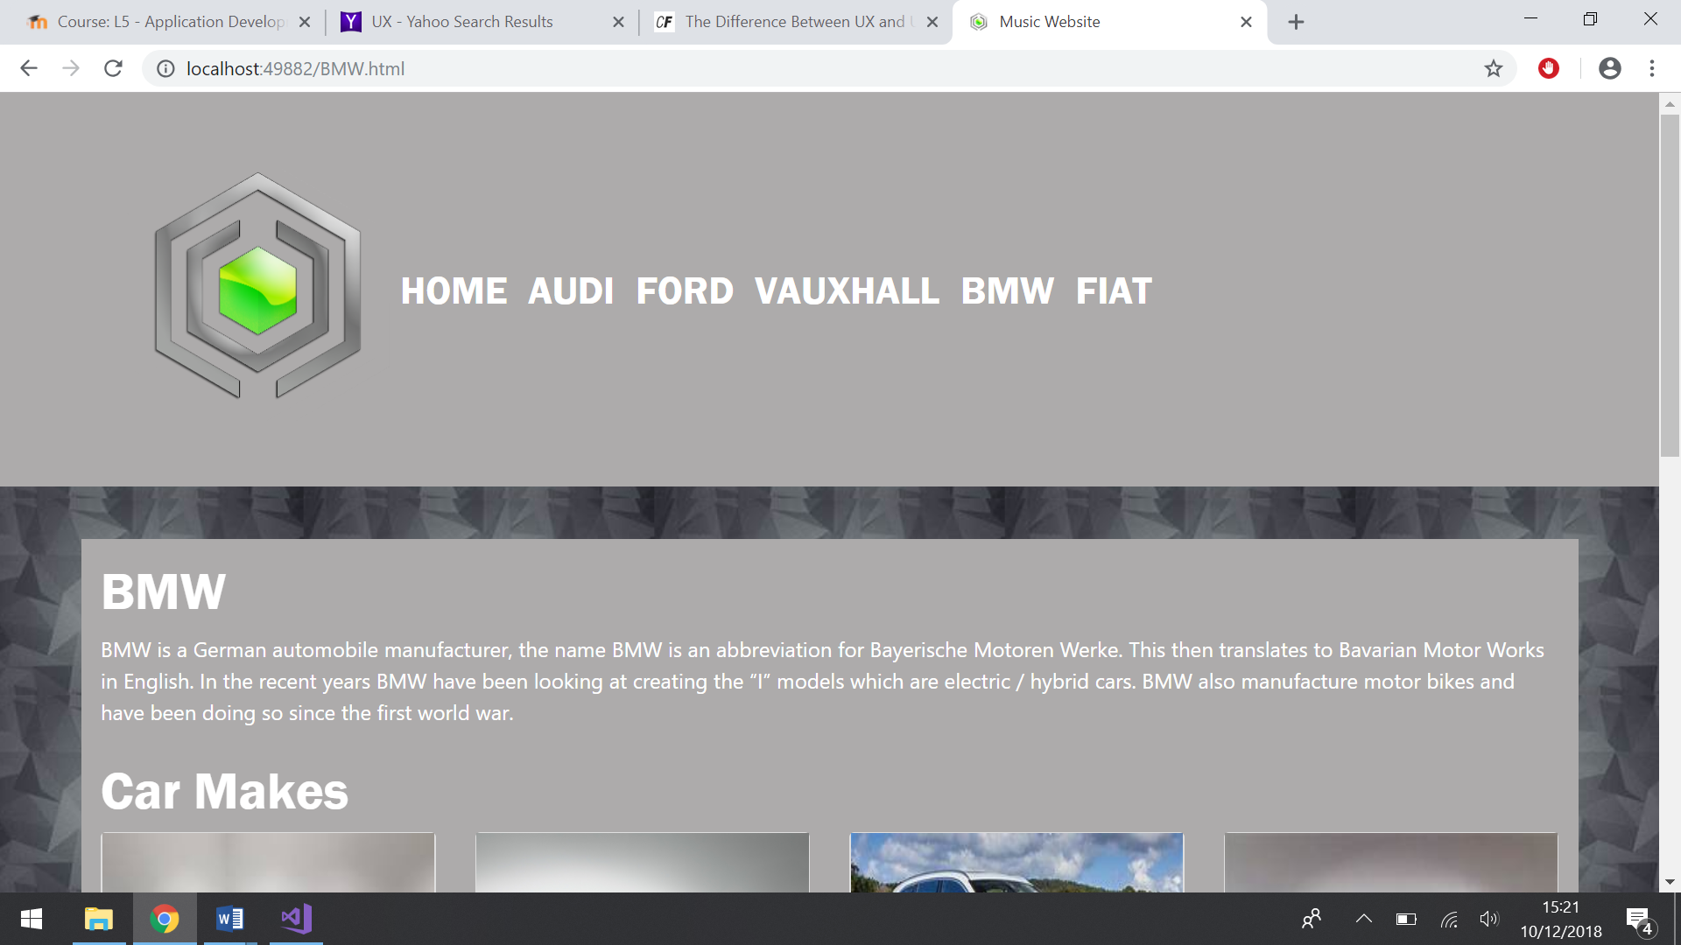
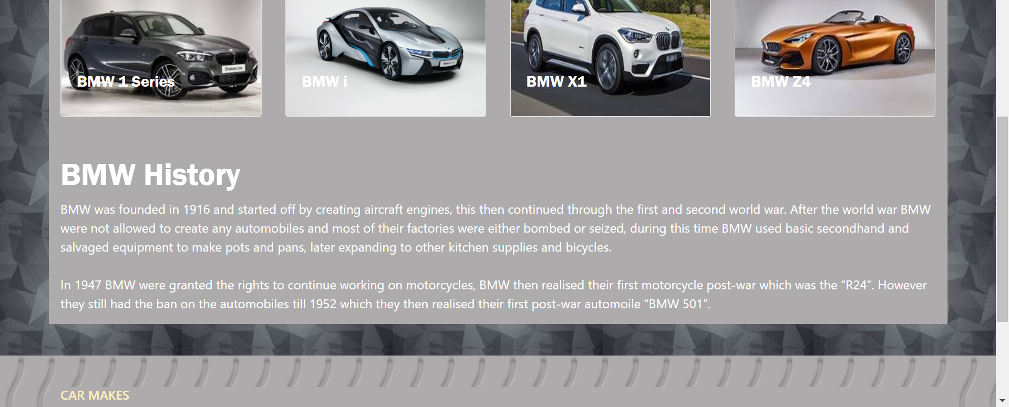
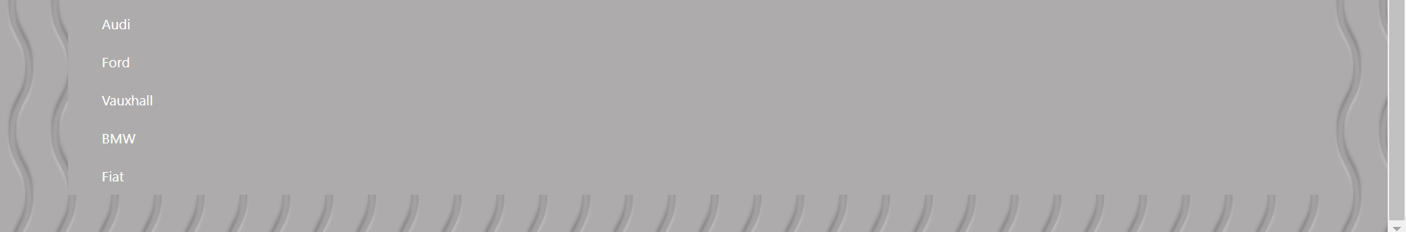

Fiat
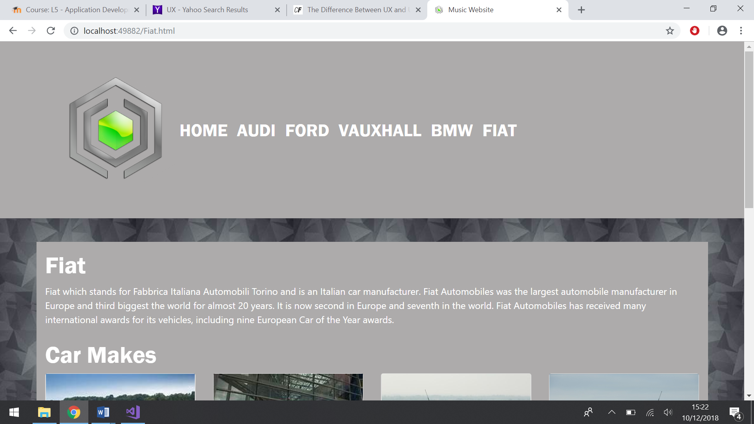
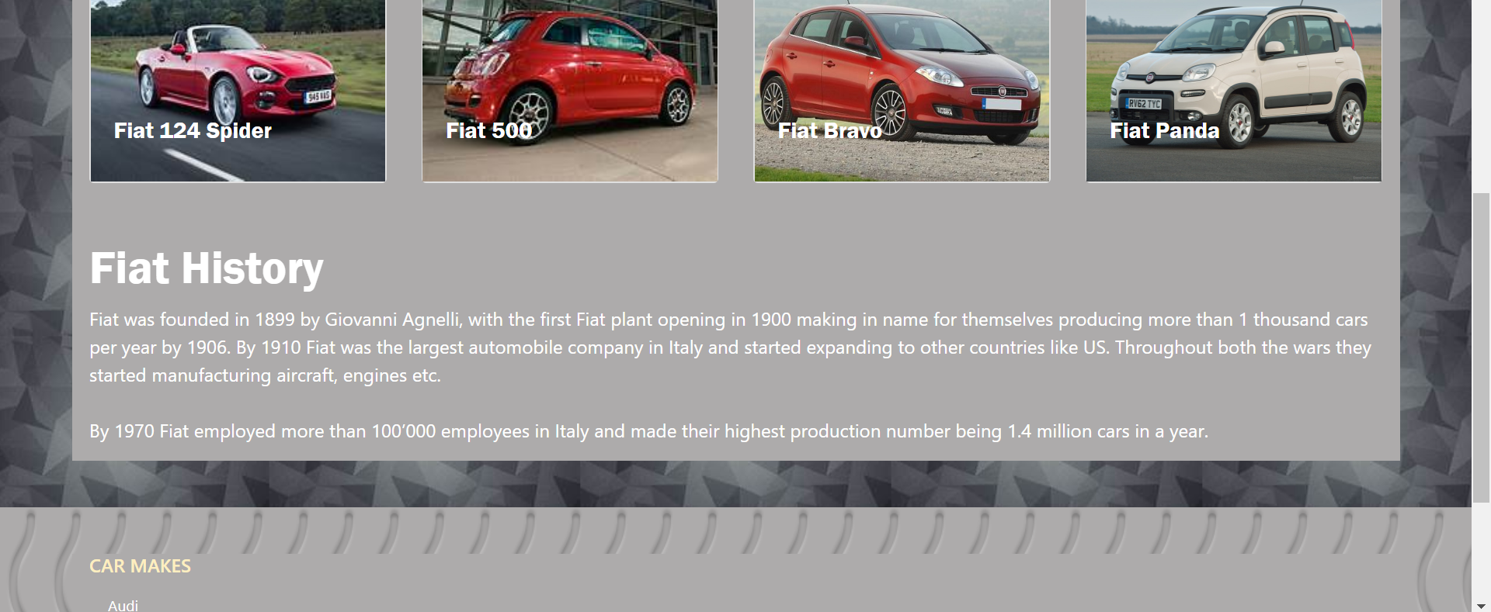
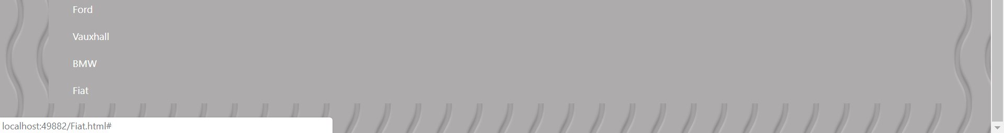

Evaluation
Testing
Test Number | Test Description | Expected outcome | Actual Outcome
1 | The first test is to make sure that the website works on a mobile phone. This is to make sure that everything loads in correctly and nothing is out of place. | The expected outcome is that everything will load correctly and that nothing is out of place | The website was fully functional and everything loaded correctly on each page.  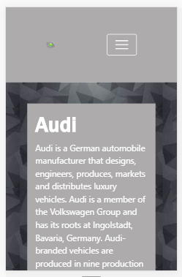  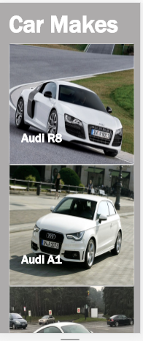
2 | The second test will be testing to see if the hamburger is fully functional and working correctly. | The expected outcome is that when the hamburger is click on it will display the menu. And the hamburger will display when the screen is shrunk. | The hamburger was fully functional and was working correctly. It displayed when the screen shrunk as well as display the menu when clicked on  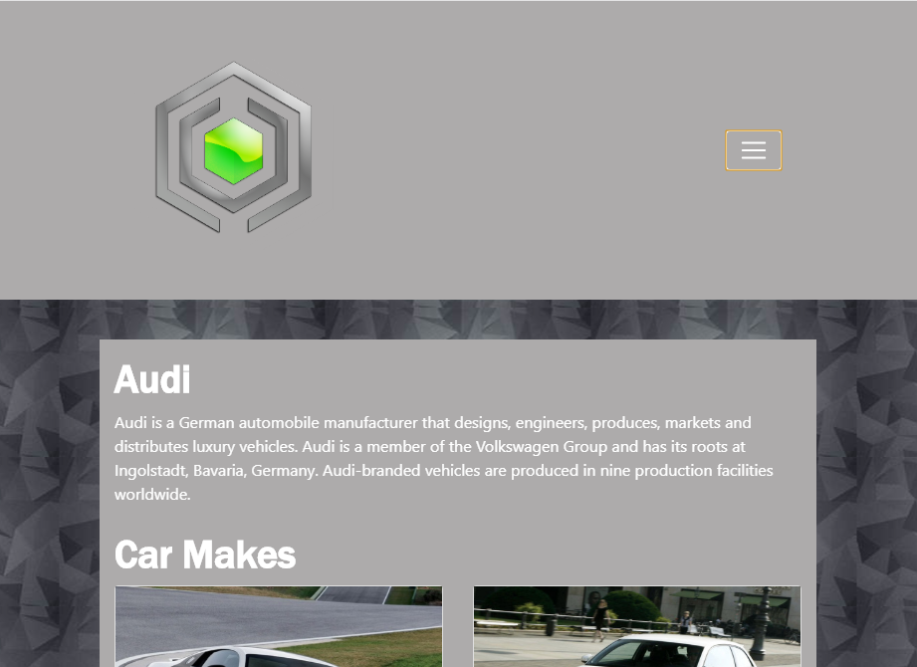  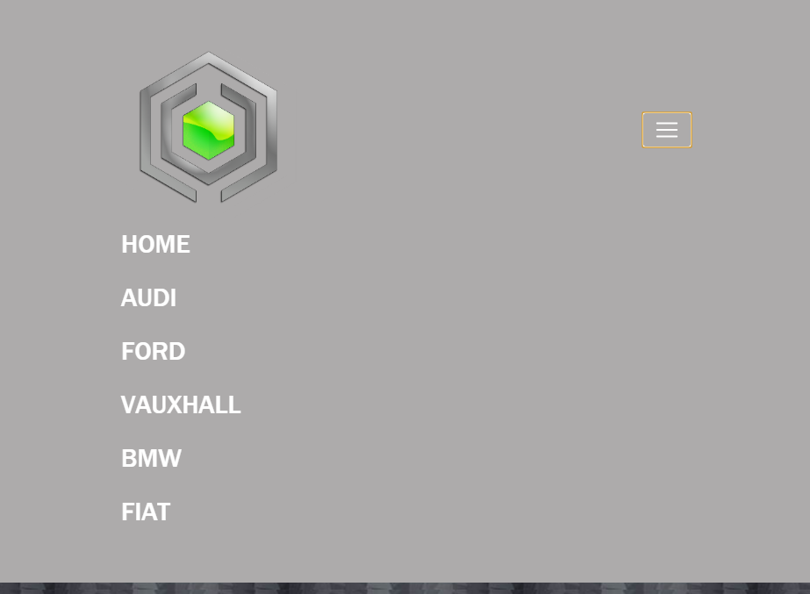
3 | In the next test will be seeing if the navigation bar is working correctly and all the links are working | When the user clicks on one of the links the correct corresponding page will be loaded up | The navigation bar was working correctly and everything loaded up when the links were clicked on.  Started off on the Audi page  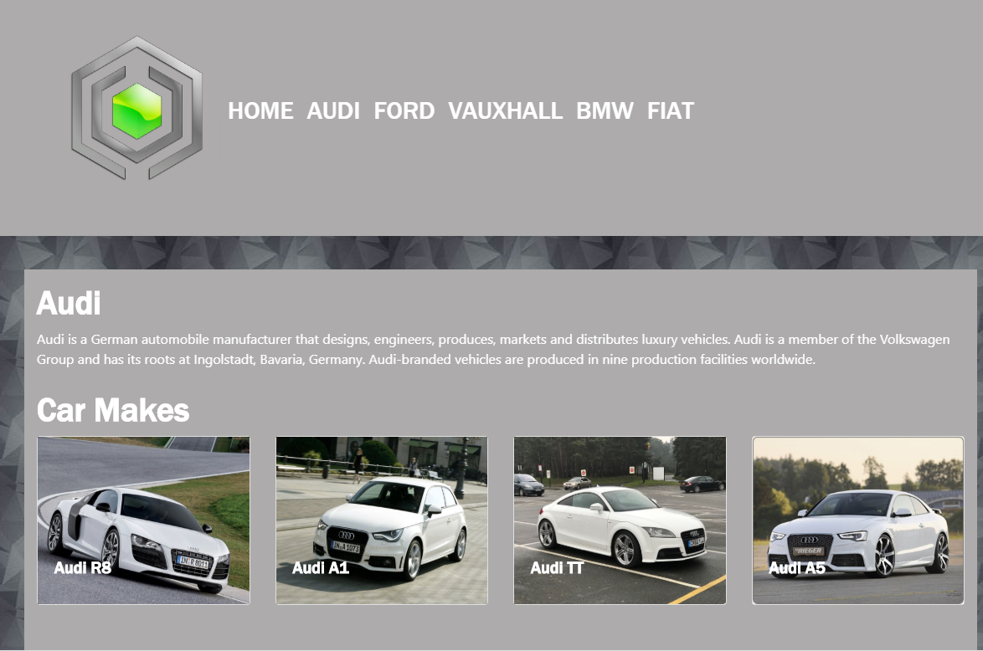  When Ford link was pressed it loaded up the Ford page.  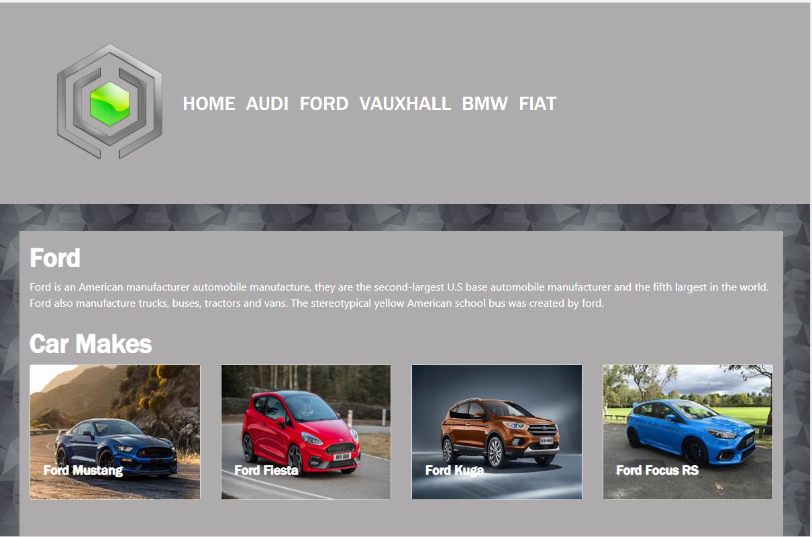

Reflection of the Implementation
Overall the website is a very professional looking website which is fully functional. One of the main key focuses was making the website responsive which it is. The website works on phones, tablets, laptop and any monitor which means that it is available to all users. All the pages have a similar design with the colour scheme and the layout staying the same throughout the website, this gives the user a sense of harmony. The colour scheme used is not to in your face while also not looking dull. The website is very easy to use with only a main navigation bar use to get to the different pages, there is also a secondary smaller navigation bar in the footer.
Also, there is a good amount of content in the website with text and pictures however, there is room for more and this might have been a good idea. Moreover, all the pictures are responsive and are working correctly, however some of the images look a bit stretched at some points.
However, there is not much website and user interaction, what is meant by this is that the only way the user is able to interact with the website is through the navigation bar and the footer mini navigation bar. This could be something to be improved in the future.

Future Improvements
As the website is now finished future improvements can be evaluated, some of the future improvements include:
- When a user clicks on one of the car pictures a box appears bellow it giving the user information on the various car, information includes stuff like prices, top speed etc.
- A search engine so that the user is able to search for the car brand that they want to know about.
- Make some sort of competition so users are able to vote for their favourite brands / models and it will total up the result every month. This makes the user feel more part of the website and will increase the chance of them coming back.

References
- J. Spacey, “23 Examples Of Design Principles,” 20 June 2017. [Online]. Available: https://simplicable.com/new/design-principles-examples. [Accessed 01 Decemeber 2018].
- S. Cable, “Design Principles - a guide,” 18 June 2015. [Online]. Available: https://www.cxpartners.co.uk/our-thinking/design-principles/. [Accessed 01 Decemeber 2018].
- S. LANOUE, “What is UX Design? 15 User Experience Experts Weigh In,” 16 Septemeber 2015. [Online]. Available: https://www.usertesting.com/blog/what-is-ux-design-15-user-experience-experts-weigh-in/. [Accessed 01 Decemeber 2018].
- “User Experience (UX) Design,” [Online]. Available: https://www.interaction-design.org/literature/topics/ux-design. [Accessed 01 Decemeber 2018].
- “User experience design,” Wikipedia, [Online]. Available: https://en.wikipedia.org/wiki/User_experience_design . [Accessed 01 Decemeber 2018].
- C. B. Staff, “10 design concepts that every web developer needs to know,” 14 Novermeber 2013. [Online]. Available: https://www.creativebloq.com/web-design/10-design-concepts-web-developers-need-know-11135255. [Accessed 01 Decemeber 2018].
- “Moodle,” UWTSD, [Online]. Available: https://moodle.uwtsd.ac.uk/. [Accessed 05 Decemeber 2018].

