University of Wales, Trinity St. David
SmartLight Project Management Report
BEng Computer Systems and Electronics
Thorbjørn R. Kristiansen
Lecturer: Sue Maw
April 2018

Contents
Introduction 2
About the SmartLight 3
Risk 4
Risk Identification 4
Risk Exposure Calculations Explained 5
Probability Impact Matrix 5
Code of Practice 6
Ethical and Legal Issues 6
Conforming with the British Computer Society Code of Conduct 6
Conforming with the IEEE Code of Conduct 7
United Kingdom Lighting Legislations 7
Sustainability and Environmental Issues 7
First, Second and Third Order Factors 7
References 9
Appendix 1 – Source Code 11
Appendix 2 – Header File Code 14

Introduction
In lieu of a new green future, bicycles are one solution to the increasingly problematic pollution problems that is destroying the environment. One inherent problem with bicycles is the safety aspect, as people are not as protected on a bicycle compared to a car. The least complex solution to this problem is enhancing visibility, which will decrease the chance of a collision.
The SmartLight bicycle illumination system was developed to make urban commuting and countryside cycling safer by utilising intelligent lighting systems. Many different stages have been completed, with good results overall. Some of the original features of the lighting system were omitted, and other features were added as development continued.
This report will cover the general project plan regarding the SmartLight e-Bike lamp from Viking e-Bike Technologies (VeT). It will cover risk assessment and management, ethical issues, legal issues and planning (Gantt-chart). The PERT-chart was omitted from this document due to its size. The current standpoint will also be discussed.
For reference, the group consists of Ashleigh Elder and Thorbjørn Kristiansen. Ashleigh Elder is developing another active lighting system mounted on clothing. Two members have left the group due to unforeseen circumstances. Their project details and progress are omitted. Andrew Hardwick’s progress is incorporated into the Gantt chart, as he contributed to the project during the initial phases.

About the SmartLight
The SmartLight system is a bike illumination system which incorporates various battery-saving technologies such as adaptive brightness based on ambient light levels and speed sensing capabilities to adjust the brightness according to the speed of the bicycle. It also incorporates an override mode which sets the front light to its maximum brightness, disregarding any input from factors such as speed or ambient light. The rear light is designed to flash at 4Hz when the brake lever is applied, and otherwise stay lit at all times.
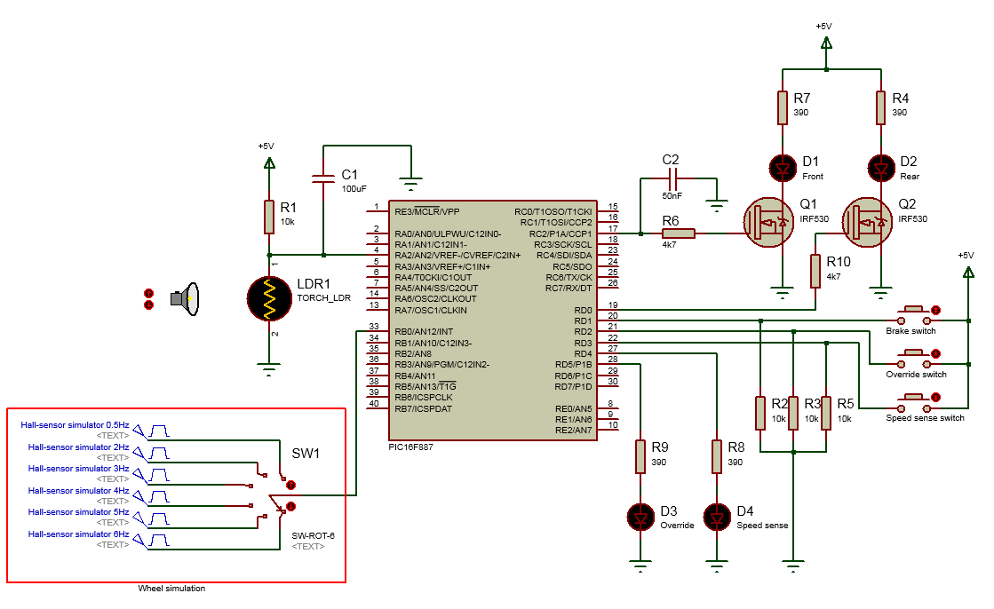
To achieve this, a prototype was built utilising a Programmable Intelligent Computer (PIC) by Microchip, and various other discreet electronic components.
Figure 1 - Circuit diagram
In figure 1, we see the completed circuit diagram in schematic view. The PIC16F887 is in the middle, controlling the output to the MOSFET’s based on user input. All the components in this schematic cost less than £2 each, except for the high brightness LEDs and the lithium batteries (not shown in schematic). This allows for cheap manufacturing, as the parts needed are readily available.

Project Plan and Current Status
The project is currently at its final stage, as evident in the Gantt-chart (figure 1). The prototype is at the protoboard stage, with final manufacture due in mid-May. Final documentation is underway, as the practical components of the project are in its finishing stage. Some delays are in effect, mainly the final prototype build. This is mainly because a focus on documentation was prioritised. Manufacture of an industry-standard prototype was considered, although this was scrapped late in the process. The timeframe did not allow this to happen, and the funding was non-existent. However, a professional PCB is still a possibility, given the production time is short enough. Please refer to appendices for technical details (source code and circuit diagrams).

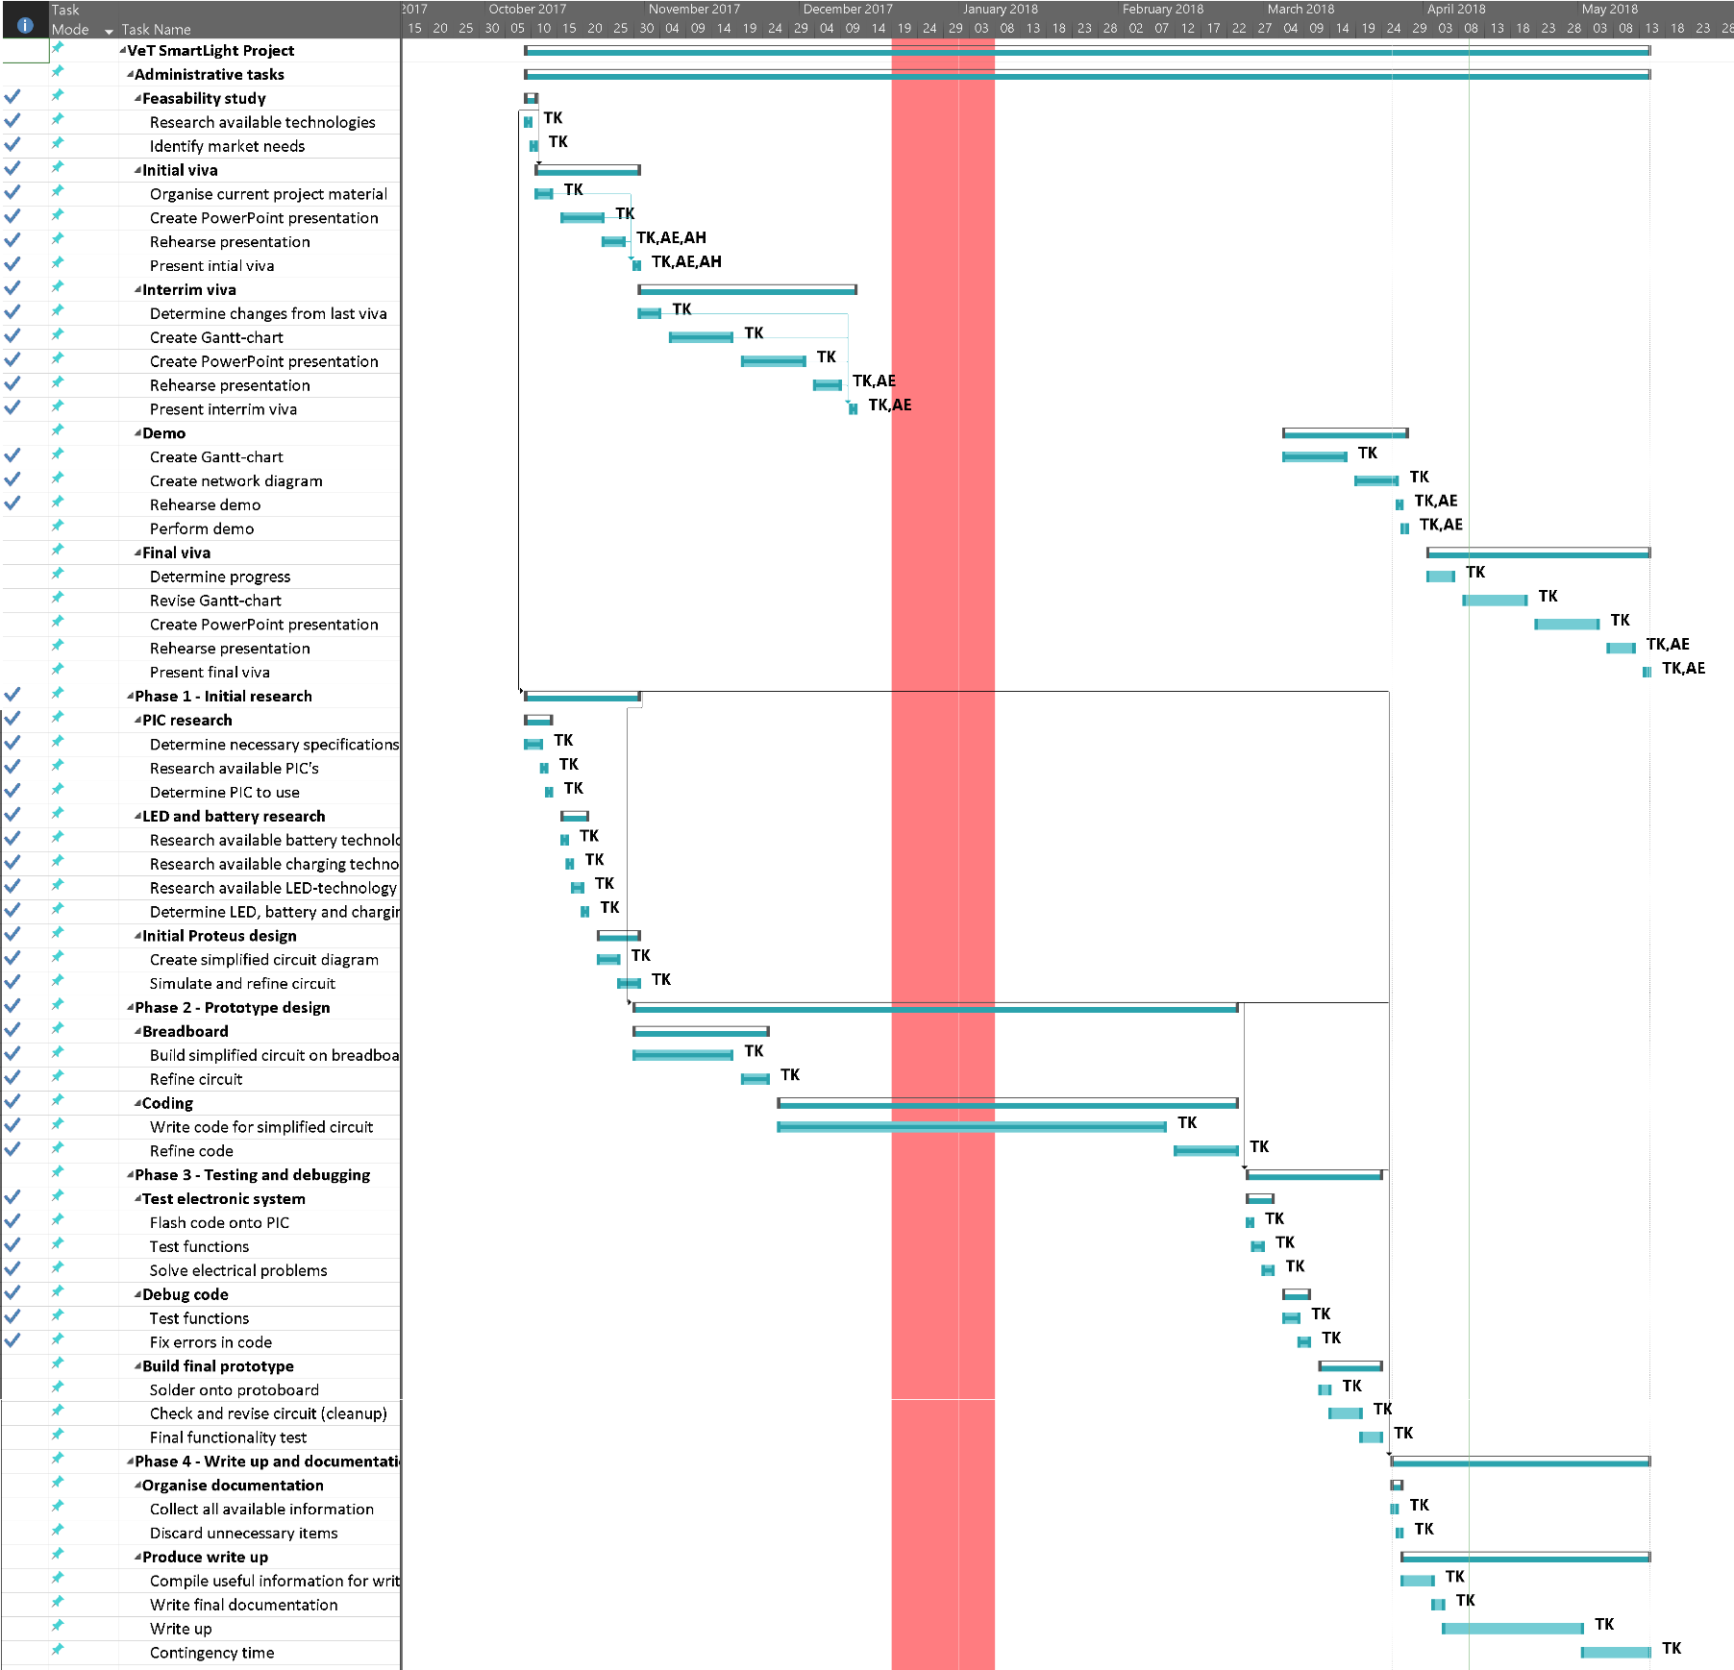
Figure 2 - Project Gantt-chart

Risk
Risk within an engineering project can be defined as the possibility of the occurrence of events leading to project failure. This is influenced by many factors, such as development issues, cost issues and personnel losses[1]. The key to managing risk lies within planning and project management, as will be explained for this specific project.

Risk Identification
This project is susceptible to a multitude of different risks, as it is highly dependant on software and hardware development. Inherently, the project is an academic exercise designed to conform with industrial circumstances. Therefore, some of the risks are less probable to occur when this is taken into consideration.
The main risks in this project can be classified in three categories:
- Personnel risks
- R1 - Physical injury (including, but not limited to: Electric shock, battery explosions, eye damage (wire clippings), fall damage (e.g. tripping over loose wires))
- R2 - Personnel losses (loss of employment, death, illness, etc.)
- R3 - Personnel incompetence
- Technological risks
- R4 - Data loss
- R5 - Dead-on-arrival components
- R6 - Development software malfunction
- R7 - Developed software malfunction
- Planning risks
- R8 - Unrealistic time frame
- R9 - Gold plating (unnecessary attributes)
- R10 - Real time performance problems
Note the difference between the last two points under the technological risks category. Development software refers to the programs utilised to develop prototypes and compile code. Developed software refers to software written by a group member. Personnel risks are critical, as this individual part of the project (SmartLight) is managed by a single individual.

Risk Exposure Calculations Explained
Risk exposure (RE) is calculated by multiplying the probability of occurrence with the potential damage for a given risk scenario[2]. Probability is on a scale from 0 to 1, where 0 is absolutely no chance, and 1 is guaranteed to occur. A probability of 0.5 therefore means there is a 50% chance of occurrence. As an example, numbers from a 1995 study by Eby can be used to demonstrate this. If a driver is a 20 year old male with one year of driving experience, the probability of a crash is 0.156 (15.6%) [3]. The car is worth £10,000. Using these numbers, the RE is calculated as follows:
$$10000×0.156≈1500$$For simplification purposes, all other factors like power, make and model are omitted. The insurance premium can be estimated to be approximately £1500 (rounded for convenience). This is assuming the car is destroyed, so the premium would be lower as there are a multitude of real life factors that will have to be incorporated into the equation to make the approximation viable.
Calculating RE for this project is unfeasible, as the statistical data about the probability of occurrence regarding the listed risk factors is limited at best. Therefore, a probability impact matrix[4] is used as a substitute, as it is more flexible and viable in this context.

Probability Impact Matrix
A probability impact matrix is a graphically simple representation of the risk factors in a project. In figure 2, the different risk codes (ref. bullet points above) are placed in accordance with the probability of occurrence and correlates with the severity of the situation. For example, R2 (personnel losses) is unlikely to happen, but it’s impact is severe. Since this project is understaffed by default, the impact will be crippling to the project. The rubrics inside the dashed line indicates that immediate action is needed to absolve the situation and rescue the project.

Code of Practice
Figure 3 - Probability impact matrix

Ethical and Legal Issues

Conforming with the British Computer Society Code of Conduct
The British Computer Society (BCS) provides an ethical code of conduct surrounding the development of software and electronics. The code ensures that members of the BCS complies both with relevant laws as well as the ethical issues that may come forth during development. Breach of these terms may result in expulsion from the society[5].
This project is not heavily reliant on ethical issues, as there is no human testing involved, and the product’s performance will not have a significant impact on the society or the environment. However, since the product is designed to increase the user’s safety, it has to deliver on this promise to conform with paragraph 2F which states “avoid injuring others, their property, reputation, or employment by false or malicious or negligent action or inaction.”[5]. Paragraphs 2A and 2B are perhaps more relevant in industry, as they dictate that an individual should not undertake work with complexity outside of their competence level. This project strives to conform with the entirety of the BCS code of conduct.

Conforming with the IEEE Code of Conduct
The Institute of Electrical and Electronics Engineers (IEEE) are more targeted towards this project, as it is predominantly an exercise in electronics design. In this code, the most relevant paragraph is the first part of §3. It states that “We will avoid injuring others, their property, data, reputation, or employment by false or malicious action.”[6].

United Kingdom Lighting Legislations
According to The Road Vehicles Lighting and Goods Vehicles Regulations of 2009, bicycle illumination needs to conform to a set of rules that ensures the safety of the user, other road users and pedestrians. Ensuring a standard of safe operation is vital, as “common sense” is too vague. According to these regulations, an illumination system is required by default. If flashing lights are incorporated (rear light in this case), the frequency most be between 1Hz-4Hz[7]. These regulations are however outdated when compared to the current technological advancements in the field. There is no mention of automatic light intensity adjustment. These regulations have not been updated since 2009, which marks almost 10 years without changes at the time of writing[8]. Some regulations are still valid today, such as mounting positions, light colour and emitted light angle.

Sustainability and Environmental Issues

First, Second and Third Order Factors
The environmental sustainability of this product is assessed by analysing the first, second and third order environmental impact factors. The first order impacts are generally the same for any electronics project, as emitting greenhouse gases can be considered a certainty by applying logic. Techniques exist to mitigate these factors, and since the components in this product are readily available and have been produced for decades, their production techniques have improved drastically. E-waste is another first order concern, as people tend to discard electronics the wrong way. Research has been made on the production of biodegradable PCB’s, with promising results[9]. Making battery production green is a more complex task, as some of the components that make up a lithium-ion battery are inherently environmentally damaging[10].
The second order effects are mostly positive, as the company hopes to make people use less fossil fuels by utilising bicycles in their daily commute. This is merely a hypothesis based on logic and common sense, as this device will aim to make the commute safer, and therefore, more attractive. As for third order effects, the device will make an impact long-term. As more and more companies get involved with making bicycles more attractive, more people will use them, and the cityscape will have to change to accommodate more bicycles and less motorised transport.

Quality
Assessing the products quality was mostly done by comparing it with existing products on the market. This gave a general overview of the market needs and consumer preference. General usability was also considered. The prototype does not allow for ergonomic testing, as it is currently in the protoboard stage. Final designs are expected to be completed by the end of May 2018. The functionality aspect is a dynamic development process, as necessary features were added, and unnecessary features were removed throughout the prototyping and testing stage. As more features impact the reliability (more things to go wrong), the feature set was kept to a minimum. This also ensures a more pleasant user experience, as more choice can lead to dissatisfaction[11].

Conclusion
This project was largely successful, though it still is marginally incomplete. Project planning is vital to ensure a smooth workflow. Proper planning also makes avoiding obstacles effortless, as a proper plan will incorporate contingency time at the appropriate places, mainly at the very end. The SmartLight has some innovative features which will hopefully make it attractive to the public. Its low component-cost also makes it cheaper overall, which would be one of the main selling points for this type of equipment.

References
[1] M. Boban, Z. Pozgaj, and H. Sertic, “Strategies for successful software development risk management,” Management, vol. 8, no. 2, pp. 71–99, 2003.
[2] B. W. Boehm, “Software Risk Management: Principles and Practices.” [Online]. Available: http://csse.usc.edu/TECHRPTS/1991/usccse91-500/usccse91-500.pdf. [Accessed: 05-Apr-2018].
[3] D. W. Eby, “An Analysis of Crash Likelihood: Age versus Driving Experience 6. Performing Organ~zation Code I 1 4 Sponsoring Agency Code.” [Online]. Available: https://deepblue.lib.umich.edu/bitstream/handle/2027.42/1115/88736.0001.001.pdf. [Accessed: 05-Apr-2018].
[4] V. Dumbravă, “Using Probability – Impact Matrix in Analysis and Risk Assessment Projects,” 2013.
[5] “Trustee Board Regulations Schedule 3 v5 – Code of Conduct for BCS Members.” [Online]. Available: http://www.bcs.org/upload/pdf/conduct.pdf. [Accessed: 09-Apr-2018].
[6] “IEEE CODE OF CONDUCT,” 2014. [Online]. Available: https://www.ieee.org/content/dam/ieee-org/ieee/web/org/about/ieee_code_of_conduct.pdf. [Accessed: 10-Apr-2018].
[7] “The Road Vehicles Lighting and Goods Vehicles (Plating and Testing) (Amendment) Regulations 2009.” [Online]. Available: http://www.legislation.gov.uk/uksi/2009/3220/made. [Accessed: 10-Apr-2018].
[8] S. Bever, “An updated guide to cycle lighting regulations | Cycling UK,” CyclingUK.org, 2017. [Online]. Available: https://www.cyclinguk.org/cyclists-library/regulations/lighting-regulations. [Accessed: 10-Apr-2018].
[9] A. Geczy, L. Gal, B. Kovacs, and I. Hajdu, “Toward producing commercial electronics on biodegradable PCB substrates,” in 2016 39th International Spring Seminar on Electronics Technology (ISSE), 2016, pp. 37–42.
[10] D. H. P. Kang, M. Chen, and O. A. Ogunseitan, “Potential Environmental and Human Health Impacts of Rechargeable Lithium Batteries in Electronic Waste,” Environ. Sci. Technol., vol. 47, no. 10, pp. 5495–5503, May 2013.
[11] B. Schwartz, “The paradox of choice.” HarperCollins, 2009.

Appendix 1 – Source Code
//One rotation per second is 2.2m/s or approximately 8km/h for a 700mm bike wheel
#include <main.h>
void reading(void);

int counter = 0; //Counter variable for RTCC overflow
int toggle = 0; //Variable for switch toggle
int x = 0; //Override toggle variable
int y = 0; //Counter varaible for wheel rotation
int flag = 0;
long int duty = 0, dutypc = 0, old_dutypc = 0; //Defines variables for pulse width modulation

#INT_RTCC //Real-time clock interrupt
void RTCC_isr(void) //Interrupt service routine
{
counter++;
if (counter == 250 && toggle == 1) //250 overflows = 1 second
{
reading(); //Calls light adjustment function
}
}

#INT_EXT //RB0 interrupt
void RB0_isr(void)
{
y++; //Rotational incrementation
clear_interrupt(INT_EXT); //Clears interrupt for next reading
}

void reading() //Light adjustment function
{
if (y <= 1)
{
y = 0;
pwm_set_duty_percent(200); //20% brightness if less than or equal to 1RPS. Mostly for stationary lighting.
}

if (y>1 && y <= 2)
{
y = 0;
pwm_set_duty_percent(400); //40% brightness if between 1 and 2 RPS
}

if (y>2 && y <= 3)
{
y = 0;
pwm_set_duty_percent(600); //60% brightness if between 2RPS to 3RPS
}

if (y>3 && y <= 5)
{
y = 0;
pwm_set_duty_percent(800); //80% brightness if between 3RPS to 5 RPS
}

if (y>5)
{
y = 0;
pwm_set_duty_percent(1000); //100% brightness if over 5RPS
}

}

void main() //Main program start

{
setup_timer_0(RTCC_INTERNAL | RTCC_DIV_16 | RTCC_8_bit); //4ms overflow. 250 overflows = 1 second.
setup_adc_ports(sAN2); //Setting AN2 to ADC
setup_adc(ADC_CLOCK_INTERNAL); //Makes AN2 use internal osc.
set_adc_channel(2); //Sets AN2 to analogue channel

delay_us(10); //Short 10us delay to help the PIC initialize

enable_interrupts(INT_RTCC);
enable_interrupts(INT_EXT_H2L);
enable_interrupts(GLOBAL);

while (TRUE) //Main program loop
{
output_high(REARLIGHT); //Powers the rear light

if (input(rpm_mode) && toggle == 0) //Speed sense toggle on
{
x = 0; //Turns off override
toggle = 1; //Toggle logic for
output_high(PIN_D4); //Turns on speed sense LED
delay_ms(250); //Small delay to prevent runaway buttons
}

if (input(rpm_mode) && toggle == 1) //Speed sense toggle off
{

toggle = 0; //Toggle
output_low(PIN_D4); //Turns off speed sense LED
delay_ms(250); //Small delay to prevent runaway buttons
}

if (input(override) && x == 0) //Override switch poll
{
toggle = 0; //Turns off rpm toggle
output_low(PIN_D4); //Turns off speed sense toggle LED
output_high(PIN_D5); //Turns on override toggle LED
x = 1;
delay_ms(250); //Small delay to prevent runaway buttons
}

while (x == 1) //Override envelope
{

output_high(REARLIGHT);
pwm_set_duty_percent(800); //Sets front light to 100%

if (input(brakesw)) //Rear light blink routine
{
output_low(REARLIGHT);//LED off
delay_ms(DELAY); //100ms delay
output_high(REARLIGHT);//LED on
delay_ms(DELAY); //100ms delay
}

if (input(override) && x == 1) //Override off
{
x = 0;
output_low(PIN_D5);
delay_ms(250); //Small delay to prevent runaway buttons
}
}

output_high(REARLIGHT);//Powers the rear light

duty = read_adc(); //Takes a reading from analogue port 2
dutypc = duty * 4; //Multiplies the reading from port 2 so it correlates closer
//to the percentage value (max 1000)

if (dutypc>800 && toggle == 0)
{
dutypc = 1000; //Sets and limits the duty cycle to max 100%
pwm_set_duty_percent(1000);
}

if (dutypc<50 && toggle == 0)
{
dutypc = 10; //Sets lower duty cycle limit to 1%
}

if (!old_dutypc >(dutypc + 100) && toggle == 0) //If ambient light has increased more than 10%
{
pwm_set_duty_percent(dutypc); //Set PWM duty cycle to match output from LDR
}

if (!old_dutypc<(dutypc - 10) && toggle == 0) //If ambient light has decreased more than 1%
{
pwm_set_duty_percent(dutypc); //Set PWM duty cycle to match output from LDR
}

old_dutypc = dutypc; //Defines ambient light reading as old ambient light reading

if (input(brakesw)) //Rear light blink routine
{
output_low(REARLIGHT); //LED off
delay_ms(DELAY); //100ms delay
output_high(REARLIGHT); //LED on
delay_ms(DELAY); //100ms delay
}
}
}

Appendix 2 – Header File Code
#include <16F887.h>
#device ADC = 8

#FUSES PUT //Power Up Timer
#FUSES NOMCLR //Master Clear pin used for I/O
#FUSES NOPROTECT //Code not protected from reading
#FUSES NOCPD //No EE protection
#FUSES BROWNOUT //Reset when brownout detected
#FUSES IESO //Internal External Switch Over mode enabled
#FUSES FCMEN //Fail-safe clock monitor enabled
#FUSES NOLVP //No low voltage prgming, B3(PIC16) or B5(PIC18) used for I/O
#FUSES BORV21 //Brownout reset at 2.1V
#FUSES NOWRT //Program memory not write protected

#use delay(internal = 4MHz)
#define front PIN_C2
#define tx PIN_C6
#define rx PIN_C7
#define rear PIN_D0
#define brakesw PIN_D1
#define override PIN_D2
#define rpm_mode PIN_D3
#use rs232(baud = 9600, parity = N, xmit = tx, rcv = rx, bits = 8, stream = PORT1, errors)

#define REARLIGHT PIN_D0
#define DELAY 100
#USE PWM(OUTPUT = PIN_C2, FREQUENCY = 1kHz, DUTY = 25)

