Data Handling and Business Intelligence
Essay

Student name: Roman Grigoriev
Student ID: 2229684
Module code: LCBB5000
Module name: Data Handling and Business Intelligence
Lecturer: Dr Molly Jack

Table of Contents

Introduction 3
Part 1 3
1. Trends in sales over the months 3
2. The most frequently purchased items 6
3. The quantity of items purchased by customers in each transaction 8
4. The most profitable segment of customers 12
5. Suggested strategies for the retailer for securing greater profits 14
Part 2 16
1. The proportion of males and females in the survey 16
2. The proportion of students qualifying and not qualifying for free lunch 17
3. Mean and Median of students who qualify or don’t qualify for free lunch 18
4. K-means Clustering and its Specific example 18
5. Advantages & disadvantages of statistical software SPSS & MS Excel 20
Conclusion 22
Reference List 23

Introduction
This assignment will demonstrate how different data analytics technologies are utilized to analyze an organization's sales and other elemental data. Decisions can be made with knowledge thanks to the analysis of data, which offers insightful information about an organization's performance and other areas. It also assesses changes in the data variables. The first section will involve the analysis of sales data from an online store located in the UK to identify patterns in monthly sales, things purchased, items bought by consumers per transaction, etc. Relevant measures will be suggested to the organization in light of these evaluations in an effort to boost profitability. MS Excel will be used for the entire analysis procedure. In part 2, SPSS and MS Excel will be used to analyze survey data from a school. Descriptive data, the proportion of female and male students, the quantity of students who receive free lunches and those who do not, and other factors will all be assessed. Additionally, the benefits and drawbacks of utilizing Microsoft Excel and SPSS will be discussed, respectively.
Organizations use two related processes, data handling and business handling, to analyze data on various levels. The process of gathering, logging, and presenting data such that it is understandable to people is referred to as data handling. However, the process of using and analyzing data to enable organizations to make well-informed business decisions is known as business intelligence.

Part 1

1. Trends in sales over the months
For the assessment of changing trends in sales over different months of the data, a pivot table will be prepared, which has been attached below –

Date | Total
11/17/2019 | £3,33,756.04
11/18/2019 | £2,83,981.88
11/20/2019 | £2,25,964.27
11/21/2019 | £3,03,521.71
11/22/2019 | £3,44,094.58
11/23/2019 | £2,53,060.26
11/24/2019 | £1,60,298.43
11/25/2019 | £1,96,698.50
11/27/2019 | £71,093.21
11/28/2019 | £1,85,503.86
11/29/2019 | £1,99,865.21
11/30/2019 | £1,81,841.24
12/01/2019 | £1,72,592.36
12/02/2019 | £1,79,868.59
12/04/2019 | £79,020.71
12/05/2019 | £2,88,295.47
12/06/2019 | £1,90,335.34
12/07/2019 | £2,63,611.26
12/08/2019 | £2,15,952.78
12/09/2019 | £6,04,502.11
Grand Total | £47,33,857.81
Using the information in the above table, a line chart has been prepared, which provides relevant insights into the trends in sales of the business –
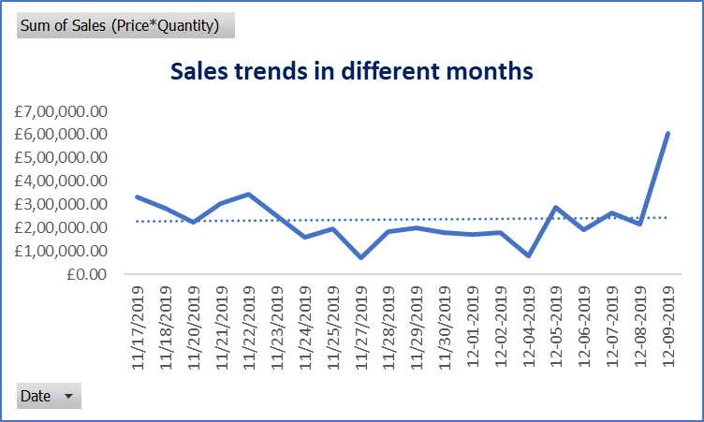
The chart contains information on each day’s sales revenue for around one month from 17th November 2019 to 9th December 2019. The trendline has remained fairly straight throughout the period, however, the slope is slightly positive, which indicates that over time, the sales revenue of the e-commerce business has steadily increased. Out of total sales of £47,33,857.81, more sales have been raised in December as compared to November. On 9th December 2019, the most sales revenue has been generated by the company.

2. The most frequently purchased items
To evaluate the items that are purchased more often by the customers, another pivot table has been generated on MS Excel and using that information of the table, a column chart has been prepared and attached below. In the following table, the most purchased 50 different items have been projected –
ProductName | Total
Asstd Design 3d Paper Stickers | 12632
Rabbit Night Light | 11251
Popcorn Holder | 11238
Paper Chain Kit 50'S Christmas | 5496
Disco Ball Christmas Decoration | 3916
Wooden Star Christmas Scandinavian | 3676
Assorted Colour Bird Ornament | 3273
World War 2 Gliders Asstd Designs | 3113
Wooden Heart Christmas Scandinavian | 3112
Vintage Doily Jumbo Bag Red | 2730
Paper Chain Kit Vintage Christmas | 2712
Cream Hanging Heart T-Light Holder | 2616
Rotating Silver Angels T-Light Hldr | 2610
60 Cake Cases Vintage Christmas | 2545
Jumbo Bag 50'S Christmas | 2489
Jumbo Bag Red Retrospot | 2484
Black Record Cover Frame | 2443
Charlotte Bag Suki Design | 2391
Christmas Hanging Star With Bell | 2190
Red Retrospot Charlotte Bag | 2114
Victorian Glass Hanging T-Light | 2009
Bicycle Puncture Repair Kit | 1864
Gardeners Kneeling Pad Keep Calm | 1860
Jam Making Set Printed | 1837
Hand Warmer Owl Design | 1810
Antique Silver T-Light Glass | 1775
Bubblegum Ring Assorted | 1765
Jumbo Bag Vintage Doily | 1739
Chilli Lights | 1692
Rain Poncho Retrospot | 1679
Hot Water Bottle Keep Calm | 1679
Classic Chrome Bicycle Bell | 1661
Jumbo Bag Vintage Christmas | 1655
Classic Bicycle Clips | 1644
Cook With Wine Metal Sign | 1595
Jumbo Bag Paisley Park | 1590
Traditional Modelling Clay | 1587
Vintage Snap Cards | 1539
Hot Water Bottle Tea And Sympathy | 1521
Doughnut Lip Gloss | 1497
Please One Person Metal Sign | 1490
Star Decoration Painted Zinc | 1489
Metal Sign Take It Or Leave It | 1478
Pack Of 12 London Tissues | 1471
Multi Colour Silver T-Light Holder | 1461
Blue Harmonica In Box | 1447
Set Of 60 I Love London Cake Cases | 1438
Alarm Clock Bakelike Red | 1425
Red Toadstool Led Night Light | 1420
Pack Of 72 Retrospot Cake Cases | 1405
Now, consider the following chart -
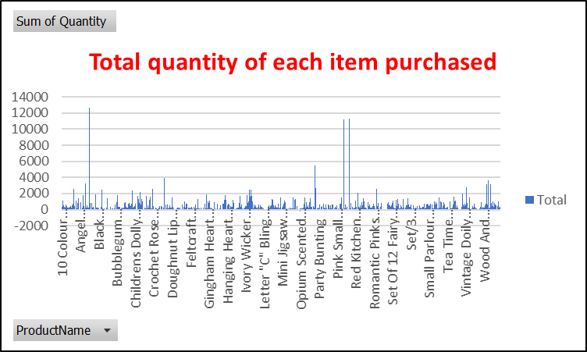
As the table shows, 2768 different products have been sold by the company to its customers during the one-month period. From those products, the most purchased item has been Asstd Design 3D Paper Stickers. A total of 12,632 quantities of that item have been purchased which is higher than any other items. The second most purchased items have been Rabbit Night Light, which has been bought 11,251 times by the customers. The third most purchased item is the Popcorn Holder, whose 11,238 quantities have been purchased.

3. The quantity of items purchased by customers in each transaction
Another pivot table has been created to assess how many quantities of products have been purchased in total for each transaction.
Transaction No | Total
581483 | 80995
578841 | 12540
581175 | 7366
578140 | 5760
580665 | 4732
581105 | 4340
580652 | 3920
578125 | 3806
581020 | 3295
580729 | 2455
581457 | 2414
579692 | 2299
581476 | 2215
576923 | 2210
580727 | 2191
581219 | 2149
578305 | 2111
579196 | 2105
579498 | 2040
581492 | 2010
580115 | 1986
580673 | 1892
580367 | 1871
580730 | 1857
581217 | 1851
578270 | 1800
579777 | 1761
581439 | 1747
580297 | 1744
578233 | 1699
580983 | 1649
577783 | 1644
580744 | 1640
577358 | 1620
579284 | 1619
578344 | 1602
577822 | 1600
578060 | 1600
577754 | 1524
579508 | 1516
578347 | 1513
580363 | 1500
581458 | 1500
577150 | 1457
579251 | 1456
580873 | 1410
581115 | 1404
578746 | 1402
579187 | 1401
581133 | 1392
579538 | 1390
579672 | 1386
578065 | 1377
577078 | 1360
579512 | 1344
579093 | 1322
578143 | 1284
578827 | 1255
577844 | 1242
579936 | 1200
581459 | 1200
577768 | 1197
578844 | 1183
577747 | 1182
579986 | 1167
580985 | 1160
580875 | 1152
580243 | 1120
580116 | 1101
580146 | 1086
578067 | 1084
581256 | 1074
581410 | 1069
581375 | 1056
580153 | 1027
579400 | 1024
581188 | 1016
578149 | 1007
580615 | 1005
577810 | 1000
580170 | 1000
580178 | 988
581266 | 987
580754 | 979
579291 | 955
579525 | 950
578358 | 948
580610 | 947
580519 | 938
579784 | 936
578321 | 920
578833 | 911
577034 | 909
577021 | 906
581146 | 902
581179 | 889
580167 | 880
580645 | 878
577850 | 870
577816 | 864
In this table, 100 transactions with the most quantity of purchases have been attached and projected for better visualisation and understanding.
By classifying the entire data in the context of different transaction IDs. around 302 items on average are purchased in each unique transaction. The ‘AVERAGE’ function has been used on the MS Excel. Also, a pivot table was prepared, which projected that the most quantities have been purchased for transaction no - 581483, a total of 80,995 quantities of items have been purchased.

4. The most profitable segment of customers
Country | Total
Australia | 1386.56
Austria | 22549.46
Belgium | 21272.21
Channel Islands | 1370.63
Cyprus | 3498.13
Czech Republic | -458.82
Denmark | 4411.08
EIRE | 75983.59
Finland | 6754.28
France | 79464.4
Germany | 82842.93
Greece | 1547.87
Iceland | 10975.14
Italy | 19186.27
Japan | 42924.61
Malta | 1829.3
Netherlands | 103698.2
Norway | 47948.12
Portugal | 14751.05
Spain | 17107.91
Sweden | 1443.85
Switzerland | 9946.49
United Kingdom | 4160911.51
USA | 2513.04
Grand Total | 4733857.81
A pivot table has been prepared on the MS Excel to analyse these aspects and using the information of the pivot table, a bar diagram has been prepared and attached below -
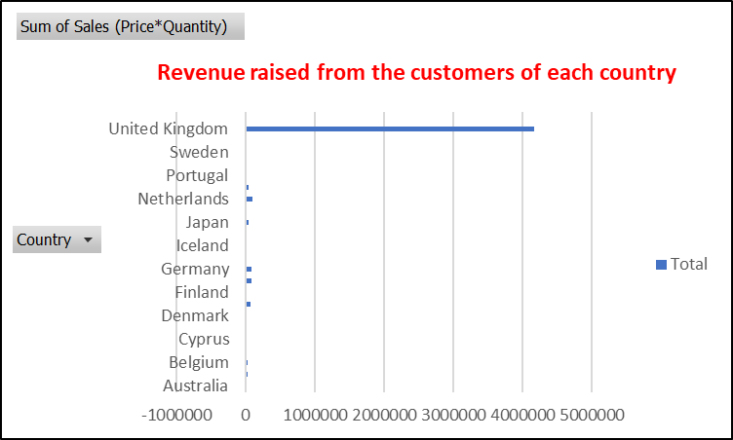
The bar chart attached above indicates that the company has generated the most revenue from customers who live in the UK. A total of £41,60,911.51 of revenue has been raised from the UK customers, therefore, the customers of the UK can be considered the most profitable segment for the e-commerce retailer. The company offers items to customers from 24 different countries, which include Australia, USA, Belgium, Japan, Czechia, Spain, Portugal, Holland, etc. However, the customers of Czechia cannot be profitable as the company has secured revenue losses from the customers of this group. Also, the e-commerce business entity looks heavily dependent on the UK customers as compared to other countries.

5. Suggested strategies for the retailer for securing greater profits
The retailer can consider the strategies referred to below -
i. Segmentation and targeting of customers:
It has been determined through study that the company's ability to turn a profit depends on its UK clientele. The UK's e-commerce retail sector is fiercely competitive, as there are other big players in the market as Amazon, Asda, ASOS, and others, therefore this reduces the likelihood of turning a bigger profit. The business should therefore concentrate on drawing in clients from other nations (Gomez et al. 2018). To get people to buy things, more deals and discounts must be made available. The organization will become more profitable as a result of diversifying its revenue source.
ii. Focus on marketing & sales:
Rather than concentrating on generating profits, the corporation ought to prioritize maximizing sales. The business must spend money on marketing in order to maximize sales volume. Promoting and promoting the brand aggressively will increase consumer awareness of it. It will also spread awareness of the company to new clients. Increased sales are the result of these actions. In comparison to traditional marketing, the e-commerce company ought to prioritize digital marketing methods (Markovitch et al. 2020). The corporation can market its brand through sponsorships, Google Ads, and social media initiatives.
iii. Expansion of the business into emerging markets:
The investigation shows that the business with its headquarters in the UK also sells to customers in a few other European nations. In this regard, the organization may consider growing into new emerging markets in Africa, South America, and Southeast Asia. Because of their dense populations, Southeast Asian nations have a significant need for retail items. Additionally, the corporation can anticipate making more money from sales in those nations due to the lower value of their currencies. Additionally, the retailer will acquire a strong monopoly power and a competitive edge in the market (LinkedIn, 2024).
iv. Optimization of the supply chain:
The business can cut production costs and streamline its supply chain processes to boost profitability. In order to accomplish this, the business might get in touch with regional suppliers and vendors that can offer materials at a reduced price and also postpone the payment deadline (Marshall, 2022). In addition, the business may establish a few factories in South East Asian nations like Bangladesh, Thailand, Sri Lanka, India, etc., where inexpensive labour is readily available. It's also necessary to increase operational efficiency. Additionally, technological development is essential for controlling rising expenses and streamlining supply chain processes.
v. Modifications in the pricing strategies:
Prices per unit should rise for products with more demand. For products with reduced demand, the corporation may choose to apply penetration pricing. Customers will be drawn in if the product prices are first set lower. The business may increase the cost of those products once a clientele has been established. Optimizing client satisfaction should receive more attention. The store can increase the products' average transaction value by upselling and cross-selling. Efficient framing of pricing strategies is necessary to retain a higher customer base and maintain revenue growth for the business (Li et al. 2023).

Part 2

1. The proportion of males and females in the survey
Gender | Count of Gender
Female | 1056
Male | 1077
Grand Total | 2133

A pivot table has been prepared in MS Excel for the dataset, which entails that there are a total of 2,133 students, out of which 1,077 students are male students and 1,056 are female students. For graphically presenting this data, a column chart has been prepared in SPSS, that has been attached below -
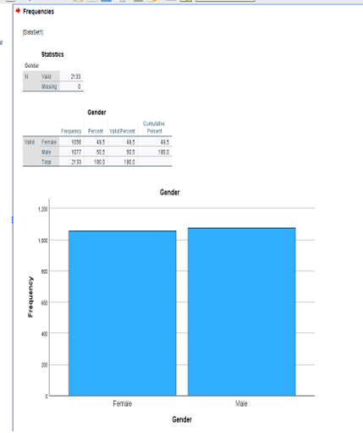
As the column chart projects, the column for male students is a taller one, which indicates that more male students are there in the school as compared to female students.

2. The proportion of students qualifying and not qualifying for free lunch
Category for applicability of free lunch | Count of Lunch
Does not qualify for free/ reduced lunch | 1215
Qualify for free/ reduced lunch | 918
Grand Total | 2133

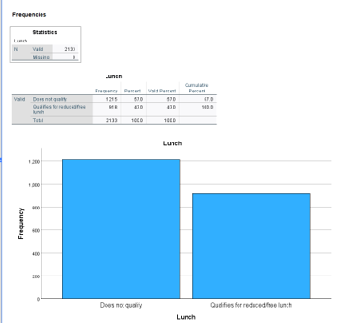
918 students are eligible for free or reduced meals, while 1,215 students do not, according to the bar diagram.

3. Mean and Median of students who qualify or don’t qualify for free lunch
The table below shows descriptive statistics for three variables: "Student_No," "Pretest," and "Posttest," based on a sample of 2,133 students. The "Pretest" scores an average score of 54.96 and a standard deviation of 13.563, indicating moderate variability. The "Posttest" scores an average score of 67.10. The standard deviation is slightly higher at 13.987, suggesting that while the average score increased, the spread of scores remained similar. This improvement in scores suggests that the students performed better after the test.

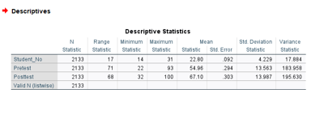

4. K-means Clustering and its Specific example
"K-means clustering" is the name of a learning algorithm for unsupervised data clustering. Unlabelled data points are clustered in this clustering technique. "K-means clustering" is a widely used technique in machine learning. The K-means clustering technique divides a data distribution into many groups according to the separation between the centroids. The median or mean of all the points within a cluster, depending on the characteristics of the data, is called a centroid.
Example using the ‘Student_Score’ dataset:
This dataset has been analysed through the SPSS software and the results of the analysis have been following -
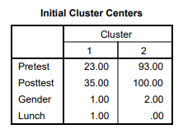
The above table shows that there are 4 different variables. The centroids of each cluster in this case, before any iterations start, are Clusters 1 and 2. Clusters 1 and 2 begin at centres 23, and 93, respectively, for the pretest variable in this case. For cluster 1 and cluster 2, the initial centres of the posttest variable are 35 and 100, respectively. Starting at 1.00 and 2.00, respectively, are Clusters 1 and 2 for the Gender Variable. Clusters 1 and 2 begin lunch at 1.00 and 0.00, respectively. These starting centres have been obtained either by random selection or by a specified initialization.
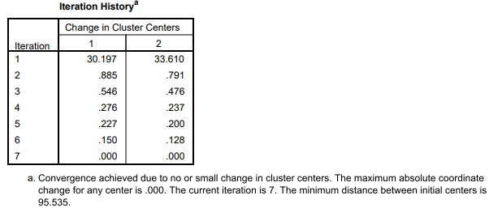
This table shows how the cluster centres changed throughout the course of seven iterations. After 30.193 and 33.610 units of change in Clusters 1 and 2, respectively, in Iteration 1. After 7 iterations, the modifications amount to 0.000, signifying that the algorithm has reached convergence and no additional tweaks are necessary. It is at this point that the algorithm is stable.
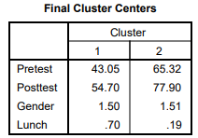
Regarding the pretest and posttest variables, there have been comparatively large variances between Clusters 1 and 2. In contrast, gender shows very little variation among clusters, suggesting that gender is not a major component that separates clusters. Additionally, there is a noticeable distinction across the ‘Lunch’ variable, suggesting that there is a variable that differs amongst the clusters.
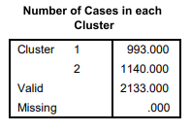
In this scenario, there are 993 cases in cluster 1 and 1,140 cases in cluster 2.
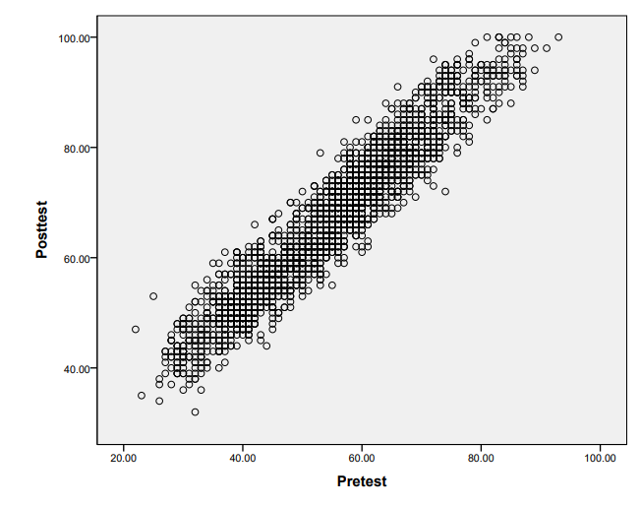
According to this chart, there is a direct and positive relationship between the Pretest and Posttest: rising Pretest values cause rising Posttest values, and vice versa.

5. Advantages & disadvantages of statistical software SPSS & MS Excel
SPSS
Advantages:
- To use SPSS is simple. The SPSS provides prompt and accurate responses as well.
- The syntax records can be saved and adjusted appropriately; however, SPSS users are not required to work with syntax. To appropriately visualize the data, SPSS offers a variety of useful tables and graphs, making it more dynamic.
- Using SPSS makes managing data straightforward. Making use of the SPSS doesn't take much work at all.
- There are fewer errors with SPSS. The graph may be altered in accordance with the needs of the data distribution.
- The fact that SPSS is available in multiple languages means that most people can readily use it.
Disadvantages:
- SPSS will not be helpful if the user needs to analyze a sizable dataset. For some industries, SPSS might not be able to assess productive results.
- The user could not get accurate results from the analysis if data is acquired by skewed or inaccurate means. If the sample is not done appropriately, the assessment of the information is misleading.
- When the precise object that researchers need to assess is not measured, the SPSS could not be helpful.
- Analyzing qualitative data is not possible using SPSS. Furthermore, compared to SAS and R, SPSS is more difficult for users to program.

MS Excel
Advantages:
- Excel for Microsoft can be used to easily insert data. Data filtering is another helpful tool that is simple to utilize (Javatpoint, 2024).
- Data can be simply obtained in Microsoft Excel. While it takes time to find data by hand, MS Excel makes it simple to seek and retrieve data (Javatpoint, 2024).
- MS Excel provides simply understood capabilities for performing a variety of mathematical and statistical tasks. Utilizing these functions also expedites the process of computation and analysis (Javatpoint, 2024).
- Passwords can be used to secure Microsoft Excel spreadsheets, reducing the likelihood of data loss or theft (Javatpoint, 2024).
- Multiple worksheets might contain information pertaining to various topics under a single file. To keep track of data from several categories, separate files and registers are not necessary (Javatpoint, 2024).
Disadvantages:
- MS Excel has limitations on file sizes. Thus, MS Excel is not able to handle data with a large number of observations adequately (Javatpoint, 2024).
- Learning how to use the features of Microsoft Excel is not simple. Therefore, it takes time for beginners to learn how to use Microsoft Excel effectively (Javatpoint, 2024).
- MS Excel does not have a fast autofill capability. It's crucial that users understand the features and other functionalities of Microsoft Excel in order to properly autofill the cells (Javatpoint, 2024).
- Random mistakes can occur in MS Excel. It's critical that users understand which information category to use. If an accurate procedure is not followed, data involving percentages and fractions may produce unsuitable outcomes (Javatpoint, 2024).

Conclusion
In this project, the data analytics process stages have been used to analyze two datasets. Data collecting, cleaning the data, analysis of data, data visualization, and data interpretation are the five steps of the data analytics process in this case. Viable insights into potential tactics to increase profitability are provided by the company's sales data analysis. To display sales trends and offer insights into other aspects, a variety of charts have been created. Part 2 has shown the benefits and drawbacks of Microsoft Excel. While SPSS is more specialized in static work, MS Excel is utilized more frequently for analytical tasks.

Reference List
Gomez, A., Loar, R. and Kramer, A.E., (2018). The impact of market segmentation and social marketing on uptake of preventive programmes: The example of voluntary medical male circumcision. A literature review. Gates Open Research, 2. https://www.ncbi.nlm.nih.gov/pmc/articles/PMC6480503/.
Javatpoint. (2024). Advantages and Disadvantages of MS Excel - Javatpoint. [online] Available at: https://www.javatpoint.com/advantages-and-disadvantages-of-ms-excel [Accessed 4 Jul. 2024].
Li, H., Xiao, Q. and Peng, T., (2023). Optimal Pricing Strategy of New Products and Remanufactured Products Considering Consumers’ Switching Purchase Behavior. Sustainability, 15(6), p.5246. https://www.mdpi.com/2071-1050/15/6/5246/pdf.
LinkedIn. (2024). Market Expansion: Unlocking New Opportunities for Sales and Profitability. [online] Available at: https://www.linkedin.com/pulse/market-expansion-unlocking-new-opportunities-sales-abhi-golhar [Accessed 4 Jul. 2024].
Markovitch, D.G., Huang, D. and Ye, P., (2020). Marketing intensity and firm performance: Contrasting the insights based on actual marketing expenditure and its SG&A proxy. Journal of Business Research, 118, pp.223-239. https://nscpolteksby.ac.id/ebook/files/Ebook/Journal%20International/Marketing/Journal%20of%20Business%20Research/Volume%20118%2C%20September%202020%2C%20Pages%20223-239.pdf.
Marshall, M. (2022). Strategies for Improving Companies’ Productivity and Profitability (Doctoral dissertation, Walden University). https://scholarworks.waldenu.edu/cgi/viewcontent.cgi?article=14040&context=dissertations.

