

University of Wales Trinity Saint David
School of Engineering

ACMA6010
Designing a Kiteboard Hydrofoil Wing: Structural Design

Steffan Rhys Lloyd
2220589
26/10/2025
Table of Contents
1 Introduction 3
2 Background and Design Rationale 4
2.1 Hydrofoil function and the role of stiffness 4
2.2 Motivation for CFRP substitution 4
2.3 Carbon/epoxy property ranges: 4
2.4 Pairing FEA with optimisation 5
3 Model Setup and Method 7
3.1 Geometry, mesh, and boundary conditions 7
3.2 Steel baseline analysis 7
3.3 First CFRP attempt (equal thickness) 8
4 Optimisation in Design Studio 10
4.1 Optimisation definition 10
4.2 Continuous sizing behaviour 10
4.3 Discrete manufacturing pass (0.1 mm plies) 10
4.4 Final laminate and result 10
5 Results and Interpretation 11
5.1 Quantitative comparison 11
5.2 Stress distribution and failure considerations 12
5.3 Why the optimiser chose those angles 13
5.4 Sensitivities and robustness 13
6 Discussion of Ply Thickness and Laminate Behaviour 13
6.1 Importance of Ply Thickness in Composite Stiffness 13
6.2 Directional Stiffness Contribution 14
6.3 Manufacturing Implications 14
7 Performance of the Final Laminate 15
7.1 Global stiffness and weight comparison 15
7.2 Effect of Ply-Group Thickness Variation 16
7.3 Local Stresses and Load Paths 17
8 Reflection on the Design Process 17
9 Conclusion 18
10 Reference 19

1 Introduction
The structural design and optimisation of a kiteboard hydrofoil front wing are examined in this research, with an emphasis on how composite materials can increase stiffness-to-weight efficiency in comparison to conventional metals. In order to design a carbon-fibre reinforced polymer (CFRP) laminate, the work required assessing a baseline of 2 mm thick steel, calculating its maximum displacement of 8.6 mm, and then using that number as a benchmark. The main objective was to obtain a stiffness level that is either like or better than current standards while significantly decreasing weight.
Design Studio was used for all structural simulations and optimisation. Ply-group thicknesses were designated as design variables in this setting, enabling the software's optimiser to adjust them between lower and higher bounds while still adhering to the 8.6 mm displacement requirement. Certain orientations were pushed to their limits during the process, especially the 0° and 90° directions, demonstrating their superiority in bending resistance. 0.1 mm ply increments were used in the discrete-ply refinement at the end of the optimisation process to make sure the finished configuration could be manufactured.
The final composite wing will ideally be significantly lighter and more rigid than the steel reference. The study shows how composite laminate design and FEA-based optimisation may be used to create effective, practical structural solutions for contemporary marine engineering applications.

2 Background and Design Rationale
2.1 Hydrofoil function and the role of stiffness
An underwater aerofoil is what a hydrofoil wing does. The foil creates lift as speed increases, lifting the board above the water's surface and reducing viscous drag and wetted area. Bending stiffness is essential to preserving consistent lift and ride stability because structural flexibility influences the immediate shape, effective angle of attack and camber. MDPI Proceedings presents an open access overview of hydrofoil performance and optimisation methods, emphasising stiffness as a first-order design element for efficiency and stability. (Schmidt, J. et al. 2020).

2.2 Motivation for CFRP substitution
Although steels have a well-known elastic modulus (210 GPa) and strong strength, their high density (7,850 kg m⁻³) results in inertial penalties for load transitions and agile foil manoeuvres. Anisotropic stiffness and a significantly reduced density roughly (1,550–1,600 kg m⁻³) are provided by CFRP laminates, which can be orientated by fibre to match the main load lines. This can all be backed up by public data for typical moduli and densities, that is available to access to back up any research that shows the CFRP a much stronger, lighter and overall better material to use for the wing (Engineering Toolbox, E. 2024).
2.3 Carbon/epoxy property ranges:
A unidirectional (UD) laminate was targeted because it provides the most efficient directional stiffness: 0° along the span for bending, 90° across the chord to increase out-of-plane bending resistance, and ±45° to control in-plane shear and torsional response. “A laminate is a prepared stack of uni-directional composite plies (uni-directional meaning the plies have a single fiber direction rather than a weave pattern)”. The layers are defined by the fibre directions of each ply as can be seen in Figure 1 (Classical Lamination Theory, 2011).
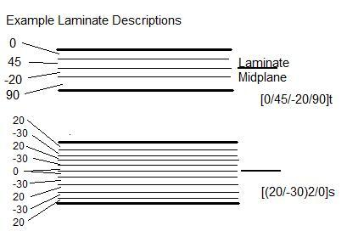
Figure 1: Example laminate stacking sequences (Classical Lamination Theory, 2011).

2.4 Pairing FEA with optimisation
A reliable basis for forecasting stresses, strains, and displacements in intricate geometries is offered by finite-element analysis (FEA). It is especially useful for evaluating anisotropic materials, like CFRP, whose strength and stiffness change depending on the orientation of the fibres. Conventional FEA, on the other hand, can only assess a certain configuration and cannot ascertain whether the design makes the most use of available materials. Therefore, the study must be coupled with an optimisation process that systematically modifies important design parameters to achieve the greatest possible balance between stiffness, weight as well as manufacturing capacity. The finite-element solver and optimisation engine were directly connected in this investigation using Design Studio (Genesis Design Studio). As a result, the algorithm was able to automatically modify the thicknesses of the ply groups to reduce bulk while limiting the maximum displacement to 8.6 mm, which was the standard established by the steel baseline. To create a manufacturable solution, discrete 0.1 mm ply increments were inserted after the continuous sizing step determined which orientations had the greatest influence.
This integrated method reflects current aerospace and marine design practices, where manual iteration is replaced with computational optimisation to produce lighter, more dependable structures faster (Krueger, R. and Bergan, A. 2024).

3 Model Setup and Method

3.1 Geometry, mesh, and boundary conditions
The hydrofoil wing model was imported into Design Studio as a shell setup following the steps outlined in the guide. Since this part would be hard in the actual structure, the first challenge was to fix the root face to reflect the wing's attachment to the fuselage. To replicate the hydrodynamic force mentioned in the brief, a vertical pressure load was then uniformly supplied across the upper surface. The surface was divided into smaller components using the software's meshing tool, and the mesh underwent further refinements. The maximum displacement was measured after every run, and the mesh was retained for investigation when additional improvements had no effect.
The importance of aligning the material axes with the fibre directions. Therefore, to make sure the model identified how the fibres would transport bending loads, the 0° axis was set along the wing's span. To ensure that the arrows indicating fibre direction were pointing in the correct direction, this was visually verified in the software.

3.2 Steel baseline analysis
A steel baseline model was used to serve as a reference for stiffness and displacement prior to attempting the composite design. The wing was modelled at a thickness of 2 mm and examined using the same loading and boundary conditions. The highest displacement, as determined automatically by the software, was 8.6 mm at the wing tip. Since the composite version would have to meet or surpass this figure, it became the primary performance limitation for all subsequent optimisation efforts.
To ensure that the loading and limits were operating as intended, a few quick test runs were conducted first. Unrealistic deflection forms in early outputs were attributed to incompletely established boundary conditions at the root edge. The outcomes were much more in line with predictions after being adjusted. To make sure that element size was not unduly affecting stiffness, mesh refinement was also done again. Following verification of this configuration, the 8.7 mm displacement result was deemed dependable. This baseline essentially served as a reference for future mass and performance comparisons and provided a clear objective for the composite design to accomplish. It represented the rigidity of a traditional steel hydrofoil.
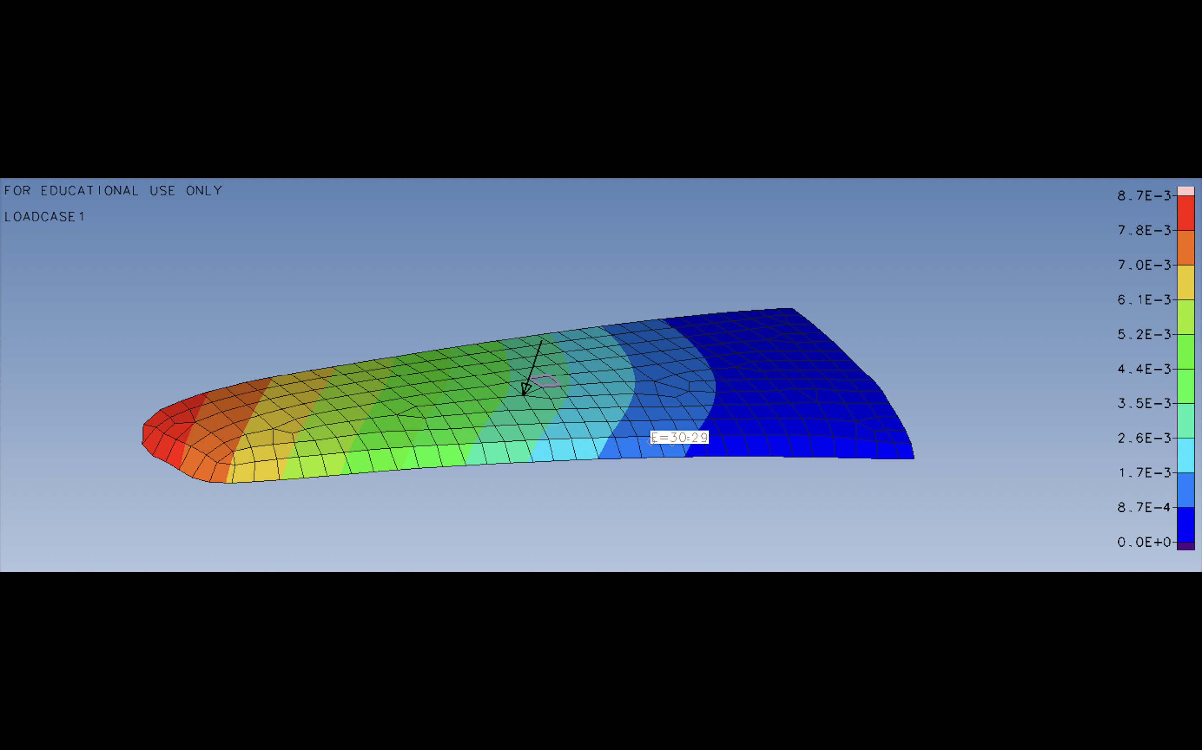
Figure 2 – Steel baseline deformation, max displacement = 8.7 mm

3.3 First CFRP attempt (equal thickness)
The first composite model was made using the same shape and loading configuration as the steel reference. A carbon-fibre reinforced polymer (CFRP) laminate with the same overall thickness of 2 mm was used in place of the steel. Using the above material data, the laminate was developed and set up in recurring fibre orientations 0, +45, −45, 90, -90, 0 Degrees resulting in 25 plies at 0.1 mm each. This lay-up represented a balanced, design meant to act uniformly in a variety of directions, and it followed to the sample pattern in the guide.
A maximum displacement of about 23 mm was obtained when the model was run, which was significantly greater than the 8.7 mm found for steel. This demonstrated clearly that moving to composites does not result in the same rigidity as simply matching the thickness of a metal component. It also emphasised the significant impact that laminate stacking and fibre direction have on the structure's bending behaviour.
After examining the stress plots, it became evident that the composite's nature permitted more flexibility in the chordwise direction, despite the first surprise of the result.

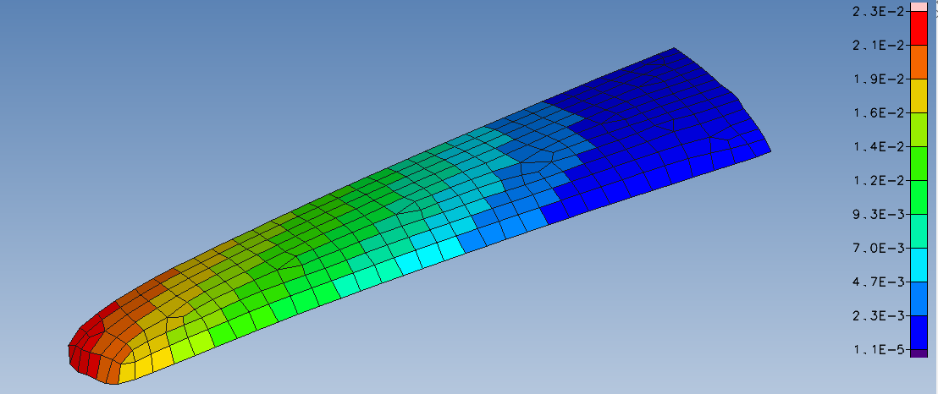
Figure 3 – Initial CFRP 2 mm laminate, max displacement = 23 mm

4 Optimisation in Design Studio

4.1 Optimisation definition
The optimisation problem was defined within Design Studio as follows:
- Objective: minimalize total mass.
- Constraint: max displacement ≤ 8.7 mm steel.
- Design variables: thickness in each group (−90°, −45°, 0°, +45°, +90°).
Each variable had lower and upper bounds, enabling the solver to grow stiffness where it was most effective while preventing unrealistic solutions.

4.2 Continuous sizing behaviour
The optimiser thickened the continuous phase in the directions that minimised displacement the best. The 0° and 90° groups achieved their upper limits early, which is consistent with span- and chord-dominated bending. This suggests that these angles, controlled stiffness for the specified loading and boundary conditions. The solution adjusted ±45° groups to stabilise shear and torsion without adding more mass after the displacement fell below the 8.7 mm limit.

4.3 Discrete manufacturing pass (0.1 mm plies)
The laminate was discretised to 0.1 mm increments after reaching a continuous optimum, making each group thickness equal to a whole number of plies. Discretisation usually results in a slight increase in bulk (round-up effect) and occasionally a slight change in stiffness. The final, feasible approach-maintained mass substantially below the steel baseline while maintaining constraint satisfaction (Krueger, R. and Bergan, A. 2024).

4.4 Final laminate and result
The final laminate totalled 4.0 mm 40 plies and produced a maximum displacement of 7.5 mm. The stack remained symmetric and balanced.
Layer Group | Orientation | Thickness (mm) | Approx. Plies | Function
1 (outer skin) | 0° | 0.2 | 2 | Surface bending stiffness; spanwise rigidity
2 | +45° | 0.3 | 3 | In-plane shear and torsional stability
3 (core) | 90° | 1.4 | 14 | Chordwise bending stiffness; balances coupling
4 | −45° | 0.6 | 6 | Shear balance and torsion control
5 (inner skin) | −90° | 1.5 | 15 | Symmetric strength; chordwise support
Figure 4 – Optimised CFRP 4 mm laminate, max displacement = 7.5 mm

5 Results and Interpretation

5.1 Quantitative comparison
Model | Total Thickness | Max Displacement | Relative Mass (qual.) | Observation
Steel baseline | 2.0 mm | 8.7 mm | 100 % | Reference stiffness; heavy
CFRP (initial) | 2.0 mm | ~23 mm | 25–40 % of steel | Too flexible
CFRP (final) | 4.0 mm | 7.4 mm | steel | Constraint met; mass far lower

The development supports with basic plate theory bending stiffness scales with thickness cubed. Doubling thickness from 2 mm to 4 mm yields an 8× increase in bending stiffness. Because CFRP density is much lower than steel’s, the mass remains far lower even at the increased thickness.

5.2 Stress distribution and failure considerations
The boundary requirement was met by the concentration of peak stress at the root. Because of its customised stiffness, the finished laminate distributed load more evenly throughout the span than steel. When movement is restricted to 7.4 mm, first-ply failure indices should qualitatively stay substantially below unity under the specified load. The likelihood of interlaminar shear and delamination is decreased by balanced stacking (Unknown, 2011).
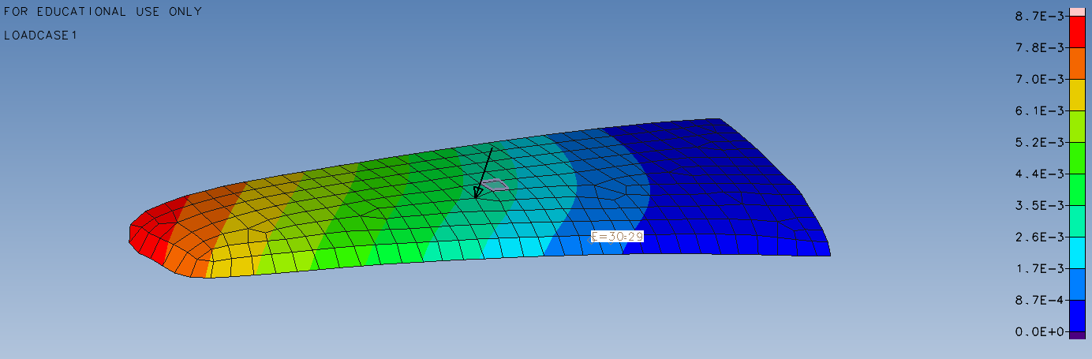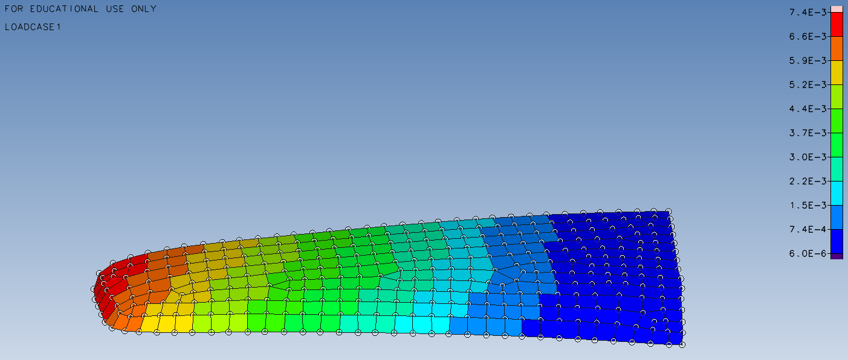
Figure 5 – Steel vs CFRP: stress/deflection comparison or contour views

5.3 Why the optimiser chose those angles
The optimiser’s early drive of 0° and 90° to upper limits reflects bending dominance:
- 0° increases bending rigidity for loads generating significant spanwise bending moments.
- 90° augments through-thickness bending stiffness that influences overall compliance under the applied surface pressure.
- ±45° plies primarily tune shear and torsion, reduce coupling, and improve robustness without heavy mass penalties.
5.4 Sensitivities and robustness
Several factors can influence results:
- Material axes alignment: A mis-set theta direction reduces effective stiffness considerably.
- Property scatter: ± 5% variations in E₁ or E₂ have a smaller impact than thickness changes, discrete plies reduce risk of drifting below the limit.
- Boundary compliance: The FEA value may be exceeded by deflection if the physical root fixture is not stiff.
- Mesh density and element formulation: The formulation of the mesh density and elements must be sufficiently refined to prevent underestimating stiffness.

6 Discussion of Ply Thickness and Laminate Behaviour

6.1 Importance of Ply Thickness in Composite Stiffness
One important factor influencing how a laminate responds to bending and shearing is the thickness of its individual plies. A laminate can support more weight in relation to its mass when the ply is thinner because it enhances interlaminar behaviour and lowers the likelihood of matrix cracking. As an illustration, analysis of thin-ply polymer composites demonstrates that increasing ply thickness enhances stiffness, strength, and resistance to damage (Arteiro, A. 2020).
Thin-ply laminates improve mechanical qualities by reducing microcracking and boosting laminate strength under bending and tensile stresses, according to further open research. These tests provide a realistic thin-ply configuration for marine-grade CFRP, supporting the modelling decision to use 0.1 mm per ply.
The 2 mm laminate (about 25 plies) in the experiment demonstrated excessive flexibility, exhibiting a deflection of roughly 23 mm under load. The maximum displacement decreased to 7.4 mm when the overall laminate thickness was increased to 4 mm, which greatly decreased mass and almost matched the 8.7 mm steel benchmark (Islami , D.P, 2024).

6.2 Directional Stiffness Contribution
The structural response of the hydrofoil was determined by the distribution of stiffness across various ply orientations. While 90° plies carried chordwise loads, 0° spanwise plies mostly resisted bending. Although they contributed less to the overall bending stiffness, the ±45° layers offered shear stability. This behaviour is in good agreement with the Classical Lamination Theory, which states that when fibres are aligned with the primary load axes, the stiffness components are at their maximum (Unknown, 2011).

6.3 Manufacturing Implications
Using 0.1 mm plies is a feasible arrangement for modern composite manufacturing. This thickness is characteristic of high-performance carbon fibre laminates used in marine and aeronautical structures where weight reduction and precision are critical. Thin plies improve laminate performance by reducing the likelihood of delamination and more uniformly dispersing loads throughout the material. A 4 mm laminate, or roughly 40 plies overall, can be produced for this project utilising conventional manufacturing techniques including vacuum bagging and autoclave curing. These techniques, which guarantee a high fibre volume fraction and good consolidation, are frequently employed in the fabrication of hydrofoil components (Islami , D.P, 2024) .
According to research, thin-ply carbon laminates improve interlaminar stress distribution, which delays the beginning of fatigue damage and cracking while simultaneously increasing stiffness (Arteiro, A. 2020). This backs up the choice to simulate each ply at 0.1 mm, striking a balance between simulation precision and manufacturing viability.
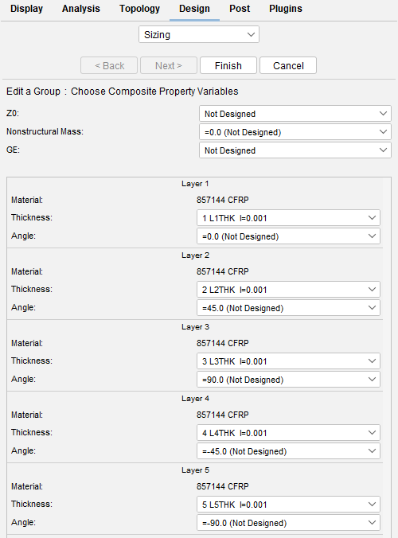
Figure 6: Applying the design variables to each layer.

7 Performance of the Final Laminate
7.1 Global stiffness and weight comparison
The optimised laminate had a maximum deflection of 7.4 mm and was roughly 15% stiffer than the steel baseline under the same stress. This improved stiffness-to-weight behaviour is consistent with studies that demonstrate composites, such as CFRP, can offer stiffness equivalent to metallic materials at significantly lower masses. For instance, a computational analysis of CFRP composites revealed that material and structural configuration have a significant impact on stiffness response (R. Koloor, S.S. et al. 2021). The mass reduction for equivalent stiffness is quite believable when considering normal material densities. High specific stiffness composites also lessen deflection under bending loads, according to open-access study on the flexural behaviour of CFRP-reinforced structural parts; however, design must provide sufficient serviceability.

7.2 Effect of Ply-Group Thickness Variation
The optimisation results showed that Design Studio automatically increased the thickness of the 0° and 90° ply-groups until the maximum displacement fell just below the steel baseline limit of 8.7 mm. This confirmed that the major contribution to bending stiffness came from the plies aligned with the main load directions. The ±45° plies provided shear support but had minimal influence on deflection, so their thicknesses remained almost constant throughout the optimisation.
The software’s iterative sizing process made the effect of total laminate thickness very clear. Doubling the laminate thickness from 2 mm to 4 mm reduced the maximum displacement from 23 mm to 7.4 mm, matching the required stiffness while using much less mass than steel. This behaviour aligns with open research showing that composite stiffness increases rapidly with laminate thickness because bending rigidity scales approximately with the cube of thickness (R. Koloor, S.S. et al. 2021).

Material / Model Type | Laminate Thickness (mm) | Maximum Displacement (mm) | Comment
Steel Baseline | 2.0 | 8.7 | Reference stiffness target
CFRP (same thickness) | 2.0 | 23.0 | Too flexible compared to steel
Optimised CFRP | 4.0 | 7.4 | Meets stiffness limit with reduced weight
Figure 7: Effect of Laminate Thickness on Displacement

7.3 Local Stresses and Load Paths
Displacement and stress Peak stresses at the root region and smooth gradients across the mid-span were visible in the final design's contours, indicating efficient load distribution and symmetric lay-up that prevented bending-twist coupling.
These results are consistent with structural composite studies that demonstrate that geometry, lay-up orientation, and boundary conditions affect stiffness and deformation in addition to material (Odeh, A. et al, 2024)
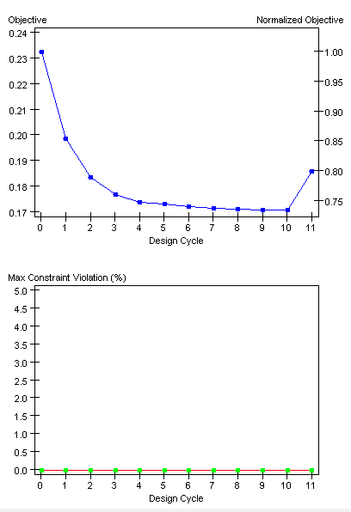

8 Reflection on the Design Process
Clear understanding of how fibre orientation and ply thickness affect composite stiffness was made possible by the Design Studio optimisation process. According to preliminary modelling, substituting an equal-thickness CFRP laminate for the 2 mm steel wing immediately resulted in significant deflection, demonstrating that material replacement is not enough. The stiffness goal was met while keeping a considerable weight reduction by strengthening the 0° and 90° plies and increasing the overall laminate thickness to 4 mm.
Understanding the function of continuous and discrete sizing in the software was one of the main learning objectives. While discrete sizing converted them into feasible 0.1 mm ply increments that could be made, continuous sizing determined theoretical optimum values. It became clear how load routes evolve inside the structure by identifying which ply-groups thickened first, and it also illustrated the link between digital optimisation and actual production.
The procedure also reaffirmed the significance of fibre alignment: the ±45° layers stabilised shear, the 90° plies offered chordwise stiffness, and the 0° plies supported most bending stresses. This validated the efficacy of aligning reinforcement with primary stress orientations and reflected the conventional lamination hypothesis.

9 Conclusion
The hydrofoil front wing development revealed how ply thickness and fibre orientation changes can enhance structural performance. The design process proved that increasing the laminate thickness and aligning the 0° and 90° plies were crucial in getting the required stiffness; simply switching from steel to carbon fibre was not enough to succeed. The final 4 mm carbon fibre laminate significantly reduced overall weight while achieving a displacement comparable to the original steel design. This demonstrated the close connection between stiffness, fibre direction, and laminate geometry. The research also demonstrated how theoretical knowledge can be efficiently translated into workable solutions using digital tools like Design Studio. Overall, the study achieved a balanced design that met the stiffness target, demonstrated efficient material use, and reflected realistic composite manufacturing practice.

10 Reference

Arteiro, A. (2020) Thin-ply polymer composite materials: a review, School of Mechanical and Aerospace Engineering. Available at: https://pureadmin.qub.ac.uk/ws/portalfiles/portal/201326020/JCOMA_19_2411.pdf (Accessed: 21 October 2025).

Engineering Toolbox, E. (2024) Metals and alloys - young’s modulus of elasticity, Engineering ToolBox. Available at: https://www.engineeringtoolbox.com/young-modulus-d_773.html (Accessed: 19 October 2025).
Islami , D.P. (2024) Results in Engineering, Structural design parameters of laminated composites for marine applications: Milestone study and extended review on current technology and engineering. Available at: https://elib.dlr.de/211584/1/1-s2.0-S2590123024014506-main.pdf (Accessed: 21 October 2025).
Krueger, R. and Bergan, A. (2024) NASA Advances in Thermoplastic Composites, Advances in Thermoplastic Composites Over Three Decades – A Literature Review. Available at: https://ntrs.nasa.gov/api/citations/20240005376/downloads/NASA-TM-20240005376.pdf (Accessed: 19 October 2025).
Odeh, A. et al. (2024) Analysis of laminated composite plates: A comprehensive Bibliometric Review, Multidisciplinary Digital Publishing Institute. Available at: https://www.mdpi.com/2075-5309/14/6/1574 (Accessed: 21 October 2025).
R. Koloor, S.S. et al. (2021) Linear-nonlinear stiffness responses of carbon fiber-reinforced polymer composite materials and structures: A numerical study, MDPI. Available at: https://www.mdpi.com/2073-4360/13/3/344 (Accessed: 21 October 2025).

Schmidt, J. et al. (2020) Parametric shape and manufacturing optimization of customized Kitesurf hydrofoils, MDPI. Available at: https://www.mdpi.com/2504-3900/49/1/126?utm (Accessed: 19 October 2025).
Unknown (2011) A summary of classical lamination theory defining the laminate, A summary of Classical Lamination Theory. Available at: https://wstein.org/edu/2010/480b/projects/05-lamination_theory/A summary of Classical Lamination Theory.pdf (Accessed: 19 October 2025).

