

University of Wales Trinity Saint David
School of Engineering

Designing a Kiteboard Hydrofoil Wing: Structural Design
Structural & Fluid Analysis – ACMA 6010

Simeon Scoberg-Evans
1252150
26/10/2025
Table of Contents
1 Introduction 1
1.1 Aims 1
1.2 Objectives 1
2 Finite Element Analysis (FEA) Optimisation 2
2.1 Introduction to FEA Optimisation 2
2.2 The History of FEA Optimisation 2
2.2.1 1960s - 1970s: The Beginning of FEA Optimisation 2
2.2.2 1980s: Mesh Topology 2
2.2.3 Late 1980s – 1990s: SIMP, and further topology optimisation 2
2.2.4 1990s – 2000s: Level-set and boundary parameterisation methods 3
2.2.5 2000s – present: Multidisciplinary and large-scale developments 3
2.3 The Future of FEA Optimisation 3
2.4 FEA Optimisation and the Design Process 4
3 FEA Optimisation of a Kiteboard Hydrofoil Wing 5
3.1 FE Model of Hydrofoil Wing 5
3.1.1 Steel Wing FEA 5
3.1.2 CFRP Wing FEA 5
3.1.3 Material Stiffness 6
3.2 FEA Optimisation 7
3.2.1 Initial FEA Phase 7
3.2.2 Initial FEA Results 8
3.2.3 Final FEA Optimisation 9
3.2.4 Stiffness of FEA Optimised CFRP Wing 10
3.2.5 Additional Design Studio Optimisation Charts 11
4 Prototyping Experimentation 12
4.1 Preparation and Instrumentation 12
4.2 Static Hydrodynamic Force testing 12
4.3 Results and Comparison with FEA 13
5 References 14

Table of Figures
Figure 1 Hydrofoil wing on the underside of a kiteboard 1
Figure 2 Displacement from a 500N load on the steel wing 5
Figure 3 Displacement from a 500N load on the CFRP wing 6
Figure 4 Objective set to minimise mass. 7
Figure 5 Constraint set for maximum displacement of 8.6mm 7
Figure 6 Design variables set. 8
Figure 7 Initial FEA optimisation results. 8
Figure 8 Sizing of the final FEA optimisation. 9
Figure 9 Displacement of final optimised CFRP wing. 9
Figure 10 Final optimisation history - objectives and constraints 11
Figure 11 Final optimisation history - layer thickness 11
Figure 12 Example of a still water test tank with a boat being tested. 12

Introduction
This report consists of the optimisation of the design of the lay-up of composite material for a kiteboard hydrofoil wing, using finite element analysis (FEA). The original wings (see Figure 1, below) are made out of 2mm thick steel and the composite wings need to be designed so that they do not exceed the deflection of the steel wings and that their mass is as low as possible.
Figure 1 Hydrofoil wing on the underside of a kiteboard
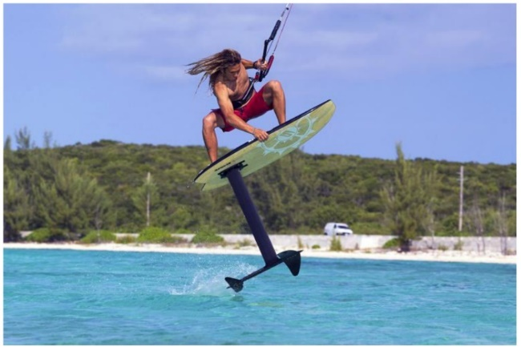

Aims
The aim of this report is to optimise the design of the lay-up of composite material in the manufacture of a hydrofoil kiteboarding wing so that it has a lower deflection than the existing steel wing, when subjected to the same forces, whilst also minimising weight. Once the design is realised, an experiment will be devised to understand the deformation of the board when subjected to the forces seen and to correlate it to the simulation carried out.

Objectives
To successfully achieve this aim, finite element analysis (FEA) software will be necessary and understanding the fundamentals of both FEA and FEA optimisation will play a major role in that. To do so, the history, and future, of FEA optimisation will need to be explored and discussed.
An FEA analysis of the existing steel wing will need to be conducted, followed by an FEA of a composite wing, to ensure that the composite meets the required criteria. Once the design is optimised, the laboratory experiment will be devised by studying and analysing existing techniques and then incorporating suitable techniques in the report’s laboratory experiment process.

Finite Element Analysis (FEA) Optimisation

Introduction to FEA Optimisation
Finite element analysis (FEA) is a computational technique that predicts the reaction of different materials when a range of forces are applied (Welch-Phillips, et al., 2020). It has become a commonplace engineering tool that uses numerical solutions to very complicated stress problems are now routinely obtained using FEA (Roylance, 2001), so the optimisation of FEA has also become a very important step in the design process.

The History of FEA Optimisation

1960s - 1970s: The Beginning of FEA Optimisation
The optimisation of structural parameters such as thickness, simple geometric parameters, and cross-sections, predate the widespread use of FEA but with the arrival of practical finite element codes in the 1960s-1970s, it became possible to evaluate design changes numerically (Vanderplaats, 2001). A number of open-source software created the initial impetus for the development of FEA in the early 1960s, but it was the arrival of the NASA sponsored NASTRAN (NASA Structural Analysis) FEA software system that the FEA systems became widespread tool in the engineering industry (Nagy, 2018).

1980s: Mesh Topology
Topology is a branch of mathematics that is concerned with the study of collections of objects with certain prescribed structures, known as sets (Mendelson, 1990), but within FEA software they are known as elements. In the 1980s there were algorithmic breakthroughs that underpin modern unstructured mesh topology, namely Delaunay refinement/triangulation, which enables the automatic generation of high-quality triangular and tetrahedral meshes in complex geometric CAD designs (Shewchuk, 2012).

Late 1980s – 1990s: SIMP, and further topology optimisation
Topology has been a rapidly evolving field, and this continued from the late 1980s and into the 1990s with the Solid Isotropic Microstructure with Penalization for intermediate densities (SIMP) method. This topology optimisation method uses a penalty function to discern the optimal material distribution within a design space (Rozvany, 2000). This was a massive breakthrough for stiffness-maximising and weight-minimising problems in structural engineering (Hou, et al., 2025).

1990s – 2000s: Level-set and boundary parameterisation methods
The level-set method is a conceptual framework that performs numerical computations involving surfaces and curves on a fixed cartesian grid without having to parameterise the objects (Osher & Sethian, 1988), which makes it easier to perform computations on shapes that change topology and with sharps corners.
Boundary parameterisation methods built upon previous techniques for describing a boundary using sets of variables or parameters (Firefly Lectures, 2013), using sensitivity analysis to directly update the control points for CAD-compatible shapes. Both methods are used for shape optimisation.

2000s – present: Multidisciplinary and large-scale developments
In the early 2000s the field focused on maturation of classical methods, to further increase the scale of FEA meshes, creating a far finer mesh. Researchers then extended topology optimisation to 3D and began addressing stress and manufacturing constraints (Deaton & Grandhi, 2016).
The 2010s coincided with the availability of more computational power and more capable algorithms enabled widespread 3D topology optimisation and the integration of additional physics such as heat transfer, dynamics and acoustics (Alexandersen & Andreasen, 2020). Also emerging in that era, was additive manufacturing (AM) which drove the need for topology designs specifically suited to AM processes. This led to research and advances into manufacturability constraints, lattice structures, support minimisation (Wu, et al., 2021).
Since 2020, the main break-through has been in ML-accelerated topology optimisation, where machine learning is used to increase the speed and efficiency of the system, letting optimisation consider microstructure/manufacturability with tractable compute cost (Najmon & Tovar, 2025).

The Future of FEA Optimisation
The field of technology is currently in a moment of unprecedented transformation, with the exponential technologies of quantum computing, blockchain, artificial intelligence (AI), and spatial computing, all converging and amplifying the impact of one another – what some have called a “Digital Renaissance” (van Rijmenam, 2025). FEA optimisation faces greater advancements in the near future than all of the breakthroughs that have taken place since its inception in the 1960s.
The classic gradient and sensitivity-based techniques are rapidly shifting toward hybrid strategies of combined multi-fidelity workflows, physics-based simulation with data-driven models, and manufacturing aware design. Multi-fidelity frameworks utilise low-cost coarse models, or surrogates, to guide highly detailed and accurate high-fidelity models (Peherstorfer, et al., 2018). Effectively, to minimise computing resources, time, and cost, many cheap, quick tests are run to explore a vast array of options, which are then refined and more precise tests are then used to confirm the best course of action (Forrester, et al., 2007).
Another breakthrough that will soon impact FEA optimisation is Physics-informed neural networks (PINNs) and hybrid “FE-PINN” approaches. In normal machine learning, you feed a neural network a great deal of data and it learns the pattern of that data but cannot apply it to real world scenarios but PINNs use physical laws (e.g. Newton’s laws of motion, fluid dynamics, heat equations, etc.) to find solutions that fit both the data and the governing physics equations (Grossmann, et al., 2024).

FEA Optimisation and the Design Process
FEA optimisation techniques have revolutionised engineering design and have become a cornerstone of the process. If a design does not satisfy a given criteria, optimisation steps have to be taken, so the success of a product, or structure, etc., relies upon an engineer’s knowledge and experience to properly understand the results of the engineering analysis (Dolšak, 2003). For example, some automotive components have been reduced in weight by as high as 80% (Mårtensson, et al., 2015), which can have a huge impact on material and transportation costs, handleability during maintenance/installation, and on costs of spare parts to the customer.
The automation of trade-offs has greatly improved upon the design process. Key design parameters/metrics like stiffness, cost, weight, recyclability, etc., must be balanced to produce an optimal design. Optimisation encodes explicit objectives and constraints to offer the best compromise from a set of Pareto-optimal solutions, based on evidence-based decision making (Grier & Campbell, 2020).
One of the major benefits with FEA optimisation is the reduction of cost and time of iterative physical prototyping. Before FEA optimisation, prototyping took weeks or months and the costs were huge (Digital Engineering 247, 2008), but now the prototyping can take place when the physical characteristics and properties are not only known, but tailored specifically for the desired function through the use of objectives and constraints (Zheng, et al., 2020). Now prototypes are produced knowing that they will work as required but ergonomics and aesthetics are a larger focus.
Multi-disciplinary design has also revolutionised the engineering design process by establishing a link between numerous parameters concerning various disciplines (Ghadge, et al., 2022). This means that thermal transfers, structural loadings, and fluid flows, for example, can be optimised through predetermined constraints and objectives, when they are incredibly difficult to reconcile manually.
Another profoundly important impact that FEA optimisation has had on the design process, is the integration of manufacturing constraints. Modern FEA software can now optimise design for manufacture in a wide range of advanced manufacturing techniques. This means that the manufacturing process can be defined and verified early in the design process, with estimated manufacturing time and material cost, which constitute a significant portion of the product cost (Chang & Tang, 2001).

FEA Optimisation of a Kiteboard Hydrofoil Wing

FE Model of Hydrofoil Wing

Steel Wing FEA
To start the FEA optimisation process, an analysis of a baseline steel wing must be conducted to understand what the requirements of the optimised CFRP wing is. The brief states that the maximum displacement of the optimised wing, under a 500N central load, must not exceed that of the steel wing, so the maximum displacement of the steel wing needs to be determined.
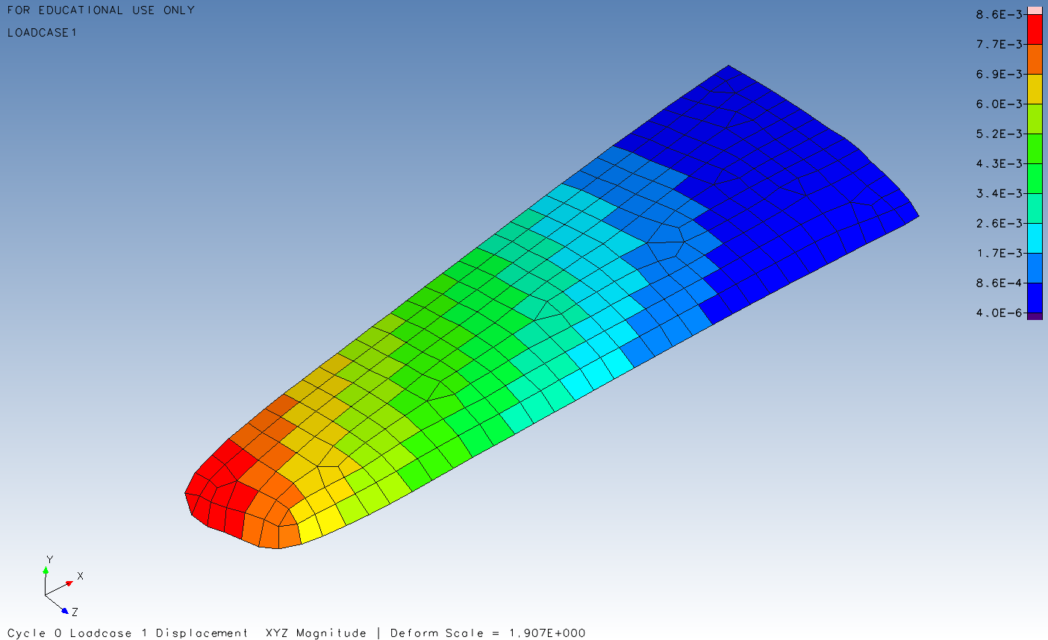
This was done by applying a 500N load central to the wing. A 3D model was provided, as well as the steel material on Design Studio 2023, an FEA software. The resulting maximum displacement on the steel wing was 8.6mm (see, Figure 2 below).
Figure 2 Displacement from a 500N load on the steel wing

CFRP Wing FEA
Now that the required maximum displacement has been determined (8.6mm), the next step is to discern the maximum displacement of a CFRP wing. This was done by changing the material mechanical properties to that of CFRP and applying that to the FE model.
The unidirectional lay up of 25 plys was set and the exact same case loading was applied, and the resulting maximum displacement was 23mm and the direction of the fibres are horizontal as denoted by the lines on Figure 3, below.
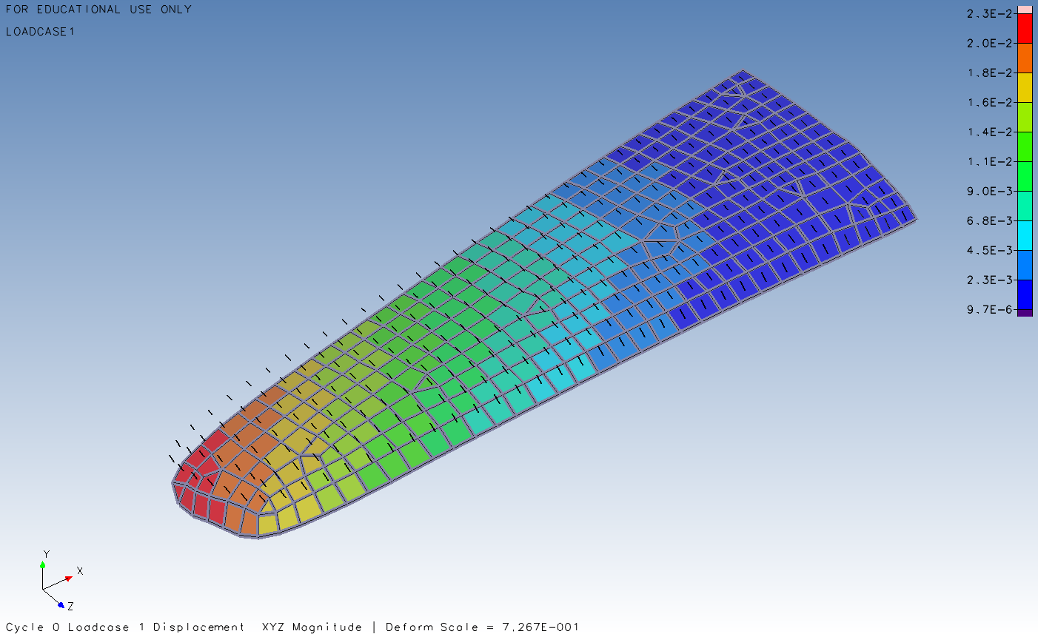
Figure 3 Displacement from a 500N load on the CFRP wing

Material Stiffness
Design Studio provides data on the maximum displacement of the wing and also gives the exact mass of the wing. Using this, we can work out the stiffness of the wing. Using Hooke’s Law, $k= \frac{F}{x}$ , we can determine the stiffness and the stiffness-to-weight ratio of the designs.

Steel Wing Stiffness
Steel Wing stiffness; $k= \frac{F}{x}= \frac{500}{8.6} =$ 58.1 N/mm
We also know that the mass of the steel wing is 0.465 kg, so the stiffness-to-weight ratio is:
$\frac{stiffness}{weight} = \frac{58.1}{(0.465)(9.81)} =$ 12.7 N²/mm

CFRP Stiffness
CFRP stiffness; $k= \frac{F}{x}= \frac{500}{23} =$ 21.7 N/mm
We also know that the mass of the steel wing is 0.116 kg, so the stiffness-to-weight ratio is:
$\frac{stiffness}{weight} = \frac{21.7}{(0.116)(9.81)} =$ 19.1 N²/mm
From the results of the equations, we can see that CFRP has a greater stiffness-to-weight ratio than steel, but the steel is far stiffer in general. This means the design must be optimised so that the optimised CFRP lay-up is at least as stiff as the steel wing, and the stiffness-to-weight ratio will be far greater, thus significantly reducing the mass.

FEA Optimisation
The FEA results of the steel wing and the unidirectional CFRP wing show that the maximum displacement of the optimised CFRP wing must be at least 8.6mm. The brief states that the optimised wing must also be as light as possible. In an FEA optimisation sense, our objective is to minimise mass and the constraint is not to exceed a maximum displacement of 8.6mm. Another parameter to factor in our design are design variables, i.e. the thickness of the layers of plys required to attain our goals.

Initial FEA Phase

Initial FEA Optimisation Set-Up
The first step of the FEA optimisation was to set parameters. The first parameter set was the objective, which was to minimise the mass of the optimised CFRP wing.
Figure 4 Objective set to minimise mass.
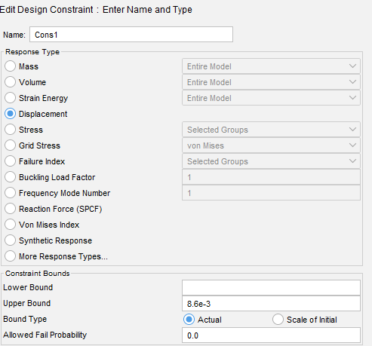
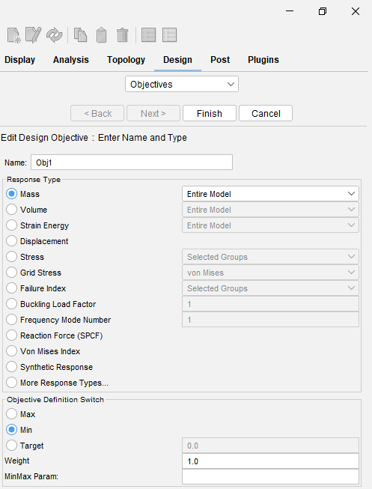
The next step is to set the constraint which will not allow the maximum displacement of the optimised CFRP wing to exceed 8.6mm.
Figure 5 Constraint set for maximum displacement of 8.6mm
The final step of the initial FEA optimisation is to set our design variables. As the CFRP plys are 0.1mm, per the brief, and 5 plys compose a layer, then the initial starting value of 0.5mm (5 plys) was set, and they were to increase in 0.1 mm increments with a limit set at 2mm.
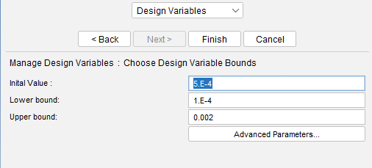
Figure 6 Design variables set.

Initial FEA Results
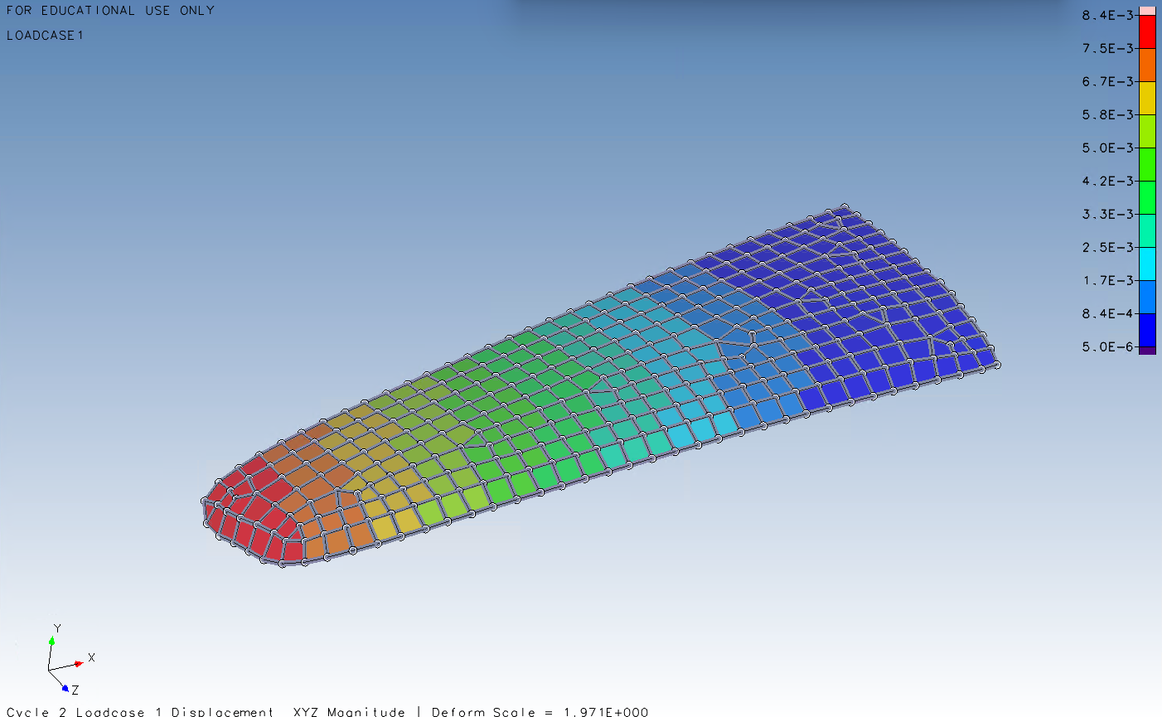
The initial results of the FEA optimisation were successful. The maximum displacement of the wing was reduced to 8.4mm, see Figure 7 below, and the weight was minimised to 0.166 kg.
Figure 7 Initial FEA optimisation results.
Upon further investigation, though, there was a serious issue as the layer thickness was not set-up correctly. The layers were not manufacturable because the number of plys per layer were not whole (see Table 1, below).
Table 1 Layer thickness of initial FEA optimisation
Layer | Layer Thickness (mm) | Number of Plys
Layer 1 | 1.12 x10⁻³ | 11.2
Layer 2 | 7.4 x10⁻⁴ | 7.4
Layer 3 | 1.12 x10⁻⁴ | 1.12
Layer 4 | 1 x10⁻⁴ | 1
Layer 5 | 1.5 x10⁻³ | 15

Final FEA Optimisation
To address this manufacturability issue, the design variables (layer thickness) had to be set as discrete variables that would increase in increments of 0.1mm. This meant that the resulting optimised design would be manufacturable and a set number of plys would be assigned to each layer. This was done by using a design feature called sizing.
Figure 8 Sizing of the final FEA optimisation.
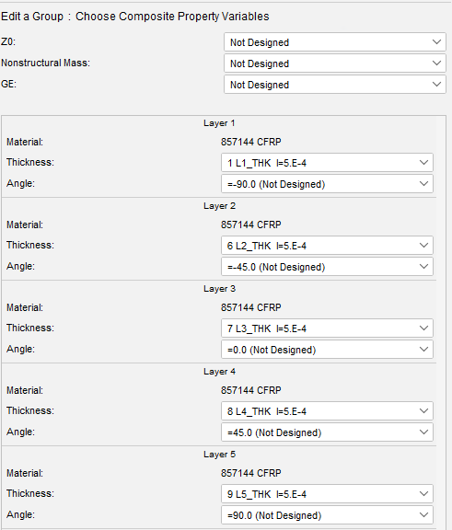
These variables allowed the software to experiment with different numbers of 0.1mm plys per layer, to discern which lay-up met the 8.6mm displacement constraint, minimised mass, and the resulting wing would be manufacturable.
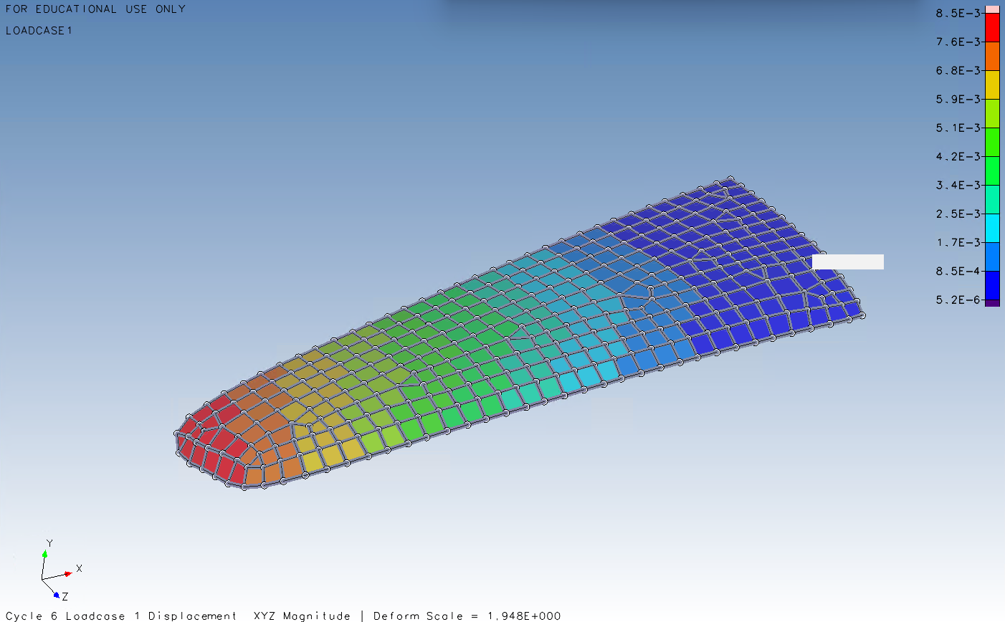
After 18 cycles, the resulting FEA optimised CFRP wing had a maximum displacement of 8.5mm (see Figure 9, below), a mass of 0.181 kg. The layers were set at a manufacturable number, as seen in Table 2, below, with a total number of 39 plys, meaning that the overall thickness of the wing is 3.9mm thick.
Figure 9 Displacement of final optimised CFRP wing.

Table 2 Layer thickness of final FEA optimisation
Layer | Layer Thickness (mm) | Number of Plys
Layer 1 | 1.1 x10⁻³ | 11
Layer 2 | 8 x10⁻⁴ | 8
Layer 3 | 2 x10⁻⁴ | 2
Layer 4 | 2 x10⁻⁴ | 2
Layer 5 | 1.6 x10⁻³ | 16

Stiffness of FEA Optimised CFRP Wing
Optimised CFRP stiffness; $k= \frac{F}{x}= \frac{500}{8.5} =$ 58.8 N/mm
We also know that the mass of the steel wing is 0.181 kg, so the stiffness-to-weight ratio is:
$\frac{stiffness}{weight} = \frac{58.8}{(0.181)(9.81)} =$ 33.1 N²/mm
Table 3 Stiffness comparison table
Material | Thickness | Deflection | Mass | Load | Stiffness | Stiffness/weight
Steel | 2mm | 8.6mm | 0.465kg | 500N | 58.1 N/mm | 12.7 N²/mm
CFRP | 2.8mm | 23mm | 0.116kg | 500N | 21.7 N/mm | 19.1 N²/mm
Optimised CFRP | 3.9mm | 8.5mm | 0.181kg | 500N | 58.8 N/mm | 33.1 N²/mm

As seen in Table 3, above, the stiffness of the optimised CFRP wing is now greater than the steel wing and the stiffness-to-weight ratio is far superior.

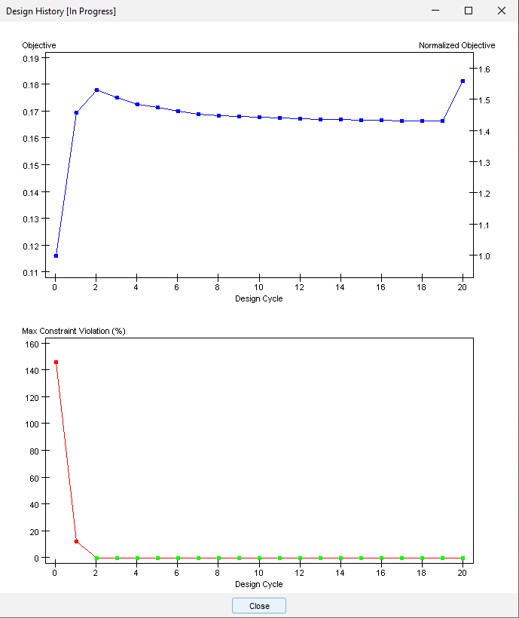
Additional Design Studio Optimisation Charts
Figure 10 Final optimisation history - objectives and constraints
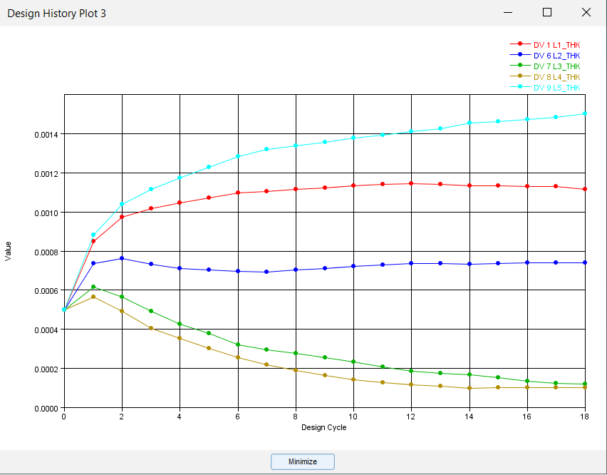
Figure 11 Final optimisation history - layer thickness

Prototyping Experimentation

Preparation and Instrumentation
Prior to testing, the prototype wing must be precisely instrumented and installed in the test rig. Strain gauges will be placed on the tip of the hydrofoil wing as well on the central body and base where it joins the body of the structure, so that it can capture the external forces that the water apply to the wing (Interface Force, 2025). Also, deflection sensors would be mounted to the wing to see how the recorded deflections compare to those of the FEA.
The foil must be mounted to a rigid support representing the mast/fuselage interface of the underside of the board. The wing will be mounted in such a position that the mid-span lies centrally in the test section as to avoid free-surface and wall-bound interactions (Brindley, et al., 2014).
The wing will be tested fully submerged, as shallower submersions cause wakes and fluctuations on the surface that can produce spikes in loadings and pressure (Vakilabadi, et al., 2024), which will not assist in our experiment and cause more anomalous results.

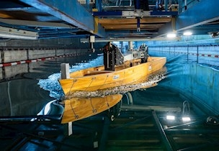
Static Hydrodynamic Force testing
Figure 12 Example of a still water test tank with a boat being tested.

The static hydrodynamic force testing would take place in a still water tank similar to, but far smaller in scale than, the example seen in Figure 12, above. For the test to be accurate and comparable to the FEA, it must be exposed to a given flow speed that will equate to a 500N force on the hydrofoil wing.
To determine a flow speed required to generate a 500N lift force on the hydrofoil wing, the lift equation from fluid dynamics can be utilised:
$$L= \frac{1}{2}ρV^{2}SC_{L}$$
$L$ = lift force (N) = 500
$ρ$ = density of water (kgm⁻³) = 1000
$V$ = flow speed (ms⁻¹)
$S$ = planform area of the hydrofoil (m²) = 0.1 m² (example)
$C_{L}$ = lift coefficient = 0.8 (typical for hydrofoils at ~5-10°) (Drela, 2014)
This can be rearranged for $V$; $V= \sqrt{\frac{2L}{ρSC_{L}} } = \sqrt{\frac{(2)(500)}{(1000)(0.1)(0.8)}}$ = 3.5 ms⁻¹

Results and Comparison with FEA
All of the data collected from the experiment will be collated and then compared to the data from the FEA. It would be expected that the deflection patterns would match but it is almost certain that the results will differ, but not greatly. For example, the maximum deflection may be half a millimetre out, or the deflection at the centre of the wing may be slightly more or less intense than in the FEA because the fluid flow is going to behave differently to a single static load on the centre of the wing.
If the FEA software was more advanced with the capability of recreating the forces of the hydrofoil in the water, then the results would be extremely close because the loads are being applied in an identical manner. FEA has become so advanced that some are arguing that prototype testing is a waste of time and resources (Duvall, 2016).

References
Alexandersen, J. & Andreasen, C. S., 2020. A Review of Topology Optimisation for Fluid-Based Problems. Fluids, 5(1), p. 29.
Bendsøe, M. P. & Kikuchi, N., 1988. Generating optimal topologies in structural design using a homogenization method. Computer Methods in Applied Mechanics and Engineering, 71(2), pp. 197-224.
Bertsekas, D. P., 2014. Constrained optimization and Lagrange multiplier methods. 2nd ed. Cambridge, Massachusetts: Academic Press.
Biancolini, M. E., Brutti, C. & Pezzuti, E., 2001. Shape optimisation for structural design by means of Finite Elements Method. Bologna, Associazione Nazionale Disegno di Macchine (ADM International).
Brindley, J., Shull, J. & Gagnon, I., 2014. Developing HydroKinetic Wingtip Devices, Silver Spring, Maryland: National Oceanic and Atmospheric Administration.
Chang, K.-H. & Tang, P.-S., 2001. Integration of design and manufacturing for structural shape optimization. Advances in Engineering Software, 32(7), pp. 555-567.
Deaton, J. D. & Grandhi, R. V., 2016. Stress-based design of thermal structures via topology optimization. Structural and Multidisciplinary Optimization, 55(2), pp. 253-270.
Digital Engineering 247, 2008. History of Mechanical Computer Aided Design: Where Have We Been?. [Online]
Available at: https://www.digitalengineering247.com/article/history-of-mechanical-computer-aided-design-where-have-we-been?utm_source=chatgpt.com
[Accessed 11 October 2025].
Dolšak, B., 2003. Intelligent Design Optimisation Based on the Results of Finite Element Analysis. The International Journal of Advanced Manufacturing Technology, 21(6), pp. 391-396.
Drela, M., 2014. Flight Vehicle Aerodynamics. 2nd ed. Cambridge, MA: MIT Press.
Duvall, A. S., 2016. Testing vs Finite Element analysis: What should the balance be?. Kobe, Japan, The International Symposium on the Packaging and Transportation of Radioactive Materials.
El Khadiri, I. et al., 2023. Topology optimization methods for additive manufacturing: a review. International Journal for Simulation and Multidisciplinary Design Optimization, Volume 14, p. 16.
Firefly Lectures, 2013. How to parametrize a Curve. [Online]
Available at: How to Parametrize a Curve
[Accessed 15 October 2025].
Forrester, A. I., Sóbester, A. & Keane, A. J., 2007. Multi-fidelity optimization via surrogate modelling. Proceedings of the royal society a: mathematical, physical and engineering sciences, 463(2088), pp. 3251-3269.
Ghadge, R., Ghorpade, R. & Joshi, S., 2022. Multi-disciplinary design optimization of composite structures: A review. Composite Structures, Volume 280, p. 114875.
Grier, A. T. & Campbell, M. I., 2020. Automated Tradeoff Analysis of Cost Versus Machinability for Design Feedback. Journal of Mechanical Design, 142(3), p. 031105.
Grossmann, T. G., Komorowska, U. J., Latz, J. & Schönlieb, C. B., 2024. Can physics-informed neural networks beat the finite element method?. IMA Journal of Applied Mathematics, 89(1), pp. 143-174.
Hou, J. et al., 2025. A Novel Multi-Objective Topology Optimization Method for Stiffness and Strength-Constrained Design Using the SIMP Approach. Computer Modeling in Engineering & Sciences, 144(2), pp. 1545-1572.
Interface Force, 2025. Hydrofoil Technology and Tank Testing with Force Measurement. [Online]
Available at: https://www.interfaceforce.com/hydrofoil-technology-and-tank-testing-with-force-measurement/?utm_source=chatgpt.com
[Accessed 25 October 2025].
Kaye, R. & Heller, M., 1997. Structural shape optimisation by iterative finite element solution, Fairbairn, Canberra: Defence Science and Technology Department, Department of Defence.
Mårtensson, P., Zenkert, D. & Åkermo, M., 2015. Effects of manufacturing constraints on the cost and weight efficiency of integral and differential automotive composite structures. Composite Structures, Volume 134, pp. 572-578.
Mendelson, B., 1990. Introduction to topology. 3rd ed. Chelmsford, Massachusetts: Courier Corporation.
Nagy, D., 2018. Analysis Origins - MSC and NASTRAN. [Online]
Available at: https://www.nafems.org/blog/posts/analysis-origins-msc-and-nastran/?srsltid=AfmBOorwStpPz3sJqrN_OL7h7bSGuLm0kOjFLtGDCd7f5oj8oy474loU
[Accessed 8 October 2025].
Najmon, J. C. & Tovar, A., 2025. Multiscale topology optimization using machine learning and displacement-driven microstructures. Structural and Multidisciplinary Optimization , 68(172), pp. 1-21.
Omega, no date. Strain gauge: Introduction to Strain gauges. [Online]
Available at: https://www.omega.co.uk/prodinfo/straingauges.html
[Accessed 25 October 2025].
Osher, S. & Sethian, J. A., 1988. Fronts propagating with curvature-dependent speed: Algorithms based on Hamilton-Jacobi formulations. Journal of Computer Physics, 79(1), pp. 12-49.
Peherstorfer, B., Willcox, K. & Gunzburger, M. D., 2018. Survey of multifidelity methods in uncertainty propogation, inference, and optimisation. SIAM Review, 60(3), p. 50–591.
Roylance, D., 2001. Finite element analysis. Cambridge, Massachusetts: Department of Materials Science and Engineering, Massachusetts Institute of Technology.
Rozvany, G., 2000. The SIMP method in topology optimization-theoretical background, advantages and new applications. Long Beach, California, The 8th Symposium on Multidisciplinary Analysis and Optimization.
Shewchuk, J. R., 2012. Lecture Notes on. Berkeley, California: Department of Eletcrical Engineering and Computer Science, University of California at Berkeley.
Vakilabadi, K. A., Ghafari, H. R. & Ghassemi, H., 2024. Investigation of front hydrofoil position influence on the hydrofoil-assisted craft,. Ocean Engineering, Volume 304, p. 117901.
van Rijmenam, M., 2025. The Digital Renaissance: A Revolution We’re Not Ready For. [Online]
Available at: https://www.thedigitalspeaker.com/digital-renaissance-revolution-not-ready-for/
[Accessed 11 October 2025].
Vanderplaats, G. N., 2001. Numerical Optimization Techniques for Engineering Design: with Applications. 3rd ed. New York City: Vanderplaats Research & Development.
Welch-Phillips, A., Gibbons, D., Ahern, D. P. & Butler, J. S., 2020. What Is Finite Element Analysis?. Clinical Spine Surgery, 33(8), pp. 323-324.
Wu, J., Sigmund, O. & Groen, J. P., 2021. Topology optimization of multi-scale structures: a review. Structural and Multidisciplinary Optimization, Volume 63, p. 1455–1480.
Zheng, W., Wang, Y., Zheng, Y. & Da, D., 2020. Efficient topology optimization based on DOF reduction and convergence acceleration methods. Advances in Engineering Software, Volume 149, p. 102890.

