

Business Development Proposal

Student Name: Samir Mhanna
Student Number: 2119514
Supervisor Name: Masud Ibrahim
Module Name: Business Development Proposal
Module Code: LCMB7037
Course Name: Master of Business Administration

2025

Declaration:
I, Samir Mahanna declare that this Business Development Proposal has been composed by myself, that the work contained herein is entirely my own except where explicitly stated otherwise in the text, and that this work has not been submitted for any other degree or qualification, in whole or in part, except as specified.
Signature Samir Mahanna
Date: 26/ 09/2025

Acknowledgements
To Allah who gives me the strength

Contents
Introduction 4
Business Description: 1 STATION LTD 5
1.1 Brand Identity 5
1.2 Legal Structure and Ownership 5
1.3 Founder and Founding Idea 6
1.4 Business Objectives and Goals 6
1.5 Services Offered 6
1.6 Economic and Social Contribution 7
1.7 Revenue and Growth Potential 7
2. Methodology 7
2.1 Research Design 8
2.2 Data Collection 8
2.3 Data Analysis 9
2.4 Limitations and Delimitations 9
2.5 Ethical Considerations 9
3. Market Research and Validation 10
3.1 National Market Context 10
3.2 Regional & Local Market: Sandwell 11
3.3 Service-by-Service Demand Analysis 12
3.4 Consumer Behaviour and Market Trends 13
3.5 Market Validation 14
4. Research Risks and Limitations 15
4.1 Time Management and Workload 15
4.2 Data Access and Secondary-Source Reliability 15
4.3 Methodological Scope and Interpretation 15
4.4 Academic and Ethical Compliance 16
4.5 Personal and Resource Factors 16
5. Research Timeline and Gantt Plan 16

Introduction
This Business Development Proposal Outline presents the concept and research plan for 1 STATION Ltd, a multi-service automotive hub designed to address the fragmented nature of the UK vehicle services industry. The business will be established in Sandwell, West Midlands, an area characterized by high car dependency, a growing vehicle parc of over 136,000 licensed cars, and limited integrated service provision. According to IBISWorld (2024), the UK automotive service and repair market is valued at more than £34 billion, yet remains highly decentralized, with most garages operating as small independents. Similarly, Department for Transport (DfT, 2024) data highlights rising vehicle ownership and an ageing fleet, both of which increase demand for reliable, one-stop maintenance solutions.
The outline demonstrates both the academic and practical relevance of the proposed venture. Using secondary data sources such as the Department for Transport (DfT), Office for National Statistics (ONS), and IBISWorld, the research applies established frameworks including the Business Model Canvas and Porter’s Five Forces to analyse market dynamics and service gaps. The study also aligns with Sandwell Council’s sustainability agenda, integrating environmentally responsible technologies such as water-recycling systems and certified EV servicing.
This document forms the foundation for the forthcoming 15,000-word Business Development Proposal. It outlines the methodological design, expected research outcomes, and key risks associated with data collection, time management, and analytical scope. A 16-week timeline, incorporating workshops, supervision meetings, and formative milestones, ensures structured progress from concept development to final submission on 7 January 2026. Ultimately, the project seeks to produce a robust, evidence-based plan for a business that combines commercial innovation with local economic and environmental contribution.
.

Business Description: 1 STATION LTD

1.1 Brand Identity
Company name: 1 STATION Ltd
Slogan/Tagline: One Stop. Every Solution.
Mission: to deliver a fully integrated, digitally enabled automotive service hub in Sandwell that simplifies vehicle ownership by providing every essential service—MOT, mechanical, EV, bodywork, tyres, and aesthetics—under one roof, combining efficiency, sustainability, and community impact.
Vision: To become the UK’s most trusted and comprehensive automotive service hub, setting a new standard for convenience and integrated vehicle care.
Core values: Customer-first service, integrity and transparency, environmental responsibility, innovation and digital excellence, and commitment to community employment and training.
1 STATION Ltd will establish a flagship multi-service automotive centre in Sandwell, West Midlands—a highly vehicle-dependent borough with 136,830 registered cars (NimbleFins, 2023). The UK automotive maintenance and repair sector is valued at £34.1 billion (IBISWorld, 2024), and market fragmentation continues to limit consumer convenience and trust (Mintel, 2024). The hub will offer every essential automotive service in one facility, creating a modern customer experience supported by professional design, transparent pricing, and seamless digital management.


Figure 1. 1 STATION Company Logo (Source: Author, 2025)

1.2 Legal Structure and Ownership
1 STATION Ltd will be incorporated as a UK Private Limited Company, registered with Companies House.
The founder will serve as Managing Director and retain 100 % ownership during the launch phase, with provision for future equity investment to fund regional expansion.
.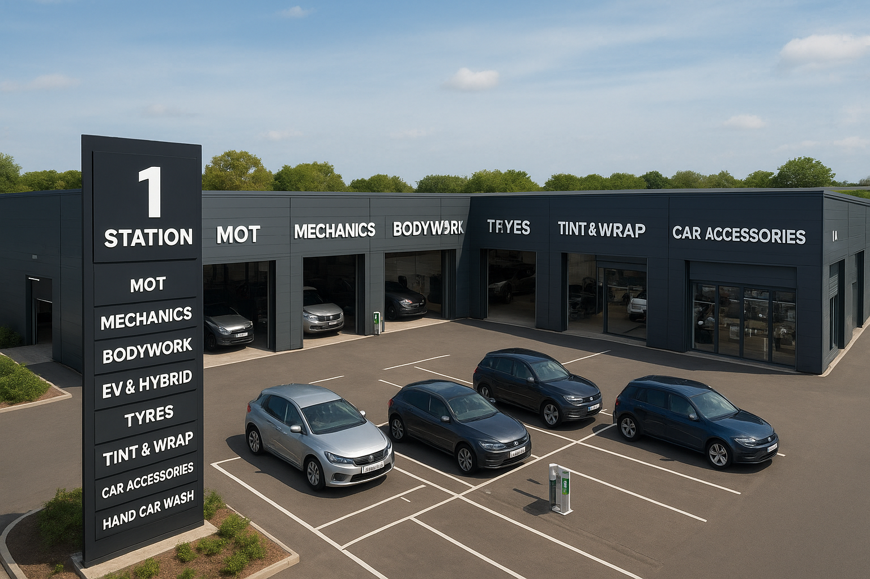
Figure 2. Proposed 1 STATION site, Sandwell (Source: Author, 2025)

1.3 Founder and Founding Idea
The concept was inspired by the founder’s hands-on experience operating a car showroom and a specialist bodywork garage. Daily interaction with motorists revealed how fragmented the UK service landscape is: customers must book separate visits for tyres, MOT, bodywork, and EV servicing, often losing time and facing inconsistent standards. Observing this gap sparked the idea of a single, fully integrated automotive hub backed by digital convenience (Porter, 2008; Osterwalder and Pigneur, 2010).

1.4 Business Objectives and Goals
1 1 STATION’s SMART objectives are:
- Acquire 1,500 repeat customers within the first 12 months.
- Capture 5 % of Sandwell’s MOT market (≈ 7,000 tests annually) by Year 2.
- Achieve operational break-even within 18 months of launch.
- Employ 25–30 local staff, including apprentices trained in EV systems.
- Reach carbon-neutral operations by 2027 through recycling and renewable-energy adoption.
- Launch a second regional site by Year 3 following Sandwell’s pilot success.
.

1.5 Services Offered
1 STATION will combine a wide range of automotive services under a single roof, including:
- Mechanical and electrical repairs for all vehicle types.
- EV and hybrid maintenance using certified, specialised equipment.
- MOT testing and servicing compliant with DVSA standards.
- Tyre sales, fitting, and wheel balancing.
- Professional car washing and detailing using eco-friendly systems.
- Bodywork and paint services, including accident repair.
- Window tinting and vehicle wrapping.
- Accessories retail shop offering high-quality parts and upgrades.
Each service line will operate as an independent profit centre, while bundled service packages and maintenance subscriptions will create steady, recurring income.

1.6 Economic and Social Contribution
1 STATION is designed to be a community asset as well as a business.
The company will create 25–30 local jobs across technical, customer service, and digital roles, with opportunities for apprenticeships and continuous skills training—especially in emerging EV technologies. Partnerships with local colleges and suppliers will help to upskill the workforce and retain value within the West Midlands economy (ONS, 2024; Sandwell Council, 2024).
Environmentally, the business will adopt eco-friendly practices such as water-recycling wash systems and safe recycling of automotive fluids and parts, supporting both local sustainability goals and the UK’s wider net-zero transition (BEIS, 2023).

1.7 Revenue and Growth Potential
By consolidating essential vehicle services under one brand, 1 STATION will generate multiple revenue streams: MOT fees, repair and maintenance charges, detailing packages, tyre and accessory sales, and premium EV servicing. Cross-selling and loyalty programmes will increase customer lifetime value, while a companion mobile and web app will drive bookings, enhance customer relationships, and provide a platform for future digital services.
The long-term vision is to replicate the model across other high-demand UK regions, building a recognised national brand that stands for quality, convenience, and innovation.

2. Methodology
This study adopts a desk-based secondary research methodology, consistent with the supervisor’s guidance and suitable for assessing the commercial feasibility of 1 STATION Ltd, a multi-service automotive hub in Sandwell. Relying exclusively on secondary data ensures the project is both cost-efficient and evidence-based, grounded in credible academic, industry, and government sources.

2.1 Research Design
The research follows a mixed-methods desk approach, combining qualitative and quantitative data analysis.
The qualitative component reviews academic models and conceptual frameworks to define the strategic rationale for 1 STATION.
The quantitative aspect interprets numerical data from industry reports, official statistics, and market studies to estimate market size, demand, and competition.
Multiple secondary sources are used to achieve triangulation—enhancing validity and reliability (Denzin, 2012).

2.2 Data Collection
Academic Literature:
Key theoretical models underpin the strategic and operational framework:
Resource-Based View (Barney, 1991) – identifies internal capabilities that generate sustained competitive advantage.
Business Model Canvas (Osterwalder and Pigneur, 2010) – structures value creation and delivery for the proposed hub.
Porter’s Five Forces (Porter, 2008) – assesses market competitiveness.
Service quality frameworks (Mukherjee and Nath, 2003; Kuo et al., 2017) – guide customer satisfaction and service integration analysis.
Industry and Market Reports:
Quantitative data will be drawn from:
IBISWorld (2024) – UK motor vehicle maintenance and repair market (£34.1bn).
Mintel (2024) – consumer preferences and convenience trends.

Grand View Research (2024) – automotive aftermarket growth forecasts.
Statista (2024) – digital booking and car ownership statistics.
SMMT (2024) – EV and hybrid registration trends.
Government and Policy Sources:
Secondary data will also be gathered from:
Department for Transport (2023) – MOT regulations and vehicle ownership trends.
ONS (2024) – household car expenditure and transport data.
Sandwell Council (2024) – regional demographics and economic priorities.
Competitor Benchmarking:
Comparative analysis will assess leading providers such as Kwik Fit, Halfords, and independent garages using published reports and trade data to benchmark pricing, customer base, and service scope.

2.3 Data Analysis
Thematic analysis (Braun and Clarke, 2006) will identify recurring themes in literature, while quantitative data from industry and policy reports will be used to estimate demand, project viability, and regional service gaps.
This integrated approach ensures a multi-dimensional understanding of market conditions, competitive positioning, and strategic opportunity for 1 STATION Ltd.

3. Market Research and Validation

3.1 National Market Context
The UK automotive services industry is a core pillar of the national economy, primarily classified under SIC 45200 (Maintenance and Repair of Motor Vehicles) and SIC 45320 (Retail Trade of Motor Vehicle Accessories).
According to IBISWorld (2024), the vehicle maintenance and repair market generated approximately £34.1 billion in 2024 and supports more than 40,000 active garages nationwide.
The Department for Transport (DfT, 2024) reports over 32.7 million licensed cars, sustaining reliable baseline demand through mandatory MOTs and ongoing servicing.
Growth is reinforced by ageing vehicles, higher mileage, and the rapid shift to electric mobility. Grand View Research (2024) forecasts the UK automotive aftermarket to reach £15.2 billion by 2028, expanding at a CAGR of 2.2 %.
Yet skills shortages persist: only 6 % of UK garages are currently EV-qualified (IMI, 2024).
Consumer preferences are also evolving—Mintel (2024) found 71 % of drivers favour one-stop convenience hubs, and Statista (2024) reported 45 % now book MOTs or services online.
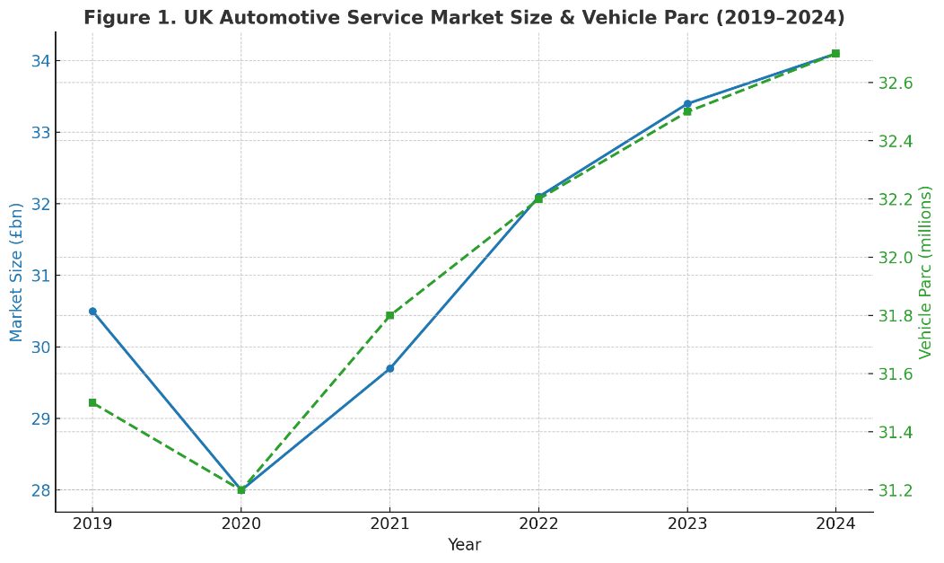
Figure 3. UK Automotive Service Market Size and Vehicle Parc (2019–2024)
Source: IBISWorld, 2024; DfT, 2024

3.2 Regional & Local Market: Sandwell
The West Midlands is the UK’s automotive heartland, hosting major manufacturing, logistics, and transport infrastructure. Within it, Sandwell—home to approximately 330 000 residents (ONS, 2023)—is one of the region’s most vehicle-dependent areas.
As of Q3 2023, Sandwell recorded 136 830 licensed cars, an increase of 6.5 % over five years (NimbleFins, 2023). More than 82 % of households own at least one vehicle (DfT, 2023), underscoring strong local reliance on automotive services for commuting and trade.
Business activity is dominated by small independents: ONS/Nomis (2024) data show that most local workshops employ fewer than 10 people and specialise narrowly (e.g., tyres, bodywork, MOT). This fragmented structure highlights the absence of a unified service hub—an identified opportunity for 1 STATION.
The DVSA (2025) database lists 115 authorised MOT stations in Sandwell.
Given 136 830 licensed cars, this equates to roughly 1 190 vehicles per station, exceeding national averages and indicating capacity pressure.
Table 1. Local Supply of Automotive Services in Sandwell (2024)
Service Line (SIC / Category) | Estimated Local Units (2024) | Source
Maintenance & Repair (SIC 45200, incl. tyre/body) | ≈ 230 | ONS/Nomis (2024) – scaled from UK totals
Retail of Accessories (SIC 45320) | ≈ 45 | ONS/Nomis (2024) – scaled
MOT Testing Stations | 115 | DVSA (2025)
Bodywork & Paint Shops | ≈ 40 | IBISWorld (2024) – regional ratio
EV & Hybrid Specialists | < 10 | IMI (2024)
Tyre Fitting Outlets | ≈ 35 | TyreSafe (2024)
Tint & Wrap Studios | < 5 | Trade Research (2024)
Car Wash & Detailing Sites | ≈ 25 | Mintel (2024)
Accessories Retail Corners | ≈ 15 | Statista (2024)
Note: SIC 45200 covers maintenance/repair—including tyre fitting & repair, bodywork, and washing/polishing. SIC 45320 covers retail trade of motor vehicle accessories

3.3 Service-by-Service Demand Analysis
outine maintenance represents around 35 % of total aftermarket spending (Mintel, 2024).
Sandwell’s ≈ 230 SIC 45200 garages are mostly micro-operations offering single-service repair, leaving a clear opportunity for an integrated, digitally managed facility.
EV and Hybrid Servicing: Battery-electric vehicles formed 21.9 % of all new UK registrations in 2024 (SMMT, 2024), implying ≈ 30,000 EVs in Sandwell. With fewer than 10 qualified providers (IMI, 2024), 1 STATION could pioneer a certified EV division.
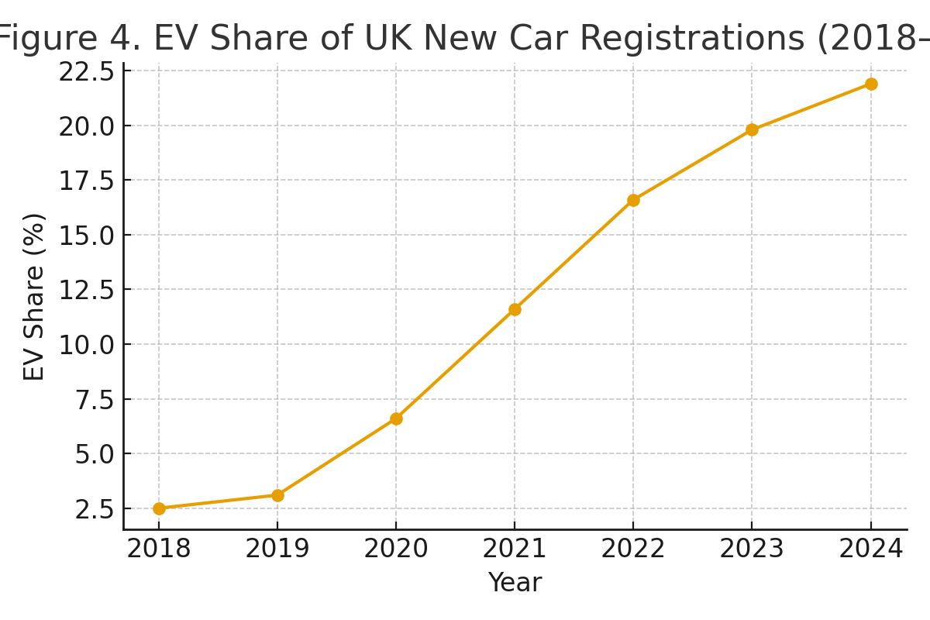
Figure 4. EV Share of UK New Car Registrations (2018–2024)
Source: SMMT (2024)
MOT Testing: 115 DVSA-approved stations serve 136,830 cars, causing booking congestion.
Adding MOT lanes at 1 STATION ensures steady customer inflow and cross-sales to servicing and tyres.
Tyre Fitting and Repair: Tyres account for ≈ 15 % of UK aftermarket expenditure (IBISWorld, 2024), replaced every 18–24 months (Mintel, 2023). Integrating tyre services boosts convenience and retention.
Bodywork and Paint: ≈ 2.2 million UK motor claims annually require body repairs (ABI, 2023). Sandwell’s ≈ 40 shops are mainly insurer-contracted; a walk-in bodyshop at 1 STATION fills this retail gap.
Car Wash and Detailing: 65 % of drivers use professional washes monthly or quarterly (Mintel, 2023). Most Sandwell sites are informal; a regulatory-compliant eco-wash system differentiates 1 STATION.
Tint and Wrap: Demand is rising among young drivers and SMEs. Fewer than five operators exist locally (Trade Research, 2024), presenting a low-cost add-on service opportunity.
Accessories Retail: 41 % of UK drivers purchased in-car tech or aesthetic upgrades in 2024 (Statista, 2024). Integrated promotions via the 1 STATION app enhance cross-selling and brand engagement.
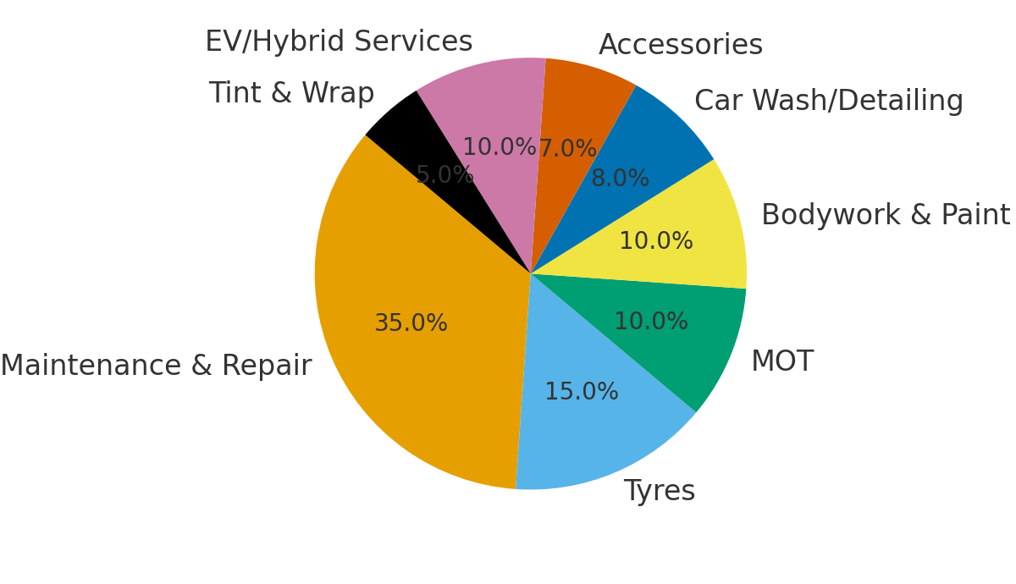
Figure 5. Estimated Demand Shares by Service Line (UK Aftermarket 2024)
Source: Mintel (2024); IBISWorld (2024)

3.4 Consumer Behaviour and Market Trends
Secondary data reveal four key behavioural and technological trends relevant to Sandwell’s market.
- Digitalisation and Convenience: 45 % of UK motorists book online (Statista, 2024); 70 % use multiple providers due to fragmented supply (Mintel, 2024). An integrated digital platform addresses this gap.
- Sustainability: 62 % of consumers consider environmental credentials (ONS, 2023). Eco-wash systems and EV maintenance align with Sandwell Council’s Greener Borough Strategy (2023–2030).
- Price Transparency and Trust: 68 % of drivers would switch providers for clearer pricing (PwC, 2024). 1 STATION’s fixed-rate menus and instant quotes strengthen customer trust.
- Local Lifestyle: Over 70 % of Sandwell’s workers commute by car (DfT, 2023), sustaining weekday fleet and weekend family traffic.
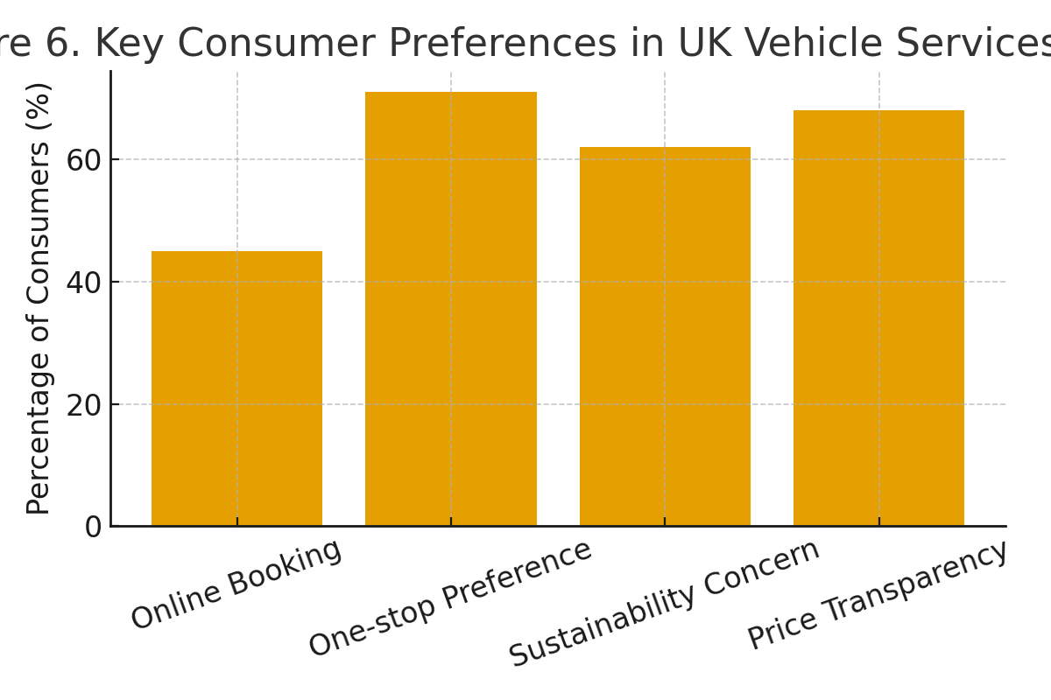
Figure 6. Key Consumer Preferences in UK Vehicle Services (2024)
Source: Statista (2024); Mintel (2024); ONS (2023); PwC (2024)

3.5 Market Validation
Triangulating ONS, DVSA, and industry data confirms strong commercial viability for 1 STATION Ltd.
Fragmented Supply: Over 230 garages operate locally, none offering a comprehensive hub model.
Capacity Pressure: One MOT station per 1,190 cars ensures steady demand and cross-sell opportunity.
Technology & Sustainability Gaps: < 10 EV-qualified sites and mostly non-compliant car washes reveal market space for eco-innovation.
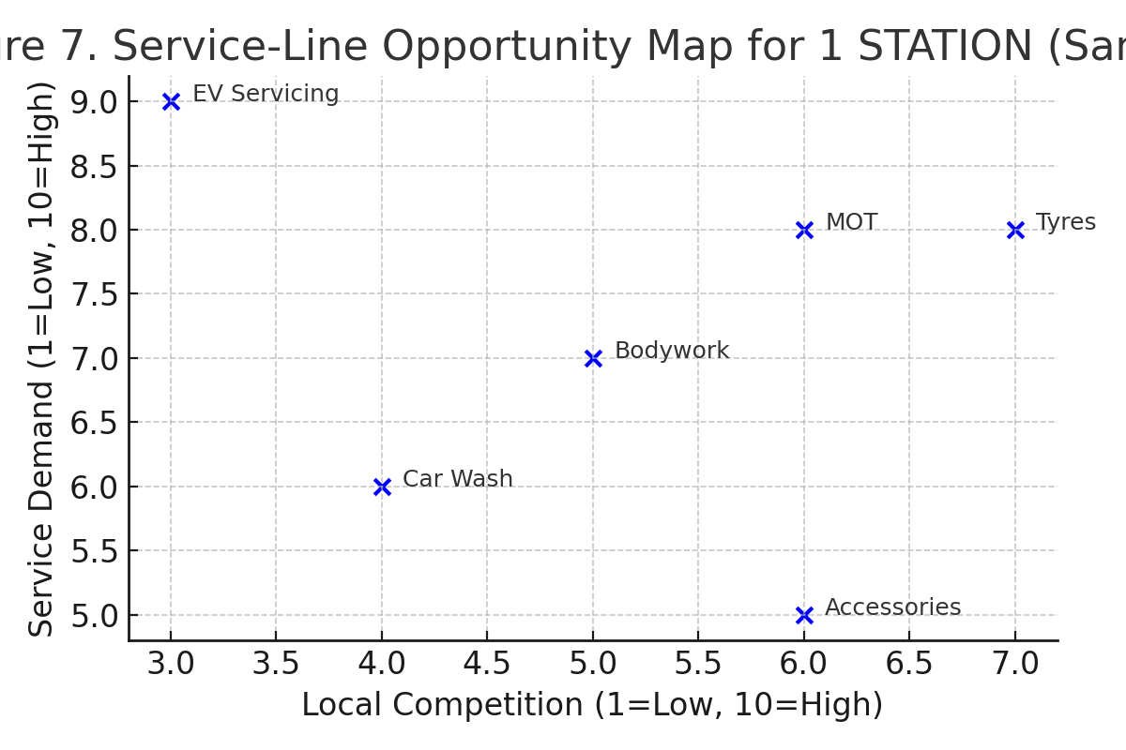
Figure 7. Service-Line Opportunity Map for 1 STATION (Sandwell)
Source: Mintel (2024); IBISWorld (2024); ONS/Nomis (2024); DVSA (2025)

4. Research Risks and Limitations
Developing this Business Development Proposal involves several research-related risks typical of master’s-level projects. Recognising these early ensures that they are managed effectively throughout the process.

4.1 Time Management and Workload
The main challenge is balancing this 15,000-word project alongside other MBA modules. Time pressure can restrict data analysis and referencing accuracy. To mitigate this, the researcher has adopted a structured weekly schedule with fixed study hours and early internal deadlines, supported by regular supervision meetings (Saunders et al., 2019).

4.2 Data Access and Reliability.
As the study relies entirely on secondary sources, there is a risk of incomplete or dated information—especially at local level. Subscription-based datasets (e.g., ONS /Nomis, DVSA, Mintel, IBISWorld) may limit access. This will be reduced through triangulation using publicly available data from the Office for National Statistics (ONS), Department for Transport (DfT), and Sandwell Council, cross-verified with academic and industry publications.

4.3 Methodological Scope and Interpretation.
Secondary research may not capture real-time consumer sentiment or service-provider behaviour. To minimise interpretation bias, the researcher will document all data sources transparently and apply recognised analytical frameworks such as Porter’s (2008) Five Forces and the Business Model Canvas (Osterwalder & Pigneur, 2010).

4.4 Academic Integrity and Ethics.
Improper citation or data misuse could compromise academic credibility. The project follows the UWTSD / BCU Harvard referencing style and GDPR-compliant data handling. All sources will be logged and verified using plagiarism-detection software before submission.

4.5 Personal and Resource Factors.
Unexpected events (e.g., illness or workload spikes) could disrupt progress. Mitigation includes consistent communication with the supervisor, daily cloud backup of all documents, and version control across devices.
Through proactive time planning, transparent data management, and continuous supervision, these risks remain within manageable limits and will not compromise the project’s validity.
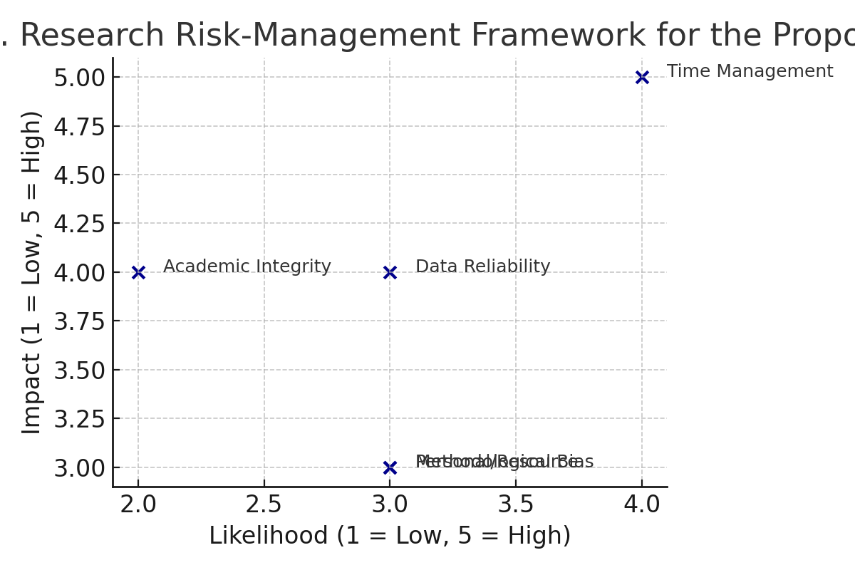
Figure 9. Research Risk-Management Framework for the Proposal
Source: Developed by Author (2025) based on ISO 31000 and Saunders et al., 2019.

5. Research Timeline and Gantt Plan
A disciplined schedule ensures timely completion of the 15,000-word Business Development Proposal (BDP). The plan follows the university’s official 16-week framework and integrates workshops, supervision sessions, and formative deadlines.
The project begins in Week 1 (October 2025) and concludes with the final submission in Week 16 (7 January 2026, 2 p.m.).
Six four-hour research workshops (Weeks 1, 2, 3, 5, 7, 9) and eight one-hour supervisions (Weeks 2, 4, 6, 8, 10, 12, 14, 16) are embedded within the schedule to maintain progress and academic guidance.

5.1 Summary Timeline.
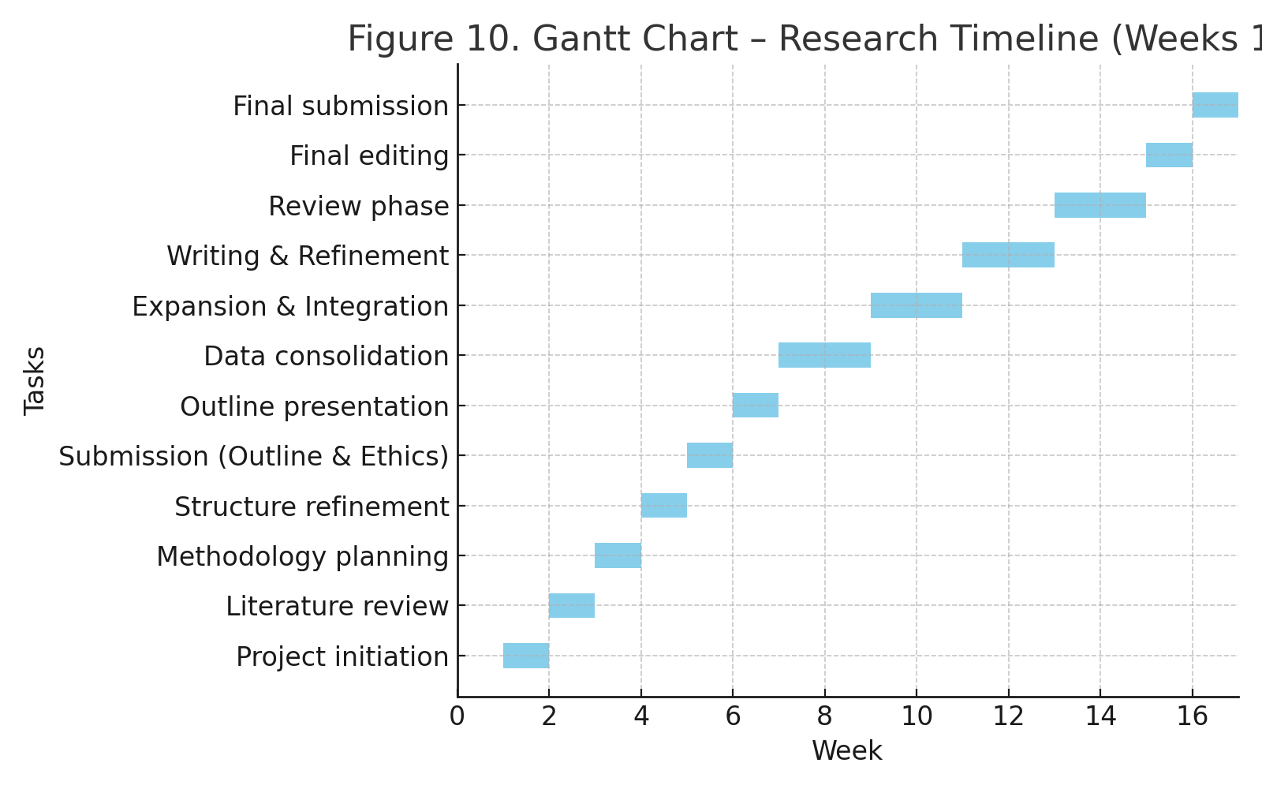
Figure 10. Gantt Chart – Research Timeline (Weeks 1–16)
Source: Developed by Author (2025).

5.2 Monitoring and Review
Progress will be tracked weekly using a spreadsheet aligned to the Gantt chart. Each supervision will review milestones and data status. Success will be measured by:
• on-time section completion,
• supervisor sign-off for methodology & ethics, and
• 100 % Harvard-referencing and ethics compliance.
This structured timeline provides a disciplined pathway from concept to completion, ensuring the research is delivered on time, academically rigorous, and aligned with the MBA learning outcomes.

References
Association of British Insurers (2025) Motor premiums fall - but repair and theft costs keep revving up claims. Available at: https://www.abi.org.uk/news/news-articles/2025/7/motor-premiums-fall---but-repair-and-theft-costs-keep-revving-up-claims/ (Accessed: 9 October 2025).
Barney, J. (1991) ‘Firm Resources and Sustained Competitive Advantage’, Journal of Management, 17(1), pp. 99–120. Available at: https://doi.org/10.1177/014920639101700108 (Accessed: 03 October 2025).
BEIS (2023) UK Net Zero Strategy: Build Back Greener. Department for Business, Energy & Industrial Strategy. London: HM Government. Available at: https://www.gov.uk/government/publications/net-zero-strategy (Accessed: 18 September 2025).
Braun, V. and Clarke, V. (2006) ‘Using Thematic Analysis in Psychology’, Qualitative Research in Psychology, 3(2), pp. 77–101. Available at: https://doi.org/10.1191/1478088706qp063oa (Accessed: 01 October 2025).
British Standards Institution (BSI) (2018) BS ISO 31000:2018 – Risk Management – Guidelines. London: BSI Standards Limited.
Denzin, N.K. (2012) ‘Triangulation 2.0’, Journal of Mixed Methods Research, 6(2), pp. 80–88. Available at: https://doi.org/10.1177/1558689812437186 (Accessed: 20 September 2025).
Department for Transport (DfT) (2023) Vehicle Licensing Statistics, United Kingdom 2023. London: HM Government. Available at: https://www.gov.uk/government/collections/vehicle-licensing-statistics (Accessed: 01 October 2025).
Department for Transport (DfT) (2024) Vehicle Licensing Statistics: Quarter 1 2024. London: HM Government. Available at: https://www.gov.uk/government/statistics/vehicle-licensing-statistics (Accessed: 19 September 2025).
Driver and Vehicle Standards Agency (DVSA) (2025) Active MOT Test Stations Dataset. London: DVSA. Available at: https://data.gov.uk/dataset/mot-test-stations (Accessed: 19 September 2025).
Grand View Research (2024) UK Automotive Aftermarket Size, Share, and Trends Analysis Report 2024–2028. San Francisco: Grand View Research.Available at: https://www.grandviewresearch.com (Accessed: 13 September 2025).
Grant, R.M. (2016) Contemporary Strategy Analysis. 9th edn. Chichester: John Wiley & Sons.
IBISWorld (2024) Motor Vehicle Maintenance and Repair in the UK – Industry Report (SIC 45200). London: IBISWorld. Available at: https://www.ibisworld.com/united-kingdom (Accessed: 13 September 2025).
Institute of the Motor Industry (IMI) (2024) Electric Vehicle Skills Gap Report 2024. Hertford: IMI. Available at: https://www.theimi.org.uk (Accessed: 01 October 2025).
Kuo, Y.-F., Wu, C.-M. and Deng, W.-J. (2017) ‘The Relationships among Service Quality, Perceived Value, Customer Satisfaction, and Post-Purchase Intention in Mobile Valuec Added Services’, Computers in Human Behavior, 25(4), pp. 887–896. Available at: https://doi.org/10.1016/j.chb.2009.03.003 (Accessed: 22 September 2025).
Mintel (2023) Car Wash and Valeting Services – UK – Market Report. London: Mintel Group Ltd. Available at: https://www.mintel.com (Accessed: 18 September 2025).
Mintel (2024) Automotive Aftermarket and Garage Services – UK – Market Report 2024. London: Mintel Group Ltd. Available at: https://www.mintel.com (Accessed: 09 October 2025).
Mintel (2024) UK Car Servicing and Repair Market Report 2024. London: Mintel Group Ltd.
Available at: https://reports.mintel.com (Accessed: 21 September 2025).
NimbleFins (2023) Car Licence Statistics – West Midlands 2023. Available at: https://www.nimblefins.co.uk/car-licence-statistics-west-midlands-england (Accessed: 02 October 2025).
NimbleFins (2023) Car Ownership Statistics in the West Midlands (2023 Q3). Available at: https://www.nimblefins.co.uk/car-licence-statistics-west-midlands-england (Accessed: 09 October 2025).
Office for National Statistics (ONS) (2023) Opinions and Lifestyle Survey: Environmental Attitudes 2023. Newport: ONS. Available at: https://www.ons.gov.uk (Accessed: 01 October 2025).
Office for National Statistics (ONS) (2024) UK Business Counts – Enterprises by Industry (SIC 2007) and Local Authority. Newport: ONS.
Available at: https://www.nomisweb.co.uk (Accessed: 18 September 2025).
Osterwalder, A. and Pigneur, Y. (2010) Business Model Generation: A Handbook for Visionaries, Game Changers, and Challengers. Hoboken, NJ: John Wiley & Sons.
Porter, M.E. (2008) ‘The Five Competitive Forces That Shape Strategy’, Harvard Business Review, 86(1), pp. 78–93.
PricewaterhouseCoopers (PwC) (2024) Automotive Consumer Insight Survey 2024: Trust and Transparency in Vehicle Services. London: PwC UK. Available at: https://www.pwc.co.uk (Accessed: 22 September 2025).
Sandwell Council (2023) Greener Borough Strategy 2023-2030. West Bromwich: Sandwell Metropolitan Borough Council. Available at: https://www.sandwell.gov.uk (Accessed: 17 September 2025).
Sandwell Council (2024) Sandwell Vision 2030: Economic and Community Development Plan. Sandwell Metropolitan Borough Council.
Available at: https://www.sandwell.gov.uk (Accessed: 18 September 2025).
Sandwell Metropolitan Borough Council (2023) Greener Borough Strategy 2023–2030. West Bromwich: Sandwell Council. Available at: https://www.sandwell.gov.uk (Accessed: 02 October 2025).
Saunders, M., Lewis, P. and Thornhill, A. (2019) Research Methods for Business Students. 8th edn. Harlow: Pearson Education Limited.
SMMT (2024) Electric Vehicle and Hybrid Car Registrations 2024. London: The Society of Motor Manufacturers and Traders. Available at: https://www.smmt.co.uk (Accessed: 01 October 2025).
Society of Motor Manufacturers and Traders (SMMT) (2024) EV and Hybrid Vehicle Registration Statistics 2024. London: SMMT. Available at: https://www.smmt.co.uk (Accessed: 23 September 2025).
Statista (2024) UK Automotive Aftermarket and Digital Service Booking Statistics 2024. Hamburg: Statista GmbH. Available at: https://www.statista.com (Accessed: 18 September 2025).
Statista (2024) UK Automotive Service Market Statistics and Digital Booking Trends 2024. Hamburg: Statista GmbH. Available at: https://www.statista.com (Accessed: 18 September 2025).
TyreSafe (2024) UK Tyre Market and Safety Report 2024. Kent: TyreSafe Organisation. Available at: https://www.tyresafe.org (Accessed: 29 September 2025).
United Kingdom General Data Protection Regulation (UK GDPR) (2021) Data Protection Act 2018 and UK GDPR Compliance Guidance. London: Information Commissioner’s Office (ICO). Available at: https://ico.org.uk (Accessed: 21 September 2025).
University of Wales Trinity Saint David (UWTSD) (2025) Research Ethics Policy. Swansea: UWTSD. Available at: https://www.uwtsd.ac.uk/research/ethics/ (Accessed: 15 September 2025).

