
Module Name: Professional Career Development

Module Code: BMBS4005

Student Name: Nilufa Sayem

Student Number: 2539196

Lecturer: Jemma Smith

Deadline: Monday 26th October 2026 23.59PM

AI Acknowledgement
I confirm that I have not presented any AI-generated text as my own work. I confirm that I have retained copies of drafts, notes, and resources used before and after the use of AI tools.
Contents
Element 1: Career Sector Investigation 3
1.1 My Chosen Sector or Business Area 3
1.2 Sector / Business Area Research 3
1.3 Skills, Qualities and Attributes Valued by Employers 3
1.4 Current Trends Affecting the Sector 3
1.5 Personal Career Fit 4
Element 2: Skills Audit and Professional Development Plan 5
2.1 Personal SWOT Analysis 5
2.2 Emotional Intelligence and Professional Behaviour 5
2.3 Applying Theories or Models 5
2.4 SMART Development Goal 6
Element 3: Recruitment Application Pack 7
3.1 Selected Job Role 7
3.2 Tailored Curriculum Vitae (CV) 7
3.3 Cover Letter 8
3.4 LinkedIn Profile 8
3.5 Application Rationale 8
Reference List 8

Element 1: Career Sector Investigation

1.1 My Chosen Sector or Business Area
The sector I want to work in is an international insurance company. I would like to work for Admiral Group PLC (a public limited company) as a General Manager. This business really inspires and motivates me to work with enthusiasm. I worked at Legal & General Insurance Company in the past as an Administrator, after I completed my studies in A-Level Business Studies and Information Technology (IT). I really enjoyed working in that sector and now want to develop my career at an advanced level. Building up my experience and developing stronger management and leadership skills.

1.2 Sector / Business Area Research
Admiral Group PLC is a major British Financial services and insurance company headquartered in Cardiff, Wales. The company was founded in 1993 as a major insurance start-up. It employs nearly 15,000 colleagues and serves over 10 million customers worldwide. Admiral operates brands like Admiral Law, Admiral Money, Admiral Pioneer and Veygo, spanning motor, home, travel, pet insurance and personal lending. Admiral has a variety of jobs. Customer Operations & Sales, which employs Customer Sales Advisors, Travel Insurance Consultants, Claims Handlers and Broker Sales Executives. Technology & Cyber Security, which employs Software Engineers and Product Designers. Data Pricing & Analytics, which employs Analytics Engineers, Data Analysts, Pricing Managers and Data Engineers. Early Careers & Leadership, which employs a dedicated entry -level path, including Admiral providing full training. Risk, Audit & Finance, which employs Credit Risk Analysts, Strategic people partners, head of reserving and third party risk managers.

1.3 Skills, Qualities and Attributes Valued by Employers
Employers at Admiral Group PLC fundamentally value skills, qualities and attributes such as a team-first attitude, enthusiasm and interpersonal qualities as a financial services company. They actively seek candidates who align with their four cultural pillars. These are Communication, Equality, Reward, and Recognition. High Motivation, empathy, strong spoken English, reliability and curiosity to learn regulatory compliance. The company pays employees a good salary and bonuses.

1.4 Current Trends Affecting the Sector
The company is widely celebrated for its unique, inclusive culture and offers a hybrid working model. Admiral is actively positioning itself as more than just a car insurer. They are selectively scaling household, travel and pet insurance. This is expanding their money growth every year. Profits are excellent, and management is fantastic. Ability to interpret complex Management information, build financial or data models, design clean code, and handle data validation.

1.5 Personal Career Fit
The jobs in this organisation interest me because of the services they provide. I have excellent communication skills and am hard-working, responsible and willing to learn new skills in the workplace. Very focused and reliable, and I can adapt to any situation. A very good team worker and can also work on my own. Skills I need to develop are management and leadership skills, which I will gain by completing a Level 4 Certificate in Business Skills and then moving to Level 5 and 6. Complete a Bachelor's Degree and hopefully do a Master’s Degree.
Element 2: Skills Audit and Professional Development Plan

2.1 Personal SWOT Analysis
STRENGTHS  • Good Communication  • Hard-working  • Responsible | WEAKNESSES / AREAS FOR DEVELOPMENT  • Emotional  • Nervous  • Management Leadership
OPPORTUNITIES  • Pass this Level 4 CertHE Business Skills  • Move to Level 5 Business Management and complete a B.A Degree | THREATS / CHALLENGES  • Public Transport  • Health Issues  •Personal Circumstances

My strengths are good communication skills. I can openly talk to a new person without being nervous. Does not matter who they are or how they are. I’m very hard-working and will complete a task with full responsibility to the best of my ability. Be fully focused on my work and not think of anything else while in the workplace. I need to develop my management and leadership skills because I am a General Manager in Admiral Group PLC, which is really important for this position. I must have these skills, or I will not be successful.

2.2 Emotional Intelligence and Professional Behaviour
In my employment, I control my emotions very well. I don’t take anything personally and stay professional. At Legal & General Insurance, I worked with people from different cultural backgrounds. With different levels of education, experience of work, and from different professions. Legal & General is a very large insurance company and also provides financial services. There was a situation where my team leader was not satisfied with our performance. She held a team meeting and discussed the tasks we needed to improve. I stayed calm, did not react and just followed her instructions, even though there was some disagreement within our team. In the end, we found a solution to resolve the problem and divided the workload within the team.

2.3 Applying Theories or Models
Pragmatist theory supports my reflection because I'm focused on learning and very practical. Test new ideas and apply new knowledge to real problems and situations. I also follow Maslow’s Hierarchy of Needs because this is essential in the workplace for me. I have to be safe, supported, connected, confident and feel inspired in the workplace to motivate me to work. I will enjoy the job and perform to the best of my abilities.
Specific | What exactly do I want to improve or achieve?  I want to achieve the BA degree in Business Management and improve my business and leadership skills. Hope fully complete a Master’s Degree after that.
Measurable | How will I know I have made progress or achieved it?  I will get positive feedback from my lecturer. Ask for feedback from student in my class. Discuss with them the things to improve on
Achievable | What actions and resources will make this realistic?  By passing the BA degree and moving on to a Master’s Degree. Get some work experience as well.
Relevant | Why is this important to my career or professional development?  For the position I want to achieve in future as a General Manager in Admiral Group PLC.
Time-bound | When will I complete or review this goal?  Hopefully in five years. This can take longer depending on situations and circumstances.
2.4 SMART Development Goal.

Element 3: Recruitment Application Pack

3.1 Selected Job Role
Job Title | Support Worker
Organization | See Ability
Location | Shippen, Oxfordshire
Where the vacancy was found | Indeed
Job Role URL | Support Worker jobs - October 2026 | CV Library

3.2 CV

Nilufa Sayem
Cardiff
12345678910
2529196@student.uwtsd.ac.uk
Personal Profile
I am an organised, confident, reliable person with excellent timekeeping skills. I have experience caring for vulnerable adults and children with good communication skills.
Employment History
Dewis June 2023 to July 2025
Support Worker
- Respite for a 12-year-old service user
- Take out calls
- 1.1 Support with meals and outdoor activities
- Going on bus rides
New Directions Education
September 2021 to May 2023.
Classroom Support Worker
- 1.1 Supporting children with special educational needs
- Outdoor activities
- Encourage them
- Social interaction

Educational and Training History
July 2023 Public Service Interpreting Level 4
Child Play Level 3 April 2017
Public Service Interpreting Level 3 March 2017
Lifelong Learning Teaching Assistant Level 2 November 2016
Hobbies and Interest
I enjoy travelling and day trips with my family and friends. I love playing netball and basketball as I used to play in school & college.
References available upon request

3.3 Cover Letter
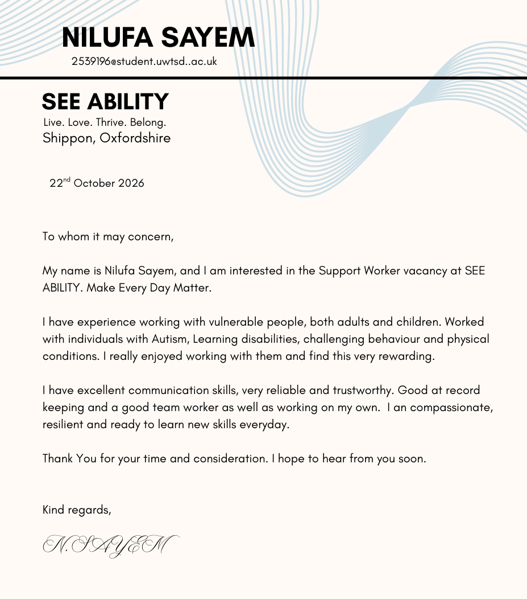

3.4 LinkedIn Profile
LinkedIn Profile URL | www.linkedin.com/in/nilufa-sayem-768302225
Professional Headline | Student at University of Wales Trinity Saint David's
Evidence / Screenshot | 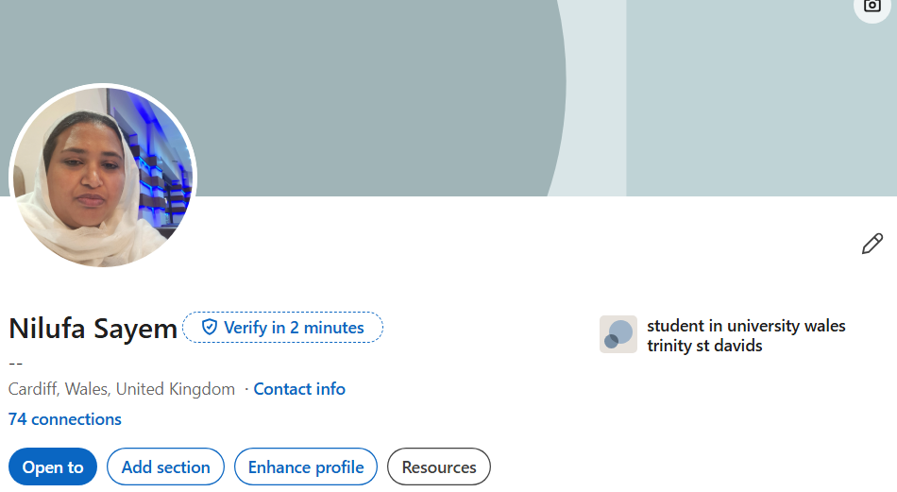

3.5 Application Rationale
Target length: 300 words
I applied for the Support Worker role at See Ability, which I found on Indeed Jobs. I have experience in this position. As described in the job description, they want experience as a Support Worker to join their supported living home. I fit in that position very well. I put on my CV the jobs I did in the past, which are similar to the position I am applying for. They need calm and patient people to work for them. In my cover letter, I explained everything in a professional way, including all the experience I have in the past and all my skills, to support the application. In my previous job, which I put on my CV, as a support worker, I used to do respite care for Dewis Spectrum Centre. Respite Care is looking after children with Special Needs for a few hours a week. This gives the parent of that child some rest to do other things or have a break. I used to look after a 12-year-old girl who was non–verbal and had weak foot muscles. I used to take her out to eat, go for walks, take her to the park and go on bus rides. My LinkedIn profile looks good and attractive to influence employers. On my LinkedIn profile, this includes all the certificates I gained when I started the Level 4 Business Management course while completing the module Digital Skills. Digital Skills is a new skill we need in the workplace. It's become an essential skill for employment and our daily lives. This role is about building strong relationships, which is just as important as providing practical support.

Reference List
- Admiral Website
- Daniel Motivation
- Gibbs Reflection Cycle
- Glassdoor
- Google Search
- Great places to work
- Honey & Mumford Learning Styles
- Indeed Jobs
- Johari Window
- LinkedIn
- Maslow Hierarchy of Needs
- Reflective Practice
- SMART Goals Framework
- Swot Analysis
- Trustpilot



