Searching

Name: Jonathan Davies
Student Number: 1707239
Lecturer: Gordon Dickers
Module Code: ACCA6011
Word Count: 1113

Table of Contents
Table of Figures 2
Table of Tables 2
1. Depth First Search 3
1.1 Application of Algorithm 3
1.2 Use of Data Structures 4
1.2.1 Stacks 4
1.2.2 Vectors 4
2. Hill Climbing 4
2.1 Common Problems 4
2.2 Other Hill Climbing Techniques 5
2.3 TABU 5
2.4 Simulated Annealing 5
2.5 Individual Eight-Tile Problem 5
2.6 Use of Data Structures 7
2.6.1 Queue 7
2.6.2 Map 7
3. Testing 7
4. Class UML 7
References 8
Appendices 9
Appendix A1 – Testing 9
Appendix B1 – B7 9
Appendix C1 - C2 9
Appendix D1 – 9
Appendix E1 – E2 9
Appendix F1 – Depth First Search UML 9
Appendix F2 – Hill Climbing UML 9

Table of Figures
Appendix B1 - User Test 1 9
Appendix B2 - User Test 2 9
Appendix B3 - User Test 3 9
Appendix B4 - User Enters Invalid Data 1 9
Appendix B5 - User Enters Invalid Data 2 9
Appendix B6 - Switch Statement Showing User Choice 9
Appendix B7 - Switch Statement Showing Invalid Choice 9

Table of Tables
Table 1 - Testing Table 8

Depth First Search

Application of Algorithm
The depth first search algorithm used on a graph structure works in much the same way as it does on a tree. Once key difference however is that graphs may contain cycles (circular routes which can allow the same node to visited more than once). To counter this issue, a visited attribute can be added to each node that can change its status depending on whether it has been visited.
The agent can be placed on a starting location and then perform a series of directional checks to test whether any of the surrounding nodes are available (in this case, hash symbols define a blocked node and empty spaces represent available nodes) and un-visited. Any nodes that meet this criterion can be added to a stack. The agent can then change its position to that of the node at the top of the stack and then that node can be popped off and marked as visited. This process repeats until every node has been visited or some other objective has been completed. Should a junction be encountered, the agent will push all available nodes onto the stack and can revisit them later if it meets a dead end.
To implement this algorithm, an Object-Oriented approach was taken which allowed for a degree of reusability and provided the additional benefit of each part of the process to be neatly encapsulated. This section will outline the functionality of the program and detail class names along with examples of the agent moving through the problem maze.
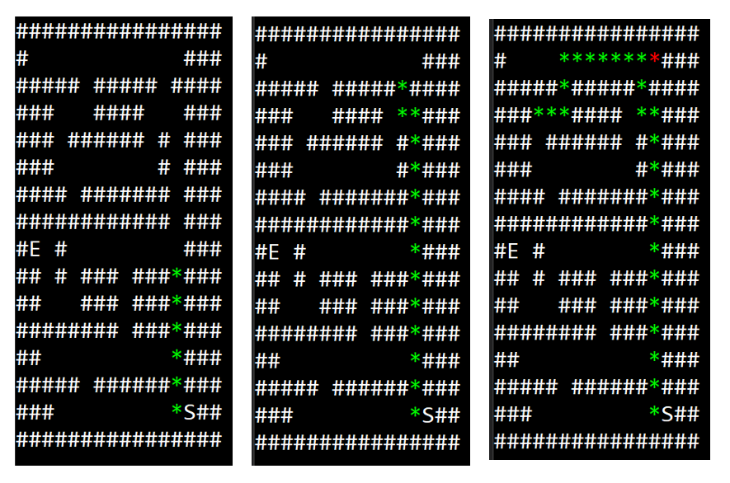
Figure 1 - Agent Navigating Maze
The program runs the depth first search algorithm inside a loop which checks the local environment of the agent and reports its findings, allowing the agent to select a node to move to. Each node that is considered must pass a criterion to be deemed a successful candidate.
When the agent reaches an intersection, it will store the first node of both available routes within a stack and then start moving down the route of whichever node was added last. The route that was not taken is saved for later the adjacent stack so that if the agent has exhausted all possible nodes on its current path, it can ‘remember’ to come back to start the unexplored section.

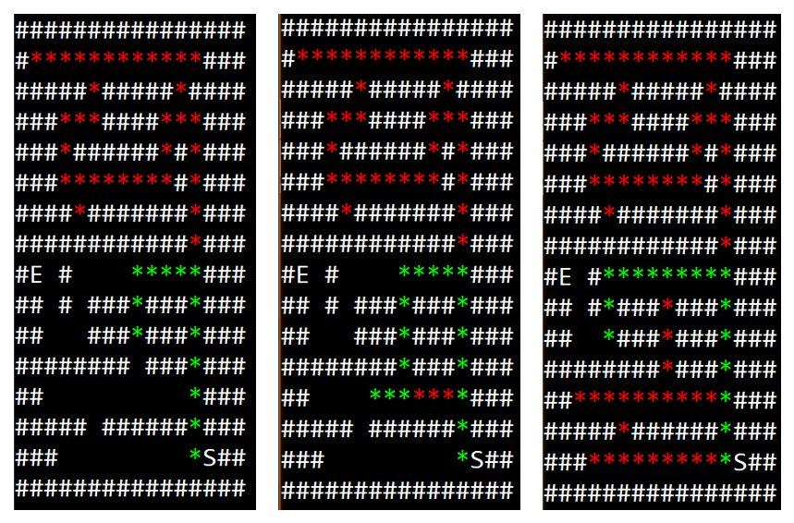
Figure 2 - Example of Backtracking
The example above illustrates how the agent deals with dead-end routes. Initially, the agent would reach a dead end and then ‘teleport’ back to the last adjacent node that was stored in the stack. In this case however, the agent systematically steps back through the visited nodes whilst subsequently marking them as ‘dead’.

Use of Data Structures

Stacks
Stacks were deemed as the most appropriate data structure available due to the ability of being able to store all nodes in the order that they were found dynamically. The ease of adding and removing nodes to the stack was also considered a major advantage over standard arrays or vectors.

Vectors
For the storage of nodes whereby there is no constant insertion or deletion, a vector is more than enough as it allows for an ever growing, contiguous data to be stored. Vectors were not chosen to keep track of the adjacent nodes as the means of removing is not as easy as it is with a stack.

Hill Climbing
Hill climbing is a local search algorithm that repeatedly queries the state of the problem to find out if an action will result in a more favourable or less favourable outcome. The outcome that is to be most beneficial to the problem is to be accepted and the process is run again until the best possible situation is achieved. Hill climbing algorithms are generally greedy, meaning that they only search the immediate surrounding area and look no further. This can easily result in what is known as the local maxima problem, whereby the algorithm claims to have achieved the best outcome when it has just found a better-than-average solution to a much smaller part of the entire problem. A key aspect of local search algorithms is that they only keep a record of the current state that is active and not any previous states that have come before it therefore limiting the decision-making skills of the algorithm.

Common Problems
Other problems that can arise include Plateauing, which is where calculating the heuristic result of every adjacent node returns the same value, therefore rendering a decision impossible under basic algorithm guidelines. Ridges can also pose a threat as every direction point to a negative outcome; this can be remedied by providing the algorithm with extra conditions prior to calculating the heuristic.

Other Hill Climbing Techniques
Advanced hill climbing algorithms exist such as Manhattan distance. This method involves calculating the distance between the position of the tile and their desired placement, this gives the heuristic function extra information which it can then add to its assessment of where it should move. A major advantage of using this method is an increase in performance due to less calculations being performed [1].

TABU
A TABU search aims to solve the problem of agents getting stuck in positions of local maxima. It is a method that can appended to any problem that involves the changing of states based upon the benefits and drawbacks of such a move. One key aspect of this algorithm is that it allows for previous state information to be stored as prohibited which can useful later when used by the evaluation system, thereby increasing its effectiveness [2] [3].

Simulated Annealing
Simulated Annealing (SA) is a technique for predicting the global minima in a potential set made up of many local minima. It is based on observations of real-world physics and a digital adaptation has been constructed to mirror its effects [4].

Individual Eight-Tile Problem
A walkthrough of the Eight-Tile problem assigned to student 1707239 has been provided below.
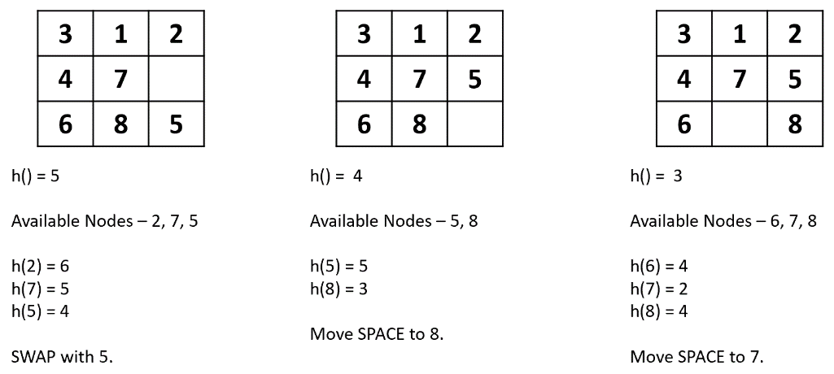
Figure 3 - Hill Climbing Walkthrough 1
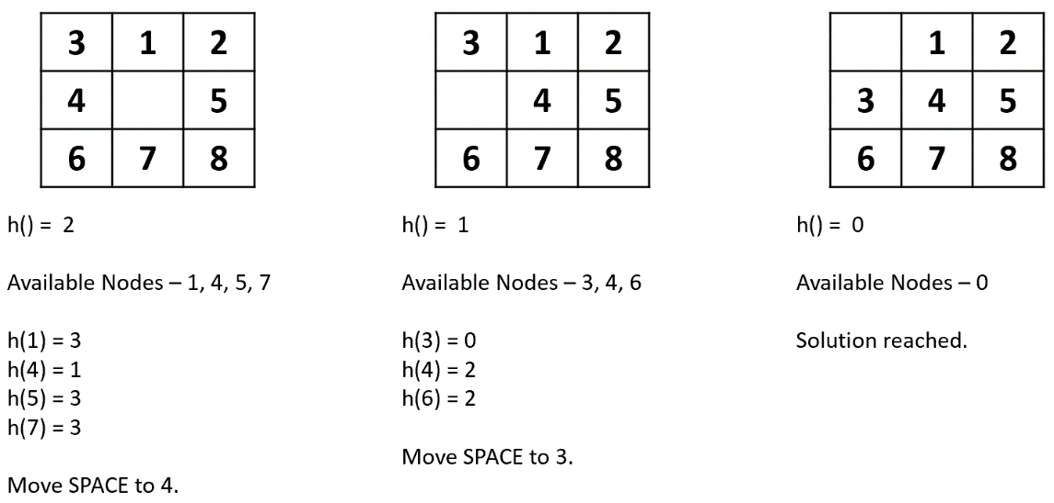
Figure 4 - Hill Climbing Walkthrough 2

Screenshots have also been added that show the program performing the same steps below.
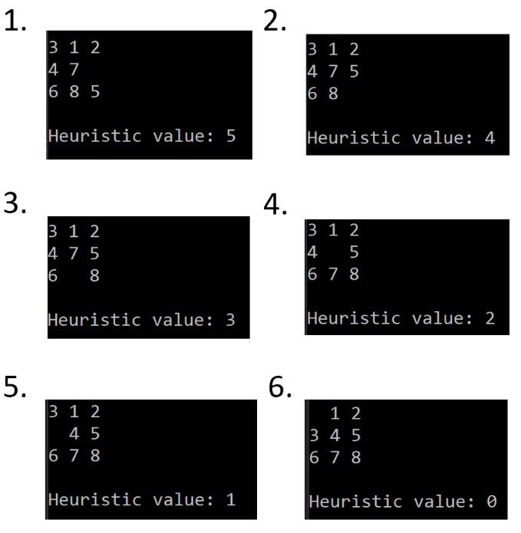
Figure 5 - Code Example of Hill Climbing

Use of Data Structures

Queue
The use of a queue was implemented to keep track of all the available tiles that the empty space could move to. The queue structure was chosen specifically because the first tile that was added could be used first to perform the heuristic checks.

Map
The map data structure was used for two purposes. Firstly, it provided a means of holding all of the tiles that were accepted for heuristic testing so that they could be easily accessed. Secondly, each heuristic value for the tiles in the map was returned and set to be the value of the key of that particular tile, therefore binding the heuristic value of the key to its associated tile. Due to the nature of the ordered map, the keys are placed in descending order which ensured that the tile that offered the lowest heuristic value could always be found at the top of the map.

Testing
All testing tables have been provided in the Appendix section of this report.

Class UML
All UML diagrams have been provided in the Appendix section of this report.

References

[1] S. Russell and P. Norvig, “Heuristic Functions,” in Artificial Intelligence: A Modern Approach, 3rd ed., Pearson Education Limited, 2016, pp. 102–103.
[2] F. Glover, “Tabu Search: A Tutorial,” Interfaces (Providence)., vol. 20, no. 4, pp. 74–94, Aug. 1990.
[3] R. Battiti, “The Reactive Tabu Search,” 1992.
[4] D. Bertsimas and J. Tsitsiklis, “Simulated Annealing,” Stat. Sci., vol. 8, no. 1, pp. 10–15, 1993.

Appendices

Appendix A1 – Testing
No. | DFS/Hill Climbing | Test Description | Expected Result | Actual Result
1 | DFS | User selection of maze correlates with the maze that runs in all three cases (currently three mazes available). – Screenshots of test can be found in appendix B1-B7 | PASS | PASS
2 | DFS | Menu runs on a separate thread of execution  - Screenshots found in appendix C1-C2 | PASS | PASS
3 | Hill Climbing | Check to see if the Map data structure stores the heuristic values in order.  - Screenshot found in appendix D1 | PASS | PASS
4 | DFS | Check if the file successfully opens.  - Screenshot found in appendix E1-E2 | PASS | PASS
Table 1 - Testing Table

Appendix B1 – B7
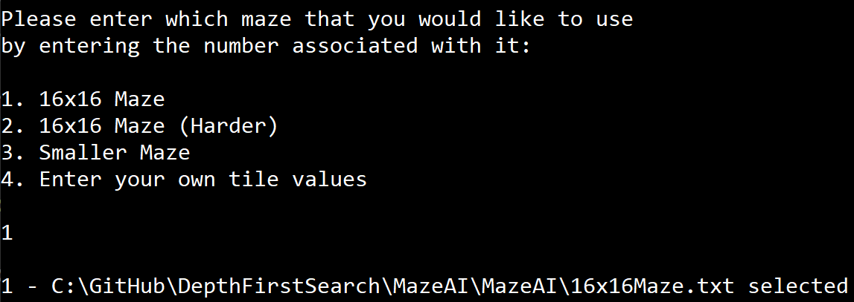
Appendix B1 - User Test 1
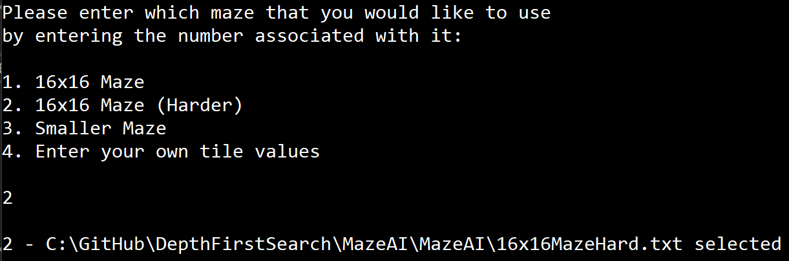
Appendix B2 - User Test 2
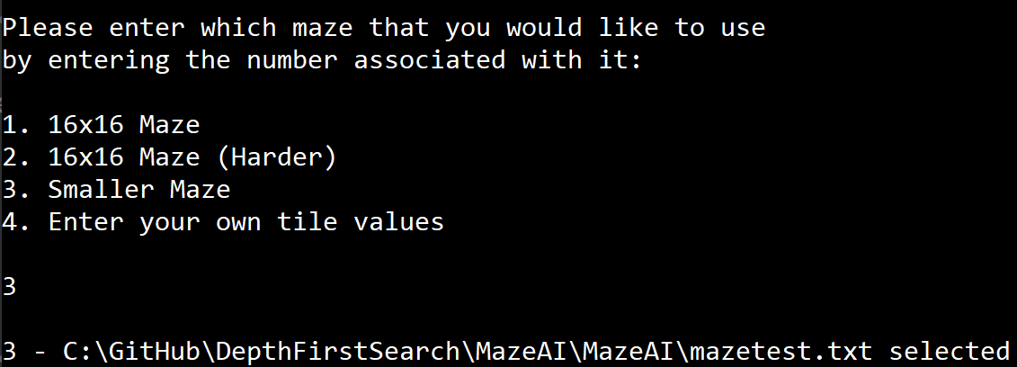
Appendix B3 - User Test 3
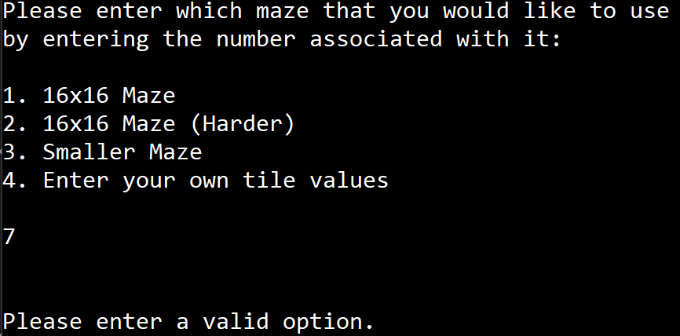
Appendix B4 - User Enters Invalid Data 1
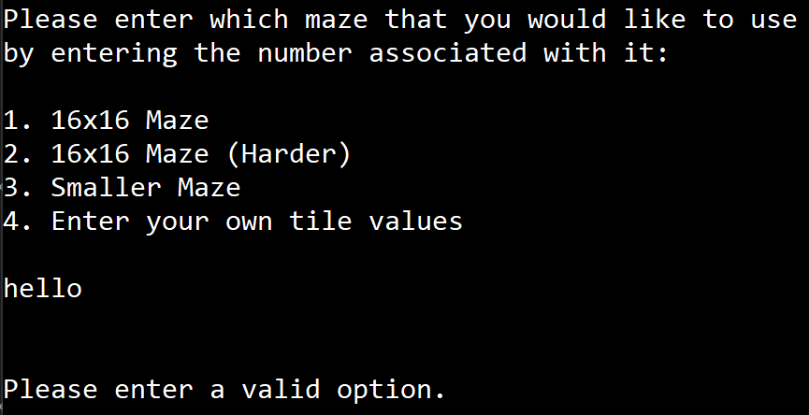
Appendix B5 - User Enters Invalid Data 2
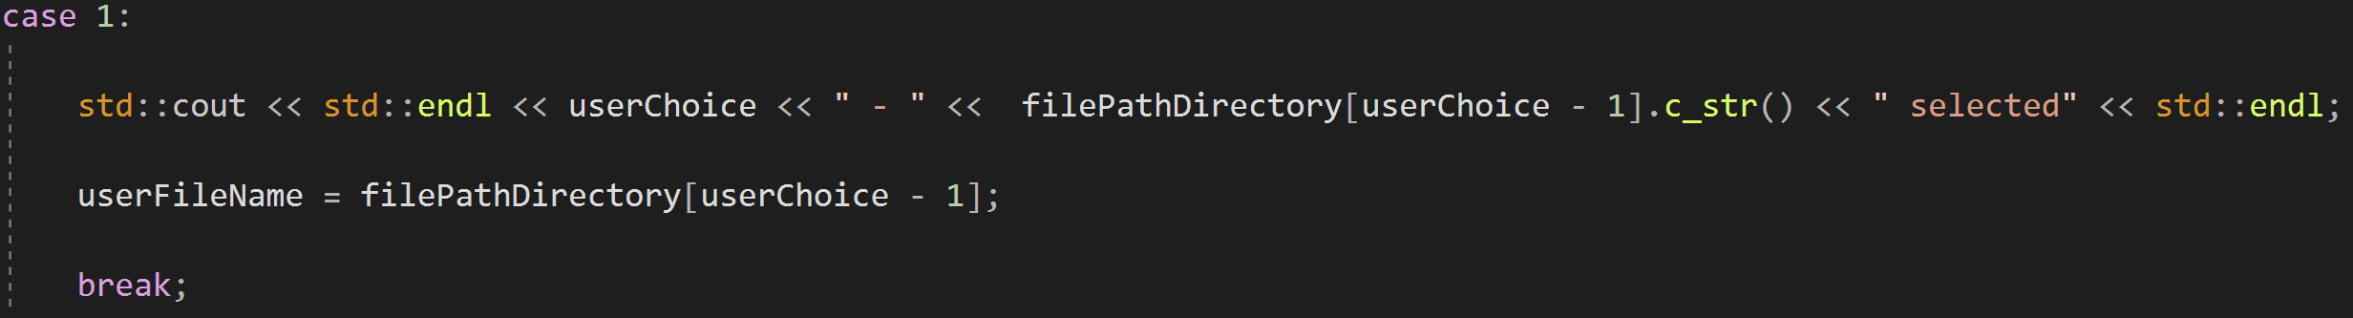
Appendix B6 - Switch Statement Showing User Choice
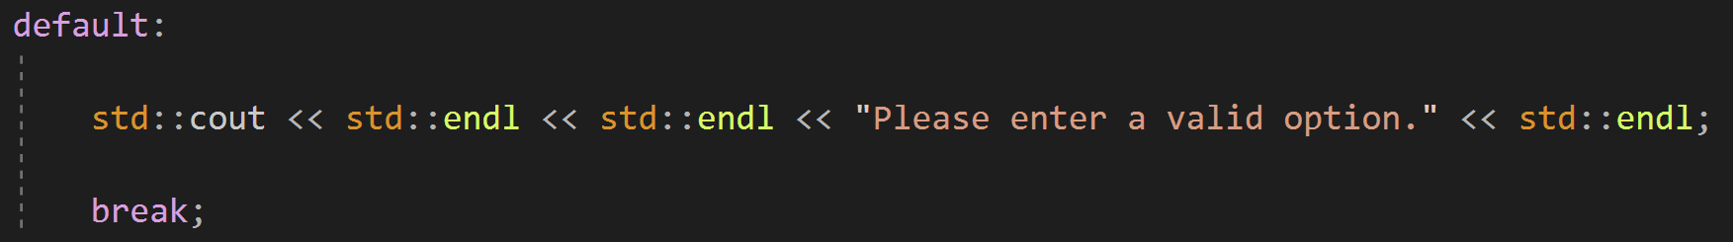
Appendix B7 - Switch Statement Showing Invalid Choice

Appendix C1 - C2
Appendix C1 - Thread IDs
Appendix C2 - Thread Implementation

Appendix D1 –
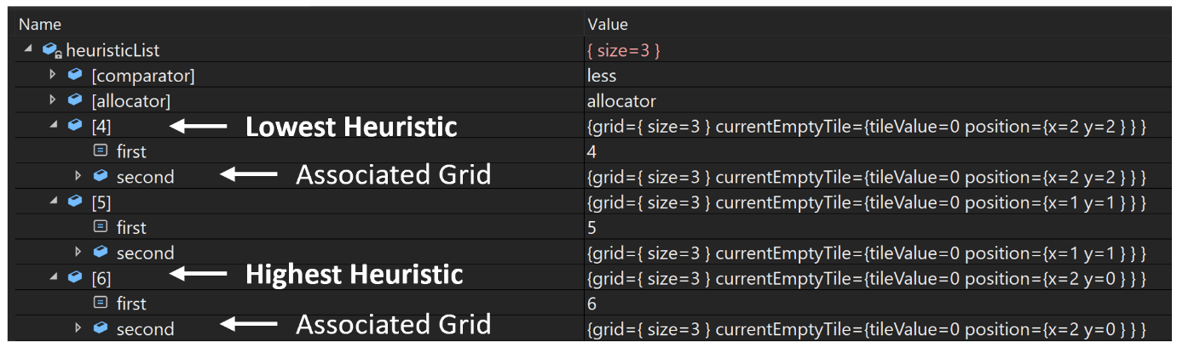
Appendix D1 - Heuristic Map Test

Appendix E1 – E2
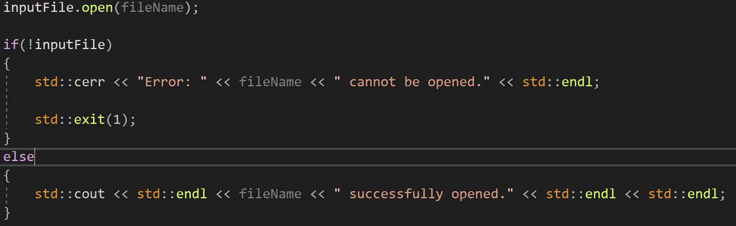
Appendix E1 - Opening File (Code)
Appendix E2 - Opening File (Runtime)

Appendix F1 – Depth First Search UML
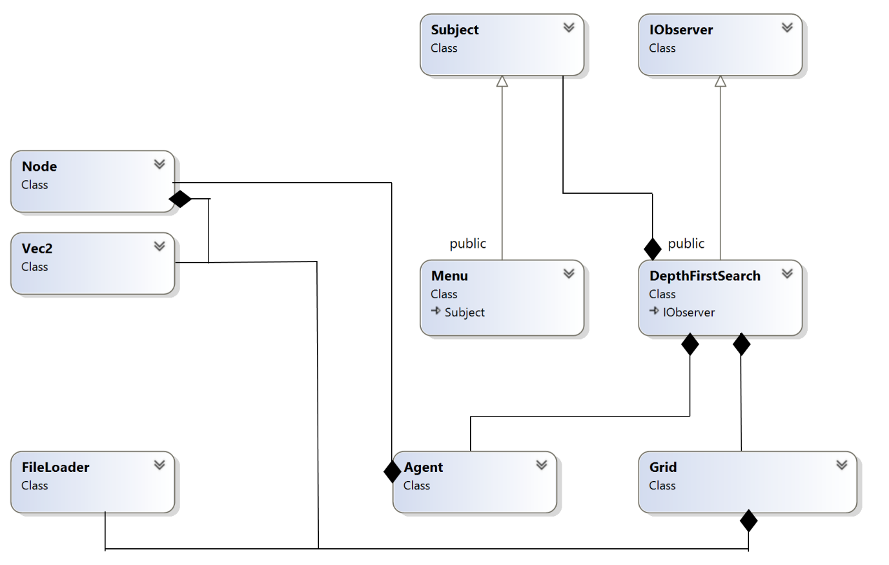
Appendix F1 - DFS UML

Appendix F2 – Hill Climbing UML


