HTML & CSS Web Development

ACCA4023 - L4 - Introduction to Web and Database Concepts (Gareth)
  - 2021807 Joshua James Harries BSc Applied Cyber Security (DDA Jan 21) 26th April 2021

Table of Contents
Introduction 2
Requirements 2
Implementation 2
Home 2
About Me 3
Portfolio / My Work 3
Services 4
Clients 4
Contact Me 5
Validation 6
HTML 6
CSS 7
Evaluation 7
Usefulness (Usability and Utility) 8
Search Engine Optimisation (SEO) 8
Accessibility 8
References 9
Appendices 10

Introduction
In this report, I will be giving a brief introduction to the website, describing its purpose and subject matter, the target audience and its relevance. I will be looking at the implementation of the website, specifically the validation of the HTML & CSS code. I will also be researching and describing the websites’ usability, accessibility, and search engine optimisation, and evaluating my findings against my own website.

Requirements
The websites intended purpose is completely fictitious, which is a business set up by myself providing IT services to corporate clients such as my employer Digital Health and Care Wales, and the University. Its subject matter will be information of the services the company would provide, along with client testimonials and previous work that I have “completed”, where in reality it’s just a mix of personal images that I’ve taken myself and copyright-free images from Unsplash [1]. The target audience would be potential clients to attract business to the company. The relevance of the website is that in the future, I potentially would like to branch out into my own business venture, and become self-sufficient. The website needs to be clean and minimalistic so not to overwhelm any potential clients, while ensuring they have enough information to make them want to make an enquiry using the Contact Me page.

Implementation

Home
The homepage features a quick introduction to the website, an animated banner that swaps from my logo, to a business photo of myself, then to an example of my work – a drone photo. It also features what services I offer – e.g. Drone Photography.
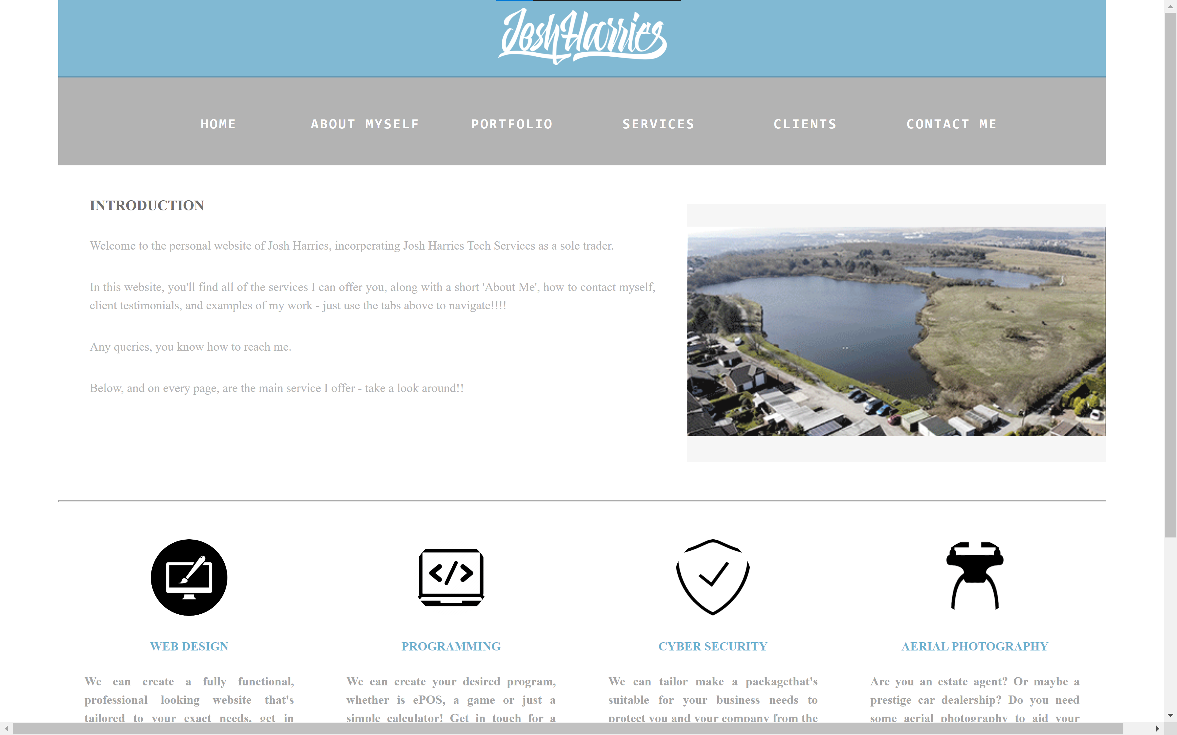

About Me
On this page, I dive into more detail about myself so that the end user feels connected with the brand and the website. This page also features the services section.
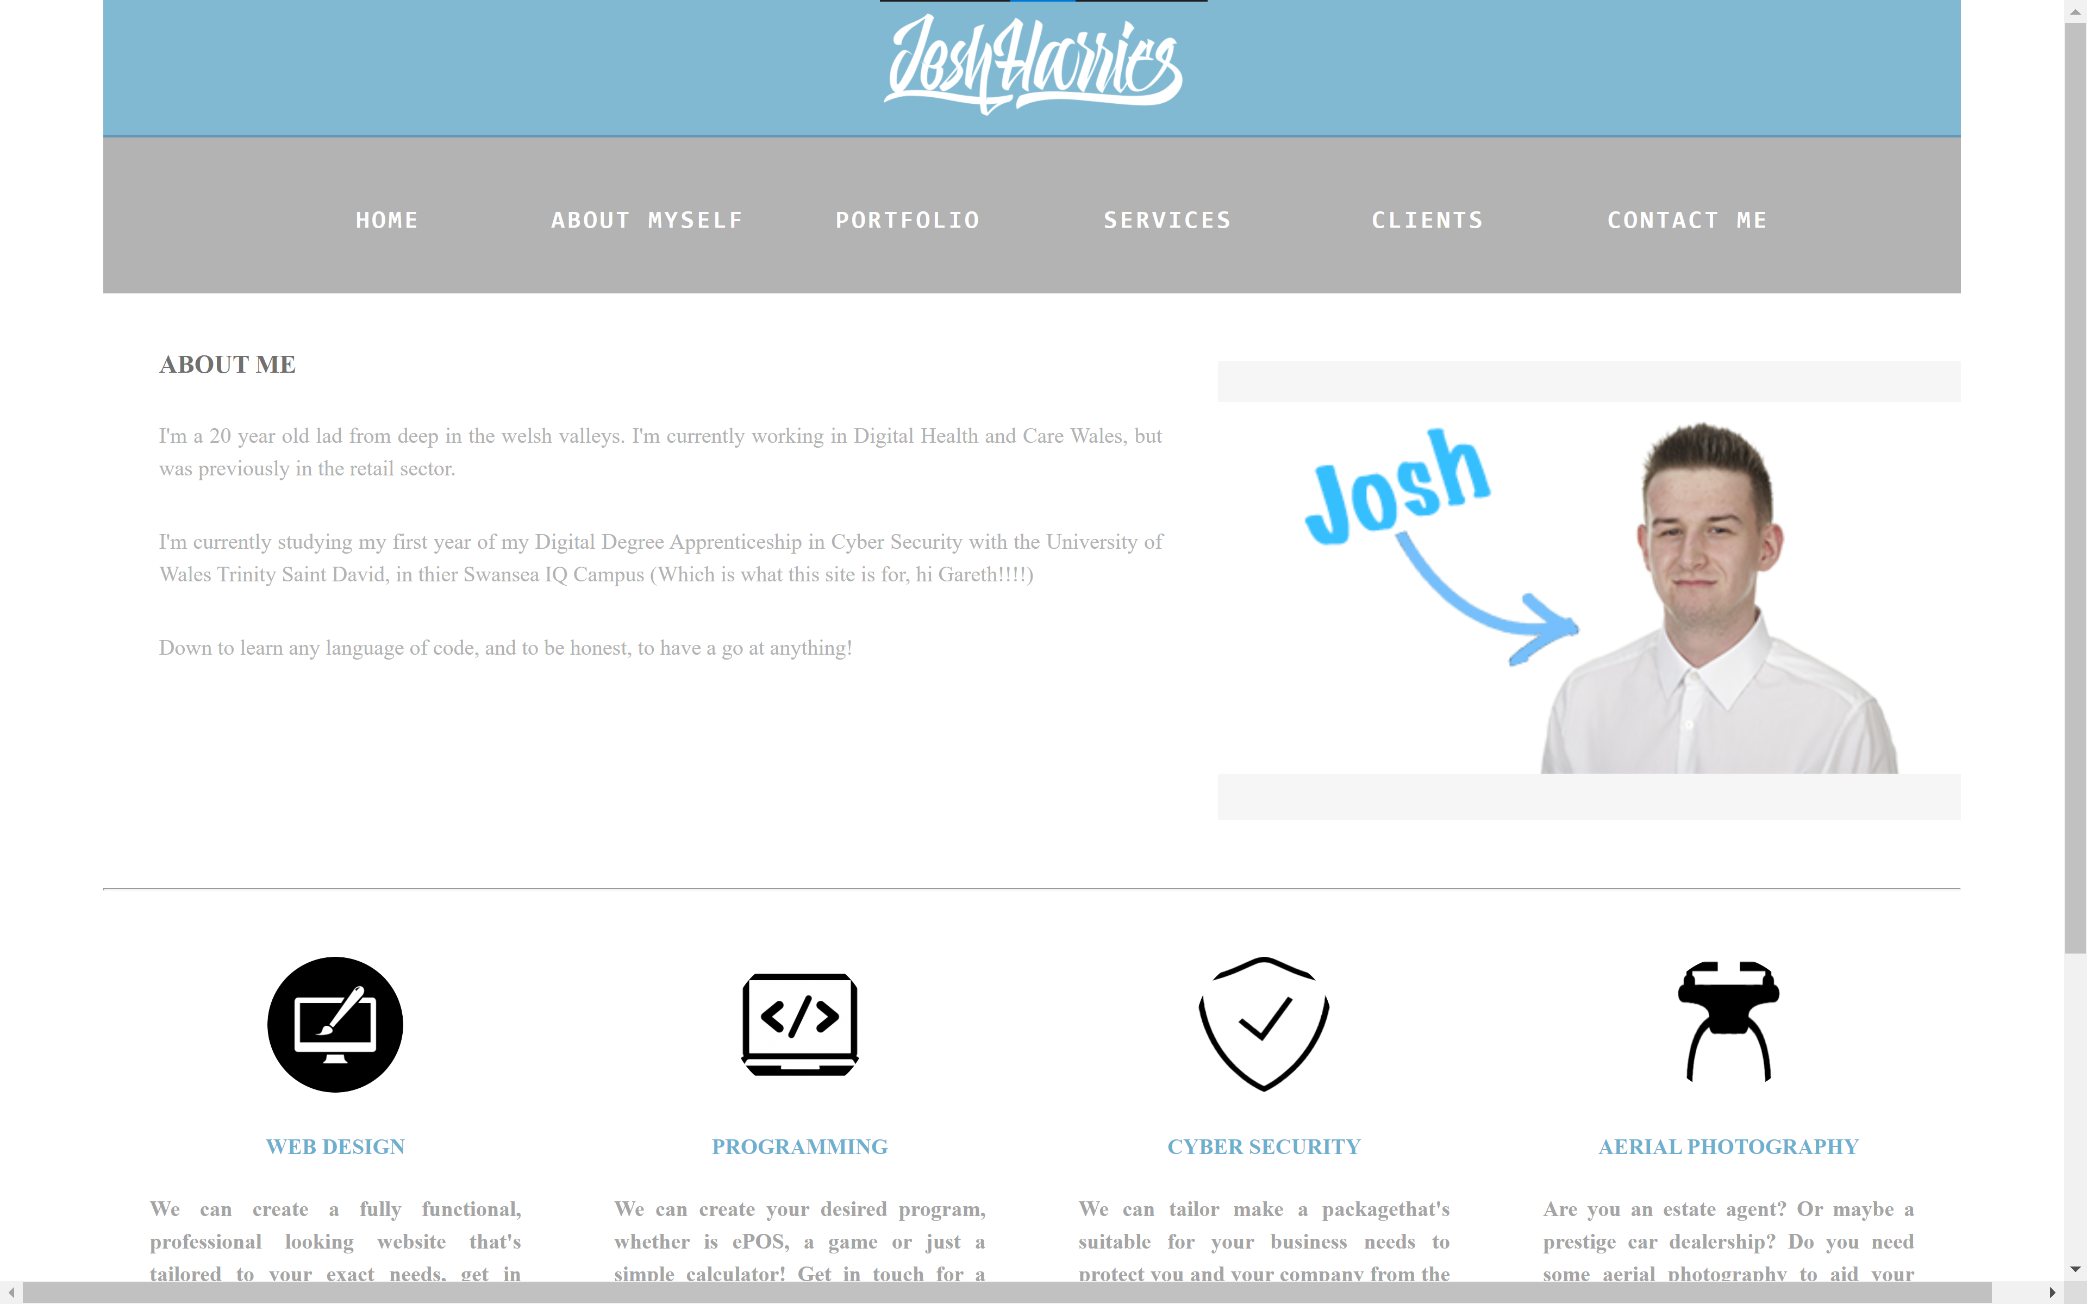

Portfolio / My Work
On this page, you’ll find various different thumbnails showing a preview of some of the work I’ve done. There’s a help and tips box at the start so end users know how to use the image gallery. When you click on one of the thumbnails, the image will expand and open into a new tab. On some images, clicking the thumbnail will open up the image on Unsplash’s site – all images hosted on the site are under their own licence, allowing you to do whatever you want with them, commercially or privately, with or without credit. I’ve used Unsplash for some of the examples to make it seem more appealing to potential shareholders.

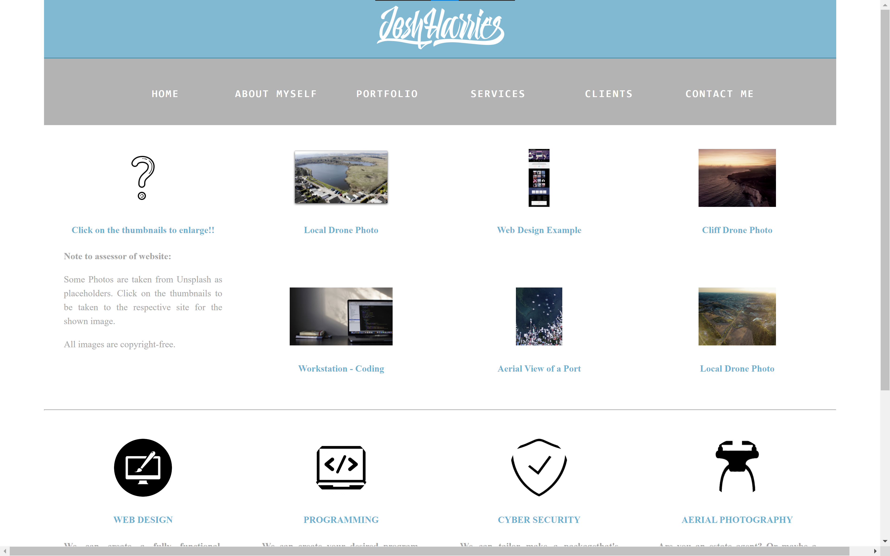

Services
On this page, it’s simply for information only – the end user will find the list of services and a brief description about them, which they’ll be used too as it repeats from the other pages that feature it.
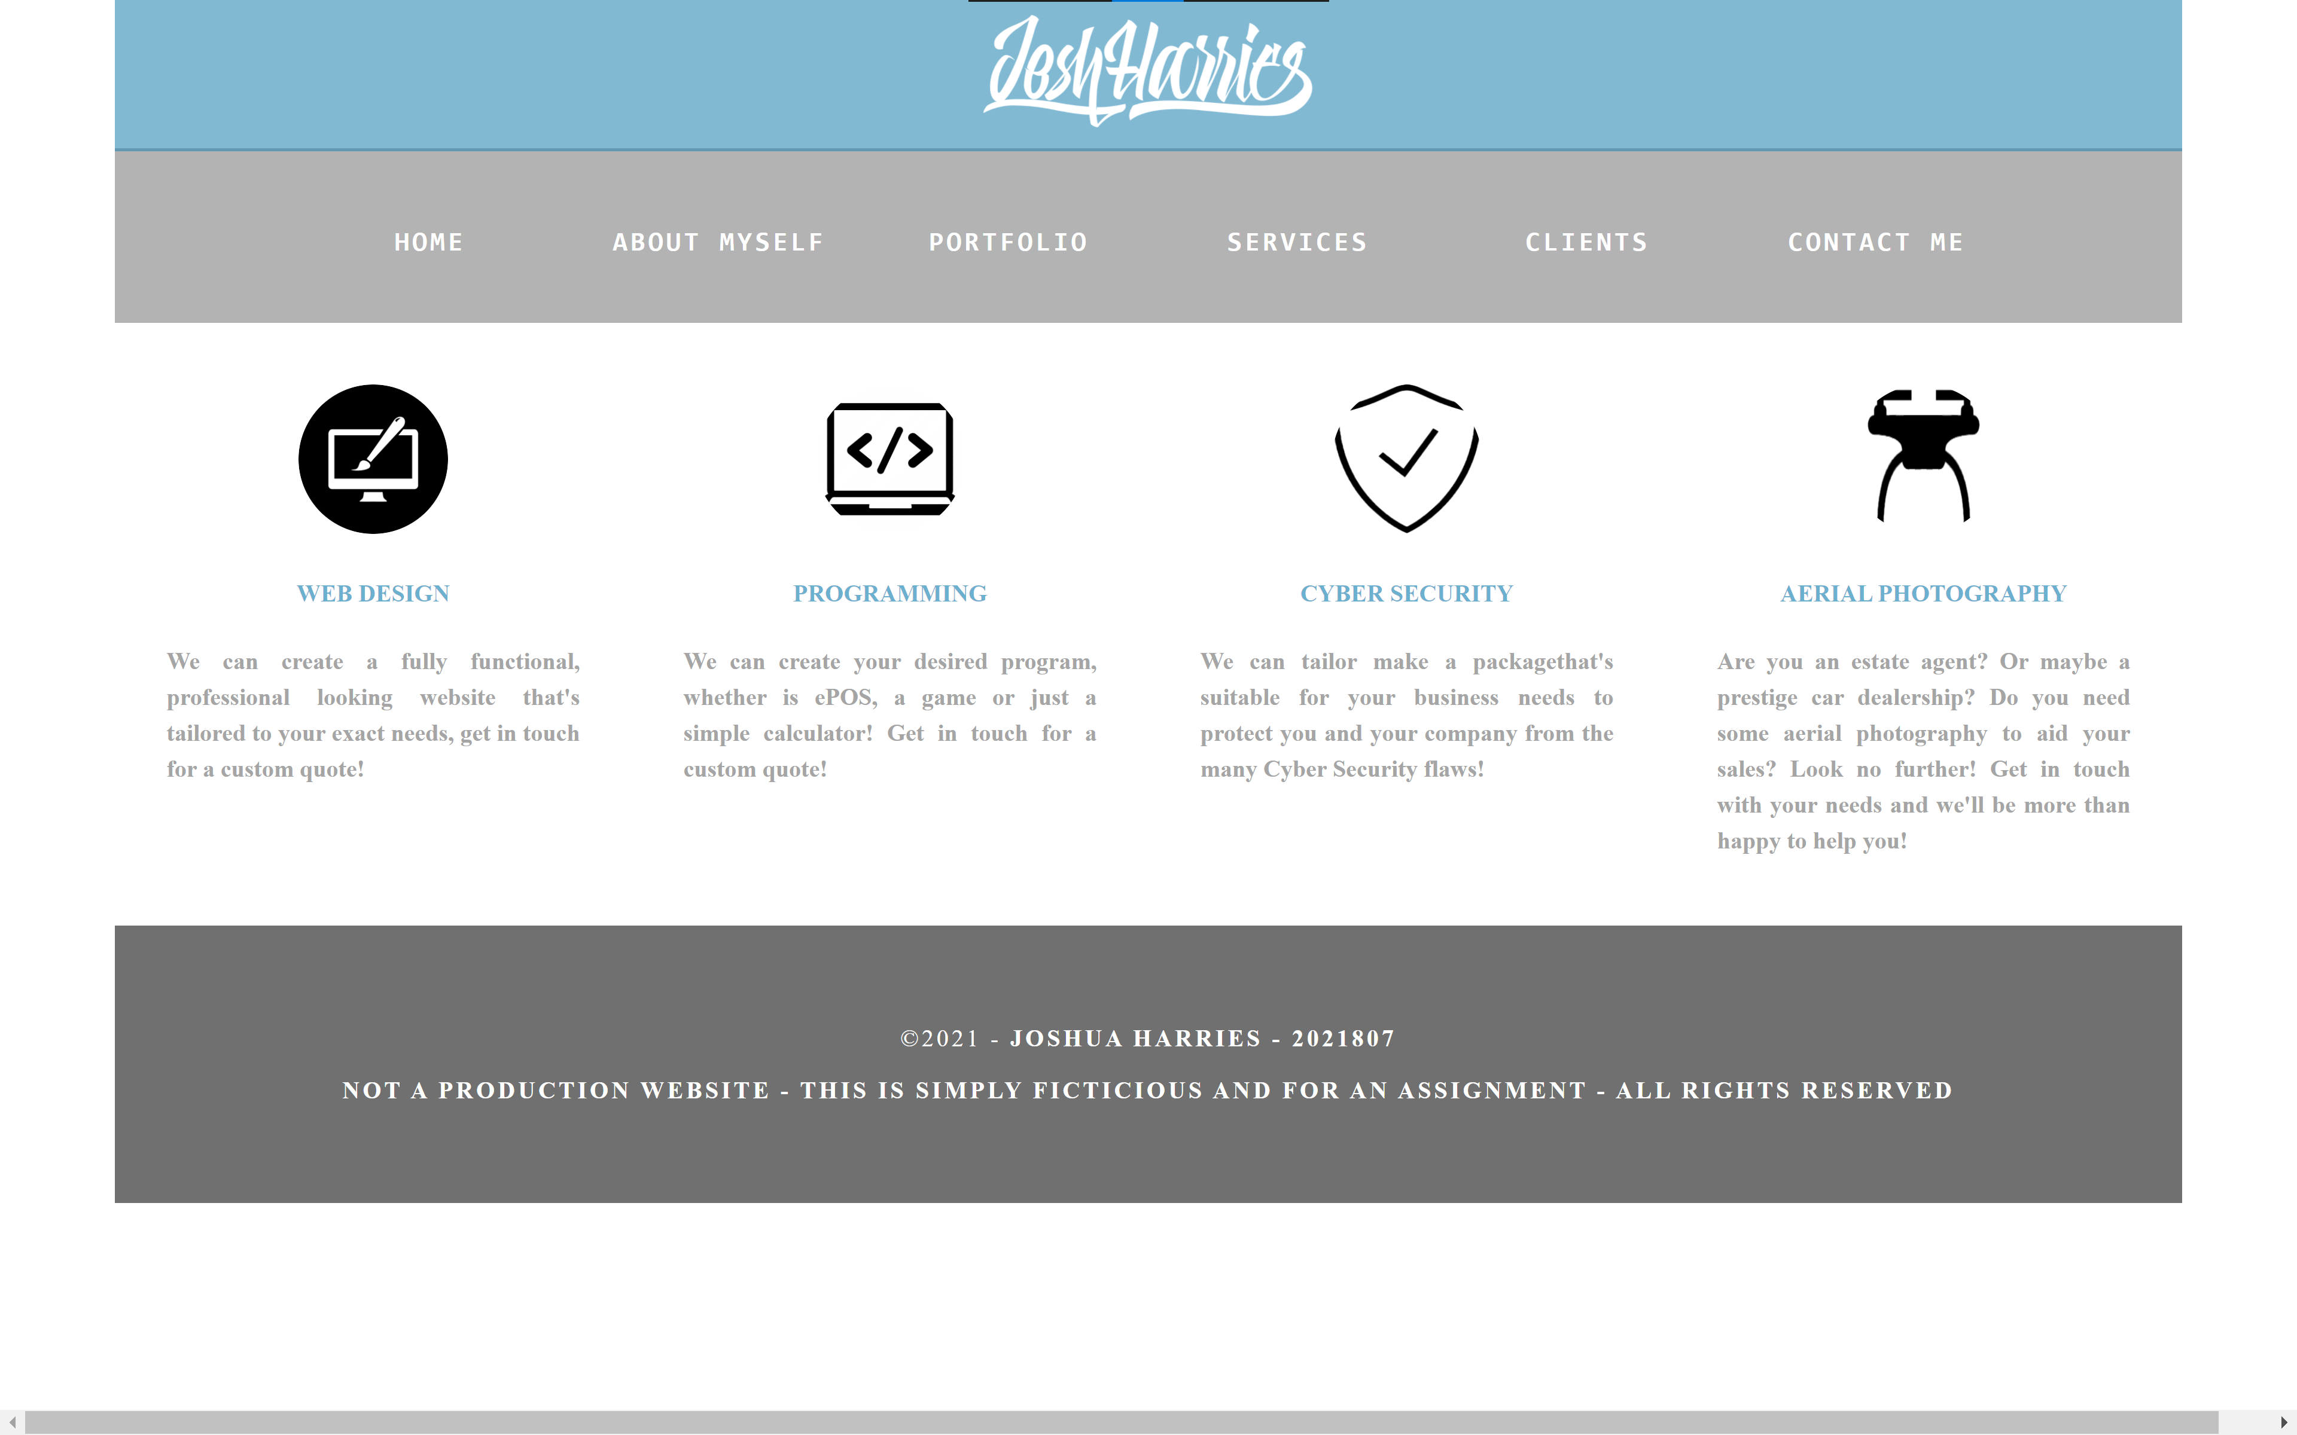

Clients
On this page, all the end user will find is past clients that I have worked with, along with a brief testimonial of their experiences. Like the services page, nothing is clickable and it’s only intended for information only, therefore accessibility is in line with my initial ideas.
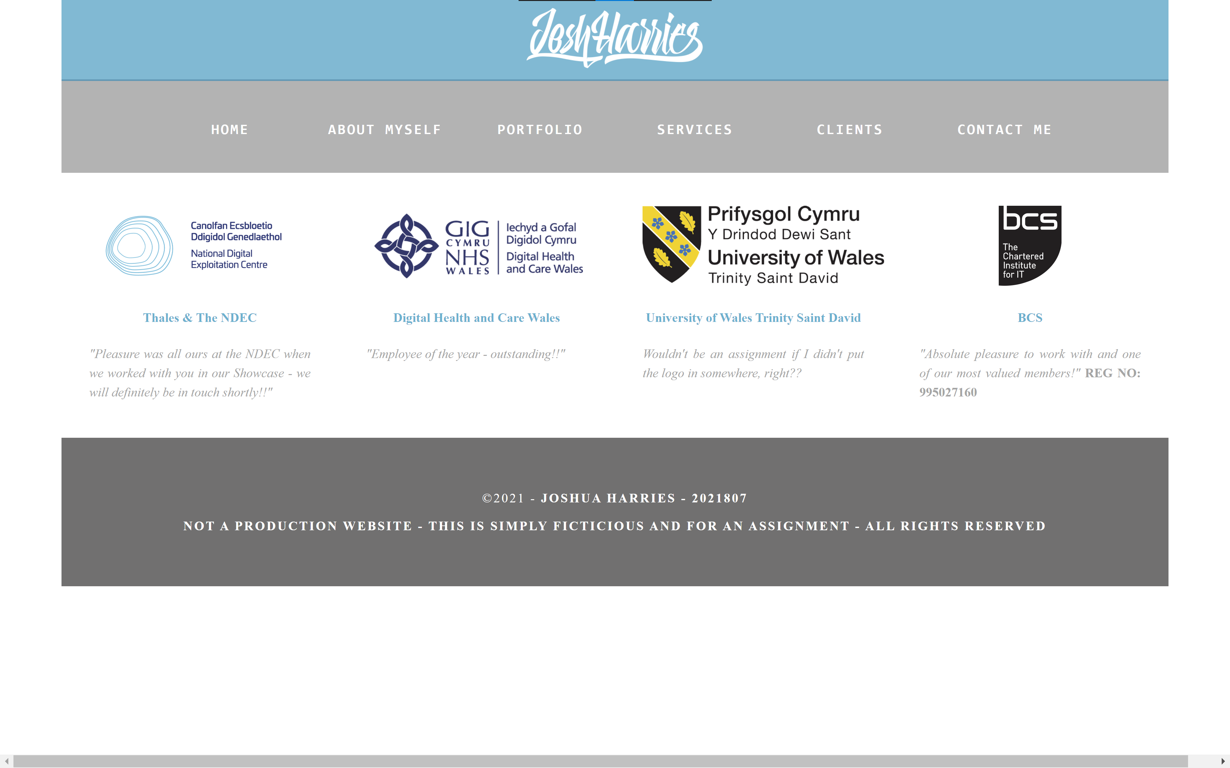

Contact Me
On the contact me page, there’s two sections – the left section contains details of how the end user can contact me to ‘Get A Quote’ and my social media links. The Right-hand side of the page then contains an interactive Google Maps, embedded into the HTML of the site using an iFrame.
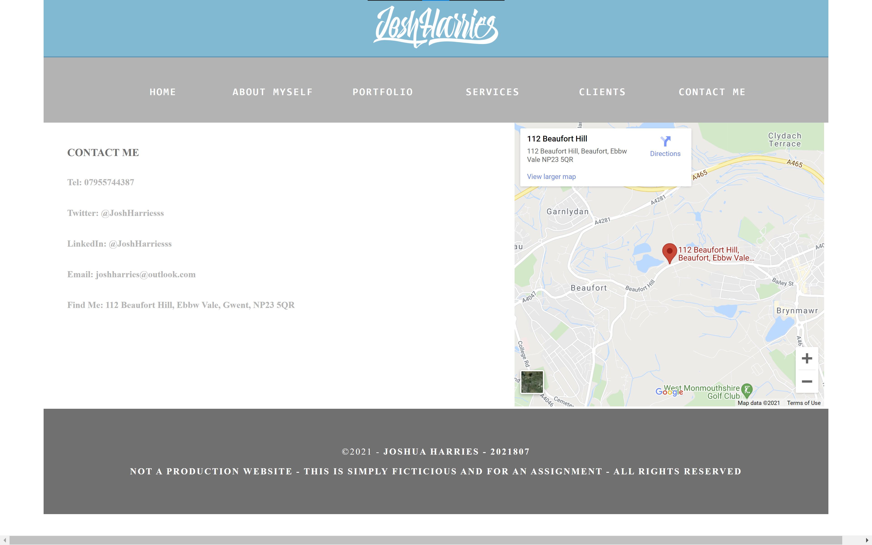

Validation

HTML
- Warning: Consider adding a lang attribute to the html start tag to declare the language of this document.
From line 1, column 16; to line 2, column 6
type html>↩<html>↩<head
- Error: Element a not allowed as child of element ul in this context. (Suppressing further errors from this subtree.)
From line 20, column 9; to line 20, column 31
>↩ <a href="contact.html"><li>CO
Contexts in which element a may be used:
Where phrasing content is expected.
Content model for element ul:
Zero or more li and script-supporting elements.
- Error: Bad value Assets/Web Dev ICON.png for attribute src on element img: Illegal character in path segment: space is not allowed.
From line 38, column 35; to line 38, column 95
l_align"> <img src="Assets/Web Dev ICON.png" alt="" class="thumbnail"/> </p>↩

To resolve the first issue, I have ensured that the HTML ‘lang’ tag is included in the head of each of my HTML pages.
To resolve the second issue, which repeats for each of the Nav Bar items, I have ensured that the <a> tag is inside the <li> tag – this issue was caused by an oversight on my part during the coding process.
To resolve the third issue, I ensured that all file names of assets that are used in the website do not contain any spaces in them, by renaming the files so something that doesn’t require spaces, or by using underscores. This will then fall in line with Camel Casing and other correct coding practices.

CSS
Sorry! We found the following errors (3)
URI : STYLESHEET.css
68 .primary_header Value Error : padding-right auto is not a padding-right value : auto
69 .primary_header Value Error : padding-left auto is not a padding-left value : auto
479 #headlogo Value Error : float center is not a float value : center

To resolve these issues, I would ensure that I use the correct CSS syntax’s – something that I have struggled with throughout this assignment.

Evaluation

Usefulness (Usability and Utility)
Webpage usability is fundamental to a websites success – a well-designed, accessible, easy to use and efficient website is essentially make or break for a user to decide on whether they will a) be able to use the website for their intended purpose and b) whether they’d return to the website in the future and potentially recommend others to visit the site. Useability can be applied to virtually anything – e.g. a website, a machine, a toaster, a garden hose etc. Useability put simply is the measure of how easy it is to use. It is essential that web designers and developers continually ensure that their website’s usability is up to scratch so that users do not get thrown off – they can do this by actively engaging with their target audience by doing surveys and remote testing, for example. [2]
Web designers and developers usually forget the basic principles of usability such as page layout, but they also must remember not to ‘tar every website with the same brush’, as one websites usability requirements may differ massively from other websites, as explained by Alastair Smith in the peer-reviewed journal ‘Homepage Usability: 50 Web sites Deconstructed’ [3].
Based on the research that I have concluded on website usability and usefulness, I feel that my website meets all the industry-standard practices, for example, a clear and concise navigation bar, and the look and feel of it is clean and sleek, so it’s accessible to all users as well. The functionality of the website I feel is extremely practical and meets the intended purpose that I set out in the requirements section. I feel that the content of the finished site is quite bare compared to what I would like a real finished website to contain, but I feel that for a basic introduction to the company, it would be more than suitable. In the future, I would like to integrate a client area where they can log in, view a knowledgebase and support tickets, and possibly transform the site into a ‘Parallex’ style website, so that it comes into the 21st century web.

Search Engine Optimisation (SEO)
Search Engine Optimisation, or commonly known as SEO, is the blanket term for influencing the websites visibility on search engine result pages, also known as SERP, on sites such as Google. For all website and business owners, the goal is to have your website at the highest position on search results or keywords linked to their company. There’s many techniques to influence the position of the website on the search results, varying from increasing the key words associated with the website throughout the pages and HTML code, to paying for a sponsored space at the top of the search results. Where you optimise search results through not paying, this is called ‘organic search engine optimisation’, compared to when you buy sponsored slots on search engines. In a study by Conductor, it is suggested that 64% of all web traffic comes from organic search results [4]. In a peer reviewed article by Ron Berman and Zsolt Katona, they examine the impact of search engine optimization on the competition between advertisers for organic and sponsored search results. In it, they say that SEO has become a ‘multi-billion dollar’ business over the past few years, and it continues to grow tremendously. They then go on to saying that correct Search Engine Optimisation is extremely important to consumers visiting the website as sometimes, the search engines’ indexing and crawling of the websites are not reliable, so it may not scrape the website correctly, which I completely agree with. [5]

Accessibility
Accessibility is more commonly associated with people with disabilities, whether hidden or visible, but the reality is it affects everyone and anyone – whether it’s a website, using a smart watch, or simply because you don’t have good internet. Accessibility is especially important in this society due to more and more people, including older adults, are getting online as it may be the only way for them to do things – such as shopping online due to then not being able to visit the shop due to COVID-19. Accessibility on a website could mean many things – large, high contrast font for hard of sight people to read; low sized websites and images for them to load quicker for people with bad internet to still be able to view them; reactive, mobile first websites for people who don’t own a PC or laptop to view correctly; and many more. Accessibility of a website is especially important to me, as its truly make or break whether my mother, who has physical disabilities, can use the site to be able to do tasks like shopping that she wouldn’t be able to do in person. w3.org defines the 4 main principles of web accessibility as a user being able to “perceive, understand, navigate, and interact with the web” [6] During my development, I used the accessibility development engine aXe to evaluate my website, so that I can ensure users who rely on website accessibility can use my website to their full potential. The findings are below.
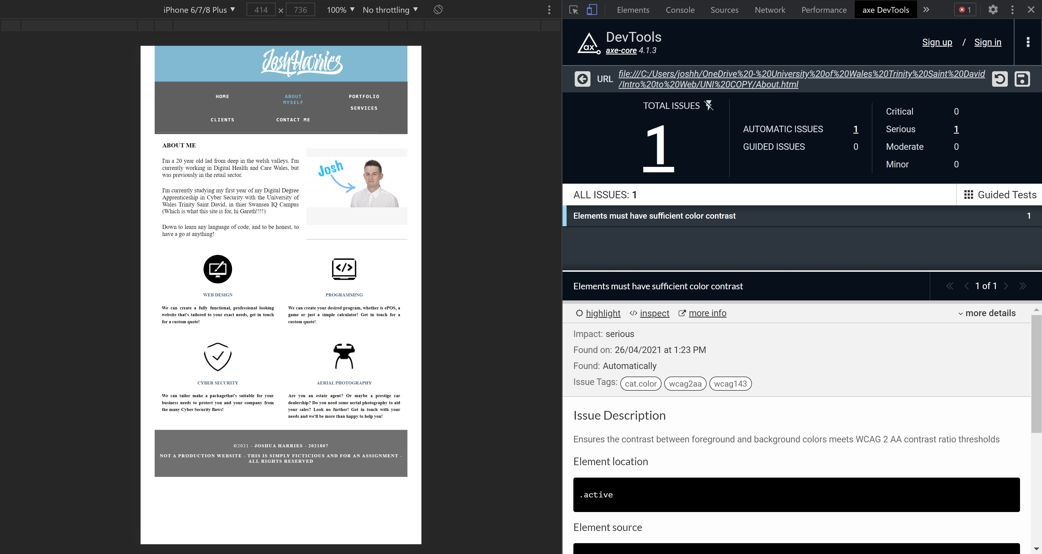
As you can see, the only issue that it’s picked up on is that the .active class, which highlights the active page in a blue colour, hasn’t got a high enough contrast ratio. I have fixed this post development to a lighter blue, so that it meets the WCAG 2.1 accessibility guidelines. You can also see the website working and displaying correctly in a responsive format, namely an iPhone. I personally believe that I have met the four principles of web accessibility, and that if a person who relied on a site being accessible used my site, they would not encounter any issues. A study that caught my attention is one by Hanson & Richards, where they go on to say how much we have progressed with web accessibility over the past years since WCAG 1.0 was introduced, but that we’re not there yet with many major sites like government sites and popular sites like Sky Bet and that there’s more work to be completed [7].
In conclusion, I believe that I have created an accessible, efficient and optimised website, albeit basic, and that in the future if I were doing this assignment over again, I would like to enhance my skills to bring the design into the 21st century, and to include more content.

References

[1] | Unsplash, “Unsplash Licence of Use,” Unsplash, 2021. [Online]. Available: https://unsplash.com/license. [Accessed 20 04 2021].
[2] | T. CHURM, “An Introduction To Website Usability Testing,” Usability Geek, 2020. [Online]. Available: https://usabilitygeek.com/an-introduction-to-website-usability-testing/. [Accessed 20 04 2021].
[3] | A. Smith, “Homepage Usability: 50 Web sites Deconstructed,” Online information review, vol. 27, no. 4, p. 293–294, 2003.
[4] | C. Ratcliff, “SEO basics: 22 essentials you need for optimizing your site,” Search Engine Watch, 21 Jan 2016. [Online]. Available: https://www.searchenginewatch.com/2016/01/21/seo-basics-22-essentials-you-need-for-optimizing-your-site/. [Accessed 24 04 2021].
[5] | R. Berman and Z. Katona, “The Role of Search Engine Optimization in Search Marketing,” Marketing science (Providence, R.I.), vol. 32, no. 4, pp. 655-651, 2013.
[6] | S. L. Henry, “Introduction to Web Accessibility,” w3 / WAI, 5 June 2019. [Online]. Available: https://www.w3.org/WAI/fundamentals/accessibility-intro/#:~:text=Web%20accessibility%20means%20that%20websites,contribute%20to%20the%20Web. [Accessed 26 04 2021].
[7] | V. L. Hanson and J. T. Richards, “Progress on Website Accessibility?,” ACM transactions on the web, vol. 7, no. 1, pp. 1-30, 2013.

Appendices

Index.html
<!doctype html>

<html lang="en">

<head>

<title>Josh Harries - HOME</title>
<link href="css/STYLESHEET.css" rel="stylesheet" type="text/css">

</head>

<body>

<div class="container">

<header>
<div class="primary_header">
<img src="Assets/Josh-Harries-Type.png" alt="JH Logo" width="auto" height="100" id="headlogo"/>
</div>
<nav class="secondary_header" id="menu">
<ul>
<li><a href="index.html" class="active">HOME</a></li>
<li><a href="About.html">ABOUT MYSELF</a></li>
<li><a href="work.html">PORTFOLIO</a></li>
<li><a href="services.html">SERVICES</a></li>
<li><a href="clients.html">CLIENTS</a></li>
<li><a href="contact.html">CONTACT ME</a></li>
</ul>
</nav>
</header>

<section>
<h2 class="noDisplay">Main Content</h2>
<article class="left_article">
<h3>Introduction</h3>
<p>Welcome to the personal website of Josh Harries, incorperating Josh Harries Tech Services as a sole trader. </p>
<p>In this website, you'll find all of the services I can offer you, along with a short 'About Me', how to contact myself, client testimonials, and examples of my work - just use the tabs above to navigate!!!! </p>
<p>Any queries, you know how to reach me. </p>
<p>Below, and on every page, are the main service I offer - take a look around!!</p>
</article>
<aside class="right_article"><img src="Assets/BannerAnimated.gif" alt="Animated banner" width="400" height="200" class="placeholder"/> </aside>
</section>

<HR>

<div class="row">
<div class="columns">
<p class="thumbnail_align"> <img src="Assets/WebDev.png" alt="Web Development" class="thumbnail"/> </p>
<h4>WEB DESIGN</h4>
<p><strong>We can create a fully functional, professional looking website that's tailored to your exact needs, get in touch for a custom quote!</strong></p>
</div>
<div class="columns">
<p class="thumbnail_align"> <img src="Assets/Programming.png" alt="Programming" class="thumbnail"/> </p>
<h4>PROGRAMMING</h4>
<p><strong>We can create your desired program, whether is ePOS, a game or just a simple calculator! Get in touch for a custom quote! </strong></p>
</div>
<div class="columns">
<p class="thumbnail_align"> <img src="Assets/CyberSecurity.png" alt="Cyber Security" class="thumbnail"/> </p>
<h4>CYBER SECURITY</h4>
<p><strong>We can tailor make a packagethat's suitable for your business needs to protect you and your company from the many Cyber Security flaws!</strong></p>
</div>
<div class="columns">
<p class="thumbnail_align"> <img src="Assets/dRONE.png" alt="Aerial Photography" class="thumbnail"/> </p>
<h4>AERIAL PHOTOGRAPHY</h4>
<p><strong>Are you an estate agent? Or maybe a prestige car dealership? Do you need some aerial photography to aid your sales? Look no further! Get in touch with your needs and we'll be more than happy to help you!</strong></p>
</div>
</div>

<footer class="secondary_header footer">
<div class="copyright">
<p>&copy;2021 - <strong>Joshua Harries - 2021807</strong></p>
<p><strong>NOT A PRODUCTION WEBSITE - THIS IS SIMPLY FICTICIOUS AND FOR AN ASSIGNMENT - ALL RIGHTS RESERVED</strong></p>
</div>
</footer>

</div>

</body>

</html>

About.html
<!doctype html>

<html LANG="EN">

<head>

<title>Josh Harries - About Me</title>
<link href="css/STYLESHEET.css" rel="stylesheet" type="text/css">

</head>

<body>

<div class="container">

<header>
<div class="primary_header">
<img src="Assets/Josh-Harries-Type.png" alt="JH Logo" width="auto" height="100" id="headlogo"/>
</div>
<nav class="secondary_header" id="menu">
<ul>
<li><a href="index.html">HOME</a></li>
<li><a href="About.html" class="active">ABOUT MYSELF</a></li>
<li><a href="work.html">PORTFOLIO</a></li>
<li><a href="services.html">SERVICES</a></li>
<li><a href="clients.html">CLIENTS</a></li>
<li><a href="contact.html">CONTACT ME</a></li>
</ul>
</nav>
</header>

<section>
<h2 class="noDisplay">Main Content</h2>
<article class="left_article">
<h3>About ME</h3>
<p>I'm a 20 year old lad from deep in the welsh valleys. I'm currently working in Digital Health and Care Wales, but was previously in the retail sector.</p>
<p>I'm currently studying my first year of my Digital Degree Apprenticeship in Cyber Security with the University of Wales Trinity Saint David, in thier Swansea IQ Campus (Which is what this site is for, hi Gareth!!!!)</p>
<p>Down to learn any language of code, and to be honest, to have a go at anything!</p>
</article>
<aside class="right_article"><img src="Assets/Josh.png" alt="Photo of me" width="400" height="200" class="placeholder"/> </aside>
</section>

<HR>

<div class="row">
<div class="columns">
<p class="thumbnail_align"> <img src="Assets/WebDev.png" alt="Web Development" class="thumbnail"/> </p>
<h4>WEB DESIGN</h4>
<p><strong>We can create a fully functional, professional looking website that's tailored to your exact needs, get in touch for a custom quote!</strong></p>
</div>
<div class="columns">
<p class="thumbnail_align"> <img src="Assets/Programming.png" alt="Programming" class="thumbnail"/> </p>
<h4>PROGRAMMING</h4>
<p><strong>We can create your desired program, whether is ePOS, a game or just a simple calculator! Get in touch for a custom quote! </strong></p>
</div>
<div class="columns">
<p class="thumbnail_align"> <img src="Assets/CyberSecurity.png" alt="Cyber Security" class="thumbnail"/> </p>
<h4>CYBER SECURITY</h4>
<p><strong>We can tailor make a packagethat's suitable for your business needs to protect you and your company from the many Cyber Security flaws!</strong></p>
</div>
<div class="columns">
<p class="thumbnail_align"> <img src="Assets/dRONE.png" alt="Aerial Photography" class="thumbnail"/> </p>
<h4>AERIAL PHOTOGRAPHY</h4>
<p><strong>Are you an estate agent? Or maybe a prestige car dealership? Do you need some aerial photography to aid your sales? Look no further! Get in touch with your needs and we'll be more than happy to help you!</strong></p>
</div>
</div>

<footer class="secondary_header footer">
<div class="copyright">
<p>&copy;2021 - <strong>Joshua Harries - 2021807</strong></p>
<p><strong>NOT A PRODUCTION WEBSITE - THIS IS SIMPLY FICTICIOUS AND FOR AN ASSIGNMENT - ALL RIGHTS RESERVED</strong></p>
</div>
</footer>

</div>

</body>

</html>

Work.html
<!doctype html>

<html lang="en">

<head>

<title>Josh Harries - Portfolio</title>
<link href="css/STYLESHEET.css" rel="stylesheet" type="text/css">

</head>

<body>

<div class="container">

<header>
<div class="primary_header">
<img src="Assets/Josh-Harries-Type.png" alt="JH Logo" width="auto" height="100" id="headlogo"/>
</div>
<nav class="secondary_header" id="menu">
<ul>
<li><a href="index.html">HOME</a></li>
<li><a href="About.html">ABOUT MYSELF</a></li>
<li><a href="work.html" class="active">PORTFOLIO</a></li>
<li><a href="services.html">SERVICES</a></li>
<li><a href="clients.html">CLIENTS</a></li>
<li><a href="contact.html">CONTACT ME</a></li>
</ul>
</nav>
</header>

<div class="row">

<div class="columns">
<p class="thumbnail_align"> <img src="Assets/question-mark.png" alt="Help!" class="thumbnail-work"/> </p>
<h4>Click on the thumbnails to enlarge!!</h4>
<p><strong>Note to assessor of website:</strong></p>
<p>Some Photos are taken from Unsplash as placeholders. Click on the thumbnails to be taken to the respective site for the shown image.</p>
<p>All images are copyright-free.</p>
</div>

<div class="columns">
<p class="thumbnail_align"> <a href="Assets/Work/Drone One.png" target="_blank"><img src="Assets/Work/Drone One.png" alt="Local Drone Photo" class="thumbnail-work"/></a> </p>
<h4>Local Drone Photo</h4>
</div>

<div class="columns">
<p class="thumbnail_align"> <a href="Assets/Work/Mockup A1.png" target="_blank"><img src="Assets/Work/Mockup A1.png" alt="Web Design" class="thumbnail-work"/></a> </p>
<h4>Web Design Example</h4>
</div>

<div class="columns">
<p class="thumbnail_align"> <a href="https://unsplash.com/photos/kaArpbitYO0" target="_blank"><img src="Assets/Work/DroneTwo.jpg" alt="Cliff Drone Photo" class="thumbnail-work"/></a> </p>
<h4>Cliff Drone Photo</h4>
</div>

<div class="columns">
<p class="thumbnail_align"> <a href="https://unsplash.com/photos/xrVDYZRGdw4" target="_blank"><img src="Assets/Work/Workstation.jpg" alt="Workstation - Coding" class="thumbnail-work"/></a> </p>
<h4>Workstation - Coding</h4>
</div>

<div class="columns">
<p class="thumbnail_align"> <a href="https://unsplash.com/photos/b20KkQ1rQmw" target="_blank"><img src="Assets/Work/DroneThree.jpg" alt="Aerial View of a Port" class="thumbnail-work"/></a> </p>
<h4>Aerial View of a Port</h4>
</div>

<div class="columns">
<p class="thumbnail_align"> <a href="https://unsplash.com/photos/-2gFakUG-SA" target="_blank"><img src="Assets/Work/Drone Four.jpg" alt="Local Drone Photo" class="thumbnail-work"/></a> </p>
<h4>Local Drone Photo</h4>
</div>

</div>

<HR>

<div class="row">
<div class="columns">
<p class="thumbnail_align"> <img src="Assets/WebDev.png" alt="Web Development" class="thumbnail"/> </p>
<h4>WEB DESIGN</h4>
<p><strong>We can create a fully functional, professional looking website that's tailored to your exact needs, get in touch for a custom quote!</strong></p>
</div>
<div class="columns">
<p class="thumbnail_align"> <img src="Assets/Programming.png" alt="Programming" class="thumbnail"/> </p>
<h4>PROGRAMMING</h4>
<p><strong>We can create your desired program, whether is ePOS, a game or just a simple calculator! Get in touch for a custom quote! </strong></p>
</div>
<div class="columns">
<p class="thumbnail_align"> <img src="Assets/CyberSecurity.png" alt="Cyber Security" class="thumbnail"/> </p>
<h4>CYBER SECURITY</h4>
<p><strong>We can tailor make a packagethat's suitable for your business needs to protect you and your company from the many Cyber Security flaws!</strong></p>
</div>
<div class="columns">
<p class="thumbnail_align"> <img src="Assets/dRONE.png" alt="Aerial Photography" class="thumbnail"/> </p>
<h4>AERIAL PHOTOGRAPHY</h4>
<p><strong>Are you an estate agent? Or maybe a prestige car dealership? Do you need some aerial photography to aid your sales? Look no further! Get in touch with your needs and we'll be more than happy to help you!</strong></p>
</div>
</div>

<footer class="secondary_header footer">
<div class="copyright">
<p>&copy;2021 - <strong>Joshua Harries - 2021807</strong></p>
<p><strong>NOT A PRODUCTION WEBSITE - THIS IS SIMPLY FICTICIOUS AND FOR AN ASSIGNMENT - ALL RIGHTS RESERVED</strong></p>
</div>
</footer>

</div>

</body>

</html>

Services.html
<!doctype html>

<html lang="en">

<head>

<title>Josh Harries - Services</title>
<link href="css/STYLESHEET.css" rel="stylesheet" type="text/css">

</head>

<body>

<div class="container">

<header>
<div class="primary_header">
<img src="Assets/Josh-Harries-Type.png" alt="JH Logo" width="auto" height="100" id="headlogo"/>
</div>
<nav class="secondary_header" id="menu">
<ul>
<li><a href="index.html">HOME</a></li>
<li><a href="About.html">ABOUT MYSELF</a></li>
<li><a href="work.html">PORTFOLIO</a></li>
<li><a href="services.html" class="active">SERVICES</a></li>
<li><a href="clients.html">CLIENTS</a></li>
<li><a href="contact.html">CONTACT ME</a></li>
</ul>
</nav>
</header>

<div class="row">
<div class="columns">
<p class="thumbnail_align"> <img src="Assets/WebDev.png" alt="Web Development" class="thumbnail"/> </p>
<h4>WEB DESIGN</h4>
<p><strong>We can create a fully functional, professional looking website that's tailored to your exact needs, get in touch for a custom quote!</strong></p>
</div>
<div class="columns">
<p class="thumbnail_align"> <img src="Assets/Programming.png" alt="Programming" class="thumbnail"/> </p>
<h4>PROGRAMMING</h4>
<p><strong>We can create your desired program, whether is ePOS, a game or just a simple calculator! Get in touch for a custom quote! </strong></p>
</div>
<div class="columns">
<p class="thumbnail_align"> <img src="Assets/CyberSecurity.png" alt="Cyber Security" class="thumbnail"/> </p>
<h4>CYBER SECURITY</h4>
<p><strong>We can tailor make a packagethat's suitable for your business needs to protect you and your company from the many Cyber Security flaws!</strong></p>
</div>
<div class="columns">
<p class="thumbnail_align"> <img src="Assets/dRONE.png" alt="Aerial Photography" class="thumbnail"/> </p>
<h4>AERIAL PHOTOGRAPHY</h4>
<p><strong>Are you an estate agent? Or maybe a prestige car dealership? Do you need some aerial photography to aid your sales? Look no further! Get in touch with your needs and we'll be more than happy to help you!</strong></p>
</div>
</div>

<footer class="secondary_header footer">
<div class="copyright">
<p>&copy;2021 - <strong>Joshua Harries - 2021807</strong></p>
<p><strong>NOT A PRODUCTION WEBSITE - THIS IS SIMPLY FICTICIOUS AND FOR AN ASSIGNMENT - ALL RIGHTS RESERVED</strong></p>
</div>
</footer>

</div>

</body>

</html>

Clients.html
<!doctype html>

<html lang="en">

<head>

<title>Josh Harries - Clients</title>
<link href="css/STYLESHEET.css" rel="stylesheet" type="text/css">

</head>

<body>

<div class="container">

<header>
<div class="primary_header">
<img src="Assets/Josh-Harries-Type.png" alt="JH Logo" width="auto" height="100" id="headlogo"/>
</div>
<nav class="secondary_header" id="menu">
<ul>
<li><a href="index.html">HOME</a></li>
<li><a href="About.html">ABOUT MYSELF</a></li>
<li><a href="work.html">PORTFOLIO</a></li>
<li><a href="services.html">SERVICES</a></li>
<li><a href="clients.html" class="active">CLIENTS</a></li>
<li><a href="contact.html">CONTACT ME</a></li>
</ul>
</nav>
</header>

<div class="row">

<div class="columns">
<p class="thumbnail_align"> <img src="Assets/NDEC.png" alt="NDEC Logo" class="thumbnail-work"/> </p>
<h4>Thales &amp; The NDEC</h4>
<p><em>"Pleasure was all ours at the NDEC when we worked with you in our Showcase - we will definitely be in touch shortly!!"</em></p>
</div>

<div class="columns">
<p class="thumbnail_align"> <img src="Assets/DHCW.png" alt="DHCW Logo" class="thumbnail-work"/> </p>
<h4>Digital Health and Care Wales</h4>
<p><em> "Employee of the year - outstanding!!" </em></p>
</div>

<div class="columns">
<p class="thumbnail_align"> <img src="Assets/UWTSD-Logo.png" alt="UWTSD LOGO" class="thumbnail-work"/> </p>
<h4>University of Wales Trinity Saint David</h4>
<p><em>Wouldn't be an assignment if I didn't put the logo in somewhere, right??</em></p>
</div>

<div class="columns">
<p class="thumbnail_align"> <img src="Assets/BCS.svg" alt="BCS logo" class="thumbnail-work"/> </p>
<h4>BCS</h4>
<p><em> "Absolute pleasure to work with and one of our most valued members!" </em><strong>REG NO: 995027160</strong><em> </em></p>
</div>

</div>

<footer class="secondary_header footer">
<div class="copyright">
<p>&copy;2021 - <strong>Joshua Harries - 2021807</strong></p>
<p><strong>NOT A PRODUCTION WEBSITE - THIS IS SIMPLY FICTICIOUS AND FOR AN ASSIGNMENT - ALL RIGHTS RESERVED</strong></p>
</div>
</footer>

</div>

</body>

</html>

Contact.html
<!doctype html>

<html lang="en">

<head>

<title>Josh Harries - Contact Me</title>
<link href="css/STYLESHEET.css" rel="stylesheet" type="text/css">

</head>

<body>

<div class="container">

<header>
<div class="primary_header">
<img src="Assets/Josh-Harries-Type.png" alt="JH Logo" width="auto" height="100" id="headlogo"/>
</div>
<nav class="secondary_header" id="menu">
<ul>
<li><a href="index.html">HOME</a></li>
<li><a href="About.html">ABOUT MYSELF</a></li>
<li><a href="work.html">PORTFOLIO</a></li>
<li><a href="services.html">SERVICES</a></li>
<li><a href="clients.html">CLIENTS</a></li>
<li><a href="contact.html" class="active">CONTACT ME</a></li>
</ul>
</nav>
</header>

<section>
<h2 class="noDisplay">Main Content</h2>
<article class="left_article">
<h3>Contact Me</h3>
<strong><p>Tel: 07955744387</p>
<p>Twitter: @JoshHarriesss </p>
<p>LinkedIn: @JoshHarriesss</p>
<p>Email: joshharries@outlook.com</p>
<p>Find Me: 112 Beaufort Hill, Ebbw Vale, Gwent, NP23 5QR</p></strong>
</article>

<aside class="right_article_contact"><iframe src="https://www.google.com/maps/embed?pb=!1m18!1m12!1m3!1d9391.417938804356!2d-3.1932965706010097!3d51.798287641875206!2m3!1f0!2f0!3f0!3m2!1i1024!2i768!4f13.1!3m3!1m2!1s0x486e26253061720b%3A0xd21ad634298a282b!2s112%20Beaufort%20Hill%2C%20Beaufort%2C%20Ebbw%20Vale%20NP23%205QR!5e0!3m2!1sen!2suk!4v1585766465518!5m2!1sen!2suk" width="545" height="500" frameborder="0" style="border:0;" allowfullscreen="false" aria-hidden="true" tabindex="-1"></iframe></aside>

</section>

<footer class="secondary_header footer">
<div class="copyright">
<p>&copy;2021 - <strong>Joshua Harries - 2021807</strong></p>
<p><strong>NOT A PRODUCTION WEBSITE - THIS IS SIMPLY FICTICIOUS AND FOR AN ASSIGNMENT - ALL RIGHTS RESERVED</strong></p>
</div>
</footer>

</div>
</body>
</html>

