

Student Name
Student Number
Programme: | MSc Public Health and Social Care in Practice
Module: | Quality Assurance and Service Improvements
Module code: | LCHS7006 | Assignment Title: | Component 2  Service Improvement Report
Lecturer: | Dilhara Mampitiya  Christopher Mafuva | Internal Verifier: | Dr Hamdi Hussain
Word Count | 3217 words

Table of Contents
Introduction 3
Main body 4
Recommendation 9
Conclusion 12
References 14

Introduction
Introduction
The Mid Staffordshire NHS Foundation (UK) is responsible for providing effective and personalised treatment for patients in vulnerable situations. However, the trust created the biggest scandal in history between 2005 and 2008 due to neglecting effective patient care services. The issue arose due to shortage of senior doctors and nurses, which put extra pressures on existing staff to meet targets, which resulted in more than 400 unnecessary deaths in between 2005 to 2008 (BBC, 2019).
Identified problem as a concern
The Mid Staffordshire NHS Foundation Trust became one of the UK’s most significant healthcare quality failures because the problems extended beyond isolated clinical errors to reflect a systemic breakdown in leadership, governance and organisational culture. It has been found that approx 400 to 1200 people are unnecessarily suffering from this system failure incident, which ignored warning sights while putting cost control and corporate self-interest ahead of patient safety (NHS.UK, 2026). Widespread failures in patient care indicate poor hygiene, inadequate staffing, neglect and the repeated dismissal of patient and staff concerns. This issue poses a severe negative impact on the public trust in the national healthcare system.
Importance of quality assurance report
The Mid Staffordshire NHS Foundation Trust scandal represents one of the most significant healthcare quality failures in NHS history because it exposed widespread systematic failures in leadership, staffing, governance and organisational culture rather than isolated clinical errors. To address this issue, the NHS needs to improve their policy and quality improvement practices by reviewing processes and systems, staffing levels, and boosting confidence to ensure best practice levels of care (NHS.UK, 2026). The Francis inquiry mainly found that the trust mainly prioritised financial outcomes over its compassionate and high-quality patient-centred care, and consequently, this case provides a valuable foundation for analysing service improvement strategies in healthcare. Thus, by reviewing the report, the trust board has asked their staff to consider the recommendations suggested by the Francis report and improve their own areas to restrict these incidents further and redouble their efforts in striving to become amongst the best in providing the best possible care for their patients.
The report aims to critically analyse the quality and patient safety failures at Mid Staffordshire NHS Foundation Trust by identifying their underlying root causes using root cause analysis models, including the Donabedian Model, Fishbone diagram and SWOT analysis.
Furthermore, evidence-based quality improvement models will be used, such as PDSA and PDCA, to propose sustainable implementation and monitoring strategies to support continuous quality improvement and restore public trust by ensuring quality, safety and effectiveness of the health services.

Main body
Critical evaluation of the issue by using relevant theories
The Mid Staffordshire NHS Foundation Trust scandal represents a major quality improvement challenge because the failures were systematic instead of isolated clinical incidents. Between 2005 and 2009, widespread deficiencies in patient care resulted in avoidable deaths, poor patient experiences and a significant loss of public confidence in the NHS (UK. GOV., 2026). The Francis Inquiry identified that ineffective leadership, weak clinical governance, inadequate staffing, poor communication and a culture prioritising financial targets over patient safety were the primary contributors to the Trust’s failure. Thus, to identify the root cause of the issues, a Fishbone diagram, Donabedian Model and SWOT analysis will be used in the following section.
Fishbone Diagram
This Fishbone diagram has five stages, which help in analysing why an issue arises and what is the main root cause of these issues in NHS trusts, hence it will apply to Mid Staffordshire NHS Foundation Trust to analyse its root cause of system failure issues.
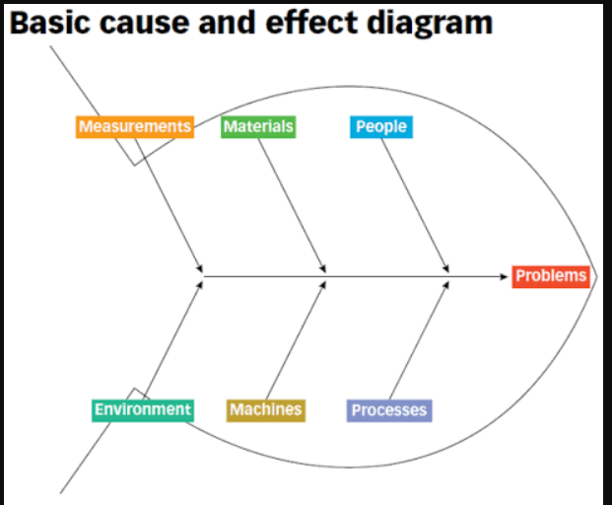
Figure 1: Fishbone Diagram
(Source: ASQ, 2026)
The quality failures in Mid Staffordshire NHS Foundation Trust were not the consequences of a single clinical mistake, but rather a complex organisational failure arising from the interconnected weaknesses in leadership, workforce and governance (While, 2015). Through the lens of the Fishbone Diagram, the regrettable events at Stafford Hospital are recognised as a leadership failure to deliver safe and compassionate care, which results in increased mortality; hence, the company needs to improve their quality of care by using evidence-based recommendations and UK healthcare commission support.
From the People (man) category It has been found that a shortage of nurses, inadequate staffing, such as the NHS experiencing 150 job losses, and poor staff morale minimised the trust’s ability to provide proactive and patient-centred care (Rafferty and Leary, 2023). Staff shortages and governance failure are the main root causes of service failure issues because existing staff are perceived to have excessive workloads, which restricts them in delivering compassionate care while increasing the likelihood of clinical errors and delayed interventions.
From the Methods category, it has been identified that ineffective governance processes such as dual systems of clinical and corporate controlled by the Board of directors and a council of Governors and poor incident reporting system as a major contributor to organisational failure (NHS England, 2021). Internal audits failed to trigger timely corrective actions, while patient complaints were systematically disregarded. Instead of using governance systems to improve care quality, the trust’s senior management prioritised organisational reputation and financial targets, which demonstrates a significant breakdown in clinical governance.
From the machines and materials perspective, it has been analysed that Staffordshire’s employees and GP’s are unable to find effective and efficient equipment, insufficient resuscitation resources, and inefficient hygiene standards, which compromise patient safety and their effective care support, and are also the main root cause of the biggest scandals of the hospital.
Finally, the Environmental category reflected the trust’s dysfunctional organisational culture driven by poor organisational culture, ineffective managerial support and weak accountability. This ineffective environment discouraged staff from learning from the environment and reinforced unsafe clinical practices (Braithwaite et al., 2017).
Donabedian Model
The Donabedian Model consists of three core stages, including structure, process and outcomes; hence, it will be used for Mid Staffordshire NHS Foundation Trust to find out the root cause of its service failure issues.
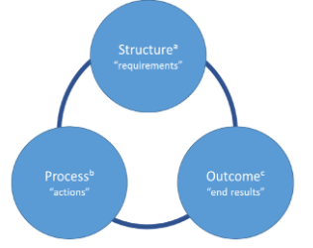
Figure 3: Donabedian Model
(Source: Tossaint-Schoenmakers, 2021)
From the structure perspective it has been found that Mid Staffordshire NHS Foundation Trust is facing chronic nursing shortages, weak board oversight, inadequate staff training and ineffective clinical governance, which are the main root causes of rising system failure issues that contribute to 400 to 1200 deaths (UK. GOV., 2026a). Staff absenteeism is increasing due to low staff morale, and senior leaders prioritise financial performance and foundation trust status, which compromises patient safety, resulting in insufficient investment in workforce capacity and quality assurance. Therefore, these structural deficiencies weakened the organisation’s ability to deliver effective, safe and patient-centred care.
Through the lens of the process dimension, evaluate how the organisation's services are delivered. It has been found that 69% of patient complaints were about the trust’s staff’s concerns being repeatedly ignored, while ineffective monitoring and delayed responses to safety incidents allowed poor clinical practices to persist (Ross, 2015). Furthermore, poor communication between healthcare professionals and management decreased organisational learning and restricted timely corrective actions, which demonstrates failures in both clinical and managerial processes of the NHS trust (Dixon-Woods, 2024). These are the main root causes of providing effective health care support to the vulnerable patients in a timely manner.
The above-mentioned structural and process failures directly contributed to poor outcomes, including an estimated 400-1200 avoidable deaths and increased health-associated infections, ultimately decreasing patient satisfaction and trust in the NHS trust (Campbell, 2013). As a result of the consequences, 900 patients stated that the most basic elements of the care were neglected by the trust’s staff, and as an outcome, their trust eroded over the selected trust. The main root cause of these poor outcomes is ineffective leadership style and the trust’s ruling board, which was inadequate and lacked appropriate sense of urgency.
SWOT analysis
Strengths: The NHS Staffordshire’s primary strength lies in operating within the National Health Service, which provides comprehensive clinical governance frameworks, national patient safety standards, regulatory oversight and access to evidence-based environment programmes (NHS.UK, 2026a). Additionally, the NHS Staffordshire has introduced significant reforms, including the Duty of Candour, NHS patient safety strategy and strengthened Care Quality Commission (CQC) inspections with robust mechanisms to improve patient safety (NHS.UK, 2026), which is another strength of the company.
Weakness: The trust is facing a severe service failure issue, which results in 400 to 1200 unnecessary deaths in the UK, which undermines public trust in the company and results in financial damage to the company (Khan, 2023; Triggle, 2013). Additionally, weakness is failure to respond to patient complaints and staff concerns, reflecting inadequate organisational learning, while financial priorities consistently outweighed patient-centred decision-making. Collectively, these weaknesses reduced organisational resilience and significantly increased the likelihood of systemic failure. Therefore, leadership reform and cultural transformation remain essential prerequisites for successful service improvement.
Opportunities: Despite these weaknesses, several significant opportunities exist to strengthen future service quality. For instance, the UK healthcare commission’s head of operational development planned to offer training and support to those 10 trust’s employees under the NHS, which have the highest number of unresolved complaints against their treatment and emergency department (Antonopoulou et al., 2024). Hence, it is the greatest opportunity for NHS Staffordshire to get support from the UK healthcare commission to improve their services and address complaints against their poor communication, unsatisfactory patient experience, poor clinical practice, and poor staff attitude. Additionally, the “Parliamentary and Health Service Ombudsman” also helps NHS trusts to ensure faster and more effective handling of patient complaints (Antonopoulou et al., 2024). Collectively, these opportunities can help the trust to reduce its complaints regarding service negligence and regain patients' trust.
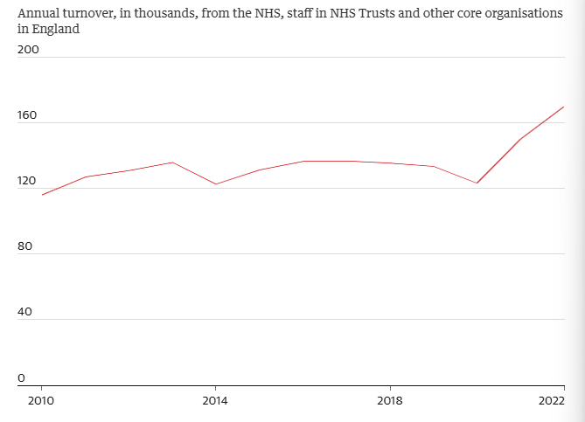
Figure 2: Hospital and community health services lost 170,000 staff in 2022
(Source: Thomas, 2023)
Threats: The organisation continues to face considerable threats that may hinder their long-term improvement because they are suffering from financial constraints, an increasing patient demand for personalised care, workforce shortage, staff burnout and increasing number of NHS trusts (Daniels et al., 2022). It has been found that 170,000 workers left their professions in the NHS trust due to the high workloads, which decreased the trust’s capability to provide effective and personalised care to patients, which is the main threat to the company (Thomas, 2023).
Integration & Critical evaluation of the issue
It has been found that these interconnected organisational weaknesses can be prevented by the timely identification and early management of clinical risks, which will allow safe practices of the trust towards its patient care and regain its consumers' trust. Therefore, a comprehensive diagnosis of the underlying causes is important before developing improvement strategies. To achieve this, a Fishbone diagram is applied to identify the multidimensional root causes of service failure, the Donabedian Model explains how weaknesses across organisational safety barriers align to produce adverse outcomes, and SWOT analysis evaluates the Trust’s strategic capacity to implement and sustain evidence-based quality improvements.
Despite the benefits of these models in finding the root causes of the NHS Trust, however, these fail to provide the significance of integrated strong leadership, clinical audits and patient feedback mechanisms to strengthen patient safety and ensure sustainable quality improvement across the trust.
Linked to the evidence-based recommendations
Fishbone Diagram, Donabedian Model and SWOT analysis found out the Mid Staffordshire NHS Foundation Trust's quality failure due to interconnected deficiencies in governance, leadership, workforce management and organisational culture, instead of its results from the isolated clinical errors. Hence, it required a comprehensive approach to address procedural, structural and strategic weaknesses. Therefore, the trust needs to focus on strengthening its clinical governance based on the method category of the Fishbone diagram to meet quality standards of the NHS. Additionally, by following the SWOT analysis, the company needs to improve workforce planning and recruit more qualified staff to reduce existing staff burnout by equally distributing the workload pressure. Lastly, through the lens of Donabedian model, developing transformational leadership and embedding a culture of continuous quality improvement is important for the NHS trust to further reduce its quality incidents. Collectively, these initiatives can help the firm to restore its patient trust and enhance its care quality, which will strengthen long-term organisational resilience.

Recommendation
From the above analysis, it has been found that the trust should adopt evidence-based quality improvement interventions, which have the potential to strengthen patient safety while also ensuring sustainable organisational change. Thus, the trust should adopt evidence-based quality improvement interventions that strengthen patient safety while ensuring sustainable organisational change through some tools, including the Plan-Do-Study-Act (PDSA) Cycle, Six Sigma and Lean, which promote continuous learning and incremental improvement.
Recommendation 1: Strengthen Clinical Governance and patient Safety Culture through the PDSA Cycle
This framework consists of four stages, which are concentrated on providing evidence-based recommendations to NHS trusts to improve their patient care quality (Bierbaum et al., 2025). For instance, through the lens of Plan stage, the trust should review incident reports, patient complaints and clinical audit findings to identify the root cause of any risks and take timely proactive actions by encouraging employees’ freedom of speech to report safety regarding incidents without fear of retaliation. Similarly, East London NHS Foundation Trust adopted this PDSA cycle through its ELFT quality improvement programme to structure staff-led patient safety and care quality projects, which reduced their patient safety incidents and medical errors, improved communication between multidisciplinary teams and enhanced patient satisfaction and quality of care (NHS Foundation Trust, 2026). Thus, through the Do stage NHS Staffordshire should recruit additional qualified nurses and healthcare professionals while implementing mentorship programmes, leadership development and regular clinical competency training. Furthermore, it will improve existing staff’s wellbeing through psychological support and reduce over workloads by assigning new qualified staff, which will reduce burnout and directly address structural weaknesses (Frias et al., 2025; Senek et al., 2025), which have been identified through the SWOT Model. However, during the Check phase, the trust needs to regularly monitor workforce’s performance by using measurable indicators, including staff retention rates, absenteeism through sickness and patient satisfaction scores. Thus, continuous analysis of these indicators is important to evaluate whether workforce interventions improve patient safety and operational efficiency. Finally, in the Act phase, the trust should finally incorporate long-term organisational policies, strong workforce allocation and ensuring continuous improvements, which will help NHS trust to reduce their quality errors and ensure high quality safety among patients.
Recommendation 2: Establish a Just Culture and Open Communication System Using Lean
From the Donabedian analysis, it has been found that during NHS trusts' poor communication between healthcare professionals and management decreased organisational learning and restricted timely corrective actions (Dixon-Woods, 2024). Thus, the trust should implement a just culture where healthcare professionals and management can openly communicate by applying Lean Methodology, which will focus on eliminating non-value-added activities and improving information flows across the healthcare process. Firstly, the trust should undertake value stream mapping to recognise communication bottlenecks and delays in incident escalation. According to Clark et al. (2025) and Mishali et al. (2025), standardised communication protocols help NHS trust to employ reporting pathways, because through this, frontline staff can raise their concerns about the patient's safety and required medical equipment and get timely responses from managerial support. Additionally, a “Just culture” promotes an organisational environment where staff can freely report a mistake to their manager without any fear of unfair punishment (Mohamed Badran et al., 2026), which boosts accountability and can help NHS trusts reduce their patient care failure through the staff-led environment. The effectiveness of this recommendation is demonstrated through how Virginia Mason’s addressed its patient care quality-related issues by adopting a lean management approach to implement continuous improvements (Ward, 2020). However, implementing a Just culture may encounter resistance from leaders and employees because they are accustomed to a traditional hierarchical culture, which can be solved through clear communication regarding the importance of implementing this culture to tackle their persistent patient care quality issues. Lastly, by implementing these lean principles within the everyday clinical practice, the Trust can strengthen its organisational learning, improve communication and establish a patient-centred culture, which reduces clinical risks and ensures the quality and safety of healthcare delivery.
Recommendation 3: Strengthen Digital Governance and Continuous Quality Monitoring Using Six Sigma
Six Sigma is a continuous improvement cycle, which can minimise clinical variation and improve patient safety with the help of the DMAIC (Define–Measure–Analyse–Improve–Control) approach (Carneiro et al., 2025).
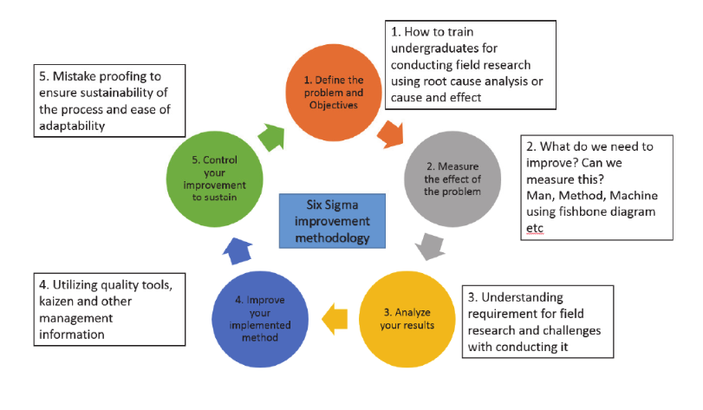
Figure 4: Six Sigma Model
(Source: Chopra et al. 2017)
As per the Define phase, the NHS trust should identify where the quality issues occur by monitoring medication errors, delayed incident reporting and poor compliance with NHS safety standards. Then, through the Measure phase, through the electronic incident reporting system, the NHS trust should collect baseline data on clinical performance and how many patients are concerned about the safety issue. After collecting data through the Analyse phase, the trust should identify root causes of performance by using clinical audits and statistical analysis. It has been found that 28,780 healthcare complaints are referred to the Health Services Ombudsman and Parliamentary and Health Service Ombudsman within 1 year (UK.GOV., 2025), which reflects that healthcare safety concerns still persist. Thus, in the Improve phase, the NHS trust should introduce digital patient safety dashboards, electronic clinical audit, and automated incident reporting system tools to support real-time monitoring and early risk identification. Lastly, in the Control phase the trust should ensure long-term sustainability of quality improvements through monthly governance reviews, benchmark comparisons and regular audits, which collectively will help the trust to improve quality standards and continuous staff training. Although financial constraints and resistance to change may present some challenges to the change, these can be mitigated through continuous monitoring, employee training and transparent communication.

Conclusion
From the report, it has been found that the Stafford Hospital is facing a service quality scandal due to chronic staff shortage issues, which ultimately results in the untimely death of many patients. Most patients' trust is lost due to the poor quality of health issues. Through the Fishbone Diagram, it has been found that the hospital’s staff ignored patients' complaints about their services, which ultimately results in late services, and patients are suffering from vulnerabilities. In addition, through the SWOT analysis, it has been found that NHS trusts are facing a workforce shortage, staff burnout, and increasing demand for personalised patient care-related issues, which ultimately decreases their quality of care and leads to patient death. Increasing number of deaths in the trust due to the quality failures around patient’s results and exposed the company to reputational damage. Lastly, through the Donabedian model, it has been found that patient safety incidents not only occur due to quality failures, but also due to poor communication between healthcare professionals and management, which decreased organisational learning and restricted timely corrective actions, which demonstrates failures in both the clinical and managerial processes of the NHS trust.
By considering the root cause analysis, it has been recommended that the trust strengthen Clinical Governance and Patient Safety Culture through the PDSA Cycle by implementing its four stages. Apart from that, the trust is suggested to establish a Just Culture and Open Communication System Using Lean, which helps to reduce miscommunication and fear of judgment among healthcare staff and will help to improve quality care by getting timely managerial support within healthcare practices. Lastly, the trust is recommended to Strengthen Digital Governance and Continuous Quality Monitoring Using Six Sigma, which can help the trust improve its quality of care by implementing the five stages of this Six Sigma model.

References
Antonopoulou, V., Meyer, C., Chadwick, P., Gibson, B., Sniehotta, F.F., Vlaev, I., Vassova, A., Goffe, L., Lorencatto, F., McKinlay, A. and Chater, A.M., 2024. Understanding healthcare professionals’ responses to patient complaints in secondary and tertiary care in the UK: A systematic review and behavioural analysis using the Theoretical Domains Framework. Health research policy and systems, 22(1), p.137. https://doi.org/10.1186/s12961-024-01209-4
ASQ (2026) Fishbone. Available at: https://asq.org/quality-resources/fishbone?srsltid=AfmBOoqYtSIH4DL2Ffb5II-XbUF4Omt_mdtkiD5UZ2nbfOIZBw3Wx1Gg (Accessed: 1st August, 2026)
BBC. (2019) ‘Stafford Hospital scandal: The real story behind Channel 4's The Cure’. Available at: https://www.bbc.com/news/uk-england-stoke-staffordshire-50836324 (Accessed: 1st August, 2026)
Bierbaum, M., Best, S., Williams, S., Fehlberg, Z., Hillier, S., Ellis, L.A., Goodrich, A., Padbury, R. and Hibbert, P. (2025) The integration of quality improvement and implementation science methods and frameworks in healthcare: a systematic review. BMC Health Services Research, 25(1), p.558. Available at: https://doi.org/10.1186/s12913-025-12730-9
Braithwaite, J., Herkes, J., Ludlow, K., Testa, L. and Lamprell, G. (2017) Association between organisational and workplace cultures, and patient outcomes: systematic review. BMJ open, 7(11), p.e017708. Available at: https://doi.org/10.1136/bmjopen-2017-017708
Campbell, D. (2013) Mid Staffs hospital scandal: the essential guide. The Guardian. Available at: https://www.theguardian.com/society/2013/feb/06/mid-staffs-hospital-scandal-guide (Accessed: 1st August, 2026)
Carneiro, F., Nóvoa, H., Carvalho, A.M. and Lamilla, F. (2025) Optimising ESG-enhanced performance: a literature review of lean, six sigma, and other continuous improvement methodologies. Total Quality Management & Business Excellence, 36(1-2), pp.146-178. Available at: https://doi.org/10.1080/14783363.2024.2442392
Chopra, K., Chopra, S. and Laux, C. (2017) Utilizing Six Sigma Methodology for Training Undergraduate Student for Conducting Global Field Research. Available at: https://doi.org/10.5703/1288284316375
Clark, D., Lawton, R., Baxter, R., Sheard, L. and O'Hara, J.K. (2025) Do healthcare professionals work around safety standards, and should we be worried? A scoping review. BMJ Quality & Safety, 34(5), pp.317-329. Available at: doi:10.1136/bmjqs-2024-017546 (Accessed: 1st August, 2026)
Daniels, K., Connolly, S., Woodard, R., van Stolk, C., Patey, J., Fong, K., France, R., Vigurs, C. and Herd, M. (2022) NHS staff wellbeing: Why investing in organisational and management practices makes business sense. London: IPPO. Available at: https://s3.amazonaws.com/kajabi-storefronts-production/file-uploads/sites/2148598877/themes/2163106936/downloads/8d4207-cd68-5250-6fdb-07f72db3faf6_IPPO_NHS_Staff_Wellbeing_report_LO160622-1849.pdf
Dixon-Woods, M. (2024) Report to the Thirlwall Inquiry: addressing Part C of the Terms of Reference. Expert report (INQ0102624). Available at: https://thirlwall.public-inquiry.uk/wp-content/uploads/thirlwall-evidence/INQ0102624%20-%20Expert%20Report%20of%20Mary%20Dixon-Woods.pdf
Frias, C.E., Samarasinghe, N., Cuzco, C., Koorankot, J., de Juan, A., Ali Rudwan, H.M., Rahim, H.F.A., Zabalegui, A., Tulley, I., Al-Harahsheh, S.T. and Al-Homaiddi, M.S.S., (2025) Strategies to support the mental health and well-being of health and care workforce: a rapid review of reviews. Frontiers in Medicine, 12, p.1530287. Available at: https://doi.org/10.3389/frhs.2025.1720494
Khan, Z. (2023) The emerging challenges and strengths of the National Health Services: a physician perspective. Cureus, 15(5). Available at: https://doi.org/10.7759/cureus.38617
Mishali, M., Sheffer, N. and Negev, M. (2025) Challenges and dynamics in reporting medical device incidents: a qualitative study. Frontiers in Health Services, 5, p.1720494. Available at: https://doi.org/10.3389/frhs.2025.1720494 (Accessed: 1st August, 2026)
Mohamed Badran, F.M., Rahman Gaber Khalifa, M.A.E., Elghannam, H.M. and Mohamed Ali, E.H. (2026) From blame to learning: implementing a just culture program for head nurses and its impact on silent behavior and error reporting among staff nurses. BMC nursing, 25(1), p.96. Available at: https://doi.org/10.1186/s12912-025-04265-5 (Accessed: 1st August, 2026)
NHS England (2021) Final-Independent-Investigation-Urology-Report-University. Available at: https://www.england.nhs.uk/north-west/wp-content/uploads/sites/48/2021/11/Final-Independent-Investigation-Urology-Report-University-Hospitals-of-Morecambe-Bay-NHS-Foundation-Trust-24-N.pdf (Accessed: 1st August, 2026)
NHS Foundation Trust (2026) Improvement Stories. Available at: https://qi.elft.nhs.uk/stories (Accessed: 1st August, 2026)
NHS.UK. (2026) Learning from the failings at the Mid Staffordshire NHS Foundation Trust - Francis inquiry. Available at: https://www.enherts-tr.nhs.uk/wp-content/uploads/2019/09/Learning-from-the-failings-at-Mid-Staffordshire-NHS-Foundation-Trust-Trust-Statement.pdf (Accessed: 1st August, 2026)
NHS.UK. (2026a) Annual report and accountants 2023/2024. Available at: https://www.combined.nhs.uk/wp-content/uploads/2024/09/Annual-Report-2023-2024.pdf (Accessed: 1st August, 2026)
Rafferty, A.M. and Leary, A. (2023) Nursing notes on a scandal. Future Healthcare Journal, 10(1), pp.3-6.
Ross, D. (2015) Thinking differently about complaints in the NHS. Future Hospital Journal, 2(1), p.72. Available at: https://doi.org/10.7861/futurehosp.14.025 (Accessed: 1st August, 2026)
Senek, M., Long, J., Ohlsen, S., Finn, R., Weich, S., Ryan, T. and Wood, E. (2025) Factors affecting the retention of healthcare assistants in English mental health services: a qualitative interview study. BMC Health Services Research, 25(1), p.505. Available at: https://doi.org/10.1186/s12913-025-12665-1
Thomas, J. U., (2023) Revealed: record 170,000 staff leave NHS in England as stress and workload take toll. Available at: https://www.theguardian.com/society/2023/jul/01/revealed-record-170000-staff-leave-nhs-in-england-as-stress-and-workload-take-toll (Accessed: 1st August, 2026)
Tossaint-Schoenmakers, R., Versluis, A., Chavannes, N., Talboom-Kamp, E. and Kasteleyn, M. (2021) The challenge of integrating eHealth into health care: systematic literature review of the Donabedian model of structure, process, and outcome. Journal of medical Internet research, 23(5), p.e27180. Available at: https://doi.org/10.2196/27180
Triggle, N. (2013) Stafford Hospital: the scandal that shames the NHS. Available at: https://www.bbc.com/news/health-21244190 (Accessed: 1st August, 2026)
UK. GOV. (2025) Review of patient safety across the health and care landscape. Available at: https://www.gov.uk/government/publications/review-of-patient-safety-across-the-health-and-care-landscape/review-of-patient-safety-across-the-health-and-care-landscape (Accessed: 1st August, 2026)
UK. GOV. (2026) Report of the Mid Staffordshire NHS Foundation Trust Public Inquiry. Available at: https://assets.publishing.service.gov.uk/media/5a7ba0faed915d13110607c8/0947.pdf (Accessed: 1st August, 2026)
UK. GOV. (2026a) Report of the Mid Staffordshire NHS Foundation Trust Public Inquiry. Available at: https://assets.publishing.service.gov.uk/media/5a7c9bec40f0b65b3de09fde/0898_i.pdf (Accessed: 1st August, 2026)
Ward, S. (2020) Virginia Mason: cycle of improvement. Available at: https://www.hfma.org.uk/articles/virginia-mason-cycle-improvement (Accessed: 1st August, 2026)
While, A. (2015) Can we learn from the Mid-Staffordshire Inquiry or is it always someone else's problem?. London journal of primary care, 7(2), p.23. Available at: https://doi.org/10.1080/17571472.2015.11493431

