Mini Cooper – Blog

Task 1A

Promotion

Student name: Andrei Ciafalan
Student ID: 1714715
Module name: Marketing Fundamentals
Module code: LCBB4004
Lecturer name: Richard Small
Mini Cooper is making a big step to electric movement:


With the new pure EV that the famous British marquise will make is going to become the biggest producer of electrical vehicles.

Driving the electric Mini Cooper through dense London traffic is a breeze, as its compact footprint and low-down electric murmur make the journey effortless.

A survey managed by MINI USA found that 63% of customers considered the new arrival the best for commuting or city driving, and 73% of the respondents said that the battery range of 75 miles is adequate for daily use.

‘Defy Labels’

Mini Cooper ad, created by Butler, Shine, Stern & Partners (BSSP) came with the message: ‘it doesn’t care what you call it’.
‘Defy Labels’ is based on the fact that everything and everyone is labelled but the way each one is managing the labels is what really matters.
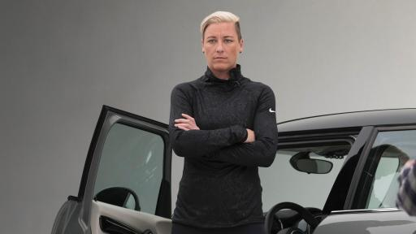
Abby Wambach Serena Williams
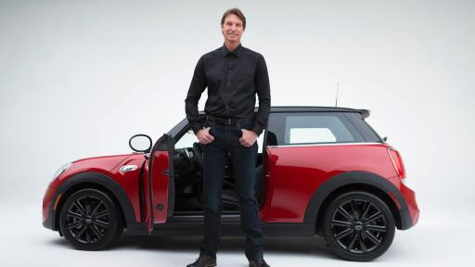
T- Pain Randy Johnson
“This campaign acknowledges those labels in a very authentic way while simultaneously showing people MINI is more than that.” said Tom Noble (http://www.multivu.com)

Mini wanted to involve personalities that had a link to the brand and could speak genuine about the labels. The ad includes Serena Williams, Abby Wambach, T-Pain, Randy Johnson, they shared their own opinions.
“This powerful concept leverages the brand’s new sophisticated positioning, with a little bit of the MINI attitude that’s always been there,” said John Butler, chief creative officer, BSSP (http://www.multivu.com)

Sales promotion
Such as company had organised contests, like the first 1,000 pre-booking for a particular model would get additional accessories as a prize. Company offered long route ride for senior citizen so that they can feel the comfort, check mileage etc.
‘12 months roadside assistance’(https://approvedusedminis.co.uk/)

If you buy an used car with ‘100% Approved Used MINI programme’ you will benefit of:
- 12 months MINI Emergency service cover across the UK
- 12 months MOT and MOT cover
- Full service history
- 12 months warranty.

MINI Financial Service
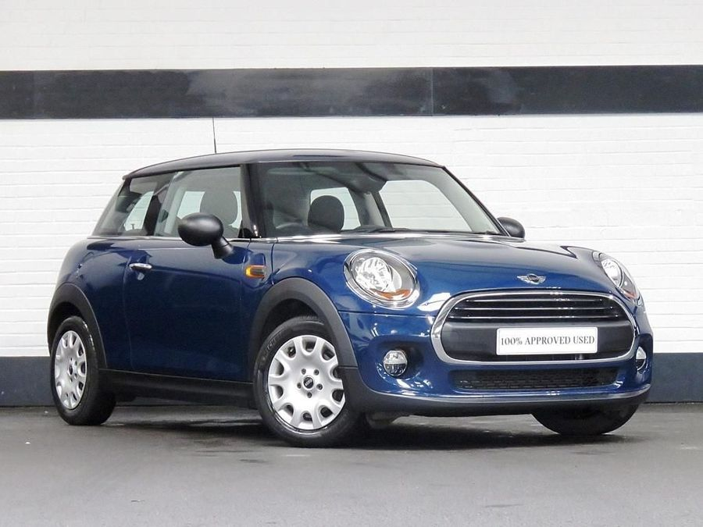
For an approved used MINI you can beneficiate of a wide range of finance options
You have to decide on the deposit and how long the agreement should last ( from 24 months to 60months). At the end of the agreement you can choose if you want to keep the car, change with a new one or return the vehicle.

Outdoor Advertising
Mini Cooper is doing outdoor advertising in many locations in the most important cities.

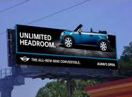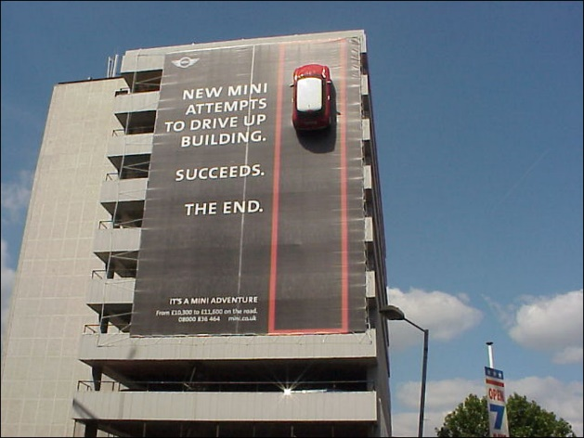

References:
https://www.bmwblog.com/category/mini/ (Accessed on 12 April 2019)
http://www.multivu.com/players/English/7741551-mini-usa-defy-labels/ (Accessed on 12 April 2019)
https://approvedusedminis.co.uk/ (Accessed on 13 April 2019)
https://approvedusedminis.co.uk/about-finance/ (Accessed on 14 April 2019)
http://rabbinoor.blogspot.com/2014/11/integrated-marketing-communication-on_4.html (Accessed on 14 April 2019)
https://www.google.com/search?rlz=1C1CHBF_en-gbGB822GB822&q=outdoor+adv+mini+cooper&tbm=isch&source=univ&sa=X&ved=2ahUKEwjJvfvKg9PhAhX-QxUIHZ-xCpAQsAR6BAgJEAE&biw=1280&bih=610#imgrc=iwSxnKqbmgkLCM: (Accessed on 14 April 2019)
https://www.mini.co.uk/en_GB/home.html (Accessed on 14 April 2019)

