Marketing Management (BMMB7012)

Charlotte Joyner (1650411)

Assessment 1 – 10 minute Ted Talk (Video Presentation)

Link to recording - Charlotte Joyner 1650411- Marketing Vlog-20230704_151822-Meeting Recording.mp4

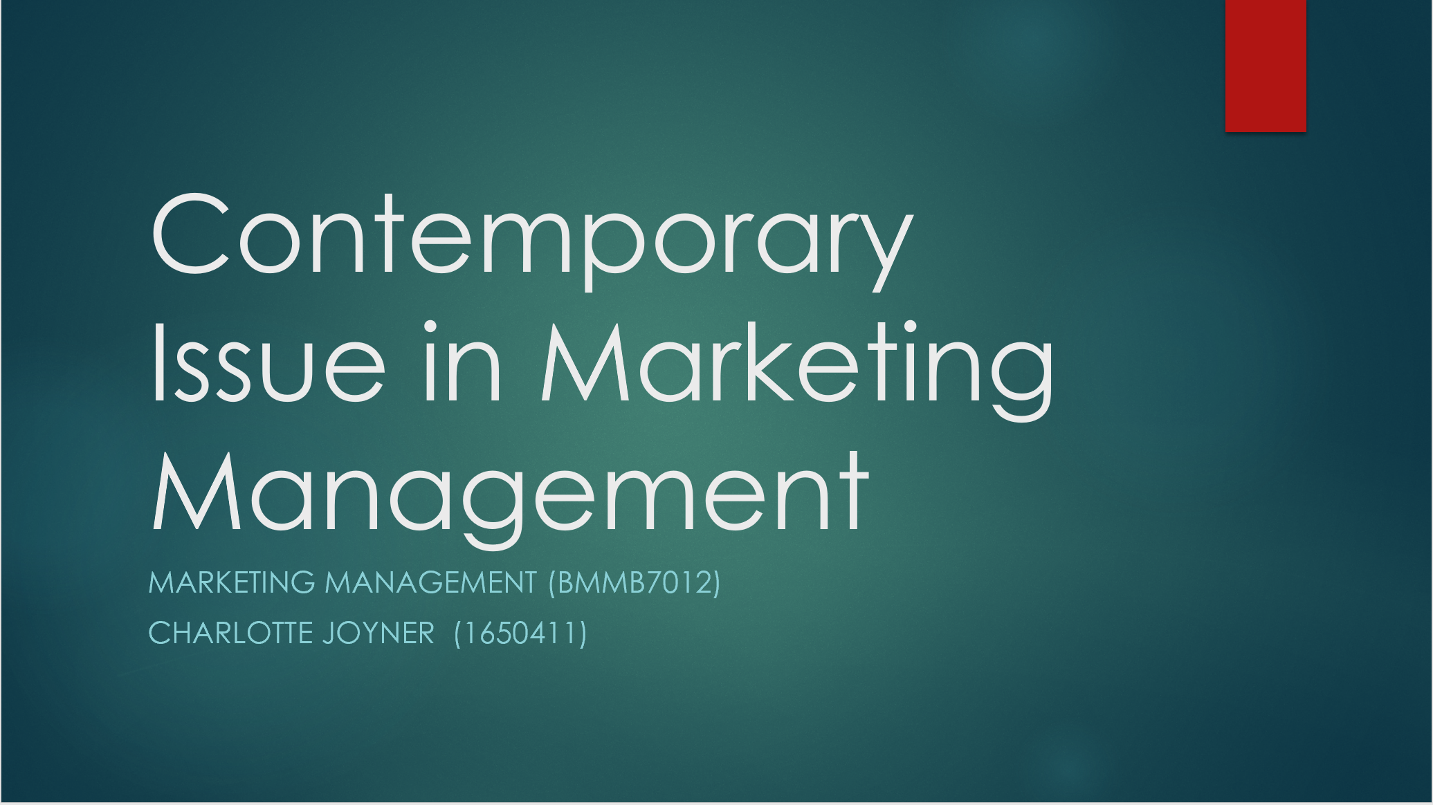
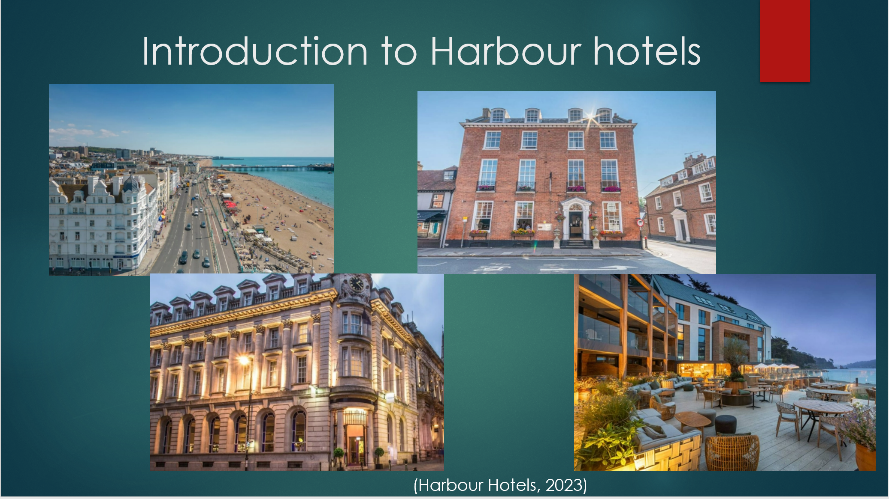
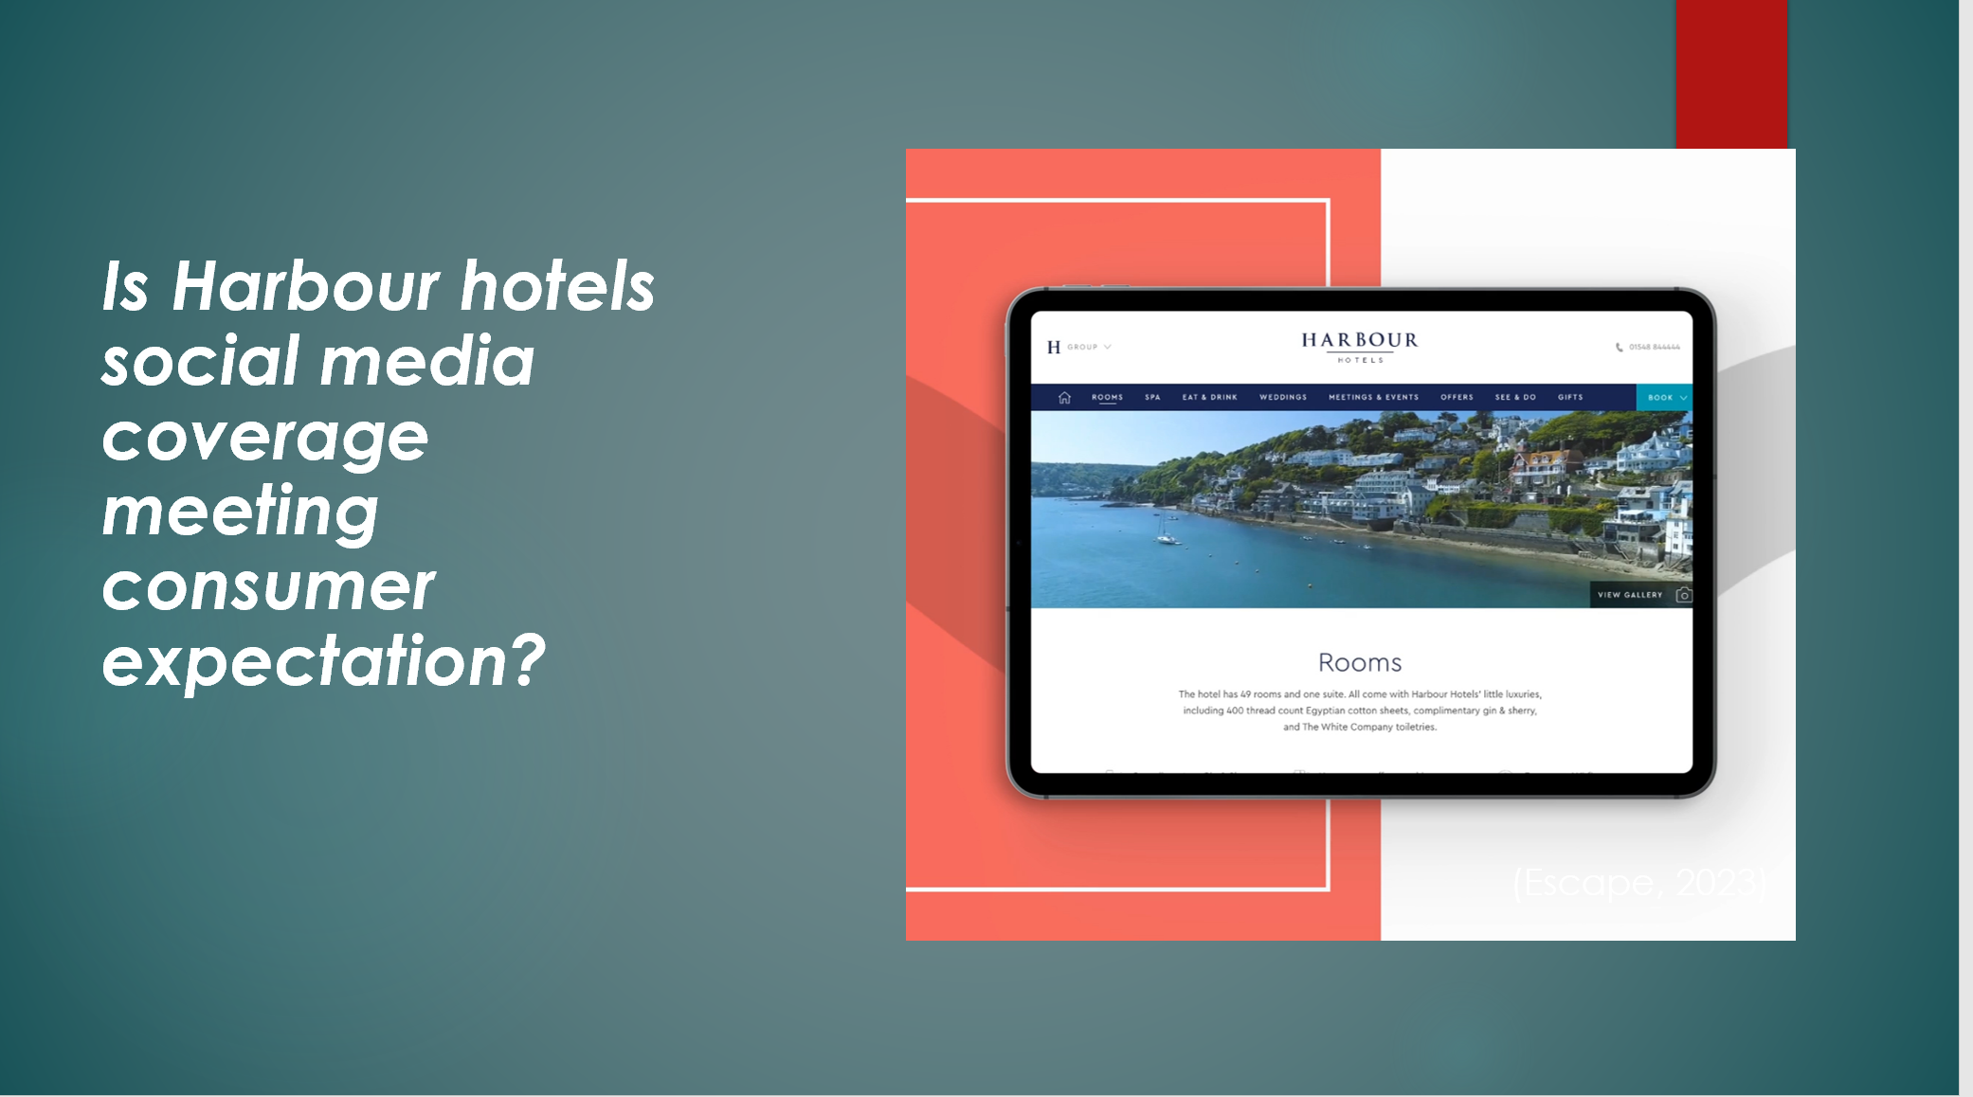
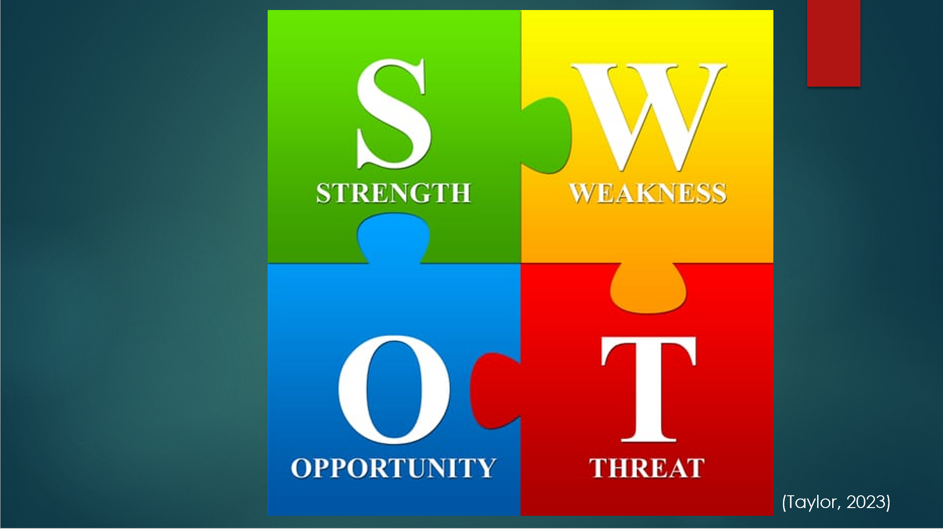
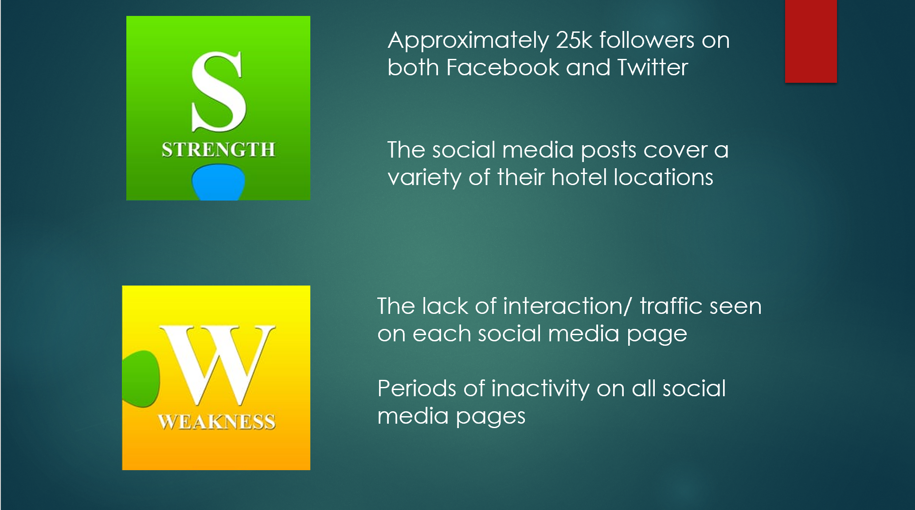
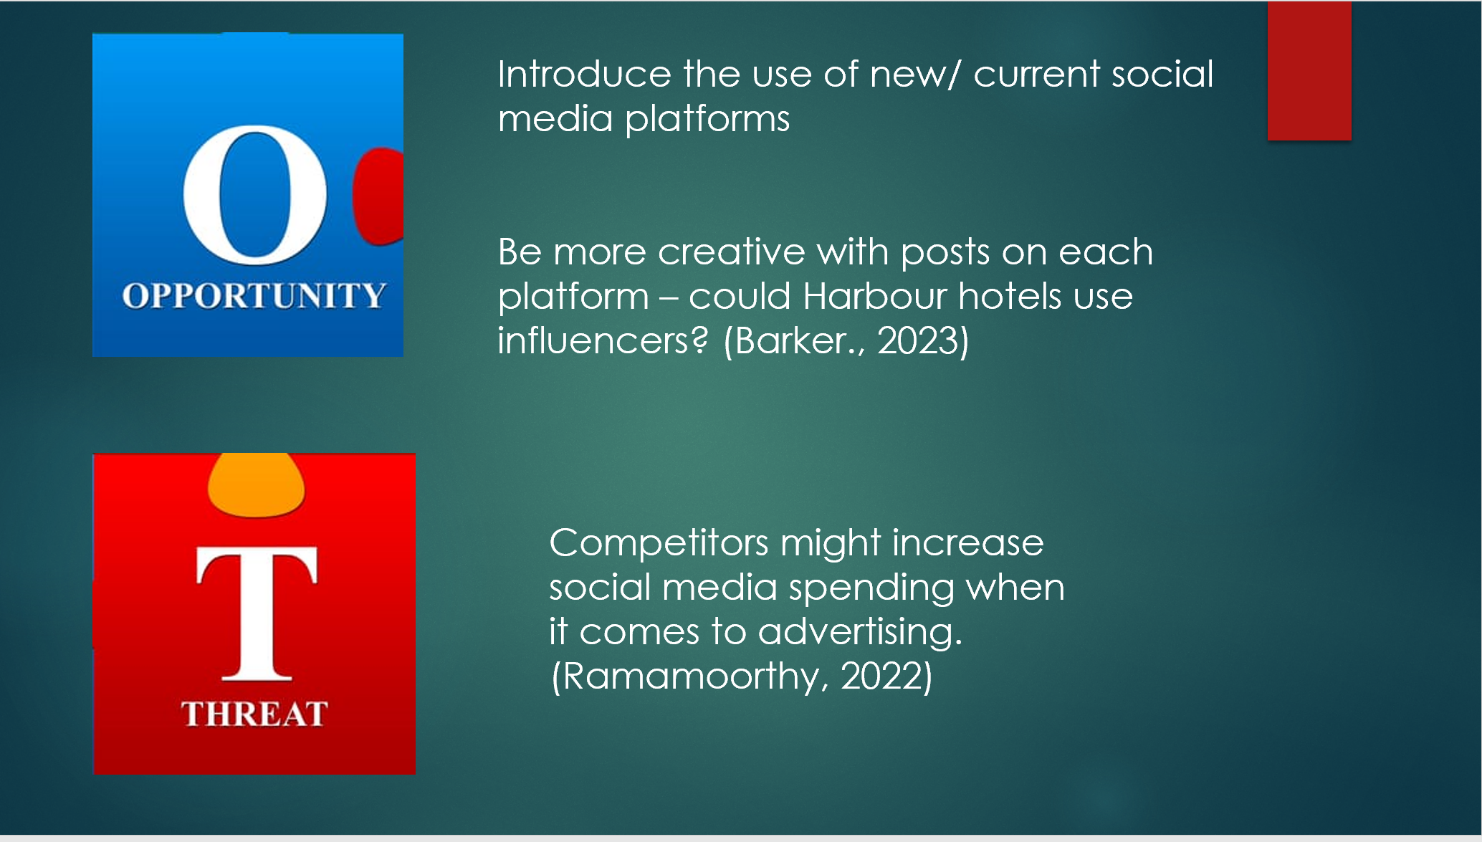
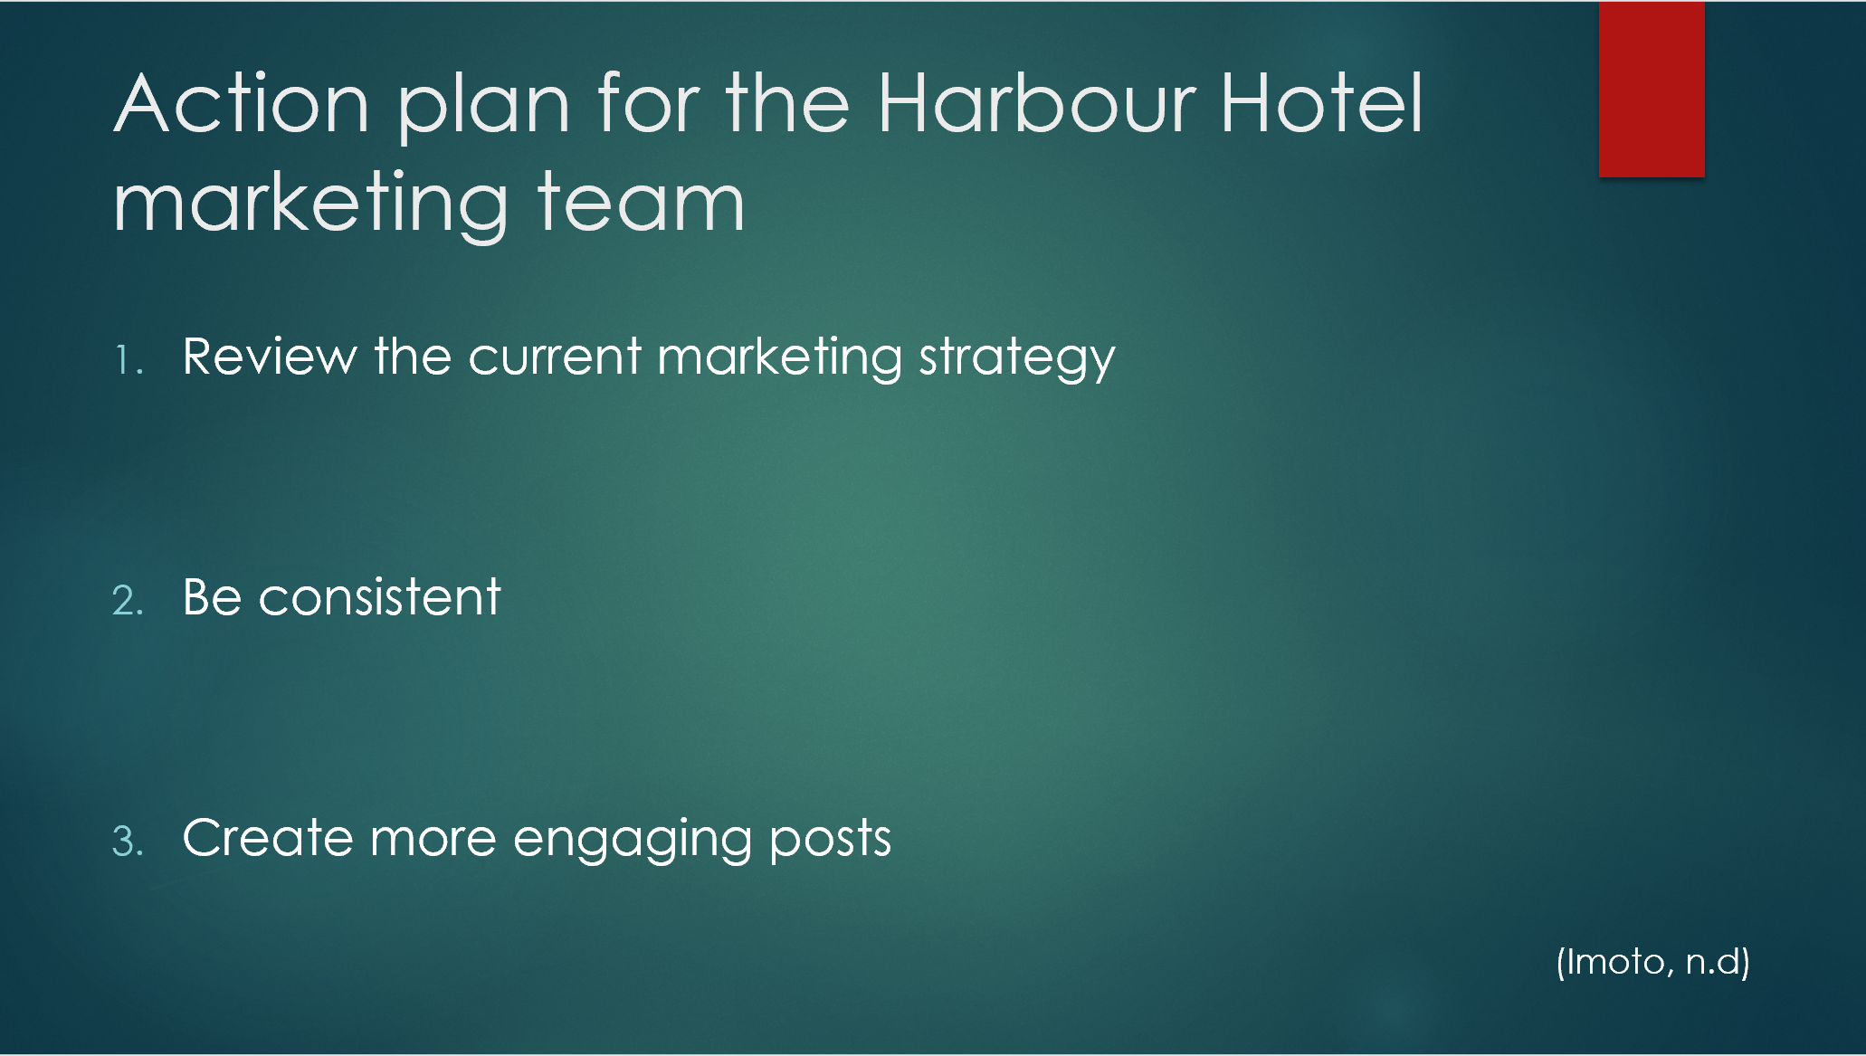


Reference list:
Appel, G., Grewal, L., Hadi, R. and Stephen, A. (2019) The Future of Social Media in Marketing. Journal of the Academy of Marketing Science. 48, pp. 79-95.
Barker, S. (2023) The future of social media marketing: 11 trends you need to know in 2023. Available from: https://shanebarker.com/blog/future-of-social-media-marketing/ [Accessed 30th June 2023]
Benzaghta, M.A., Elwalda, A. and Mousa, M.M. (2021) Swot Analysis Applications: An Integrative Literature Review. Journal of Global Business Insights. 6 (1), pp. 55-73.
Escape (n.d) Making waves with a new website for the Hotel Group of the Year. Available from: https://www.the-escape.co.uk/work/harbour-hotel-group [Accessed 30th June 2023]
Evans, D., Bratton, S. and McKee, J. (2021) Social Media Marketing. Indiana: Wiley.
Geyser, W. (2022) 5 of the biggest social media marketing challenges. Available from: https://influencermarketinghub.com/social-media-marketing-challenges/ [Accessed 30th June 2023]
Growjo (2023) Harbour Hotels Group revenue and competitors. Available from: Harbour Hotels Group: Revenue, Competitors, Alternatives (growjo.com) [Accessed 30th June 2023]
Harbour Hotels (2023) Harbour Hotels. [Facebook]. Available from: https://www.facebook.com/HarbourHotels/ [Accessed 30th June 2023]
Harbour Hotels (2023) harbour_hotels. [Instagram]. Available from: https://www.instagram.com/harbour_hotels/?hl=en [Accessed 30th June 2023]
Harbour Hotels (2023) Our hotels & specialist venues. Available from: Hotels & Venues Across the UK | Harbour Hotels Group [Accessed 30th June 2023]
Imoto, M. (n.d) 5 Tips to successful social media marketing. Available from: https://www.bu.edu/prlab/2022/03/01/5-tips-to-successful-social-media-marketing/ [Accessed 30th June 2023]
Linkedin (n.d) Harbour Hotel Group. Available from: Harbour Hotels Group | LinkedIn [Accessed 30th June 2023]
Ramamoorthy, A. (2022) The ultimate guide to social media SWOT analysis. Available from: The Ultimate Guide To Social Media SWOT Analysis [+Template] (statusbrew.com) [Accessed 30th June 2023]
Statista (202) Active social media audience in the United Kingdom (UK) IN January 2023. Available from: https://www.statista.com/statistics/507405/uk-active-social-media-and-mobile-social-media-users/ [Accessed 30th June 2023]
Taylor, I. (2023 ) A SWOT analysis template for the overwhelmed marketer. Available from: A SWOT Analysis Template For The Overwhelmed Marketer | QuestionPro [Accessed 30th June 2023]
The Hoxton (2023) The Hoxton. [Facebook]. Available from: https://www.facebook.com/TheHoxtonHotel/?locale=en_GB [Accessed 30th June 2023]
The Qhotels Collection (2023) The Qhotels collection. [Facebook]. Available from: https://www.facebook.com/TheQHotelsCollection/ [Accessed 30th June 2023]

